Mysql练习题

**Class表的定义**

|  |  |  |  |  |  |  |  |
| --- | --- | --- | --- | --- | --- | --- | --- |
| **字段名** | **字段描述** | **数据类型** | **主键** | **外键** | **非空** | **唯一** | **自增** |
| class_id | 编号 | INT(10) | 是 | 否 | 是 | 是 | 是 |
| class_name | 班级名称 | VARCHAR(64) | 否 | 否 | 是 | 否 | 否 |

INSERT INTO `class` VALUES ('1', '三年二班'), ('2', '三年三班'), ('3', '一年二班'), ('4', '二年九班');

**Subject表的定义**

|  |  |  |  |  |  |  |  |
| --- | --- | --- | --- | --- | --- | --- | --- |
| **字段名** | **字段描述** | **数据类型** | **主键** | **外键** | **非空** | **唯一** | **自增** |
| subject_id | 编号 | INT(10) | 是 | 否 | 是 | 是 | 是 |
| subject_name | 班级名称 | VARCHAR(64) | 否 | 否 | 是 | 否 | 否 |
| teacher_id | 教师id | INT(10) | 否 | 否 | 否 | 否 | 否 |

INSERT INTO `course` VALUES ('1', '生物', '1'), ('2', '物理', '2'), ('3', '体育', '3'), ('4', '美术', '2');

**Score表的定义**

|  |  |  |  |  |  |  |  |
| --- | --- | --- | --- | --- | --- | --- | --- |
| **字段名** | **字段描述** | **数据类型** | **主键** | **外键** | **非空** | **唯一** | **自增** |
| score_id | 编号 | INT(10) | 是 | 否 | 是 | 是 | 是 |
| subject_id | 课程id | INT(10) | 否 | 否 | 是 | 否 | 否 |
| student_id | 学生id | INT(10) | 否 | 否 | 否 | 否 | 否 |
| score | 分数 | INT(10) | 否 | 否 | 否 | 否 | 否 |

INSERT INTO `score` VALUES ('1', '1', '1', '10'), ('2', '1', '2', '9'), ('5', '1', '4', '66'), ('6', '2', '1', '8'), ('8', '2', '3', '68'), ('9', '2', '4', '99'), ('10', '3', '1', '77'), ('11', '3', '2', '66'), ('12', '3', '3', '87'), ('13', '3', '4', '99'), ('14', '4', '1', '79'), ('15', '4', '2', '11'), ('16', '4', '3', '67'), ('17', '4', '4', '100'), ('18', '5', '1', '79'), ('19', '5', '2', '11'), ('20', '5', '3', '67'), ('21', '5', '4', '100'), ('22', '6', '1', '9'), ('23', '6', '2', '100'), ('24', '6', '3', '67'), ('25', '6', '4', '100'), ('26', '7', '1', '9'), ('27', '7', '2', '100'), ('28', '7', '3', '67'), ('29', '7', '4', '88'), ('30', '8', '1', '9'), ('31', '8', '2', '100'), ('32', '8', '3', '67'), ('33', '8', '4', '88'), ('34', '9', '1', '91'), ('35', '9', '2', '88'), ('36', '9', '3', '67'), ('37', '9', '4', '22'), ('38', '10', '1', '90'), ('39', '10', '2', '77'), ('40', '10', '3', '43'), ('41', '10', '4', '87'), ('42', '11', '1', '90'), ('43', '11', '2', '77'), ('44', '11', '3', '43'), ('45', '11', '4', '87'), ('46', '12', '1', '90'), ('47', '12', '2', '77'), ('48', '12', '3', '43'), ('49', '12', '4', '87'), ('52', '13', '3', '87');

**Student表的定义**

|  |  |  |  |  |  |  |  |
| --- | --- | --- | --- | --- | --- | --- | --- |
| **字段名** | **字段描述** | **数据类型** | **主键** | **外键** | **非空** | **唯一** | **自增** |
| student_id | 编号 | INT(10) | 是 | 否 | 是 | 是 | 是 |
| sex | 性别 | VARCHAR(64) | 否 | 否 | 是 | 否 | 否 |
| class_id | 班级id | INT(10) | 否 | 否 | 否 | 否 | 否 |
| student_name | 学生姓名 | VARCHAR(64) | 否 | 否 | 否 | 否 | 否 |

INSERT INTO `student` VALUES ('1', '男', '1', '理解'), ('2', '女', '1', '钢蛋'), ('3', '男', '1', '张三'), ('4', '男', '1', '张一'), ('5', '女', '1', '张二'), ('6', '男', '1', '张四'), ('7', '女', '2', '铁锤'), ('8', '男', '2', '李三'), ('9', '男', '2', '李一'), ('10', '女', '2', '李二'), ('11', '男', '2', '李四'), ('12', '女', '3', '如花'), ('13', '男', '3', '刘三'), ('14', '男', '3', '刘一'), ('15', '女', '3', '刘二'), ('16', '男', '3', '刘四');

**Teacher表的定义**

|  |  |  |  |  |  |  |  |
| --- | --- | --- | --- | --- | --- | --- | --- |
| **字段名** | **字段描述** | **数据类型** | **主键** | **外键** | **非空** | **唯一** | **自增** |
| teacher_id | 编号 | INT(10) | 是 | 否 | 是 | 是 | 是 |
| teacher_name | 姓名 | VARCHAR(64) | 否 | 否 | 是 | 否 | 否 |

INSERT INTO `teacher` VALUES ('1', '张磊老师'), ('2', '李平老师'), ('3', '刘海燕老师'), ('4', '朱云海老师'), ('5', '李杰老师');

1. 查询男生、女生的人数；

select

class_id '学号',

COUNT(sex) '人数'

from student

group by sex

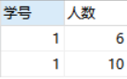

1. 查询姓“张”的学生名单；

select *

from student

where

student_name like '张%'

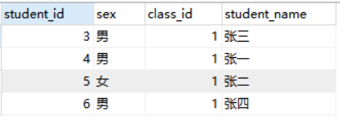

1. 课程平均分从高到低显示

select

subject_id '课程编号',

AVG(score) '平均分数'

from

score

GROUP BY subject_id

ORDER BY AVG(score) desc

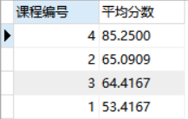

1. 查询有课程成绩小于60分的同学的学号、姓名；

select

stu.student_id '学号',

stu.student_name '姓名',

sc.score '分数'

from

student stu ,score sc

where

sc.score < 60 and

stu.student_id = sc.student_id

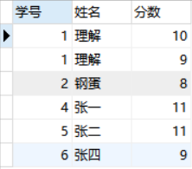

1. 查询至少有一门课与学号为1的同学所学课程相同的同学的学号和姓名；

select

stu.student_id '学号',

stu.student_name '学生姓名'

from

(select DISTINCT student_id from score

where

subject_id in(select subject_id from score where student_id = '1')) a,

student stu

where

stu.student_id = a.student_id

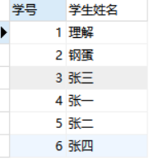

1. 查询出只选修了一门课程的全部学生的学号和姓名；

select

stu.student_name '学生姓名',

stu.student_id '学号'

from

student stu,(select a.student_id from (select student_id,COUNT(subject_id) 'number' from score GROUP BY student_id) a where a.number = 1) b

where

stu.student_id = b.student_id



1. 查询各科成绩最高和最低的分：以如下形式显示：课程ID，最高分，最低分；

select

c.subject_id '课程',

c.max '最高分',

d.min '最低分'

from

(select subject_id,MAX(score) 'max' from score GROUP BY subject_id) c,

(select subject_id,MIN(score) 'min' from score GROUP BY subject_id) d

where

c.subject_id = d.subject_id

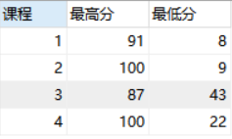

1. 查询课程编号“2”的成绩比课程编号“1”课程低的所有同学的学号、姓名；

SELECT

student_id '学号',

student_name '学生姓名'

FROM

student

WHERE

student_id IN (

SELECT

sca.student_id

FROM

(

SELECT

student_id,

subject_id,

score

FROM

score

WHERE

subject_id = '1'

) sca

INNER JOIN (

SELECT

student_id,

subject_id,

score

FROM

score

WHERE

subject_id = '2'

) scb ON sca.student_id = scb.student_id

)

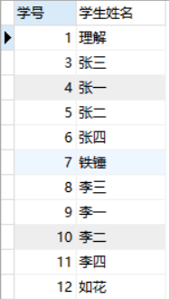

1. 查询“生物”课程比“物理”课程成绩高的所有学生的学号；

SELECT

sca.student_id

FROM

(

select

sc.student_id,

sub.subject_name,

sc.score

from

score sc,subject sub

where

sc.subject_id = '1' and

sub.subject_id = sc.subject_id

) sca

INNER JOIN (

select

sc.student_id,

sub.subject_name,

sc.score

from

score sc,subject sub

where

sc.subject_id = '2' and

sub.subject_id = sc.subject_id

) scb ON sca.student_id = scb.student_id

where

sca.score > scb.score

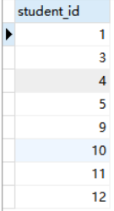

1. 查询平均成绩大于60分的同学的学号和平均成绩;

select

student_id '学号',

AVG(score) '平均分'

from

score

GROUP BY student_id HAVING AVG(score)>60

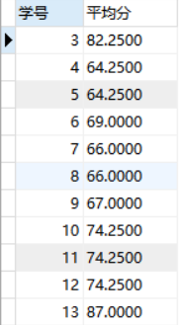

1. 查询所有同学的学号、姓名、选课数、总成绩；

select

stu.student_id '学号',

stu.student_name '姓名',

sce.count '选课数',

sce.sum '总成绩'

from

student stu,

(select

student_id,

sum(score) 'sum',

count(subject_id) 'count'

from

score

GROUP BY student_id ) sce

where

sce.student_id = stu.student_id

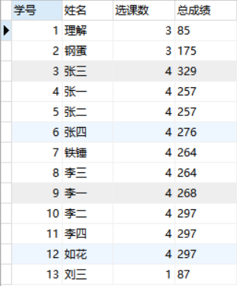

1. 查询姓“李”的老师的个数；

select

COUNT(teacher_name) '个数'

from

teacher

where

teacher_name like '李%'



1. 查询没学过“张磊老师”课的同学的学号、姓名；

select

stu.student_id '学号',

stu.student_name '姓名'

from

student stu

RIGHT JOIN (select

student_id,

subject_id

from

score

GROUP BY student_id having subject_id not in(select

subject_id

from

`subject`

where

teacher_id in(SELECT teacher_id FROM teacher where teacher_name = '张磊老师'))) suba on stu.student_id = suba.student_id



1. 查询学过“1”并且也学过编号“2”课程的同学的学号、姓名；

select

student_id '学号',

student_name '姓名'

from

student

WHERE

student_id in(select sc1.student_id 'id'

FROM

(SELECT

*

from

score

where

subject_id = '1') sc1

INNER JOIN (SELECT

*

from

score

where

subject_id = '2') sc2 on sc1.student_id = sc2.student_id)

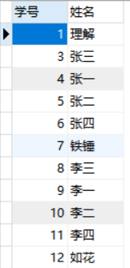

1. 查询学过“李平老师”所教的所有课的同学的学号、姓名；

select

stu.student_id '学号',

stu.student_name '姓名'

from

student stu , `subject` sub, score sc , teacher tea

where

stu.student_id = sc.student_id

and sc.subject_id = sub.subject_id

and sub.teacher_id = tea.teacher_id

and tea.teacher_name = '李平老师'

GROUP BY stu.student_id

having count(*) = 2

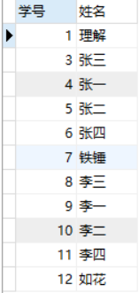

1. 查询没有学全所有课的同学的学号、姓名；

SELECT

student_id '学号',

student_name '姓名'

FROM

student

WHERE

student_id IN (

SELECT

student_id

FROM

(

SELECT

count(subject_id) c_subject_id,

student_id

FROM

score

GROUP BY

student_id

) t1

WHERE

t1.c_subject_id < (

SELECT

count(subject_id)

FROM

`subject`

)

)

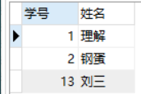

1. 查询和“002”号的同学学习的课程完全相同的其他同学学号和姓名；

SELECT

stu.student_id '学号',

stu.student_name '姓名'

FROM

Student stu,

Score sc

WHERE

stu.student_id = sc.student_id

AND stu.student_id NOT IN (

SELECT

student_id

FROM

Score

WHERE

subject_id NOT IN (

SELECT

subject_id

FROM

Score

WHERE

student_id = 2

)

)

AND stu.student_id != 2

GROUP BY

stu.student_id

HAVING

COUNT(*) = (

SELECT

COUNT(*)

FROM

Score

WHERE

student_id = 2

)



1. 删除学习“李平”老师课的SC表记录；

DELETE

FROM

Score1

where

score_id in(select

score_id

from

score sc,

(select

subject_id

from

subject

where

teacher_id in (SELECT

teacher_id

FROM

teacher

where

teacher_name = '李平老师')) a

where

sc.subject_id = a.subject_id)

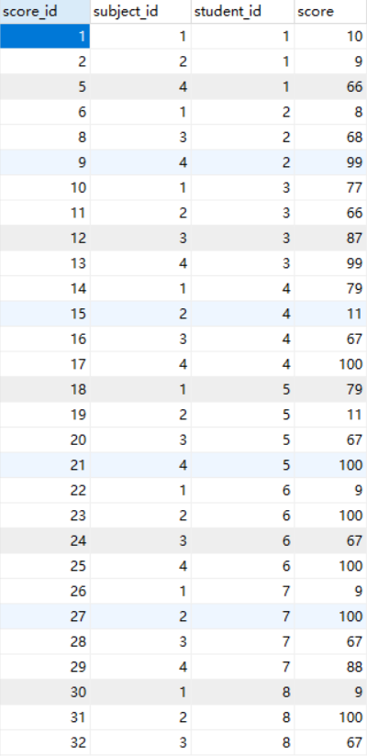 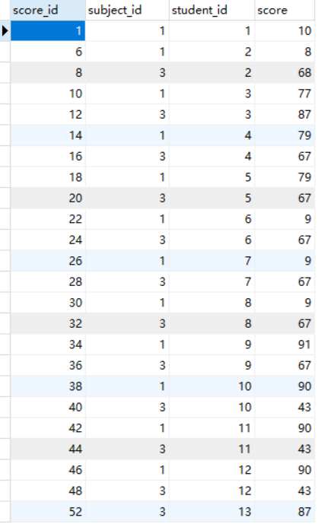

1. 向SC表中插入一些记录，这些记录要求符合以下条件：①没有上过编号“002”课程的同学学号；②插入“002”号课程的平均成绩；
2. 按平均成绩从低到高显示所有学生的“生物”、“物理”、“体育”三门的课程成绩，按如下形式显示： 学生ID,生物,物理,体育,有效课程数,有效平均分；

SELECT

sc.student_id '学号',

(

SELECT

score

FROM

score

LEFT JOIN SUBJECT ON score.subject_id = subject.subject_id

WHERE

subject_name = '生物'

AND score.student_id = sc.student_id

) AS '生物',

(

SELECT

score

FROM

score

LEFT JOIN SUBJECT ON score.subject_id = subject.subject_id

WHERE

subject_name = '物理'

AND score.student_id = sc.student_id

) AS '物理',

(

SELECT

score

FROM

score

LEFT JOIN SUBJECT ON score.subject_id = subject.subject_id

WHERE

subject_name = '体育'

AND score.student_id = sc.student_id

) AS '体育',

(

SELECT

score

FROM

score

LEFT JOIN SUBJECT ON score.subject_id = subject.subject_id

WHERE

subject_name = '美术'

AND score.student_id = sc.student_id

) AS '美术',

count(sc.subject_id) '有效课程数',

avg(sc.score) '有效平均分'

FROM

score sc

GROUP BY

student_id

ORDER BY

avg(sc.score)

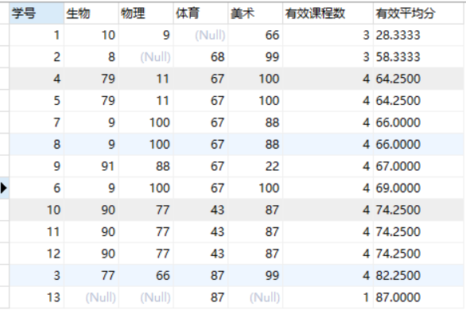

1. 查询各科成绩最高和最低的分：以如下形式显示：课程ID，最高分，最低分；

select

subject_id '课程id',

MAX(score) '最高分',

min(score) '最低分'

FROM

score

GROUP BY subject_id

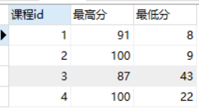

1. 按各科平均成绩从低到高和及格率的百分数从高到低顺序；

SELECT

t_out1.subject_id '课程',

t_out1.avgnum '平均分',

t_out2.pass_per '及格率'

FROM

(

SELECT

subject_id,

avg(score) avgnum

FROM

score

GROUP BY

subject_id

) t_out1

LEFT JOIN (

SELECT

t1.subject_id,

t1.count1 / t2.count2 pass_per

FROM

(

SELECT

subject_id,

count(subject_id) count1

FROM

score

WHERE

score > 60

GROUP BY

subject_id

) t1

LEFT JOIN (

SELECT

subject_id,

count(subject_id) count2

FROM

score

GROUP BY

subject_id

) t2 ON t1.subject_id = t2.subject_id

) t_out2 ON t_out1.subject_id = t_out2.subject_id

ORDER BY

avgnum,

pass_per DESC;

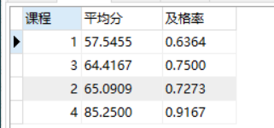

1. 查询各科成绩前三名的记录:(不考虑成绩并列情况)

SELECT

t1.student_id,

t1.subject_id,

t1.score

FROM

score t1

LEFT JOIN (

SELECT

score_id,

subject_id,

(

SELECT

score

FROM

score AS s2

WHERE

s2.subject_id = s1.subject_id

ORDER BY

score DESC

LIMIT 0,

1

) AS first_num,

(

SELECT

score

FROM

score AS s2

WHERE

s2.subject_id = s1.subject_id

ORDER BY

score DESC

LIMIT 1,

1

) AS second_num,

(

SELECT

score

FROM

score AS s2

WHERE

s2.subject_id = s1.subject_id

ORDER BY

score DESC

LIMIT 2,

1

) AS third_num

FROM

score AS s1

) t2 ON t1.score_id = t2.score_id

WHERE

t1.score = t2.first_num

OR t1.score = t2.second_num

OR t1.score = t2.third_num;

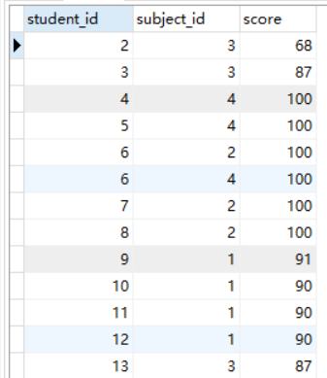

1. 查询每门课程被选修的学生数；

SELECT

subject_id,

count(student_id)

from

score

GROUP BY subject_id

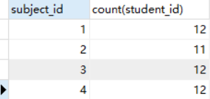

1. 查询同名同姓学生名单，并统计同名人数；

SELECT

student_name,

COUNT(student_name)

FROM

student

GROUP BY student_name HAVING student_name >1

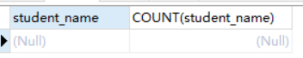

1. 查询每门课程的平均成绩，结果按平均成绩升序排列，平均成绩相同时，按课程号降序排列；

SELECT

subject_id,

avg(score)

FROM

score

GROUP BY subject_id

ORDER BY avg(score),subject_id DESC

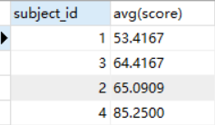

1. 查询平均成绩大于85的所有学生的学号. 姓名和平均成绩；

SELECT

stu.student_id '学号',

stu.student_name '姓名',

AVG(score) '平均分'

FROM

score sc , student stu

WHERE

sc.student_id = stu.student_id

GROUP BY sc.student_id HAVING AVG(score)>85



1. 查询课程名称为“物理”，且分数低于60的学生姓名和分数；

select

stu.student_id '学号',

stu.student_name '姓名',

sc.score '成绩'

FROM

subject sub , score sc , student stu

where

sub.subject_name = '物理'

and sc.score <60

and stu.student_id = sc.student_id

and sc.subject_id = sub.subject_id

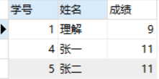

1. 查询课程编号为003且课程成绩在80分以上的学生的学号和姓名；

select

stu.student_id '学号',

stu.student_name '学生姓名'

from

score sc,student stu

where

subject_id = 3

and score >80

and sc.student_id = stu.student_id

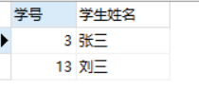

1. 求选了课程的学生人数

SELECT

COUNT(DISTINCT student_id) '学生个数'

FROM

score



1. 查询选修“刘海燕”老师所授课程的学生中，成绩最高的学生姓名及其成绩；

SELECT

student.student_name '姓名',

score.score '成绩'

from

score , teacher , subject,student

where

teacher_name = '刘海燕老师'

and score.subject_id = `subject`.subject_id

and teacher.teacher_id = `subject`.teacher_id

and student.student_id = score.student_id

ORDER BY score DESC LIMIT 1

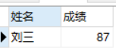

1. 查询各个课程及相应的选修人数；

SELECT

subject_id,

count(student_id)

FROM

score

GROUP BY subject_id

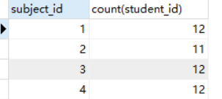

1. 查询不同课程但成绩相同的学生的学号、课程号、学生成绩；

SELECT DISTINCT

sca.student_id,

sca.subject_id,

sca.score,

scb.student_id,

scb.subject_id,

scb.score

FROM

score sca , score scb

WHERE

sca.score = scb.score and sca.subject_id != scb.subject_id

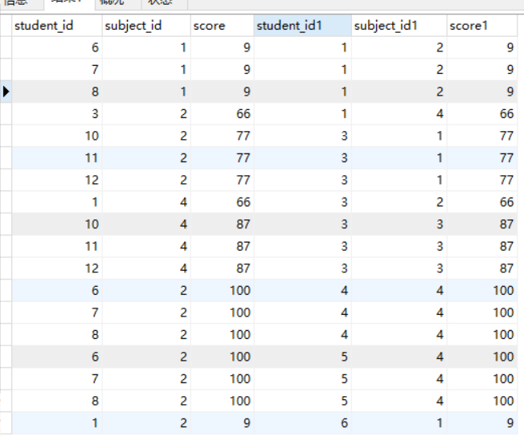

1. 查询每门课程成绩最好的前两名；

SELECT

*

FROM

score

LEFT JOIN (

SELECT

score_id,

(

SELECT

score

FROM

score AS s2

WHERE

s2.subject_id = s1.subject_id

ORDER BY

score DESC

LIMIT 0,

1

) AS first_num,

(

SELECT

score

FROM

score AS s2

WHERE

s2.subject_id = s1.subject_id

ORDER BY

score DESC

LIMIT 1,

1

) AS second_num

FROM

score AS s1

) AS T ON score.score_id= T.score_id

WHERE

score.score <= T.first_num

AND score.score >= T.second_num

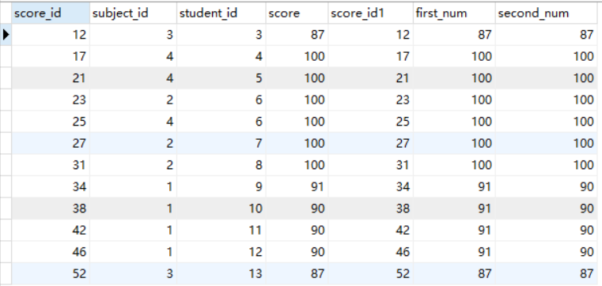

1. 检索至少选修两门课程的学生学号；

SELECT

student_id

FROM

score

GROUP BY

student_id

HAVING

COUNT(subject_id)>=2

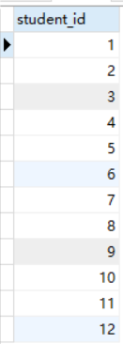

1. 查询全部学生都选修的课程的课程号和课程名；

SELECT

subject_id

FROM

score

GROUP BY

subject_id

HAVING

count(student_id) = (

SELECT

count(student_id)

FROM

student

);

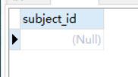

1. 查询没学过“叶平”老师讲授的任一门课程的学生姓名；

SELECT

student_name

FROM

student

WHERE

student_id NOT IN (

SELECT DISTINCT

student_id

FROM

score

WHERE

subject_id IN (

SELECT

subject_id

FROM

`subject`

WHERE

teacher_id IN (

SELECT

teacher_id

FROM

teacher

WHERE

teacher_name = '李平老师'

)

)

)

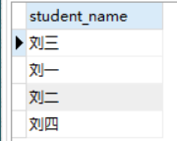

1. 查询两门以上不及格课程的同学的学号及其平均成绩；

SELECT

student_id '学号',

avg(score) '平均分'

FROM

score

WHERE

score < 60

GROUP BY

student_id

HAVING

count(score) >= 2;

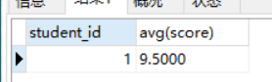

1. 检索“004”课程分数小于60，按分数降序排列的同学学号；

SELECT

student_id

FROM

score

WHERE

score < 60

AND subject_id = 4

ORDER BY

score DESC

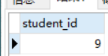

1. 删除“002”同学的“001”课程的成绩；

DELETE

FROM score

where

student_id = 2

and subject_id = 1;