Mysql练习题

**Class表的定义**

|  |  |  |  |  |  |  |  |
| --- | --- | --- | --- | --- | --- | --- | --- |
| **字段名** | **字段描述** | **数据类型** | **主键** | **外键** | **非空** | **唯一** | **自增** |
| class_id | 编号 | INT(10) | 是 | 否 | 是 | 是 | 是 |
| class_name | 班级名称 | VARCHAR(64) | 否 | 否 | 是 | 否 | 否 |

INSERT INTO `class` VALUES ('1', '三年二班'), ('2', '三年三班'), ('3', '一年二班'), ('4', '二年九班');

**Subject表的定义**

|  |  |  |  |  |  |  |  |
| --- | --- | --- | --- | --- | --- | --- | --- |
| **字段名** | **字段描述** | **数据类型** | **主键** | **外键** | **非空** | **唯一** | **自增** |
| subject_id | 编号 | INT(10) | 是 | 否 | 是 | 是 | 是 |
| subject_name | 班级名称 | VARCHAR(64) | 否 | 否 | 是 | 否 | 否 |
| teacher_id | 教师id | INT(10) | 否 | 否 | 否 | 否 | 否 |

INSERT INTO `course` VALUES ('1', '生物', '1'), ('2', '物理', '2'), ('3', '体育', '3'), ('4', '美术', '2');

**Score表的定义**

|  |  |  |  |  |  |  |  |
| --- | --- | --- | --- | --- | --- | --- | --- |
| **字段名** | **字段描述** | **数据类型** | **主键** | **外键** | **非空** | **唯一** | **自增** |
| score_id | 编号 | INT(10) | 是 | 否 | 是 | 是 | 是 |
| subject_id | 课程id | INT(10) | 否 | 否 | 是 | 否 | 否 |
| student_id | 学生id | INT(10) | 否 | 否 | 否 | 否 | 否 |
| score | 分数 | INT(10) | 否 | 否 | 否 | 否 | 否 |

INSERT INTO `score` VALUES ('1', '1', '1', '10'), ('2', '1', '2', '9'), ('5', '1', '4', '66'), ('6', '2', '1', '8'), ('8', '2', '3', '68'), ('9', '2', '4', '99'), ('10', '3', '1', '77'), ('11', '3', '2', '66'), ('12', '3', '3', '87'), ('13', '3', '4', '99'), ('14', '4', '1', '79'), ('15', '4', '2', '11'), ('16', '4', '3', '67'), ('17', '4', '4', '100'), ('18', '5', '1', '79'), ('19', '5', '2', '11'), ('20', '5', '3', '67'), ('21', '5', '4', '100'), ('22', '6', '1', '9'), ('23', '6', '2', '100'), ('24', '6', '3', '67'), ('25', '6', '4', '100'), ('26', '7', '1', '9'), ('27', '7', '2', '100'), ('28', '7', '3', '67'), ('29', '7', '4', '88'), ('30', '8', '1', '9'), ('31', '8', '2', '100'), ('32', '8', '3', '67'), ('33', '8', '4', '88'), ('34', '9', '1', '91'), ('35', '9', '2', '88'), ('36', '9', '3', '67'), ('37', '9', '4', '22'), ('38', '10', '1', '90'), ('39', '10', '2', '77'), ('40', '10', '3', '43'), ('41', '10', '4', '87'), ('42', '11', '1', '90'), ('43', '11', '2', '77'), ('44', '11', '3', '43'), ('45', '11', '4', '87'), ('46', '12', '1', '90'), ('47', '12', '2', '77'), ('48', '12', '3', '43'), ('49', '12', '4', '87'), ('52', '13', '3', '87');

**Student表的定义**

|  |  |  |  |  |  |  |  |
| --- | --- | --- | --- | --- | --- | --- | --- |
| **字段名** | **字段描述** | **数据类型** | **主键** | **外键** | **非空** | **唯一** | **自增** |
| student_id | 编号 | INT(10) | 是 | 否 | 是 | 是 | 是 |
| sex | 性别 | VARCHAR(64) | 否 | 否 | 是 | 否 | 否 |
| class_id | 班级id | INT(10) | 否 | 否 | 否 | 否 | 否 |
| student_name | 学生姓名 | VARCHAR(64) | 否 | 否 | 否 | 否 | 否 |

INSERT INTO `student` VALUES ('1', '男', '1', '理解'), ('2', '女', '1', '钢蛋'), ('3', '男', '1', '张三'), ('4', '男', '1', '张一'), ('5', '女', '1', '张二'), ('6', '男', '1', '张四'), ('7', '女', '2', '铁锤'), ('8', '男', '2', '李三'), ('9', '男', '2', '李一'), ('10', '女', '2', '李二'), ('11', '男', '2', '李四'), ('12', '女', '3', '如花'), ('13', '男', '3', '刘三'), ('14', '男', '3', '刘一'), ('15', '女', '3', '刘二'), ('16', '男', '3', '刘四');

**Teacher表的定义**

|  |  |  |  |  |  |  |  |
| --- | --- | --- | --- | --- | --- | --- | --- |
| **字段名** | **字段描述** | **数据类型** | **主键** | **外键** | **非空** | **唯一** | **自增** |
| teacher_id | 编号 | INT(10) | 是 | 否 | 是 | 是 | 是 |
| teacher_name | 姓名 | VARCHAR(64) | 否 | 否 | 是 | 否 | 否 |

INSERT INTO `teacher` VALUES ('1', '张磊老师'), ('2', '李平老师'), ('3', '刘海燕老师'), ('4', '朱云海老师'), ('5', '李杰老师');

1. 查询男生、女生的人数；

SELECT sex,COUNT(*) AS '人数' FROM student

GROUP BY sex;

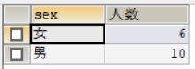

1. 查询姓“张”的学生名单；

SELECT student_name FROM student WHERE student_name LIKE '张%'

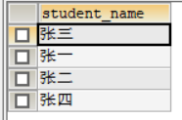

1. 课程平均分从高到低显示

SELECT subject_name,AVG(sc.score) AS '平均分'

FROM score sc,SUBJECT su

WHERE sc.subject_id=su.subject_id

GROUP BY su.subject_name

ORDER BY AVG(sc.score) DESC;

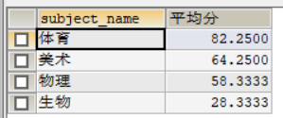

1. 查询有课程成绩小于60分的同学的学号、姓名；

SELECT st.student_id,student_name,sc.score

FROM student st,score sc

WHERE st.student_id=sc.student_id

AND score<60;

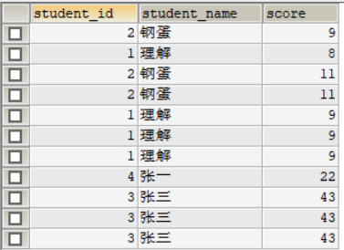

1. 查询至少有一门课与学号为1的同学所学课程相同的同学的学号和姓名；

select student_id,student_name from student where student_id in (select distinct student_id from score where subject_id in (select subject_id from score where student_id = 1));

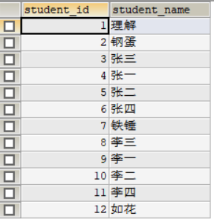

1. 查询出只选修了一门课程的全部学生的学号和姓名；

SELECT st.student_id,st.student_name

FROM student st,score sc

WHERE st.student_id=sc.student_id

GROUP BY sc.subject_id HAVING COUNT(sc.subject_id)=1



1. 查询各科成绩最高和最低的分：以如下形式显示：课程ID，最高分，最低分；

SELECT su.subject_id,MAX(sc.score) AS '最高分',MIN(sc.score) AS '最低分'

FROM score sc,SUBJECT su

WHERE sc.subject_id=su.subject_id

GROUP BY subject_id

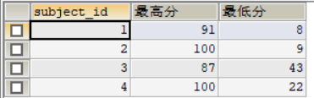

1. 查询课程编号“2”的成绩比课程编号“1”课程低的所有同学的学号、姓名；

SELECT  
student_id,  
student_name  
FROM  
student  
WHERE  
student_id IN (  
SELECT  
t1.student_id  
FROM  
(  
SELECT  
score num2,  
student_id  
FROM  
score  
WHERE  
subject_id = 2  
) t2  
INNER JOIN (  
SELECT  
student_id,  
score num1  
FROM  
score  
WHERE  
subject_id = 1  
) t1 ON t1.student_id = t2.student_id  
WHERE  
num2 < num1  
);

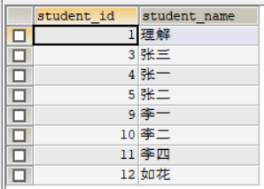

1. 查询“生物”课程比“物理”课程成绩高的所有学生的学号；

SELECT * FROM(

(SELECT * FROM score WHERE subject_id IN (SELECT subject_id FROM SUBJECT WHERE subject_name = '生物')) t1

LEFT JOIN

(SELECT * FROM score WHERE subject_id IN(SELECT subject_id FROM SUBJECT WHERE subject_name='物理')) t2

ON t1.student_id = t2.student_id)

WHERE t1.score>t2.score

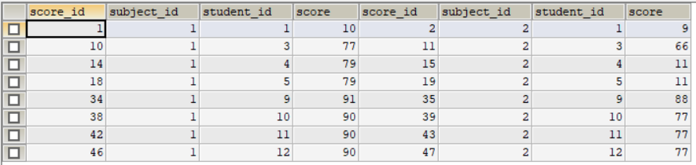

10.查询平均成绩大于60分的同学的学号和平均成绩;

select student_id,avg(score) from score group by student_id having avg(score) > 60;

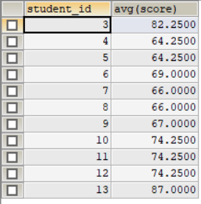

11.查询所有同学的学号、姓名、选课数、总成绩；

SELECT st.student_id,st.student_name,COUNT(*) '选课数',AVG(sc.score)

FROM student st,score sc

WHERE st.student_id=sc.student_id

GROUP BY student_id

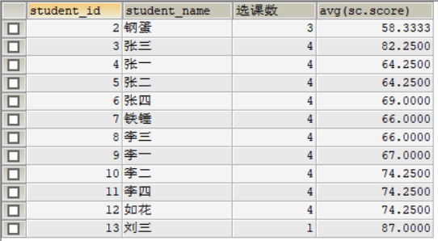

12.查询姓“李”的老师的个数；

SELECT COUNT(*) AS '人数'

FROM teacher

WHERE teacher_name LIKE '李%';



1. 查询没学过“张磊老师”课的同学的学号、姓名；

SELECT

student_id'学号',

student_name'姓名'

FROM

student

WHERE

student_id

NOT IN(

SELECT student_id FROM score

WHERE

subject_id =

(SELECT subject_id FROM SUBJECT

WHERE

teacher_id =

(

SELECT tea.teacher_id FROM teacher tea

WHERE teacher_name = '张磊老师')))

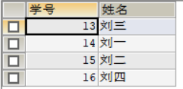

1. 查询学过“1”并且也学过编号“2”课程的同学的学号、姓名；

select student_id,student_name from student where student_id in (select t1.student_id from (select student_id from score where subject_id = 1) t1 inner join (select student_id from score where subject_id = 2) t2 on t1.student_id = t2.student_id);

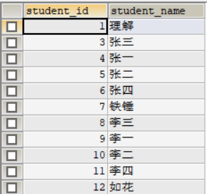

1. 查询学过“李平老师”所教的所有课的同学的学号、姓名；

select student_id,student_name from student where student_id in (

select student_id from (

select student_id,count(subject_id) subject_count from score where subject_id in ( select subject_id from `subject` where teacher_id in (select teacher_id from teacher where teacher_name ='李平老师')) group by student_id) t1

where t1.subject_count =

(select count(subject_id) from `subject` where teacher_id in (select teacher_id from teacher where teacher_name ='李平老师')));

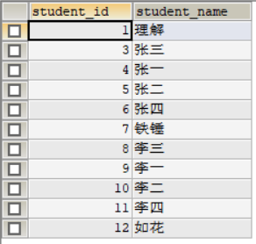

1. 查询没有学全所有课的同学的学号、姓名；

select student_id,student_name from student where student_id in (

select student_id from (select count(subject_id) c_subject_id,student_id from score group by student_id

) t1 where t1.c_subject_id < (select count(subject_id) from `subject`))

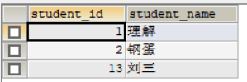

1. 查询和“002”号的同学学习的课程完全相同的其他同学学号和姓名；

select student_id from score where student_id not in (

select student_id from score where subject_id not in (select subject_id from score where student_id=2)

) and student_id !=2

group by student_id

having count(subject_id)= (select count(subject_id) from score where student_id=2);

18.删除学习“叶平”老师课的SC表记录；

20.按平均成绩从低到高显示所有学生的“语文”、“数学”、“英语”三门的课程成绩，按如下形式显示： 学生ID,语文,数学,英语,有效课程数,有效平均分；

select stu.student_id 学生ID,t2.score 物理,t1.score 生物, t3.score 体育,t4.score 美术,t5.count_subject 有效课程数,t5.avg_score 有效平均分 from student stu

left join (select student_id,score from score where subject_id = (select subject_id from `subject` where subject_name = '生物')) t1

on stu.student_id = t1.student_id

left join (select student_id,score from score where subject_id = (select subject_id from `subject` where subject_name = '物理')) t2

on stu.student_id = t2.student_id

left join (select student_id,score from score where subject_id = (select subject_id from `subject` where subject_name = '体育')) t3

on stu.student_id = t3.student_id

left join (select student_id,score from score where subject_id = (select subject_id from `subject` where subject_name = '美术')) t4

on stu.student_id = t4.student_id

left join (select student_id,avg(score) avg_score,count(score) count_subject from score group by student_id) t5

on stu.student_id = t5.student_id

1. 查询各科成绩最高和最低的分：以如下形式显示：课程ID，最高分，最低分；

22.按各科平均成绩从低到高和及格率的百分数从高到低顺序；

SELECT

t_out1.subject_id,

t_out1.avgnum,

t_out2.pass_per

FROM

(

SELECT

subject_id,

AVG(score) avgnum

FROM

score

GROUP BY

subject_id

) t_out1

LEFT JOIN (

SELECT

t1.subject_id,

t1.count1 / t2.count2 pass_per

FROM

(

SELECT

subject_id,

COUNT(subject_id) count1

FROM

score

WHERE

score > 60

GROUP BY

subject_id

) t1

LEFT JOIN (

SELECT

subject_id,

COUNT(subject_id) count2

FROM

score

GROUP BY

subject_id

) t2 ON t1.subject_id = t2.subject_id

) t_out2 ON t_out1.subject_id = t_out2.subject_id

ORDER BY

avgnum,

pass_per DESC

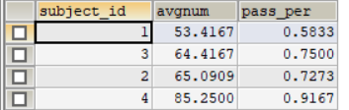

23.查询各科成绩前三名的记录:(不考虑成绩并列情况)

SELECT

t1.student_id,t1.subject_id,t1.score FROM score t1

LEFT JOIN

(

SELECT score_id,subject_id,

(SELECT score FROM score AS s2 WHERE s2.subject_id = s1.subject_id ORDER BY score DESC LIMIT 0, 1) AS first_num,

(SELECT score FROM score AS s2 WHERE s2.subject_id = s1.subject_id ORDER BY score DESC LIMIT 1, 1) AS second_num

FROM score AS s1

) t2

ON t1.score_id = t2.score_id

WHERE t1.score = t2.first_num OR t1.score = t2.second_num ;

1. 查询每门课程被选修的学生数；

select subject_id,count(subject_id) from score group by subject_id;

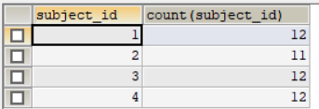

25.查询同名同姓学生名单，并统计同名人数；

select student_name,count(1) as count from student group by student_name

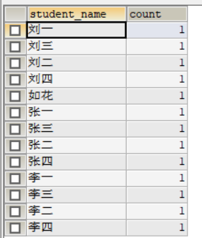

1. 查询每门课程的平均成绩，结果按平均成绩升序排列，平均成绩相同时，按课程号降序排列；

SELECT subject_id,AVG(score)'平均分'

FROM score

GROUP BY subject_id

ORDER BY 平均分 ASC,subject_id DESC

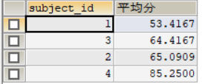

1. 查询平均成绩大于85的所有学生的学号. 姓名和平均成绩；

SELECT *

FROM (SELECT student_id,student_name FROM student) t1

LEFT JOIN (SELECT student_id,AVG(score) AS 'avg' FROM score GROUP BY student_id) t2

ON t1.student_id=t2.student_id

WHERE AVG>=85



1. 查询课程名称为“数学”，且分数低于60的学生姓名和分数；

SELECT s.student_name,sc.score

FROM SUBJECT su LEFT JOIN score sc

ON su.subject_id=sc.subject_id

LEFT JOIN student s

ON s.student_id=sc.student_id

WHERE su.subject_name='物理' AND sc.score<=60

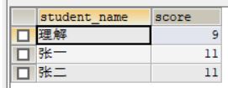

1. 查询课程编号为003且课程成绩在80分以上的学生的学号和姓名；

SELECT s.student_id,s.student_name

FROM student s LEFT JOIN score sc

ON s.student_id=sc.student_id

WHERE sc.subject_id=3

AND sc.score>80;

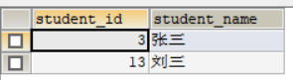

1. 求选了课程的学生人数

SELECT DISTINCT s.student_name

FROM student s LEFT JOIN score sc

ON s.student_id=sc.student_id

WHERE sc.subject_id IS NOT NULL

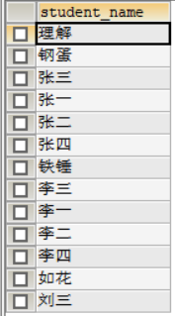

1. 查询选修“杨艳”老师所授课程的学生中，成绩最高的学生姓名及其成绩；

SELECT MAX(sc.score)

FROM teacher te LEFT JOIN SUBJECT su

ON te.teacher_id=su.teacher_id

LEFT JOIN score sc

ON su.subject_id=sc.subject_id

WHERE te.teacher_name='刘海燕老师'

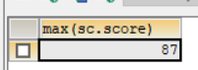

1. 查询各个课程及相应的选修人数；

select sub.subject_name,count(1) from score

left join subject sub on score.subject_id = sub.subject_id

group by sub.subject_id;

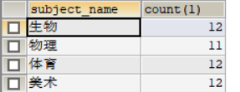

1. 查询不同课程但成绩相同的学生的学号、课程号、学生成绩；

select DISTINCT s1.subject_id,s2.subject_id,s1.score,s2.score from score as s1, score as s2 where s1.score = s2.score and s1.subject_id != s2.subject_id;

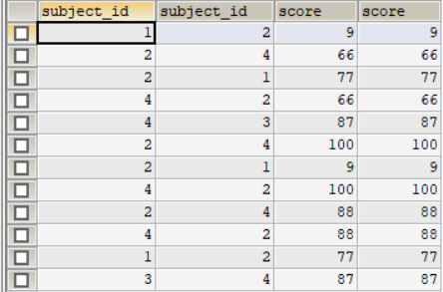

1. 查询每门课程成绩最好的前两名；

select

t1.student_id,t1.subject_id,t1.score from score t1

left join

(

select score_id,subject_id,

(select score from score as s2 where s2.subject_id = s1.subject_id order by score desc limit 0, 1) as first_num,

(select score from score as s2 where s2.subject_id = s1.subject_id order by score desc limit 1, 1) as second_num

from score as s1

) t2

on t1.score_id = t2.score_id

where t1.score = t2.first_num or t1.score = t2.second_num ;

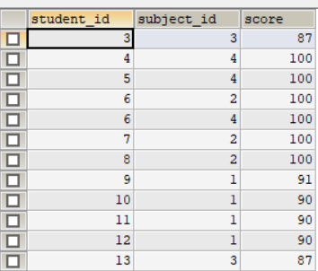

1. 检索至少选修两门课程的学生学号；

select student_id from score group by student_id having count(student_id) > 1;

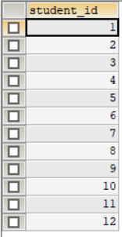

1. 查询全部学生都选修的课程的课程号和课程名；

select subject_id from score group by subject_id having count(student_id) = (select count(student_id) from student);

1. 查询没学过“叶平”老师讲授的任一门课程的学生姓名；

select student_name from student where student_id not in (select distinct student_id from score where subject_id in (select subject_id from `subject` where teacher_id in (select teacher_id from teacher where teacher_name = '李平老师')));

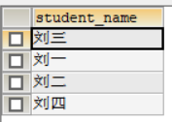

1. 查询两门以上不及格课程的同学的学号及其平均成绩；

select student_id,avg(score) from score where score<60 group by student_id having count(score)>=2;



1. 检索“004”课程分数小于60，按分数降序排列的同学学号；

select student_id from score where score < 60 and subject_id = 4 order by score desc



1. 删除“002”同学的“001”课程的成绩；

delete from score where subject_id = 1 and student_id = 2

