**Mysql综合练习题**

**#使用db3数据库**

**USE day23;**

**#创建Class表**

**CREATE TABLE class(**

**class_id INT(10) PRIMARY KEY NOT NULL UNIQUE AUTO_INCREMENT,**

**class_name VARCHAR(64) NOT NULL**

**);**

**#向Class表插入数据**

**INSERT INTO class VALUES(1,'三年二班'),(2,'三年三班'),(3,'一年二班'),(4,'二年九班');**

**#创建subject表**

**CREATE TABLE SUBJECT(**

**subject_id INT(10) PRIMARY KEY UNIQUE NOT NULL AUTO_INCREMENT,**

**subject_name VARCHAR(64) NOT NULL,**

**teacher_id INT(10)**

**);**

**#向subject表插入数据**

**INSERT INTO SUBJECT VALUES(1,'生物',1),(2,'物理',2),(3,'体育',3),(4,'美术',2);**

**#创建score表**

**CREATE TABLE score(**

**score_id INT(10) PRIMARY KEY NOT NULL UNIQUE AUTO_INCREMENT,**

**subject_id INT(10) NOT NULL,**

**student_id INT(10),**

**score INT(10)**

**);**

**#向score表插入数据**

**INSERT INTO `score` (score_id,student_id,subject_id,score)VALUES ('1', '1', '1', '10'), ('2', '1', '2', '9'), ('5', '1', '4', '66'), ('6', '2', '1', '8'), ('8', '2', '3', '68'), ('9', '2', '4', '99'), ('10', '3', '1', '77'), ('11', '3', '2', '66'), ('12', '3', '3', '87'), ('13', '3', '4', '99'), ('14', '4', '1', '79'), ('15', '4', '2', '11'), ('16', '4', '3', '67'), ('17', '4', '4', '100'), ('18', '5', '1', '79'), ('19', '5', '2', '11'), ('20', '5', '3', '67'), ('21', '5', '4', '100'), ('22', '6', '1', '9'), ('23', '6', '2', '100'), ('24', '6', '3', '67'), ('25', '6', '4', '100'), ('26', '7', '1', '9'), ('27', '7', '2', '100'), ('28', '7', '3', '67'), ('29', '7', '4', '88'), ('30', '8', '1', '9'), ('31', '8', '2', '100'), ('32', '8', '3', '67'), ('33', '8', '4', '88'), ('34', '9', '1', '91'), ('35', '9', '2', '88'), ('36', '9', '3', '67'), ('37', '9', '4', '22'), ('38', '10', '1', '90'), ('39', '10', '2', '77'), ('40', '10', '3', '43'), ('41', '10', '4', '87'), ('42', '11', '1', '90'), ('43', '11', '2', '77'), ('44', '11', '3', '43'), ('45', '11', '4', '87'), ('46', '12', '1', '90'), ('47', '12', '2', '77'), ('48', '12', '3', '43'), ('49', '12', '4', '87'), ('52', '13', '3', '87');**

**#创建student表**

**CREATE TABLE student(**

**student_id INT(10) PRIMARY KEY NOT NULL UNIQUE AUTO_INCREMENT,**

**sex VARCHAR(64) NOT NULL,**

**class_id INT(10),**

**student_name VARCHAR(64)**

**);**

**#向student表插入数据**

**INSERT INTO `student` VALUES ('1', '男', '1', '理解'), ('2', '女', '1', '钢蛋'), ('3', '男', '1', '张三'), ('4', '男', '1', '张一'), ('5', '女', '1', '张二'), ('6', '男', '1', '张四'), ('7', '女', '2', '铁锤'), ('8', '男', '2', '李三'), ('9', '男', '2', '李一'), ('10', '女', '2', '李二'), ('11', '男', '2', '李四'), ('12', '女', '3', '如花'), ('13', '男', '3', '刘三'), ('14', '男', '3', '刘一'), ('15', '女', '3', '刘二'), ('16', '男', '3', '刘四');**

**#创建teacher表**

**CREATE TABLE teacher(**

**teacher_id INT(10) PRIMARY KEY NOT NULL UNIQUE AUTO_INCREMENT,**

**teacher_name VARCHAR(64) NOT NULL**

**);**

**#向teacher表中插入数据**

**INSERT INTO `teacher` VALUES ('1', '张磊老师'), ('2', '李平老师'), ('3', '刘海燕老师'), ('4', '朱云海老师'), ('5', '李杰老师');**

**#1.查询男生、女生人数**

**SELECT sex '性别', COUNT(sex) '人数'**

**FROM student**

**GROUP BY sex;**

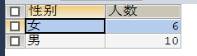

**#2.查询姓“张”的学生名单**

**SELECT student_name '姓名'**

**FROM student**

**WHERE student_name LIKE '张%';**

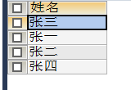

**#3.课程平均分从高到低显示**

**SELECT subject_id '课程id', SUM(score) '总分'**

**FROM score**

**GROUP BY subject_id**

**ORDER BY SUM(score) DESC;**

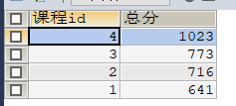

**#4.查询有课程成绩小于60分的同学的学号、姓名**

**SELECT stu.student_id '学号', stu.student_name '姓名'**

**FROM student stu, Score sco**

**WHERE stu.class_id = sco.score_id**

**AND score < 60;**



**#5.查询至少有一门课与学号为 1 的同学所学课程相同的同学的学号和名字**

**SELECT DISTINCT stu.student_id '学号', stu.student_name '姓名'**

**FROM student stu**

**WHERE stu.student_id IN (SELECT DISTINCT student_id**

**FROM score**

**WHERE subject_id IN (**

**SELECT subject_id**

**FROM score**

**WHERE student_id = 1));**

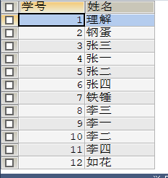

**#6.查询出只选修了一门课的全部学生的学号和姓名**

**SELECT sco.student_id '学号', stu.student_name '姓名'**

**FROM student stu, score sco**

**WHERE stu.student_id = sco.student_id**

**GROUP BY stu.student_id**

**HAVING COUNT(sco.student_id) = 1**



**#7.查询各科成绩最高和最低的分**

**SELECT subject_id '课程ID', MAX(score) '最高分', MIN(score) '最低分'**

**FROM score**

**GROUP BY subject_id**

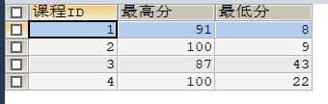

**#8.查询课程编号“2”的成绩比课程编号“1”课程低的所有同学的学号，姓名**

**SELECT A.student_id '学号',A.student_name '姓名'**

**FROM**

**(SELECT stu.student_id, stu.student_name, sco.score 'yi' FROM student stu,score sco WHERE subject_id = 1 AND stu.`student_id` = sco.`student_id` ) AS A**

**RIGHT JOIN**

**(SELECT stu.student_id, stu.student_name, sco.score 'er' FROM student stu,score sco WHERE subject_id = 2 AND stu.`student_id` = sco.`student_id` ) AS B**

**ON A.student_id = B.student_id**

**WHERE er < IF(ISNULL(yi),0,yi);**

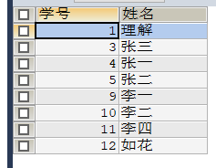

**#9.查询“生物”课程比“物理”课程成绩高的所有学生的学号**

**SELECT A.student_id '学号'**

**FROM**

**(SELECT sco.`student_id`, sco.`subject_id`, sub.`subject_name`, sco.`score` 'sw'**

**FROM score sco, SUBJECT sub**

**WHERE sco.`subject_id` = sub.`subject_id` AND sub.`subject_name` = '生物') A**

**LEFT JOIN**

**(SELECT sco.`student_id`, sco.`subject_id`, sub.`subject_name`, sco.`score` 'wl'**

**FROM score sco, SUBJECT sub**

**WHERE sco.`subject_id` = sub.`subject_id` AND sub.`subject_name` = '物理') B**

**ON A.student_id = B.student_id**

**WHERE sw > IF(ISNULL(wl),0,wl);**



**#10.查询平均成绩大于60分的学号和平均成绩**

**SELECT stu.`student_id` '学号', AVG(score) '平均成绩'**

**FROM score sco, student stu**

**WHERE stu.`student_id` = sco.`student_id`**

**GROUP BY sco.`student_id`**

**HAVING AVG(score) > 60;**

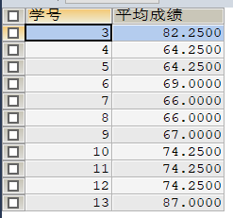

**#11.查询所有同学的学号、姓名、选课数、总成绩**

**SELECT stu.`student_id` '学号', stu.`student_name` '姓名', COUNT(sco.`score_id`) '选课数', SUM(sco.`score`) '总成绩'**

**FROM student stu, score sco**

**WHERE stu.`student_id` = sco.`student_id`**

**GROUP BY stu.`student_id`;**

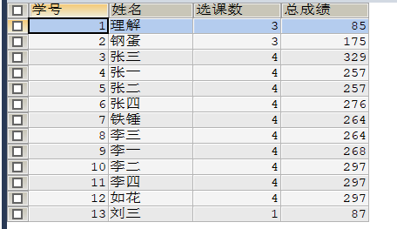

**#12.查询姓”李“的老师的个数**

**SELECT COUNT(tea.`teacher_name`) '姓李个数'**

**FROM teacher tea**

**WHERE tea.`teacher_name` LIKE '李%';**



**#13.查询没学过”张磊老师”课的同学的学号、姓名**

**SELECT stu.`student_id` '学号', stu.`student_name` '姓名'**

**FROM student stu**

**WHERE stu.`student_id` NOT IN (**

**SELECT DISTINCT stu.`student_id`**

**FROM student stu, score sco**

**WHERE sco.`subject_id` IN (SELECT subject_id FROM SUBJECT WHERE teacher_id = (SELECT teacher_id FROM teacher WHERE teacher_name = '张磊老师'))**

**AND sco.`student_id` = stu.`student_id`)**

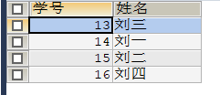

**#14.查询学过“1”并且也学过编号“2”课程的同学的学号、姓名**

**SELECT stu.`class_id` '学号', stu.`student_name` '姓名'**

**FROM student stu, (SELECT * FROM score sco WHERE sco.`subject_id` = 1) A, (SELECT * FROM score sco WHERE sco.`subject_id` = 2) B**

**WHERE stu.`student_id` = A.student_id AND B.`student_id` = A.student_id;**

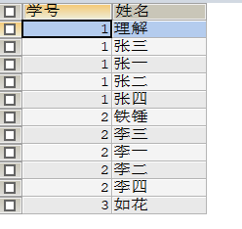

**#15.查询学过“李平老师”所教的所有课的同学的学号、姓名**

**SELECT DISTINCT stu.`student_id` '学号', stu.`student_name` '姓名'**

**FROM student stu, score sco**

**WHERE sco.`subject_id` IN (SELECT subject_id FROM SUBJECT WHERE teacher_id = (SELECT teacher_id FROM teacher WHERE teacher_name = '李平老师'))**

**AND sco.`student_id` = stu.`student_id`;**

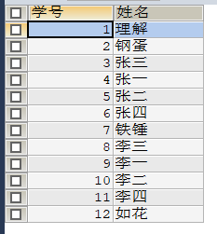

**#16.查询没有学全所有课的同学的学号、姓名**

**SELECT DISTINCT stu.`student_id` '学号', stu.`student_name` '姓名'**

**FROM student stu, score sco**

**WHERE stu.`student_id` = sco.`student_id`**

**GROUP BY stu.`student_id`**

**HAVING COUNT(stu.`student_id`) < (SELECT COUNT(subject_id) FROM SUBJECT);**

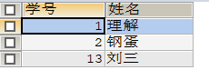

**#17.查询和 “002” 号的同学学习的课程完全相同的其他同学学号和姓名**

**SELECT stu.student_id '学号', student_name '姓名'**

**FROM score sco, student stu**

**WHERE stu.`student_id` = sco.`student_id`**

**AND stu.student_id NOT IN**

**(SELECT DISTINCT student_id**

**FROM score**

**WHERE subject_id NOT IN(SELECT subject_id FROM score WHERE student_id = 2)**

**GROUP BY student_id) AND stu.`student_id`!=2**

**GROUP BY stu.student_id**

**HAVING COUNT(stu.student_id) = (SELECT COUNT(subject_id) FROM score WHERE student_id = 2)**



**#18.删除学习“李平”老师课的sc表记录**

**DELETE**

**FROM score**

**WHERE subject_id IN (SELECT subject_id FROM SUBJECT WHERE teacher_id = (SELECT teacher_id FROM teacher WHERE teacher_name = '李平老师'))**

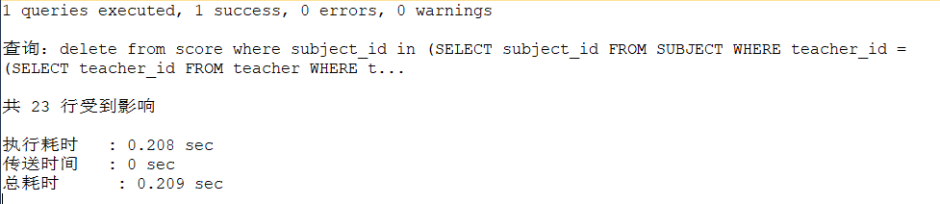

**#19.向sc表中插入一些记录，这些记录要求符合以下条件：**

**# 1.没有上过编号“002”课程的同学学号；**

**# 2.插入“002”号课程的平均成绩；**

**INSERT INTO score(subject_id, student_id, score)**

**SELECT DISTINCT 2,student_id,(SELECT AVG(score) FROM score WHERE subject_id <> 2)**

**FROM student**

**WHERE student_id NOT IN (SELECT student_id FROM score WHERE subject_id = 2);**

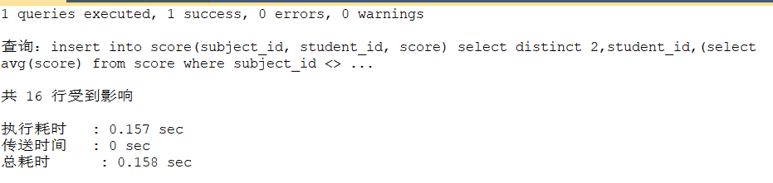

**#20.按平均成绩从低到高显示所有学生的“生物”，“物理”，“体育”，“美术”四门的课程成绩，**

**# 格式：学生ID，生物，物理，体育，美术，有效课程数，有效平均分**

**SELECT s.student_id '学生ID',**

**(SELECT score FROM score s1 WHERE subject_id = (SELECT subject_id FROM SUBJECT sub WHERE subject_name = '生物') AND s1.student_id = s.student_id) '生物',**

**(SELECT score FROM score s1 WHERE subject_id = (SELECT subject_id FROM SUBJECT sub WHERE subject_name = '物理') AND s1.student_id = s.student_id) '物理',**

**(SELECT score FROM score s1 WHERE subject_id = (SELECT subject_id FROM SUBJECT sub WHERE subject_name = '体育') AND s1.student_id = s.student_id) '体育',**

**(SELECT score FROM score s1 WHERE subject_id = (SELECT subject_id FROM SUBJECT sub WHERE subject_name = '美术') AND s1.student_id = s.student_id) '美术',**

**COUNT(s.student_id) '有效课程数',**

**AVG(score) '有效平均数'**

**FROM score s**

**GROUP BY s.student_id**

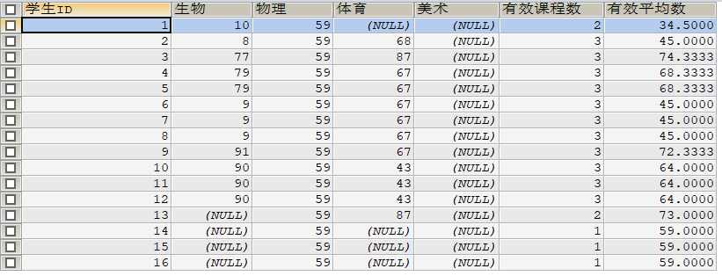

**#21.查询各科成绩最高和最低的分：以如下形式显示：课程ID，最高分，最低分**

**SELECT subject_id '课程ID', MAX(score) '最高分', MIN(score) '最低分'**

**FROM score**

**GROUP BY subject_id**

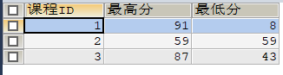

**#22.按各科平均成绩从低到高和及格率的百分数从高到低排序**

**SELECT subject_id '课程ID', AVG(score) '平均成绩', SUM(CASE WHEN score>=60 THEN 1 ELSE 0 END)/COUNT(1)*100 '及格率'**

**FROM score**

**GROUP BY subject_id**

**ORDER BY AVG(score) ASC, 及格率 DESC;**

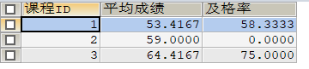

**#23.查询各科成绩前三名的记录（不考虑成绩并列情况）**

**SELECT DISTINCT sco.`student_id` '学号', sco.subject_id '课程编号', sco.`score` '分数'**

**FROM score sco INNER JOIN**

**( SELECT DISTINCT s.subject_id, s.student_id,**

**(SELECT DISTINCT score FROM score s1 WHERE s1.subject_id = s.subject_id ORDER BY score DESC LIMIT 0,1) FIRST,**

**(SELECT DISTINCT score FROM score s2 WHERE s2.subject_id = s.subject_id ORDER BY score DESC LIMIT 1,1) SECOND,**

**(SELECT DISTINCT score FROM score s3 WHERE s3.subject_id = s.subject_id ORDER BY score DESC LIMIT 2,1) third**

**FROM score s) AS t**

**ON sco.`subject_id` = t.subject_id**

**WHERE sco.`score` IN (FIRST,SECOND,third)**

**ORDER BY sco.subject_id ASC, score DESC**

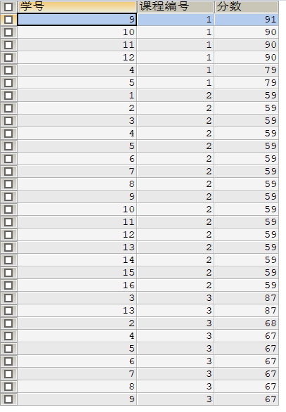

**#24.查询每门课程被选修的学生数**

**SELECT subject_id '课程ID', COUNT(student_id) '选修学生数'**

**FROM score**

**GROUP BY subject_id**

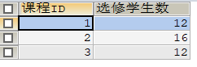

**#25.查询同名同姓学生名单，并统计同名人数**

**SELECT student_name '姓名', COUNT(student_name) - 1 '同名人数'**

**FROM student**

**GROUP BY student_name**

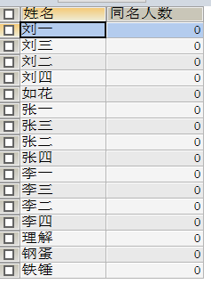

**#26.查询每门课程的平均成绩，结果按平均成绩升序排序，平均成绩相同时，按课程号降序排列**

**SELECT AVG(score) '平均成绩', subject_id '课程ID'**

**FROM score**

**GROUP BY subject_id**

**ORDER BY AVG(score) ASC, subject_id DESC;**

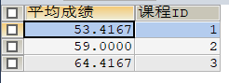

**#27.查询平均成绩大于85的所有学生的学号，姓名和平均成绩**

**SELECT sco.student_id '学号', student_name '姓名', AVG(score) '平均成绩'**

**FROM score sco, student stu**

**WHERE sco.`student_id` = stu.`student_id`**

**GROUP BY sco.student_id**

**HAVING AVG(score) > 85**



**#28.查询课程名称为“数学“，且分数低于60的学生姓名和分数**

**SELECT student_name '学生姓名', score '分数'**

**FROM student stu, score sco**

**WHERE stu.student_id = sco.student_id**

**AND subject_id = (SELECT subject_id FROM SUBJECT WHERE subject_name = '生物')**

**AND score < 60**

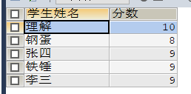

**#29.查询课程编号为003且课程成绩在80分以上的学生的学号和姓名**

**SELECT stu.student_id '学号', student_name '姓名'**

**FROM student stu, score sco**

**WHERE subject_id = 3**

**AND score > 80**

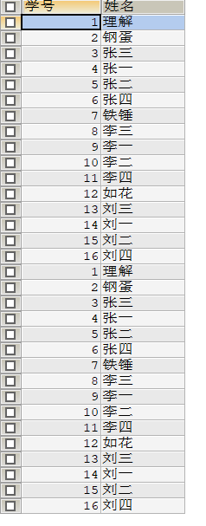

**#30.求选了课程的学生人数**

**SELECT COUNT(DISTINCT student_id) '选了课学生人数'**

**FROM score**



**#31.查询选修“刘海燕老师”老师所授课课程的学生中，成绩最高的学生姓名及其成绩**

**SELECT student_name '学生姓名', score '最高成绩'**

**FROM student stu, score sco**

**WHERE subject_id = (SELECT subject_id FROM SUBJECT WHERE teacher_id = (SELECT teacher_id FROM teacher WHERE teacher_name = '刘海燕老师'))**

**AND stu.`student_id` = sco.`student_id`**

**ORDER BY score**

**LIMIT 1**



**#32.查询各个课程及响应的选修人数**

**SELECT DISTINCT subject_id '课程号', COUNT(subject_id) '选修人数'**

**FROM score sco**

**GROUP BY subject_id**

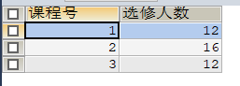

**#33.查询不同课程但成绩相同的学生的学号、课程号、学生成绩**

**SELECT DISTINCT s1.student_id '学号', s1.subject_id '第一门课程号', s2.subject_id '第二门课程号', s1.score '学生成绩'**

**FROM score s1**

**LEFT JOIN**

**score s2 ON s1.subject_id != s2.subject_id**

**WHERE s1.score = s2.score**

**AND s1.student_id = s2.student_id**



**#34.查询每门课程成绩最好的前两名**

**SELECT DISTINCT sco.`student_id` '学号', sco.subject_id '课程编号', sco.`score` '分数'**

**FROM score sco INNER JOIN**

**( SELECT DISTINCT s.subject_id, s.student_id,**

**(SELECT DISTINCT score FROM score s1 WHERE s1.subject_id = s.subject_id ORDER BY score DESC LIMIT 0,1) FIRST,**

**(SELECT DISTINCT score FROM score s2 WHERE s2.subject_id = s.subject_id ORDER BY score DESC LIMIT 1,1) SECOND**

**FROM score s) AS t**

**ON sco.`subject_id` = t.subject_id**

**WHERE sco.`score` IN (FIRST,SECOND)**

**ORDER BY sco.subject_id ASC, score DESC;**

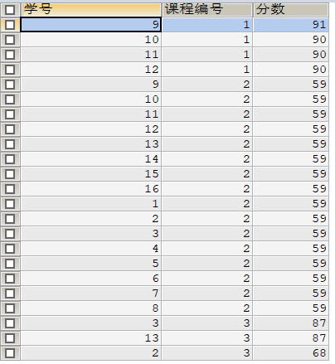

**#35.检索至少选修两门课的学生编号**

**SELECT student_id '学 号'**

**FROM score**

**GROUP BY student_id**

**HAVING COUNT(student_id) >= 2;**



**#36.查询全部学生都选修的课程的课程号和课程名**

**SELECT sco.subject_id '课程号', subject_name '课程名'**

**FROM score sco, SUBJECT sub**

**WHERE sco.`subject_id` = sub.`subject_id`**

**GROUP BY sco.subject_id**

**HAVING COUNT(sco.student_id) = (SELECT COUNT(student_id) FROM student);**



**#37.查询没学过“叶平“老师讲授的任意门课程的学生姓名**

**SELECT student_name '姓名'**

**FROM student**

**WHERE student_id NOT IN**

**(**

**SELECT DISTINCT s1.student_id**

**FROM score s1**

**WHERE s1.student_id IN((SELECT subject_id FROM SUBJECT WHERE teacher_id = (SELECT teacher_id FROM teacher WHERE teacher_name = '李平老师')))**

**);**



**#38.查询两门以上不及格课程的同学的学号及其平均成绩**

**SELECT student_id '学号', AVG(score) '平均成绩'**

**FROM score**

**WHERE student_id IN(**

**SELECT student_id '学号' FROM score WHERE score < 60 GROUP BY student_id HAVING COUNT(student_id) > 2**

**);**



**#39.检索”004“课程分数小于60，按分数降序排列的同学学号**

**SELECT student_id '学号'**

**FROM score**

**WHERE subject_id = 4**

**AND score < 60**

**ORDER BY score DESC;**



**#40.删除”002“同学的”001“课程的成绩**

**UPDATE score**

**SET score = NULL**

**WHERE student_id = 2**

**AND subject_id = 1**

