Mysql练习题

**Class表的定义**

|  |  |  |  |  |  |  |  |
| --- | --- | --- | --- | --- | --- | --- | --- |
| **字段名** | **字段描述** | **数据类型** | **主键** | **外键** | **非空** | **唯一** | **自增** |
| class_id | 编号 | INT(10) | 是 | 否 | 是 | 是 | 是 |
| class_name | 班级名称 | VARCHAR(64) | 否 | 否 | 是 | 否 | 否 |

INSERT INTO `class` VALUES ('1', '三年二班'), ('2', '三年三班'), ('3', '一年二班'), ('4', '二年九班');

**Subject表的定义**

|  |  |  |  |  |  |  |  |
| --- | --- | --- | --- | --- | --- | --- | --- |
| **字段名** | **字段描述** | **数据类型** | **主键** | **外键** | **非空** | **唯一** | **自增** |
| subject_id | 编号 | INT(10) | 是 | 否 | 是 | 是 | 是 |
| subject_name | 班级名称 | VARCHAR(64) | 否 | 否 | 是 | 否 | 否 |
| teacher_id | 教师id | INT(10) | 否 | 否 | 否 | 否 | 否 |

INSERT INTO `course` VALUES ('1', '生物', '1'), ('2', '物理', '2'), ('3', '体育', '3'), ('4', '美术', '2');

**Score表的定义**

|  |  |  |  |  |  |  |  |
| --- | --- | --- | --- | --- | --- | --- | --- |
| **字段名** | **字段描述** | **数据类型** | **主键** | **外键** | **非空** | **唯一** | **自增** |
| score_id | 编号 | INT(10) | 是 | 否 | 是 | 是 | 是 |
| subject_id | 课程id | INT(10) | 否 | 否 | 是 | 否 | 否 |
| student_id | 学生id | INT(10) | 否 | 否 | 否 | 否 | 否 |
| score | 分数 | INT(10) | 否 | 否 | 否 | 否 | 否 |

INSERT INTO `score` VALUES ('1', '1', '1', '10'), ('2', '1', '2', '9'), ('5', '1', '4', '66'), ('6', '2', '1', '8'), ('8', '2', '3', '68'), ('9', '2', '4', '99'), ('10', '3', '1', '77'), ('11', '3', '2', '66'), ('12', '3', '3', '87'), ('13', '3', '4', '99'), ('14', '4', '1', '79'), ('15', '4', '2', '11'), ('16', '4', '3', '67'), ('17', '4', '4', '100'), ('18', '5', '1', '79'), ('19', '5', '2', '11'), ('20', '5', '3', '67'), ('21', '5', '4', '100'), ('22', '6', '1', '9'), ('23', '6', '2', '100'), ('24', '6', '3', '67'), ('25', '6', '4', '100'), ('26', '7', '1', '9'), ('27', '7', '2', '100'), ('28', '7', '3', '67'), ('29', '7', '4', '88'), ('30', '8', '1', '9'), ('31', '8', '2', '100'), ('32', '8', '3', '67'), ('33', '8', '4', '88'), ('34', '9', '1', '91'), ('35', '9', '2', '88'), ('36', '9', '3', '67'), ('37', '9', '4', '22'), ('38', '10', '1', '90'), ('39', '10', '2', '77'), ('40', '10', '3', '43'), ('41', '10', '4', '87'), ('42', '11', '1', '90'), ('43', '11', '2', '77'), ('44', '11', '3', '43'), ('45', '11', '4', '87'), ('46', '12', '1', '90'), ('47', '12', '2', '77'), ('48', '12', '3', '43'), ('49', '12', '4', '87'), ('52', '13', '3', '87');

**Student表的定义**

|  |  |  |  |  |  |  |  |
| --- | --- | --- | --- | --- | --- | --- | --- |
| **字段名** | **字段描述** | **数据类型** | **主键** | **外键** | **非空** | **唯一** | **自增** |
| student_id | 编号 | INT(10) | 是 | 否 | 是 | 是 | 是 |
| sex | 性别 | VARCHAR(64) | 否 | 否 | 是 | 否 | 否 |
| class_id | 班级id | INT(10) | 否 | 否 | 否 | 否 | 否 |
| student_name | 学生姓名 | VARCHAR(64) | 否 | 否 | 否 | 否 | 否 |

INSERT INTO `student` VALUES ('1', '男', '1', '理解'), ('2', '女', '1', '钢蛋'), ('3', '男', '1', '张三'), ('4', '男', '1', '张一'), ('5', '女', '1', '张二'), ('6', '男', '1', '张四'), ('7', '女', '2', '铁锤'), ('8', '男', '2', '李三'), ('9', '男', '2', '李一'), ('10', '女', '2', '李二'), ('11', '男', '2', '李四'), ('12', '女', '3', '如花'), ('13', '男', '3', '刘三'), ('14', '男', '3', '刘一'), ('15', '女', '3', '刘二'), ('16', '男', '3', '刘四');

**Teacher表的定义**

|  |  |  |  |  |  |  |  |
| --- | --- | --- | --- | --- | --- | --- | --- |
| **字段名** | **字段描述** | **数据类型** | **主键** | **外键** | **非空** | **唯一** | **自增** |
| teacher_id | 编号 | INT(10) | 是 | 否 | 是 | 是 | 是 |
| teacher_name | 姓名 | VARCHAR(64) | 否 | 否 | 是 | 否 | 否 |

INSERT INTO `teacher` VALUES ('1', '张磊老师'), ('2', '李平老师'), ('3', '刘海燕老师'), ('4', '朱云海老师'), ('5', '李杰老师');

1. 查询男生、女生的人数；

SELECT

sex '性别',

count(*) '人数'

FROM

Student

GROUP BY

Sex

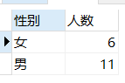

1. 查询姓“张”的学生名单；

SELECT *

FROM Student

where

student_name like '张%'

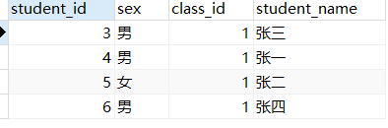

1. 课程平均分从高到低显示

SELECT

subject_id '课程编号',

avg(score) '平均分'

FROM

Score

GROUP BY

subject_id

ORDER BY avg(score) desc

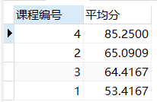

1. 查询有课程成绩小于60分的同学的学号、姓名；

SELECT

stu.student_id '学号',

stu.student_name '姓名'

FROM

student stu,

score sc

WHERE

stu.student_id = sc.student_id

AND sc.score < 60

GROUP BY

stu.student_name

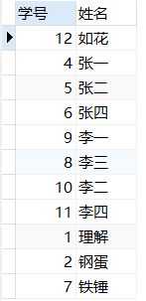

1. 查询至少有一门课与学号为1的同学所学课程相同的同学的学号和姓名；

SELECT

DISTINCT

stu.student_id '学号',

stu.student_name '姓名'

FROM

student stu,score sc

WHERE

stu.student_id=sc.student_id

AND

sc.subject_id

IN

(SELECT

subject_id

FROM

score

WHERE

student_id=1)

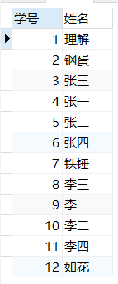

1. 查询出只选修了一门课程的全部学生的学号和姓名；

SELECT

stu.student_id '学号',

stu.student_name '姓名'

FROM

( SELECT student_id, count( subject_id ) '课程数' FROM score GROUP BY student_id ) a,

student stu

WHERE

stu.student_id = a.student_id

AND a.student_id =1



1. 查询各科成绩最高和最低的分：以如下形式显示：课程ID，最高分，最低分；

SELECT

subject_id '课程id',

MAX(score) '最高分',

Min(score) '最低分'

FROM

Score

GROUP BY

subject_id

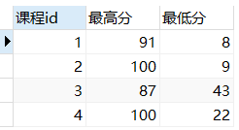

1. 查询课程编号“2”的成绩比课程编号“1”课程低的所有同学的学号、姓名；

SELECT

DISTINCT

stu.student_id '学号',

stu.student_name '姓名'

FROM

student stu,

(select

student_id '学号',

score '编号1课程成绩'

from

score

where

subject_id =1

) a,

(select

student_id '学号',

score '编号2课程成绩'

from

score

where

subject_id =2

) b

where

stu.student_id = a.`学号` =b.`学号`

and

a.`编号1课程成绩` > b.`编号2课程成绩`

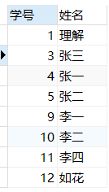

1. 查询“生物”课程比“物理”课程成绩高的所有学生的学号；

SELECT

DISTINCT sc1.student_id '学号'

FROM

score sc1,subject sub

WHERE

subject_name='生物'

AND

score>

(SELECT

score

FROM

score sc2,subject sub2

WHERE

subject_name='物理'

AND

sc2.student_id=sc1.student_id

AND

sc2.subject_id=sub2.subject_id

)

AND

sc1.subject_id=sub.subject_id

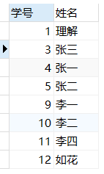

1. 查询平均成绩大于60分的同学的学号和平均成绩;

SELECT

AVG(score) '平均成绩',

student_id '学号'

from

score

GROUP BY

student_id

having avg(Score)>60

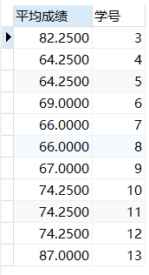

1. 查询所有同学的学号、姓名、选课数、总成绩；

SELECT

student_id '学号',

student_name '姓名',

a.cid '选课数',

a.ssc '总成绩'

FROM

(select

count(student_id) cid,

sum(score) ssc,

student_id si

FROM

score

group by

student_id) a,

student stu

where

stu.student_id = a.si

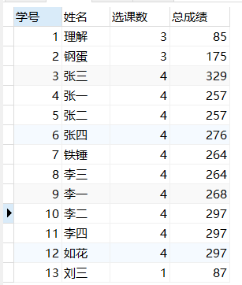

1. 查询姓“李”的老师的个数；

SELECT

count(teacher_id) '姓‘李’老师个数'

from

teacher

where

teacher_name like '李%'



1. 查询没学过“张磊老师”课的同学的学号、姓名；

SELECT

student_id '学号',

student_name '姓名'

FROM

student

WHERE

student_id

NOT IN

(

SELECT

sc.student_id

FROM

teacher tea,subject sub,score sc

WHERE

tea.teacher_id=sub.teacher_id

AND

sub.subject_id=sc.subject_id

AND

tea.teacher_name='张磊老师'

)

1. 查询学过“1”并且也学过编号“2”课程的同学的学号、姓名；

SELECT

stu.student_id '学号',

stu.student_name '姓名'

FROM

student stu,

score sc

WHERE

stu.student_id = sc.student_id

AND sc.subject_id = 1

AND stu.student_id IN (

SELECT

sc1.student_id

FROM

score sc1

WHERE

sc1.subject_id = 2)

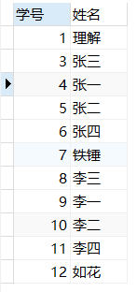

1. 查询学过“李平老师”所教的所有课的同学的学号、姓名；

SELECT

student_id '学号',

student_name '姓名'

FROM

student

WHERE

student_id

IN

(

SELECT

sc.student_id

FROM

teacher tea,subject sub,score sc

WHERE

tea.teacher_id=sub.teacher_id

AND

sub.subject_id=sc.subject_id

AND

tea.teacher_name='李平老师'

)

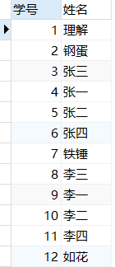

1. 查询没有学全所有课的同学的学号、姓名；

SELECT

student_id '学号',

student_name '姓名'

FROM

student

WHERE

student_id

not IN

(

SELECT

student_id

FROM

score

group by student_id

having count(student_id) = 4

)

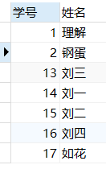

1. 查询和“002”号的同学学习的课程完全相同的其他同学学号和姓名；

SELECT

b.student_id,

b.student_name

FROM

score a,

student b

WHERE

b.student_id != 2

AND a.student_id = b.student_id

AND a.student_id NOT IN ( SELECT DISTINCT student_id FROM score WHERE subject_id NOT IN ( SELECT subject_id FROM score WHERE student_id = 2 ) )

GROUP BY

b.student_id,

b.student_name

HAVING

sum( subject_id ) = (

SELECT

sum( subject_id )

FROM

score

WHERE

student_id = 2)



1. 删除学习“叶平”老师课的SC表记录；

DELETE from

score

where

subject_id in

(

select

subject_id from

(

select sc.subject_id

from

score sc,

subject sub,

teacher tea

where

sc.subject_id = sub.subject_id

and

sub.teacher_id = tea.teacher_id

and

tea.teacher_name = '叶平老师'

) a

)

1. 按平均成绩从低到高显示所有学生的“语文”、“数学”、“英语”三门的课程成绩，按如下形式显示： 学生ID,语文,数学,英语,有效课程数,有效平均分；

select stu.student_id 学生ID,t2.score 物理,t1.score 生物, t3.score 体育,t4.score 美术,t5.count_subject 有效课程数,t5.avg_score 有效平均分 from student stu

left join (select student_id,score from score where subject_id = (select subject_id from `subject` where subject_name = '生物')) t1

on stu.student_id = t1.student_id

left join (select student_id,score from score where subject_id = (select subject_id from `subject` where subject_name = '物理')) t2

on stu.student_id = t2.student_id

left join (select student_id,score from score where subject_id = (select subject_id from `subject` where subject_name = '体育')) t3

on stu.student_id = t3.student_id

left join (select student_id,score from score where subject_id = (select subject_id from `subject` where subject_name = '美术')) t4

on stu.student_id = t4.student_id

left join (select student_id,avg(score) avg_score,count(score) count_subject from score group by student_id) t5

on stu.student_id = t5.student_id

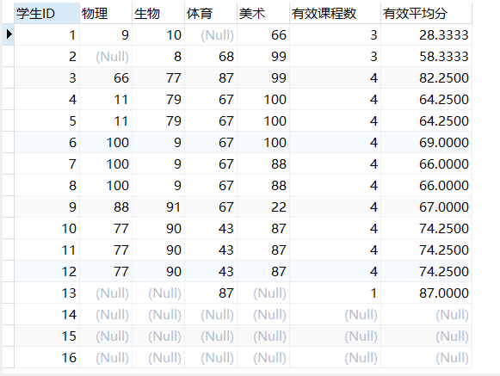

1. 查询各科成绩最高和最低的分：以如下形式显示：课程ID，最高分，最低分；

SELECT

subject_id '课程id',

MAX(score) '最高分',

Min(score) '最低分'

FROM

Score

GROUP BY

subject_id

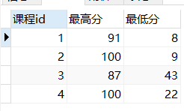

1. 按各科平均成绩从低到高和及格率的百分数从高到低顺序；

select subject_id '课程id',avg(score) '平均成绩',

sum(case when score>=60 then 1 else 0 end)/count(*)

as '及格率'

from score

group by subject_id

order by avg(score) ,'及格率' desc;

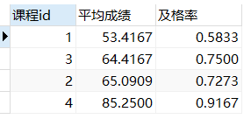

1. 查询各科成绩前三名的记录:(不考虑成绩并列情况)

SELECT

subject_id,score

FROM

score sc1

WHERE

(SELECT

COUNT(*)

FROM

score sc2

WHERE

sc1.score<sc2.score

AND

sc1.subject_id=sc2.subject_id

)<3

ORDER BY subject_id

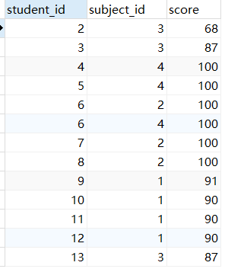

1. 查询每门课程被选修的学生数；

SELECT

sub.subject_id '课程id',

count(sc.subject_id) '人数'

from

subject sub

left join score sc on sub.subject_id = sc.subject_id

group by

sub.subject_id

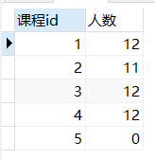

1. 查询同名同姓学生名单，并统计同名人数；

SELECT

student_name '姓名',

count(student_name) '人数'

from

student

GROUP BY

student_name

having

count(student_name) >1



1. 查询每门课程的平均成绩，结果按平均成绩升序排列，平均成绩相同时，按课程号降序排列；

select

subject_id '课程id',

avg(score) '平均成绩'

from

score

group by

subject_id

order by

avg(score) asc,

subject_id desc

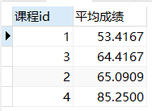

1. 查询平均成绩大于85的所有学生的学号. 姓名和平均成绩；

select

stu.student_id '学号',

stu.student_name '姓名',

avg(score) '平均成绩'

from

score sc,

student stu

where

stu.student_id = sc.student_id

group by

sc.student_id

having

avg(score) >85



1. 查询课程名称为“数学”，且分数低于60的学生姓名和分数；

select

stu.student_name '姓名',

sc.score '分数'

from

student stu,

score sc,

subject sub

where

stu.student_id = sc.student_id

and

sc.subject_id = sub.subject_id

and

sub.subject_name = '体育'

and

sc.score < 60

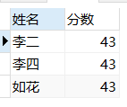

1. 查询课程编号为003且课程成绩在80分以上的学生的学号和姓名；

select

stu.student_id '学号',

stu.student_name '姓名'

from

student stu,

score sc

where

stu.student_id = sc.student_id

and

sc.subject_id = 3

and

sc.score > 80

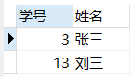

1. 求选了课程的学生人数

select

count(DISTINCT student_id) '人数'

from

score



1. 查询选修“杨艳”老师所授课程的学生中，成绩最高的学生姓名及其成绩；

select

stu.student_name '姓名',

sc.score

from

student stu,

score sc,

subject sub,

teacher tea

where

stu.student_id = sc.student_id

and

sc.subject_id = sub.subject_id

and

sub.teacher_id = tea.teacher_id

and

tea.teacher_name = '李平老师'

and

sc.score in (select max(score)

from

score sc1,

subject sub1,

teacher tea1

where

sc1.subject_id = sub1.subject_id

and

sub1.teacher_id = tea1.teacher_id

and

tea1.teacher_name = '李平老师'

)

group by

sc.student_id

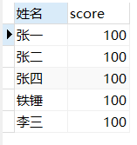

1. 查询各个课程及相应的选修人数；

SELECT

subject_id '课程id',

count(student_id) '人数'

from

score

group by

subject_id

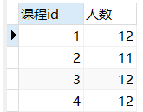

1. 查询不同课程但成绩相同的学生的学号、课程号、学生成绩；

SELECT

sc.student_id '学号',

sc.subject_id '课程号',

sc.score '学生成绩'

from

score sc

INNER JOIN score sc1 on

sc.student_id = sc1.student_id

where

sc.score = sc1.score

and

sc.subject_id != sc1.subject_id

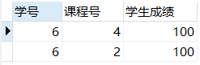

1. 查询每门课程成绩最好的前两名；

select

t1.student_id,t1.subject_id,t1.score from score t1

left join

(

select score_id,subject_id,

(select score from score as s2 where s2.subject_id = s1.subject_id order by score desc limit 0, 1) as first_num,

(select score from score as s2 where s2.subject_id = s1.subject_id order by score desc limit 1, 1) as second_num

from score as s1

) t2

on t1.score_id = t2.score_id

where t1.score = t2.first_num or t1.score = t2.second_num ;

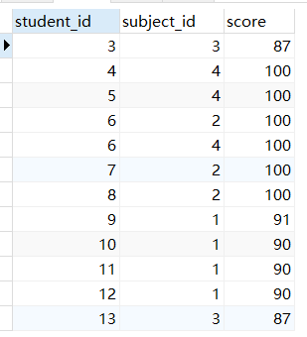

1. 检索至少选修两门课程的学生学号；

SELECT

stu.student_id '学号',

count(sc.subject_id) '选修的数量'

from

student stu,

score sc

where

stu.student_id = sc.student_id

group by

sc.student_id

having count(sc.subject_id) >1

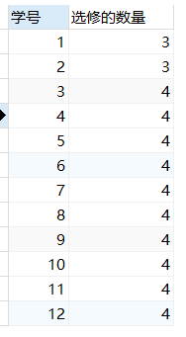

1. 查询全部学生都选修的课程的课程号和课程名；

SELECT

sc.subject_id '课程号',

sub.subject_name '课程名'

FROM

score sc,

subject sub

where

sub.subject_id = sc.subject_id

GROUP BY

sc.subject_id

HAVING

count( student_id ) = ( SELECT count( student_id ) FROM student );

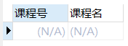

1. 查询没学过“叶平”老师讲授的任一门课程的学生姓名；

SELECT

student_name '学生姓名'

FROM

student

WHERE

student_id NOT IN (

SELECT DISTINCT

sc1.student_id

FROM

score sc1,

SUBJECT sub1,

teacher tea1

WHERE

sc1.subject_id = sub1.subject_id

AND sub1.teacher_id = tea1.teacher_id

AND tea1.teacher_name = '李平老师'

)

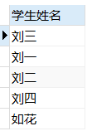

1. 查询两门以上不及格课程的同学的学号及其平均成绩；

SELECT

student_id '学号',

avg( score ) '平均成绩'

FROM

score

WHERE

score < 60 GROUP BY student_id HAVING count( subject_id ) >=2



1. 检索“004”课程分数小于60，按分数降序排列的同学学号；

select

student_id '学号'

from

score

where

subject_id = 4

and

score < 60

group by

student_id

order by score desc



40.删除“002”同学的“001”课程的成绩；

delete from score where subject_id = 1 and student_id = 2