-- 1.查询男生、女生的人数；

SELECT sex,COUNT(sex) AS '人数' FROM student GROUP BY sex

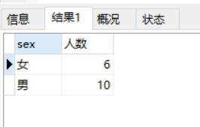

-- 2.查询姓“张”的学生名单；

SELECT student_name FROM student WHERE student_name LIKE '张%'

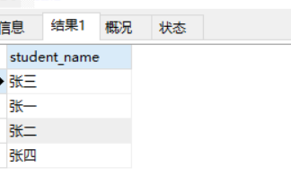

-- 3.课程平均分从高到低显示

SELECT subject_id,AVG(score) FROM score GROUP BY score ORDER BY score DESC

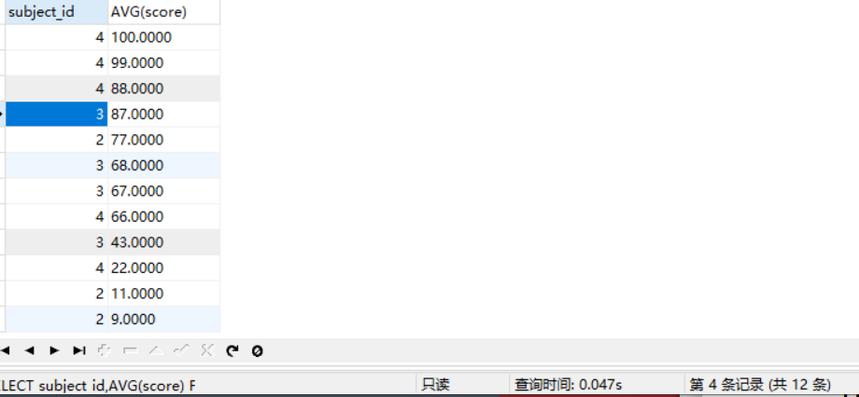

-- 4.查询有课程成绩小于60分的同学的学号、姓名；

SELECT

student.student_id,

student.student_name

FROM

student

LEFT JOIN score ON student.student_id = score.student_id

WHERE

score.score < 60

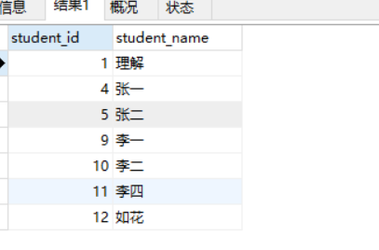

-- 5.查询至少有一门课与学号为1的同学所学课程相同的同学的学号和姓名；

SELECT

DISTINCT student_name,

stu.student_id,

stu.student_name

FROM

score sc,

student stu

WHERE

sc.student_id=stu.student_id

AND

sc.subject_id in(

SELECT

DISTINCT

subject_id

FROM

score sc

WHERE

sc.student_id=1)

AND

sc.student_id!=1

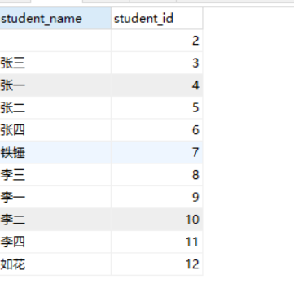

-- 6.查询出只选修了一门课程的全部学生的学号和姓名；

SELECT

stu.student_id,

stu.student_name

FROM

student stu,

score sc

GROUP BY

sc.subject_id

HAVING

count(sc.subject_id)=1

-- 7.查询各科成绩最高和最低的分：以如下形式显示：课程ID，最高分，最低分；

SELECT

subject_id,

max(score),

min(score)

FROM

score

GROUP BY

subject_id

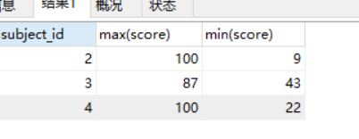

-- 8.查询课程编号“2”的成绩比课程编号“1”课程低的所有同学的学号、姓名；

SELECT

s1.student_id,

stu.student_id

FROM

student stu,

(SELECT *FROM score WHERE subject_id=1) as s1,

(SELECT *FROM score WHERE subject_id=2) as s2

WHERE

s1.student_id=s2.student_id

AND

s1.score>s2.score

AND

s1.student_id=stu.student_id

-- 9.查询“生物”课程比“物理”课程成绩高的所有学生的学号；

SELECT

s1.student_id '学号'

FROM

(SELECT *FROM score where subject_id=1) AS s1,

(SELECT *FROM score where subject_id=2) AS s2

WHERE

s1.score>s2.score

AND

s1.student_id=s2.student_id

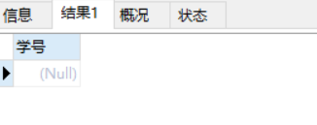

-- 10.查询平均成绩大于60分的同学的学号和平均成绩;

SELECT

student_id,

avg(score) avg

FROM

score

GROUP BY

student_id

HAVING

avg>60

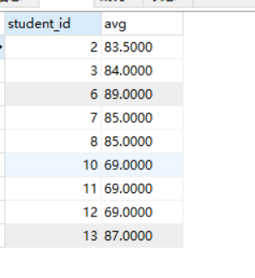

-- 11.查询所有同学的学号、姓名、选课数、总成绩；

SELECT

stu.student_id,

stu.student_name,

count(sc.subject_id) '选课数',

SUM(sc.score) '总分'

FROM

student stu

LEFT JOIN

score sc

ON

stu.student_id=sc.student_id

GROUP BY stu.student_id

-- 12.查询姓“李”的老师的个数；

SELECT

COUNT(*) '姓李的个数'

FROM

teacher

WHERE

teacher_name

LIKE

'李%'

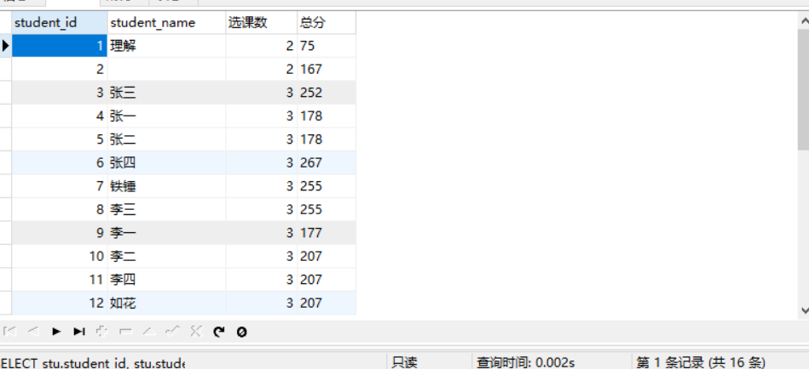

-- 13.查询没学过“张磊老师”课的同学的学号、姓名；

select student_id,student_name from student where student_id not in

(select student_id from score where subject_id=(select subject_id from

`subject` where teacher_id=(select teacher_id from teacher where

teacher_name='张磊老师')));

-- 14.查询学过“1”并且也学过编号“2”课程的同学的学号、姓名；

（学过1课程的没有，因为第18题删除了）

SELECT

stu.student_id,

stu.student_name

FROM

(SELECT *FROM score WHERE subject_id=1) AS s1,

(SELECT *FROM score WHERE subject_id=2) AS s2,

student stu

where

s1.student_id=s2.student_id

AND

stu.student_id=s1.student_id

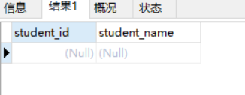

-- 15.查询学过“李平老师”所教的所有课的同学的学号、姓名；

SELECT

stu.student_id,

stu.student_name

FROM

(SELECT

*FROM

score

WHERE

score.subject_id

IN

(SELECT

su.subject_id

FROM

`subject` su

LEFT JOIN teacher te

ON su.teacher_id=te.teacher_id

WHERE

te.teacher_name='李平老师')

GROUP BY score.student_id)

AS sc

LEFT JOIN student stu

ON sc.student_id=stu.student_id

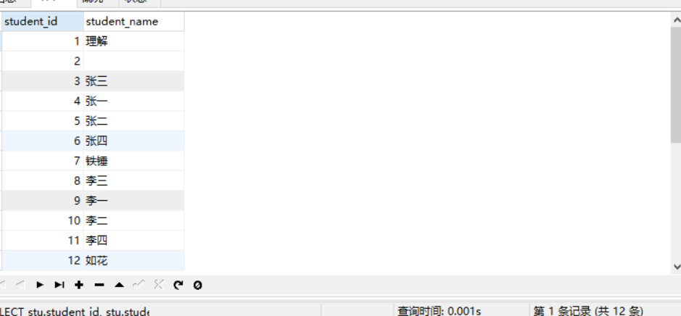

-- 16.查询没有学全 所有课的同学的学号、姓名；

SELECT

stu.student_id,

stu.student_name

FROM

student stu,

score sc

WHERE

stu.student_id=sc.student_id

GROUP BY stu.student_id

HAVING COUNT(sc.subject_id)<(SELECT count(*) FROM `subject`)

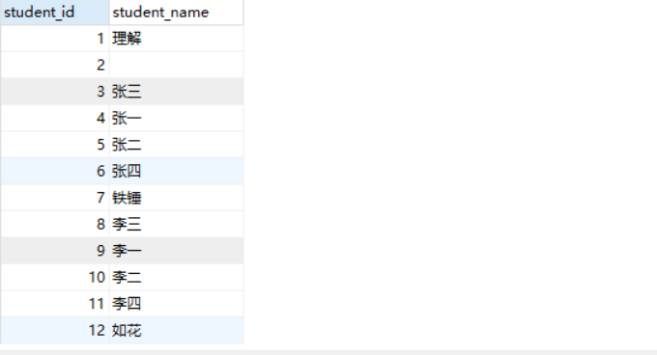

-- 17.查询和“002”号的同学学习的课程完全相同的其他同学学号和姓名；

SELECT score.student_id FROM score WHERE score.student_id NOT IN(

SELECT score.student_id FROM score WHERE score.subject_id NOT IN(

SELECT score.subject_id FROM score WHERE score.student_id=2)

)AND score.student_id!=2

GROUP BY score.student_id HAVING

count(subject_id)= (select count(subject_id) from score where student_id=2)

-- 18.删除学习“张磊”老师课的SC表记录

DELETE FROM score where score.subject_id IN

(SELECT `subject`.subject_id FROM `subject` WHERE teacher_id IN

(SELECT teacher_id FROM teacher WHERE teacher_name='张磊老师')

)

-- 19.向SC表中插入一些记录，这些记录要求符合以下条件：①没有上过编号“002”课程的同学学号；

-- ②插入“002”号课程的平均成绩；

-- 20.按平均成绩从低到高显示所有学生的“语文”、“数学”、“英语”三门的

-- 课程成绩，按如下形式显示：学生ID,语文,数学,英语,有效课程数,有效平均分；

select stu.student_id学生ID,t2.score物理,t1.score生物,t3.score体

育,t4.score美术,t5.count_subject有效课程数,t5.avg_score有效平均分

from student stu

left join(select student_id,score from score where subject_id=(select

subject_id from`subject` where subject_name='生物'))t1

on stu.student_id=t1.student_id

left join(select student_id,score from score where subject_id=(select

subject_id from`subject` where subject_name='物理'))t2

on stu.student_id=t2.student_id

left join(select student_id,score from score where subject_id=(select

subject_id from`subject` where subject_name='体育'))t3

on stu.student_id=t3.student_id

left join(select student_id,score from score where subject_id=(select

subject_id from` subject`where subject_name='美术'))t4

on stu.student_id=t4.student_id

left join(select student_id,avg(score)avg_score,count(score)

count_subject from score group by student_id)t5

on stu.student_id=t5.student_id

-- 21.查询各科成绩最高和最低的分：以如下形式显示：课程ID，最高分，最低分；

SELECT

subject_id '课程id',

MAX(score) '最高分',

MIN(score) '最低分'

FROM

score

GROUP BY

subject_id

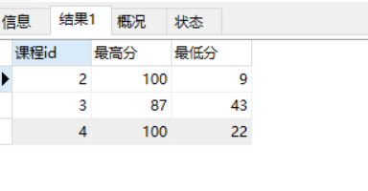

-- 22.按各科平均成绩从低到高和及格率的百分数从高到低顺序；

SELECT

subject_id,avg(score) '平均成绩',

sum(case when score>=60 then 1 else 0 end)/count(*) AS 及格率

FROM

score

GROUP BY subject_id

ORDER BY avg(score) ASC,及格率 ASC

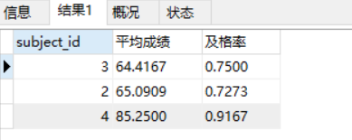

-- 23.查询各科成绩前三名的记录:(不考虑成绩并列情况)(不会）

select

t1.student_id,t1.subject_id,t1.score from score t1

left join

(

select score_id,subject_id,

(select score from score as s2 where s2.subject_id=s1.subject_id

order by score desc limit 0,1)as first_num,

(select score from score as s2 where s2.subject_id=s1.subject_id

order by score desc limit1,1)as second_num,

(select score from score as s2 where s2.subject_id=s1.subject_id

order by score desc limit2,1)as third_num

from score as s1

)t2

on t1.score_id=t2.score_id

where t1.score=t2.first_num or t1.score=t2.second_num or t1.score=

t2.third_num;

24.查询每门课程被选修的学生数；

SELECT

su.subject_id,

count(sc.student_id)

FROM

`subject` su

LEFT JOIN

score sc

ON su.subject_id=sc.subject_id

GROUP BY

subject_id

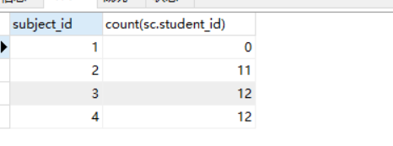

-- 25.查询同名同姓学生名单，并统计同名人数；

SELECT

COUNT(s1.student_id) '人数'

FROM

student s1,

student s2

WHERE

s1.student_id != s2.student_id

AND

s2.student_name=s1.student_name

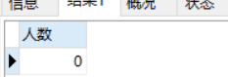

-- 26.查询每门课程的平均成绩，结果按平均成绩升序排列，平均成绩相同时，按

-- 课程号降序排列；

SELECT

su.subject_id '课程号',

avg(sc.score) '平均成绩'

FROM

`subject` su

LEFT JOIN

score sc

ON su.subject_id=sc.subject_id

GROUP BY sc.subject_id

ORDER BY avg(sc.score) ASC,su.subject_id DESC

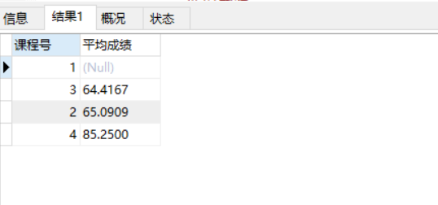

-- 27.查询平均成绩大于85的所有学生的学号.姓名和平均成绩；

SELECT

stu.student_id,

stu.student_name,

avg(sc.score) AS '平均成绩'

FROM

score sc

LEFT JOIN

student stu

ON sc.student_id=stu.student_id

GROUP BY sc.student_id HAVING AVG(sc.score)>85

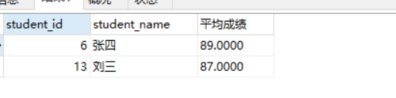

-- 28.查询课程名称为“物理”，且分数低于60的学生姓名和分数；

SELECT

stu.student_name '学生姓名',

sc.score '分数'

FROM

student stu,

(SELECT *FROM score WHERE subject_id IN(

(select subject_id FROM `subject` WHERE subject_name='物理')

)) AS sc

WHERE

stu.student_id=sc.student_id

AND sc.score < 60

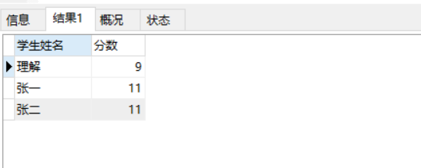

29.查询课程编号为003且课程成绩在80分以上的学生的学号和姓名；

SELECT

stu.student_id,

stu.student_name,

sc.score

FROM

score sc

LEFT JOIN

student stu

ON stu.student_id=sc.student_id

WHERE sc.score>80 AND sc.subject_id=3

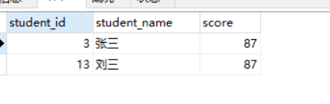

-- 30.求选了课程的学生人数

SELECT

subject_id,

count(student_id)

FROM

score

GROUP BY

subject_id

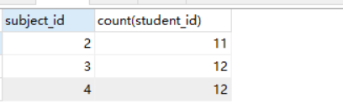

-- 31.查询选修“杨艳”老师所授课程的学生中，成绩最高的学生姓名及其成绩；

SELECT

stu.student_name,

sc.subject_id,

max(sc.score)

FROM

score sc,

student stu

WHERE

sc.subject_id IN(SELECT subject_id FROM `subject` WHERE teacher_id IN(

(SELECT teacher_id FROM teacher WHERE teacher_name='李平老师')

))

GROUP BY sc.subject_id

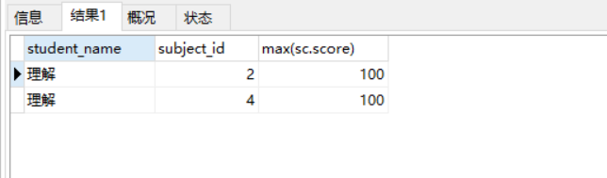

-- 32.查询各个课程及相应的选修人数；

SELECT

subject_id,

count(student_id) '人数'

FROM

score

GROUP BY

subject_id

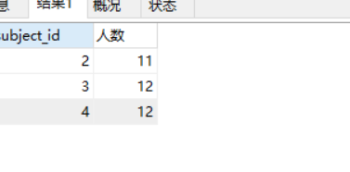

-- 33.查询不同课程但成绩相同的学生的学号、课程号、学生成绩；

SELECT

DISTINCT sc.student_id,

sc.subject_id,

sc.score

FROM

score sc,

score sc1

WHERE

sc.subject_id!=sc1.subject_id

AND

sc.score=sc1.score

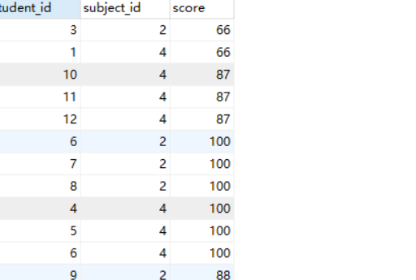

-- 34.查询每门课程成绩最好的前两名；

select

t1.student_id,t1.subject_id,t1.scorefromscoret1

leftjoin

(

selectscore_id,subject_id,

(selectscorefromscoreass2wheres2.subject_id=s1.subject_id

orderbyscoredesclimit0,1)asfirst_num,

(selectscorefromscoreass2wheres2.subject_id=s1.subject_id

orderbyscoredesclimit1,1)assecond_num

fromscoreass1

)t2

ont1.score_id=t2.score_id

wheret1.score=t2.first_numort1.score=t2.second_num;

-- 35.检索至少选修两门课程的学生学号；

SELECT

student_id,

COUNT(subject_id)

FROM

score

GROUP BY

student_id

HAVING COUNT(subject_id)>=2

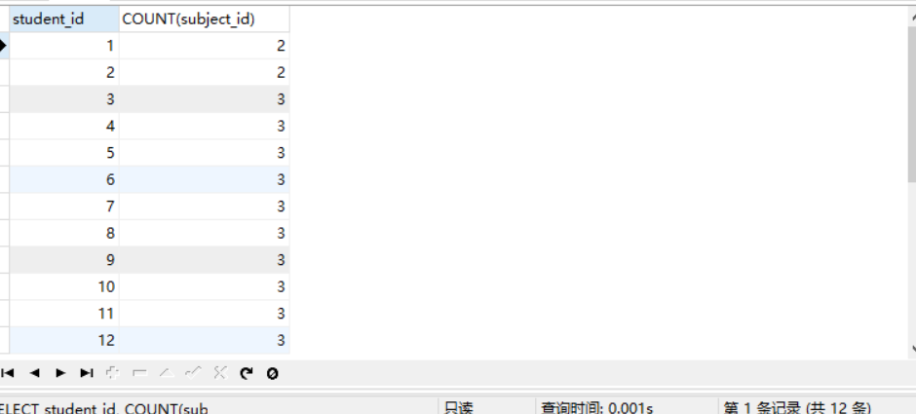

-- 36.查询全部学生都选修的课程的课程号和课程名；

select subject_id from score group by subject_id having count(student_id)

=(select count(student_id)from student);

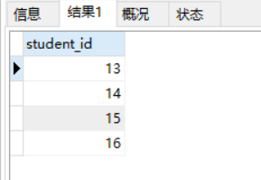

-- 37.查询没学过“李平”老师讲授的任一门课程的学生姓名；

SELECT student_id FROM student where student_id NOT IN(

SELECT DISTINCT student_id FROM score WHERE subject_id IN (

(SELECT subject_id FROM `subject` WHERE teacher_id IN(

(SELECT teacher_id from teacher where teacher_name='李平老师')

))

)

)

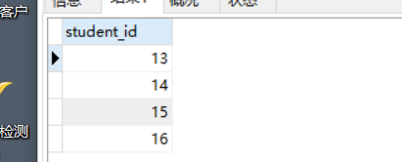

-- 38.查询两门以上不及格课程的同学的学号及其平均成绩；

SELECT

student_id,

AVG(score)

FROM

score

WHERE score<60

GROUP BY student_id HAVING COUNT(score)>2

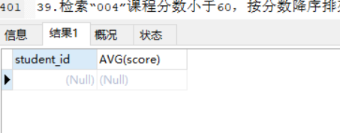

39.检索“004”课程分数小于60，按分数降序排列的同学学号；

SELECT

student_id

FROM

score

WHERE

subject_id=4

AND

score<60

ORDER BY score DESC

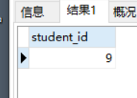

40.删除“002”同学的“001”课程的成绩；

DELETE FROM score where student_id=2 AND subject_id=1