Mysql练习题

**Class表的定义**

|  |  |  |  |  |  |  |  |
| --- | --- | --- | --- | --- | --- | --- | --- |
| **字段名** | **字段描述** | **数据类型** | **主键** | **外键** | **非空** | **唯一** | **自增** |
| class_id | 编号 | INT(10) | 是 | 否 | 是 | 是 | 是 |
| class_name | 班级名称 | VARCHAR(64) | 否 | 否 | 是 | 否 | 否 |

INSERT INTO `class` VALUES ('1', '三年二班'), ('2', '三年三班'), ('3', '一年二班'), ('4', '二年九班');

**Subject表的定义**

|  |  |  |  |  |  |  |  |
| --- | --- | --- | --- | --- | --- | --- | --- |
| **字段名** | **字段描述** | **数据类型** | **主键** | **外键** | **非空** | **唯一** | **自增** |
| subject_id | 编号 | INT(10) | 是 | 否 | 是 | 是 | 是 |
| subject_name | 班级名称 | VARCHAR(64) | 否 | 否 | 是 | 否 | 否 |
| teacher_id | 教师id | INT(10) | 否 | 否 | 否 | 否 | 否 |

INSERT INTO `course` VALUES ('1', '生物', '1'), ('2', '物理', '2'), ('3', '体育', '3'), ('4', '美术', '2');

**Score表的定义**

|  |  |  |  |  |  |  |  |
| --- | --- | --- | --- | --- | --- | --- | --- |
| **字段名** | **字段描述** | **数据类型** | **主键** | **外键** | **非空** | **唯一** | **自增** |
| score_id | 编号 | INT(10) | 是 | 否 | 是 | 是 | 是 |
| subject_id | 课程id | INT(10) | 否 | 否 | 是 | 否 | 否 |
| student_id | 学生id | INT(10) | 否 | 否 | 否 | 否 | 否 |
| score | 分数 | INT(10) | 否 | 否 | 否 | 否 | 否 |

INSERT INTO `score` VALUES ('1', '1', '1', '10'), ('2', '1', '2', '9'), ('5', '1', '4', '66'), ('6', '2', '1', '8'), ('8', '2', '3', '68'), ('9', '2', '4', '99'), ('10', '3', '1', '77'), ('11', '3', '2', '66'), ('12', '3', '3', '87'), ('13', '3', '4', '99'), ('14', '4', '1', '79'), ('15', '4', '2', '11'), ('16', '4', '3', '67'), ('17', '4', '4', '100'), ('18', '5', '1', '79'), ('19', '5', '2', '11'), ('20', '5', '3', '67'), ('21', '5', '4', '100'), ('22', '6', '1', '9'), ('23', '6', '2', '100'), ('24', '6', '3', '67'), ('25', '6', '4', '100'), ('26', '7', '1', '9'), ('27', '7', '2', '100'), ('28', '7', '3', '67'), ('29', '7', '4', '88'), ('30', '8', '1', '9'), ('31', '8', '2', '100'), ('32', '8', '3', '67'), ('33', '8', '4', '88'), ('34', '9', '1', '91'), ('35', '9', '2', '88'), ('36', '9', '3', '67'), ('37', '9', '4', '22'), ('38', '10', '1', '90'), ('39', '10', '2', '77'), ('40', '10', '3', '43'), ('41', '10', '4', '87'), ('42', '11', '1', '90'), ('43', '11', '2', '77'), ('44', '11', '3', '43'), ('45', '11', '4', '87'), ('46', '12', '1', '90'), ('47', '12', '2', '77'), ('48', '12', '3', '43'), ('49', '12', '4', '87'), ('52', '13', '3', '87');

**Student表的定义**

|  |  |  |  |  |  |  |  |
| --- | --- | --- | --- | --- | --- | --- | --- |
| **字段名** | **字段描述** | **数据类型** | **主键** | **外键** | **非空** | **唯一** | **自增** |
| student_id | 编号 | INT(10) | 是 | 否 | 是 | 是 | 是 |
| sex | 性别 | VARCHAR(64) | 否 | 否 | 是 | 否 | 否 |
| class_id | 班级id | INT(10) | 否 | 否 | 否 | 否 | 否 |
| student_name | 学生姓名 | VARCHAR(64) | 否 | 否 | 否 | 否 | 否 |

INSERT INTO `student` VALUES ('1', '男', '1', '理解'), ('2', '女', '1', '钢蛋'), ('3', '男', '1', '张三'), ('4', '男', '1', '张一'), ('5', '女', '1', '张二'), ('6', '男', '1', '张四'), ('7', '女', '2', '铁锤'), ('8', '男', '2', '李三'), ('9', '男', '2', '李一'), ('10', '女', '2', '李二'), ('11', '男', '2', '李四'), ('12', '女', '3', '如花'), ('13', '男', '3', '刘三'), ('14', '男', '3', '刘一'), ('15', '女', '3', '刘二'), ('16', '男', '3', '刘四');

**Teacher表的定义**

|  |  |  |  |  |  |  |  |
| --- | --- | --- | --- | --- | --- | --- | --- |
| **字段名** | **字段描述** | **数据类型** | **主键** | **外键** | **非空** | **唯一** | **自增** |
| teacher_id | 编号 | INT(10) | 是 | 否 | 是 | 是 | 是 |
| teacher_name | 姓名 | VARCHAR(64) | 否 | 否 | 是 | 否 | 否 |

INSERT INTO `teacher` VALUES ('1', '张磊老师'), ('2', '李平老师'), ('3', '刘海燕老师'), ('4', '朱云海老师'), ('5', '李杰老师');

1.查询男生、女生的人数；

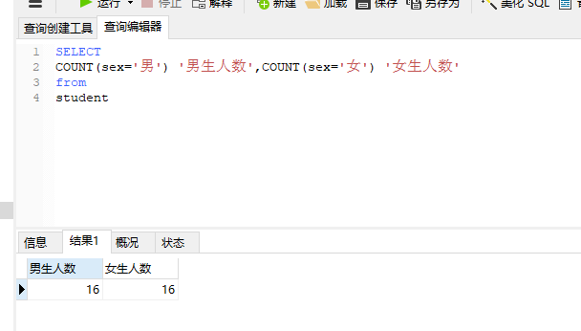

2.查询姓“张”的学生名单；

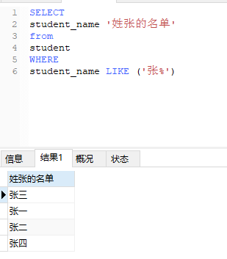

3.课程平均分从高到低显示

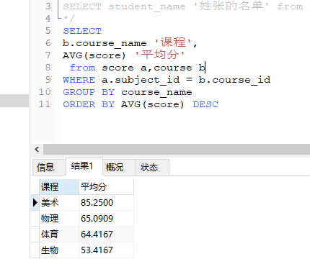

4.查询有课程成绩小于60分的同学的学号、姓名；

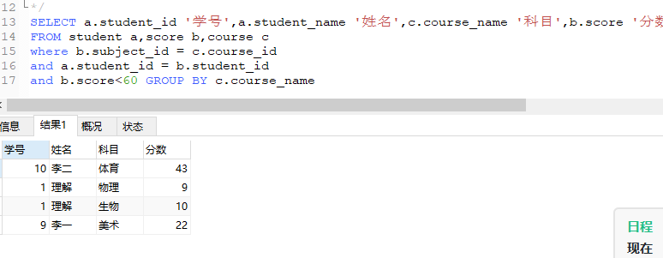

5.查询至少有一门课与学号为1的同学所学课程相同的同学的学号和姓名；

方法一

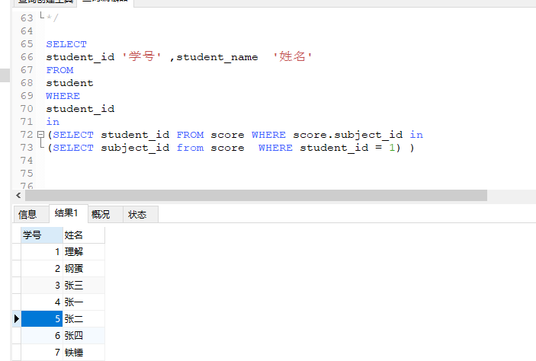

方法二

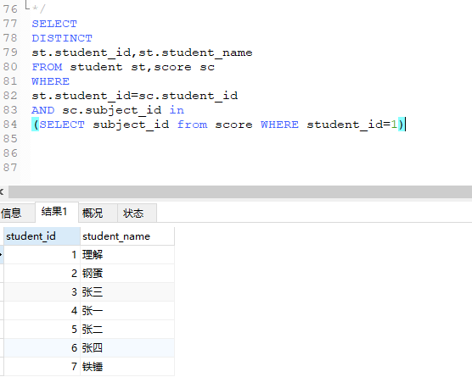

6.查询出只选修了一门课程的全部学生的学号和姓名；

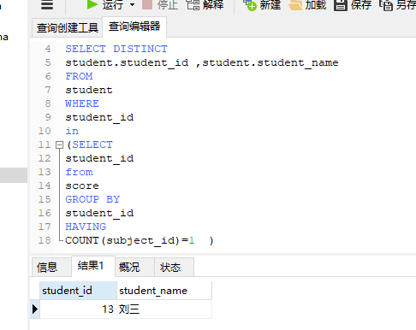

7.查询各科成绩最高和最低的分：以如下形式显示：课程ID，最高分，最低分；

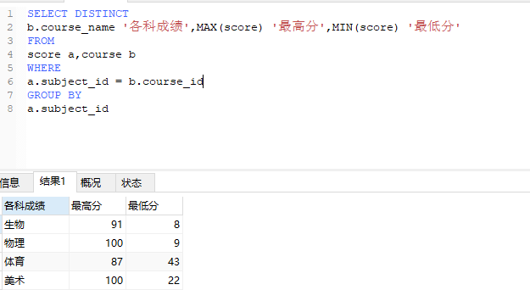

8.查询课程编号“2”的成绩比课程编号“1”课程低的所有同学的学号、姓名；

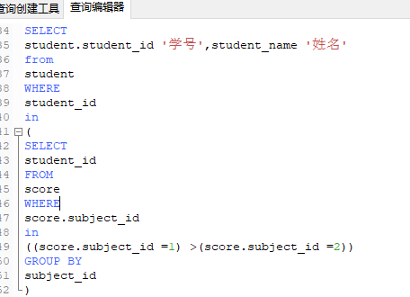

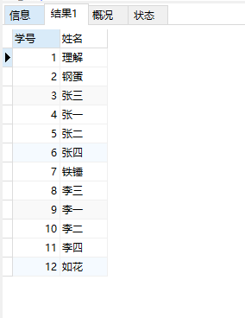

9.查询“生物”课程比“物理”课程成绩高的所有学生的学号；

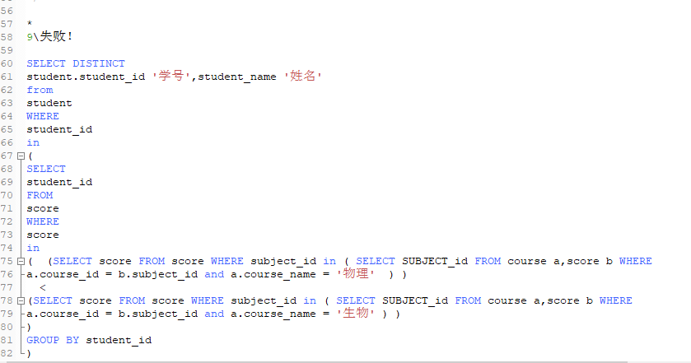

10.查询平均成绩大于60分的同学的学号和平均成绩;

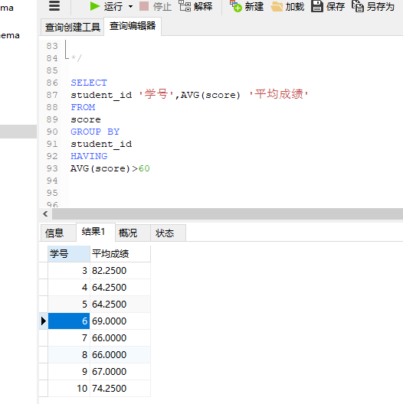

11.查询所有同学的学号、姓名、选课数、总成绩；

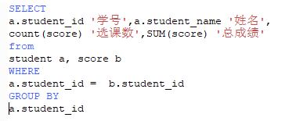

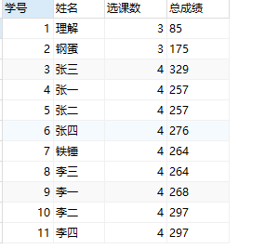

12.查询姓“李”的老师的个数；

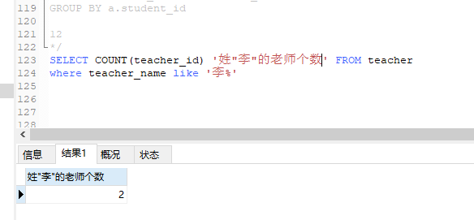

13.查询没选过“张磊老师”课的同学的学号、姓名；

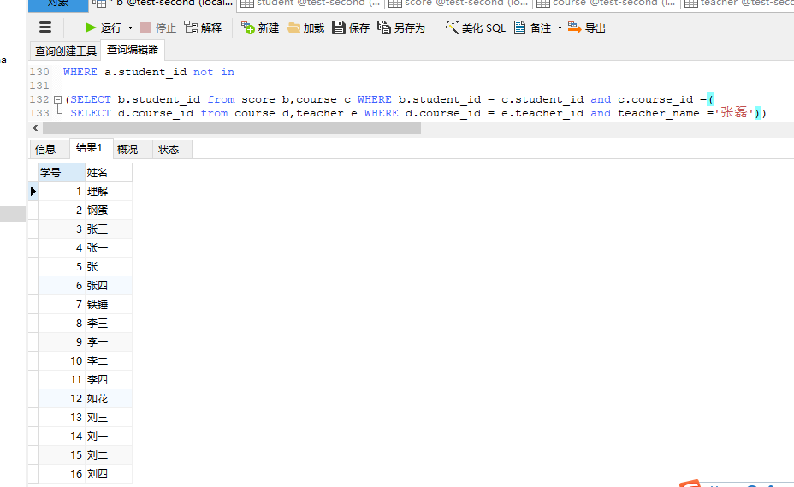

14.查询学过“1”并且也学过编号“2”课程的同学的学号、姓名；

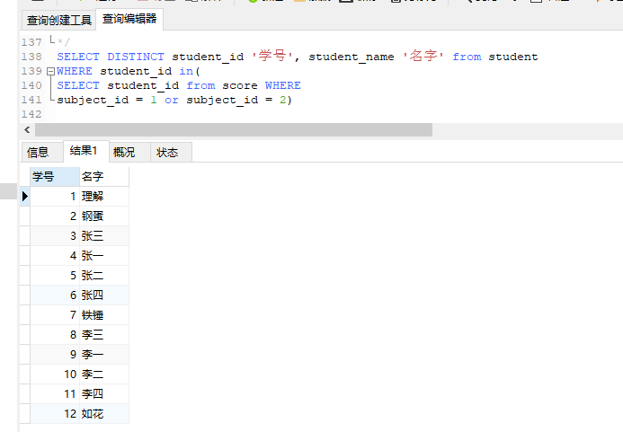

15.查询学过“李平老师”所教的所有课的同学的学号、姓名；

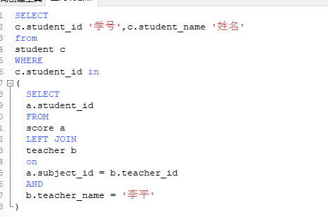

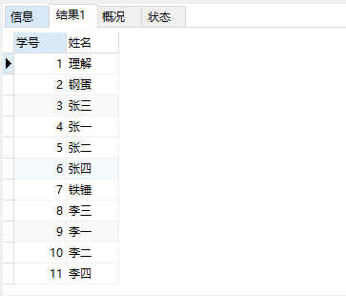

16.查询没有学全所有课的同学的学号、姓名；

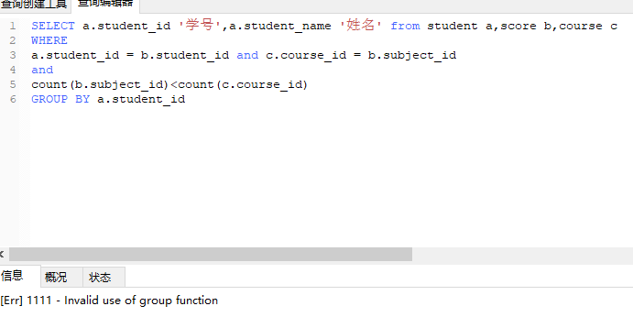

17.查询和“002”号的同学学习的课程完全相同的其他同学学号和姓名；

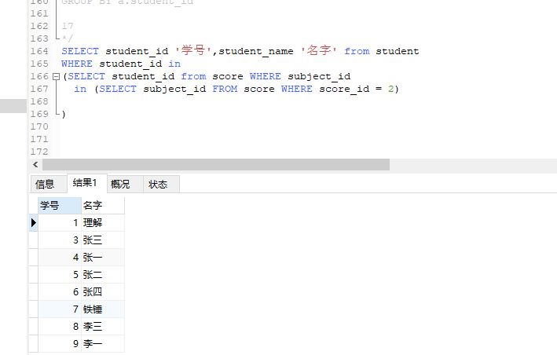

18.删除学习“叶平”老师课的SC表记录；

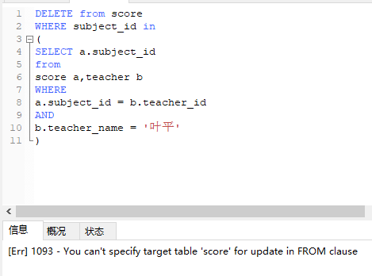

19.向SC表中插入一些记录，这些记录要求符合以下条件：①没有上过编号“002”课程的同学学号；②插入“002”号课程的平均成绩；

20.按平均成绩从低到高显示所有学生的“语文”、“数学”、“英语”三门的课程成绩，按如下形式显示： 学生ID,语文,数学,英语,有效课程数,有效平均分；

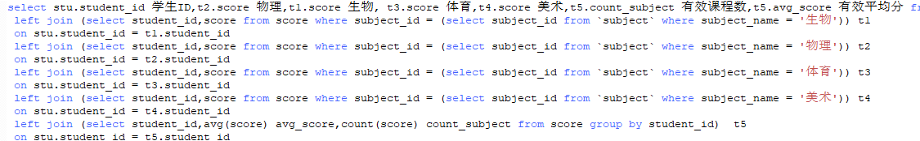

1. 查询各科成绩最高和最低的分：以如下形式显示：课程ID，最高分，最低分；

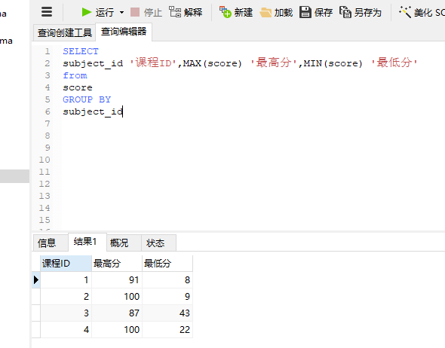

22.按各科平均成绩从低到高和及格率的百分数从高到低顺序；

SELECT

t_out1.subject_id,

t_out1.avgnum,

t_out2.pass_per

FROM

(

SELECT

subject_id,

avg(score) avgnum

FROM

score

GROUP BY

subject_id

) t_out1

LEFT JOIN (

SELECT

t1.subject_id,

t1.count1 / t2.count2 pass_per

FROM

(

SELECT

subject_id,

count(subject_id) count1

FROM

score

WHERE

score > 60

GROUP BY

subject_id

) t1

LEFT JOIN (

SELECT

subject_id,

count(subject_id) count2

FROM

score

GROUP BY

subject_id

) t2 ON t1.subject_id = t2.subject_id

) t_out2 ON t_out1.subject_id = t_out2.subject_id

ORDER BY

avgnum,

pass_per DESC;

23.查询各科成绩前三名的记录:(不考虑成绩并列情况)

select

t1.student_id,t1.subject_id,t1.score from score t1

left join

(

select score_id,subject_id,

(select score from score as s2 where s2.subject_id = s1.subject_id order by score desc limit 0, 1) as first_num,

(select score from score as s2 where s2.subject_id = s1.subject_id order by score desc limit 1, 1) as second_num,

(select score from score as s2 where s2.subject_id = s1.subject_id order by score desc limit 2, 1) as third_num

from score as s1

) t2

on t1.score_id = t2.score_id

where t1.score = t2.first_num or t1.score = t2.second_num or t1.score = t2.third_num;

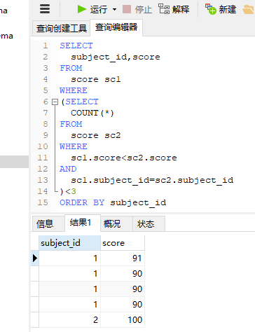

24.查询每门课程被选修的学生数；

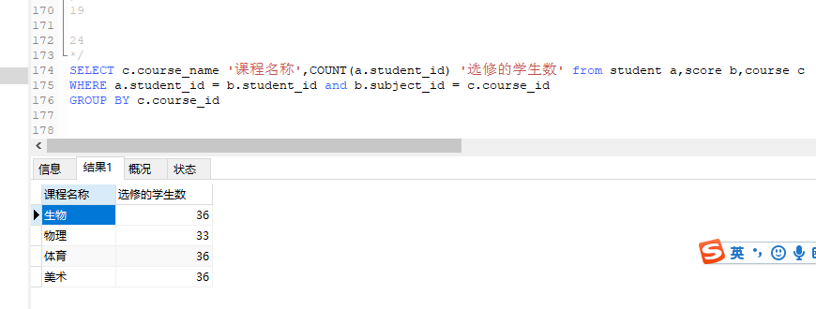

25.查询同名同姓学生名单，并统计同名人数；

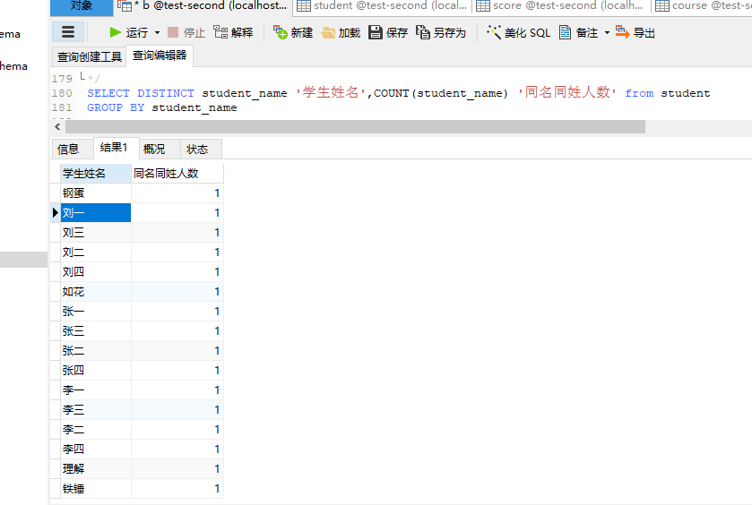

26.查询每门课程的平均成绩，结果按平均成绩升序排列，平均成绩相同时，按课程号降序排列；

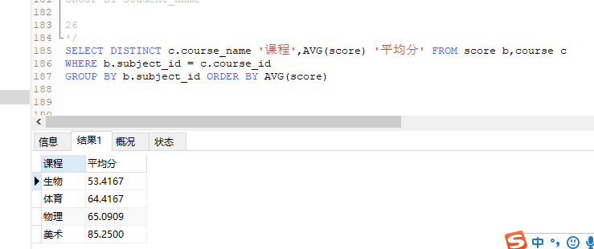

27.查询平均成绩大于85的所有学生的学号. 姓名和平均成绩；

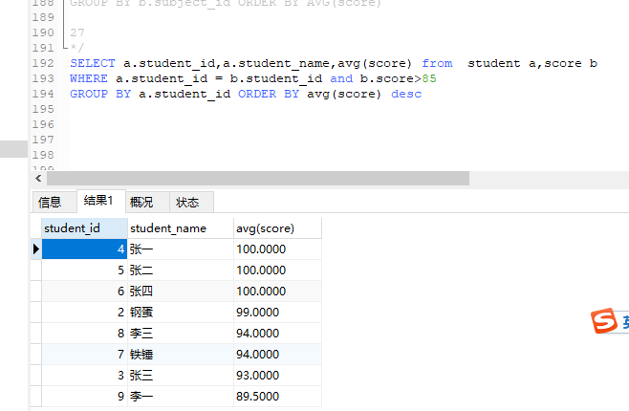

28.查询课程名称为“数学”，且分数低于60的学生姓名和分数；

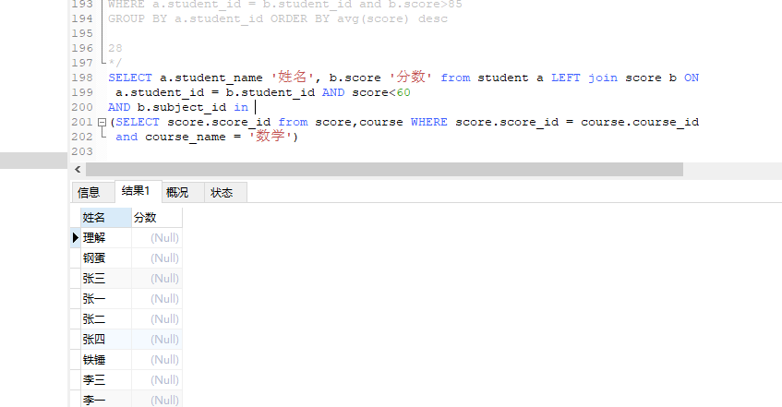

29.查询课程编号为003且课程成绩在80分以上的学生的学号和姓名；

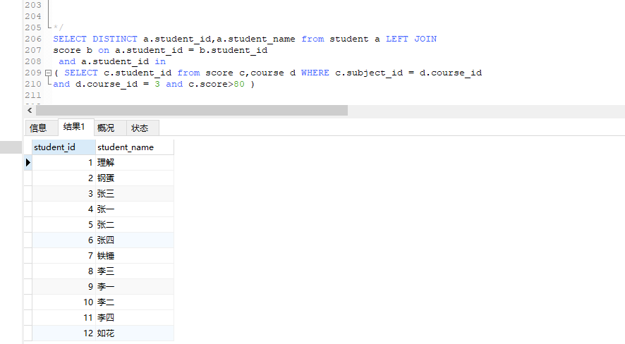

30.求选了课程的学生人数

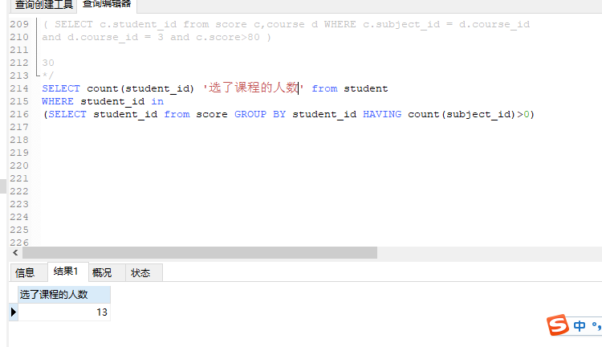

31.查询选修“李平”老师所授课程的学生中，成绩最高的学生姓名及其成绩；

select student.student_name,t1.score from(

select distinct student_id,score from score

where score = (select max(score) from score where subject_id in (select subject_id from `subject` where teacher_id in (select teacher_id from teacher where teacher_name = '李平老师')))

and subject_id in (select subject_id from `subject` where teacher_id in (select teacher_id from teacher where teacher_name = '李平老师'))

) t1

left join

student

on

t1.student_id = student.student_id

32.查询各个课程及相应的选修人数；

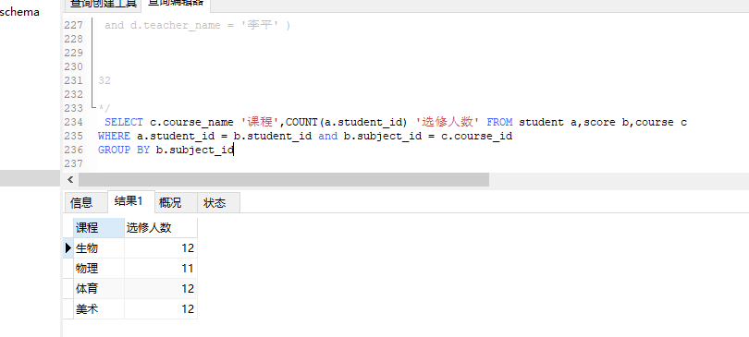

33.查询不同课程但成绩相同的学生的学号、课程号、学生成绩；

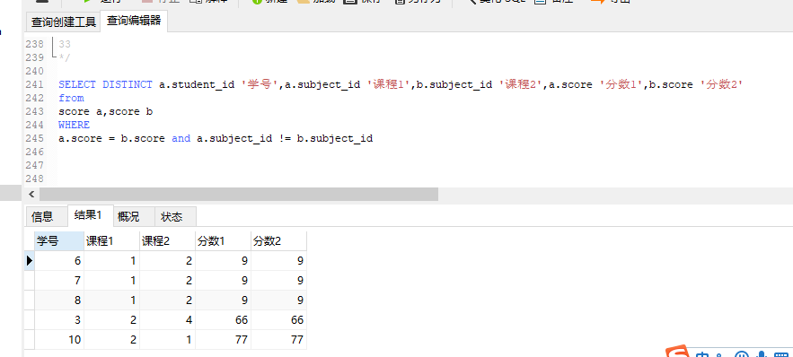

34.查询每门课程成绩最好的前两名；

select

t1.student_id,t1.subject_id,t1.score from score t1

left join

(

select score_id,subject_id,

(select score from score as s2 where s2.subject_id = s1.subject_id order by score desc limit 0, 1) as first_num,

(select score from score as s2 where s2.subject_id = s1.subject_id order by score desc limit 1, 1) as second_num

from score as s1

) t2

on t1.score_id = t2.score_id

where t1.score = t2.first_num or t1.score = t2.second_num ;

35.检索至少选修两门课程的学生学号；

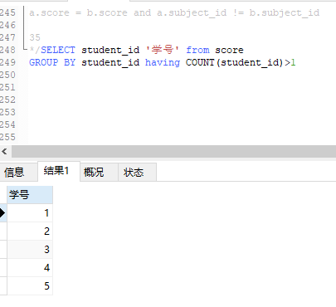

36.查询全部学生都选修的课程的课程号和课程名；

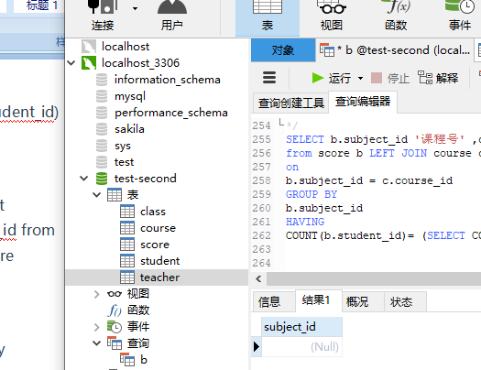

37.查询没学过“李平”老师讲授的任一门课程的学生姓名；

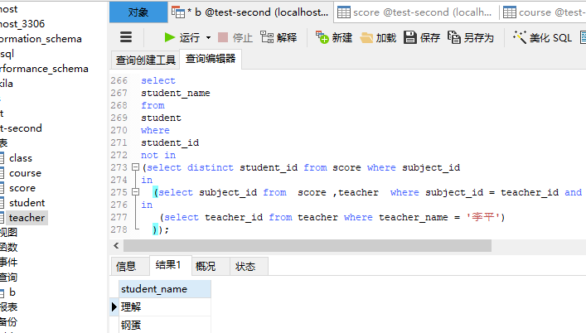

38.查询两门以上不及格课程的同学的学号及其平均成绩；

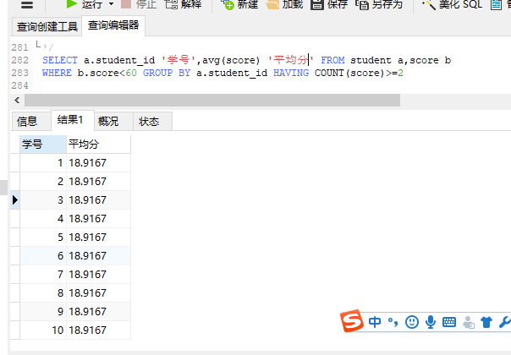

39.检索“004”课程分数小于60，按分数降序排列的同学学号；

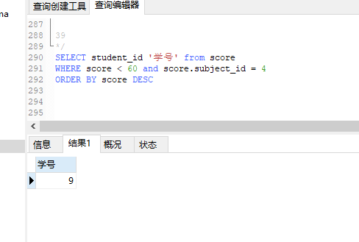

40.删除“002”同学的“001”课程的成绩；

