1. 查询男生、女生的人数；

SELECT

sex,

COUNT(sex)

FROM

student

GROUP BY sex ;



1. 查询姓“张”的学生名单；

SELECT

*

FROM

student

WHERE student.`student_name` LIKE ('张%') ;

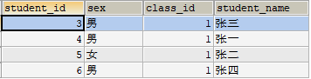

1. 课程平均分从高到低显示

SELECT

score.`subject_id` '课程编号',

subject.`subject_name` '课程名',

AVG(score) '平均分'

FROM

score

LEFT JOIN

SUBJECT

ON score.`subject_id` = subject.`subject_id`

GROUP BY score.`subject_id`

ORDER BY AVG(score) DESC;

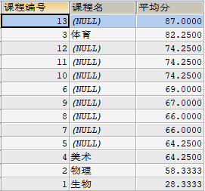

1. 查询有课程成绩小于60分的同学的学号、姓名；

SELECT

student.`student_id` '学号',

Student.`student_name` '姓名'

FROM

score,

student

WHERE student.`student_id` = score.`student_id`

AND score.`score` < 60

GROUP BY student.`student_id` ;

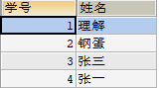

1. 查询至少有一门课与学号为1的同学所学课程相同的同学的学号和姓名；

SELECT

student.`student_id`,

student.`student_name`

FROM

score,

student

WHERE score.score_id IN (1, 2, 4)

GROUP BY student.`student_id` ;

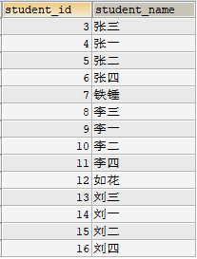

1. 查询出只选修了一门课程的全部学生的学号和姓名；

SELECT

stu.`student_id` '学号',

stu.`student_name` '姓名'

FROM

student stu,

score s

WHERE stu.`student_id` = s.`student_id`

GROUP BY s.`student_id`

HAVING COUNT(s.`subject_id`) = 1 ;



1. 查询各科成绩最高和最低的分：以如下形式显示：课程ID，最高分，最低分；

SELECT

s.`subject_id` '课程ID',

MAX(score) '最高分',

MIN(score) '最低分'

FROM

score s

GROUP BY s.`subject_id`;

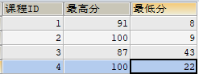

1. 查询课程编号“2”的成绩比课程编号“1”课程低的所有同学的学号、姓名；

SELECT

stu.`student_id`,

stu.`student_name` ,

s.`subject_id`,

s.`score`

FROM

score s,

student stu

WHERE

s.`student_id` = stu.`student_id`

AND s.`subject_id` = 1 ;

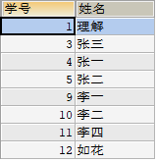

1. 查询“生物”课程比“物理”课程成绩高的所有学生的学号；

SELECT

stu.`student_id` '学号',

stu.`student_name` '姓名'

FROM

score s,

SUBJECT su,

Student stu

WHERE

s.`subject_id` = su.`subject_id`

AND s.`student_id` = stu.`student_id`

AND su.`subject_name` = '生物'

AND s.`score` > (SELECT score FROM SUBJECT su,score s WHERE su.`subject_name` = '物理'

AND su.`subject_id` = s.`score_id`

AND s.`score`);

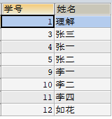

1. 查询平均成绩大于60分的同学的学号和平均成绩;

SELECT

stu.`student_id` '学号',

stu.`student_name` '姓名',

t1.a '平均成绩'

FROM

(SELECT

AVG(score) a,

s.`student_id`

FROM

score s

GROUP BY s.`student_id`) t1,

student stu

WHERE stu.`student_id` = t1.student_id

AND t1.a > 60 ;

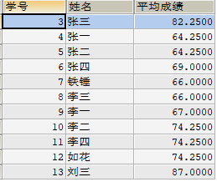

1. 查询所有同学的学号、姓名、选课数、总成绩；

SELECT

stu.`student_id` '学号',

stu.`student_name` '姓名',

t1.cnt '选课数',

t1.sum '总分'

FROM

Student stu,

(SELECT

s.`student_id`,

SUM(s.`score`) SUM,

COUNT(s.`subject_id`) cnt

FROM

score s

GROUP BY s.`student_id`) t1

WHERE stu.`student_id` = t1.`student_id` ;

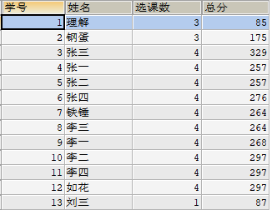

1. 查询姓“李”的老师的个数；

SELECT

COUNT(t1.`teacher_id`) '姓“李”的老师的个数'

FROM

teachar t1

WHERE t1.`teacher_name` LIKE ('李%') ;



1. 查询没学过“张磊老师”课的同学的学号、姓名；

SELECT

t1.`student_id`,

t1.`student_name`

FROM

(SELECT

stu.`student_id`,

stu.`student_name`,

t.`teacher_name`

FROM

student stu,

teachar t,

score s,

SUBJECT sub

WHERE stu.`student_id` = s.`student_id`

AND s.`subject_id` = sub.`subject_id`

AND sub.`teacher_id` = t.`teacher_id`

GROUP BY stu.`student_id`

HAVING t.`teacher_name` NOT IN ('张磊老师')) t1 ;



1. 查询学过“1”并且也学过编号“2”课程的同学的学号、姓名；

SELECT

s1.`student_id`,

s1.`student_name`

FROM

student s1,

score s2,

SUBJECT s3

WHERE s1.`student_id` = s2.`student_id`

AND s2.`subject_id` = s3.`subject_id`

AND s3.`subject_id` IN (1, 2)

GROUP BY s1.`student_id`

HAVING COUNT(s1.`student_id`) = 2 ;

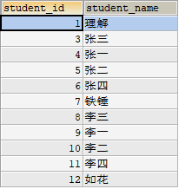

1. 查询学过“李平老师”所教的所有课的同学的学号、姓名；

SELECT

stu.`student_id`,

stu.`student_name`

FROM

student stu,

teachar t,

score s,

SUBJECT sub

WHERE stu.`student_id` = s.`student_id`

AND s.`subject_id` = sub.`subject_id`

AND sub.`teacher_id` = t.`teacher_id`

AND t.`teacher_name` IN ('李平老师')

GROUP BY stu.`student_id`;

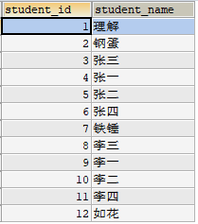

1. 查询没有学全所有课的同学的学号、姓名；

SELECT

t1.student_id '学号',

t1.student_name '姓名'

FROM

(SELECT

stu.`student_id`,

stu.`student_name`

FROM

student stu,

teachar t,

score s,

SUBJECT sub

WHERE stu.`student_id` = s.`student_id`

AND s.`subject_id` = sub.`subject_id`

AND sub.`teacher_id` = t.`teacher_id`

GROUP BY stu.`student_id`

HAVING COUNT(sub.`subject_id`) != 4) t1 ;

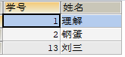

1. 查询和“002”号的同学学习的课程完全相同的其他同学学号和姓名；

SELECT

t1.student_id,

t1.student_name

FROM

(SELECT

s1.`student_id`,

s1.`student_name`,

COUNT(t1.subject_id) '相同科目数'

FROM

student s1,

score s2,

(SELECT

sub.`subject_id`,

sub.`subject_name`

FROM

student stu,

teachar t,

score s,

SUBJECT sub

WHERE stu.`student_id` = s.`student_id`

AND s.`subject_id` = sub.`subject_id`

AND sub.`teacher_id` = t.`teacher_id`

AND stu.`student_id` = 2) t1

WHERE s1.`student_id` = s2.`student_id`

AND s2.`subject_id` = t1.subject_id

GROUP BY s1.`student_id`

HAVING COUNT(t1.subject_id) = 3) t1 ;

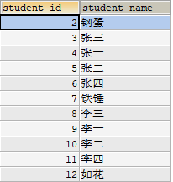

1. 删除学习“叶平”老师课的SC表记录；

DELETE

FROM

score

WHERE score.`subject_id` =

(SELECT

s.`subject_id`

FROM

SUBJECT s

WHERE s.`teacher_id` =

(SELECT

t.`teacher_id`

FROM

teachar t

WHERE t.`teacher_name` = '李平老师'));

1. 向SC表中插入一些记录，这些记录要求符合以下条件：①没有上过编号“002”课程的同学学号；②插入“002”号课程的平均成绩；
2. 按平均成绩从低到高显示所有学生的“生物”、“物理”、“美术”、“体育”四门的课程成绩，按如下形式显示： 学生ID、生物、物理、美术、体育、有效课程数,有效平均分；

SELECT

s1.`student_id` 学生ID,t1.`score` 生物,t2.`score` 物理,t3.`score` 美术,t4.`score` 体育,t5.a 有效科目,t6.a 有效平均分

FROM

score s1

LEFT JOIN (SELECT s1.`student_id`,s2.`subject_name`,s1.`score` FROM score s1,SUBJECT s2 WHERE s1.`subject_id` = s2.`subject_id` AND s2.`subject_name` = '生物') t1

ON s1.`student_id` = t1.`student_id`

LEFT JOIN (SELECT s1.`student_id`,s2.`subject_name`,s1.`score` FROM score s1,SUBJECT s2 WHERE s1.`subject_id` = s2.`subject_id` AND s2.`subject_name` = '物理') t2

ON s1.`student_id` = t2.`student_id`

LEFT JOIN (SELECT s1.`student_id`,s2.`subject_name`,s1.`score` FROM score s1,SUBJECT s2 WHERE s1.`subject_id` = s2.`subject_id` AND s2.`subject_name` = '美术') t3

ON s1.`student_id` = t3.`student_id`

LEFT JOIN (SELECT s1.`student_id`,s2.`subject_name`,s1.`score` FROM score s1,SUBJECT s2 WHERE s1.`subject_id` = s2.`subject_id` AND s2.`subject_name` = '体育') t4

ON s1.`student_id` = t4.`student_id`

LEFT JOIN (SELECT s.`student_id`,COUNT(s.`student_id`) a FROM score s GROUP BY s.`student_id` ) t5

ON s1.`student_id` = t5.`student_id`

LEFT JOIN (SELECT s.`student_id`,AVG(s.`score`) a FROM score s GROUP BY s.`student_id` ) t6

ON s1.`student_id` = t6.`student_id`

GROUP BY s1.`student_id`;

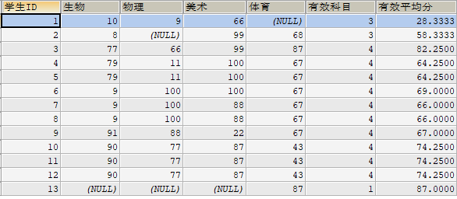

21.查询各科成绩最高和最低的分：以如下形式显示：课程ID，最高分，最低分；

SELECT

s2.`subject_id` '课程ID',

MAX(s2.`score`) '最高分',

MIN(s2.`score`) '最低分'

FROM

score s2

GROUP BY s2.`subject_id`

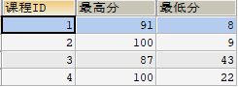

1. 按各科平均成绩从低到高和及格率的百分数从高到低顺序；

SELECT

s2.subject_name,

AVG(s1.`score`) 平均分,

100*SUM(CASE

WHEN s1.score>=60

THEN 1 ELSE 0

END)/COUNT(*) 及格率

FROM

score s1,

SUBJECT s2

WHERE

s1.`subject_id` = s2.`subject_id`

GROUP BY s1.`subject_id`;

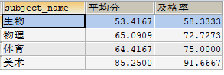

1. 查询各科成绩前三名的记录:(不考虑成绩并列情况)
2. 查询每门课程被选修的学生数；

SELECT

s3.subject_name 科目,

COUNT(s1.`student_id`) 人数

FROM

student s1,

score s2,

SUBJECT s3

WHERE s1.`student_id` = s2.`student_id`

AND s2.`subject_id` = s3.`subject_id`

GROUP BY s3.subject_name

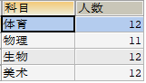

1. 查询同名同姓学生名单，并统计同名人数；

SELECT

s.`student_name` 姓名,

COUNT(*) 重名人数

FROM

student s

GROUP BY s.`student_name` HAVING COUNT(*) > 1;



1. 查询每门课程的平均成绩，结果按平均成绩升序排列，平均成绩相同时，按课程号降序排列；

SELECT

AVG(s.`score`)

FROM

score s

GROUP BY s.`subject_id`

ORDER BY s.`score`,

s.`subject_id` DESC ;

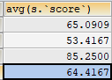

1. 查询平均成绩大于85的所有学生的学号. 姓名和平均成绩；

SELECT

s1.`student_id` 学号,

s1.`student_name` 姓名,

平均分

FROM

student s1,

(SELECT

score.`student_id`,

AVG(score.`score`) 平均分

FROM

score

GROUP BY score.`student_id`) s2

WHERE s1.`student_id` = s2.`student_id`

AND 平均分 > 85

GROUP BY s1.`student_id` ;



1. 查询课程名称为“生物”，且分数低于60的学生姓名和分数；

SELECT

s3.`student_name` 姓名,s1.`score`分数

FROM

score s1,

SUBJECT s2,

student s3

WHERE

s1.`student_id` = s3.`student_id`

AND s2.`subject_id` = s1.`subject_id`

AND s2.`subject_name` = '生物'

AND s1.`score` < 60

GROUP BY s3.`student_name`

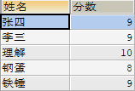

1. 查询课程编号为003且课程成绩在80分以上的学生的学号和姓名；

SELECT

s3.`student_name` 姓名,s1.`score`分数

FROM

score s1,

SUBJECT s2,

student s3

WHERE

s1.`student_id` = s3.`student_id`

AND s2.`subject_id` = s1.`subject_id`

AND s2.`subject_id` = 3

AND s1.`score` > 80

GROUP BY s3.`student_name`



1. 求选了课程的学生人数

SELECT

COUNT(t1.`student_id`) 人数

FROM

(SELECT

s1.`student_id`

FROM

student s1,

score s2

WHERE s1.`student_id` = s2.`student_id`

AND s2.`subject_id` IS NOT NULL

GROUP BY s1.`student_id`) t1



1. 查询选修“张磊”老师所授课程的学生中，成绩最高的学生姓名及其成绩；

SELECT

t1.`student_name`,

t2.`score`

FROM

student t1,

score t2,

SUBJECT t3,

teachar t4

WHERE t1.`student_id` = t2.`student_id`

AND t2.`subject_id` = t3.`subject_id`

AND t3.`teacher_id` = t4.`teacher_id`

AND t4.`teacher_name` = '张磊老师'

AND t2.`score` =

(SELECT

MAX(s1.`score`) 成绩最高分数

FROM

score s1,

SUBJECT s2,

teachar s3

WHERE s2.`subject_id` = s1.`subject_id`

AND s2.`teacher_id` = s3.`teacher_id`

AND s3.`teacher_name` = '张磊老师');



1. 查询各个课程及相应的选修人数；

SELECT

s3.`subject_name` 课程,COUNT(s1.`student_id`) 人数

FROM

student s1,

score s2,

SUBJECT s3

WHERE

s1.`student_id` = s2.`student_id`

AND s2.`subject_id` = s3.`subject_id`

GROUP BY s3.`subject_name`

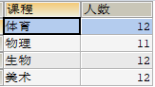

1. 查询不同课程但成绩相同的学生的学号、课程号、学生成绩；

SELECT DISTINCT

s.`student_id` 学号,s.`student_name`,s1.`subject_id` 第一门课程,s2.`subject_id` 第二名课程,s1.`score`

FROM

student s,

score s1,

score s2

WHERE

s.`student_id` = s1.`student_id`

AND s.`student_id` = s2.`student_id`

AND s1.`subject_id` != s2.`subject_id`

AND s2.`score` = s1.`score`

GROUP BY s.`student_id`



1. 查询每门课程成绩最好的前两名；

SELECT

t1.student_id,t1.subject_id,t1.score FROM score t1

LEFT JOIN

(

SELECT score_id,subject_id,

(SELECT score FROM score AS s2 WHERE s2.subject_id = s1.subject_id ORDER BY score DESC LIMIT 0, 1) AS first_num,

(SELECT score FROM score AS s2 WHERE s2.subject_id = s1.subject_id ORDER BY score DESC LIMIT 1, 1) AS second_num

FROM score AS s1

) t2

ON t1.score_id = t2.score_id

WHERE t1.score = t2.first_num OR t1.score = t2.second_num ;

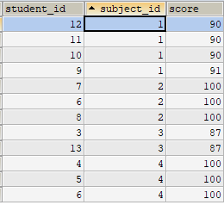

35.检索至少选修两门课程的学生学号；

SELECT

s1.`student_id` 学号,s1.`student_name` 姓名

FROM

student s1,

score s2

WHERE

s1.`student_id` = s2.`student_id`

GROUP BY s1.`student_id` HAVING (COUNT(s2.`subject_id`) >=2)

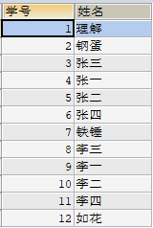

36.查询全部学生都选修的课程的课程号和课程名；

SELECT DISTINCT

s3.`subject_id` , s3.`subject_name`

FROM

student s1,

score s2,

SUBJECT s3

WHERE

s1.`student_id` = s2.`student_id`

AND s2.`subject_id` = s3.`subject_id`

GROUP BY s1.`student_id` HAVING (COUNT(s2.`subject_id`) = MAX(s3.`subject_id`));



37.查询没学过“李平”老师讲授的任一门课程的学生姓名；

SELECT

student_name

FROM

student

WHERE student_id NOT IN

(SELECT DISTINCT

student_id

FROM

score

WHERE subject_id IN

(SELECT

subject_id

FROM

SUBJECT

WHERE teacher_id IN

(SELECT

teacher_id

FROM

teachar

WHERE teacher_name = '李平老师'))) ;

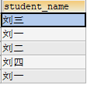

1. 查询两门以上不及格课程的同学的学号及其平均成绩；

SELECT

t1.student_id 学号,

AVG(t2.score) 平均成绩

FROM

(SELECT

student_id,COUNT(*)

FROM

score

WHERE score < 60

GROUP BY student_id

HAVING COUNT(*) > 1) t1,

score t2

WHERE t1.student_id = t2.student_id



1. 检索“004”课程分数小于60，按分数降序排列的同学学号；

SELECT

s1.`student_id` 学号

FROM

score s1

WHERE

s1.`subject_id` = 4

AND s1.`score` < 60

ORDER BY s1.`score` DESC



1. 删除“002”同学的“001”课程的成绩；

DELETE FROM score WHERE student_id = 2 AND subject_id = 1;