Mysql练习题

**Class表的定义**

|  |  |  |  |  |  |  |  |
| --- | --- | --- | --- | --- | --- | --- | --- |
| **字段名** | **字段描述** | **数据类型** | **主键** | **外键** | **非空** | **唯一** | **自增** |
| class_id | 编号 | INT(10) | 是 | 否 | 是 | 是 | 是 |
| class_name | 班级名称 | VARCHAR(64) | 否 | 否 | 是 | 否 | 否 |

INSERT INTO `class` VALUES ('1', '三年二班'), ('2', '三年三班'), ('3', '一年二班'), ('4', '二年九班');

**Subject表的定义**

|  |  |  |  |  |  |  |  |
| --- | --- | --- | --- | --- | --- | --- | --- |
| **字段名** | **字段描述** | **数据类型** | **主键** | **外键** | **非空** | **唯一** | **自增** |
| subject_id | 编号 | INT(10) | 是 | 否 | 是 | 是 | 是 |
| subject_name | 班级名称 | VARCHAR(64) | 否 | 否 | 是 | 否 | 否 |
| teacher_id | 教师id | INT(10) | 否 | 否 | 否 | 否 | 否 |

INSERT INTO `course` VALUES ('1', '生物', '1'), ('2', '物理', '2'), ('3', '体育', '3'), ('4', '美术', '2');

**Score表的定义**

|  |  |  |  |  |  |  |  |
| --- | --- | --- | --- | --- | --- | --- | --- |
| **字段名** | **字段描述** | **数据类型** | **主键** | **外键** | **非空** | **唯一** | **自增** |
| score_id | 编号 | INT(10) | 是 | 否 | 是 | 是 | 是 |
| subject_id | 课程id | INT(10) | 否 | 否 | 是 | 否 | 否 |
| student_id | 学生id | INT(10) | 否 | 否 | 否 | 否 | 否 |
| score | 分数 | INT(10) | 否 | 否 | 否 | 否 | 否 |

INSERT INTO `score` VALUES ('1', '1', '1', '10'), ('2', '1', '2', '9'), ('5', '1', '4', '66'), ('6', '2', '1', '8'), ('8', '2', '3', '68'), ('9', '2', '4', '99'), ('10', '3', '1', '77'), ('11', '3', '2', '66'), ('12', '3', '3', '87'), ('13', '3', '4', '99'), ('14', '4', '1', '79'), ('15', '4', '2', '11'), ('16', '4', '3', '67'), ('17', '4', '4', '100'), ('18', '5', '1', '79'), ('19', '5', '2', '11'), ('20', '5', '3', '67'), ('21', '5', '4', '100'), ('22', '6', '1', '9'), ('23', '6', '2', '100'), ('24', '6', '3', '67'), ('25', '6', '4', '100'), ('26', '7', '1', '9'), ('27', '7', '2', '100'), ('28', '7', '3', '67'), ('29', '7', '4', '88'), ('30', '8', '1', '9'), ('31', '8', '2', '100'), ('32', '8', '3', '67'), ('33', '8', '4', '88'), ('34', '9', '1', '91'), ('35', '9', '2', '88'), ('36', '9', '3', '67'), ('37', '9', '4', '22'), ('38', '10', '1', '90'), ('39', '10', '2', '77'), ('40', '10', '3', '43'), ('41', '10', '4', '87'), ('42', '11', '1', '90'), ('43', '11', '2', '77'), ('44', '11', '3', '43'), ('45', '11', '4', '87'), ('46', '12', '1', '90'), ('47', '12', '2', '77'), ('48', '12', '3', '43'), ('49', '12', '4', '87'), ('52', '13', '3', '87');

**Student表的定义**

|  |  |  |  |  |  |  |  |
| --- | --- | --- | --- | --- | --- | --- | --- |
| **字段名** | **字段描述** | **数据类型** | **主键** | **外键** | **非空** | **唯一** | **自增** |
| student_id | 编号 | INT(10) | 是 | 否 | 是 | 是 | 是 |
| sex | 性别 | VARCHAR(64) | 否 | 否 | 是 | 否 | 否 |
| class_id | 班级id | INT(10) | 否 | 否 | 否 | 否 | 否 |
| student_name | 学生姓名 | VARCHAR(64) | 否 | 否 | 否 | 否 | 否 |

INSERT INTO `student` VALUES ('1', '男', '1', '理解'), ('2', '女', '1', '钢蛋'), ('3', '男', '1', '张三'), ('4', '男', '1', '张一'), ('5', '女', '1', '张二'), ('6', '男', '1', '张四'), ('7', '女', '2', '铁锤'), ('8', '男', '2', '李三'), ('9', '男', '2', '李一'), ('10', '女', '2', '李二'), ('11', '男', '2', '李四'), ('12', '女', '3', '如花'), ('13', '男', '3', '刘三'), ('14', '男', '3', '刘一'), ('15', '女', '3', '刘二'), ('16', '男', '3', '刘四');

**Teacher表的定义**

|  |  |  |  |  |  |  |  |
| --- | --- | --- | --- | --- | --- | --- | --- |
| **字段名** | **字段描述** | **数据类型** | **主键** | **外键** | **非空** | **唯一** | **自增** |
| teacher_id | 编号 | INT(10) | 是 | 否 | 是 | 是 | 是 |
| teacher_name | 姓名 | VARCHAR(64) | 否 | 否 | 是 | 否 | 否 |

INSERT INTO `teacher` VALUES ('1', '张磊老师'), ('2', '李平老师'), ('3', '刘海燕老师'), ('4', '朱云海老师'), ('5', '李杰老师');

1. 查询男生、女生的人数；

select sex, count(sex) from student group by sex;

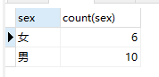

1. 查询姓“张”的学生名单；

select * from student where student_name like '张%';

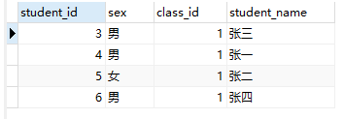

1. 课程平均分从高到低显示

select sc.subject_id, avg(score) from score sc group by sc.subject_id order by avg(score) desc;

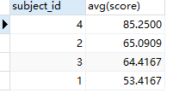

1. 查询有课程成绩小于60分的同学的学号、姓名；

select distinct stu.student_id, stu.student_name from student stu, score sc where stu.student_id = sc.student_id and sc.score < 60;

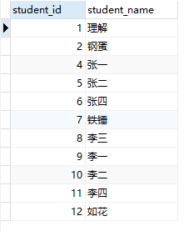

1. 查询至少有一门课与学号为1的同学所学课程相同的同学的学号和姓名；

select stu.student_id, stu.student_name from student stu where stu.student_id in (select distinct sc.student_id from score sc where sc.subject_id in (select sc1.subject_id from score sc1 where sc1.student_id = 1))

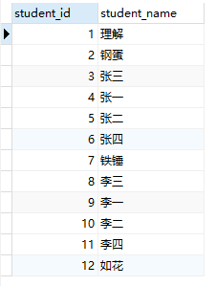

1. 查询出只选修了一门课程的全部学生的学号和姓名；

select student_id,student_name from student where student_id in (select student_id from score group by student_id having count(student_id) =1);



1. 查询各科成绩最高和最低的分：以如下形式显示：课程ID，最高分，最低分；

select subject_id, max(score), min(score) from score group by subject_id;

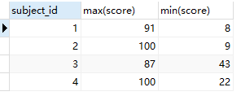

1. 查询课程编号“2”的成绩比课程编号“1”课程低的所有同学的学号、姓名；

select stu.student_id, stu.student_name from student stu where (select sc.score from score sc where sc.student_id = stu.student_id and sc.subject_id = 2) < (select sc1.score from score sc1 where sc1.student_id = stu.student_id and sc1.subject_id = 1);

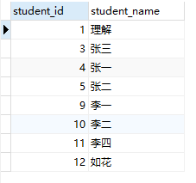

1. 查询“生物”课程比“物理”课程成绩高的所有学生的学号；

select stu.student_id from student stu where (select sc.score from score sc,subject sub where sc.subject_id = sub.subject_id and sub.subject_name = '生物' and stu.student_id = sc.student_id) > (select sc.score from score sc,subject sub where sc.subject_id = sub.subject_id and sub.subject_name = '物理' and stu.student_id = sc.student_id)

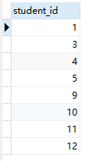

1. 查询平均成绩大于60分的同学的学号和平均成绩;

select sc.student_id, avg(sc.score) from score sc group by sc.student_id having avg(sc.score) > 60

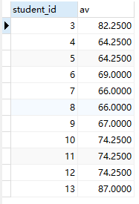

1. 查询所有同学的学号、姓名、选课数、总成绩；

select stu.student_id, stu.student_name, count(sc.subject_id), sum(sc.score) from student stu left join score sc on stu.student_id = sc.student_id group by stu.student_id;

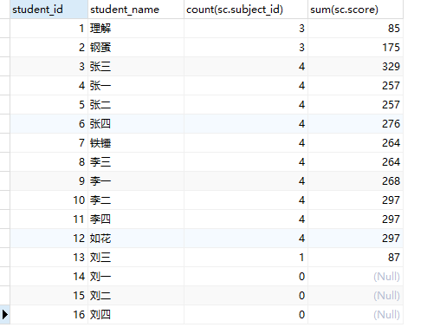

1. 查询姓“李”的老师的个数；

select count(*) from teacher where teacher_name like '李%';



1. 查询没学过“张磊老师”课的同学的学号、姓名；

select stu.student_id,stu.student_name from student stu where stu.student_id not in (select sc.student_id from score sc where sc.subject_id in (select sub.subject_id from subject sub where sub.teacher_id in (select tea.teacher_id from teacher tea where tea.teacher_name = '张磊老师')));

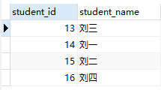

1. 查询学过“1”并且也学过编号“2”课程的同学的学号、姓名；

select stu.student_id,stu.student_name from student stu left join (select sc.student_id,sc.subject_id from score sc where sc.subject_id = 1 or sc.subject_id = 2) temp on temp.student_id = stu.student_id group by stu.student_id having count(stu.student_id) > 1

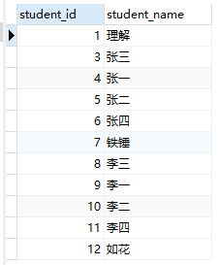

1. 查询学过“李平老师”所教的所有课的同学的学号、姓名；

select stu.student_id,stu.student_name from student stu where stu.student_id in (select sc.student_id from score sc where sc.subject_id in (select sub.subject_id from subject sub where sub.teacher_id in (select tea.teacher_id from teacher tea where tea.teacher_name = '李平老师')) group by student_id having count(stu.student_id) = ((select count(sub.subject_id) from subject sub where sub.teacher_id in (select tea.teacher_id from teacher tea where tea.teacher_name = '李平老师'))));

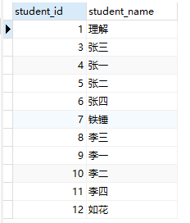

1. 查询没有学全所有课的同学的学号、姓名；

select stu.student_id, stu.student_name from student stu where (select count(sc.subject_id) from score sc where stu.student_id = sc.student_id group by sc.student_id) < (select count(subject_id) from subject);

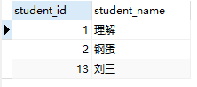

1. 查询和“002”号的同学学习的课程完全相同的其他同学学号和姓名；

select student_id from score where student_id not in (select student_id from score where subject_id not in (select subject_id from score where student_id=2)) and student_id !=2 group by student_id having count(subject_id)= (select count(subject_id) from score where student_id = 2);



20.按平均成绩从低到高显示所有学生的“语文”、“数学”、“英语”三门的课程成绩，按如下形式显示： 学生ID,语文,数学,英语,有效课程数,有效平均分；

select stu.student_id '学生ID',t2.score '物理',t1.score '生物', t3.score '体育',t4.score '美术',t5.count_subject '有效课程数',t5.avg_score '有效平均分' from student stu left join (select sc.student_id, sc.score from score sc, subject sub where sc.subject_id = sub.subject_id and sub.subject_name = '生物') t1 on stu.student_id = t1.student_id left join (select sc.student_id, sc.score from score sc, subject sub where sc.subject_id = sub.subject_id and sub.subject_name = '物理') t2 on stu.student_id = t2.student_id left join (select sc.student_id, sc.score from score sc, subject sub where sc.subject_id = sub.subject_id and sub.subject_name = '体育') t3 on stu.student_id = t3.student_id left join (select sc.student_id, sc.score from score sc, subject sub where sc.subject_id = sub.subject_id and sub.subject_name = '美术') t4 on stu.student_id = t4.student_id left join (select sc.student_id, count(sc.subject_id) count_subject, avg(sc.score) avg_score from score sc group by sc.student_id) t5 on stu.student_id = t5.student_id;

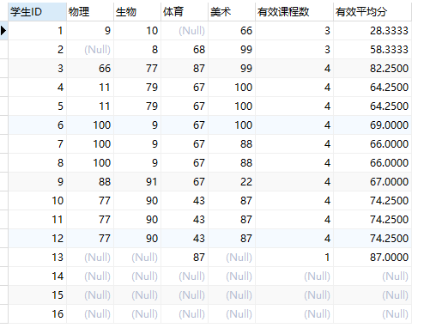

21.查询各科成绩最高和最低的分：以如下形式显示：课程ID，最高分，最低分；

select sc.subject_id, max(sc.score), min(sc.score) from score sc group by sc.subject_id;

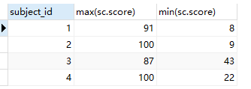

22.按各科平均成绩从低到高和及格率的百分数从高到低顺序；

select t1.subject_id, (count_stu1 / count_stu2) pass, avg_score from

(select sc.subject_id, sc.student_id, count(sc.student_id) count_stu1 from score sc where sc.score > 60 group by sc.subject_id) t1, (select sc.subject_id, avg(sc.score) avg_score, count(sc.student_id) count_stu2 from score sc group by sc.subject_id) t2 where t1.subject_id = t2.subject_id order by avg_score asc, pass desc;

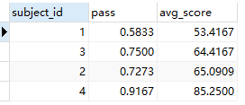

23.查询各科成绩前三名的记录:(不考虑成绩并列情况)

select t1.student_id,t1.subject_id, t1.score from score t1 left join (select score_id,subject_id, (select score from score as s2 where s2.subject_id = s1.subject_id order by score desc limit 0, 1) as first_num,(select score from score as s2 where s2.subject_id = s1.subject_id order by score desc limit 1, 1) as second_num,(select score from score as s2 where s2.subject_id = s1.subject_id order by score desc limit 2, 1) as third_num from score as s1) t2 on t1.score_id = t2.score_id where t1.score = t2.first_num or t1.score = t2.second_num or t1.score = t2.third_num;

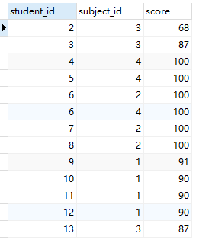

24.查询每门课程被选修的学生数；

select sc.subject_id, count(sc.subject_id) cnt from score sc group by sc.subject_id

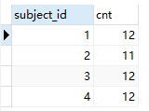

25.查询同名同姓学生名单，并统计同名人数；

select stu.student_name,count(stu.student_name) from student stu group by stu.student_name having count(stu.student_name) > 1;



26.查询每门课程的平均成绩，结果按平均成绩升序排列，平均成绩相同时，按课程号降序排列；

select sc.subject_id, avg(sc.score) from score sc group by sc.subject_id order by avg(sc.score), sc.subject_id desc;

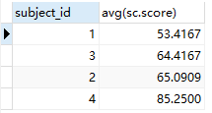

27.查询平均成绩大于85的所有学生的学号. 姓名和平均成绩；

select stu.student_id, stu.student_name, temp.average from student stu, (select sc.student_id, avg(sc.score) average from score sc group by sc.student_id having average > 85) temp where stu.student_id = temp.student_id;



28.查询课程名称为“生物”，且分数低于60的学生姓名和分数；

select stu.student_name, temp.score from student stu, (select sc.student_id, sc.score from score sc, subject sub where sc.subject_id = sub.subject_id and sub.subject_name = '生物' and sc.score < 60) temp where stu.student_id = temp.student_id;

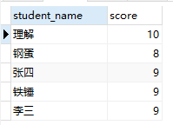

29.查询课程编号为003且课程成绩在80分以上的学生的学号和姓名；

select stu.student_id, stu.student_name from student stu where stu.student_id in (select sc.student_id from score sc where sc.subject_id = 3 and sc.score > 80);

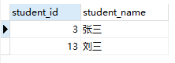

30.求选了课程的学生人数

select count(stu.student_id) from student stu, (select sc.student_id, count(sc.subject_id) cnt from score sc group by sc.student_id having cnt >= 1) temp where stu.student_id = temp.student_id;



31.查询选修“杨艳”老师所授课程的学生中，成绩最高的学生姓名及其成绩；

select stu.student_name, t1.score from (select distinct student_id, score from score where score = (select max(score) from score where subject_id in (select subject_id from subject where teacher_id = (select teacher_id from teacher where teacher_name = '李平老师')))) t1 left join student stu on t1.student_id = stu.student_id;

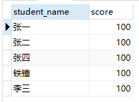

32.查询各个课程及相应的选修人数；

select sub.subject_name, temp.cnt '人数' from subject sub, (select sc.subject_id, count(sc.subject_id) cnt from score sc group by sc.subject_id) temp where sub.subject_id = temp.subject_id;

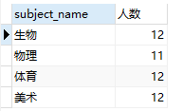

33.查询不同课程但成绩相同的学生的学号、课程号、学生成绩；

select distinct t1.subject_id, t2.subject_id, t1.score, t2.score from score t1, score t2 where t1.score = t2.score and t1.subject_id != t2.subject_id;

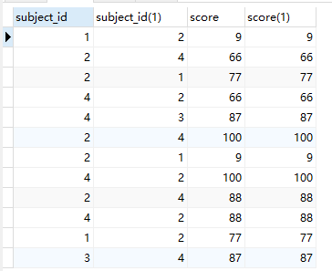

34.查询每门课程成绩最好的前两名；

select t1.student_id,t1.subject_id,t1.score from score t1

left join(select score_id,subject_id,(select score from score as s2 where s2.subject_id = s1.subject_id order by score desc limit 0, 1) as first_num,(select score from score as s2 where s2.subject_id = s1.subject_id order by score desc limit 1, 1) as second_num from score as s1) t2 on t1.score_id = t2.score_id where t1.score = t2.first_num or t1.score = t2.second_num ;

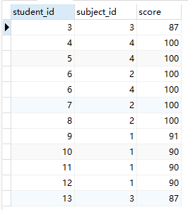

35.检索至少选修两门课程的学生学号；

select sc.student_id from score sc group by sc.student_id having count(sc.subject_id) >= 2;

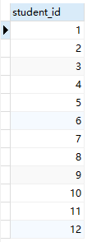

36.查询全部学生都选修的课程的课程号和课程名；

select subject_id, subject_name from subject where subject_id in (select subject_id from score group by subject_id having count(student_id) = (select count(student_id) from student));



37.查询没学过“叶平”老师讲授的任一门课程的学生姓名；

select stu.student_id, stu.student_name from student stu where stu.student_id not in (select distinct sc.student_id from score sc where sc.subject_id in(select sub.subject_id from subject sub, teacher tea where sub.teacher_id = tea.teacher_id and tea.teacher_name = '李平老师'))

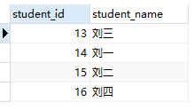

38.查询两门以上不及格课程的同学的学号及其平均成绩；

select student_id,avg(score) from score where score< 60 group by student_id having count(score) >= 2;



39.检索“004”课程分数小于60，按分数降序排列的同学学号；

select student_id from score where subject_id = 4 and score < 60 order by score desc;



40.删除“002”同学的“001”课程的成绩；

delete from score where student_id = 2 and subject_id = 1;