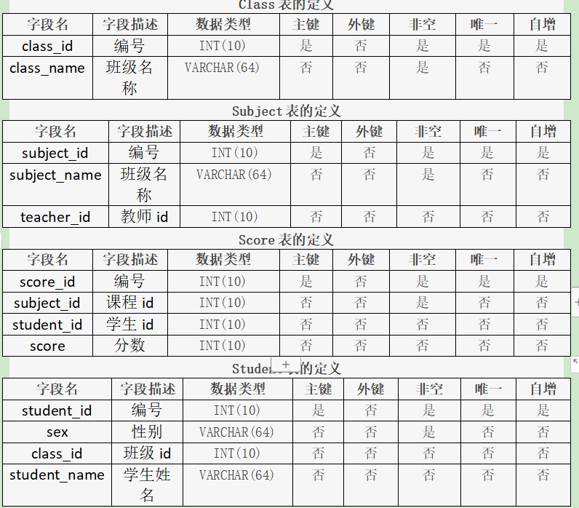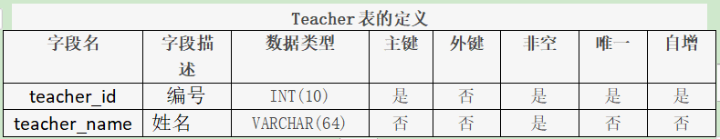

数据准备:

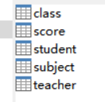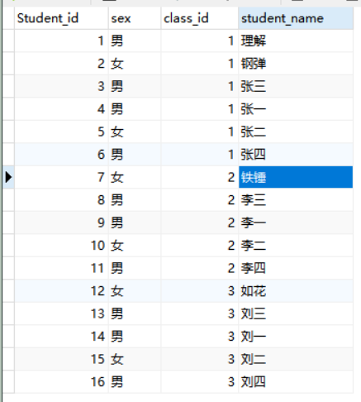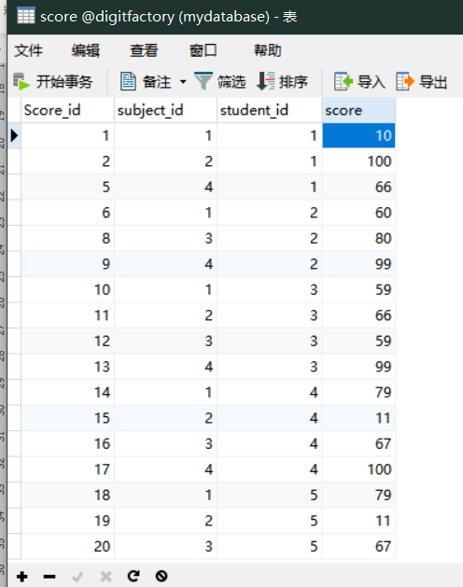

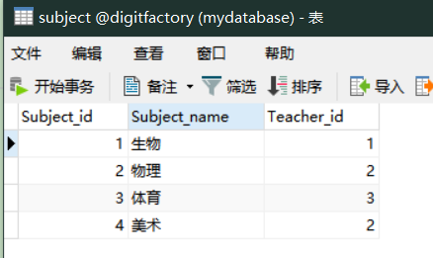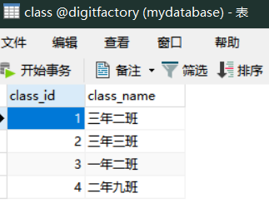

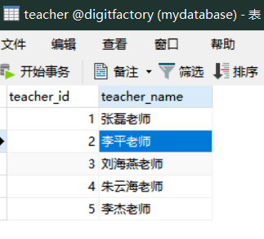

1. 查询男生、女生的人数；

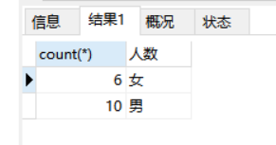

SELECT count(*),sex '人数' from student

GROUP BY sex ;

1. 查询姓“张”的学生名单；

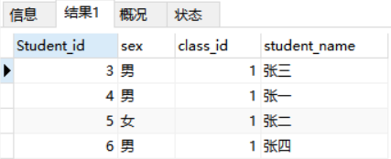

-- SELECT * from student

-- where student_name LIKE '张%'

1. 课程平均分从高到低显示

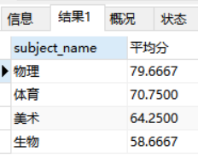

-- SELECT

-- su.subject_name,

-- AVG(sc.score) as '平均分'

-- from subject su,score sc

-- where su.subject_id = sc.student_id

-- group by su.subject_name

-- order by 平均分 desc;

1. 查询有课程成绩小于60分的同学的学号、姓名；

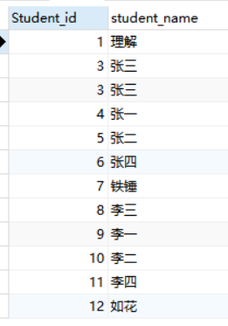

SELECT

st.Student_id,st.student_name

from

student st,score sc

Where

st.Student_id = sc.student_id and sc.score<60

1. 查询至少有一门课与学号为1的同学所学课程相同的同学的学号和姓名；

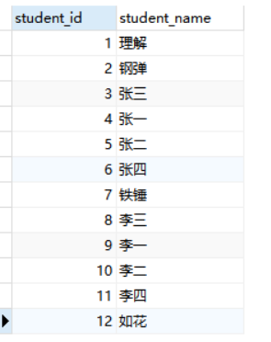

SELECT

student_id,

student_name

FROM

student

WHERE

student_id IN (

SELECT DISTINCT

student_id

FROM

score

WHERE

subject_id IN (

SELECT

subject_id

FROM

score

WHERE

student_id = 1

)

);

1. 查询出只选修了一门课程的全部学生的学号和姓名；

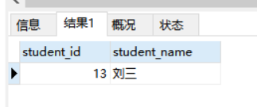

SELECT

student_id,

student_name

FROM

student

WHERE

student_id IN (

SELECT

student_id

FROM

score

GROUP BY

student_id

HAVING

count(student_id) = 1

);

1. 查询各科成绩最高和最低的分：以如下形式显示：课程ID，最高分，最低分；

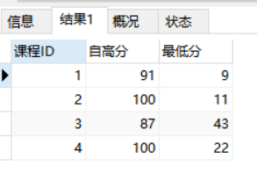

select

subject.subject_id '课程ID',

max(score) '自高分',

min(score) '最低分'

from subject,score

where score.subject_id = subject.subject_id

group by score.subject_id

1. 查询课程编号“2”的成绩比课程编号“1”课程低的所有同学的学号、姓名；

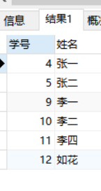

select DISTINCT

student.Student_id '学号',

student.student_name '姓名'

from student,score sc

where

student.Student_id = sc.student_id

AND

(select score from score where student.Student_id = score.student_id

and score.subject_id = 2)

<(select score from score where student.Student_id = score.student_id

and score.subject_id = 1)

1. 查询“生物”课程比“物理”课程成绩高的所有学生的学号；

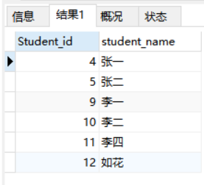

select DISTINCT

st.Student_id,st.student_name

from

subject su,student st,score sc

where

st.student_id = sc.student_id

and

sc.subject_id = su.subject_id

AND

(select sc_2.score from score sc_2,subject su_2 where sc_2.student_id = sc.student_id

and su_2.subject_name = '生物' and su_2.subject_id = sc_2.subject_id )

>

(select sc_2.score from score sc_2,subject su_2 where sc_2.student_id = sc.student_id

and su_2.subject_name = '物理' and su_2.subject_id = sc_2.subject_id )

1. 查询平均成绩大于60分的同学的学号和平均成绩;

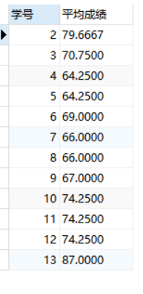

select

st.Student_id '学号',

avg(sc.score) as '平均成绩'

from

student st,score sc

where st.student_id = sc.student_id

group by st.student_id

having 平均成绩 >60

1. 查询所有同学的学号、姓名、选课数、总成绩；

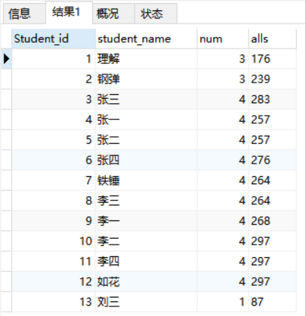

SELECT DISTINCT

st.Student_id,st.student_name,

kec.num,

allscore.alls

FROM

student st,subject su,

score sc,

(select count(*) as num,sc_2.student_id as st_a from score sc_2

group by sc_2.student_id

) kec,

(select SUM(sc_3.score) as alls,sc_3.student_id as st_b from score sc_3

group by sc_3.student_id

)allscore

where

st.Student_id = sc.student_id

AND

sc.subject_id = su.subject_id

and

kec.st_a = st.Student_id

AND

allscore.st_b = st.Student_id

1. 查询姓“李”的老师的个数；

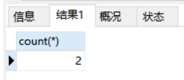

SELECT count(*) from teacher

where teacher_name like '李%'

1. 查询没学过“张磊老师”课的同学的学号、姓名；

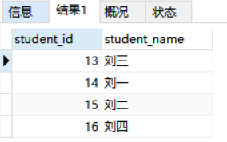

select DISTINCT

st.Student_id '学号',

st.student_name '姓名'

FROM

student st,score sc,subject su,teacher te

-- LEFT JOIN on student

where

st.Student_id = sc.student_id

AND

(

select count(*) from

score sc_1,

subject su_1,

teacher te_1

where sc_1.subject_id = su_1.subject_id

and su_1.teacher_id = te_1.teacher_id

and te_1.teacher_name = '张磊老师'

and sc_1.student_id = st.student_id

and sc_1.student_id = sc.student_id

)=0

AND

sc.subject_id = su.subject_id

AND

su.teacher_id = te.teacher_id;

1. 查询学过“1”并且也学过编号“2”课程的同学的学号、姓名；

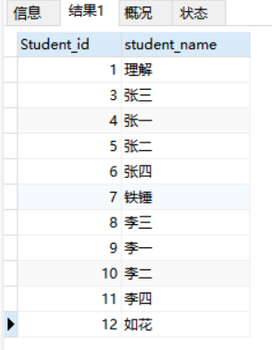

select DISTINCT

st.Student_id,st.student_name

from

student st,score sc

WHERE

sc.student_id = st.Student_id

AND

(select count(*) from score sc_2 WHERE

sc_2.subject_id = 1

and sc_2.student_id = sc.student_id) >0

AND

(select count(*) from score sc_2 WHERE

sc_2.subject_id = 2

and sc_2.student_id = sc.student_id) >0

1. 查询学过“李平老师”所教的所有课的同学的学号、姓名；

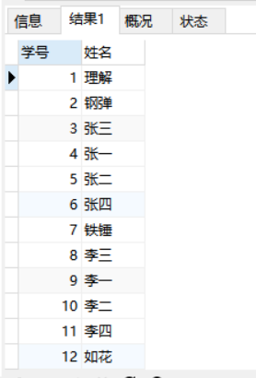

select DISTINCT

st.Student_id '学号',

st.student_name '姓名'

FROM

student st,score sc,subject su,teacher te

where

st.Student_id = sc.student_id

AND

(

select count(*) from

score sc_1,

subject su_1,

teacher te_1

where sc_1.subject_id = su_1.subject_id

and su_1.teacher_id = te_1.teacher_id

and te_1.teacher_name = '李平老师'

and sc_1.student_id = st.student_id

and sc_1.student_id = sc.student_id

)>0

AND

sc.subject_id = su.subject_id

AND

su.teacher_id = te.teacher_id;

1. 查询没有学全所有课的同学的学号、姓名；

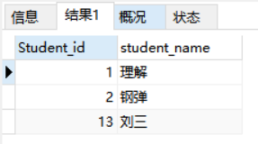

select DISTINCT

st.Student_id,st.student_name

from

student st,

score sc,

subject su

WHERE

st.Student_id = sc.student_id

AND

(select count(*) from score sc_2

where

sc_2.student_id = st.Student_id

)

<>

(SELECT count(*) from subject)

1. 查询和“002”号的同学学习的课程完全相同的其他同学学号和姓名；

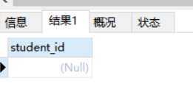

SELECT

student_id

FROM

score

WHERE

student_id NOT IN (

SELECT

student_id

FROM

score

WHERE

subject_id NOT IN (

SELECT

subject_id

FROM

score

WHERE

student_id = 2

)

)

AND student_id <> 2

GROUP BY

student_id

HAVING

count(subject_id) = (

SELECT

count(subject_id)

FROM

score

WHERE

student_id = 2

);

1. 删除学习“叶平”老师课的SC表记录；

DELETE

FROM

score

WHERE

subject_id IN (

SELECT

su.subject_id

FROM

SUBJECT su,

teacher te

WHERE

te.teacher_name = '李平老师'

AND su.teacher_id = te.teacher_id

)

1. 向SC表中插入一些记录，这些记录要求符合以下条件：①没有上过编号“002”课程的同学学号；②插入“002”号课程的平均成绩；

INSERT INTO score (

subject_id,

student_id,

score

) SELECT DISTINCT

'2',

sc.Student_id,

(

SELECT

AVG(sc_.score)

FROM

score sc_

WHERE

sc_.subject_id =3

)

FROM

score sc

WHERE

sc.student_id NOT IN (

SELECT DISTINCT

sc_2.student_id

FROM

score sc_2

WHERE

sc_2.subject_id =2

)

1. 按平均成绩从低到高显示所有学生的“语文”、“数学”、“英语”三门的课程成绩，按如下形式显示： 学生ID,语文,数学,英语,有效课程数,有效平均分；

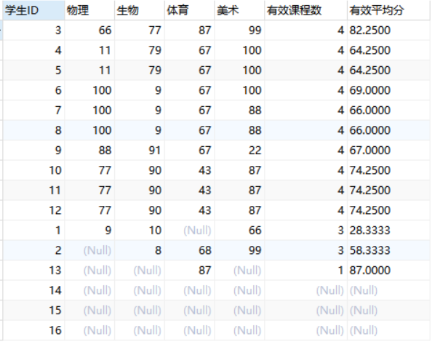

SELECT DISTINCT

sc.student_id,

(select score from score sc_A,subject su_A where sc.student_id = sc_A.student_id and sc_A.subject_id = su_A.subject_id

and su_A.subject_name='生物') '生物',

(select score from score sc_A,subject su_A where sc.student_id = sc_A.student_id and sc_A.subject_id = su_A.subject_id

and su_A.subject_name='物理') '物理',

(select score from score sc_A,subject su_A where sc.student_id = sc_A.student_id and sc_A.subject_id = su_A.subject_id

and su_A.subject_name='体育') '体育',

(select score from score sc_A,subject su_A where sc.student_id = sc_A.student_id and sc_A.subject_id = su_A.subject_id

and su_A.subject_name='美术') '美术',

(select count(*) from score sc_b where sc_b.score>=60 AND sc_b.student_id = sc.student_id) '有效课程数',

(select avg(sc_c.score) from score sc_c where sc_c.score>=60 AND sc_c.student_id = sc.student_id) '有效平均分'

FROM

subject su,score sc,student st

where st.student_id = sc.student_id

1. 查询各科成绩最高和最低的分：以如下形式显示：课程ID，最高分，最低分；

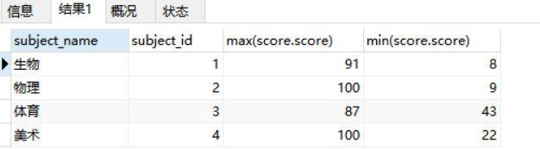

select

subject.subject_name,

score.subject_id,

max(score.score),

min(score.score)

FROM

score,subject

WHERE

subject.subject_id = score.subject_id

group by score.subject_id

1. 按各科平均成绩从低到高和及格率的百分数从高到低顺序；

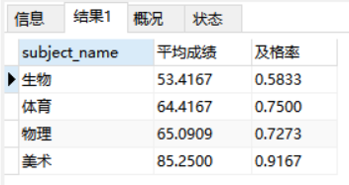

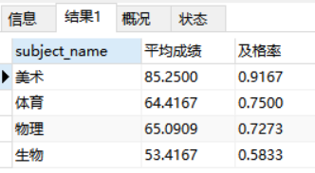

select

su.subject_name,

avg(score.score) '平均成绩',

(select count(*) from score where score.subject_id = su.subject_id and score.score>=60)/

(select count(*) from score where score.subject_id = su.subject_id)

'及格率'

FROM

score, subject su

where

score.subject_id = su.subject_id

group by score.subject_id

order by 平均成绩 asc ,及格率 desc

1. 查询各科成绩前三名的记录:(不考虑成绩并列情况)

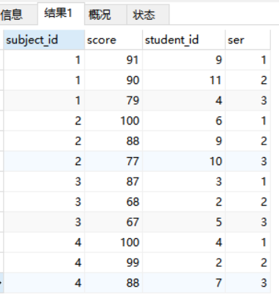

SELECT

sc_1.subject_id,

sc_1.score,

sc_1.student_id,

count(DISTINCT sc_2.score) AS ser

FROM

score AS sc_1

INNER JOIN score AS sc_2 ON sc_1.subject_id = sc_2.subject_id

AND sc_1.score <= sc_2.score

GROUP BY

sc_1.subject_id,

sc_1.score

HAVING

ser <= 3

ORDER BY

subject_id,

score DESC

1. 查询每门课程被选修的学生数；

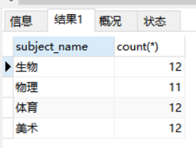

select

su.subject_name,count(*)

FROM

score sc,subject su

where

sc.subject_id = su.subject_id

group by

sc.subject_id

25.查询同名同姓学生名单，并统计同名人数；

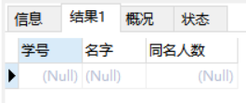

修改数据，使得存在同名学生

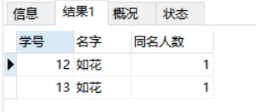

select DISTINCT

st.Student_id '学号',st.student_name '名字',

(select count(*) from student st_1 where st_1.student_name = st.student_name)-1 '同名人数'

FROM

student st

INNER JOIN

student st2

ON st.student_name = st2.student_name AND (select count(*)

from student st_1 where st_1.student_name = st.student_name)>1

1. 查询每门课程的平均成绩，结果按平均成绩升序排列，平均成绩相同时，按课程号降序排列；

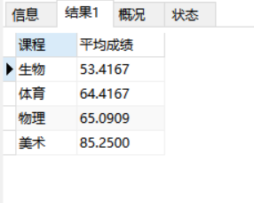

select

su.subject_name '课程',avg(sc.score) '平均成绩'

FROM

score sc,subject su

WHERE

su.subject_id = sc.subject_id

group by

sc.subject_id

order by 平均成绩 asc

27.查询平均成绩大于85的所有学生的学号. 姓名和平均成绩；

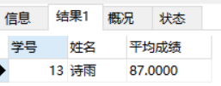

select

su.subject_name '课程',avg(sc.score) '平均成绩'

FROM

score sc,subject su

WHERE

su.subject_id = sc.subject_id

group by

sc.subject_id

order by 平均成绩 asc

1. 查询课程名称为“数学”，且分数低于60的学生姓名和分数；

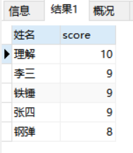

select

st.student_name '姓名',

sc.score

FROM

subject su,score sc,student st

where

st.student_id = sc.student_id

and

sc.subject_id = su.subject_id

and

su.subject_name = '生物'

and

sc.score <60

order by sc.score desc

1. 查询课程编号为003且课程成绩在80分以上的学生的学号和姓名；

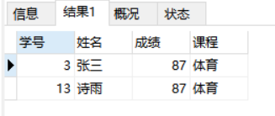

select

st.Student_id '学号',

st.student_name '姓名',

sc.score '成绩',

su.subject_name '课程'

FROM

student st,score sc,subject su

where

st.Student_id = sc.student_id

and

su.subject_id = sc.subject_id

and

sc.subject_id = 3

AND

sc.score>80

1. 求选了课程的学生人数

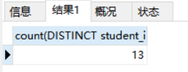

select DISTINCT

count(DISTINCT student_id)

from

score sc_1

where

(select count(*) from score sc_3 where

sc_1.student_id = sc_3.student_id

)>0

1. 查询选修“杨艳”老师所授课程的学生中，成绩最高的学生姓名及其成绩；

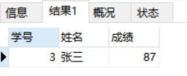

select

st.student_id '学号',

st.student_name '姓名',

sc.score '成绩'

from

student st,score sc,teacher te,subject su

WHERE

st.student_id = sc.student_id

and

sc.subject_id = su.subject_id

and

su.teacher_id = te.teacher_id

and

te.teacher_name = '刘海燕老师'

group by

sc.student_id

order by 成绩 DESC

limit 0,1

1. 查询各个课程及相应的选修人数；

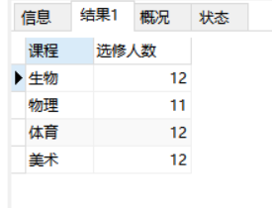

select

su.subject_name '课程',

count(*) '选修人数'

from

subject su,score sc

WHERE

su.subject_id = sc.subject_id

group by sc.subject_id

1. 查询不同课程但成绩相同的学生的学号、课程号、学生成绩；

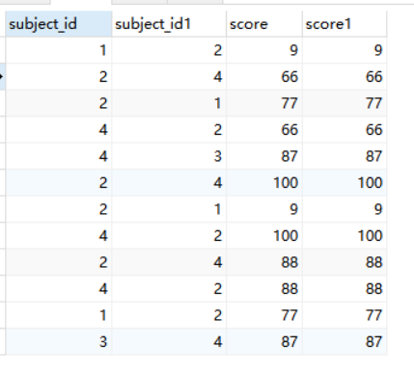

SELECT DISTINCT

s1.subject_id,

s2.subject_id,

s1.score,

s2.score

FROM

score AS s1,

score AS s2

WHERE

s1.score = s2.score

AND s1.subject_id != s2.subject_id;

1. 查询每门课程成绩最好的前两名；

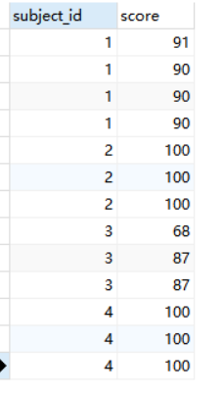

SELECT

subject_id,score

FROM

score sc1

WHERE

(SELECT

COUNT(*)

FROM

score sc2

WHERE

sc1.score<sc2.score

AND

sc1.subject_id=sc2.subject_id

)<3

ORDER BY subject_id

1. 检索至少选修两门课程的学生学号；

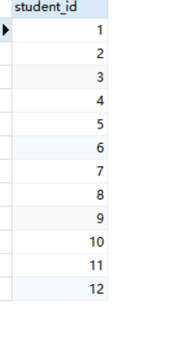

select DISTINCT

sc.student_id

FROM

student st,score sc,

(select DISTINCT sc_A.student_id as id from score sc_A where (select count(*) from score sc_B where

sc_A.student_id = sc_B.student_id)>=2) result

WHERE

result.id = sc.student_id

AND

sc.student_id = st.Student_id

1. 查询全部学生都选修的课程的课程号和课程名；

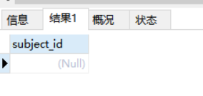

SELECT

subject_id

FROM

score

GROUP BY

subject_id

HAVING

count(student_id) = (

SELECT

count(student_id)

FROM

student

);

1. 查询没学过“叶平”老师讲授的任一门课程的学生姓名；

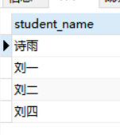

SELECT

student_name

FROM

student

WHERE

student_id NOT IN (

SELECT DISTINCT

student_id

FROM

score

WHERE

subject_id IN (

SELECT

subject_id

FROM

`subject`

WHERE

teacher_id IN (

SELECT

teacher_id

FROM

teacher

WHERE

teacher_name = '李平老师'

)

)

);

1. 查询两门以上不及格课程的同学的学号及其平均成绩；

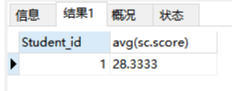

select

st.Student_id,

avg(sc.score)

from

score sc,student st

where

(select count(*) from score sc_A where sc_A.student_id=sc.student_id and sc_A.score <60)>=2

and

st.Student_id = sc.student_id

group by sc.student_id

1. 检索“004”课程分数小于60，按分数降序排列的同学学号；

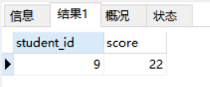

select

sc.student_id ,

sc.score

from

score sc,subject su

WHERE

sc.subject_id = su.subject_id

and

su.subject_id = 4

AND

sc.score<60

order by sc.score desc

40.删除“002”同学的“001”课程的成绩；

delete from score sc where

sc.student_id = 2

AND

sc.subject_id = 1