Mysql练习题

**Class表的定义**

|  |  |  |  |  |  |  |  |
| --- | --- | --- | --- | --- | --- | --- | --- |
| **字段名** | **字段描述** | **数据类型** | **主键** | **外键** | **非空** | **唯一** | **自增** |
| class_id | 编号 | INT(10) | 是 | 否 | 是 | 是 | 是 |
| class_name | 班级名称 | VARCHAR(64) | 否 | 否 | 是 | 否 | 否 |

INSERT INTO `class` VALUES ('1', '三年二班'), ('2', '三年三班'), ('3', '一年二班'), ('4', '二年九班');

**Subject表的定义**

|  |  |  |  |  |  |  |  |
| --- | --- | --- | --- | --- | --- | --- | --- |
| **字段名** | **字段描述** | **数据类型** | **主键** | **外键** | **非空** | **唯一** | **自增** |
| subject_id | 编号 | INT(10) | 是 | 否 | 是 | 是 | 是 |
| subject_name | 班级名称 | VARCHAR(64) | 否 | 否 | 是 | 否 | 否 |
| teacher_id | 教师id | INT(10) | 否 | 否 | 否 | 否 | 否 |

INSERT INTO `course` VALUES ('1', '生物', '1'), ('2', '物理', '2'), ('3', '体育', '3'), ('4', '美术', '2');

**Score表的定义**

|  |  |  |  |  |  |  |  |
| --- | --- | --- | --- | --- | --- | --- | --- |
| **字段名** | **字段描述** | **数据类型** | **主键** | **外键** | **非空** | **唯一** | **自增** |
| score_id | 编号 | INT(10) | 是 | 否 | 是 | 是 | 是 |
| subject_id | 课程id | INT(10) | 否 | 否 | 是 | 否 | 否 |
| student_id | 学生id | INT(10) | 否 | 否 | 否 | 否 | 否 |
| score | 分数 | INT(10) | 否 | 否 | 否 | 否 | 否 |

INSERT INTO `score` VALUES ('1', '1', '1', '10'), ('2', '1', '2', '9'), ('5', '1', '4', '66'), ('6', '2', '1', '8'), ('8', '2', '3', '68'), ('9', '2', '4', '99'), ('10', '3', '1', '77'), ('11', '3', '2', '66'), ('12', '3', '3', '87'), ('13', '3', '4', '99'), ('14', '4', '1', '79'), ('15', '4', '2', '11'), ('16', '4', '3', '67'), ('17', '4', '4', '100'), ('18', '5', '1', '79'), ('19', '5', '2', '11'), ('20', '5', '3', '67'), ('21', '5', '4', '100'), ('22', '6', '1', '9'), ('23', '6', '2', '100'), ('24', '6', '3', '67'), ('25', '6', '4', '100'), ('26', '7', '1', '9'), ('27', '7', '2', '100'), ('28', '7', '3', '67'), ('29', '7', '4', '88'), ('30', '8', '1', '9'), ('31', '8', '2', '100'), ('32', '8', '3', '67'), ('33', '8', '4', '88'), ('34', '9', '1', '91'), ('35', '9', '2', '88'), ('36', '9', '3', '67'), ('37', '9', '4', '22'), ('38', '10', '1', '90'), ('39', '10', '2', '77'), ('40', '10', '3', '43'), ('41', '10', '4', '87'), ('42', '11', '1', '90'), ('43', '11', '2', '77'), ('44', '11', '3', '43'), ('45', '11', '4', '87'), ('46', '12', '1', '90'), ('47', '12', '2', '77'), ('48', '12', '3', '43'), ('49', '12', '4', '87'), ('52', '13', '3', '87');

**Student表的定义**

|  |  |  |  |  |  |  |  |
| --- | --- | --- | --- | --- | --- | --- | --- |
| **字段名** | **字段描述** | **数据类型** | **主键** | **外键** | **非空** | **唯一** | **自增** |
| student_id | 编号 | INT(10) | 是 | 否 | 是 | 是 | 是 |
| sex | 性别 | VARCHAR(64) | 否 | 否 | 是 | 否 | 否 |
| class_id | 班级id | INT(10) | 否 | 否 | 否 | 否 | 否 |
| student_name | 学生姓名 | VARCHAR(64) | 否 | 否 | 否 | 否 | 否 |

INSERT INTO `student` VALUES ('1', '男', '1', '理解'), ('2', '女', '1', '钢蛋'), ('3', '男', '1', '张三'), ('4', '男', '1', '张一'), ('5', '女', '1', '张二'), ('6', '男', '1', '张四'), ('7', '女', '2', '铁锤'), ('8', '男', '2', '李三'), ('9', '男', '2', '李一'), ('10', '女', '2', '李二'), ('11', '男', '2', '李四'), ('12', '女', '3', '如花'), ('13', '男', '3', '刘三'), ('14', '男', '3', '刘一'), ('15', '女', '3', '刘二'), ('16', '男', '3', '刘四');

**Teacher表的定义**

|  |  |  |  |  |  |  |  |
| --- | --- | --- | --- | --- | --- | --- | --- |
| **字段名** | **字段描述** | **数据类型** | **主键** | **外键** | **非空** | **唯一** | **自增** |
| teacher_id | 编号 | INT(10) | 是 | 否 | 是 | 是 | 是 |
| teacher_name | 姓名 | VARCHAR(64) | 否 | 否 | 是 | 否 | 否 |

INSERT INTO `teacher` VALUES ('1', '张磊老师'), ('2', '李平老师'), ('3', '刘海燕老师'), ('4', '朱云海老师'), ('5', '李杰老师');

1.查询男生、女生的人数；

2.查询姓“张”的学生名单；

3.课程平均分从高到低显示

4.查询有课程成绩小于60分的同学的学号、姓名；

5.查询至少有一门课与学号为1的同学所学课程相同的同学的学号和姓名；

6.查询出只选修了一门课程的全部学生的学号和姓名；

7.查询各科成绩最高和最低的分：以如下形式显示：课程ID，最高分，最低分；

8.查询课程编号“2”的成绩比课程编号“1”课程低的所有同学的学号、姓名；

9.查询“生物”课程比“物理”课程成绩高的所有学生的学号；

10.查询平均成绩大于60分的同学的学号和平均成绩;

11.查询所有同学的学号、姓名、选课数、总成绩；

12.查询姓“李”的老师的个数；

13.查询没学过“张磊老师”课的同学的学号、姓名；

14.查询学过“1”并且也学过编号“2”课程的同学的学号、姓名；

15.查询学过“李平老师”所教的所有课的同学的学号、姓名；

16.查询没有学全所有课的同学的学号、姓名；

17.查询和“002”号的同学学习的课程完全相同的其他同学学号和姓名；

18.删除学习“叶平”老师课的SC表记录；

19.向SC表中插入一些记录，这些记录要求符合以下条件：①没有上过编号“002”课程的同学学号；②插入“002”号课程的平均成绩；

20.按平均成绩从低到高显示所有学生的“语文”、“数学”、“英语”三门的课程成绩，按如下形式显示： 学生ID,语文,数学,英语,有效课程数,有效平均分；

21.查询各科成绩最高和最低的分：以如下形式显示：课程ID，最高分，最低分；

22.按各科平均成绩从低到高和及格率的百分数从高到低顺序；

23.查询各科成绩前三名的记录:(不考虑成绩并列情况)

24.查询每门课程被选修的学生数；

25.查询同名同姓学生名单，并统计同名人数；

26.查询每门课程的平均成绩，结果按平均成绩升序排列，平均成绩相同时，按课程号降序排列；

27.查询平均成绩大于85的所有学生的学号. 姓名和平均成绩；

28.查询课程名称为“数学”，且分数低于60的学生姓名和分数；

29.查询课程编号为003且课程成绩在80分以上的学生的学号和姓名；

30.求选了课程的学生人数

31.查询选修“杨艳”老师所授课程的学生中，成绩最高的学生姓名及其成绩；

32.查询各个课程及相应的选修人数；

33.查询不同课程但成绩相同的学生的学号、课程号、学生成绩；

34.查询每门课程成绩最好的前两名；

35.检索至少选修两门课程的学生学号；

36.查询全部学生都选修的课程的课程号和课程名；

37.查询没学过“叶平”老师讲授的任一门课程的学生姓名；

38.查询两门以上不及格课程的同学的学号及其平均成绩；

39.检索“004”课程分数小于60，按分数降序排列的同学学号；

40.删除“002”同学的“001”课程的成绩；

CREATE TABLE class(

class_id INT(10) AUTO_INCREMENT NOT NULL,

class_name VARCHAR(64) not null,

primary key (class_id)

);

alter table class convert to character set utf8;

INSERT INTO class (class_id,class_name)

VALUES ('1','三年二班'),

('2', '三年三班'),

('3', '一年二班'),

('4', '二年九班');

CREATE TABLE subject(

subject_id INT(10) AUTO_INCREMENT NOT NULL,

subject_name VARCHAR(64) not null,

teacher_id INT(10),

primary key (subject_id)

);

alter table subject convert to character set utf8;

INSERT INTO subject(subject_id,subject_name,teacher_id)

VALUES ('1', '生物', '1'),

('2', '物理', '2'),

('3', '体育', '3'),

('4', '美术', '2');

CREATE TABLE score_student(

score_id INT(10) AUTO_INCREMENT NOT NULL,

subject_id VARCHAR(64) not null,

student_id INT(10),

score int(10),

primary key (score_id)

);

alter table score_student convert to character set utf8;

INSERT INTO score_student(score_id,student_id,subject_id,score)VALUES ('1', '1', '1', '10'), ('2', '1', '2', '9'), ('5', '1', '4', '66'), ('6', '2', '1', '8'), ('8', '2', '3', '68'), ('9', '2', '4', '99'), ('10', '3', '1', '77'), ('11', '3', '2', '66'), ('12', '3', '3', '87'), ('13', '3', '4', '99'), ('14', '4', '1', '79'), ('15', '4', '2', '11'), ('16', '4', '3', '67'), ('17', '4', '4', '100'), ('18', '5', '1', '79'), ('19', '5', '2', '11'), ('20', '5', '3', '67'), ('21', '5', '4', '100'), ('22', '6', '1', '9'), ('23', '6', '2', '100'), ('24', '6', '3', '67'), ('25', '6', '4', '100'), ('26', '7', '1', '9'), ('27', '7', '2', '100'), ('28', '7', '3', '67'), ('29', '7', '4', '88'), ('30', '8', '1', '9'), ('31', '8', '2', '100'), ('32', '8', '3', '67'), ('33', '8', '4', '88'), ('34', '9', '1', '91'), ('35', '9', '2', '88'), ('36', '9', '3', '67'), ('37', '9', '4', '22'), ('38', '10', '1', '90'), ('39', '10', '2', '77'), ('40', '10', '3', '43'), ('41', '10', '4', '87'), ('42', '11', '1', '90'), ('43', '11', '2', '77'), ('44', '11', '3', '43'), ('45', '11', '4', '87'), ('46', '12', '1', '90'), ('47', '12', '2', '77'), ('48', '12', '3', '43'), ('49', '12', '4', '87'), ('52', '13', '3', '87'); .

CREATE TABLE student_a(

student_id INT(10) AUTO_INCREMENT NOT NULL,

sex VARCHAR(64) not null,

class_id INT(10),

student_name VARCHAR(64),

primary key (student_id)

);

alter table student_a convert to character set utf8;

insert INTO student_a (student_id,sex,class_id,student_name)

VALUES ('1', '男', '1', '理解'), ('2', '女', '1', '钢蛋'), ('3', '男', '1', '张三'), ('4', '男', '1', '张一'), ('5', '女', '1', '张二'), ('6', '男', '1', '张四'), ('7', '女', '2', '铁锤'), ('8', '男', '2', '李三'), ('9', '男', '2', '李一'), ('10', '女', '2', '李二'), ('11', '男', '2', '李四'), ('12', '女', '3', '如花'), ('13', '男', '3', '刘三'), ('14', '男', '3', '刘一'), ('15', '女', '3', '刘二'), ('16', '男', '3', '刘四');

CREATE TABLE teacher(

teacher_id INT(10) AUTO_INCREMENT NOT NULL,

teacher_name VARCHAR(64) not null,

primary key (teacher_id)

);

alter table teacher convert to character set utf8;

INSERT INTO teacher (teacher_id,teacher_name)

VALUES ('1', '张磊老师'), ('2', '李平老师'), ('3', '刘海燕老师'), ('4', '朱云海老师'), ('5', '李杰老师');

-- 1

select sex,COUNT(sex)

FROM student_a

GROUP BY sex

-- 2

select student_name

from student_a

where student_name LIKE '张%'

-- 3

select score_id,AVG(score)

FROM score_student

GROUP BY(subject_id)

ORDER BY AVG(score) DESC

-- 4

select student_a.student_id,student_a.student_name,score_student.score

FROM student_a

INNER JOIN score_student on student_a.student_id=score_student.student_id

WHERE score_student.score<60

-- 5

SELECT * FROM student_a,

(SELECT DISTINCT score_student.student_id FROM score_student WHERE subject_id IN (SELECT subject_id FROM score_student WHERE student_id = 1))b

WHERE student_a.student_id = b.student_id and student_a.student_id!=1

-- 6

select *

from Score_student

group by student_id

having count(*) = 1

-- 7

select subject.subject_name,score_student.score_id,max(score_student.score),MIN(score_student.score)

from score_student

INNER JOIN subject on subject.subject_id=score_student.subject_id

GROUP BY subject.subject_id

-- 8

select d.student_id,d.Student_NAME

FROM student_a d,

(select a.stu

FROM (select student_id stu,score as 'score02'

FROM score_student

where subject_id=2) a,

(select student_id stu,score as 'score01'

FROM score_student

where subject_id=1) b

where a.stu=b.stu and a.score02<b.score01)c

where d.student_id=c.stu

-- 9

select d.student_id,d.Student_NAME

FROM student_a d,

(select a.stu

FROM (select student_id stu,score as 'score02'

FROM score_student

where subject_id=((select subject_id

FROM subject

where subject_name='生物'))) a,

(select student_id stu,score as 'score01'

FROM score_student

where subject_id=((select subject_id

FROM subject

where subject_name='物理'))) b

where a.stu=b.stu and a.score02>b.score01)c

where d.student_id=c.stu

-- 10

SELECT a.student_id,a.score

FROM (SELECT student_id,AVG(score) as'score'

FROM score_student

GROUP BY student_id) a

WHERE a.score>60

-- 11

SELECT tb2.student_name,tb1.student_id,tb1.count,tb1.sum

FROM student_a tb2

LEFT JOIN

(select student_id,count(*)as 'count',sum(score)as 'sum'

FROM score_student

GROUP BY student_id) tb1

on tb2.student_id=tb1.student_id

-- 12

SELECT COUNT(*)

FROM teacher

where teacher.teacher_name like '李%'

-- 13

select tb1.student_id,tb2.student_name

FROM (SELECT *

FROM score_student

GROUP BY student_id) tb1,student_a tb2

WHERE tb2.student_id=tb1.student_id and tb1.subject_id!=(select subject_id

FROM subject

where teacher_id=

(SELECT teacher_id

FROM teacher

where teacher_name='张磊老师'))

-- 14

select d.student_id,d.Student_NAME

FROM student_a d,

(select a.stu

FROM (select student_id stu,score as 'score02'

FROM score_student

where subject_id=((select subject_id

FROM subject

where subject_id=1))) a,

(select student_id stu,score as 'score01'

FROM score_student

where subject_id=((select subject_id

FROM subject

where subject_id=2))) b

where a.stu=b.stu )c

where d.student_id=c.stu

-- 15

select stu.student_id,stu.student_name

FROM student_a stu

INNER JOIN

(select a.student_id

FROM score_student a

INNER JOIN (

select tb2.subject_id

FROM teacher tb1

LEFT JOIN subject tb2

on tb1.teacher_id=tb2.teacher_id

where tb1.teacher_name='李平老师') b

on b.subject_id=a.subject_id

GROUP BY a.student_id) stuid

on stuid.student_id=stu.student_id

-- 16

select tb2.student_id,tb2.student_name,tb1.count as '课数'

FROM student_a tb2

INNER JOIN

(select student_id,COUNT(*)as count

FROM score_student

GROUP BY student_id) tb1

on tb1.student_id=tb2.student_id

where tb1.count<(select COUNT(*)FROM subject)

-- 17

select tb1.student_id,tb1.student_name

FROM student_a tb1

INNER JOIN

(select student_id,COUNT(*)

FROM score_student

where subject_id in(select subject_id

from score_student

where student_id=2)

GROUP BY student_id HAVING COUNT(*)=3) tb2

on tb2.student_id=tb1.student_id

select student_id

from score_student

where student_id

not in(select student_id from score_student where subject_id

not in (select subject_id from score_student where student_id=2))

group by student_id

having count(*)=(select count(*)

from score_student where student_id=2) and student_id !=2

-- 18

select *

FROM score_student

where subject_id in

(select subject_id

FROM subject

where teacher_id=(select teacher_id

FROM teacher

where teacher_name='李平老师'))

SELECT student_id

from student_a

where student_id

not in(select student_id

FROM score_student

where subject_id=2)

-- 19

insert into score_student(student_id, subject_id, score)

select student_id,2,(select avg(score) from score_student where subject_id = 2)

from student_a where student_id not in (

select student_id from score_student where subject_id = 2

)

-- 20

SELECT *

FROM student_a tb2

INNER JOIN (select student_id,score as'c'

FROM score_student

where subject_id=3) tb1

on tb2.student_id=tb1.student_id

select sc.student_id,

(select score from score_student left join subject on score_student.subject_id = subject.subject_id where subject.subject_name = "生物" and score_student.student_id=sc.student_id) as s,

(select score from score_student left join subject on score_student.subject_id = subject.subject_id where subject.subject_name = "物理" and score_student.student_id=sc.student_id) as w,

(select score from score_student left join subject on score_student.subject_id = subject.subject_id where subject.subject_name = "体育" and score_student.student_id=sc.student_id) as t,

count(sc.student_id),

avg(sc.score)

from score_student as sc

group by student_id

ORDER BY avg(sc.score) desc

-- 21

select subject_id,MAX(score),MIN(score)

FROM score_student

GROUP BY subject_id

-- 22

select subject_id,AVG(score),sum(case when score_student.score > 60 then 1 else 0 END)/count(1)*100 as percent

FROM score_student

GROUP BY subject_id

ORDER BY avg(score) DESC

-- 23!!!!!!!!!!!!!!!!!!!!!!!!!!!!!!!!!!!!!!!!!!!

SELECT

a.student_id,

a.subject_id,

a.score

FROM

score_student a

LEFT JOIN score_student b ON a.subject_id = b.subject_id

AND a.score <= b.score

GROUP BY

a.student_id,

a.subject_id,

a.score

HAVING

COUNT( b.student_id ) <= 3

ORDER BY

a.subject_id,

a.score DESC

-- 第2写法

SELECT

sub.subject_name,

( SELECT score FROM score_student sc2 WHERE sc2.subject_id=sc.subject_id ORDER BY score DESC LIMIT 0, 1 ) frist,

( SELECT score FROM score_student sc2 WHERE sc2.subject_id=sc.subject_id ORDER BY score DESC LIMIT 1, 1 ) SECOND,

( SELECT score FROM score_student sc2 WHERE sc2.subject_id=sc.subject_id ORDER BY score DESC LIMIT 2, 1 ) third

FROM

score_student sc

INNER JOIN `subject` sub ON sub.subject_id = sc.subject_id

AND sub.subject_id IN ( SELECT subject_id FROM `subject` )

GROUP BY sc.subject_id

ORDER BY

sc.subject_id

-- 24

select tb1.subject_id,tb2.subject_name, count(*)

from score_student as tb1

INNER JOIN `subject` as tb2

on tb1.subject_id=tb2.subject_id

group by tb1.subject_id;

-- 25

select student_name,COUNT(*)

FROM student_a

GROUP BY student_name HAVING COUNT(*)>1

-- 26

select subject_id,AVG(score)

FROM score_student

GROUP BY subject_id

ORDER BY avg(score) ,subject_id

-- 27

select score_student.student_id,student_a.student_name,AVG(score) as avg

FROM score_student

INNER JOIN student_a

on student_a.student_id=score_student.student_id

GROUP BY student_id HAVING avg>80

ORDER BY avg(score)

-- 28

select sc.student_id,stu.student_name

from score_student as sc

INNER JOIN student_a as stu

on stu.student_id=sc.score

where subject_id=(select subject_id

FROM subject

where subject_name ='物理') and score<60

-- 29

SELECT stu.student_id,stu.student_name

FROM score_student sc

LEFT JOIN student_a as stu

on stu.student_id=sc.student_id

where subject_id=3 and score>80

-- 30

select COUNT(*)

FROM

(select student_id,COUNT(*)

FROM score_student

GROUP BY student_id) as tb1

-- 31

select student_name,max(score)

FROM score_student

INNER JOIN student_a

on student_a.student_id=score_student.student_id

where subject_id=

(select sub.subject_id

FROM teacher as th

INNER JOIN `subject` as sub

on sub.teacher_id=th.teacher_id

where th.teacher_name='张磊老师')

-- 32

select `subject`.subject_name,COUNT(*)

FROM score_student

INNER JOIN `subject`

on `subject`.subject_id=score_student.subject_id

GROUP BY score_student.subject_id

-- 33

select t2.student_id,t2.subject_id,t1.student_id,t1.subject_id,t2.score

FROM score_student as t2

INNER JOIN score_student as t1

on t2.score=t1.score and t2.subject_id != t1.subject_id

-- 34

SELECT

sub.subject_name,

( SELECT score FROM score_student sc2 WHERE sc2.subject_id=sc.subject_id ORDER BY score DESC LIMIT 0, 1 ) frist,

( SELECT score FROM score_student sc2 WHERE sc2.subject_id=sc.subject_id ORDER BY score DESC LIMIT 1, 1 ) SECOND

FROM

score_student sc

INNER JOIN `subject` sub ON sub.subject_id = sc.subject_id

AND sub.subject_id IN ( SELECT subject_id FROM `subject` )

GROUP BY sc.subject_id

ORDER BY

sc.subject_id

-- 35

select *,COUNT(*)

FROM score_student

GROUP BY student_id HAVING COUNT(*)>1

-- 36

SELECT sc.subject_id,sub.subject_name

FROM score_student as sc

INNER JOIN `subject` as sub

on sc.subject_id=sub.subject_id

GROUP BY subject_id HAVING COUNT(*)=(select COUNT(*)

FROM student_a)

-- 37

select st.student_name

FROM score_student stu

INNER JOIN student_a st

on st.student_id=stu.student_id

where subject_id not in(

select sub.subject_id

FROM teacher th

INNER JOIN `subject` sub

on th.teacher_id=sub.teacher_id

where th.teacher_name='李平老师')

GROUP BY st.student_name

-- 38

select *,COUNT(*),avg(score)

FROM score_student

where score<60

GROUP BY student_id HAVING COUNT(*)>1

-- 39

SELECT *

FROM score_student

where subject_id=4 and score<60

ORDER BY DESC

-- 40

-- DELETE

select *

FROM score_student

where student_id=2 and subject_id=1

1. 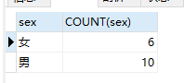
2. 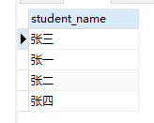
3. 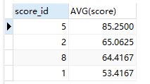
4. 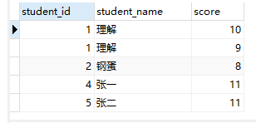
5. 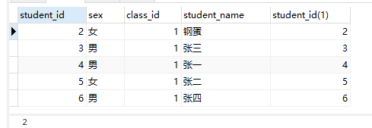
6. 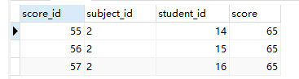
7. 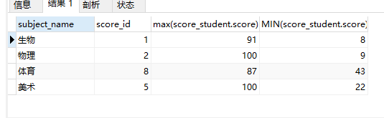
8. 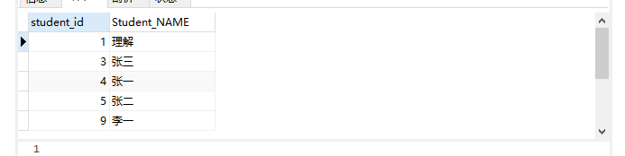
9. 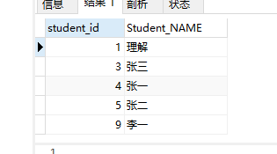
10. 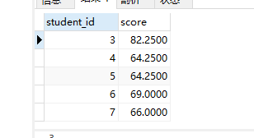
11. 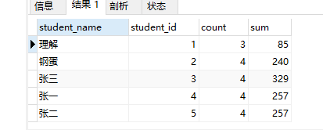
12. 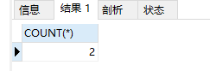
13. 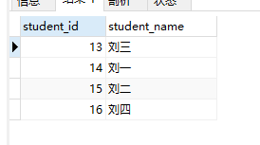
14. 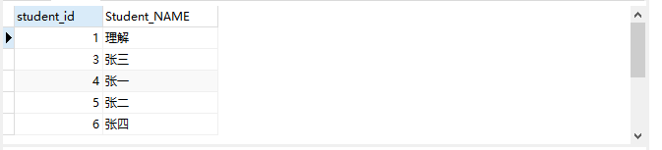
15. 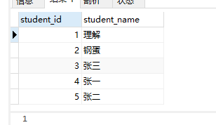
16. 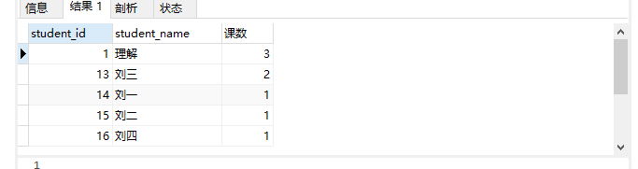
17. 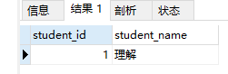
18. 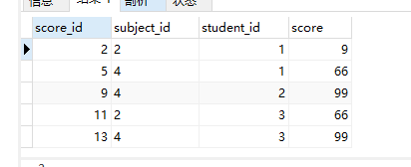

20. 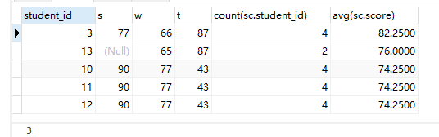

21. 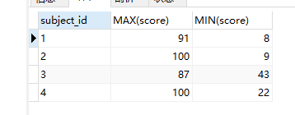

22. 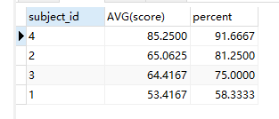

23. 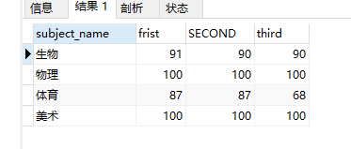

24. 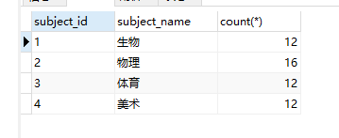

25. 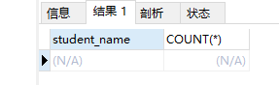

26. 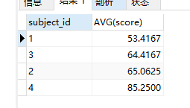

27. 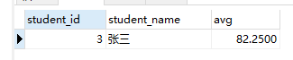

28. 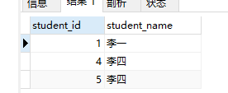

29. 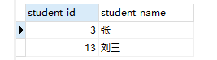

30 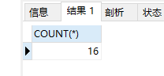

31. 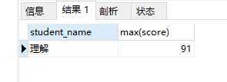

32 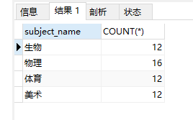

33 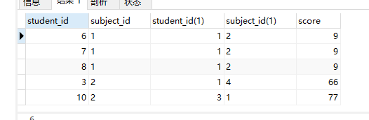

34 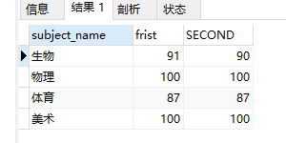

35 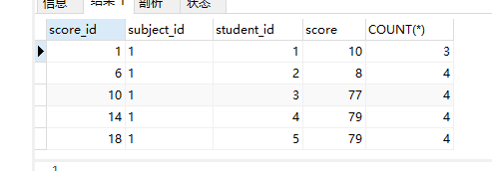

36 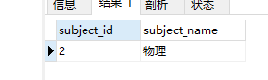

37 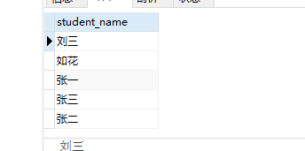

38 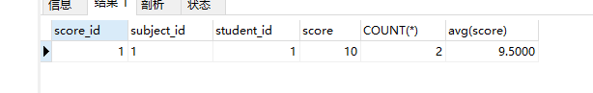

39. 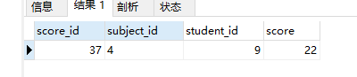

40 