Mysql练习题

**Class表的定义**

|  |  |  |  |  |  |  |  |
| --- | --- | --- | --- | --- | --- | --- | --- |
| **字段名** | **字段描述** | **数据类型** | **主键** | **外键** | **非空** | **唯一** | **自增** |
| class_id | 编号 | INT(10) | 是 | 否 | 是 | 是 | 是 |
| class_name | 班级名称 | VARCHAR(64) | 否 | 否 | 是 | 否 | 否 |

INSERT INTO `class` VALUES ('1', '三年二班'), ('2', '三年三班'), ('3', '一年二班'), ('4', '二年九班');

**Subject表的定义**

|  |  |  |  |  |  |  |  |
| --- | --- | --- | --- | --- | --- | --- | --- |
| **字段名** | **字段描述** | **数据类型** | **主键** | **外键** | **非空** | **唯一** | **自增** |
| subject_id | 编号 | INT(10) | 是 | 否 | 是 | 是 | 是 |
| subject_name | 班级名称 | VARCHAR(64) | 否 | 否 | 是 | 否 | 否 |
| teacher_id | 教师id | INT(10) | 否 | 否 | 否 | 否 | 否 |

INSERT INTO `subject` VALUES ('1', '生物', '1'), ('2', '物理', '2'), ('3', '体育', '3'), ('4', '美术', '2');

**Score表的定义**

|  |  |  |  |  |  |  |  |
| --- | --- | --- | --- | --- | --- | --- | --- |
| **字段名** | **字段描述** | **数据类型** | **主键** | **外键** | **非空** | **唯一** | **自增** |
| score_id | 编号 | INT(10) | 是 | 否 | 是 | 是 | 是 |
| subject_id | 课程id | INT(10) | 否 | 否 | 是 | 否 | 否 |
| student_id | 学生id | INT(10) | 否 | 否 | 否 | 否 | 否 |
| score | 分数 | INT(10) | 否 | 否 | 否 | 否 | 否 |

INSERT INTO `score` VALUES ('1', '1', '1', '10'), ('2', '1', '2', '9'), ('5', '1', '4', '66'), ('6', '2', '1', '8'), ('8', '2', '3', '68'), ('9', '2', '4', '99'), ('10', '3', '1', '77'), ('11', '3', '2', '66'), ('12', '3', '3', '87'), ('13', '3', '4', '99'), ('14', '4', '1', '79'), ('15', '4', '2', '11'), ('16', '4', '3', '67'), ('17', '4', '4', '100'), ('18', '5', '1', '79'), ('19', '5', '2', '11'), ('20', '5', '3', '67'), ('21', '5', '4', '100'), ('22', '6', '1', '9'), ('23', '6', '2', '100'), ('24', '6', '3', '67'), ('25', '6', '4', '100'), ('26', '7', '1', '9'), ('27', '7', '2', '100'), ('28', '7', '3', '67'), ('29', '7', '4', '88'), ('30', '8', '1', '9'), ('31', '8', '2', '100'), ('32', '8', '3', '67'), ('33', '8', '4', '88'), ('34', '9', '1', '91'), ('35', '9', '2', '88'), ('36', '9', '3', '67'), ('37', '9', '4', '22'), ('38', '10', '1', '90'), ('39', '10', '2', '77'), ('40', '10', '3', '43'), ('41', '10', '4', '87'), ('42', '11', '1', '90'), ('43', '11', '2', '77'), ('44', '11', '3', '43'), ('45', '11', '4', '87'), ('46', '12', '1', '90'), ('47', '12', '2', '77'), ('48', '12', '3', '43'), ('49', '12', '4', '87'), ('52', '13', '3', '87');

**Student表的定义**

|  |  |  |  |  |  |  |  |
| --- | --- | --- | --- | --- | --- | --- | --- |
| **字段名** | **字段描述** | **数据类型** | **主键** | **外键** | **非空** | **唯一** | **自增** |
| student_id | 编号 | INT(10) | 是 | 否 | 是 | 是 | 是 |
| sex | 性别 | VARCHAR(64) | 否 | 否 | 是 | 否 | 否 |
| class_id | 班级id | INT(10) | 否 | 否 | 否 | 否 | 否 |
| student_name | 学生姓名 | VARCHAR(64) | 否 | 否 | 否 | 否 | 否 |

INSERT INTO `student` VALUES ('1', '男', '1', '理解'), ('2', '女', '1', '钢蛋'), ('3', '男', '1', '张三'), ('4', '男', '1', '张一'), ('5', '女', '1', '张二'), ('6', '男', '1', '张四'), ('7', '女', '2', '铁锤'), ('8', '男', '2', '李三'), ('9', '男', '2', '李一'), ('10', '女', '2', '李二'), ('11', '男', '2', '李四'), ('12', '女', '3', '如花'), ('13', '男', '3', '刘三'), ('14', '男', '3', '刘一'), ('15', '女', '3', '刘二'), ('16', '男', '3', '刘四');

**Teacher表的定义**

|  |  |  |  |  |  |  |  |
| --- | --- | --- | --- | --- | --- | --- | --- |
| **字段名** | **字段描述** | **数据类型** | **主键** | **外键** | **非空** | **唯一** | **自增** |
| teacher_id | 编号 | INT(10) | 是 | 否 | 是 | 是 | 是 |
| teacher_name | 姓名 | VARCHAR(64) | 否 | 否 | 是 | 否 | 否 |

INSERT INTO `teacher` VALUES ('1', '张磊老师'), ('2', '李平老师'), ('3', '刘海燕老师'), ('4', '朱云海老师'), ('5', '李杰老师');

1.查询男生、女生的人数；

|  |
| --- |
| select sex, count(sex) from student group by sex |

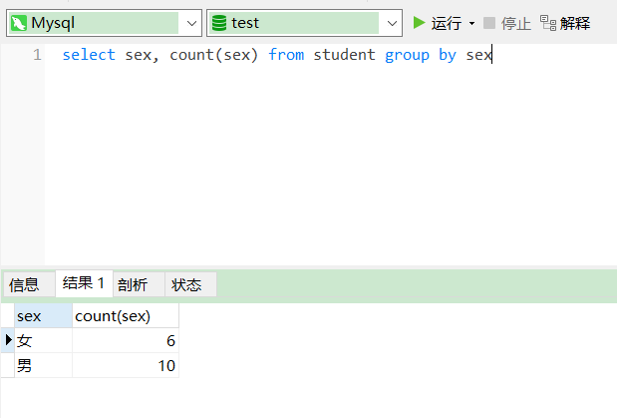

2.查询姓“张”的学生名单；

|  |
| --- |
| select student_name, sex from student where student_name like '张%' |

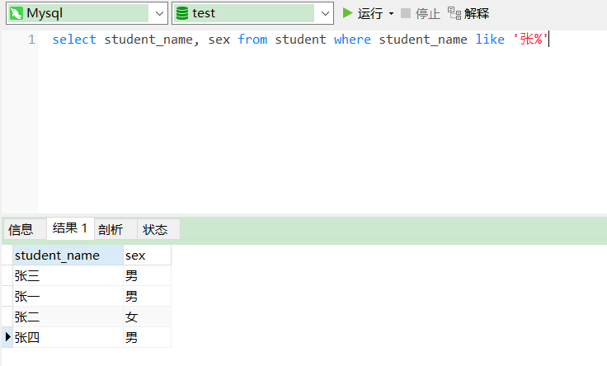

3.课程平均分从高到低显示

|  |
| --- |
| select subject.subject_name, avg(score) as '平均分' from subject left join score on score.subject_id = subject.subject_id group by subject_name |

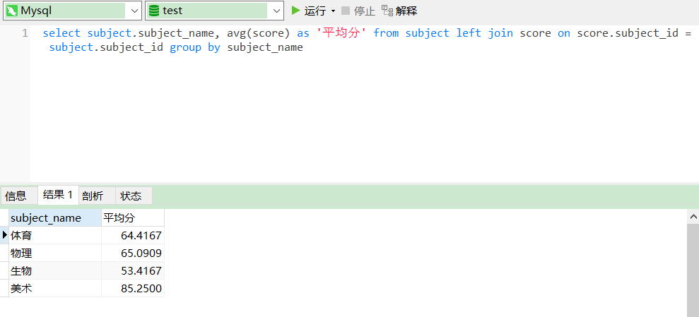

4.查询有课程成绩小于60分的同学的学号、姓名；

|  |
| --- |
| select student.student_id, student_name, subject_name from student, score, subject where student.student_id = score.student_id and score < 60 and subject.subject_id = score.subject_id |

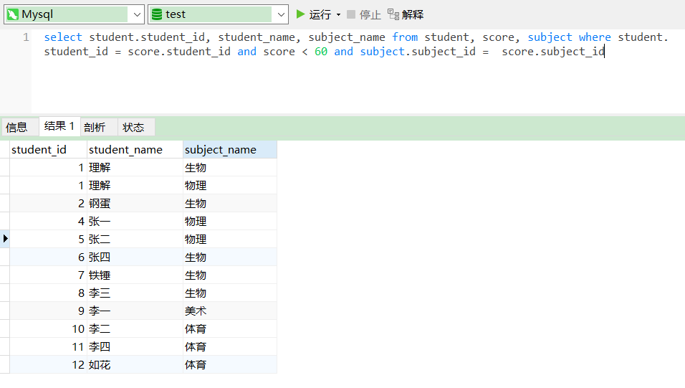

5.查询至少有一门课与学号为1的同学所学课程相同的同学的学号和姓名；

|  |
| --- |
| select student.student_id, student.student_name, after_subject.subject_name from (  SELECT SUBJECT_name, SUBJECT.subject_id  FROM  SUBJECT,  student,  score  WHERE  student.student_id = 1  AND SUBJECT.subject_id = score.subject_id  and score.student_id = student.student_id  ) as after_subject, student, score  where  after_subject.subject_id = score.subject_id  and score.student_id = student.student_id |

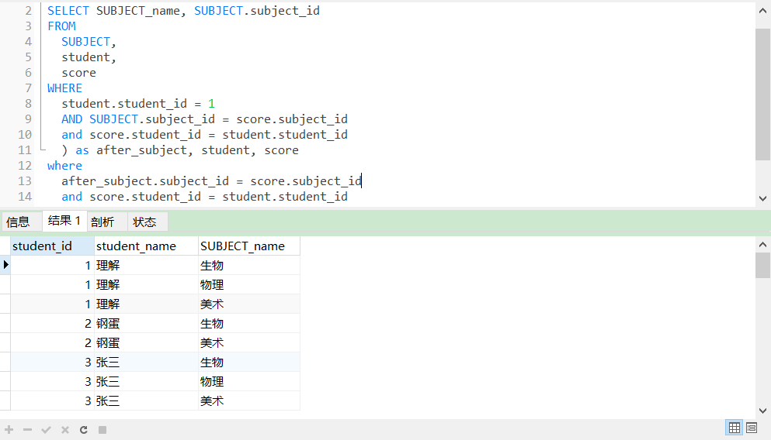

6.查询出只选修了一门课程的全部学生的学号和姓名；

|  |
| --- |
| SELECT  stu.student_id '学号',  stu.student_name '姓名'  FROM  ( SELECT sc.student_id FROM score sc ) a,  student stu  WHERE  stu.student_id = a.student_id  GROUP BY  stu.student_name  HAVING  COUNT( a.student_id ) = 1 |

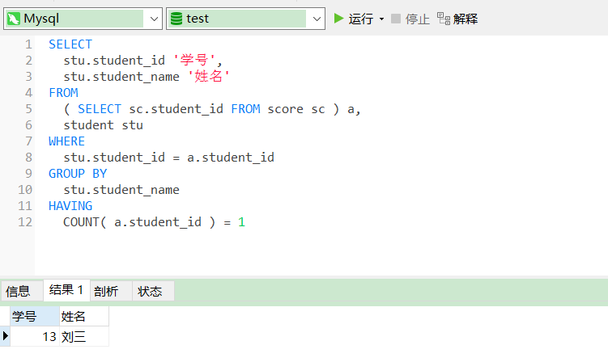

7.查询各科成绩最高和最低的分：以如下形式显示：课程ID，最高分，最低分；

|  |
| --- |
| select subject_id, max(score) '最高分', min(score) '最低分' from score group by subject_id |

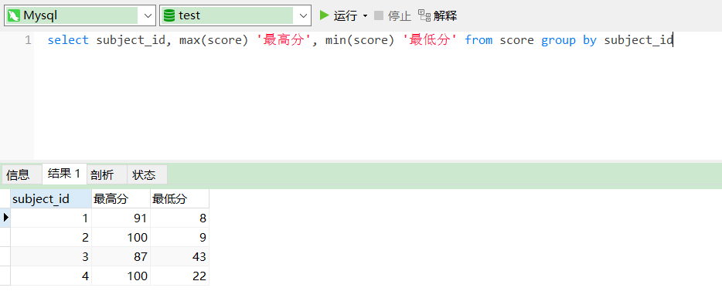

8.查询课程编号“2”的成绩比课程编号“1”课程低的所有同学的学号、姓名；

|  |
| --- |
| SELECT DISTINCT  b.student_id,  student.student_name  FROM  ( SELECT subject_id, student_id, score FROM score WHERE subject_id = 2 ) AS b,  ( SELECT subject_id, student_id, score FROM score WHERE subject_id = 1 ) AS a,  student  WHERE  b.score < a.score  AND b.student_id = student.student_id |

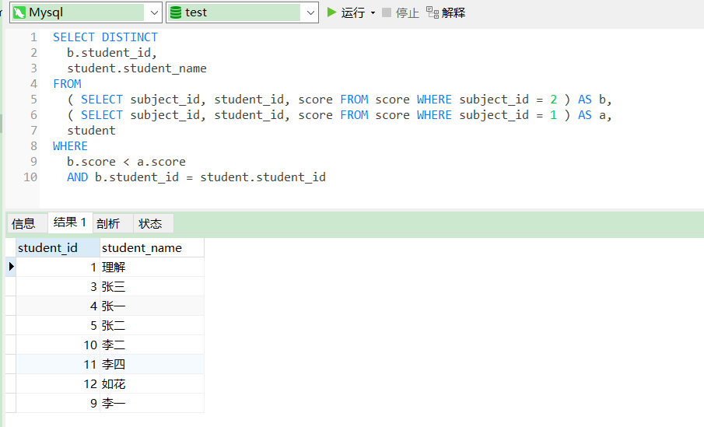

9.查询“生物”课程比“物理”课程成绩高的所有学生的学号；

|  |
| --- |
| SELECT DISTINCT  a.student_id  FROM  ( SELECT score.student_id, score FROM SUBJECT, score WHERE subject_name = '生物' AND SUBJECT.subject_id = score.subject_id ) AS a,  ( SELECT score.student_id, score FROM SUBJECT, score WHERE subject_name = '物理' AND SUBJECT.subject_id = score.subject_id ) AS b  WHERE  a.score > b.score |

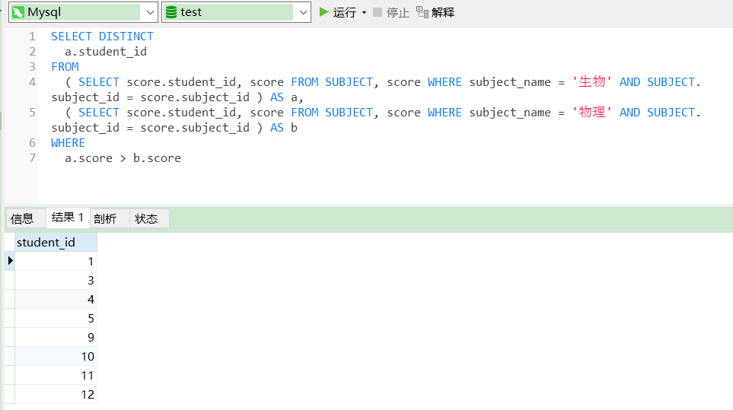

10.查询平均成绩大于60分的同学的学号和平均成绩;

|  |
| --- |
| select student.student_id, avg(score) as '平均成绩' from student, score where student.student_id = score.student_id group by score.student_id having avg(score) > 60 |

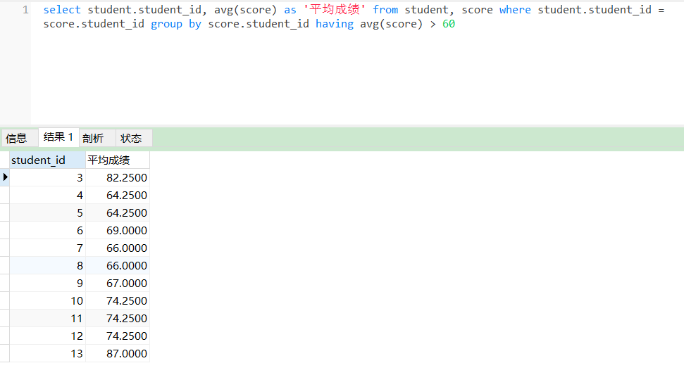

11.查询所有同学的学号、姓名、选课数、总成绩；

|  |
| --- |
| SELECT  student.student_id,  student.student_name,  count( score.subject_id ) AS '选课数',  sum( score.score ) AS '总成绩'  FROM  student,  score  WHERE  student.student_id = score.student_id  GROUP BY  score.student_id |

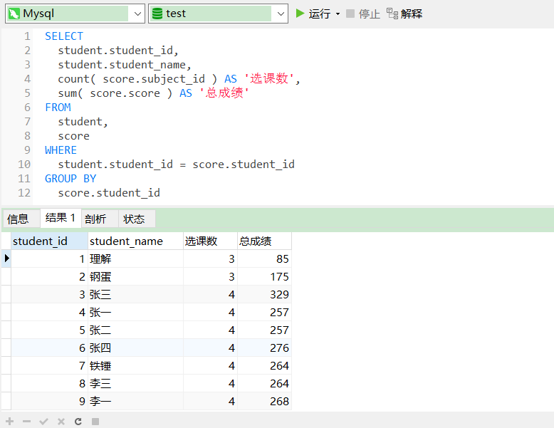

12.查询姓“李”的老师的个数；

|  |
| --- |
| select count(teacher_id) as '李姓老师个数' from teacher where teacher_name like '李%' |

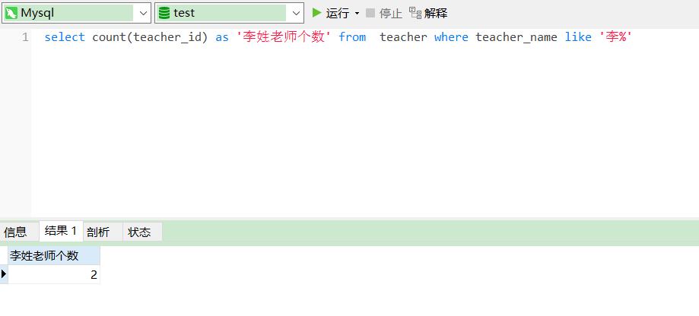

13.查询没学过“张磊老师”课的同学的学号、姓名；

|  |
| --- |
| SELECT  student.student_id,  student.student_name  FROM  student  WHERE  student_id NOT IN (  SELECT  score.student_id AS s_id  FROM  teacher,  score,  SUBJECT  WHERE  teacher.teacher_name = '张磊老师'  AND teacher.teacher_id = SUBJECT.teacher_id  AND SUBJECT.subject_id = score.subject_id  ) |

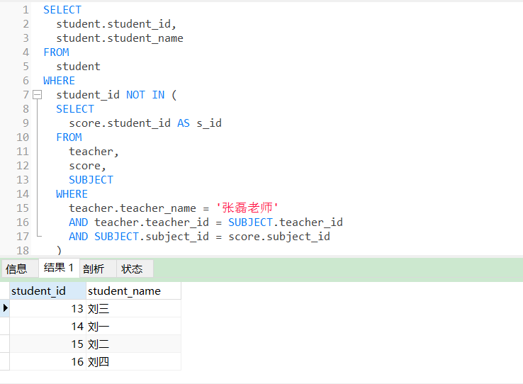

14.查询学过“1”并且也学过编号“2”课程的同学的学号、姓名；

|  |
| --- |
| select student.student_id, student.student_name from student where  student_id in (select score.student_id from score where score.subject_id = 1)  and  student_id in (select score.student_id from score where score.subject_id = 2) |

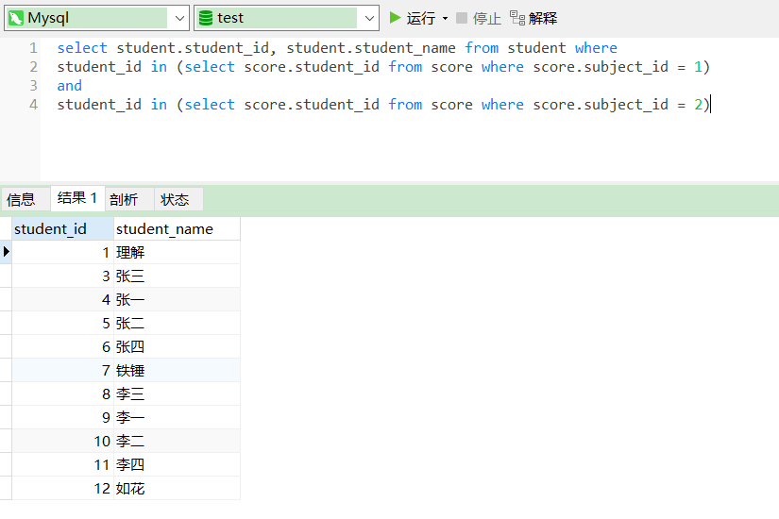

15.查询学过“李平老师”所教的所有课的同学的学号、姓名；

|  |
| --- |
| SELECT  student.student_id,  student.student_name  FROM  student  WHERE  student_id IN (  SELECT  score.student_id  FROM  teacher,  score,  SUBJECT  WHERE  teacher.teacher_name = '李平老师'  AND teacher.teacher_id = SUBJECT.teacher_id  AND SUBJECT.subject_id = score.subject_id  group by student_id  having count(student_id) > 1  ) |

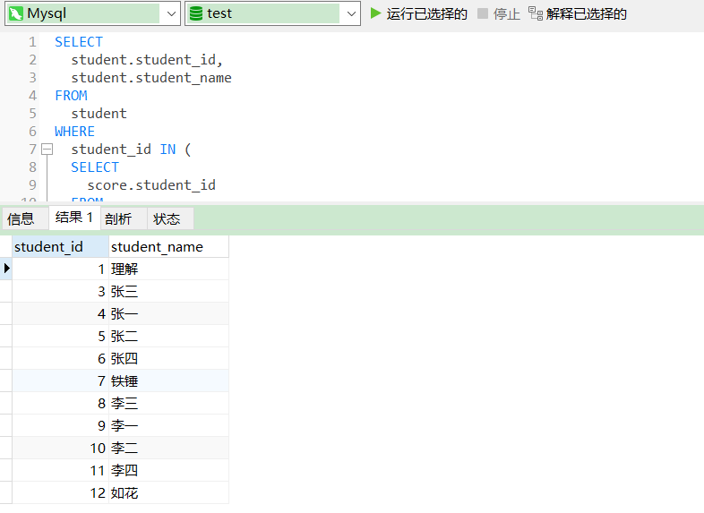

16.查询没有学全所有课的同学的学号、姓名；

|  |
| --- |
| SELECT  student.student_id,  student.student_name  FROM  student,  score  WHERE  student.student_id = score.student_id  GROUP BY  score.student_id  HAVING  count( score.subject_id ) < ( SELECT count( subject_id ) FROM SUBJECT ) |

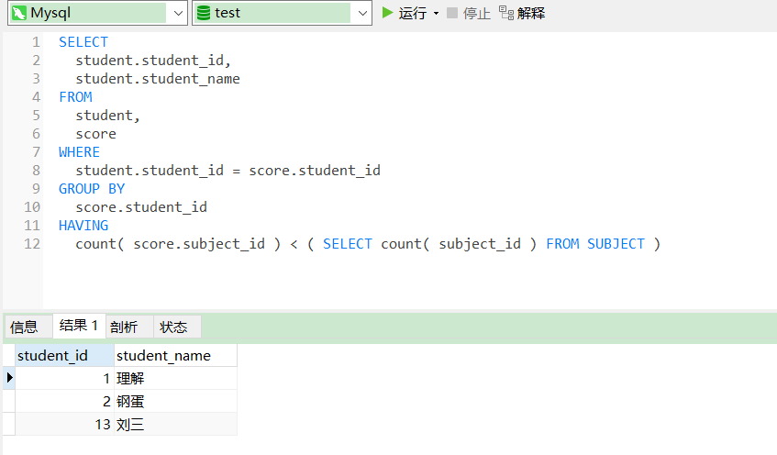

17.查询和“002”号的同学学习的课程完全相同的其他同学学号和姓名；

|  |
| --- |
| SELECT  student_id  FROM  score  WHERE  student_id NOT IN ( SELECT student_id FROM score WHERE subject_id NOT IN ( SELECT subject_id FROM score WHERE student_id = 2 ) )  AND student_id != 2  GROUP BY  student_id  HAVING  count( subject_id )= ( SELECT count( subject_id ) FROM score WHERE student_id = 2 ); |

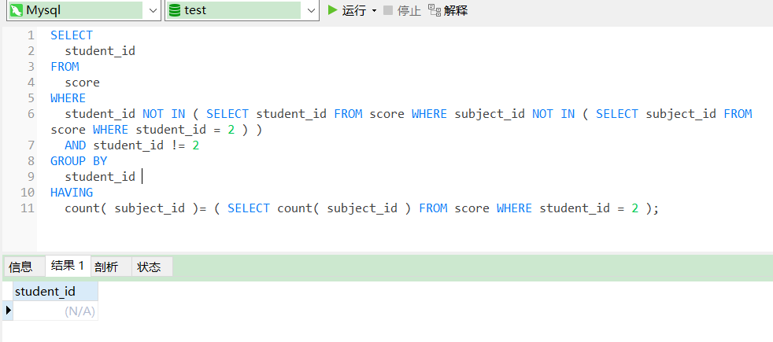

18.删除学习“叶平”老师课的SC表记录；

|  |
| --- |
| DELETE score  FROM  score,  SUBJECT,  teacher  WHERE  score.subject_id = SUBJECT.subject_id  AND SUBJECT.teacher_id = teacher.teacher_id  AND teacher.teacher_name = '叶平老师' |

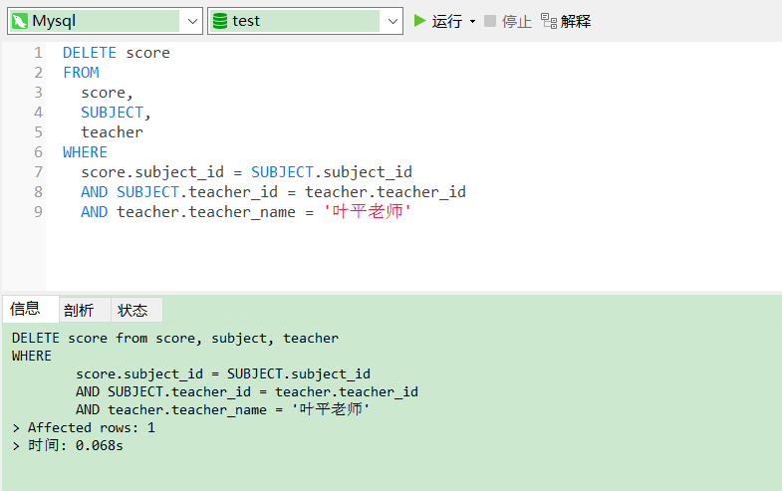

19.向SC表中插入一些记录，这些记录要求符合以下条件：①没有上过编号“002”课程的同学学号；②插入“002”号课程的平均成绩；

|  |
| --- |
| 不用做 |

20.按平均成绩从低到高显示所有学生的“语文”、“数学”、“英语”三门的课程成绩，按如下形式显示： 学生ID,语文,数学,英语,有效课程数,有效平均分；

|  |
| --- |
| SELECT  stu.student_id '学生ID',  t1.score 生物,  t2.score 物理,  t3.score 体育,  t4.score 美术,  t5.count_subject 有效课程数,  t5.avg_score 有效平均分  FROM  student stu  LEFT JOIN (  SELECT  student_id,  score  FROM  score  WHERE  subject_id = ( SELECT subject_id FROM `subject` WHERE subject_name = '生物' )) t1 ON stu.student_id = t1.student_id  LEFT JOIN (  SELECT  student_id,  score  FROM  score  WHERE  subject_id = ( SELECT subject_id FROM `subject` WHERE subject_name = '物理' )) t2 ON stu.student_id = t2.student_id  LEFT JOIN (  SELECT  student_id,  score  FROM  score  WHERE  subject_id = ( SELECT subject_id FROM `subject` WHERE subject_name = '体育' )) t3 ON stu.student_id = t3.student_id  LEFT JOIN (  SELECT  student_id,  score  FROM  score  WHERE  subject_id = ( SELECT subject_id FROM `subject` WHERE subject_name = '美术' )) t4 ON stu.student_id = t4.student_id  LEFT JOIN ( SELECT student_id, avg( score ) avg_score, count( score ) count_subject FROM score GROUP BY student_id ) t5 ON stu.student_id = t5.student_id  order by t5.avg_score |

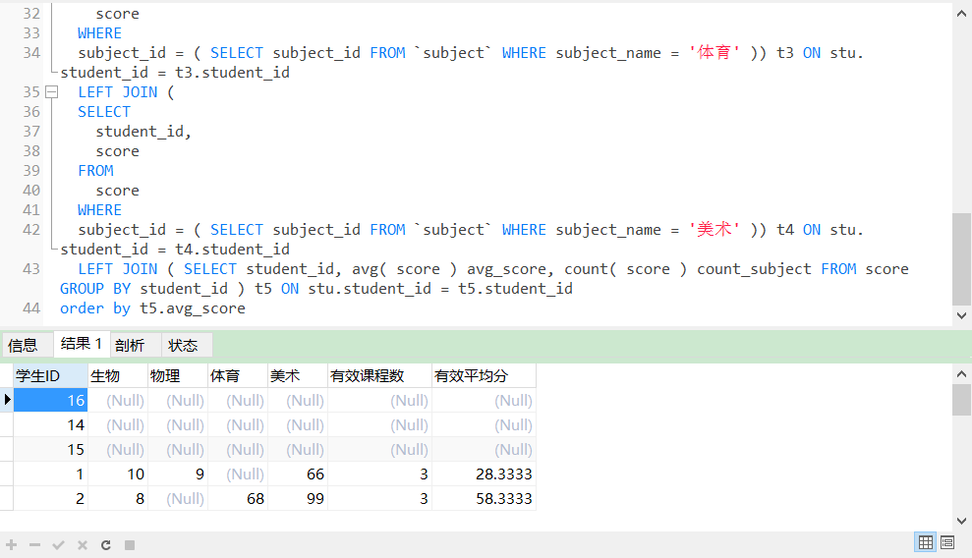

21.查询各科成绩最高和最低的分：以如下形式显示：课程ID，最高分，最低分；

|  |
| --- |
| select subject_id, max(score), min(score) from score group by subject_id |

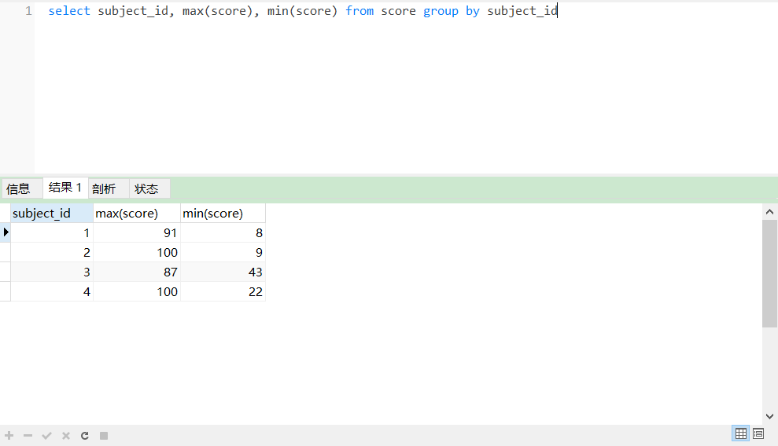

22.按各科平均成绩从低到高和及格率的百分数从高到低顺序；

|  |
| --- |
| SELECT  score.subject_id,  avg( score ) AS '平均成绩',  jige.jigelv  FROM  score,  ( SELECT sum( score > 60 ) / count( score ) AS jigelv, subject_id FROM score GROUP BY subject_id ) AS jige  WHERE  jige.subject_id = score.subject_id  GROUP BY  score.subject_id  ORDER BY  avg( score ),  jigelv DESC |

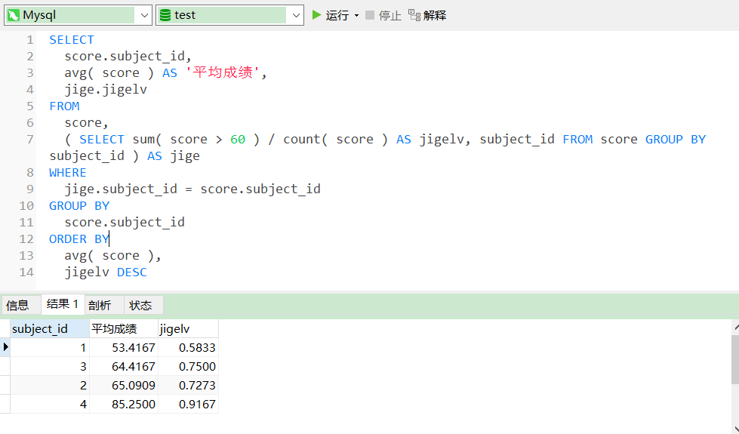

23.查询各科成绩前三名的记录:(不考虑成绩并列情况)

|  |
| --- |
| select  t1.student_id,t1.subject_id,t1.score from score t1  left join  (  select score_id,subject_id,  (select score from score as s2 where s2.subject_id = s1.subject_id order by score desc limit 0, 1) as first_num,  (select score from score as s2 where s2.subject_id = s1.subject_id order by score desc limit 1, 1) as second_num,  (select score from score as s2 where s2.subject_id = s1.subject_id order by score desc limit 2, 1) as third_num  from score as s1  ) t2  on t1.score_id = t2.score_id  where t1.score = t2.first_num or t1.score = t2.second_num or t1.score = t2.third_num; |

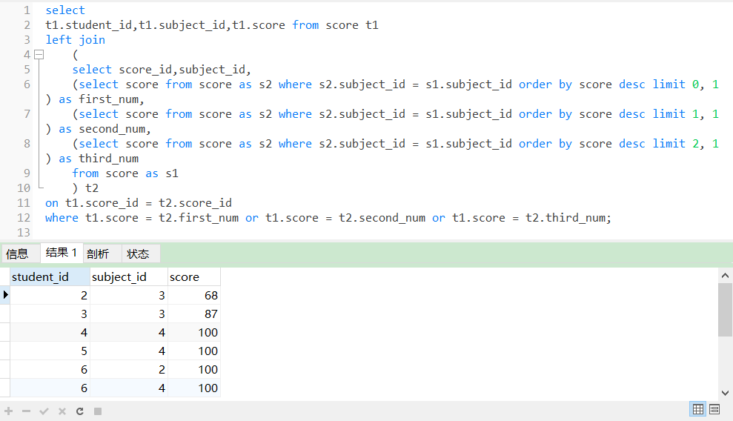

24.查询每门课程被选修的学生数；

|  |
| --- |
| select subject_id, count(subject_id) from score group by subject_id |

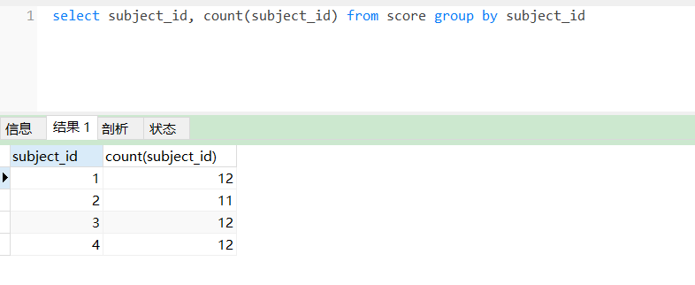

25.查询同名同姓学生名单，并统计同名人数；

|  |
| --- |
| select student_name, count(student_name) from student group by student_name having count(student_name) > 1 |

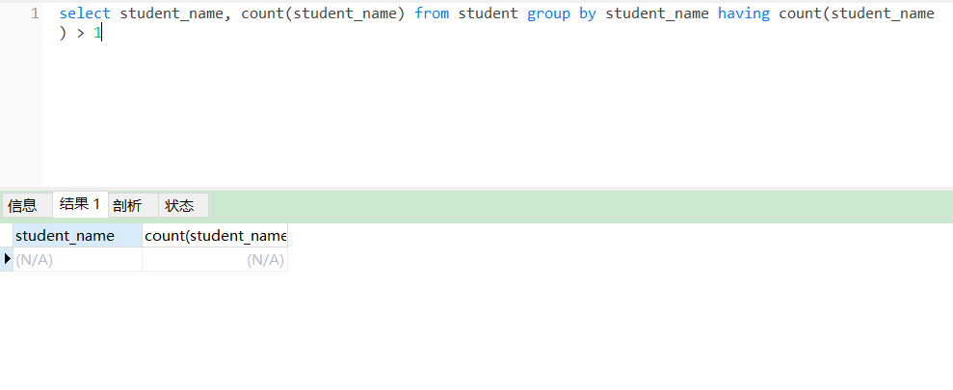

26.查询每门课程的平均成绩，结果按平均成绩升序排列，平均成绩相同时，按课程号降序排列；

|  |
| --- |
| select subject_id,avg(score) as avg from score group by subject_id order by avg asc,subject_id desc; |

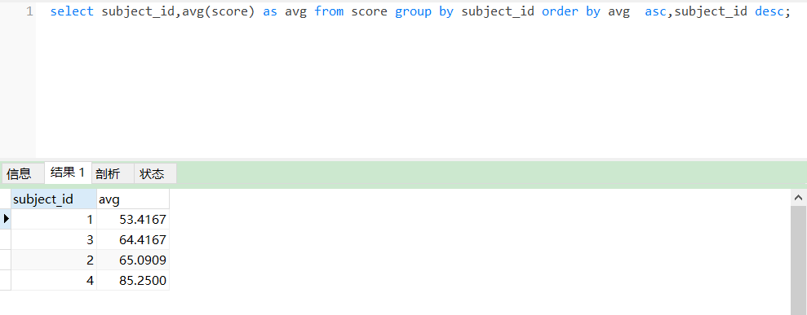

27.查询平均成绩大于85的所有学生的学号. 姓名和平均成绩；

|  |
| --- |
| SELECT  sc.student_id,  avg( score ),  stu.student_name  FROM  score sc  LEFT JOIN student stu ON stu.student_id = sc.student_id  GROUP BY  student_id  HAVING  avg( score ) > 85; |

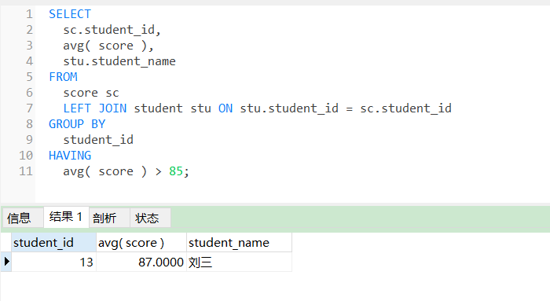

28.查询课程名称为“数学”，且分数低于60的学生姓名和分数；

|  |
| --- |
| SELECT  student.student_name,  score.score  FROM  student,  score,  SUBJECT  WHERE  SUBJECT.subject_id = score.subject_id  AND score.student_id = student.student_id  AND SUBJECT.subject_name = '物理'  AND score.score < 60 |

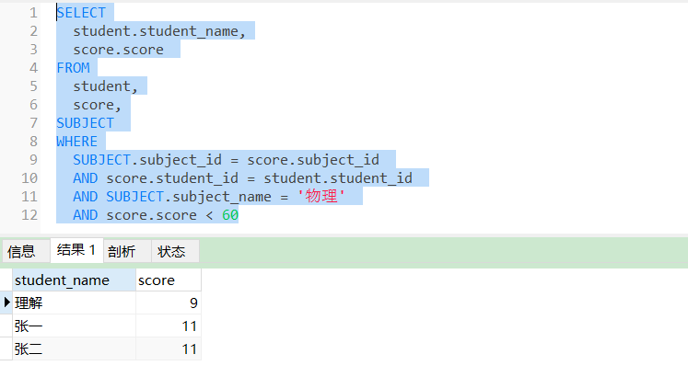

29.查询课程编号为003且课程成绩在80分以上的学生的学号和姓名；

|  |
| --- |
| SELECT  score.student_id,  student.student_name  FROM  student,  score  WHERE  score.student_id = student.student_id  AND score.subject_id = 3  AND score.score > 80 |

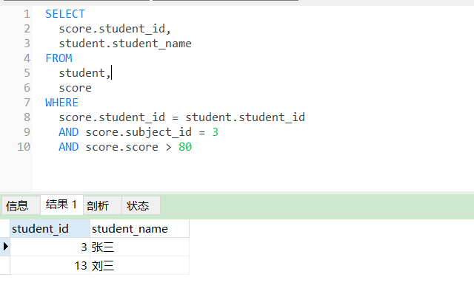

30.求选了课程的学生人数

|  |
| --- |
| select count(student_id) from (select student_id from score group by student_id) t |

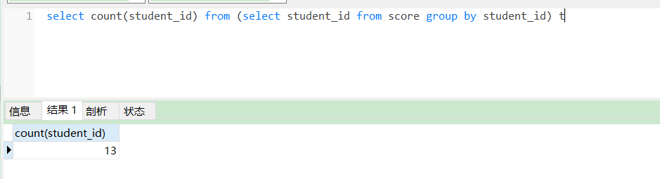

31.查询选修“杨艳”老师所授课程的学生中，成绩最高的学生姓名及其成绩；

|  |
| --- |
| SELECT  student.student_name,  t1.score  FROM  (  SELECT DISTINCT  student_id,  score  FROM  score  WHERE  score = (  SELECT  max( score )  FROM  score  WHERE  subject_id IN (  SELECT  subject_id  FROM  `subject`  WHERE  teacher_id IN ( SELECT teacher_id FROM teacher WHERE teacher_name = '张磊老师' )))  AND subject_id IN (  SELECT  subject_id  FROM  `subject`  WHERE  teacher_id IN ( SELECT teacher_id FROM teacher WHERE teacher_name = '张磊老师' ))  ) t1  LEFT JOIN student ON t1.student_id = student.student_id |

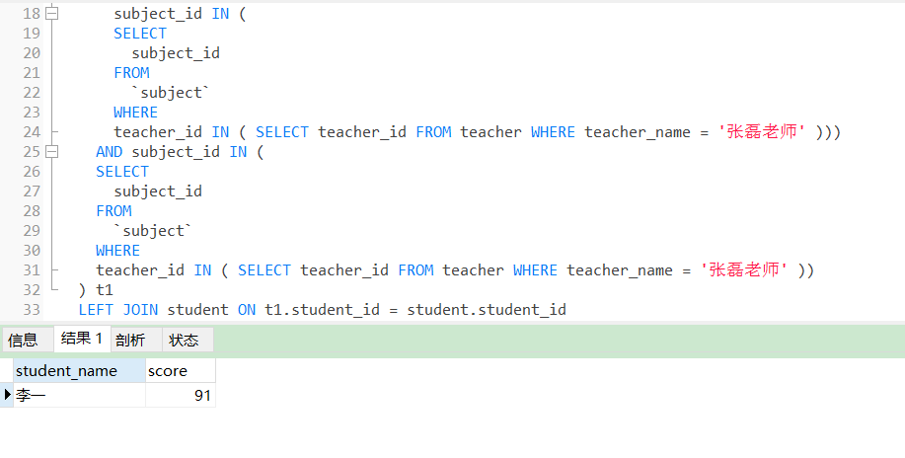

32.查询各个课程及相应的选修人数；

|  |
| --- |
| SELECT  SUBJECT.subject_name,  count( * )  FROM  score  LEFT JOIN SUBJECT ON score.subject_id = SUBJECT.subject_id  GROUP BY  SUBJECT.subject_id; |

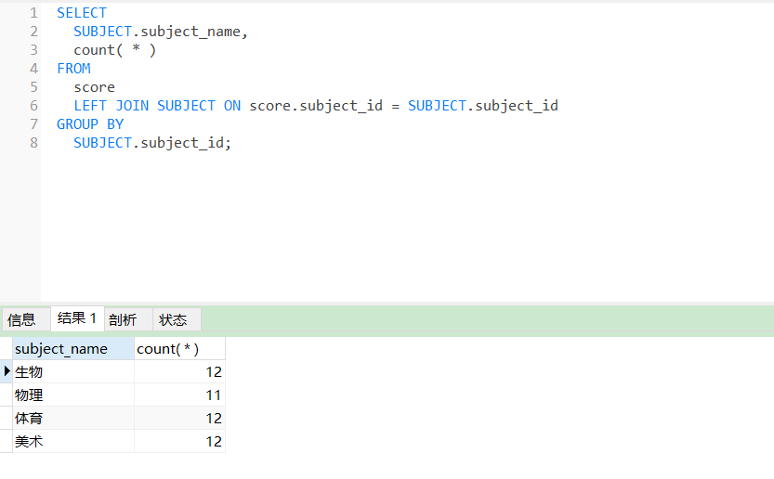

33.查询不同课程但成绩相同的学生的学号、课程号、学生成绩；

|  |
| --- |
| SELECT DISTINCT  s1.subject_id,  s2.subject_id,  s1.score,  s2.score  FROM  score AS s1,  score AS s2  WHERE  s1.score = s2.score  AND s1.subject_id != s2.subject_id; |

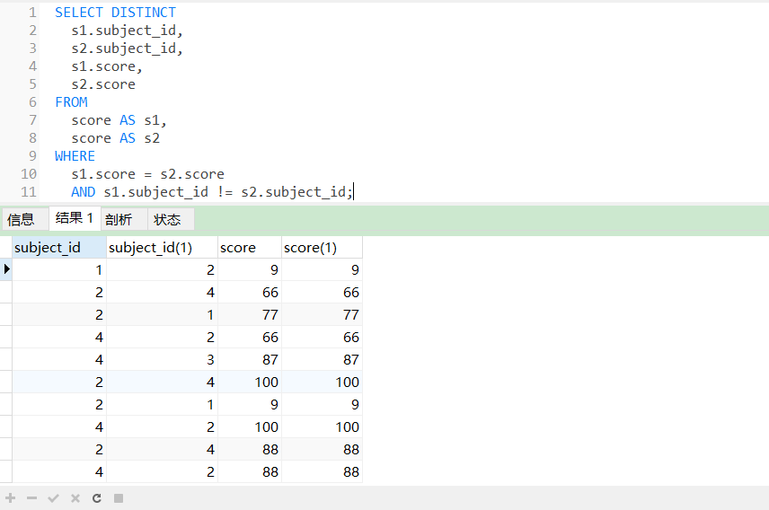

34.查询每门课程成绩最好的前两名；

|  |
| --- |
| SELECT  t1.student_id,  t1.subject_id,  t1.score  FROM  score t1  LEFT JOIN (  SELECT  score_id,  subject_id,  ( SELECT score FROM score AS s2 WHERE s2.subject_id = s1.subject_id ORDER BY score DESC LIMIT 0, 1 ) AS first_num,  ( SELECT score FROM score AS s2 WHERE s2.subject_id = s1.subject_id ORDER BY score DESC LIMIT 1, 1 ) AS second_num  FROM  score AS s1  ) t2 ON t1.score_id = t2.score_id  WHERE  t1.score = t2.first_num  OR t1.score = t2.second_num; |

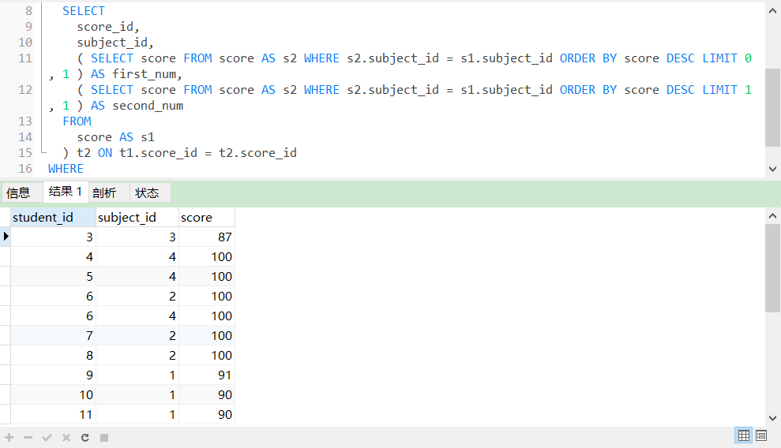

35.检索至少选修两门课程的学生学号；

|  |
| --- |
| select student_id from score group by student_id having count(student_id) > 1 |

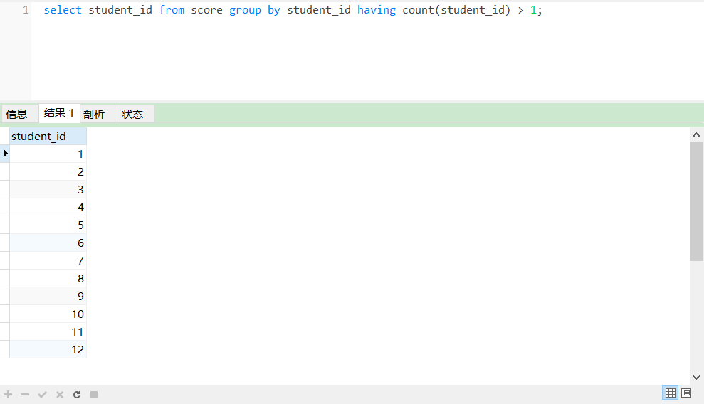

36.查询全部学生都选修的课程的课程号和课程名；

|  |
| --- |
| select subject_id from score group by subject_id having count(student_id) = (select count(student_id) from student); |

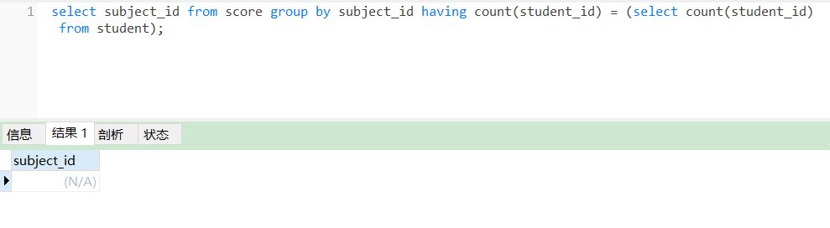

37.查询没学过“叶平”老师讲授的任一门课程的学生姓名；

|  |
| --- |
| SELECT  student_name  FROM  student  WHERE  student_id NOT IN (  SELECT DISTINCT  student_id  FROM  score  WHERE  subject_id IN (  SELECT  subject_id  FROM  `subject`  WHERE  teacher_id IN ( SELECT teacher_id FROM teacher WHERE teacher_name = '李平老师' ))); |

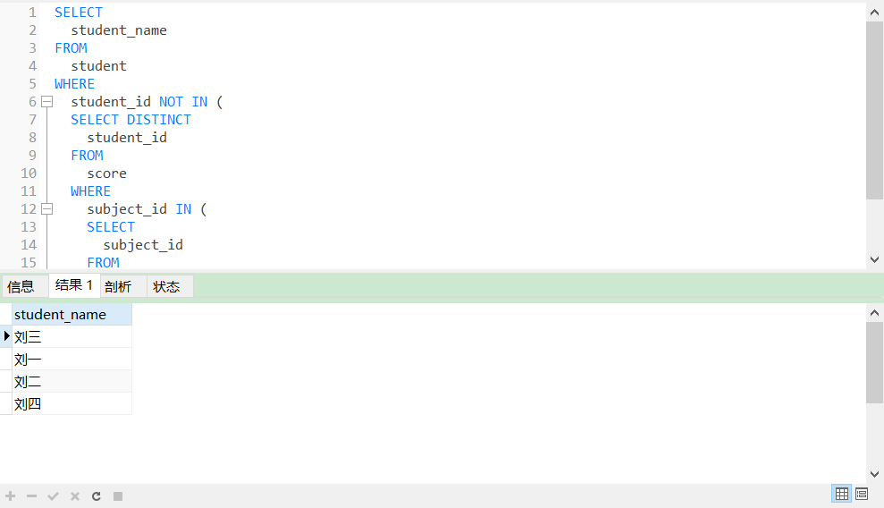

38.查询两门以上不及格课程的同学的学号及其平均成绩；

|  |
| --- |
| select student_id,avg(score) from score where score<60 group by student_id having count(score)>=2; |

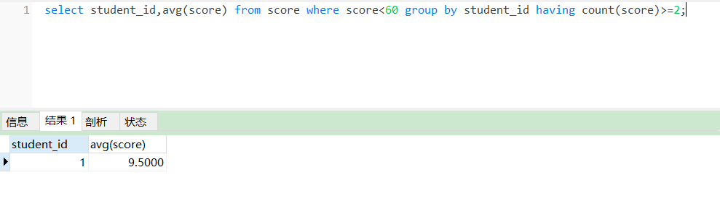

39.检索“004”课程分数小于60，按分数降序排列的同学学号；

|  |
| --- |
| select student_id from score where score < 60 and subject_id = 4 order by score desc |

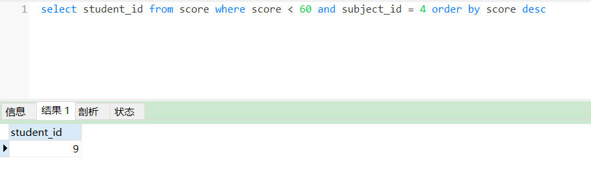

40.删除“002”同学的“001”课程的成绩；

|  |
| --- |
| delete from score where subject_id = 1 and student_id = 2 |

