# **Adding new Patient List (for “emergency telehealth” and “community tele-paramedicine”)**

Click on “Patient list” grey button on left upper corner of the status board. You will find a random list below.

Click on “New visit list.” Has a green plus sign.

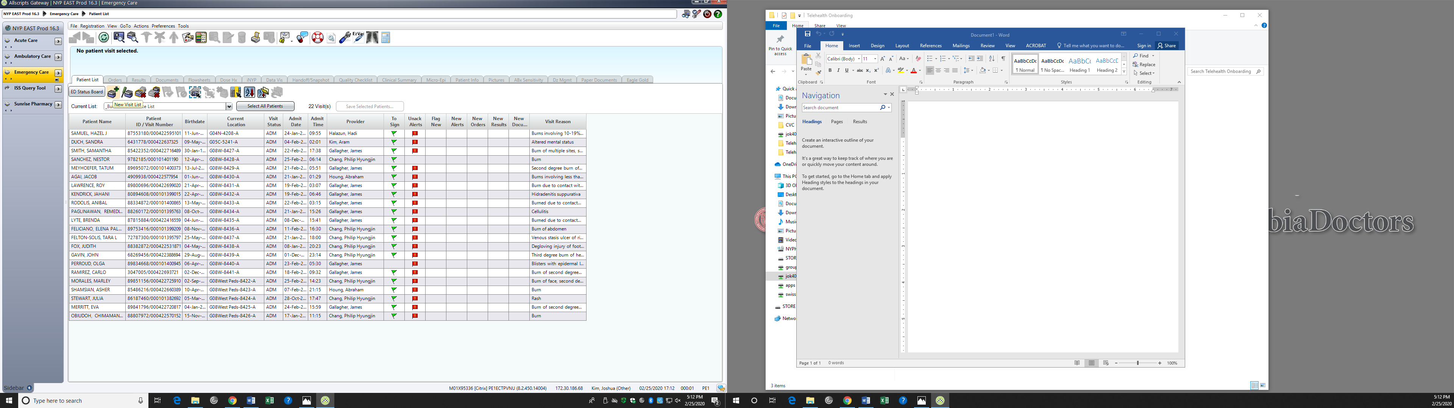

Click on “location” tab.

Click on “inlcude patients at selected locations only” (3rd option here below.)

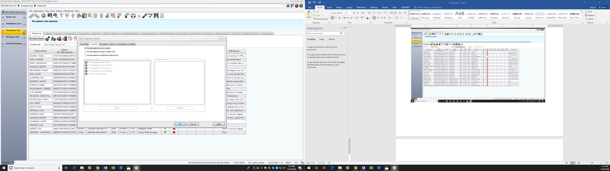

Click on “NY Presbyterian Weill-Cornell.” Expand the list

Scroll down to “EMERGENCY TELEHEALTH”

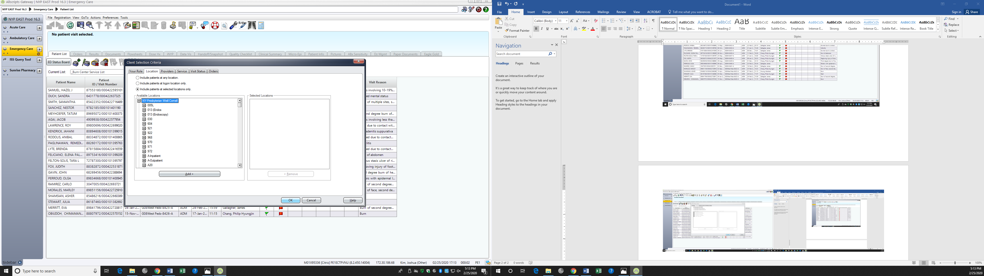

“Add” Emergency Telehealth to column on right.

Hit “OK”

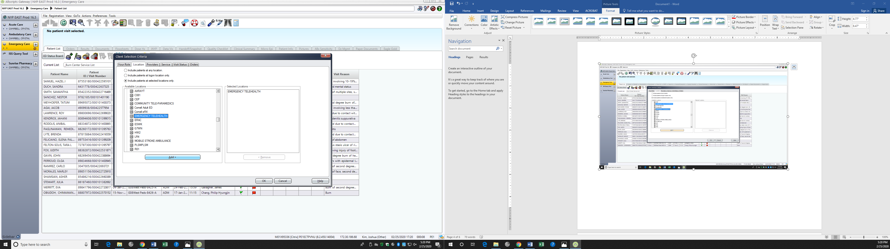

Rename the list as “.emergencytelehealth”

Starting with a “.” helps bring it up to top of list.

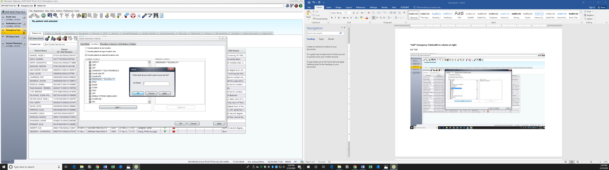

**You are done!**

**Sort by “Admit Date” is the easiest way to navigate the list.**

**Repeat the same steps for CTP.**