Testing

During the course of developing this system I would, naturally, have had to test my system to ensure that it worked correctly. The following is evidence that I have done so:

ArrayDirectory – Examples in ArrayTest.java

Insertion
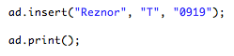

Running the method “insert(String, String, String)” will insert an entry with those credentials into the directory, as evidenced by the output of the print() method below.
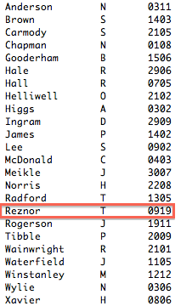

Lookup
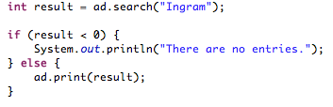

For lookup you have to run the search(String) method, which returns an integer (for reasons which will become apparent later), if the entry is not found the method returns -1, otherwise the print(int) method is called to print out the entry in the directory as seen below.

Delete by Surname
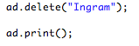

Running the delete(String) method will print the entry to be deleted, then ask the user to confirm deletion.
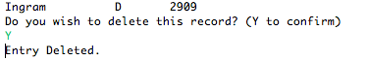

As you can see from the printed table below, the entry no longer exists within our directory.
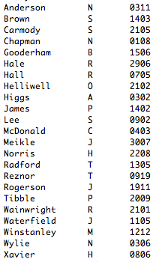

Editing Entries
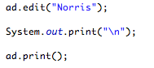

The line edit(String) will call the edit method. This method asks the user to change the extension and then confirm the change.
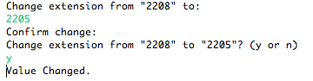

As you can tell from the printed table below, this was successful.
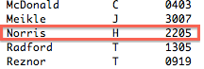

ListDirectory – Examples in ListTest.java
Methods work the same as they do in ArrayDirectory.

Insertion
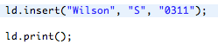

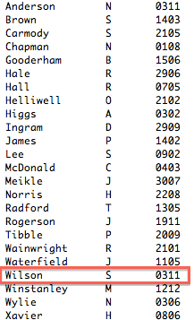

Searching
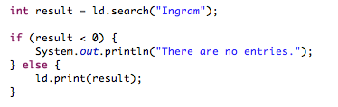

returns

Delete by Name
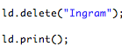

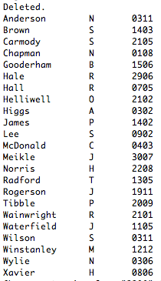

Editing
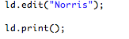

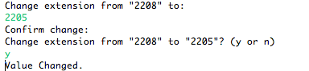

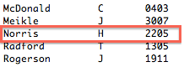

HashDirectory – Evidence in HashTest.java

Identical to ListDirectory.

Timing Discussion

Array – Searches: 9ms, Inserts: 15ms
List – Searches: 12ms, Inserts: 24ms
Hash – Searches: 6ms, Inserts: 18ms

Above are the average times taken to do searching and inserting into the three directories which I have created for this project. At first glance it would seem that the ArrayDirectory results are the most efficient of the three, but this is not the case. My HashDirectory class is by far and away the most efficient in terms of the speed in which it searches the entries and also the method of insertion used. Speed of insertion isn't necessarily an important aspect of this program, whereas efficiency is. The 3ms difference between insertion on the ArrayDirectory and the HashDirectory will decrease rapidly the more entries added. This is because when you add entries to the ArrayDirectory class is order to sort the entries by surname all entries later than the one you are inputting are slowly moved one space higher in the array. This means that if you have a directory of 1,000 entries and you want to insert an entry starting with, say, “A” you will have to move all 1,000 entries down one space to accommodate the new entry. The HashDirectory, more specifically the ListDirectory – given that the HashDirectory is just an array of ListDirectories, negates this by using several LinkedLists (26 in fact) to first assign the entry to the correct list by first character (“A” would go in the first list, “Z” would go in the last) then using the inherit functionality of the LinkedList, inserts the entry seamlessly into the list at the correct location, without disturbing the other entries. This means that insertion is much more efficient in the HashDirectory than the other two classes, it also means that searching is ridiculously fast in comparison, due to the fact that you search a list based on the first character of the search term.

