Daniel Ingram (083808582)
CSC1021: Programming I
Project 1
Testing

TaxCalculator

Test No. | Test | Expected Result | Actual Result | Pass | Notes
1 | Output testing | The class prints an output containing both Tax and Income. | The class prints an output containing both Tax and Income. | Yes
2 | Accuracy Testing #1 | An input of £75 will give an output of £75 with no tax. | The output is £75 with no tax. | Yes
3 | Accuracy Testing #2 | An input of £100 will give an output of £100 with no tax. | The output is £100 with no tax. | Yes
4 | Accuracy Testing #3 | An input of £125 will give an output of £122 with £3 tax. | The output is £122 with £3 tax. | Yes
5 | Accuracy Testing #4 | An input of £150 will give an output of £145 with £5 tax. | The output is £145 with £5 tax. | Yes
6 | Accuracy Testing #5 | An input of £200 will give an output of £185 with £15 tax. | The output is £185 with £15 tax. | Yes
7 | Accuracy Testing #6 | An input of £250 will give an output of £215 with £35 tax. | The output is £215 with £35 tax. | Yes
8 | Accuracy Testing #7 | An input of £300 will give an output of £245 with £55 tax. | The output is £245 with £55 tax. | Yes
9 | Accuracy Testing #8 | An input of £350 will give an output of £265 with £85 tax. | The output is £265 with £85 tax. | Yes
10 | Accuracy Testing #9 | An input of £400 will give an output of £285 with £115 tax. | The output is £400 with £285 tax. | Yes
11 | Accuracy Testing #10 | An input of £450 will give an output of £275 with £175 tax. | The output is £450 with £275 tax. | Yes
12 | Accuracy Testing #11 | An input of £1825 will give an output of £0 with £1825 tax. | The output is £0 with £1825 tax. | Yes
13 | Accuracy Testing #12 | An input of £189.75 will give an output of £176.75 with £13 tax. | The output is £176.75 and the tax is £13. | Yes

TaxChart

Test No. | Test | Expected Result | Actual Result | Pass | Notes
14 | Output Testing #1 | The class should print out a table of values listing Input, Gross Income and Tax Paid. | The class prints the table as expected. (see fig.1) | Yes
15 | Output Format Testing | The table should look like a table, and the values should be aligned correctly. The Gross Income and Tax Paid should have two decimal places. | The table is formatted correctly. | Yes | Purely aesthetic, no real need for this to be accurate.
16 | Output Testing #2 | The class should create a bar chart which contains bars of two colours (red and yellow). | The class produces a bar-chart. (see fig.1) | Yes
17 | Chart Correlation | The chart created should correlate to the values in the table. | The chart correlates. | Yes
18 | Table Correlation | The values in the table should correlate to what is output should the input be put into the TaxCalculator class. | The values in the table are the same as the values in the class. | Yes
19 | Output Analysis | The number of values in the table should be the same as the number of values in the array. | The number of values is identical. | Yes

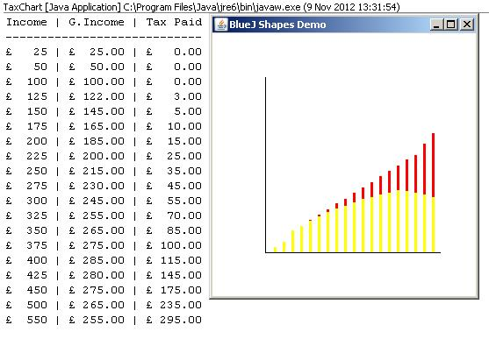fig.1
BogOff

Test No. | Test | Expected Result | Actual Result | Pass | Notes
20 | Functionality Testing | The class successfully executes. | The class runs as expected | Yes
21 | Output Testing | The class prints a chart and a table of values like we found in the TaxChart class. | The class prints a table of values and a bar chart. (see fig.2) | Yes
22 | Input Testing | The values input into the array include at least one for each tax-bracket. | The values are: 50, 100, 125, 150, 200, 250, 300, 340, 400 and 475. This includes one value in each bracket. | Yes

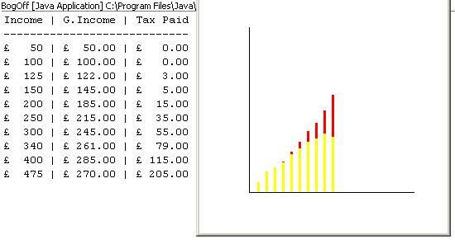fig.2
During the course of development of this program I obviously had to test it multiple times to ensure that I was getting the correct result, this included a lot of hand-written mathematics and design of classes which I have decided against including within this document (though can be produced at a moments notice). The reason for which I have decided to take this course of action is because it really won't make any difference as to whether the program works or not. I could provide substantial evidence that the program works, but if the final executable program which is distributed doesn't work, then all of that evidence is rendered null and void. The way I know that the program works properly is because it does.

The first class (TaxCalculator) is expected to take a user input and then produce an output which informs the user how much tax a child is being paid and how much money that would leave the child as actual income. This is achieved adequately by this class as a written output. The second class (TaxChart) is expected to take an array of inputs and produce two outputs: a bar-chart with multi-coloured bars to indicate the gross income and the tax paid, the sum of these should add up to the initial value input; the second output is a table of values which tells the user the net income, the income after tax, and then the tax paid. The sum of the two calculated values should equal the initial input. This, again, has been done adequately; though I feel that the bar-chart is slightly underwhelming without any labelling on the x or y axis and no indication of actual values, meaning that if you looked at it without the table you'd probably be lost. If there is any time before the actual deployment of this software I would propose that the time is invested in creating a chart with a labelled axis so the user knew what they were looking at.

The final class works as an amalgamation of the two previous classes. The input array is specified by the user and then the previous classes are called and the output is calculated. This class works exactly as expected, and the only improvement I can think of is that the user might like to manually type in an array of variables which would then be calculated and output. The program has the capacity to do this, it would just require an extra line of code or two. The main issue with this is that the chart will not change size so that if the user inputs more than 16 or 17 values it will run off the end of the x axis and look a bit silly. This could probably be altered, though I would need permissions to alter the Canvas class which we used.

Required Output
Though it is included above, I will show the Required Output again here just to be certain that it has been done effectively.

Required Output

