Atkinson, Amanda

21688366

Black Diamond Mine Field Preparation HW

* **Background**

Our Company has been contacted by an agency overseeing regional parks in the area. One of their parks is located in an area that was mined for coal toward the end of the 19th century, and then silica (for glass making) in the beginning of the 20th century.

The mining activities have ceased, however occasionally the shallow workings collapse and surface subsidence occurs. In some cases the underground workings become open presenting a safety threat to the visitors of the park. In fact, people have died at the site.

A few years ago a section of the mine collapsed causing subsidence. The nature of the subsidence indicated that a larger volume exists beneath the site, however the actual dimensions are unknown and could range from a coal mine drift (cross- sectional area of 4 m2) to a large room of the coal mine (say 4x5x5 m3). The depth to the top of the works could be as shallow as 3 m, and as deep as approximately 10 m. The workings are thought to lie beneath and perpendicular to the gravel road shown in (Figure 1). The site of the proposed survey is outlined in red. The gray symbol marks the location of the surface subsidence.

* **Problem Statement**

The park district would like assistance in 1) verifying the existence of an underground cavity, and 2) if such a cavity exists, its dimension.

* **Feasibility Analysis**

Given Assumtions:

air=0.0 g/cc

soil=1.6 g/cc (dry sand with gravel)

sandstone=2.3 g/cc (solid, well cemented sandstone)

Vp_soil=400 m/s

Vp_sandstone=3000 m/s

Vp_deeper_sandstone=5000 m/s

kair=0.0 (cgs/emu units)

ksoil=0.00005 (cgs/emu units)

ksandstone=0.0005 (cgs/emu units)

The magnetic declination at the site is approximately 15 degrees east, and the inclination is approximately 62 degrees

1) Given the parameters, I have concluded that there are 4 different situations to account for:

-Shallow tunnel (3m)

-Deep tunnel (10m)

-Shallow room

-Deep room

We need to characterize the gravity and magnetic fields for four different situations: shallow tunnel with small room, shallow tunnel with large room, deep tunnel with small room, and a deep tunnel with a large room. To make things more efficient, I graphed three scenarios: the minimum-a small, shallow room, the maximum-a large, deep room, and the median-a small, deep room.

First I graphed the minimum, which is shallow tunnel with the small room:

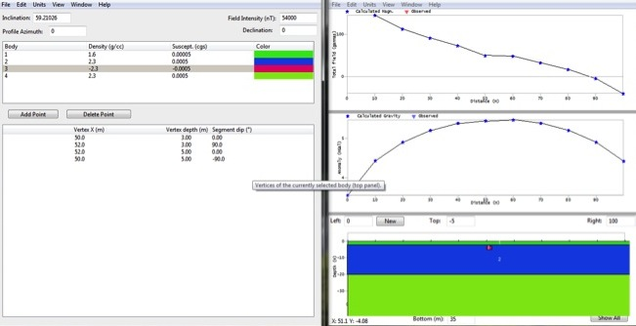The density contrast for this scenario is too small for the gravity anomaly to be valid, resulting in a symmetric gravity anomaly curve with no anomaly.

The magnetic model showed a minuscule anomaly that appears as a kink at 50m in the otherwise straight line. This anomaly could be used as supporting evidence for the existence of the tunnel, but I would not base my case on the magnetic anomaly alone.

Next I graphed the deep tunnel, small room scenario, which would be the median scenario.

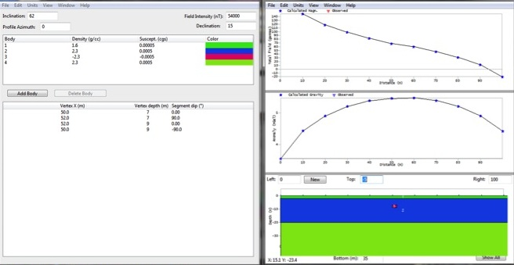

The gravity anomaly is still too small to be remotely conclusive. The magnetic anomaly is unnoticeable, rendering the magnetic testing inconclusive as well.

Graphing the maximum-large, deep room:

While the gravity is once again inconclusive, the magnetic survey shows a distinct anomaly. A magnetic survey could be used to find a large room in a deep tunnel.

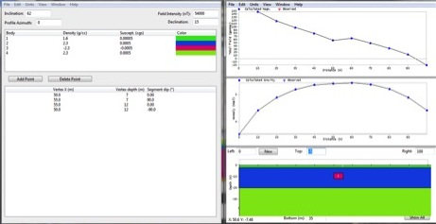

2) To calculate the seismic implications of the tunnel, we need to model what the survey would look like if no tunnel existed. We assume that a dense refracting layer exists beneath the possible tunnels at a depth of 20m. That will be considered our control.

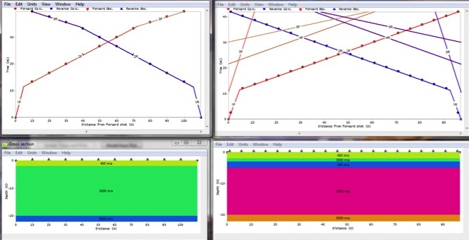We model the shallow tunnel against the control:

In the control, shown on the left, the velocity of the P-waves slows as it propagates through each layer. They are direct waves

In the model on the right, you can see the head waves (F1,F2), which is the p wave propagating through the first two layers. You can see the discrepancy at F3 which is where the wave hits the tunnel. When a P wave hits a tunnel, it does not make a head wave-instead it refracts down into the tunnel. It does create a reflecting wave, however, which is what we are seeing. I think.

3) For shallow tunnels like the one in this study, you could also use surface wave backscattering. I would use Rayleigh waves in particular, because they scatter off of tunnels, and move both forward and backward.

You could also use body wave diffraction for deeper tunnels or resonant imaging for persistent, resonant signals

4) I graphed the area on Google Maps. The red rectangle is our area of interest, the opaque line is where the tunnel is predicted to exist. The gravity modeling proved to be inconclusive, so it would be an unnecessary use of money and time to conduct gravity surveys.

The magnetic models showed a small anomaly, so it may be beneficial to bring along a portable magnetometer to conduct a magnetic survey to back up results from the seismic methods. The magnetometer is in a backpack, so I would walk over the area of interest to get an accurate survey.

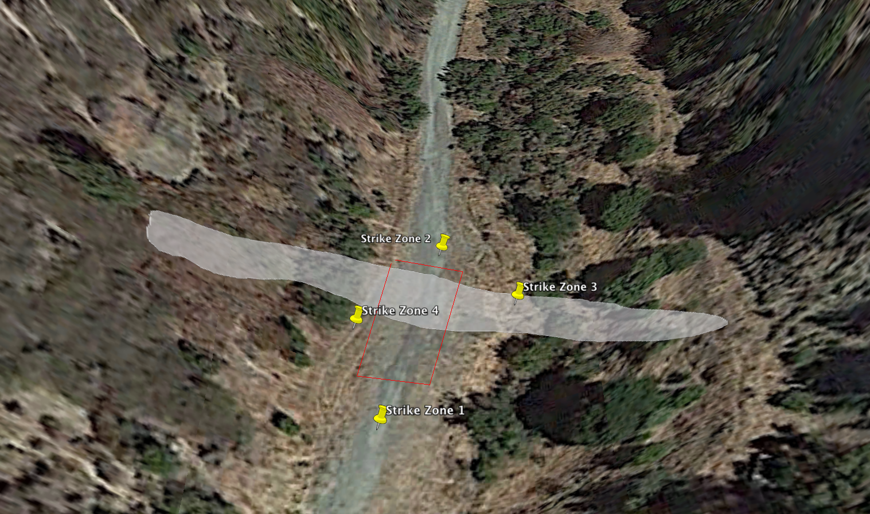The terrain on either side of the road was too steep to place a long line of strike zones, so I placed them on all sides of the rectangle. That way, the geophones will form a cross over the area of interest and optimize the response.

5) I decided to not perform the gravity survey, which saved $600 for a gravimeter rental.

The rest of the equipment are rentals provided by Geometrics. They are charged by the day.

Magnetometers:

Base station: $27

Portable backpack: $80

Seismographs:

Geode G24 Full System: $127

Geophone: $5

Cables: $80

For the surveys I would like to conduct, I would need a budget of at least $350-$400. Including meals and transportation for my entire group, a budget of around $700 should suffice. I also charge $60/hour for my services, but that should be considered by the company employing me.

Obstacles and Assumptions

We are assuming layers are all parallel to surface, we are using a 2-D model instead of a 3-D model, and we are assuming level topography.