Mechanics:
Platforms:
Elevator platform:
2 variants, one that moves up or down when a player collides with the collision box, this move itself up or down depending on current height
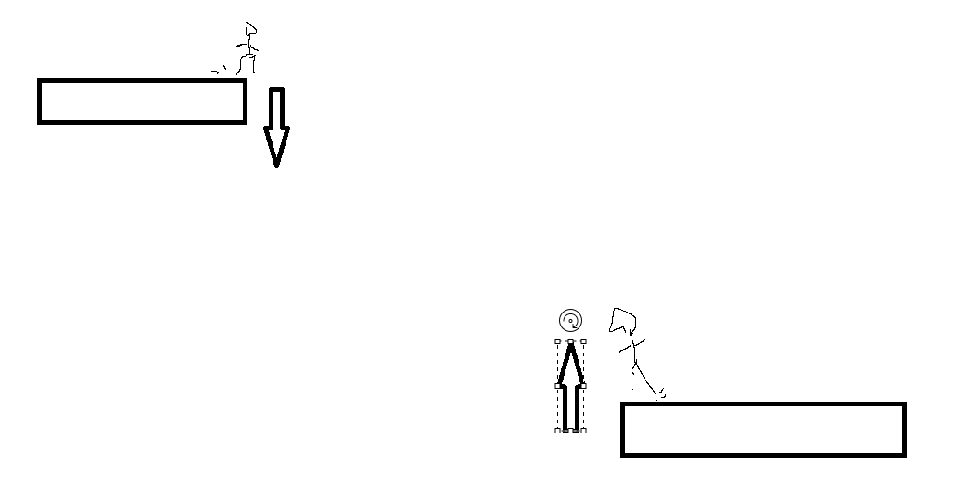
Continuous movement up and down
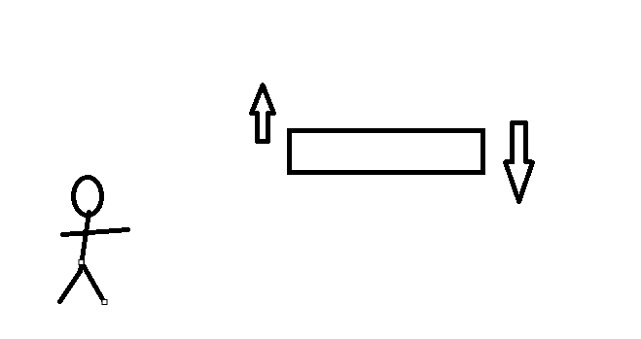
Disappearing platform:
When the player collides with the collision a delay set until it crumbles and the player fall through the platform unless they move off quick enough
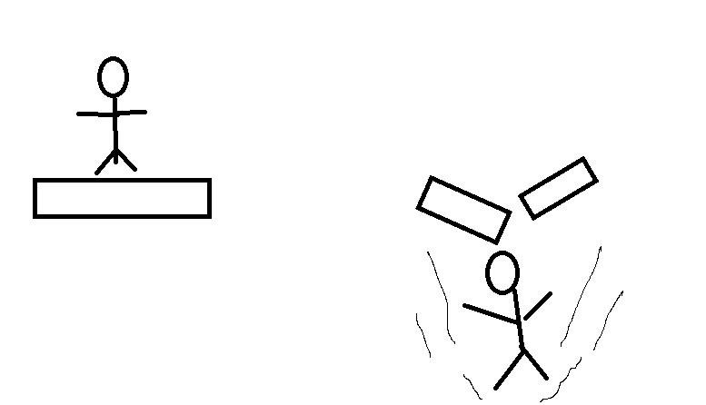
Lantern only visible platforms:
Platforms with visibility disabled until the collision box based off the lantern collides with them, setting visibility to true
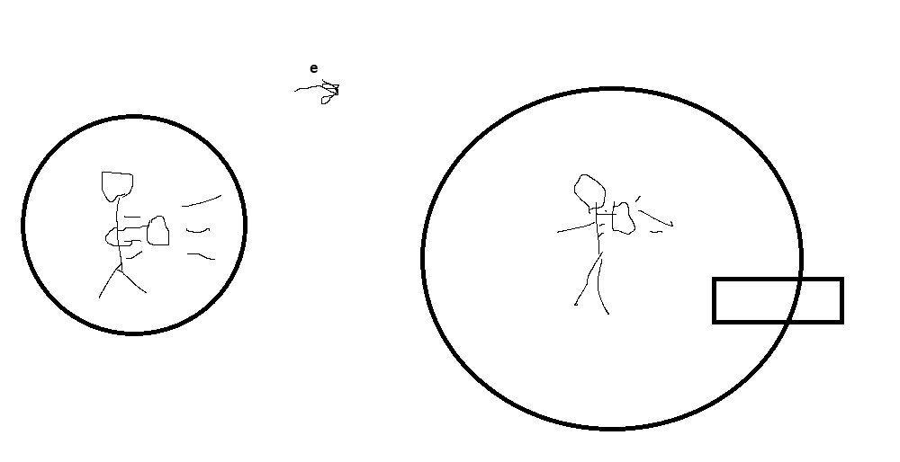
corruption platforms:
these platforms disable the lantern and set the player speed lower
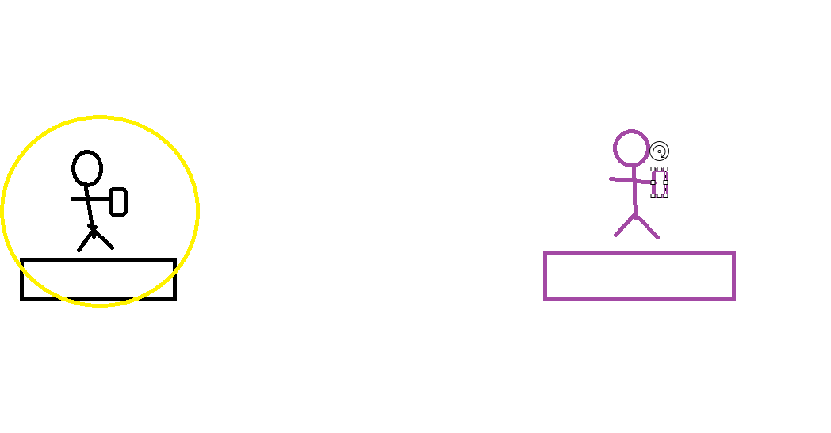
Move set:
Variable jump
Normal jump gives base height, but with a longer button press extend the height usually available
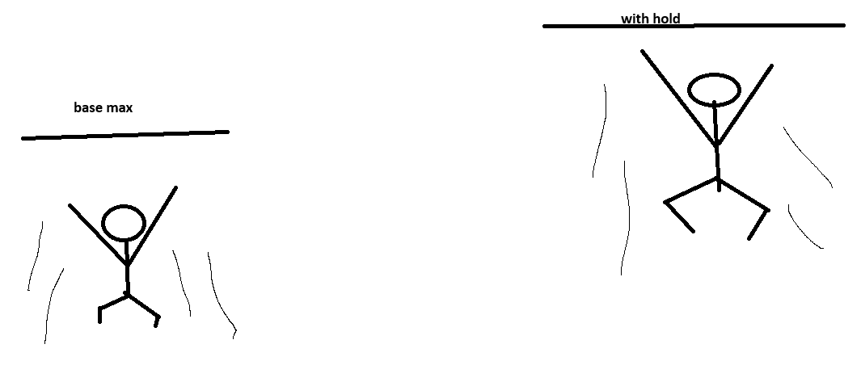
Dive
The dive is a desperation move used within the air to help correct a bad jump or cover a larger distance, but this comes with a 1 second stun due to the landing
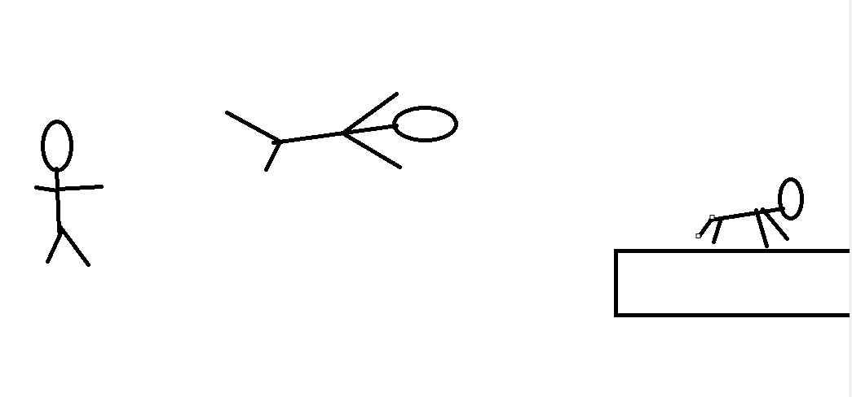
Lantern:
The lantern functionally is one big circular collision box with 2 inputs to control its scale, this collision box allows for unique interactions such as stunning enemies by changing their set behaviour, but this come with one problem why not just have it extended continually, that where the oil bar comes in, this makes using the larger area more punished by having oil go at max 2x speed and it lowest 0.75x speed in the decreases.
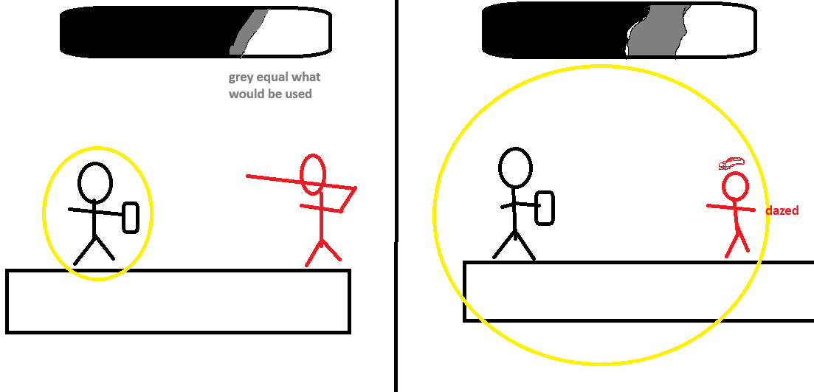
Sanity system:
A timer or countdown is set at the start of the players playtime, as this ticks down it eventually reach certain threshold sane to unstable to on the verge to insane, currently not everything’s is decided on what each state will affect but for sure there is fake aspects of the level that will spawn in when the players reach a certain threshold along with this enemy will become more numerous. Also, our score system, how sane the character is. Eg score ranks sss, a+, f
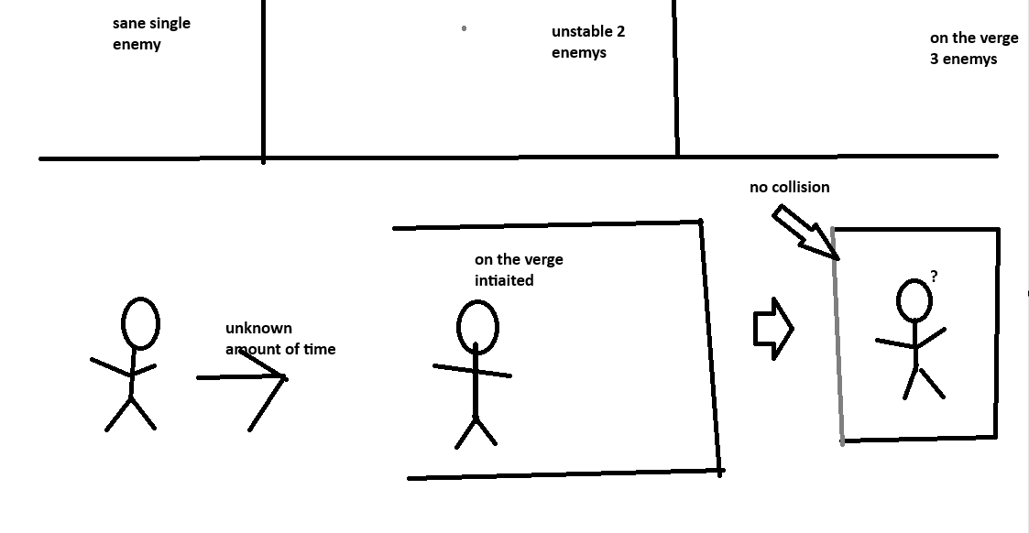
Items/ collectibles:
Shattered memories
These are rewards for platforming or puzzle completions that reveal parts of the story, the unlocked memories will be available to read once then only on the title screen, due to our ui limitations. Eg on collect the story is visible but once gone, title screen only.
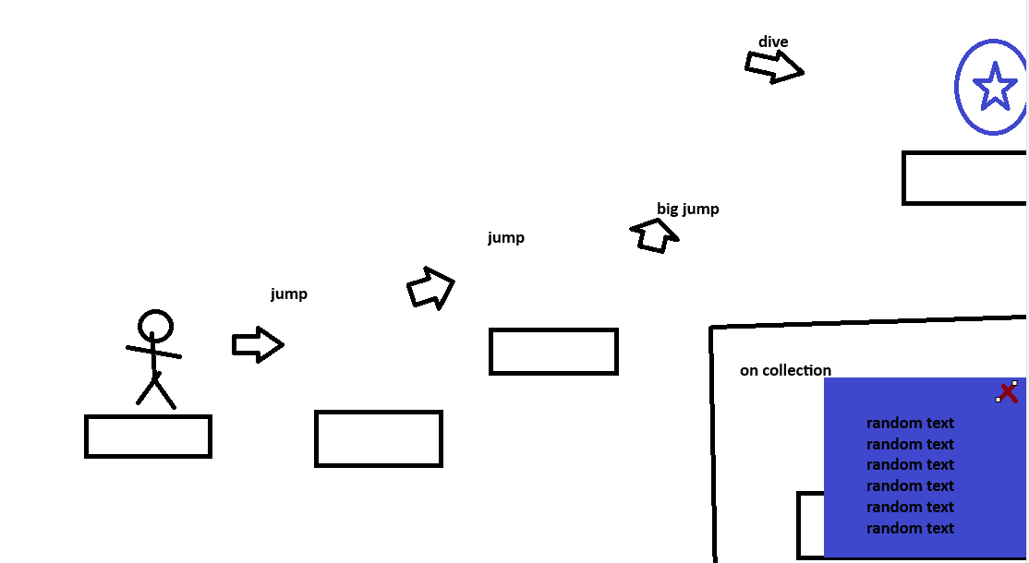
Oil pickups
On collection add a set amount to the lanterns oil amount
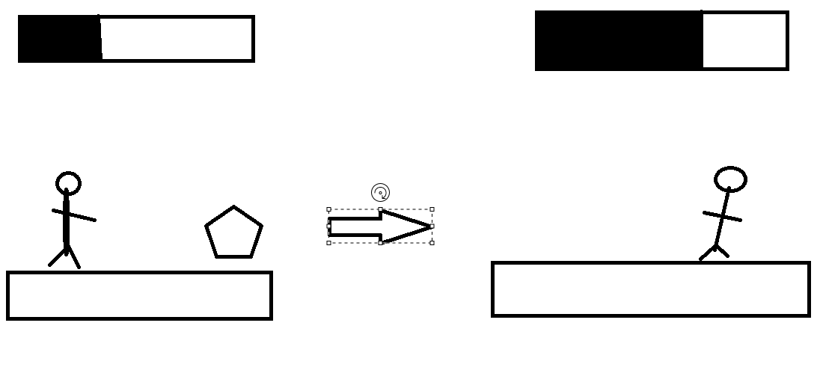
Enemy:
The enemy is a ranged attacker as otherwise the base amount of light would stop any attack from being possible, it spots the player moves into range, runs a 1-2 second wind up then launch its own arm or some sort projectile at the player unless the player, extend the lantern or close the gap in time, dazing the creature for as long as it in the light, then once out of it taking 2-5 seconds to recover.
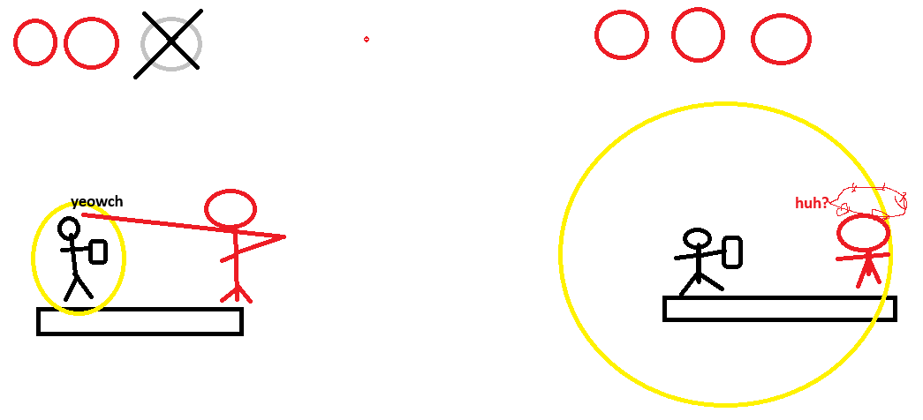
Puzzle mechanic:
Lock and key:
The player finds a key hidden or in plain sight that is then collected by the player, which allows the player to open a locked doors, this could hide extra items, or secret collectibles or be the level advancement.
