UECS1104/1144 Object-Oriented Application Development

Group Assignment

Name & Programme : Group 20

Eivonne Goh Yee Fang (Leader) | SE
Chin Kee Jeay | SE
Ker Ding Wei | SE
Max Vun Sheng Khai | SE

 | Component | Missing | Poor | Average | Good | Excellent | Max Marks | Marks Obtained
2 | Introduction |  |  |  |  |  | 10
3 | Class Diagram (Notation used, relationship, multiplicities) |  |  |  |  |  | 20
4-6 | Implementation/ Functionalities |  |  |  |  |  | 40
4-6 | File Handling |  |  |  |  |  | 5
4-6 | Exception Handling |  |  |  |  |  | 5
4-6 | Sample of Input data |  |  |  |  |  | 5
4-6 | Sample Output (Screenshot) |  |  |  |  |  | 5
4-6 | Presentation / General Effort |  |  |  |  |  | 10
Total |  |  |  |  |  |  | 100
Remarks (for Examiner only):

Introduction
UX Gallery focuses on selling modern fine art, particularly lithographs and photography. They need an application to keep track of the customers and their art purchases, information of artists and their artworks. They also need to keep track of the current inventory. Hence, the application developed by us is a console-based management application.We are using Eclipse IDE for Java Developers to develop this application.

Functional Requirements
FR01. The application shall allow the user to create an account.
FR02. The application shall allow the user to login to the account.
FR03. The application shall allow the user to logout from the account.
FR04.The application shall allow the user to change their password for their own account.
FR05. The application shall allow the user to upload the information of customers, artists and artworks which are newly registered.
FR06. The application shall allow the user to remove the details of customers, artists, and artworks.
FR07. The application shall allow the user to modify the detail of customers, artists, and artworks.
FR08. The application shall allow the user to view the information of customers and artists.
FR09. The application shall allow the user to view the detail of artwork according to different categories.
FR10. The application shall allow the user to view the details of inventory including the purchase price of the artwork and the selling price when sold.
FR11. The application shall allow the user to view the list of unsold artworks.

Use case diagram
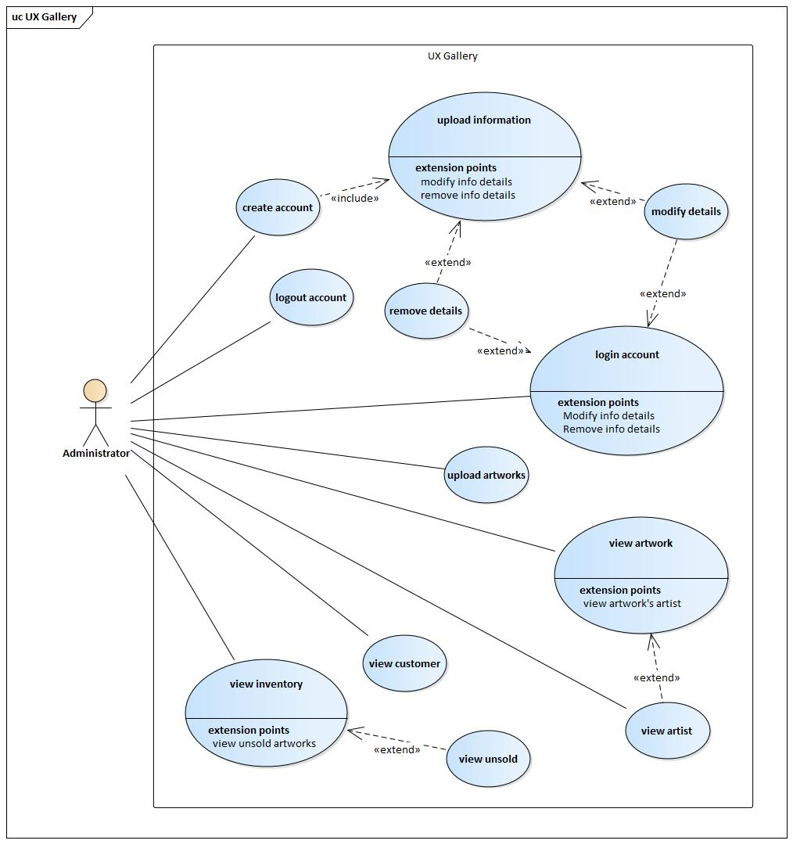

Assumptions
1. The application will only show the purchase price for the unsold artworks when users search the details of inventory.
2. The application will provide secure login and registration for users.
3. The application will have a way to securely store data.
4. Users must use their own password to login to their account.
5. Customers need to select their artist preferences when they register with the UX gallery to be a customer.
6. If customers want to change their artist preferences, they need to contact the staff in the UX gallery to help them modify their information.
7. User is the admin of the application.

Workload Allocation

Name of Student | Workload
Eivonne Goh Yee Fang | Allocate workload, set deadline, write report (Introduction), draw the class diagram, develop the application (....), compile all the work done
Chin Kee Jeay | Double check the report,draw the class diagram and develop the application (.....)
Ker Ding Wei | Write report (Functional requirement, use case diagram, assumption),draw the class diagram and double check the report
Max Vun Sheng Khai | Write report (Functional requirement, use case diagram, assumption), draw the class diagram and double check the report

