状态模式(State Pattern)
对象状态影响对象行为：
对象拥有不同的状态，往往会行使不同的行为...
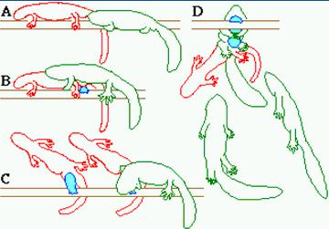
动机：
在软件构建过程中，某些对象的状态如果改变以及其行为也会随之而发生变化，比如文档处于只读状态，其支持的行为和读写状态支持的行为就可能完全不同。
如何在运行时根据对象的状态来透明更改对象的行为？而不会为对象操作和状态转化之间引入紧耦合？
意图：
允许一个对象在其内部状态改变时改变它的行为。从而使对象看起来似乎修改了其行为。 ------《设计模式》GOF
结构图：
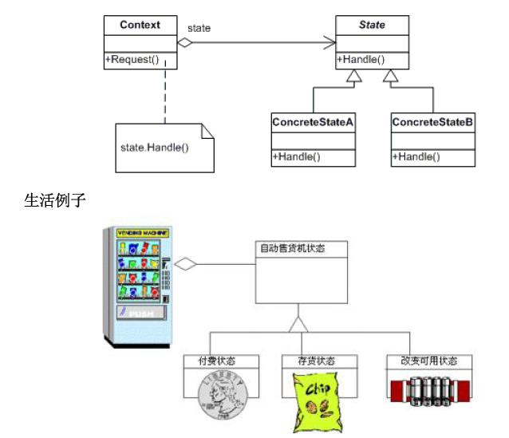
适用性：
1.一个对象的行为取决于它的状态，并且它必须在运行时刻根据状态改变它的行为。
2.一个操作中含有庞大的多分支的等条件语句，且这些分支依赖于该对象的状态。这个状态通常用一个或多个枚举常量表示。通常，有多个操作包含这一相同的条件结构。State模式将每一个分支放入一个独立的类中。这使得你可根据对象自身的情况将对象的状态作为一个对象，这一对象可以不依赖于其他对象而独立变化。
代码实现：

class MainApp
{
static void Main()
{
// Open a new account
Account account = new Account("Jim Johnson");
// Apply financial transactions
account.Deposit(500.0);
account.Deposit(300.0);
account.Deposit(550.0);
account.PayInterest();
account.Withdraw(2000.00);
account.Withdraw(1100.00);
// Wait for user
Console.Read();
}
}
// "State"
abstract class State
{
protected Account account;
protected double balance;
protected double interest;
protected double lowerLimit;
protected double upperLimit;
// Properties
public Account Account
{
get{ return account; }
set{ account = value; }
}
public double Balance
{
get{ return balance; }
set{ balance = value; }
}
public abstract void Deposit(double amount);
public abstract void Withdraw(double amount);
public abstract void PayInterest();
}
// "ConcreteState"
// Account is overdrawn
class RedState : State
{
double serviceFee;
// Constructor
public RedState(State state)
{
this.balance = state.Balance;
this.account = state.Account;
Initialize();
}
private void Initialize()
{
// Should come from a datasource
interest = 0.0;
lowerLimit = -100.0;
upperLimit = 0.0;
serviceFee = 15.00;
}
public override void Deposit(double amount)
{
balance += amount;
StateChangeCheck();
}
public override void Withdraw(double amount)
{
amount = amount - serviceFee;
Console.WriteLine("No funds available for withdrawal!");
}
public override void PayInterest()
{
// No interest is paid
}
private void StateChangeCheck()
{
if (balance > upperLimit)
{
account.State = new SilverState(this);
}
}
}
// "ConcreteState"
// Silver is non-interest bearing state
class SilverState : State
{
// Overloaded constructors
public SilverState(State state) :
this( state.Balance, state.Account)
{
}
public SilverState(double balance, Account account)
{
this.balance = balance;
this.account = account;
Initialize();
}
private void Initialize()
{
// Should come from a datasource
interest = 0.0;
lowerLimit = 0.0;
upperLimit = 1000.0;
}
public override void Deposit(double amount)
{
balance += amount;
StateChangeCheck();
}
public override void Withdraw(double amount)
{
balance -= amount;
StateChangeCheck();
}
public override void PayInterest()
{
balance += interest * balance;
StateChangeCheck();
}
private void StateChangeCheck()
{
if (balance < lowerLimit)
{
account.State = new RedState(this);
}
else if (balance > upperLimit)
{
account.State = new GoldState(this);
}
}
}
// "ConcreteState"
// Interest bearing state
class GoldState : State
{
// Overloaded constructors
public GoldState(State state)
: this(state.Balance,state.Account)
{
}
public GoldState(double balance, Account account)
{
this.balance = balance;
this.account = account;
Initialize();
}
private void Initialize()
{
// Should come from a database
interest = 0.05;
lowerLimit = 1000.0;
upperLimit = 10000000.0;
}
public override void Deposit(double amount)
{
balance += amount;
StateChangeCheck();
}
public override void Withdraw(double amount)
{
balance -= amount;
StateChangeCheck();
}
public override void PayInterest()
{
balance += interest * balance;
StateChangeCheck();
}
private void StateChangeCheck()
{
if (balance < 0.0)
{
account.State = new RedState(this);
}
else if (balance < lowerLimit)
{
account.State = new SilverState(this);
}
}
}
// "Context"
class Account
{
private State state;
private string owner;
// Constructor
public Account(string owner)
{
// New accounts are 'Silver' by default
this.owner = owner;
state = new SilverState(0.0, this);
}
// Properties
public double Balance
{
get{ return state.Balance; }
}
public State State
{
get{ return state; }
set{ state = value; }
}
public void Deposit(double amount)
{
state.Deposit(amount);
Console.WriteLine("Deposited {0:C} --- ", amount);
Console.WriteLine(" Balance = {0:C}", this.Balance);
Console.WriteLine(" Status = {0}\n" ,
this.State.GetType().Name);
Console.WriteLine("");
}
public void Withdraw(double amount)
{
state.Withdraw(amount);
Console.WriteLine("Withdrew {0:C} --- ", amount);
Console.WriteLine(" Balance = {0:C}", this.Balance);
Console.WriteLine(" Status = {0}\n" ,
this.State.GetType().Name);
}
public void PayInterest()
{
state.PayInterest();
Console.WriteLine("Interest Paid --- ");
Console.WriteLine(" Balance = {0:C}", this.Balance);
Console.WriteLine(" Status = {0}\n" ,
this.State.GetType().Name);
}
}
结果：
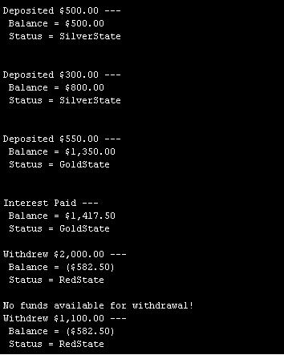
State模式的几个要点：
1.State模式将所有一个特定状态相关的行为都放入一个State的子类对象中，在对象状态切换时，切换相应的对象;但同时维持State的接口，这样实现了具体操作与状态转换之间的解耦。
2.为不同的状态引入不同的对象使得状态转换变得更加明确，而且可以保证不会出现状态不一致的情况，因为转换是原子性的----即要么彻底转换过来，要么不转换。
3.如果State对象没有实例变量，那么各个上下文可以共享 同一个State对象，从而节省对象开销。

