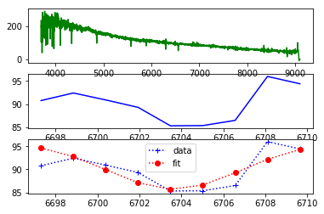

SUBCLASS= 'A7IV

一项高斯拟合度R2= 0.624696135520935



FWHM= 5.261098402562702