SmartTutor Report
CSIT 5900 Spring 2026 | AI Group Project
1. Overview
SmartTutor is a homework tutoring agent built for first-year university students. The system focuses on four supported subjects: Math, History, Economics, and Chemistry. Its main goal is not only to answer academic questions, but also to reliably reject invalid requests such as off-topic, dangerous, or unverifiable local questions. In addition, the agent supports a conversation summary request so that a user can review the discussion so far.
The implementation follows a lightweight multi-stage pipeline:
User Input -> Input Validation -> Quick Keyword Check -> LLM Intent Classification -> Subject Routing / Rejection -> Streamed Response
This design was chosen because the assignment emphasizes both usability and reliability. The keyword layer gives a fast first-pass filter for obviously unsafe or irrelevant requests, while the LLM classifier provides a more flexible final routing decision. Once a request is accepted, SmartTutor forwards it to a subject-specific agent.
2. Agent Design
The system is implemented in Streamlit and organized into several modules:
- app.py: the main web application. It manages the chat interface, session history, sidebar settings, and response streaming.
- guardrails.py: the core safety and routing module. It validates input length, checks dangerous/off-topic/obscure keywords, detects summary requests, and uses the LLM for final intent classification.
- math_agent.py, history_agent.py, economics_agent.py, chemistry_agent.py: subject-specific tutoring agents. Each agent uses a dedicated system prompt to produce explanations appropriate for homework help.
- llm_utils.py: a wrapper around the LLM API. It supports multiple backends and streams model output to the user interface.
The most important design decision is the guardrails-first architecture. Instead of sending every request directly to a general-purpose model, SmartTutor first decides whether the question should be accepted at all. This reduces irrelevant responses and makes the system closer to a real educational assistant rather than a generic chatbot. The interface also allows the user to choose the API source and grade level, which changes the explanation style.
3. Running Instructions
From the project root:
cd code
pip install -r requirements.txt
streamlit run app.py
After launching Streamlit, open the local URL shown in the terminal, choose the “ModelScope” API source in the sidebar, and then ask a homework question. The agent accepts supported academic questions, rejects invalid ones, and also accepts summary requests.
4. Example Interactions
The following screenshots are taken from the implemented system and match the assignment requirement of including accepted questions, rejected questions, and a summary request.
Example 1: Accepted history question
User question: Who was the first president of the United States?
This is accepted as a valid history question. The agent routes it to the history tutor and gives a direct factual answer.
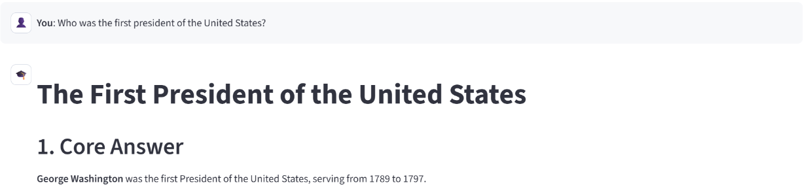
Example 2: Accepted math question
User question: How do I solve the equation 2x + 5 = 13?
This is accepted as a valid math homework problem. The math agent provides a worked solution.
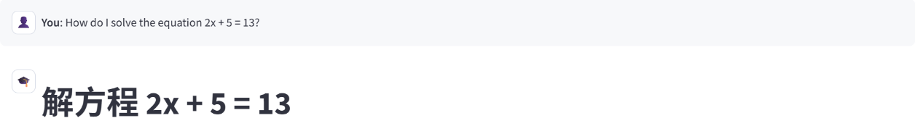
Example 3: Accepted summary request
User request: Can you summarise our conversation so far?
This is accepted because summary requests are explicitly supported by the guardrails module. The agent summarizes both accepted and rejected turns in the conversation history.
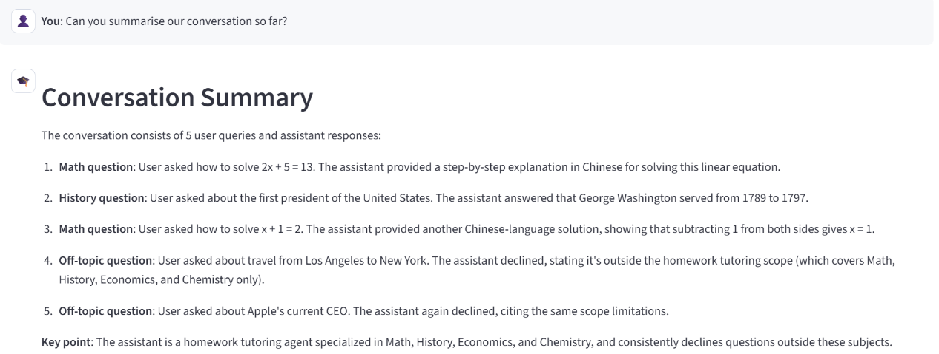
Example 4: Rejected off-topic question
User question: What is the best way to travel from Los Angeles to New York?
This request is rejected because it is outside the homework domain. The guardrails detect the off-topic keyword travel and return a refusal message.
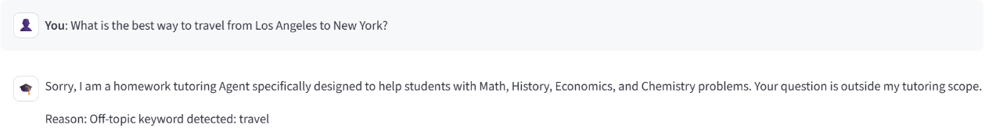
Example 5: Rejected unsupported general question
User question: Who is the current CEO of Apple?
This request is also rejected. It is not a homework question in one of the supported subjects, so the system refuses it rather than acting as a general knowledge assistant.
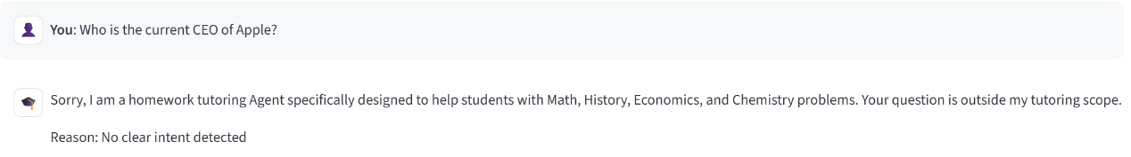
5. Discussion
Overall, SmartTutor satisfies the assignment goal of building a focused academic agent with clear boundaries. Its strengths are:
- support for multiple academic subjects rather than only one domain;
- a practical guardrails mechanism that rejects invalid inputs early;
- conversation memory and summary support;
- a simple Streamlit interface that is easy to demonstrate.
The current system is intentionally narrow in scope: it prioritizes reliable homework support over open-ended general chat. That tradeoff is appropriate for this course project, because it makes the agent easier to control, evaluate, and explain.

