**Guided Capstone Project Report**

Big Mountain Resort offers spectacular views of Glacier National Park and Flathead National Forest, with access to 105 trails. Every year about 350,000 people ski or snowboard at Big Mountain. This mountain can accommodate skiers and riders of all levels and abilities. These are serviced by 11 lifts, 2 T-bars, and 1 magic carpet for novice skiers. The longest run is named Hellfire and is 3.3 miles in length. The base elevation is 4,464 ft, and the summit is 6,817 ft with a vertical drop of 2,353 ft. Big Mountain Resort has recently installed an additional chair lift to help increase the distribution of visitors across the mountain. This additional chair increases their operating costs by $1,540,000 this season. The main target for the analysis is to predict the most appropriate ticket price comparing all the ski resorts of the Montana state and the national wide. And the following 4 different strategies have been discussed and compared.

1. Permanently closing down up to 10 of the least used runs. This doesn't impact any other resort statistics.
2. Increase the vertical drop by adding a run to a point 150 feet lower down but requiring the installation of an additional chair lift to bring skiers back up, without additional snow making coverage
3. Same as number 2, but adding 2 acres of snow making cover
4. Increase the longest run by 0.2 mile to boast 3.5 miles length, requiring an additional snow making coverage of 4 acres

We compared two models of linear regression and random forest. We selected the random forest as our final model, since the prediction is the closest to the current data. And the following features are the ones having most impact to the ticket price.

1. vertical_drop
2. Snow Making_ac
3. total_chairs
4. fastQuads
5. Runs
6. LongestRun_mi
7. trams
8. SkiableTerrain_ac

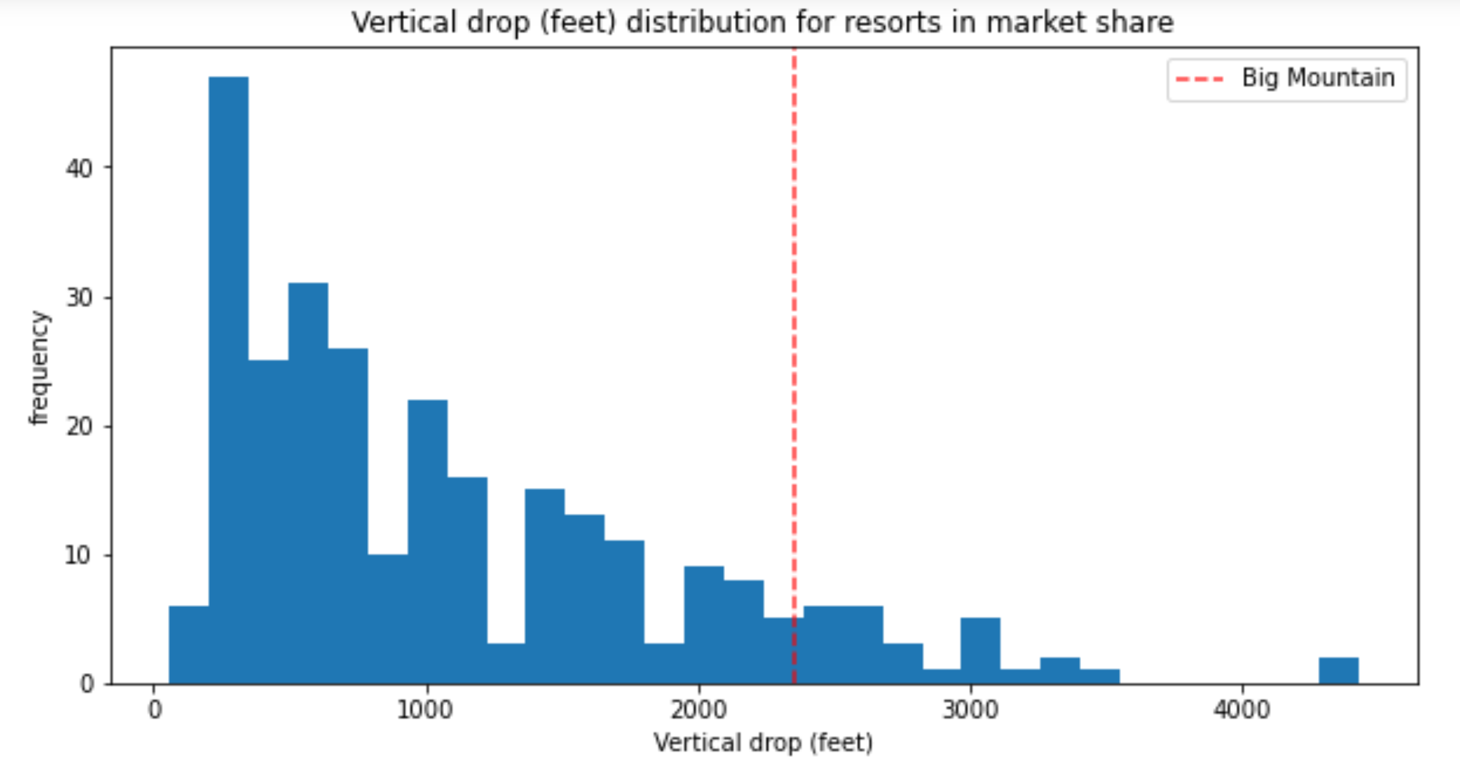

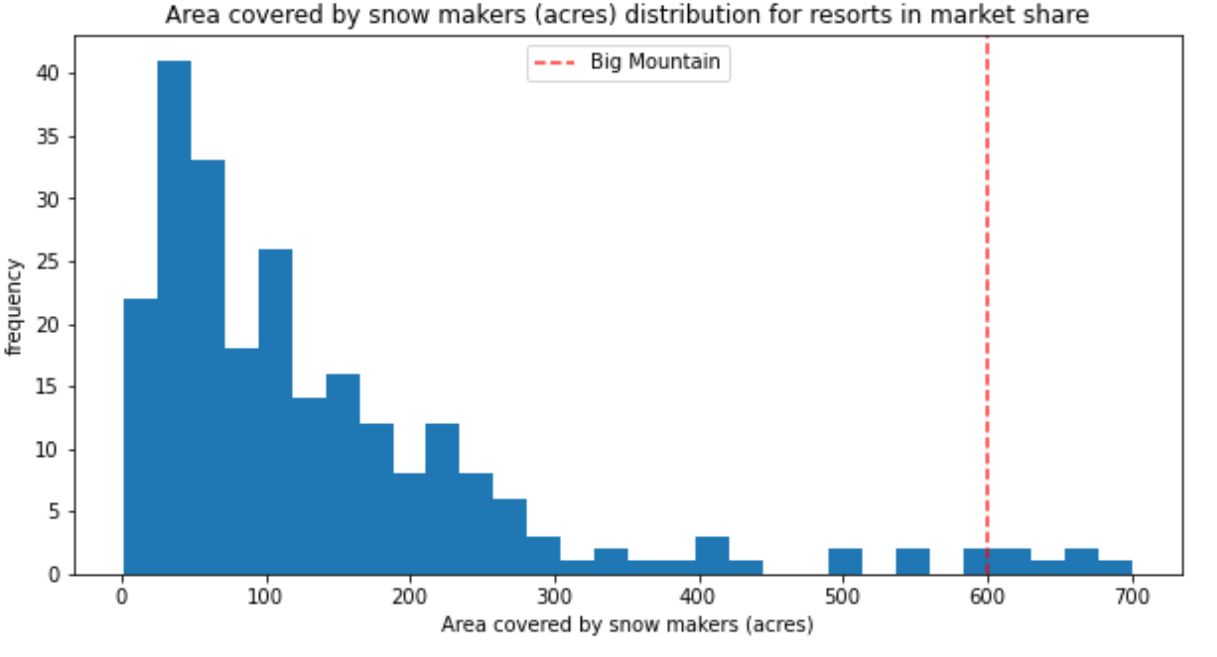

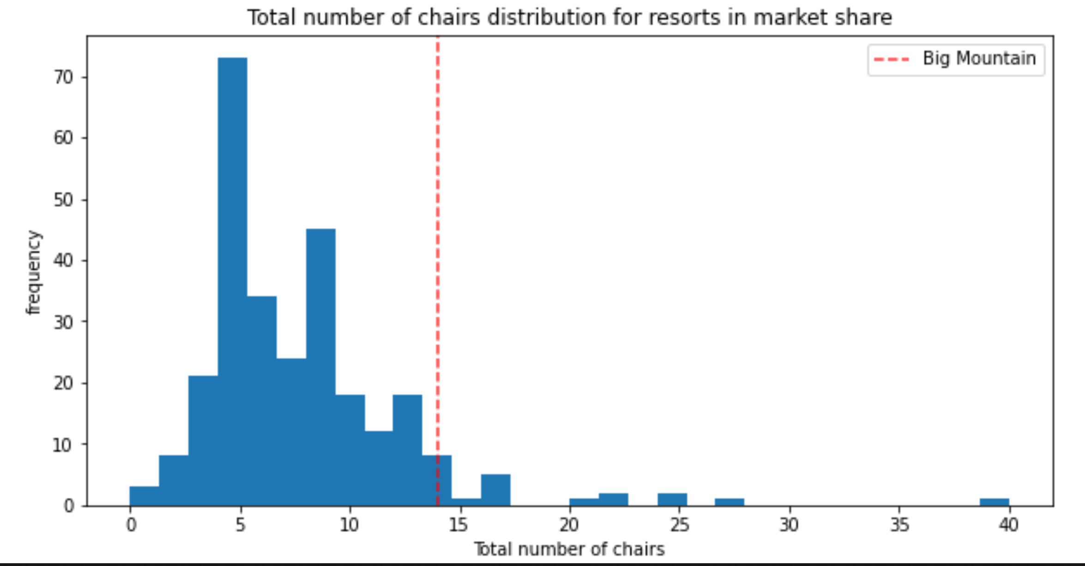

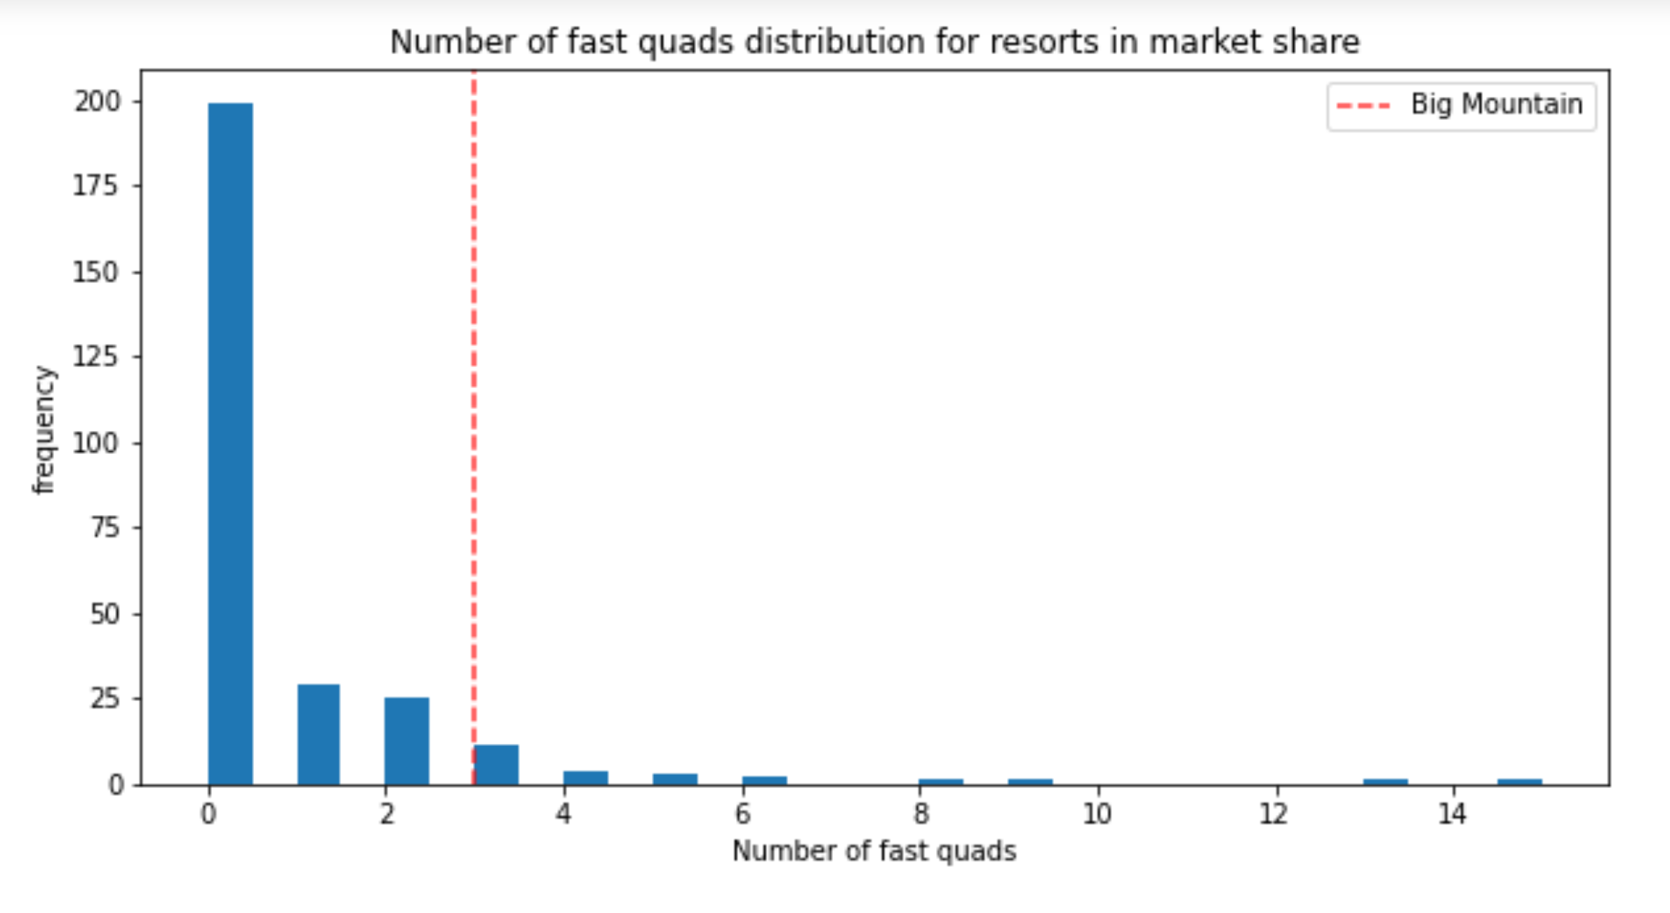

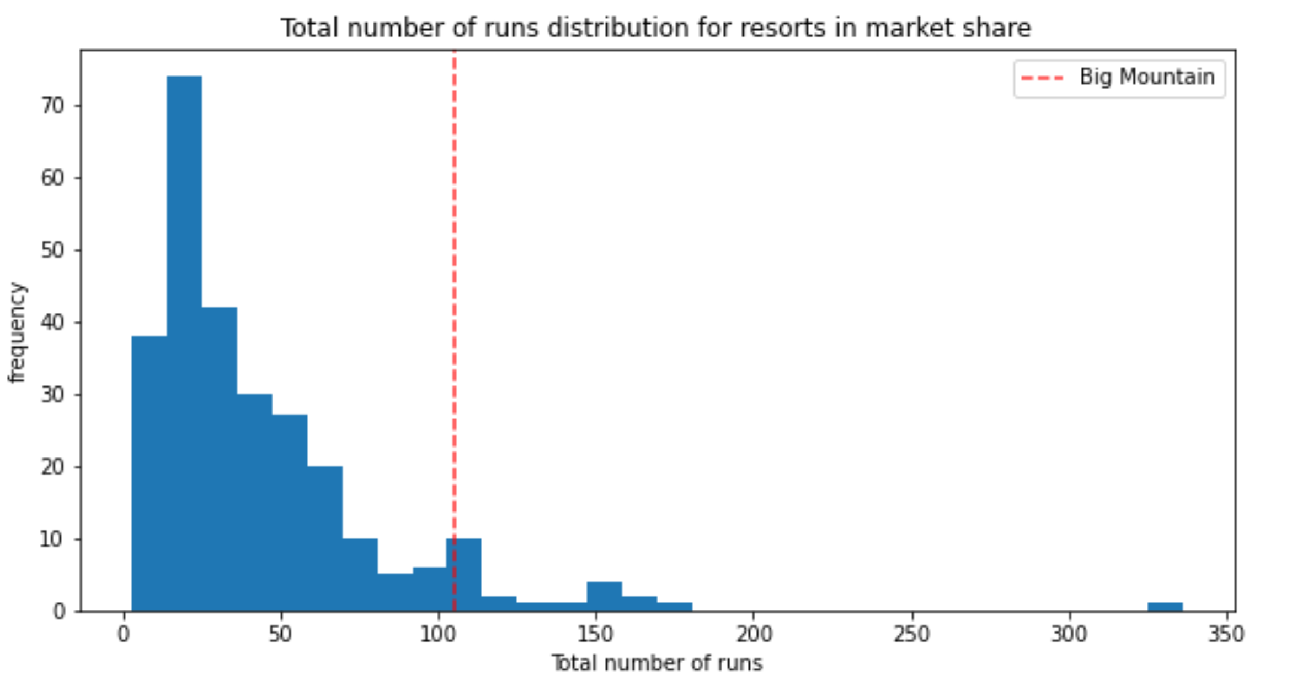

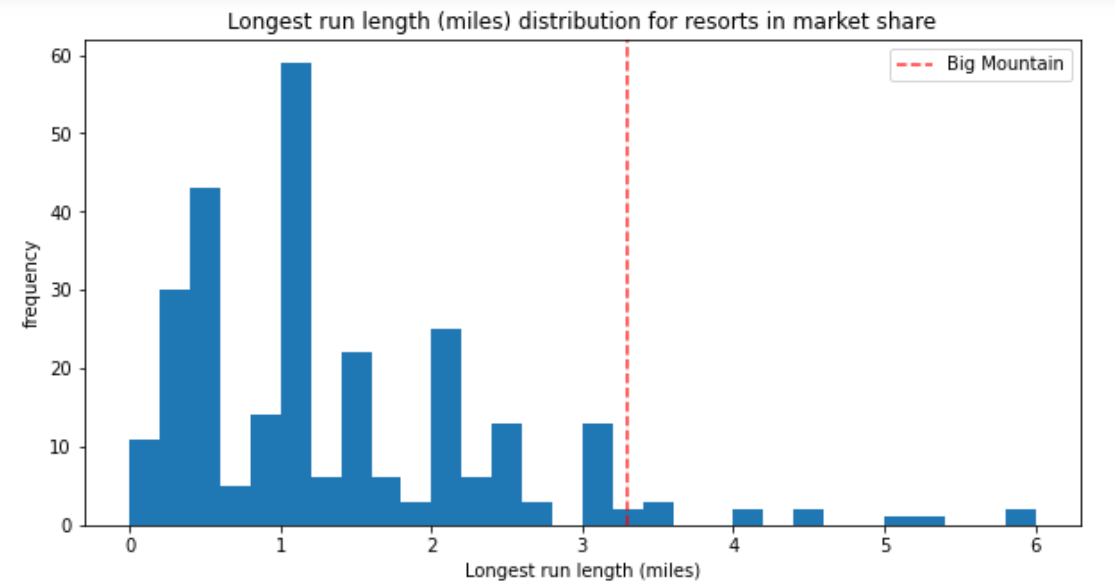

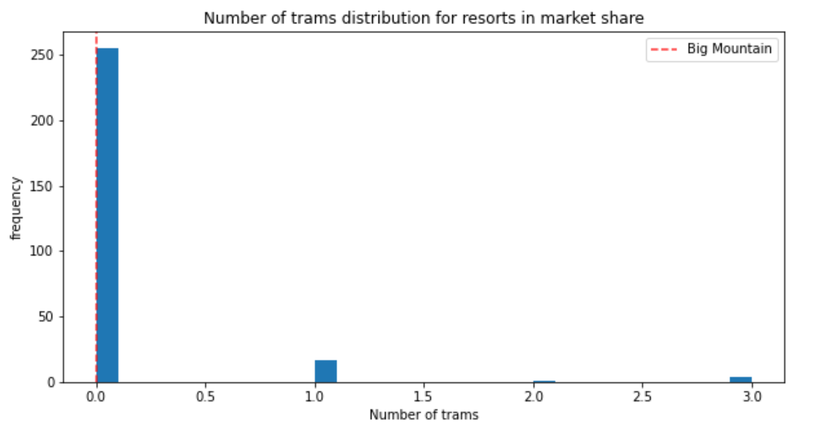

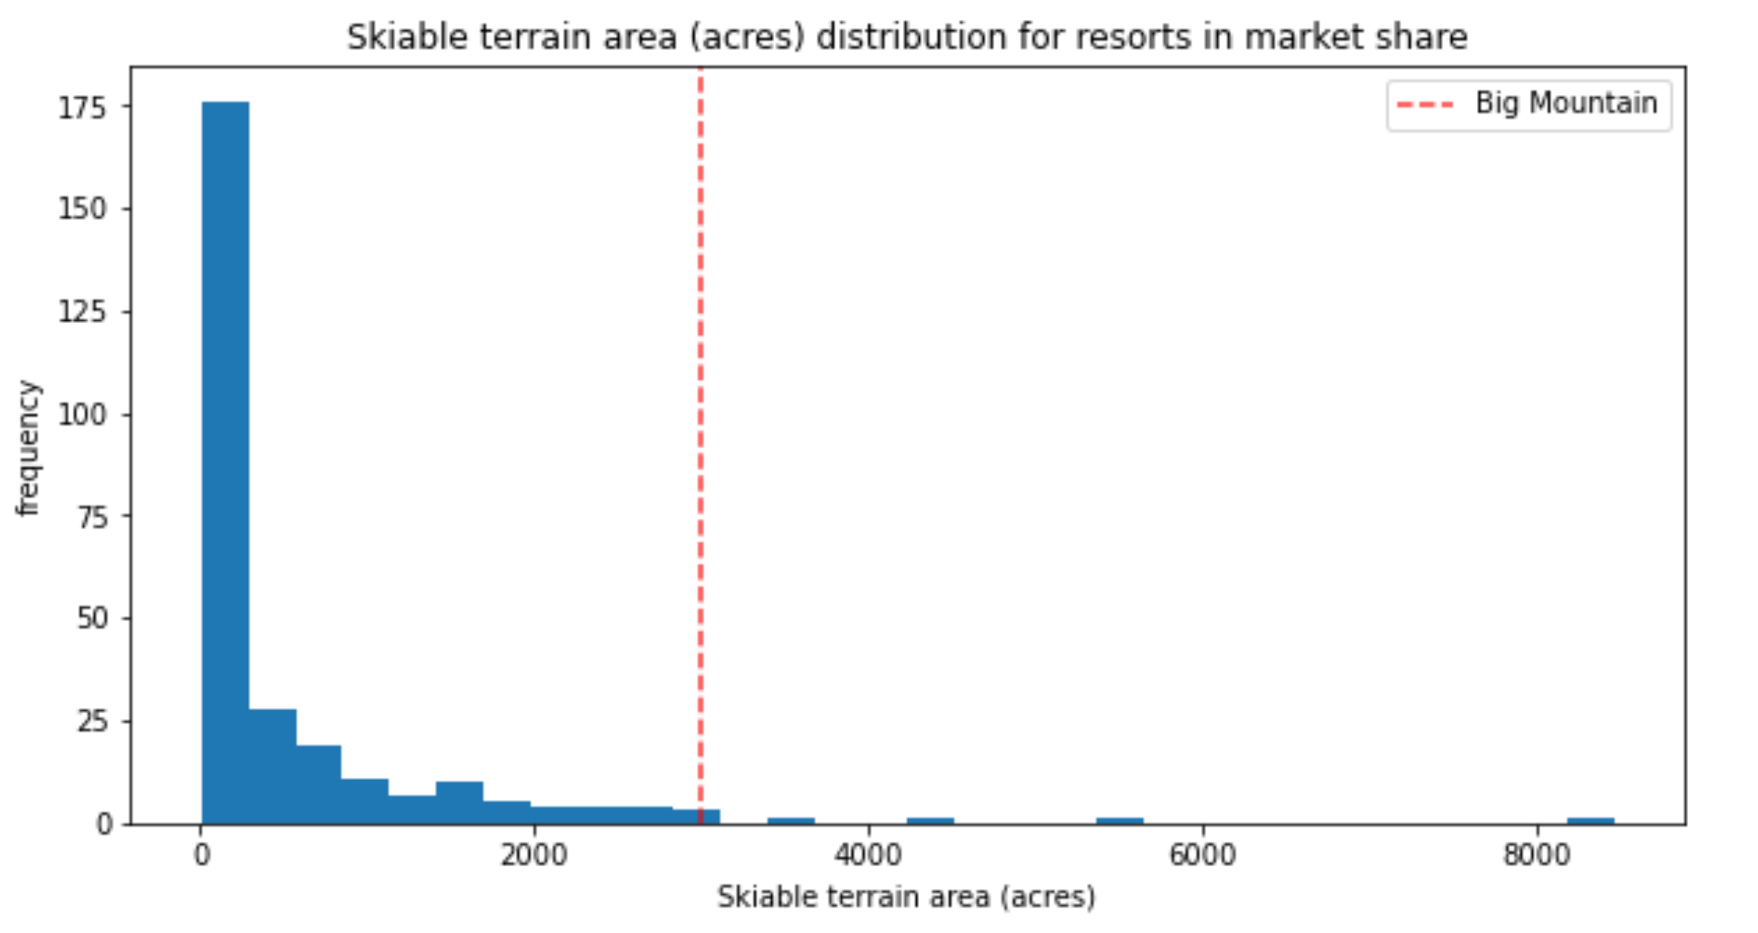

After analysis, Big Mountain Resort modelled price is $95.87, actual price is $81.00, which suggests there is room for an increase.

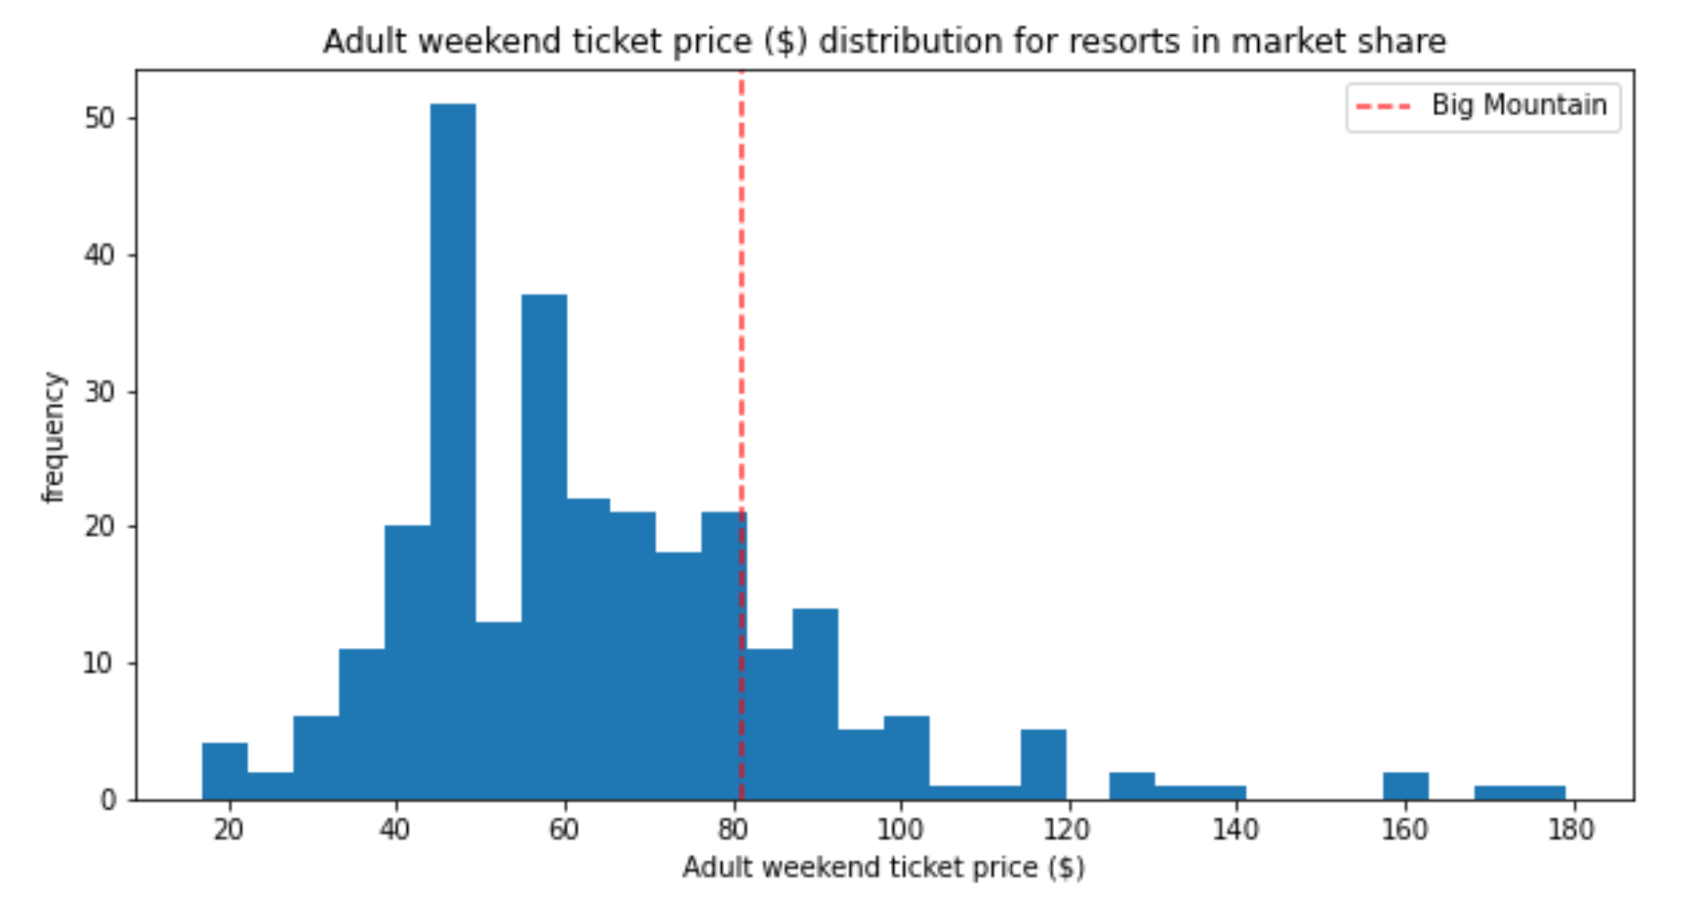

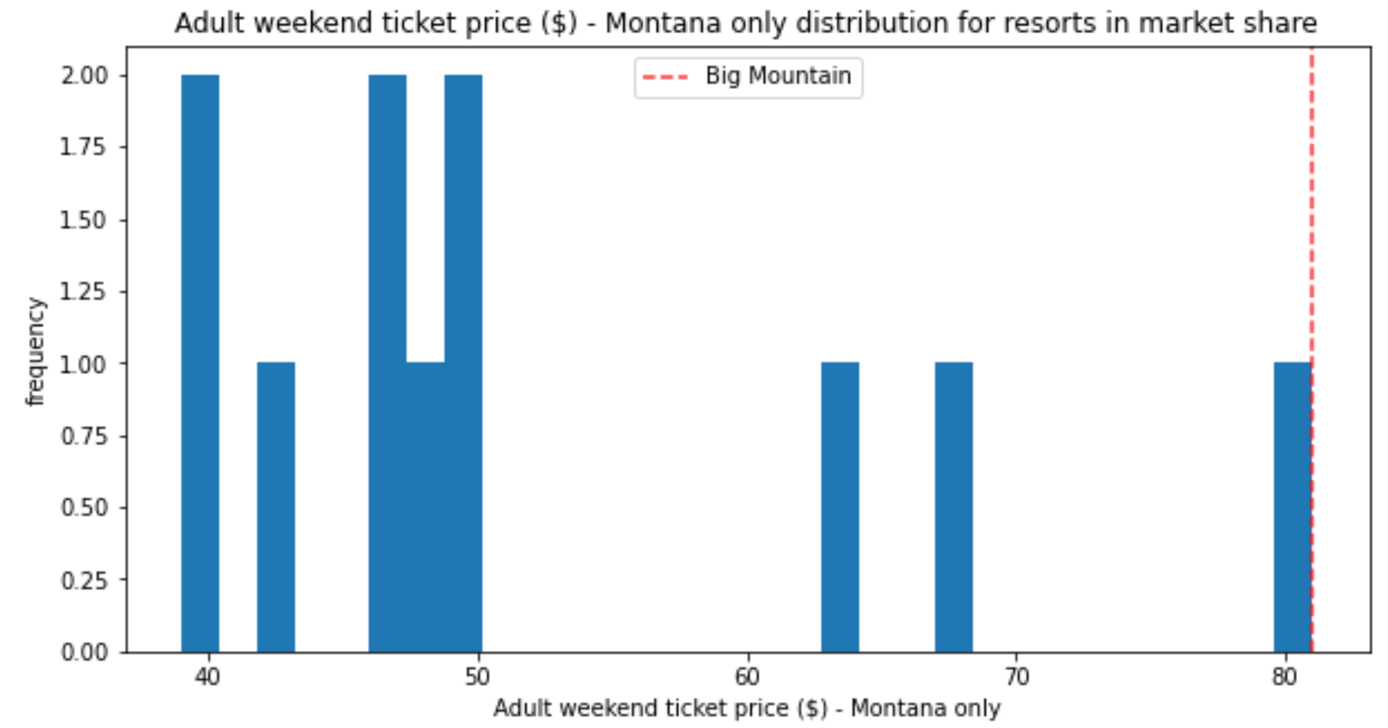

Regarding to the 4 strategies comparison, based on the philosophy of reduce the cost or increase the revenue, we get conclusion as below:

The result will recommend business to consider the Senario 1 and 2. With Senario 1: Permanently closing down up to no more than 3 runs of the least used runs. Otherwise the revenue will drop tremendously.

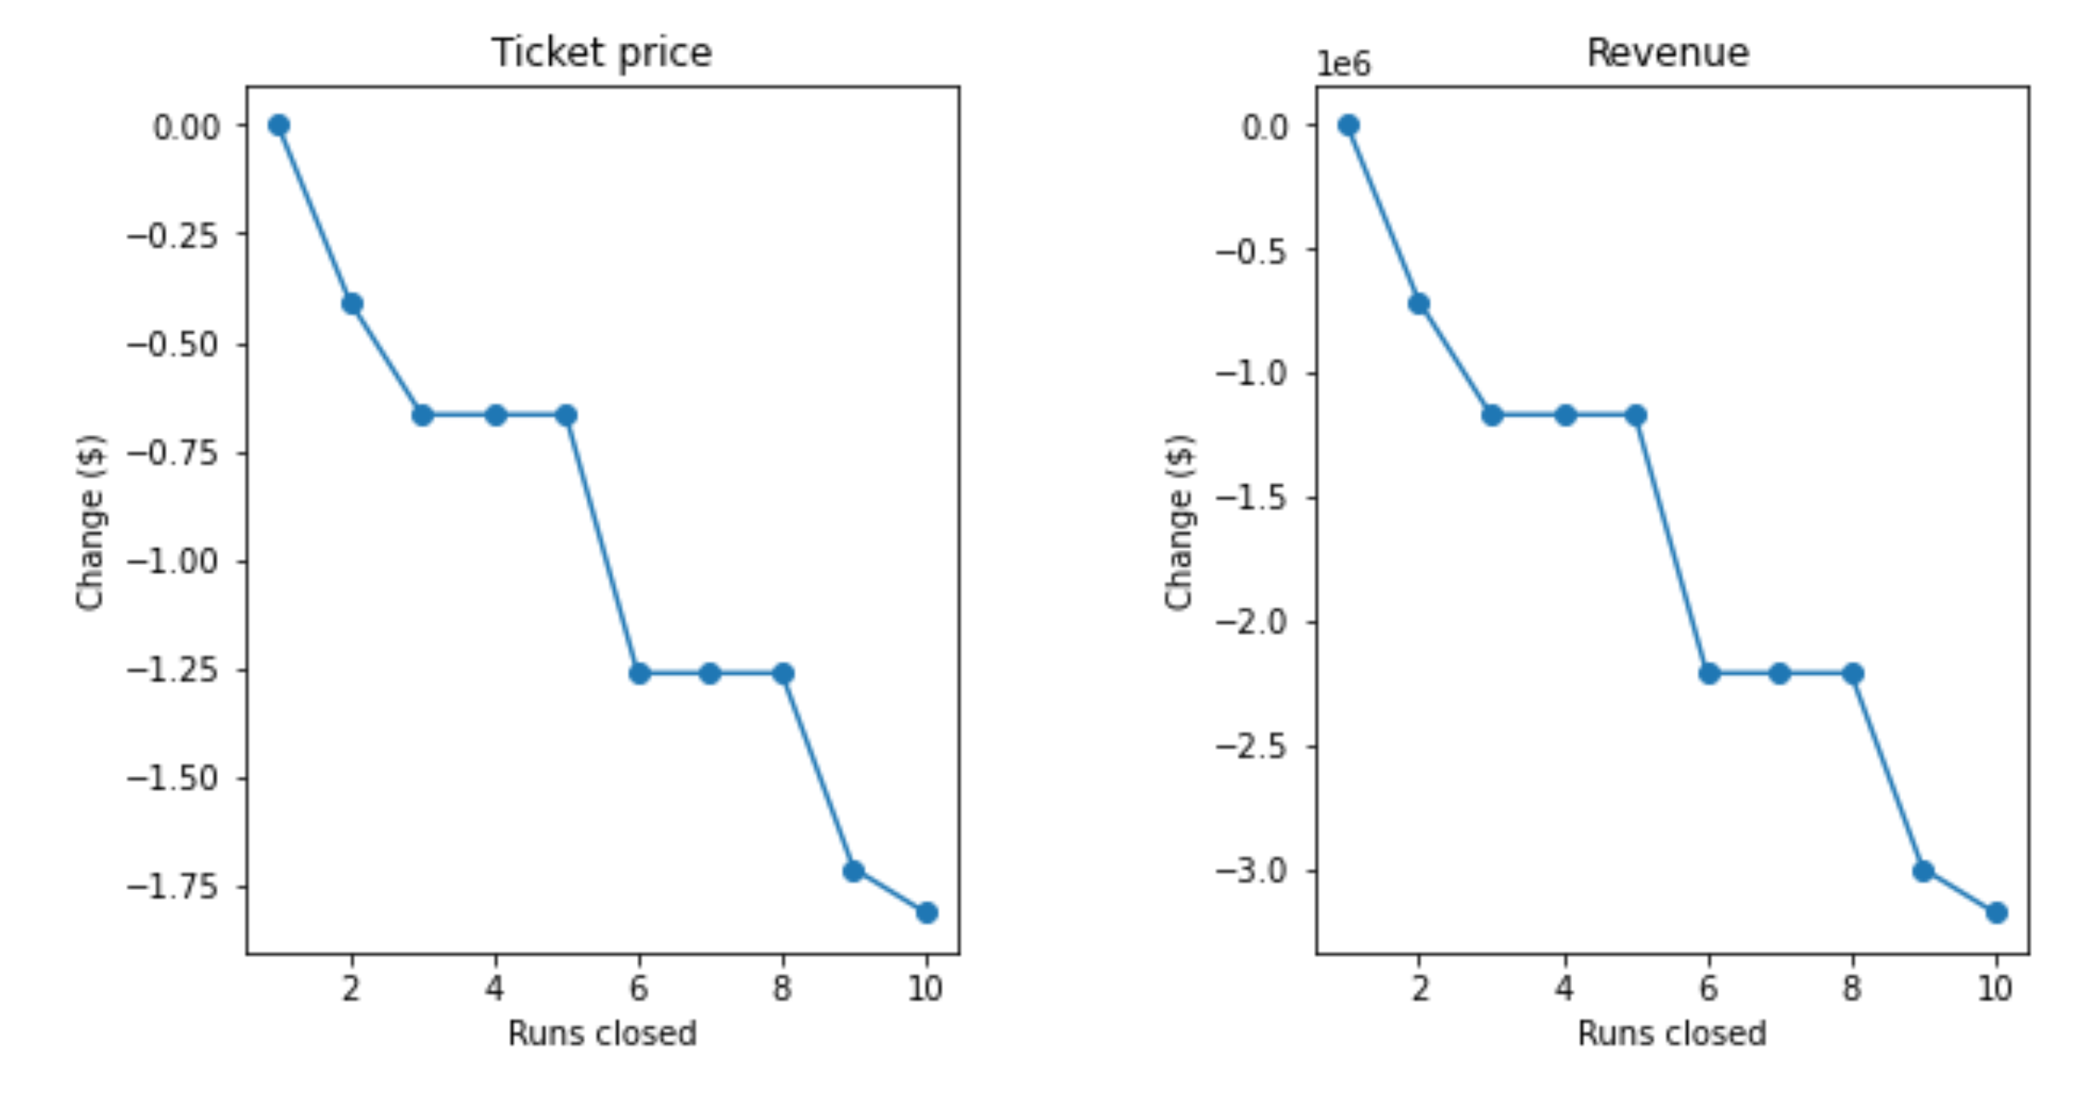

With Senario 2: Increase the vertical drop by adding a run to a point 150 feet lower down will generate $3,474,638 revenue potentially which can cover the installation of an additional chair lift to bring skiers back up plus the previous recent installed chair lift which cost $1,540,000.