CREATE DATABASE name_of_database;
USE name_of_database;
CREATE TABLE name_of_table(
first_column DATA_TYPE [NOT NULL] [AUTO_INCREMENT]
[PRIMARY KEY],
second_column DATA_TYPE [NOT NULL] [DEFAULT VALUES],
…
[CONSTRAINT pk PRIMARY KEY(first_column),]
[CONSTRAINT fk FOREIGN KEY(column) REFERENCES name_of_diffrent_table
(column)]
);
Chú ý: [s#] phải có [] do có ký tự đặc biệt
Bản thân khóa chính không chấp nhận giá trị NULL.
Khóa chính xác định duy nhất 1 bộ trong quan hệ.
Khóa ngoại dùng để kết nối các quan hệ với nhau trong CSDL.
DATA_TYPE: CHAR(n), VARCHAR(n), INT, DEC(m,n), DATE, DATETIME…

-How the name_of_table table you created look, you can use the DESC command to view it:
DESC name_of_table;
-The statement SHOW CREATE_TABLE will return a CREATE TABLE statement that can exactly recreate our table, minus any data in it.
SHOW CREATE TABLE name_of_table;
-Delete table:
DROP TABLE name_of_table;

-To add data int your table, you’ll use the INSERT statement
INSERT INTO name_of_table ( column_name1, column_name2,… )
VALUES (‘values1’, ‘values2’,…);
-Một vài kiểu của câu lệnh INSERT
INSERT INTO name_of_table
VALUES( giá trị của các cột tương ứng với thứ tự như lúc tạo bảng);
INSERT INTO name_of_table ( ds cột với thứ tự có thể khác so với lúc tạo bảng )
VALUES (giá trị tương ứng với cột);
INSERT INTO name_of_table( ds các cột)
VALUES( giá trị tương ứng với cột);
(các cột không có trong ds thì sẽ nhận giá trị mặc định (default))
Chú ý: INSERT INTO name_of_table (location) VALUES (‘Grover\’s Mill’); //Grover’s Mill
-Câu lệnh SELECT
SELECT [DINTINCT] * | <Thuộc tính> | <Ds biểu thức> [ INTO<Bảng>]
FROM <Tên bảng>[ ,… ]
[WHERE <Điều kiện>]
[GROUP BY <Thuộc tính>]
[HAVING <Điều kiện>]
[ORDER BY <Thuộc tính> ASC | DESC]

-Một số hàm và toán tử được sử dụng trong câu lệnh truy vấn
+Hàm
+Toán tử:
Số học
Logic: NOT, AND, OR
So sánh: =, <>, >, >=, <, <=
Các toán tử khác: IN, BETWEEN, LIKE, ANY, EXIST, ALL,…
-Use IS NULL to find NULLs
Eg: SELECT drink_name FROM drink_info WHERE calories IS NULL;
-Tiết kiệm thời gian với từ khóa: LIKE
SELECT * FROM s WHERE sname LIKE ‘s*’; /* s% */
Liệt kê hãng cung ứng có tên hãng với ký tự đầu là s
SELECT * FROM my_contacts WHERE first_name LIKE ‘_im’;
Kết quả trả về là tên với 1 ký tự trước “im” như Jim, Kim,…
-BETWEEN … AND …;
SELECT * FROM drink_info WHERE calories BETWEEN 30 AND 60; // 30 <= calories <= 60
-IN
SELECT [s#] FROM sp WHERE [p#] IN (‘p1’, ‘p2’);
-NOT
…WHERE <Attribute> NOT IN …; //…WHERE NOT <Attribute> IN …;
…WHERE NOT <Attribute> BETWEEN … AND …;
…WHERE NOT <Attribute> LIKE …;
… WHERE <Attribute> IS NOT NULL; //… WHERE NOT <Attribute> IS NULL;

-DELETE
DELETE FROM name_of_table WHERE <Condition>;
+Không thể xóa giá trị trong cột
+Có thể xóa 1 dòng hoặc nhiều dòng phụ thuộc vào mệnh đề WHERE
+Xóa tất cả các dòng trong bảng:
DELETE FROM name_of_table;
DELETE / INSERT

-Thay đổi dữ liệu với UPDATE
UPDATE name_of_table SET column=’value1’ WHERE <Condition>;
-Haflway to 1NF
Each row of data must contain atomic values.
Each row of data must have a unique identifier, known as a Primary Key.
-A primary key is a column in your table that makes each record unique.
A primary key can’t be NULL
The primary key must be given a value when the record is inserted
The primary key must be compact
The primary key values can’t be changed.

-1,2,3 … auto incrementally
CREATE TABLE name_of_table
(
contact_id INT NOT NULL AUTO_INCREMENT,
…,
PRIMARY KEY (contact_id )
);
-Adding a PRIMARY KEY to an existing table
ALTER TABLE name_of_table
ADD COLUMN contact_id INT NOT NULL AUTO_INCREMENT FIRST,
ADD PRIMARY KEY (contact_id );

-ALTER : Rewritting the Past
CHANGE both the name and data type of an existing column *
MODIFY the data type or position of an existing column *
ADD a column to your table- you pick the data type
DROP a column from your table *
*Possible loss of data may occur, no guarantees offered.
(ADD SERVICES Rearrange your columns (Only available when using ADD))
+ALTER TABLE my_contacts ADD COLUMN phone VARCHAR(10) FIRST;
(LAST, SECOND,…,FIFTH, BEFORE name_column, AFTER name_column)
+ALTER TABLE projekts RENAME TO project_list;
+ ALTER TABLE project_list
CHANGE COLUMN number proj_id INT NOT NULL AUTO_INCREMENT,
ADD PRIMARY KEY (‘proj_id’);
ALTER TABLE project_list
CHANGE COLUMN descriptionfproj proj_desc VARCHAR(100);
[ ALTER TABLE project_list
CHANGE your_id your_id INT NOT NULL; ]
+ ALTER TABLE project_list MODIFY COLUMN proj_desc VARCHAR(120);
ALTER TABLE project_list MODIFY COLUMN date AFTER proj_desc;
+ ALTER TABLE project_table DROP COLUMN start_date;

-Seattle, WA
Natchez, MS …
Look for patterns: City Name, XX
To SELECT the last characters
SELECT RIGHT(location, 2) FROM my_contacts;
To SELECT everything in front of the comma
SELECT SUBSTRING_INDEX(location, ‘,’ ,1 ) FROM my_contacts;
-Một số hàm khác:
SUBSTRING(your_string, start_position, length)
UPPER (your_string)
LOWER(your_string)
REVERSE(your_string)
LENGTH(your_string)

-CASE… WHEN
UPADTE my_table
SET new_column=
CASE
WHEN column1= somevalue1
THEN newvalue1
WHEN column2= somevalue2
THEN newvalue2
ELSE newvalue3
END;

-ORDER BY(single column, two column, multiple column)(ASC:Ascending,DESC:Descending)
SELECT title, category FROM movie_table WHERE category=’family’
ORDER BY title;
0123ABCDabcd!@#$%^&*()-_+=[]{};: ’ ” \| …
SELECT title, category, puchased FROM movie_table
ORDER BY category, puchased ;
SELECT * FROM movie_table
ORDER BY category, puchased, title ;

-SUM
SELECT SUM(sales) FROM cookie_sales WHERE first_name = ‘Nicole’;
SELECT first_name, SUM(sales) FROM cookie_sales
GROUP BY first_name ORDER BY SUM(sales) DESC;

-AVG( Average)
SELECT first_name, AVG(sales) FROM cookie_sales
GROUP BY first_name;
-MIN and MAX
SELECT first_name, MAX(sales) FROM cookie_sales
GROUP BY first_name;
SELECT first_name, MIN(sales) FROM cookie_sales
GROUP BY first_name;

-COUNT
SELECT COUNT(sale_date) FROM cookie_sales ;
SELECT COUNT(DISTINCT sale_date) FROM cookie_sales ;

-LIMIT the number of results (begin 0)
SELECT first_name, SUM(sales) FROM cookie_sales
GROUP BY first_name ORDER BY SUM(sales) DESC;
SELECT first_name, SUM(sales) FROM cookie_sales
GROUP BY first_name ORDER BY SUM(sales) DESC LIMIT 2; //(SELECT TOP 2 ..)

-The foreign key can be used to make sure that the rows in one table have corresponding rows in another table.
Foreign key values can be null, even though primary key values can’t.
Foreign keys don’t have to be unique—in fact, they often aren’t.

-Second Normal Form or 2NF:
Rule 1: Be in 1NF
Rule 2: Have no partial functional dependencies.

-Third Normal Form or 3NF:
Rule 1: Be in 2NF
Rule 2: Have no transitive dependencies
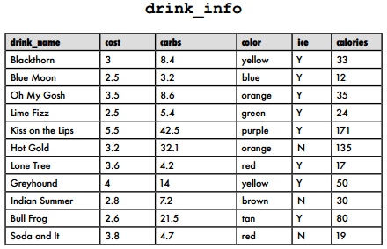
-ALTER
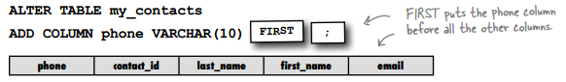
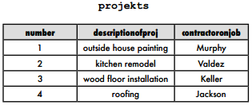
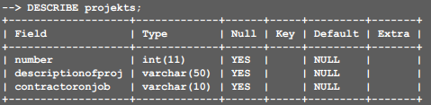
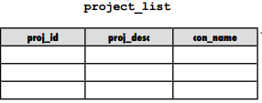
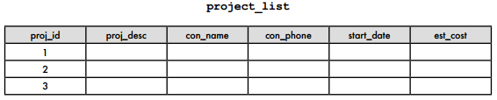
-UPDATE
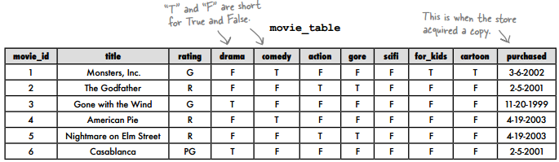
UPDATE movie_table
SET category =
CASE
WHEN drama = 'T' THEN 'drama'
WHEN comedy = 'T' THEN 'comedy'
WHEN action = 'T' THEN 'action'
WHEN gore = 'T' THEN 'horror'
WHEN scifi = 'T' THEN 'scifi'
WHEN for_kids = 'T' THEN 'family'
WHEN cartoon = 'T' THEN 'family'
ELSE 'misc'
END;



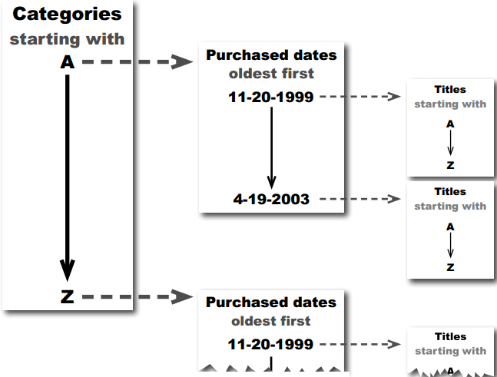

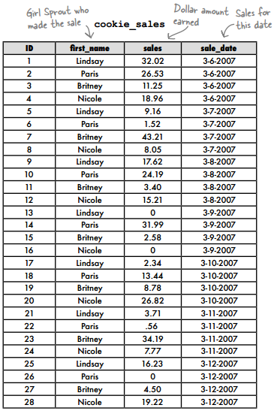

SELECT first_name, sales FROM cookie_sales
ORDER BY first_name;

SELECT SUM(sales)FROM cookie_sales
WHERE first_name = 'Nicole';

SELECT first_name, SUM(sales)FROM cookie_sales
GROUP BY first_name
ORDER BY SUM(sales)DESC;
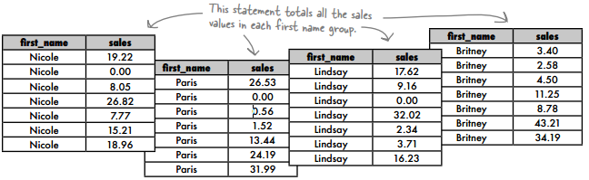
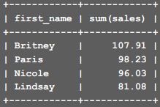
-Relationships between tables
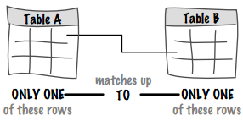
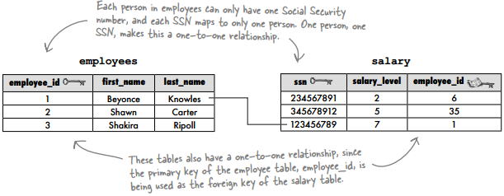
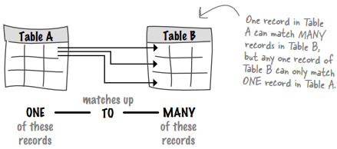
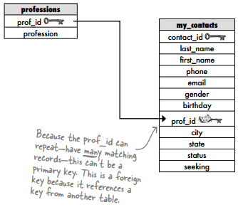


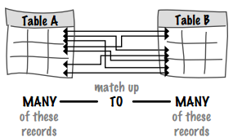
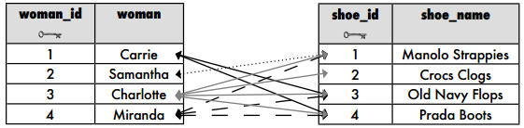

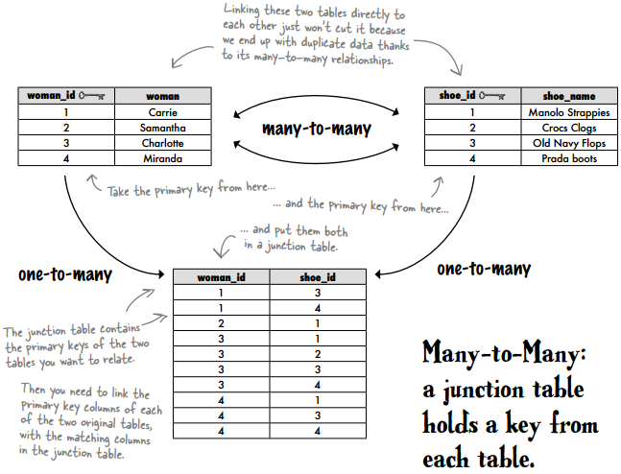
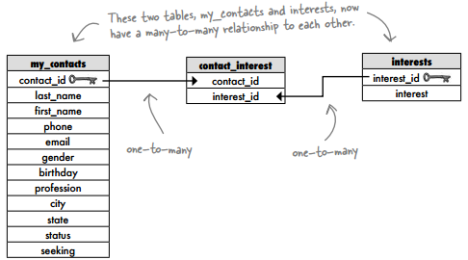

-AS: does exactly what it sounds like it does
CREATE TABLE profession AS
SELECT profession FROM my_contacts
GROUP BY profession
ORDER BY profession;
ALTER TABLE profession
ADD COLUMN id INT NOT NULL AUTO_INCREMENT FIRST,
ADD PRIMARY KEY (id);

CREATE TABLE profession(
id INT(11) NOT NULL AUTO_INCREMENT PRIMARY KEY,
profession varchar(20)
) AS
SELECT profession FROM my_contacts
GROUP BY profession
ORDER BY profession;

-CROSS JOIN: The CROSS JOIN returns every row from one table crossed with every row from the second.
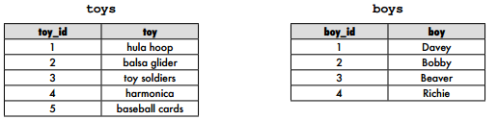
SELECT t.toy, b.boy FROM toys AS t
CROSS JOIN
boys AS b;
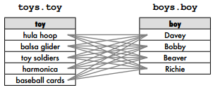

Inner Join On condition; Natural Join; Inner Join Using(attrs); Left | Right | Full Outer Join
- INNER JOIN (JOIN): An INNER JOIN combines the records from two tables using comparison operators in a condition. //( EQUIJOIN inner joins test for equality)
SELECT somecolumns FROM table1
INNER JOIN table2
ON somecondition;

SELECT boys.boy, toys.toy
FROM boys INNER JOIN toys
ON boys.toy_id = toys.toy_id;
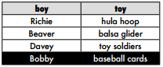
//NON-EQUIJOIN inner joins test for inequality.
// SELECT boys.boy, toys.toy
// FROM boys
// INNER JOIN
// toys
// (ON boys.toy_id <> toys.toy_id
// ORDER BY boys.boy;)

- NATURAL JOIN inner joins identify matching column names.
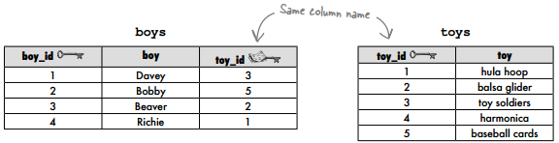
SELECT boys.boy, toys.toy
FROM boys
NATURAL JOIN
toys;

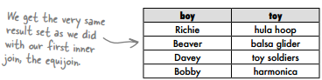

- LEFT OUTER JOIN: The left outer join matches EVERY ROW in the LEFT table with a row from the right table.
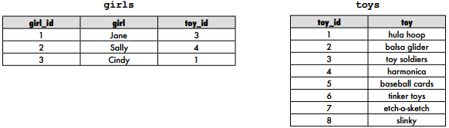
SELECT g.girl, t.toy FROM girls g
LEFT OUTER JOIN toys t
ON g.toy_id = t.toy_id;

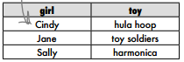

SELECT g.girl, t.toy FROM toys t
LEFT OUTER JOIN girls g
ON g.toy_id = t.toy_id;

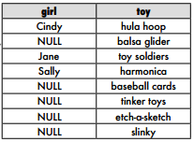

- RIGHT OUTER JOIN : The right outer join evaluates the right table against the left table.
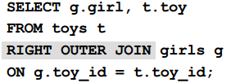
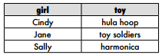

-The self-join allows you to query a single table as though there were two tables with exactly the same information in them.
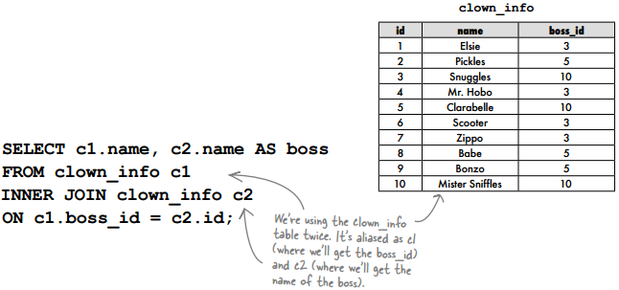
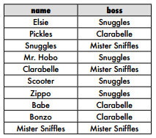

-FULL OUTER JOIN

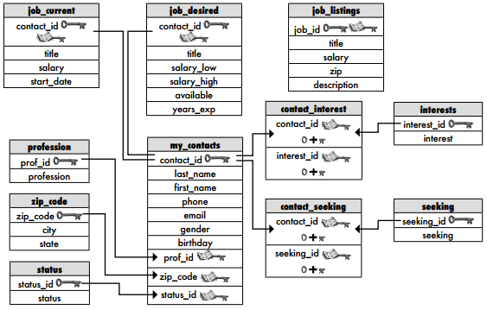

-UNION
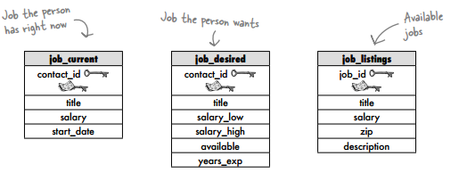
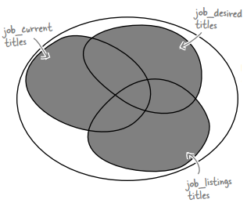

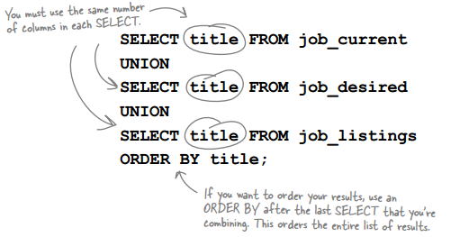

UNION ALL works exactly the same way as UNION, except it returns all the values from the columns, rather than one instance of each value that is duplicated.
SELECT title FROM job_current
UNION ALL
SELECT title FROM job_desired
UNION ALL
SELECT title FROM job_listings
ORDER BY title;

-INTERSECT returns only those columns that are in the first query and also in the second query.
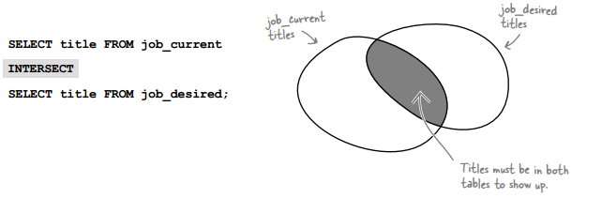

-EXCEPT returns only those columns that are in the first query, but not in the second query.
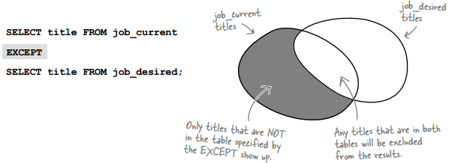
- Subqueries:
OUTER query + INNER query = Query with a subquery

SELECT mc.first_name, mc.last_name, mc.phone, jc.title
FROM job_current AS jc NATURAL JOIN my_contacts AS mc
WHERE jc.title IN (SELECT title FROM job_listings);
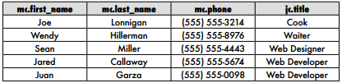

Subquery rules:
-A subquery is always a singleSELECT statement.
-Subqueries are always inside PARENTHESES.
-Subqueries do not get their own SEMICOLON. As always,one SEMICOLON goes at the END of the entire query.
-Subqueries can show up in four places in a query: SELECT clause, SELECT COLUMN LIST as one of the columns, FROM clause, and in a HAVING clause.
-Subqueries can be used with INSERT, DELETE, UPDATE, and, of course, SELECT.

SELECT mc.first_name, mc.last_name, jc.salary
FROM my_contacts AS mc NATURAL JOIN job_current AS jc
WHERE jc.salary = (SELECT MAX(jc.salary) FROM job_current jc);
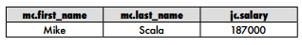

SELECT mc.first_name, mc.last_name, mc.phone, jc.title
FROM job_current jc NATURAL JOIN my_contacts mc
WHERE jc.title NOT IN (SELECT title FROM job_listings);

A (useful) correlated subquery with NOT EXISTS
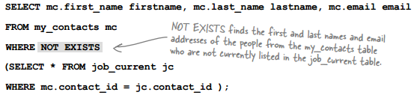

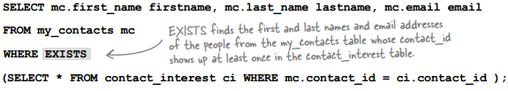

Write a query that returns the email of people who have at least one interest but don’t exist in the job_current table.
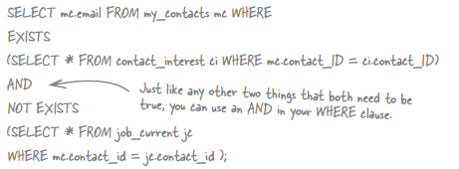

-A CHECK constraint restricts what values you can insert into a column. It uses the same conditionals as a WHERE clause.
CREATE TABLE piggy_bank (
id INT AUTO_INCREMENT NOT NULL PRIMARY KEY,
coin CHAR(1) CHECK (coin IN ('P','N','D','Q'))
)

ALTER TABLE my_contacts
ADD CONSTRAINT CHECK gender IN ('M','F');

CREATE TABLE mystery_table
(
column1 INT(4) CHECK (column1 > 200),
column2 CHAR(1) CHECK (column2 NOT IN ('x', 'y', 'z')),
column3 VARCHAR(3) CHECK ('A' = SUBSTRING(column_3, 1, 1)),
column4 VARCHAR(3) CHECK ('A' = SUBSTRING(column_4, 1, 1)
AND '9' = SUBSTRING(column_4, 2, 1))
)
-VIEW
A VIEW is basically a table that only exists when you use the view in a query. It’s considered a virtual table because it acts like a table, and the same operations that can be performed on a table can be
performed on a view.

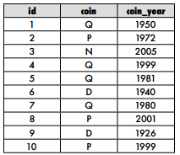

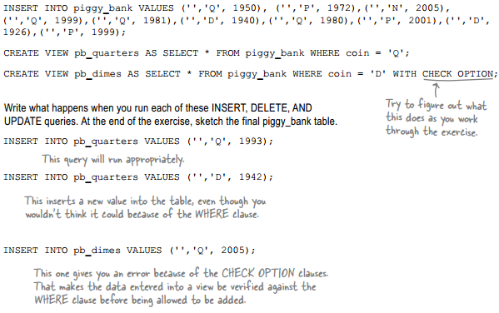
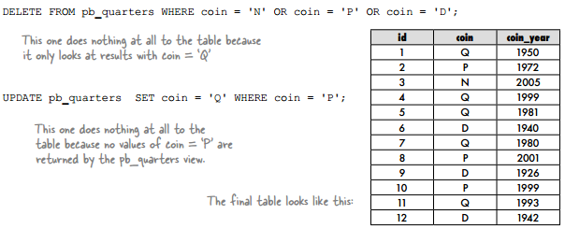
Select * from piggy_bank;
CHECK OPTION checks each query you try to INSERT or UPDATE to see if it’s allowed according to the WHERE clause in your view.
DROP VIEW pb_dimes;

-Transactions
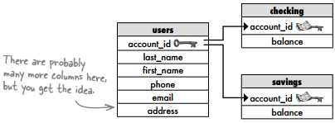
We’ve got three SQL transaction tools to help keep us safe:
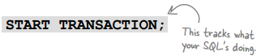
START TRANSACTION keeps track of all the SQL that follows until you enter either COMMIT or ROLLBACK.

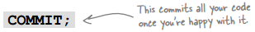
If you’ve got all your statements in place and everything looks good, type COMMIT to make it permanent.


If something isn’t quite right, ROLLBACK reverses everything to the way it was before you typed START TRANSACTION.

No changes will occur to the database until you COMMIT
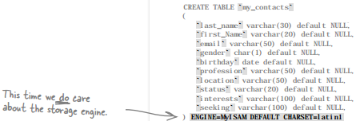
You need to make sure your storage engine is either BDB or InnoDB, the two choices
that support transactions.

For our purposes right now, it doesn’t matter which you choose. To change your engine, use this syntax:
ALTER TABLE your_table TYPE = InnoDB;

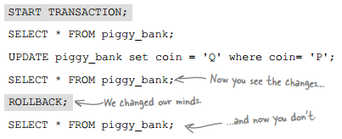
The second time we’ll use COMMIT because we’re okay with the changes:
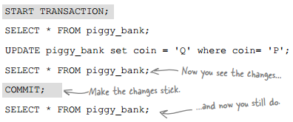

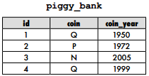
START TRANSACTION;
UPDATE piggy_bank set coin = 'Q' where coin = 'N' AND coin_year > 1950;
ROLLBACK; → Result?

START TRANSACTION;
UPDATE piggy_bank set coin = 'D' where coin = 'Q' AND coin_year > 1980;
COMMIT; → Result?
-Security
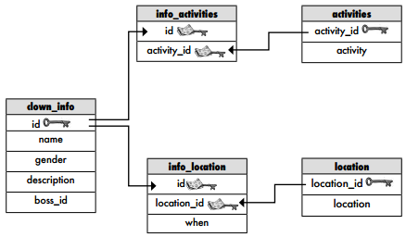

By default, the first user—the rootuser—has complete control over everything in the database. This is important, because the root user needs to be able to create user accounts for all other users. We don’t want to limit what the root user can do, but we do want to give our root account a password. In MySQL, the command is simply:

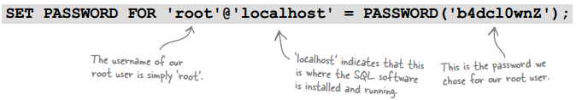

Other RDBMS techniques vary. Oracle uses:
alter user root identified by new-password;

Add a new user
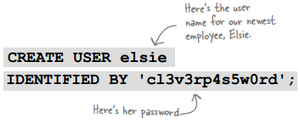

You can control exactly what users can do to tables and columns with the GRANT statement.
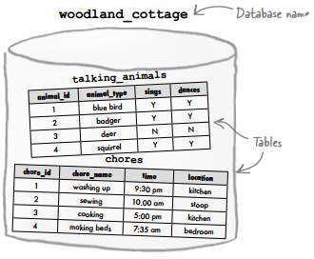
Root: root
User: bashful, doc, dopey, grumpy, happy, sleepy, sneezy

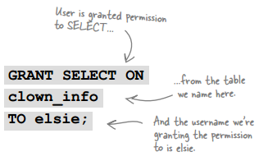

GRANT SELECT ON activities TO elsie;
GRANT SELECT ON location TO elsie;
GRANT SELECT ON info_activities TO elsie;
GRANT SELECT ON info_location TO elsie;

GRANT variations
You can name multiple users in the same GRANT statement.
WITH GRANT OPTION gives users permission to give other users the permission they were just given.
A specific column, or columns, in a table can be used instead of the entire table.
You can specify more than one permission on a table.
GRANT ALL gives users permission to SELECT, UPDATE, INSERT, and DELETE from the specified table.
You can specify every table in a database with database_name.*

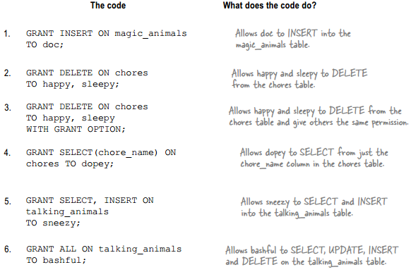
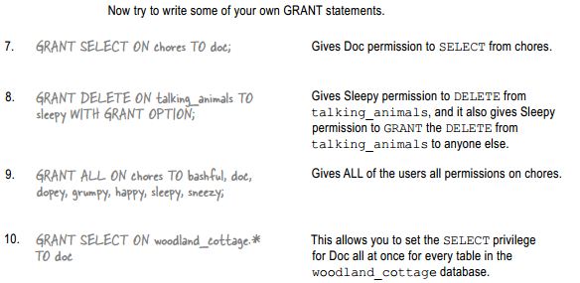

REVOKE privileges
Suppose we decide to remove the SELECT privilege we gave to Elsie. To do that, we need the REVOKE statement.
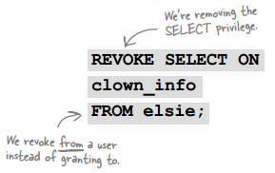
You can also just revoke the WITH GRANT OPTION but leave the privilege intact.
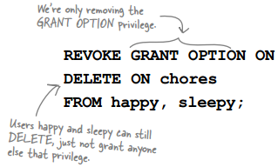

REVOKING a used GRANT OPTION
- gives DELETE on chores with GRANT OPTION
- gives DELETE on chores
revokes DELETE on chores with GRANT OPTION from sleepy
sleepy does nothing, but sneezy loses his privilege also.

A side effect of the REVOKE statement was that sneezy also lost the privilege. There are two keywords you can use that will let you control what you want to happen when you’re revoking.

-The first, CASCADE, removes the privilege from the user you target (in this case, sleepy) as well as anyone else that that user gave permissions to.
REVOKE DELETE ON chores FROM sleepy CASCADE;
→ CASCADE means the revoke will affect anyone down the chain, as well as the original target.
(revokes DELETE on chores with GRANT OPTION from sleepy
sleepy does nothing, but sneezy loses his privilege also.)

-Using RESTRICT when you want to remove a privilege from a user will return an error if that user has granted privileges to anyone else.
REVOKE DELETE ON chores FROM sleepy RESTRICT;
→If someone else will be affected, using RESTRICT in your REVOKE statement will return an error.
(tries to revoke DELETE on chores with from sleepy …
… but fails because sneezy will also be affected.)

You need a way to give the groups the privileges they need, while at the same time giving each
user an individual account.
What you need are roles. A role is a way you can group together specific privileges, and apply those to everyone in a group. Your role becomes an object in your database that you can change as needed when your database changes, without having to explicitly change every single user’s privileges to reflect the database changes.

And setting up a role is really simple:
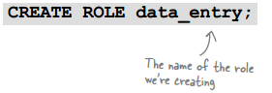
To add privileges to the role, you simply treat it as you would a username:
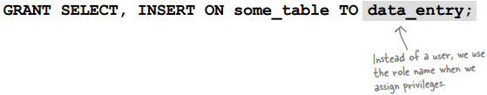
We’ve created our role and given it privileges.
Now we need to assign it to someone...

The old way:
GRANT SELECT, INSERT ON talking_animals TO doc;
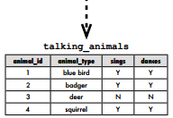

Now all we need to do is substitute the GRANT operation for our new role and apply it to doc.
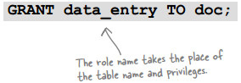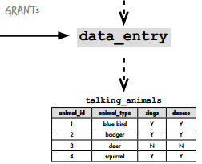

Role dropping

Using your role WITH ADMIN OPTION
Just like the GRANT statement has WITH GRANT OPTION, a role has the similar WITH ADMIN OPTION. This option allows anyone with that role to grant that role to anyone else. For example, if we use this statement:
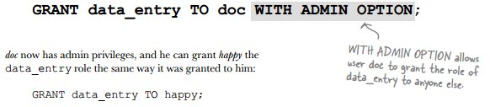

When used with a role, the REVOKE command has the same keywords CASCADE and RESTRICT. Let’s take a look at how they work:

-REVOKE role with CASCADE
Used with CASCADE, the REVOKE affects everyone down the chain as well as the original target:
REVOKE data_entry FROM doc CASCADE;

Used with CASCADE, the revoke will affect anyone down the chain, as well as the original target
(revokes data_entry role from doc.
happy loses the privileges doc granted him.)

-REVOKE role with RESTRICT
Using RESTRICT when you want to remove a privilege from a user will return an error if that user has granted privileges to anyone else.
REVOKE data_entry FROM doc RESTRICT;

If someone else will be affected, using RESTRICT in your REVOKE statement will return an error.
(trys to revoke data_entry from doc…
… but fails because happy will also be affected.)

SELECT CURRENT_DATE;
SELECT CURRENT_TIME;
SELECT CURRENT_USER;

DATE YYYY-MM-DD
DATETIME YYYY-MM-DD HH:MM:SS
TIME HH:MM:SS

