FPT ACADEMY INTERNATIONAL

FPT APTECH 1 - Ha Noi – Viet Nam

--o0o--


DOCTORS WEB FORUM
Name : DWF

Batch : C0708G
Falculty: Pham Thanh Trung

Team: 3
Member :
Ta Dang An
Tran Hong Hai
Le Van Khanh
Cu Duc Tung

Ha Noi 9/2009

Contents

- Problem Definition 3

- Customer Requirement Specification 4
- Client
- Project Objective
- Input Provided by the Client
- Hardware requirement
- Software requirement
- Scope the work(in brief)
- Detail Function

- Architecture 8

- Flowchart 9

- Diagram 15

- Entity Relationship Diagram (ERD) 21

- Database Design/Structure 22

- Task Sheet 25

- Checklist Of Validations 26

- Submision Checklist 27

- Screenshot 28

1-Problem Definition:

After reading the request of the Doctor,we will create a Doctors’s Web Forum so that doctors,patients or anyone in the world can register and then discuss,request and reply with each other.

Queries related to the system can be one or more of the following :

- What kind of login for Administrtor and User ?

- How will an Admin manage the forum and the users ?

- How will the user register to the Doctor Web Forum ?

- How to create new topic,post a request or comment,reply in other’s topic ?

- How will the user chose his/her account’s profile to be private or public ?

- How will the user use the advance search option ?

- Can non-register user post a question ?

- Can the Doctor Web Forum contain other category ?

2-Customer Requirement Specification:

Client : Web site User

Project Objective :

Create a Web-based forum where doctors,patients or anyone discuss with each other about the diseases. A GUI which will provide user-friendly interface for the user to work with the Web-base application.The application has a registration page where everyone can register online, and everybody contact each other through the form where one can post a query and the other can reply.

There will be a logo common to all the pages of the application, and all the pages will include the symbol of the cross, as a back ground.

The registered users will have an option where his accounts can be made viewable based on public or private. Also,the users will only be able to update his / her account, access the details. And the administrator will have the right of removing or deleting the user.

Inputs provided by the Client :

- Inputs for the Web-based application.

- Process involved in the Web-based application.

Hardware Requirements :

- Pentium IV CPU 2.80 GHz

- 512MB of RAM or higher

- Hard disk requirement : Minimum 4 GB

- Windows 2000/XP/Vista

Software Requirements :

- ASP.NET 2.0

- Visual Studio 2008

- IIS 4.0 or higher

- Internet Explorer 6.0 or higher

- SQL Server 2005 or higher

Scope of the Work(in brief) :

Depending on the project objectives,the application needs to be developed with the following functionality :

- Registration of new users and authentication of existing users.

- A logo common to all the pages of the application, and all the pages will include the symbol of the cross, as a back ground.

- A GUI which will provide user-friendly interface for the user to work with the Web-based application.

- Allow users to contact each other through the form where one can post a query and the other can reply. Also,users can chose his / her account to be made viewable based on public or private.

- The Advanced search option is to be included that includes the location,specialization, and experience.

- Separate login for the admin and users.

- The Administrator can removing or deleting the users.

Function Details :

a. Login system for administrator :
Purpose:
Allow admin declare identification to used application.
Object used:
Administrator.
Functional request:
- Allow admin input username and password and validate information.
- The program will display error if username or password is invalid.
Execute condition:

b. Users management :
Purpose:
Allow administrator manage user information .
Object used:
Admin.
Functional request:
The application must allow admin to searched, edited, deleted and listed group of users in system.
Execute condition:
Admin has to logged in.

c. Register new account :
Purpose:
Allow user to register new account in the application.
Object used:
Anyone.
Functional request:
The Application must allow user to create new account,with information includes :
        - Username
        - Password
        - Name
        - Sex
        - Birthday
        - City
        - Country
        - Phone No.
        - Address
        - Email
        - Speciality
        - Hospital
        - Skype account (if have)
        - Yahoo account (if have)
        - Avatar
        - Favourites
        - Private or Public (registered user can chose his/her information details can be viewable by other user or not.
Execute condition:

d. Login system for user :
Purpose:
Allow users declare identification to used application.
Object used:
Registered users.
Functional request:
- Allow users input username and password and validate information.
- The application will display error if username or password is invalid.
Execute condition:

e.Manage categories :
Purpose:
Allow admin to manage categories.
Object used:
Administrator.
Functional request:
1. The application allow admin to manage categories.
2. Admin will be able to add , edit or delete categories.
Execute condition:
Admin has to logged in to application.

f. Post and comment :
Purpose:
Allow users to post and comment in the application.
Object used:
User in system.
Functional request:
1. The application allow users to post and comment
2. User can create new topic and the others can comment in that.
Execute condition:
User has to logged in to aplication.

g.Advance Search
Purpose:
Allow users to use advance search option.
Object used:
Users in system.
Functional request:
      - The application allow users to use advance search option.
      - The advance search option includes the location,specialization and the experience.
Execute condition:
Users has to logged in to application.

3-Architecture:

The application will be made of a Web-based distributed three-tier architecture to support multiple user transactions at the same time.

Web - Tier
User Interface with HTML and ASPX pages

C# (Code behind) files containing business logic

Middle - Tier

SQL Server 2005

Database - Tier

Web-based Distributed 3-Tier Architechure of the Project

4- Flow Chart:
4.1 Flow Chart Login Admin:
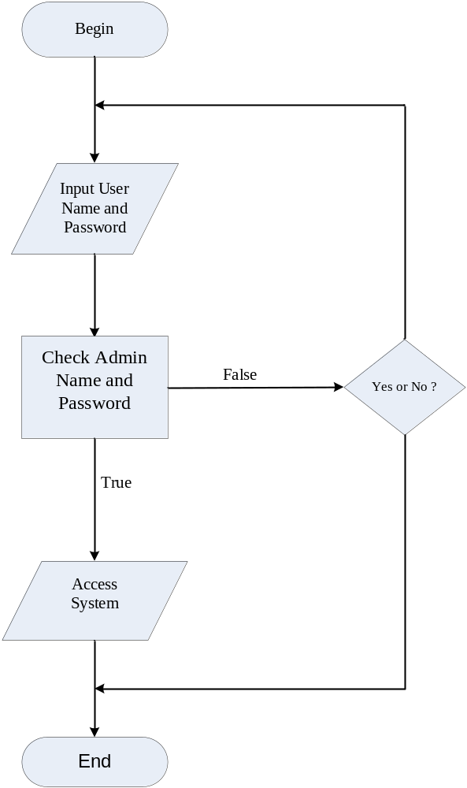

4.2 Flow Chart Search

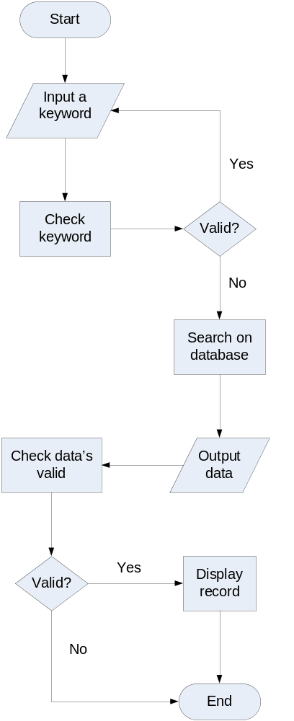

4.3 Flow Chart Delete:
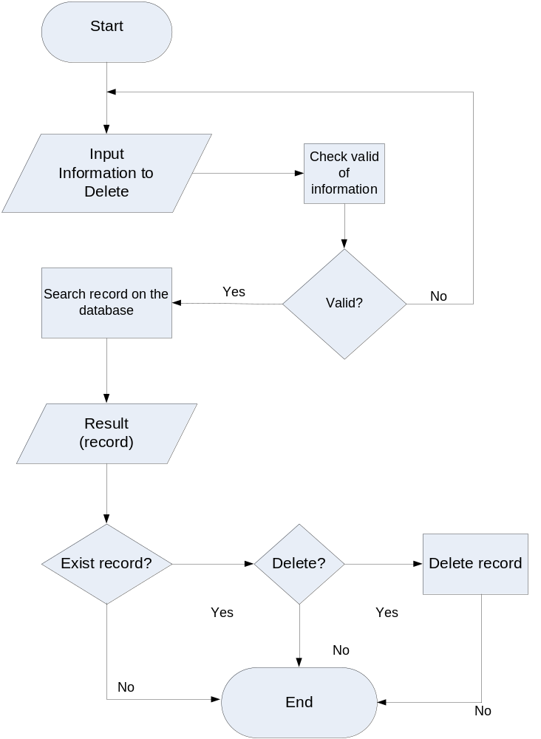

4.4 Flow Chart Registration:
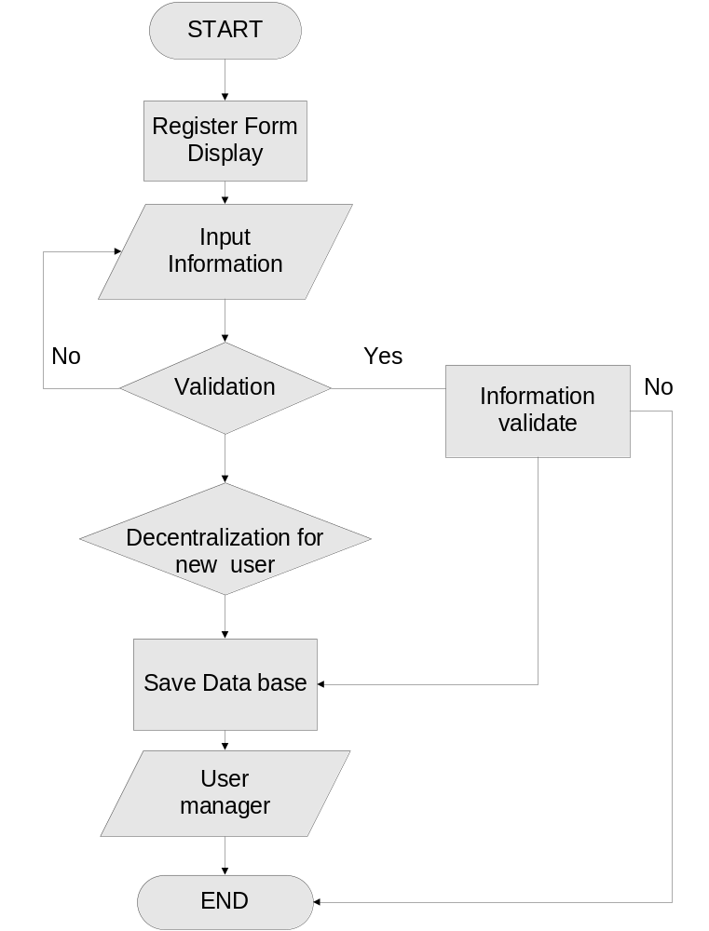

4.5 Flow Chart Login User:
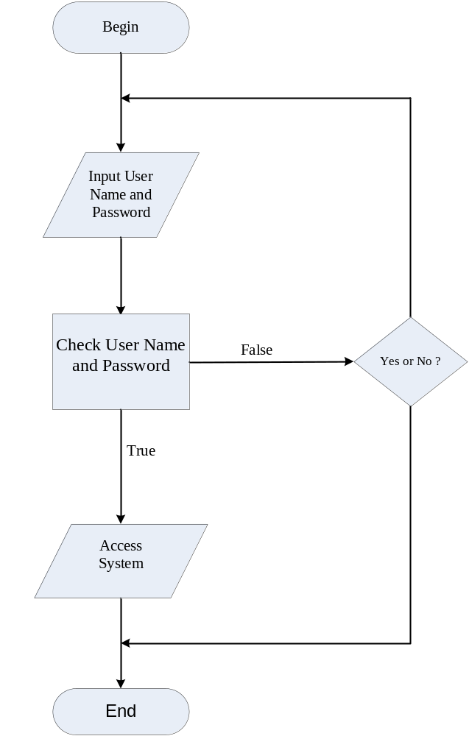

4.6 Flow Chart Post:

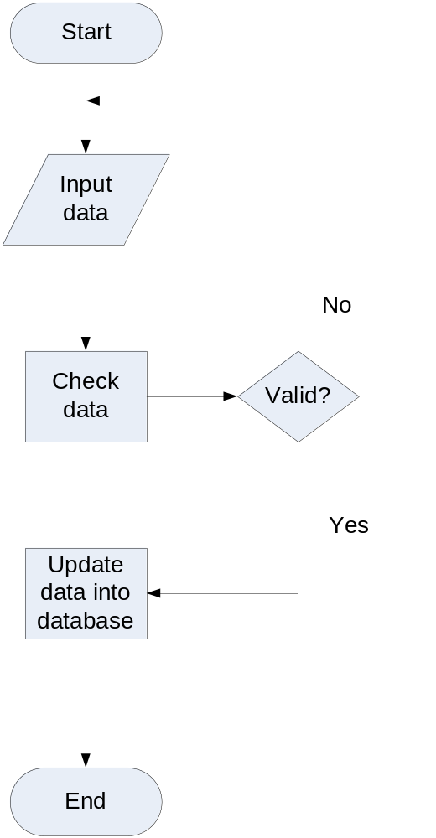

5. Data Flow Diagram (DFD):

Administrator
Doctor Website Forum
Authentication
Details
User Details
DFD LEVEL 0 – Context Diagram
User

Administrator
Authentication
Authentication
Details
DFD LEVEL 1 – Application Process
Resource Management
Commands
Reports
Password
User
User Details

Administrator
Delete
Add new
Search
View
TblUser
Require info
Feedback
Feedback
Require info
Replying info
Feedback
Feedback
Checking info
Require info
Require info
Level 1.1. Admin management
Checking info
Replying info
TblUser
Checking info
Checking info
Replying info
Replying info

Administrator
Banned
Update
Search
View
Add
User
Require info
Feedback
Feedback
Require info
Require info
Require info
Feedback
Feedback
Feedback
Feedback
Require info
Require info
Require info
Feedback
Level 1.2. User Management
TblUser
Checking info
Replying info
Replying info
Checking info
TblUser
Replying info
Replying info
Checking info
TblUser
Checking info
Replying info

User
Reply
Post
Search
View
TblUser
Require info
Feedback
Feedback
Require info
Replying info
Feedback
Feedback
Checking info
Require info
Require info
Level 2. User
Checking info
Replying info
TblCategories

Checking info
Checking info
Replying info
Replying info

6-Entity Relationship Diagram (ERD) :

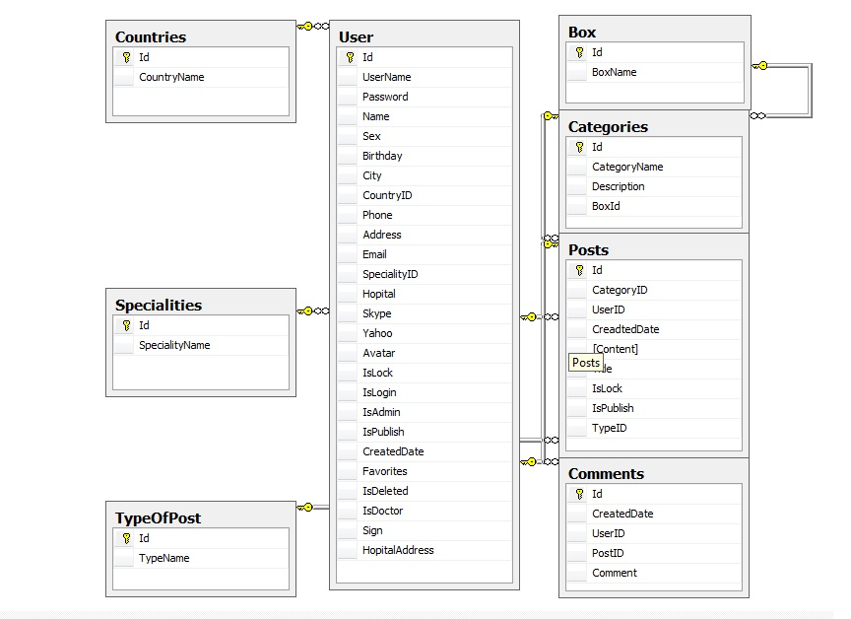

7-Database Design/Structure :

Table : User
Field Name |  | Data Type |  | Null | Key | Description
Id |  | Int |  | No | PK | Stores the ID of User
UserName |  | Nvarchar(50) |  | Yes |  | Stores the of User Name
Password |  | Nvarchar(50) |  | Yes |  | Stores the password of user
Name |  | Nvarchar(50) |  | Yes |  | Stores the name of user
Sex |  | bit |  | Yes |  | Stores the gender of user
Birthday |  | DateTime |  | Yes |  | Stores the birthday of user
City |  | Nvarchar(50) |  | Yes |  | Stores the city of user
CountryID |  | Int |  | Yes | FK | Stores the country of user
Phone |  | Nvarchar(50) |  | Yes |  | Stores the phone No. of user
Address |  | Nvarchar(150) |  | Yes |  | Stores the address of user
Email |  | Nvarchar(50) |  | Yes |  | Stores the email of user
SpecialityID |  | Int |  | Yes | FK | Stores the speciality of user
Hospital |  | Nvarchar(50) |  | Yes |  | Stores the hospital where user works (if is a doctor)
Skype |  | Nvarchar(50) |  | Yes |  | Stores the Skype account of user
Yahoo |  | Nvarchar(50) |  | Yes |  | Stores the Yahoo account of user
IsLock | bit |  | Yes |  |  | Check if user’s account is lock or not
IsLogin | bit |  | Yes |  |  | Check if user is login or not
IsPublish | bit |  | Yes |  |  | Check if user’s information is public or private
CreatedDate | DateTime |  | Yes |  |  | Stores the created date of user’s account
Favorites | Nvarchar(50) |  | Yes |  |  | Stores the favorites of user
IsDeleted | bit |  | Yes |  |  | Check if user’s account is deleted or not
IsDoctor | bit |  | Yes |  |  | Check if user is doctor or not

Table: Categories
Field Name | Data Type | Null | Key | Description
Id | Int | No | PK | Stores the ID of Category
CategoryName | Nvarchar(100) | Yes |  | Stores the name of Category
Description | Nvarchar(MAX) | Yes |  | Stores the description of Category

Table: Countries
Field Name | Data Type | Null | Key | Description
Id | Int | No | PK | Stores the ID of Country
CountryName | Nvarchar(50) | Yes |  | Stores the name of Country

Table: Specialities
Field Name | Data Type | Null | Key | Description
Id | Int | No | PK | Stores the ID of Speciality
SpecialityName | Nvarchar(50) | Yes |  | Stores the name of Speciality

Table: Posts
Field Name | Data Type | Null | Key | Description
Id | Int | No | PK | Stores the ID of Post
CategoryID | Int | Yes | FK | Stores the ID of Customer
UserID | Int | Yes | FK | Stores the ID of User
CreatedDate | DateTime | Yes |  | Stores the created date of post
[Content] | Nvarchar(MAX) | Yes |  | Stores the content of post
Title | Nvarchar(200) | Yes |  | Stores the title of post
IsLock | Bit | Yes |  | Check if post is lock or not
IsPublish | Bit | Yes |  | Check if post if public or private

Table: Comments
Field Name | Data Type | Null | Key | Description
Id | Int | No | PK | Stores the ID of Comment
CreatedDate | DateTime | Yes |  | Stores created date of comment
UserID | Int | Yes |  | Stores the ID of user
PostID | Int | Yes | FK | Stores the ID of post
Comment | Nvarchar(MAX) | Yes |  | Stores the comment

Table: Box
Field Name | Data Type | Null | Key | Description
Id | Int | No | PK | Stores the ID of Box
BoxName | Varchar(MAX) | Yes |  | Stores the Name of Box

Table: TypeOfPost
Field Name | Data Type | Null | Key | Description
Id | Int | No | PK | Stores the ID of type of post
TypeName | Varchar(MAX) | Yes | FK | Stores the name of type of post

8–Tasks Sheet
A: Write Report

Project Ref No. |  | Project Title: | Activity Plan Prepared By: | Date od Preparation of Activity Plan:
Sr.No. | Task | Project Title: | Activity Plan Prepared By: | Actual Start Date | Actual Days | Team Members Names | Status
1 | Program definition | DWF |  | 4/9 | 1 | Tran Hong Hai, Ta Dang An, Cu Duc Tung, Le Van Khanh | Complete
2 | Customer Requirement Specification | DWF |  | 5/9 | 1 | Tran Hong Hai, Ta Dang An | Complete
3 | Architecture | DWF |  | 6/9 | 1 | Tran Hong Hai, Cu Duc Tung | Complete
4 | Diagrams | DWF |  | 7/9 | 3 | Cu Duc Tung, Ta Dang An | Complete
5 | Flowcharts | DWF |  | 8/9 | 2 | Cu Duc Tung, Ta Dang An | Complete
6 | Entity Relationship  (ER) Diagram | DWF |  | 9/9 | 2 | Tran Hong Hai, Ta Dang An, Cu Duc Tung, Le Van Khanh | Complete
7 | Database Design/Structure | DWF |  | 9/9 | 1 | Tran Hong Hai , Ta Dang An, Cu Duc Tung, Le Van Khanh | Complete

B: Coding
Project Ref No. |  | Project Title: | Activity Plan Prepared By: | Date od Preparation of Activity Plan:
Sr.No. | Task | Project Title: | Activity Plan Prepared By: | Actual Start Date | Actual Days | Team Members Names | Status
1 | Design GUI ALL | DWF |  | 10/9 | 6 | Tran Hong Hai, Ta Dang An, Cu Duc Tung, Le Van Khanh | Complete
2 | Register Page |  |  | 15/9 | 2 | Tran Hong Hai | Complete
3 | Login system for admin and user |  |  | 16/9 | 3 | Tran Hong Hai | Complete
4 | Admin management |  |  | 16/9 | 2 | Tran Hong Hai, Le Van Khanh | Complete
5 | Advance Search |  |  | 17/9 | 2 | Tran Hong Hai, Cu Duc Tung | Complete
6 | User management |  |  | 18/9 | 5 | Tran Hong Hai | Complete
7 | Post and Comment system |  |  | 20/9 | 7 | Tran Hong Hai | Complete
8 | Testing |  |  | 24/9 | 2 | Tran Hong Hai, Ta Dang An, Cu Duc Tung, Le Van Khanh | Complete

9.Checklist of Validations:

Option | Validated
Can administrator create a new user to enter the application ? | Yes
Has the hardware and software been correctly chosen ? | Yes
Can registered user post new topic in this application ? | Yes
Does the application’s functionality resolve the user problem,and satisfy their needs | Yes
Do all the options present in the application display the correct result ? | Yes

10.Submission Checklist:

Sr.No | Particulars | Yes | No | N/A | Comments
1.  2.  3.  4.  5. | Home Page  Register Page  Categories Page  Box Page  Post View Page | Yes  Yes  Yes  Yes  Yes |  |  | Completed  Completed  Completed  Completed  Completed

11.Screenshot :

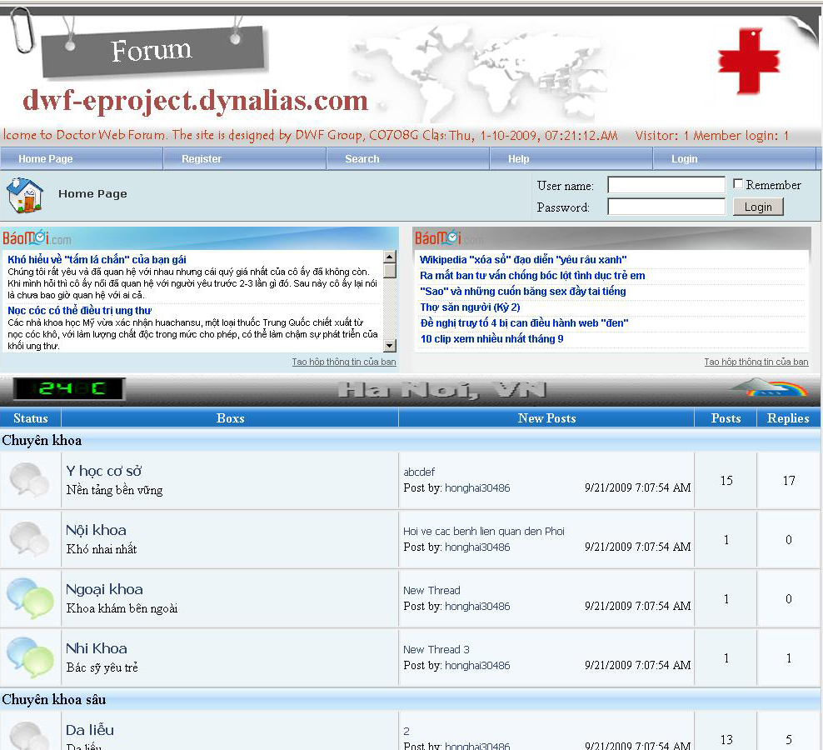

Home Page

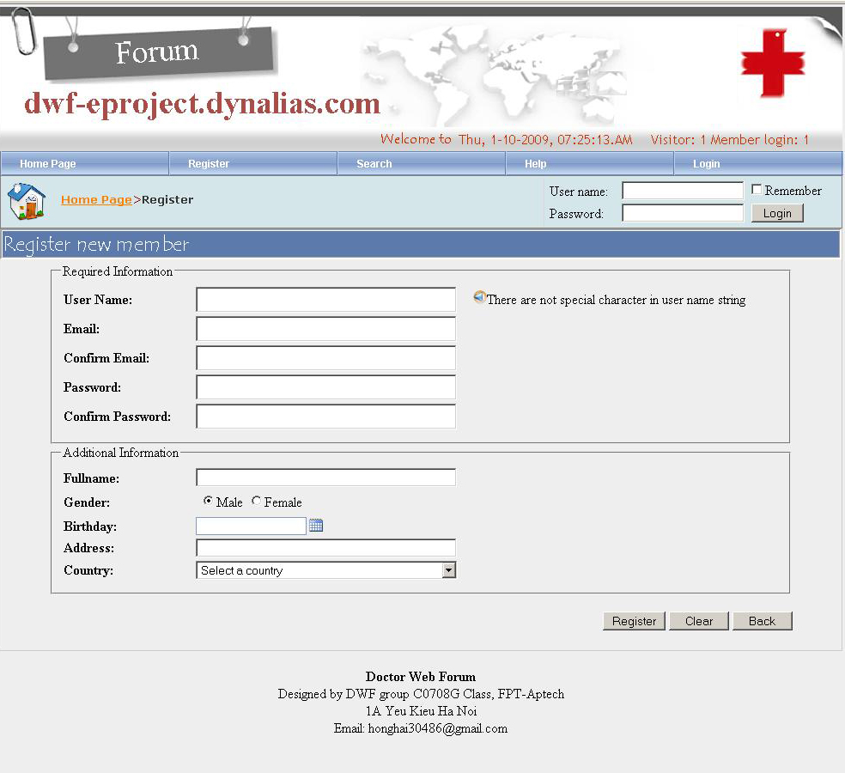

Register Page

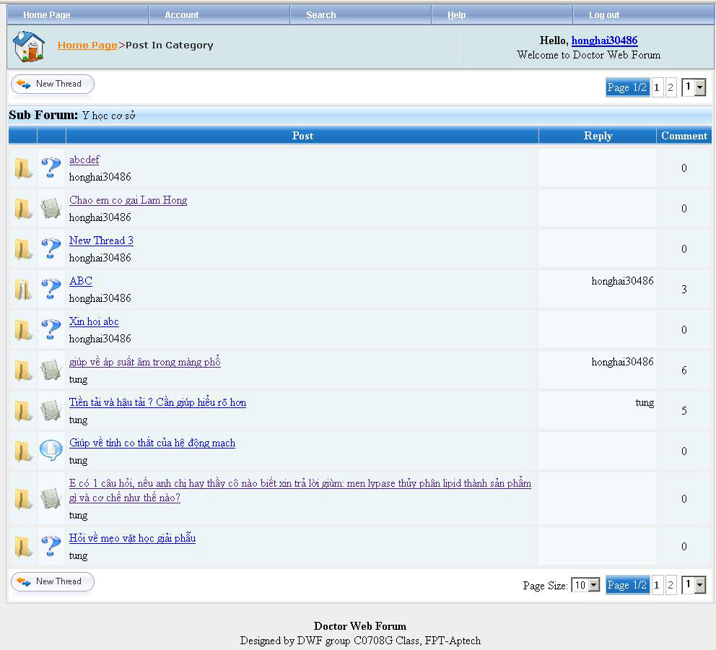

SubForum Page

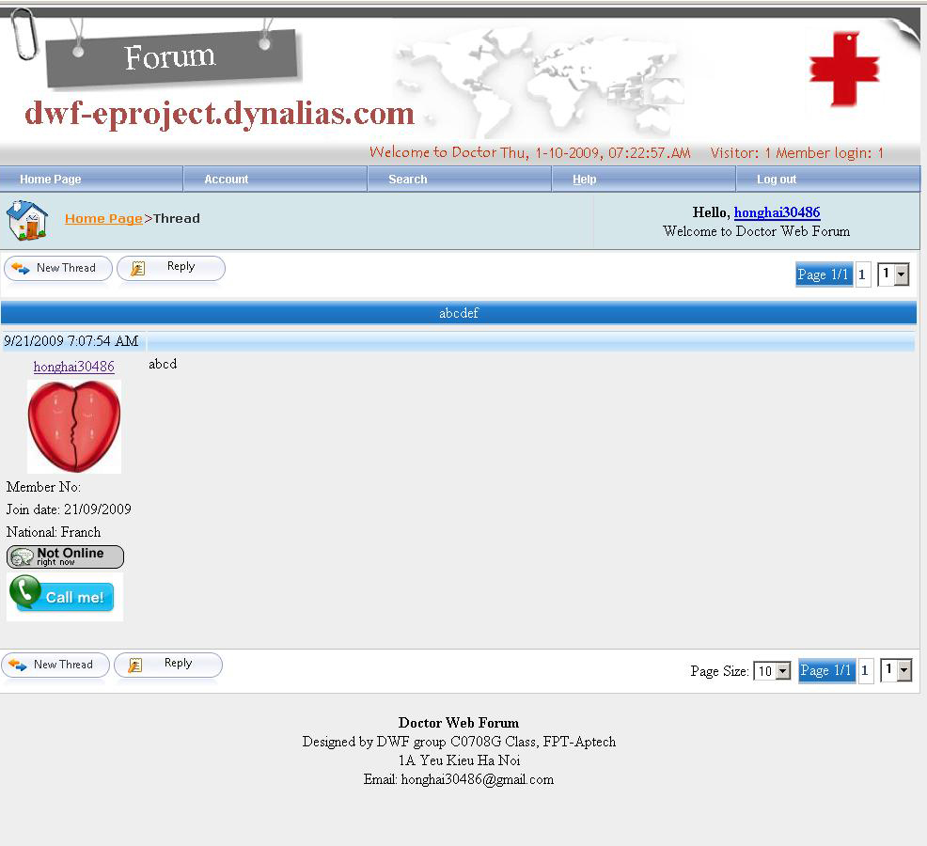

Thread Page

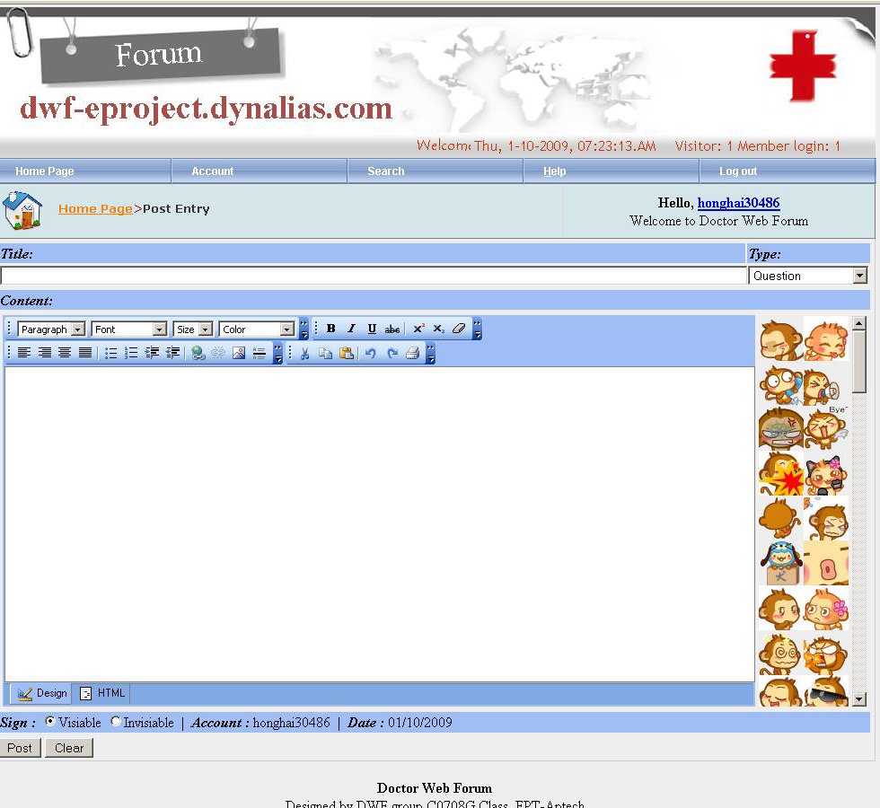

Post Entry Page

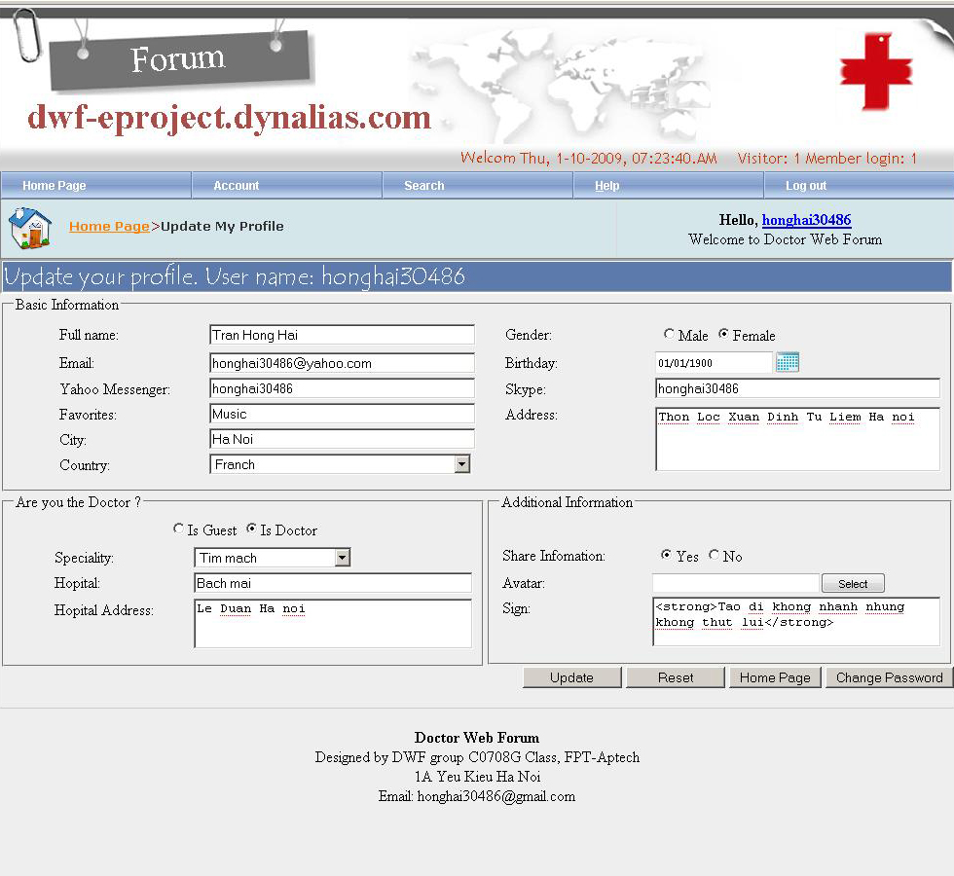

Update Profile Page

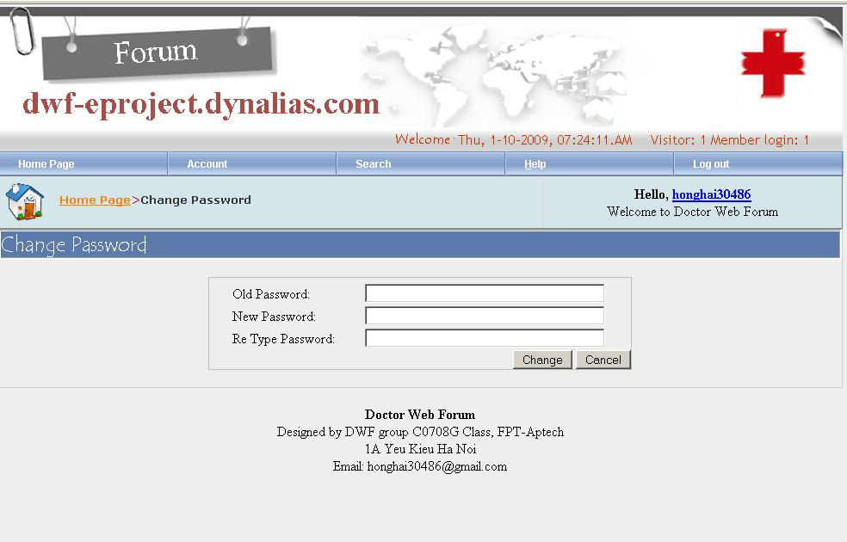

Change Password Page

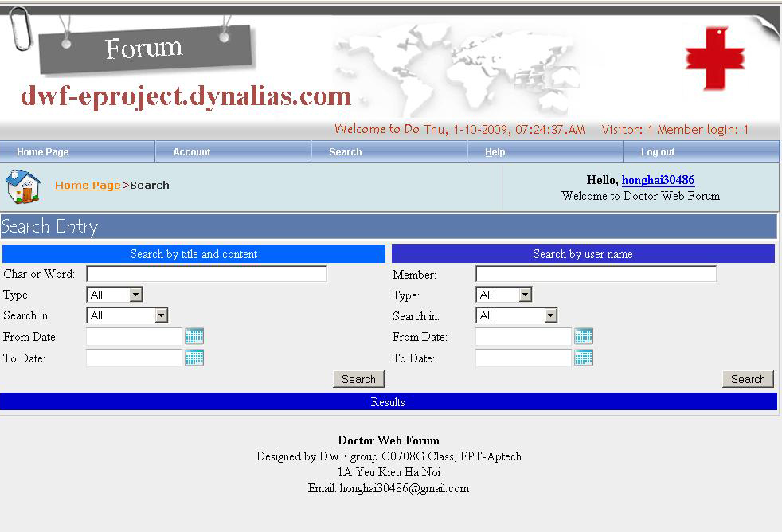

Search Page

