Introduction

The thirst for learning, upgrading technical skills and applying the concepts in real life environment at a fast pace is what the industry demands from IT professionals today. However busy work schedules, far-flung locations, and unavailability of convenient time-slots pose as major barriers when it comes to applying the concepts into realism. And hence the need to look out for alternative means of implementation in the form of laddered approach.

The above truly pose as constraints especially for our students too! With their busy schedules, it is indeed difficult for our students to keep up with the genuine and constant need for integrated application which can be seen live especially so in the field of IT education where technology can change on the spur of a moment. *Well, technology does come to our rescue at such times!!*

Keeping the above in mind and in tune with our constant endeavour to use Technology in our training model, we at Aptech have thought of revolutionizing the way our students learn and implement the concepts using tools themselves by providing a *live and synchronous eProject learning environment!*

I think. Use this guide. will help you better understand our web site

User guide includes two parts

* Manual Admin Pages
* User manual user pages

1 - Original interface of the site

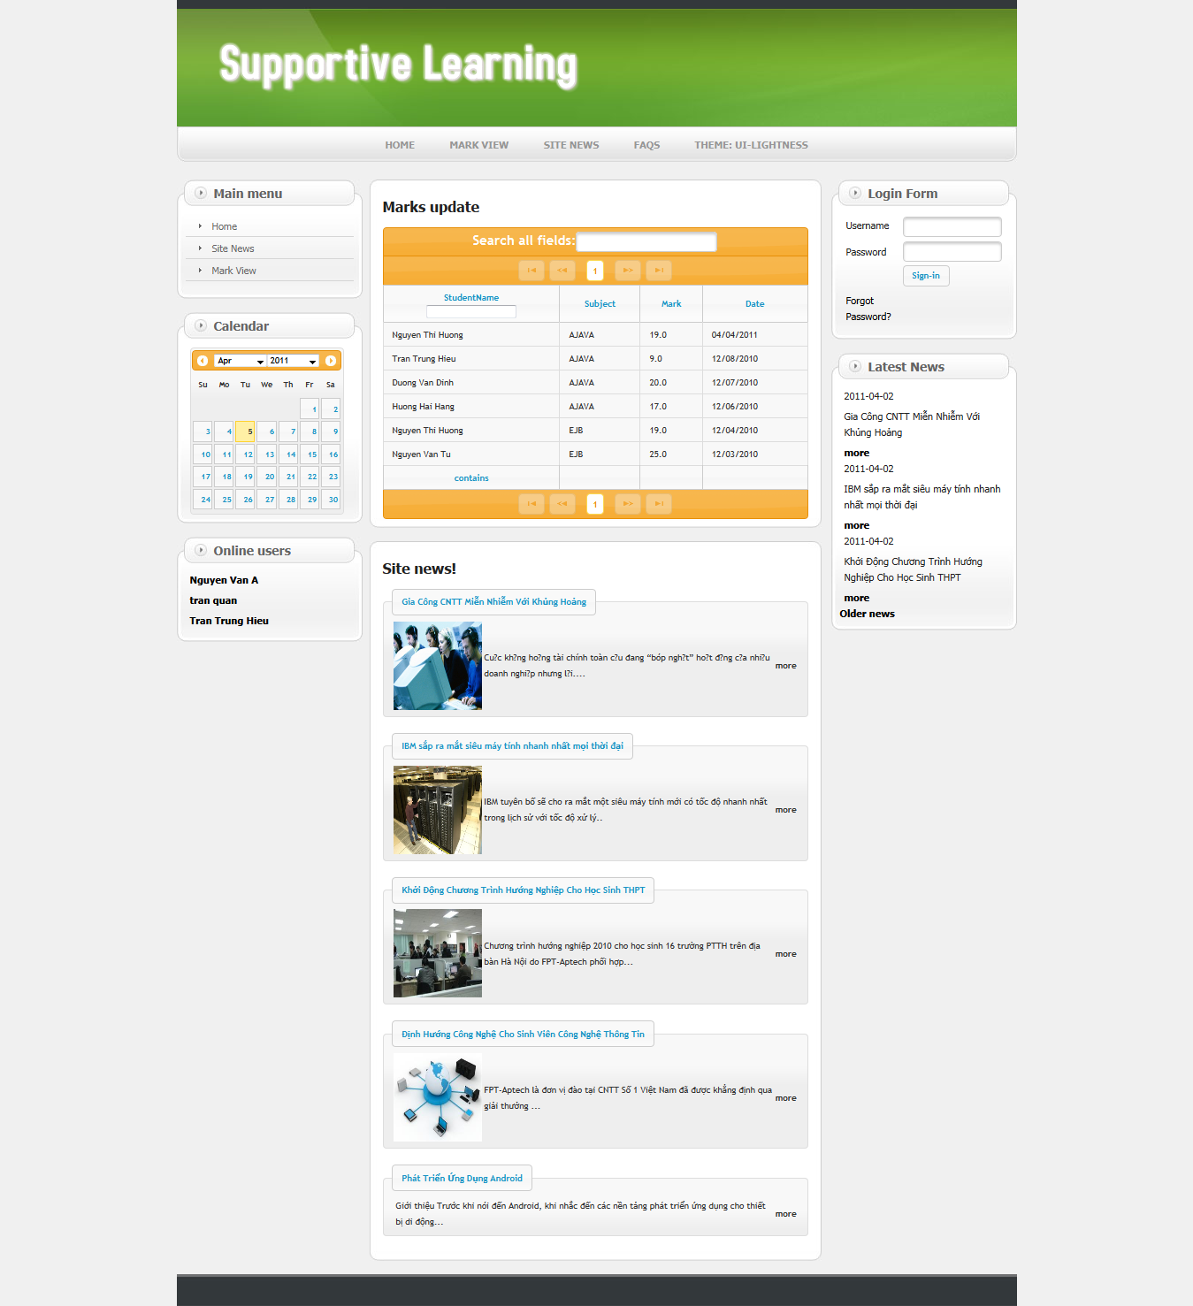

2 - Index page, we can search student

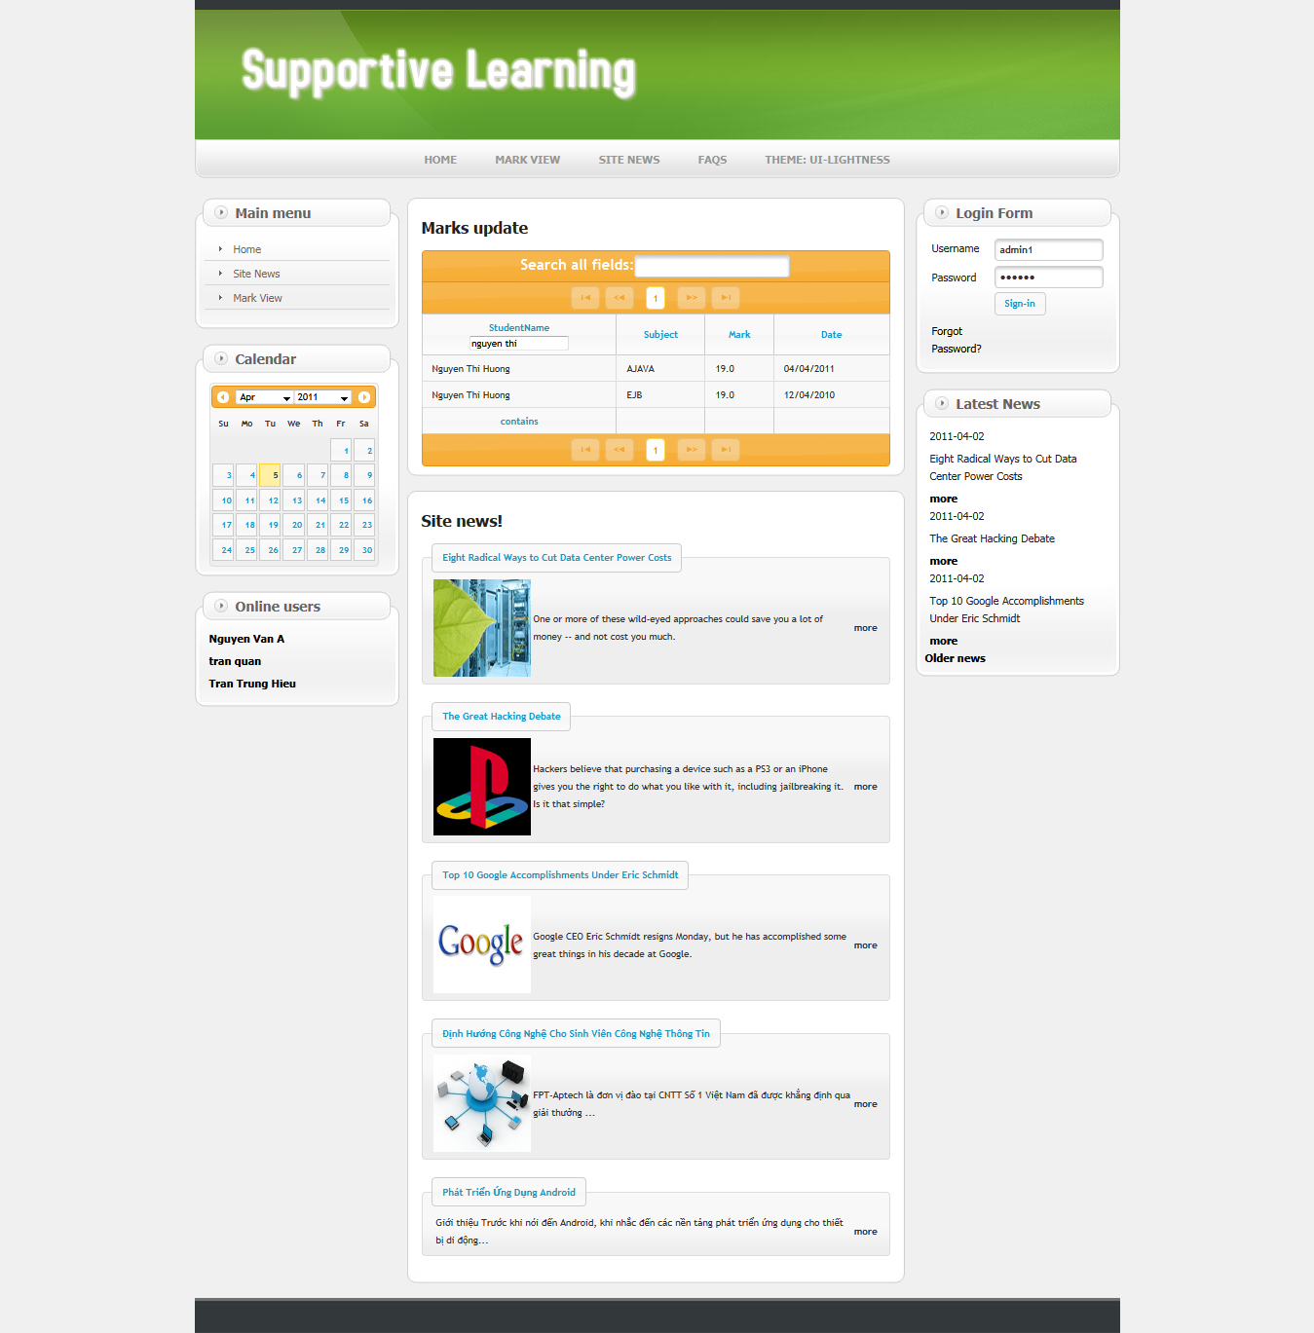

3 - Interface of the news

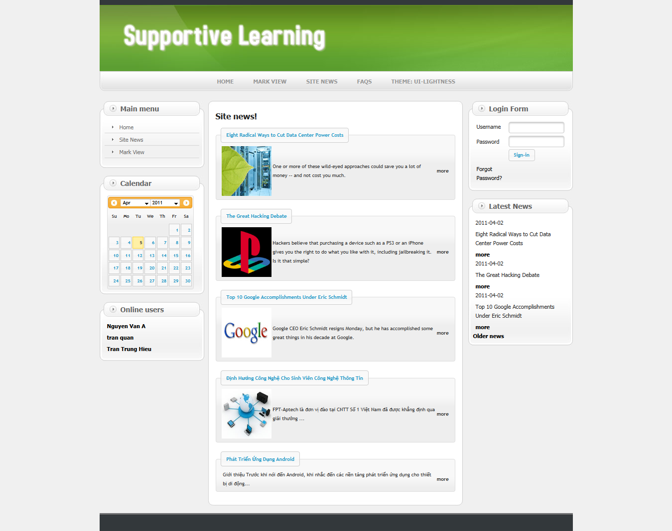

4 - Interface of the details news: When we click “more” from news page

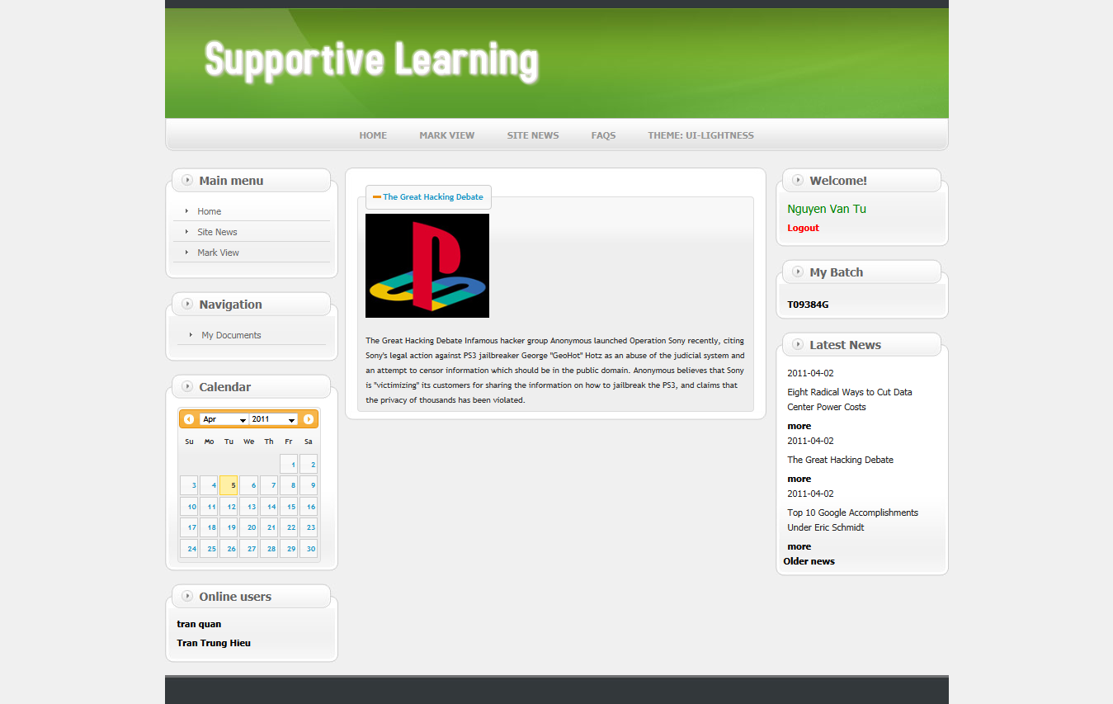

5 - Interface of the Mark view: We will enter Roll number of Student

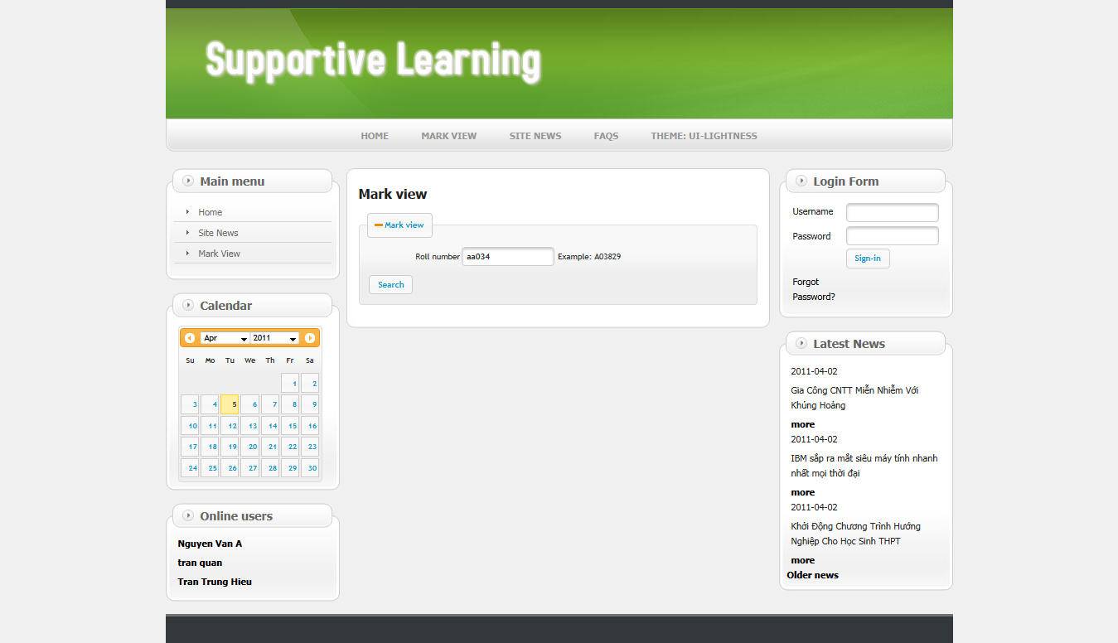

6 - Interface of the Mark view: Display of student’s mark

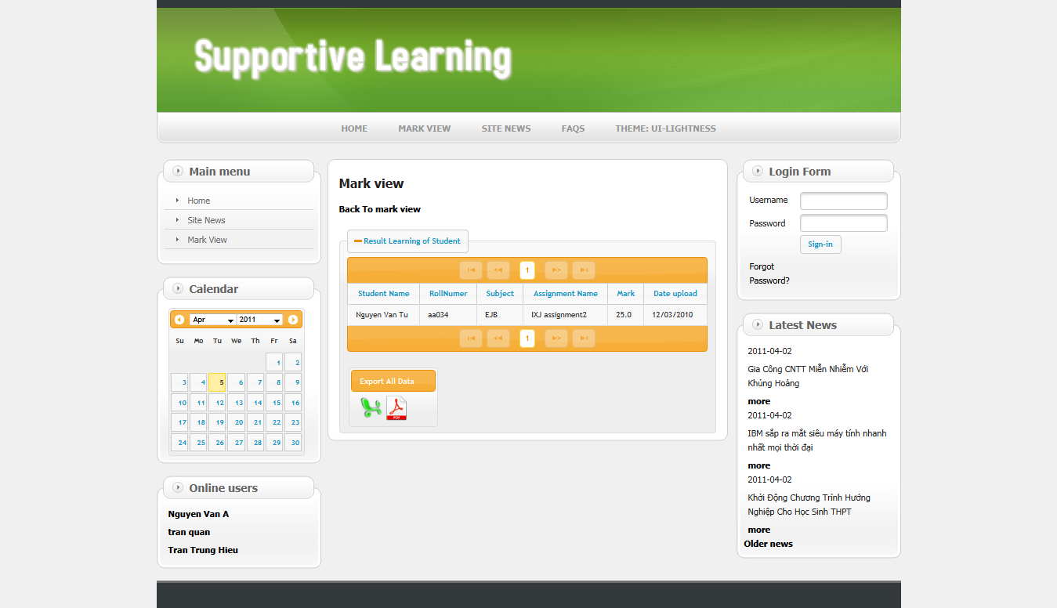

Staff operations

1 - Original interface My Batch when staff login success

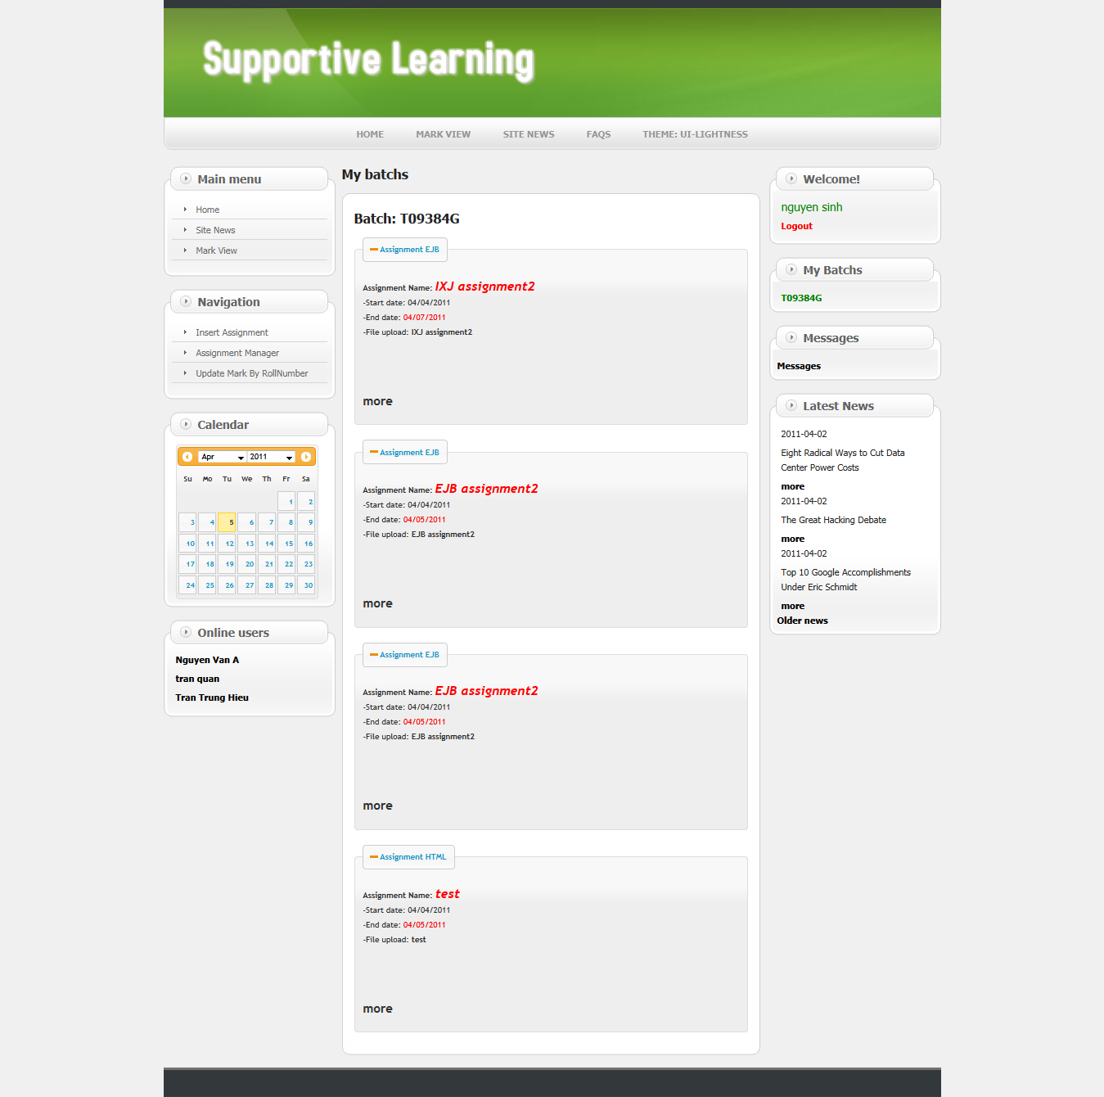

2 - Details Assignment page: When staff click “more” from My Batch

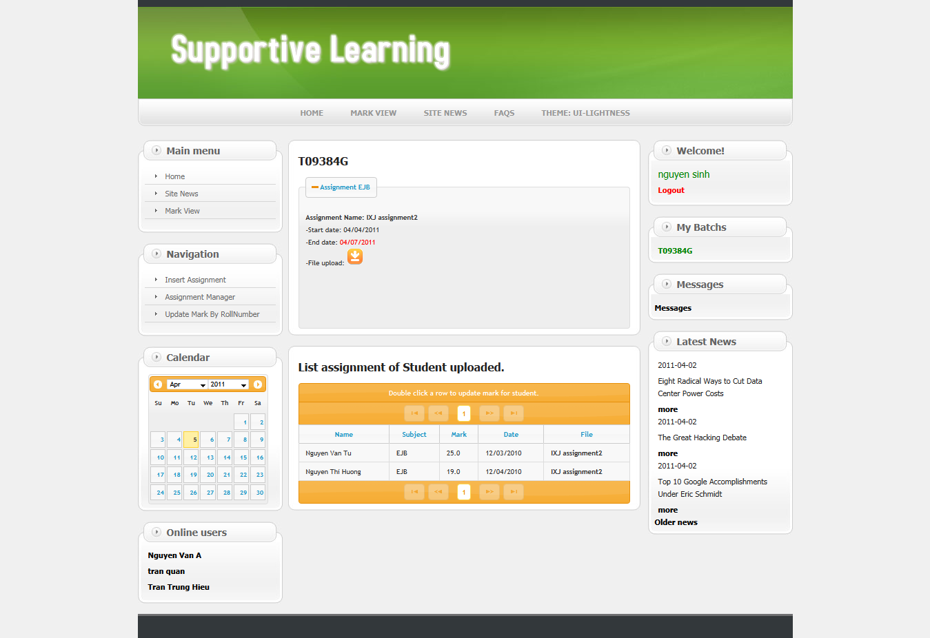

3 – Insert Assignment page: Staff create new Assignment

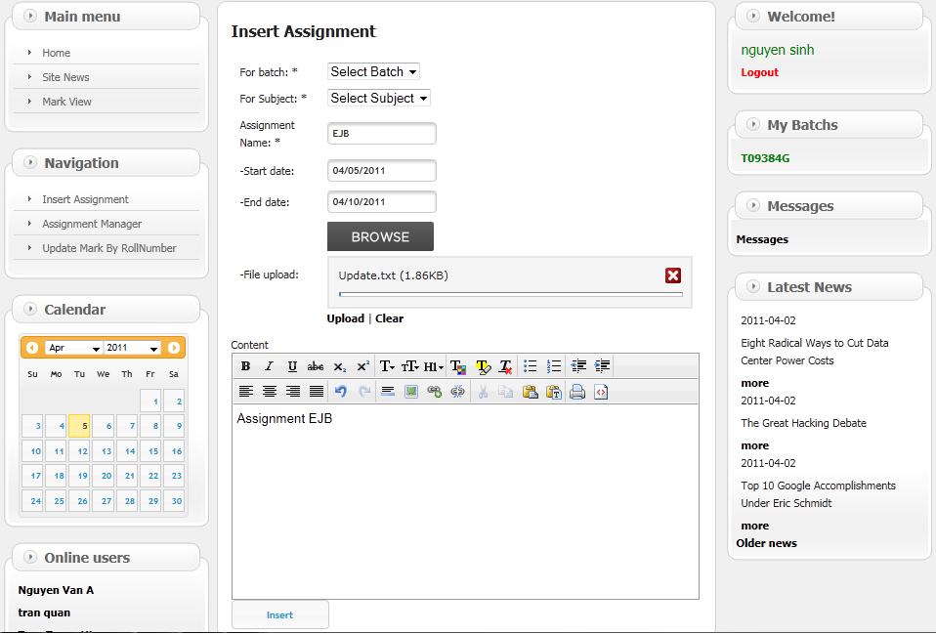

4 – Assignment Manager page:

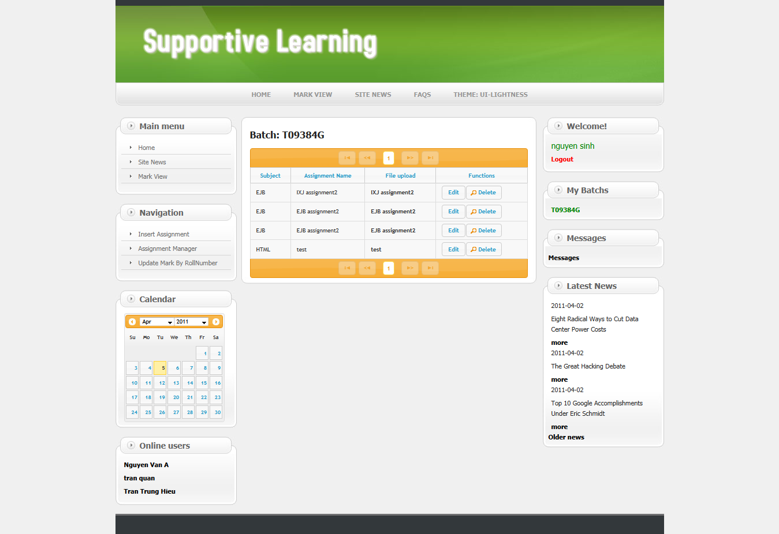

5 - Edit Assignment page: When staff click “Edit” from Assignment Manager page

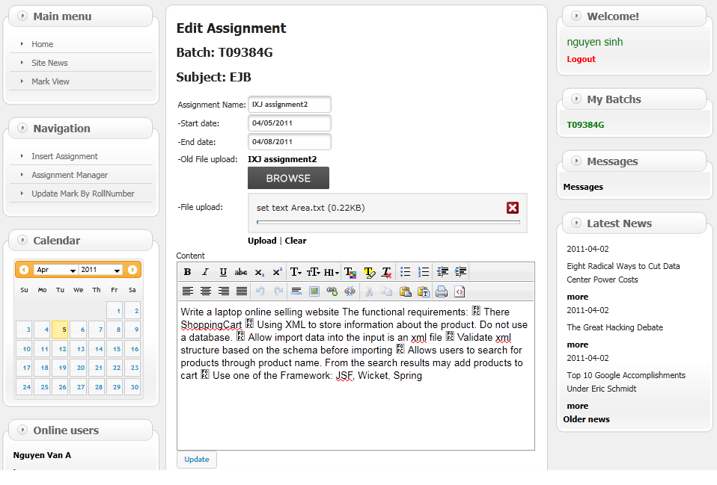

6 - Dialog Delete Assignment: When staff click “Delete” from Assignment Manager page

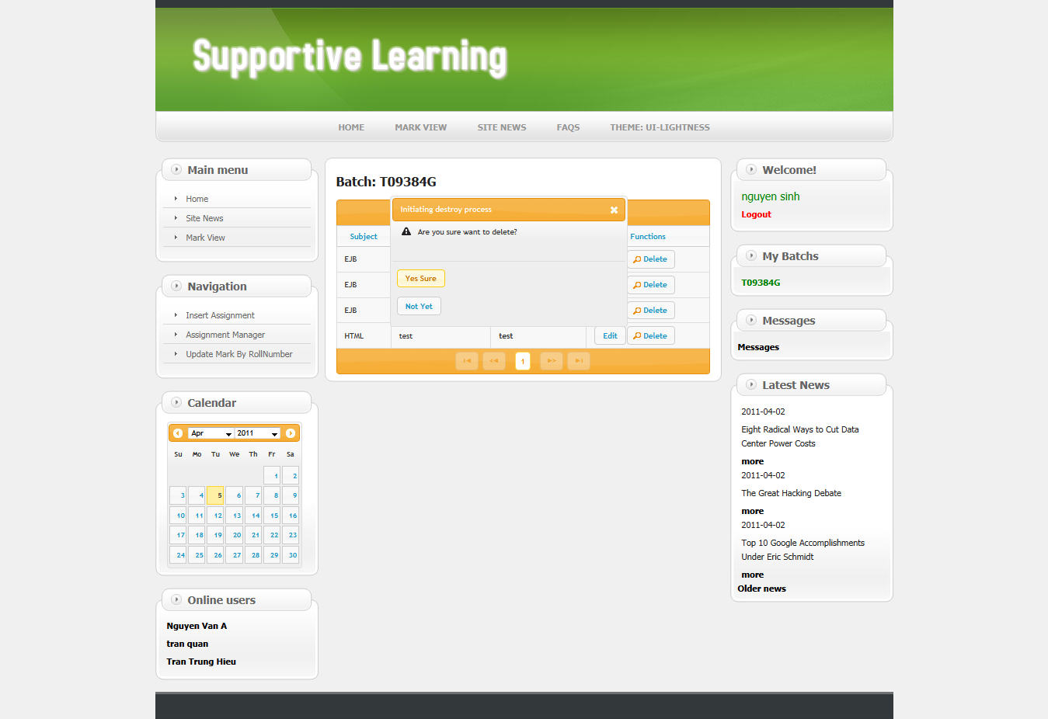

7 - List Message page

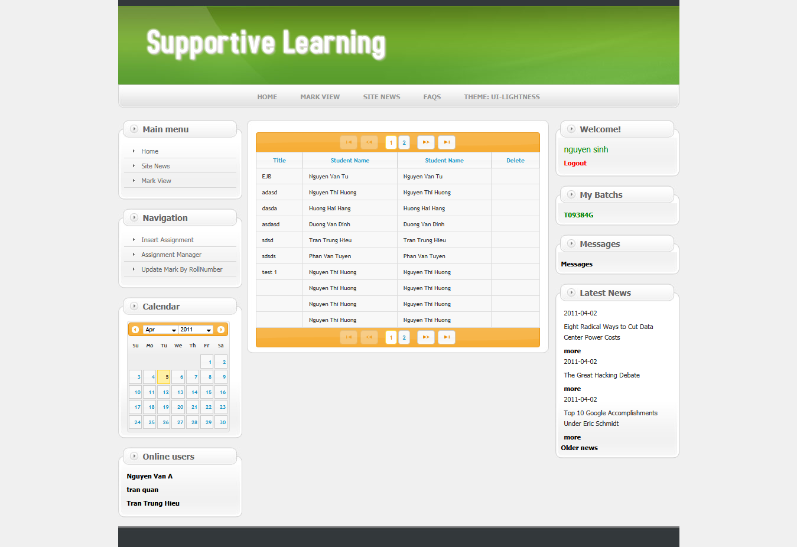

8 - Answer Message page: When staff click message from List Message

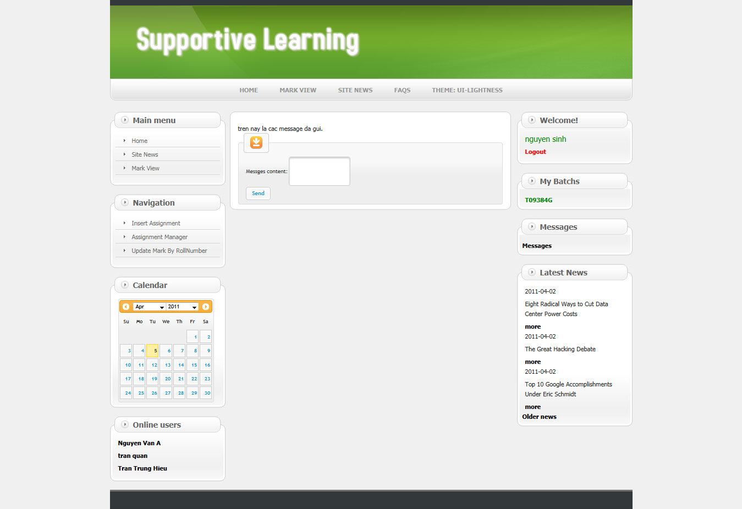

9 - Update Mark page:

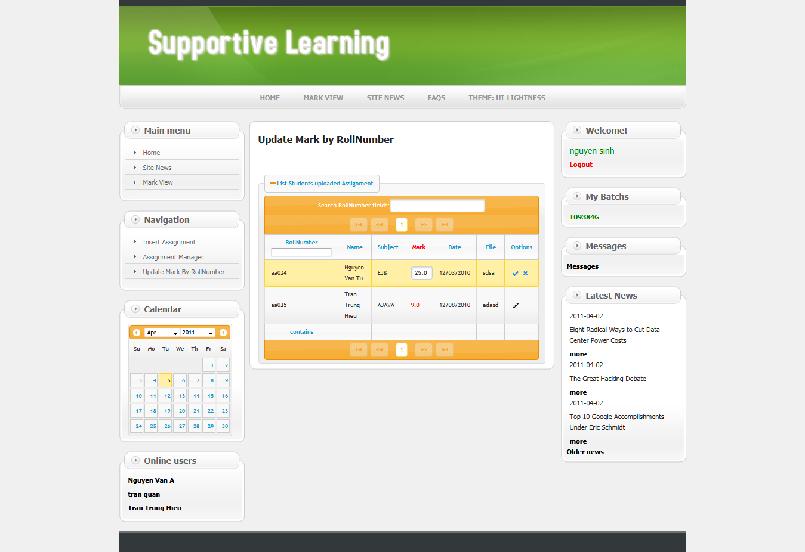

Student operations

1 - Original interface index page when staff login success

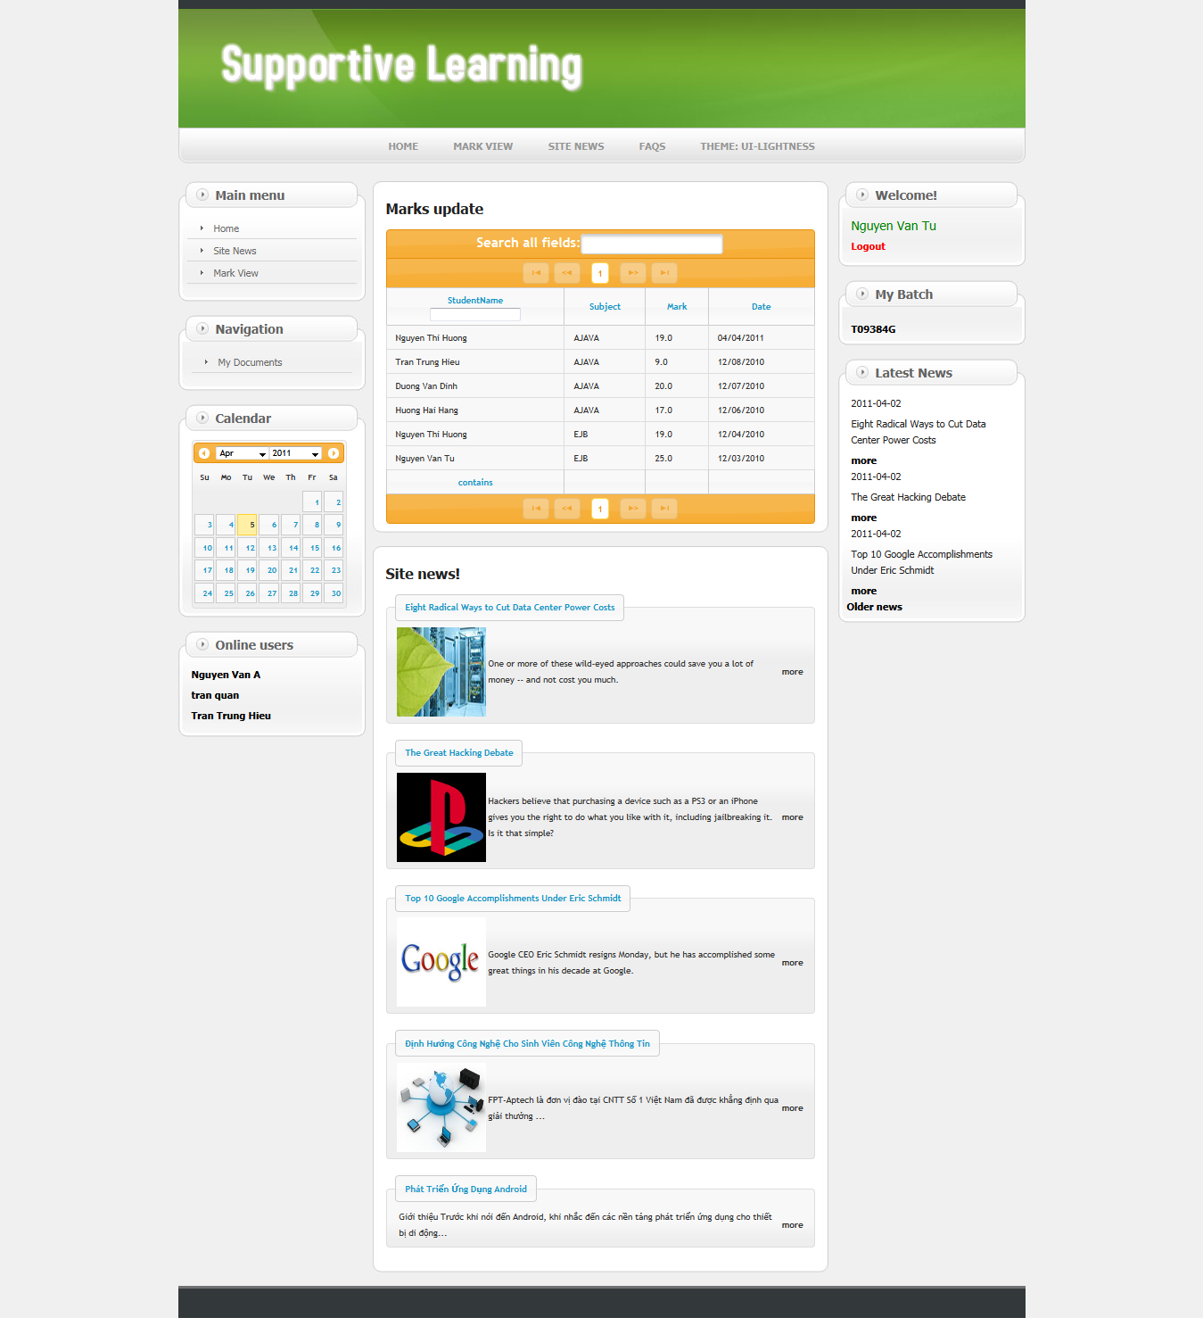

2 - List Assignment page: When student click “batch” from index page

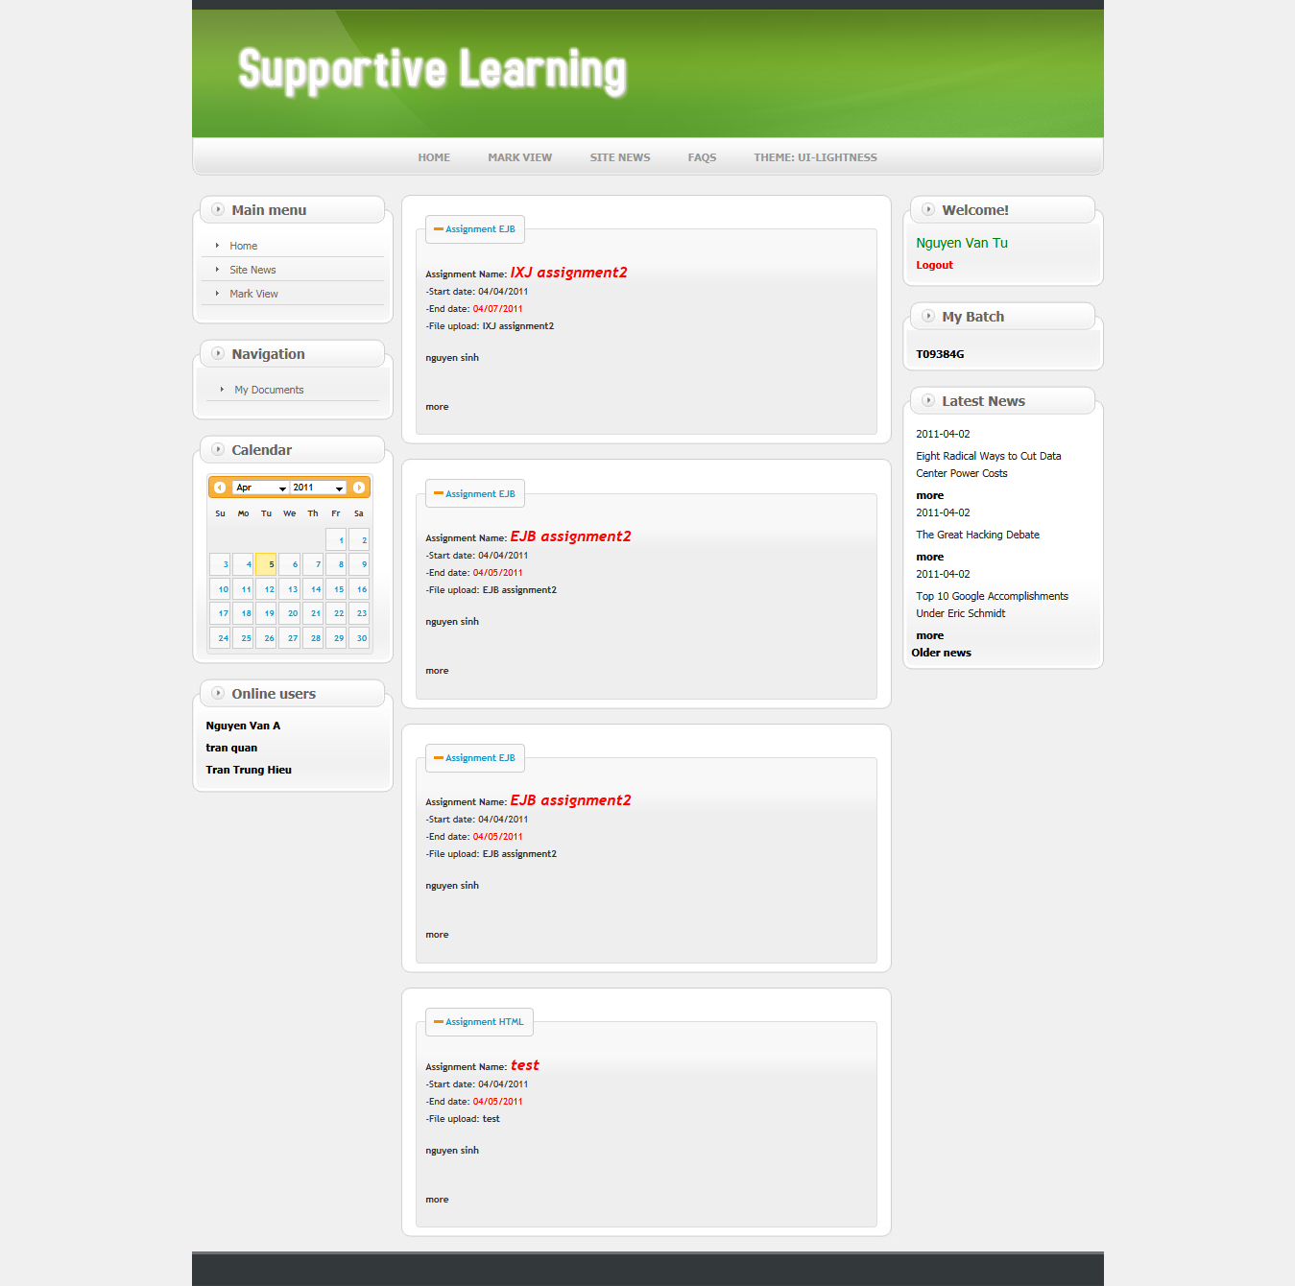

3 – Upload File page: When student click “more” from List Assignment page

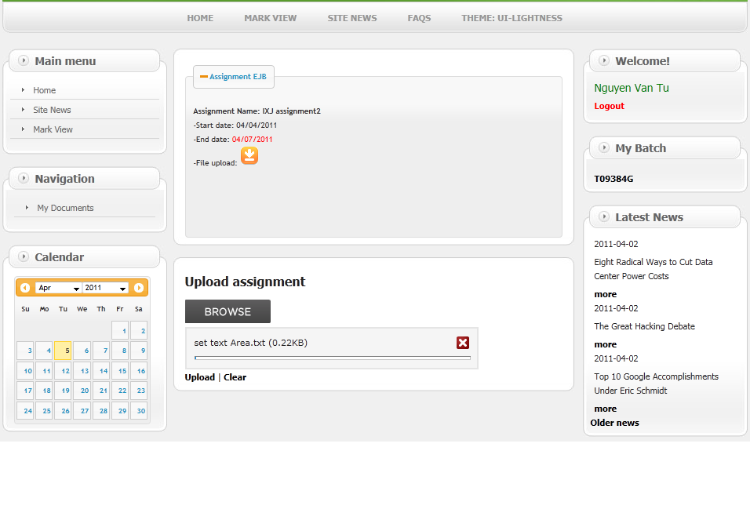

4 – My File page: When student click “My Documents” from index page

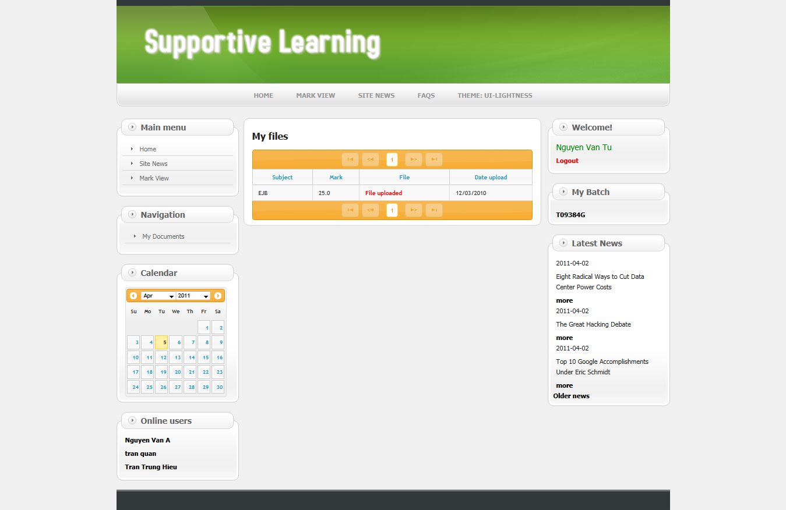

5 – Send Feedback page: When student click user on list User Online

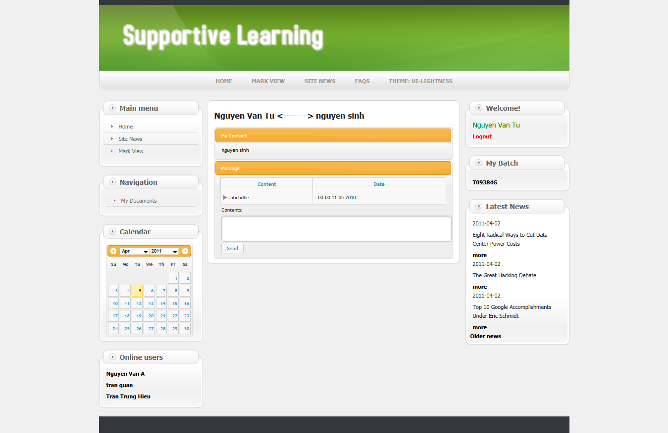

6 – FAQs page:

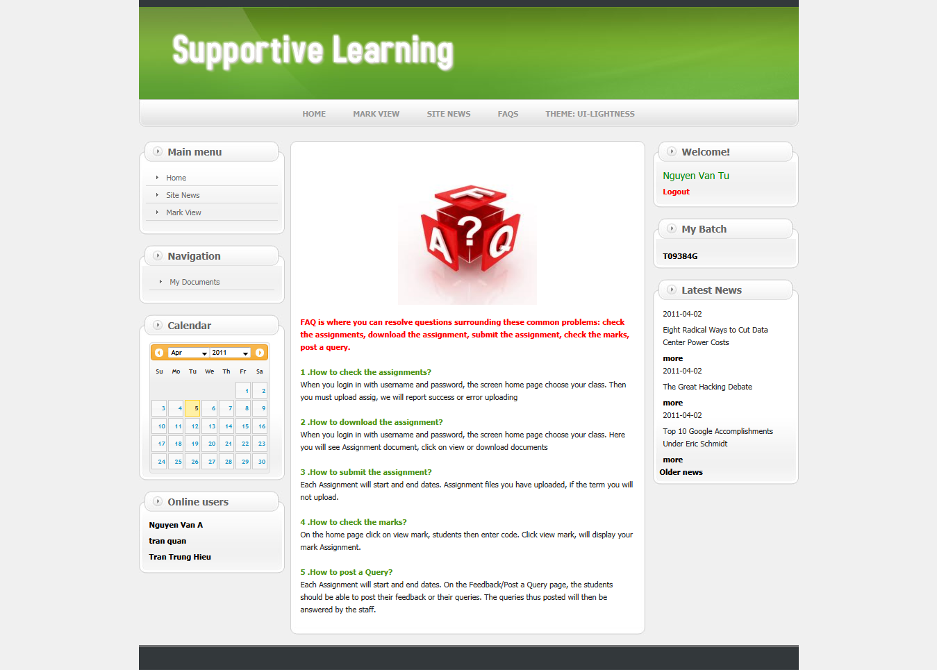

Admin operations

1 - Original interface index page when Admin login success

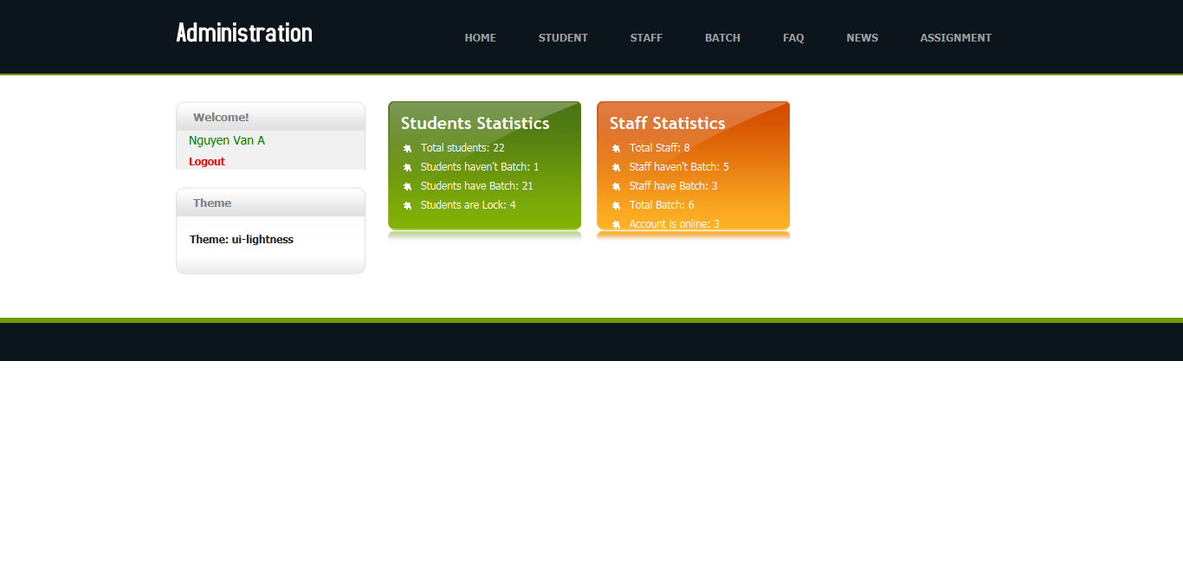

2 – Staff Manager: When Admin click tab “Staff” in menu

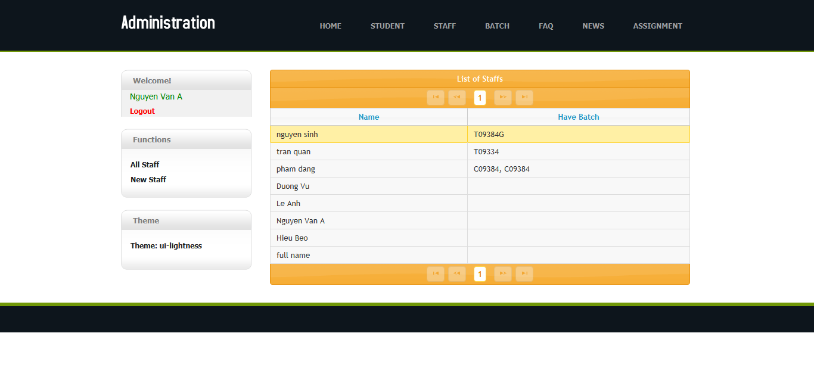

3 – Manager Detail Staff: When admin double click staff name

Click delete Batch from detail from staff detail

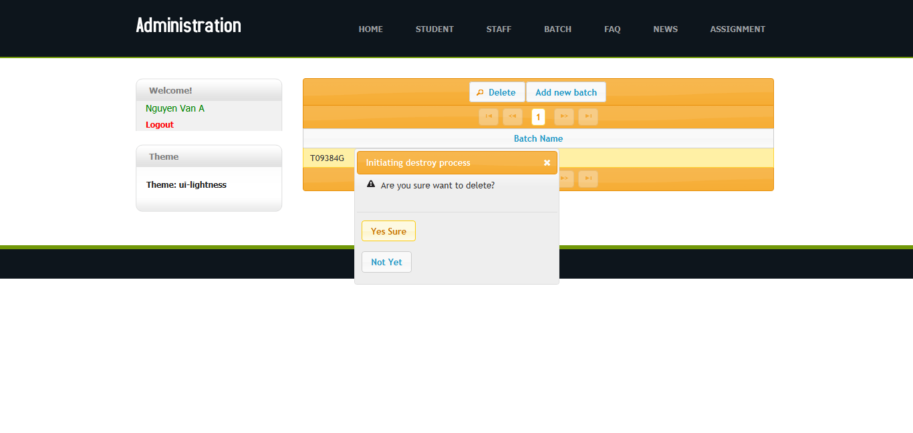

4 – Add Batch: Add new Batch to staff detail

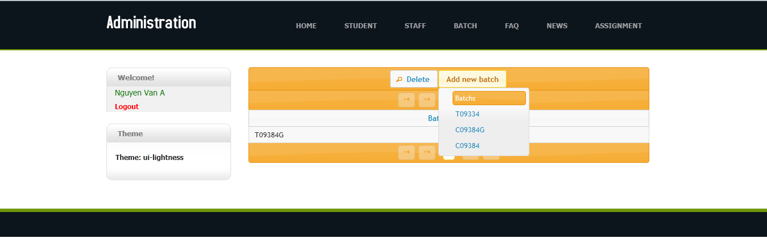

5 – Add New Staff page

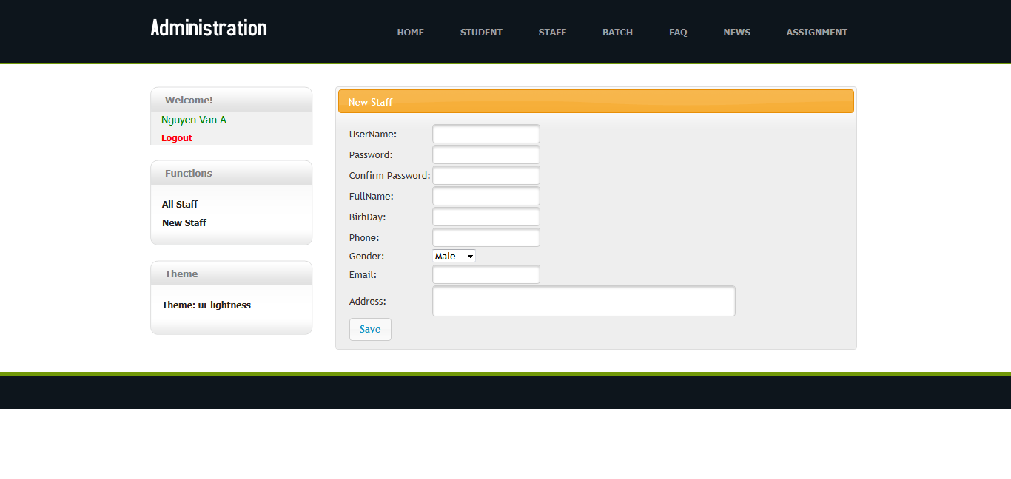

6 - Staff Manager: When Admin click tab “Batch” in menu

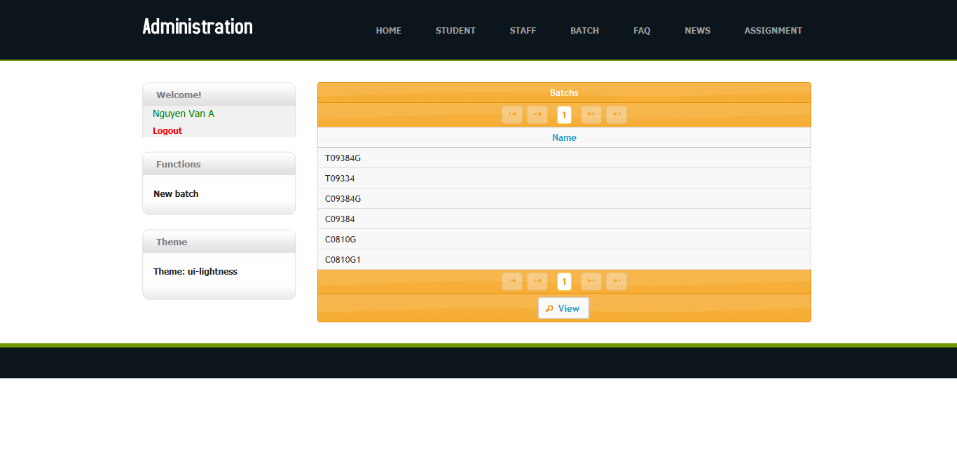

7 – List Student in Batch page: When admin double click batch name

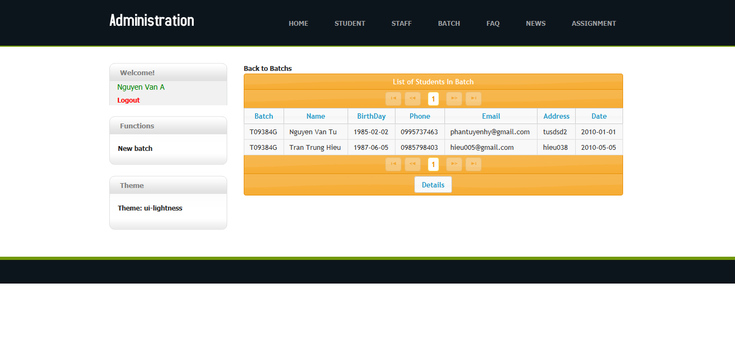

8 – Detail Student dialog: When admin double click student name

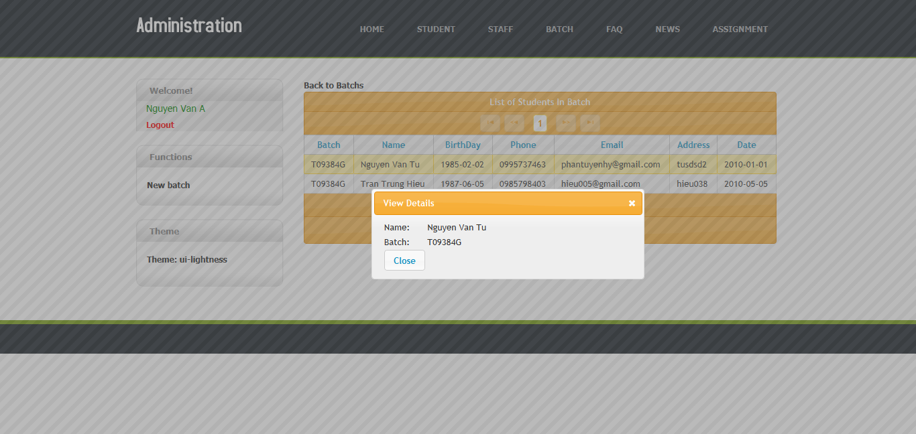

9 – Add new Batch page

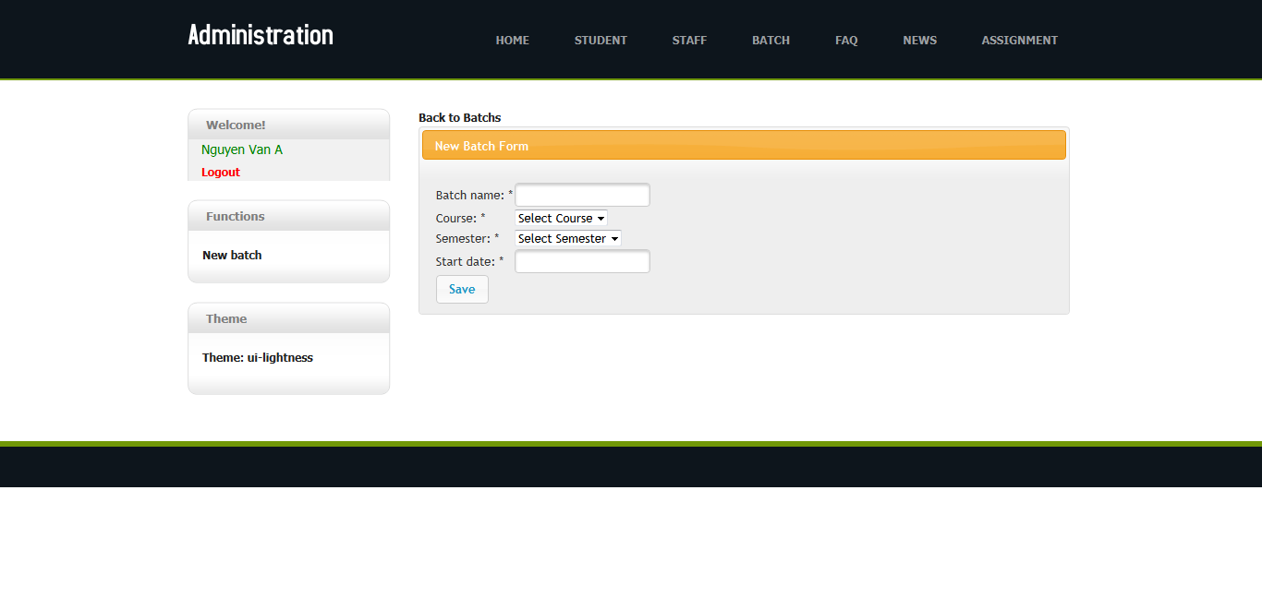

10 - Staff Manager: When Admin click tab “Assignment” in menu

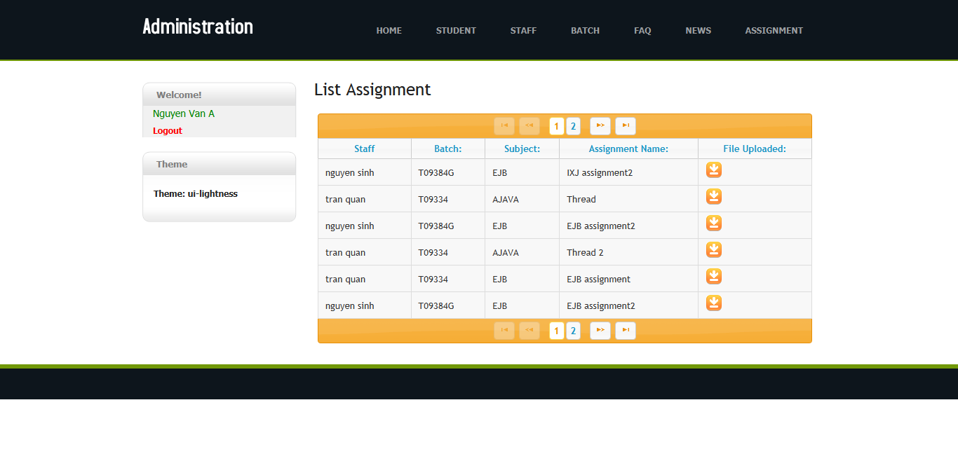

11 – FAQs Manager: When Admin click tab “FAQs” in menu

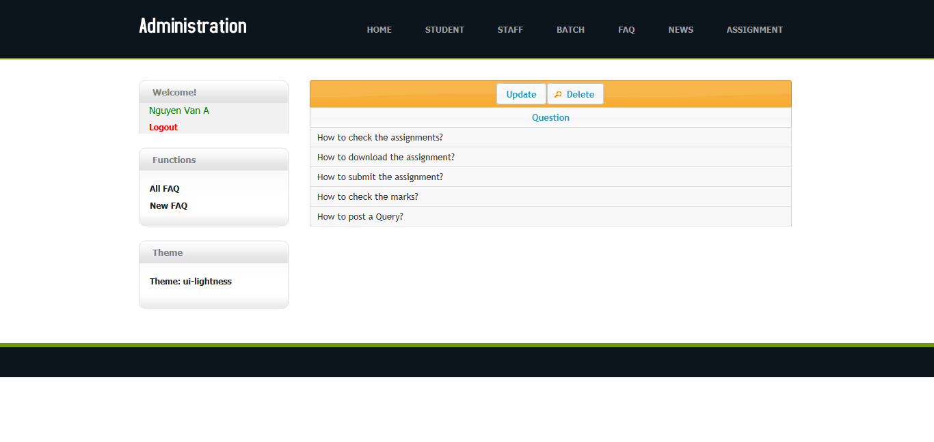

12 – Update FAQs page: When admin click “update” from FAQs Manager

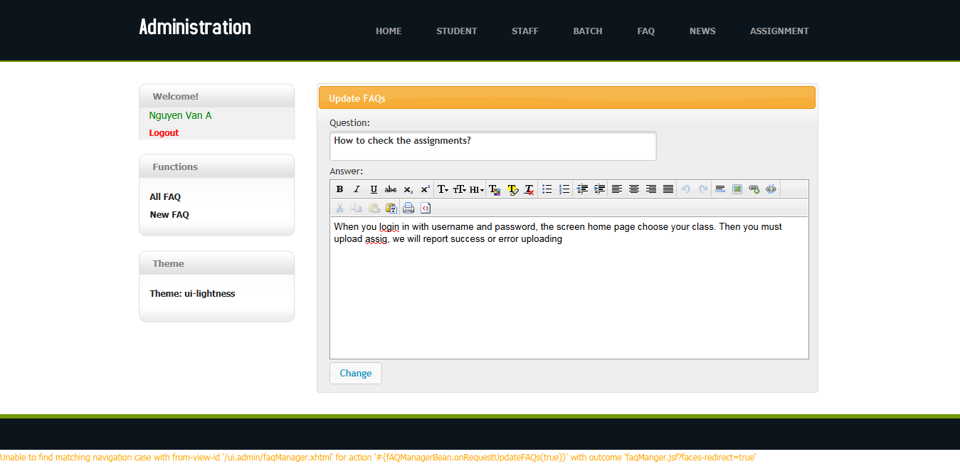

13 – Delete FAQs dialog: When admin click “delete”

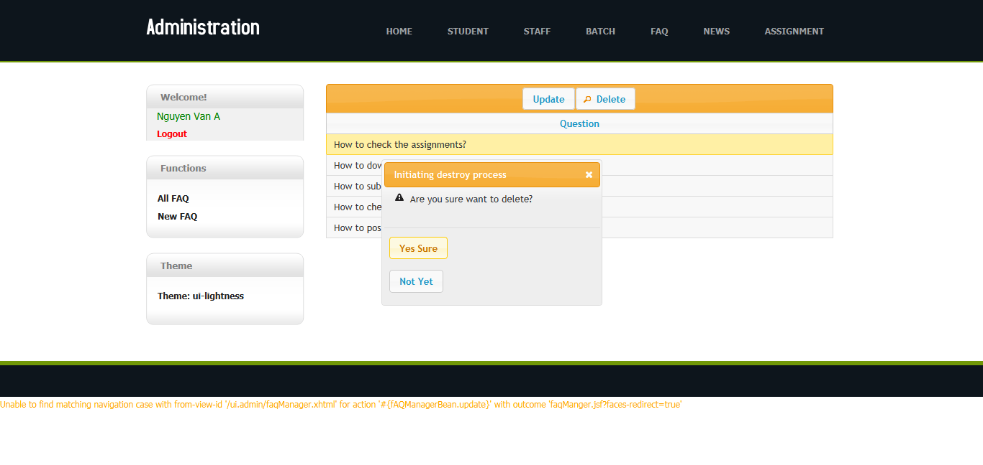

14 – New FAQs page:

