

Hotel Management System
Software Design Document
Project Code: HMS
Document Code: HMS_SDD– v1.0

– Ha Noi, October, 2026 –

Table of Contents
1 Introduction 5
1.1 Purpose 5
1.2 Definitions, Acronyms and Abbreviations 5
1.3 References 8
2 System Architecture 9
2.1 System Overview 9
2.2 Assumptions 11
2.3 Design Constraints 12
3 Software Architecture Design 14
3.1 Architectural Representation 14
3.2 Software Architecture 15
3.2.1 Process View 16
3.2.2 Logical View 17
3.2.3 Development View 21
3.2.3.1 Package Diagram 21
3.2.3.1.1 Back end package diagram 21
3.2.3.1.2 Front-end package diagram 23
3.2.4 Deployment View 24
4.1 Common Design 24
4.1.1 General Conventions 25
4.1.1.1 API Conventions 25
4.1.1.2 Date/Time and Currency Handling 25
4.1.2 Exception Handling 26
4.1.2.1 Backend 26
4.1.2.2 Frontend 28
4.1.3 Logging 28
4.1.3.1 Application Log (Backend) 29
4.1.3.2 System Error Log (Persisted Errors) 29
4.1.3.3 Audit Log (Backend) 29
4.1.3.4 Frontend Logging 30
4.1.3.5 Log Viewer (Administrator) 30
4.1.4 Messages Processing 30
4.1.4.1 Message Catalogue 30
4.1.4.2 UI Display Specification 31
4.1.5 Authentication and Authorization 32
4.1.5.1 Backend 32
4.1.5.2 Frontend 33
4.1.6 Validation 33
4.1.7 Security 34
4.1.8 UI Structures (Frontend) 35
4.1.9 Utility Classes/Components 35
4.1.9.1 Backend 35
4.1.9.2 Frontend 35
4.1.10 Transaction Management (Backend) 36
4.2 Account & Authentication Management 36
4.2.1 Screen Design 36
4.2 Account & Authentication Management 38
4.2.1 Screen Design 38
4.2.2 Class/Component Design 40
4.2.2.1 Backend Class Diagram 40
4.2.2.2 Classes/Component Description 41
4.2.3 Object Interactions (Sequence Diagram) 44
4.3 Room & Facility Management 46
4.3.1 Screen Design 46
4.3.2 Class/Component Design 48
4.3.2.1 Backend Class Diagram 48
4.3.2.2 Classes/Component Description 48
4.3.3 Object Interactions (Sequence Diagram) 51
4.4 Reservation & Front-Desk Operations 54
4.4.1 Screen Design 54
4.4.2 Class/Component Design 58
4.4.2.1 Backend Class Diagram 58
4.4.2.2 Classes/Component Description 59
4.4.3 Object Interactions (Sequence Diagram) 62
4.5 Ancillary Services & Billing Management 65
4.5.1 Screen Design 65
4.5.2 Class/Component Design 66
4.5.2.1 Backend Class Diagram 66
4.5.2.2 Classes/Component Description 67
4.5.3 Object Interactions (Sequence Diagram) 70
4.6 Reviews, Audit & Reporting Management 72
4.6.1 Screen Design 72
4.6.2 Class/Component Design 73
4.6.2.1 Backend Class Diagram 73
4.6.2.2 Classes/Component Description 74
4.6.3 Object Interactions (Sequence Diagram) 76
5. Database Design 78
5.1 Database Design 78
a. Role 78
b. Account 79
c. Room_Type 79
d. Room 79
e. Reservation 80
f. Reservation_Detail 80
g. Guest_Stay 81
h. Stay_Room_Assignment 81
i. Review 81
j. Hotel_Service 82
k. Service_Order 82
l. Folio 83
m. Additional_Charge 83
n. Voucher 83
o. Invoice 84
p. Payment 85
q. Customer 85
r. Payment_Attempt 86
s. Staff 86
t. Department 87
u. Audit_Log 87
v. Room_Type_Price 88
w. Reservation_Nightly_Rate 88
x. Housekeeping_Task 89
5.2 Data File Design 89

1 Introduction

1.1 Purpose
This Software Design Document (SDD) provides a comprehensive architectural and detailed technical design for the Hotel Management System (HMS). It translates the functional and non-functional requirements specified in the HMS Software Requirement Specification (HMS-SRS-v1.2) into an executable software architecture, component structure, and relational database schema.
Specifically, this document contains the following information:
- System Architecture (Section 2): Defines the high-level Client-Server architecture, the interaction between user groups, the frontend Single Page Application (SPA), the backend application server, the relational database server (Microsoft SQL Server), and external integrated services (Payment Gateway and Mail Notification Service), along with system assumptions and design constraints.
- Software Architecture Design (Section 3): Presents the architectural views of the system, including the Process View, Logical View, Development View, and Deployment View, following the 3-Layer Architecture pattern.
- Detailed Component Design (Section 4): Specifies the common design mechanisms (error handling, logging, security filters, transaction management) and the detailed class diagrams, class specifications, screen definitions, and sequence diagrams for the system's features and use cases.
- Database Design (Section 5): Details the physical relational database tables in Microsoft SQL Server and the mapped JPA Entity and Data Transfer Object (DTO) classes.
This document is intended for the following readers:
- SBA301 Instructors: To review and evaluate the architectural soundness, adherence to software engineering standards, and compliance with the SBA301 technical stack.
- Software Developers (Frontend & Backend Engineers): To serve as the authoritative technical specification for implementing ReactJS components, Spring Boot REST controllers, business services, and Spring Data JPA repositories.
- Quality Assurance (QA) / Testing Engineers: To understand component interfaces, API contracts, and transaction boundaries when designing unit and integration test cases.

1.2 Definitions, Acronyms and Abbreviations
The table below lists all common business and technical definitions, acronyms, and abbreviations used throughout this Software Design Document:

Term / Acronym | Full Form / Definition | Description
HMS | Hotel Management System | The centralized web-based software platform designed to coordinate daily lodging operations across independent 3-star to 4-star hotels.
SRS | Software Requirement Specification | The baseline requirements document (HMS-SRS-v1.2) specifying the functional and non-functional requirements of the HMS.
SDD | Software Design Document | This document, which describes the system architecture, component design, and database design of the HMS.
SPA | Single Page Application | A web application implemented in ReactJS that dynamically updates the current page via JavaScript without requiring full page reloads from the server.
CSR | Client-Side Rendering | A rendering model in which the client web browser renders the user interface using JavaScript and exchanges JSON data with backend APIs.
REST | Representational State Transfer | An architectural style for networked applications using standard stateless HTTP methods (GET, POST, PUT, DELETE) to manipulate resources.
API | Application Programming Interface | A set of defined endpoints exposed by the backend server to enable communication with the frontend client and external services.
JWT | JSON Web Token | An open standard (RFC 7519) used for stateless user authentication and authorization between the client browser and the backend server.
RBAC | Role-Based Access Control | A security approach that restricts system access to authorized user roles (Customer, Front-Desk Staff, Housekeeping Staff, Service Staff, Administrator).
ORM | Object-Relational Mapping | A programming technique (using Hibernate) that maps object-oriented domain entities in Java to relational database tables.
JPA | Java Persistence API | The Jakarta EE specification used via Spring Data JPA for managing relational data in Java applications.
DTO | Data Transfer Object | An object used to encapsulate and transfer data between the presentation layer and the service layer, decoupling database entities from API payloads.
DAO / Repository | Data Access Object / Repository | The persistence layer abstraction responsible for executing database CRUD queries and encapsulating data access logic.
RDBMS | Relational Database Management System | The relational database engine (Microsoft SQL Server) used to store structured, transactional hotel data.
Folio | Guest Stay Folio | The financial ledger of an active guest stay that accumulates room charges, service orders, and surcharges prior to invoice generation.
SMTP | Simple Mail Transfer Protocol | The standard communication protocol used to send outbound transactional emails via an external mail server.

1.3 References
The following table lists the documents, standards, and technical specifications referenced by this Software Design Document:

No. | Document Title / Standard | Version | Date | Author / Source / Location
1 | Hotel Management System – Software Requirement Specification (HMS-SRS) | v1.2 | Oct 2026 | HMS Project Team (KhangND, HieuVQ, GiapND, LinhNH, TungPV) – FPT University
2 | Software Design Document (SDD) Template | v1.0 | 2026 | Department of Software Engineering, FPT University
3 | SBA301 Courseware & Lecture Materials | 2026 | 2026 | FPT University Academic Curriculum (ReactJS SPA, RESTful APIs, Spring Boot 3, JPA/Hibernate, JWT Security)
4 | Spring Boot & Spring Security Reference Documentation | 3.2+ | 2024 | VMware / Spring.io (https://docs.spring.io/spring-boot/)
5 | React Official Documentation | 18.2+ | 2024 | Meta Open Source (https://react.dev/)
6 | OpenAPI Specification (Springdoc-OpenAPI / Swagger 3) | 3.0.3 | 2024 | OpenAPI Initiative (https://swagger.io/specification/)
7 | RFC 7519 – JSON Web Token (JWT) | Standard | May 2015 | Internet Engineering Task Force (https://datatracker.ietf.org/doc/html/rfc7519)

2 System Architecture

2.1 System Overview
The Hotel Management System (HMS) is designed based on a decoupled Client-Server Architecture represented using a clear box-and-line model. The architecture separates the frontend source code hosting environment (NodeJS), the client-side execution environment (Web Browser running HMS Frontend), the backend application server container (Apache Tomcat 10 hosting HMS Backend Software), the relational database server (Microsoft SQL Server hosting HMS Database), and external third-party services (Google Mail Service and VNPay Payment Gateway).
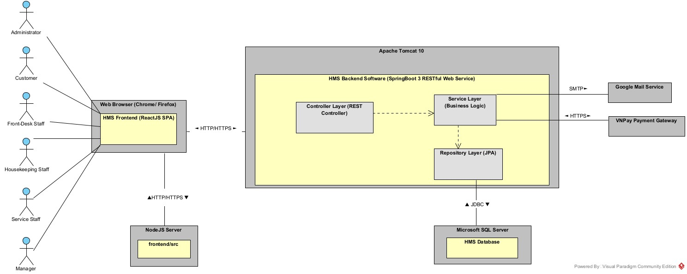
Figure 2-1: System Architectural Overview
As described in Figure 2-1, the system will have the following components:
- User Groups (Actors):
  - Customer: External guests who interact with the HMS Frontend inside the Web Browser to browse room categories, search available rooms, create online reservations, pay advance deposits via VNPay, order room services during an active stay, view booking histories, and submit room reviews after departure.
  - Front-Desk Staff: Receptionists who use the application to confirm direct/offline reservations, perform guest check-ins, allocate inspected physical rooms, handle room transfers and stay extensions, compile itemized invoices, apply discount vouchers, record counter payments, and complete guest check-outs.
  - Housekeeping Staff: Floor staff who monitor room statuses, receive assigned room cleaning tasks from the Manager, update room cleanliness states (Dirty $→$ Clean $→$ Inspected), and report defective rooms for maintenance.
  - Service Staff: Ancillary service personnel (F&B, room service, minibar, spa, laundry) who view service orders, post consumed service charges onto active guest stay folios, and void unrendered service orders.
  - Manager: Hotel managerial, sales/marketing, and accounting personnel who configure room categories, physical room inventory, hotel services, and promotional vouchers; assign dirty rooms to Housekeeping Staff for cleaning (UC-51); moderate customer reviews; inspect system audit logs; and generate occupancy, revenue, and service consumption analytical reports.
  - Administrator: IT system administrators responsible strictly for managing user accounts, toggling account active/inactive statuses, assigning staff roles, configuring audit tracking parameters, and inspecting system security audit logs.
- NodeJS (frontend/src): This component serves as the source code hosting environment that stores the frontend ReactJS source code (frontend/src). When an end-user accesses the HMS web address, the Web Browser communicates with NodeJS via HTTP/HTTPS to retrieve the frontend source code to the client machine.
- Web Browser & HMS Frontend:
  - Web Browser (Chrome / Firefox / Edge): The client-side runtime environment used by all six user groups. It fetches the source code from NodeJS over HTTP/HTTPS and sends business requests to the Apache Tomcat 10 server over HTTP/HTTPS.
  - HMS Frontend: The Single Page Application (SPA) built with ReactJS 18, React Router DOM, React-Bootstrap, and Axios that executes directly inside the Web Browser after loading the source code from frontend/src. End-users interact directly with this HMS Frontend component.
- Apache Tomcat 10 & HMS Backend Software:
  - Apache Tomcat 10: The application server container that listens for incoming HTTP/HTTPS requests from the Web Browser and dispatches them down to the Controller layer of the HMS Backend Software deployed inside it.
  - HMS Backend Software: The developing server software built on Java 21 and Spring Boot 3, secured by Spring Security 6 (JWT) and documented with Swagger 3 / OpenAPI. Internally, it follows a strict 3-Layer Architecture:
    - Controller Layer: Receives HTTP requests forwarded by Apache Tomcat 10, validates request payloads, and invokes the Service Layer.
    - Service Layer: Executes business logic, enforces operational rules (BR-01 to BR-43), manages ACID transactions, communicates with Google Mail Service and VNPay Payment Gateway, and calls the Repository Layer.
    - Repository Layer: Built on Spring Data JPA / Hibernate, responsible for opening JDBC connections to Microsoft SQL Server to query and persist data.
- Microsoft SQL Server & HMS Database:
  - Microsoft SQL Server: The Relational Database Management System (RDBMS) server that receives JDBC queries from the Repository layer of the HMS Backend Software.
  - HMS Database: The physical relational database hosted inside Microsoft SQL Server that stores all persistent tables of the system (users, roles, room types, rooms, housekeeping assignments, reservations, guest stays, services, service orders, folios, invoices, vouchers, payments, reviews, and audit logs).
- Google Mail Service (Gmail SMTP): An external email server integrated with the Service layer of the HMS Backend Software via the SMTP protocol (JavaMailSender) to dispatch password recovery verification links (UC-10), booking confirmation emails (UC-23, UC-26), and digital invoice receipts.
- VNPay Payment Gateway: An external electronic payment gateway integrated with the Service layer of the HMS Backend Software via HTTPS APIs to process online reservation deposit payments (UC-23) and return authenticated transaction results.

2.2 Assumptions
This system is designed based on the following assumptions regarding hardware, software, operating systems, end-user characteristics, and operational environment:
- Server Operating System & Runtime Environment:
  - Windows Server 2019/2022 or Ubuntu Linux 22.04 LTS (64-bit).
  - Java Development Kit (JDK) 21 LTS installed on the application server with a minimum of 8 GB RAM.
  - Node.js v18.x LTS or higher and npm v9.x+ available in the build environment for compiling the ReactJS frontend bundle.
- Database Management Systems:
  - Microsoft SQL Server 2019 or 2022 installed and accessible via TCP port 1433.
  - Automated nightly database backups are configured at the infrastructure level to retain backups for 30 days and maintain a Recovery Point Objective (RPO) of less than 24 hours (OR-04).
- Client Hardware, Operating Systems & Software:
  - End-user devices (desktop PCs at the front desk, laptops, tablets, or smartphones) running Windows 10/11, macOS, Android, or iOS.
  - Modern ECMAScript 6+ compliant web browsers: Google Chrome (v110+), Mozilla Firefox (v110+), Microsoft Edge (v110+), or Apple Safari (v16+) with JavaScript and localStorage enabled.
  - Standard A4/A5 laser or thermal receipt printers connected to front-desk workstations and PDF viewer software (e.g., Adobe Acrobat Reader or built-in browser print engine) to print itemized invoice receipts (Section 5.1.2 & OR-02 of SRS).
- Network & External Services Availability:
  - The hotel property (60 to 150 rooms) has stable local area network (LAN) and continuous broadband internet connectivity.
  - External third-party services—specifically the Payment Gateway (VNPay/OnePay) and the SMTP Mail Notification Service—are operational, reachable over the internet, and respond within standard network timeout limits.
- End-User Characteristics & Operational Scope:
  - Hotel staff (Front-Desk, Housekeeping, Service Staff, and Administrators) possess basic computer literacy and web browser navigation skills.
  - Physical room key cards are handed over manually by front-desk receptionists and recorded by serial number in the Guest Check-in Form (UC-27); direct hardware integration with physical RFID door lock encoders is outside the scope of this software

2.3 Design Constraints
This system must comply with the following global limitations, architectural standards, and business rules imposed by the HMS-SRS-v1.2 and the SBA301 technical framework:
- Architectural & Technology Stack Constraints:
  - 3-Layer Backend Architecture: The Spring Boot backend must strictly separate responsibilities into three layers: controllers (REST API handling), services (business logic and transaction management), and repositories (data persistence). Controllers must not access Repositories directly, and database Entity objects must not be exposed directly to the client without Data Transfer Object (DTO) mapping.
  - Single Page Application (SPA) Frontend: The user interface must be implemented as a ReactJS SPA using Functional Components and React Hooks (useState, useEffect, useContext). Legacy React Class Components and server-side HTML rendering (e.g., JSP) are prohibited.
  - Client-Server Communication Protocol: All data transfers between the web browser and the backend server must be executed asynchronously via Axios over HTTP/HTTPS using RESTful conventions and application/json; charset=UTF-8 payloads.
- Performance & Scalability Constraints:
  - 3-Second Response Time SLA: In compliance with Section 5.2.3 of the SRS, every core operation—including Room Availability Search (UC-21), Booking Creation (UC-23), Guest Check-in (UC-27), Invoice Compilation (UC-37), Payment Settlement (UC-39), and Report Generation (UC-45..47)—must complete and display results within 3 seconds under normal operating conditions.
  - Server-Side Pagination: All list and search endpoints (room inventory, customer bookings, user accounts, service catalog, and audit logs) must implement server-side pagination and filtering using Spring Data's Pageable and Page<T> interfaces to prevent memory bottlenecks (CR-10).
- Security & Access Control Constraints:
  - Stateless JWT Authentication & Account Status Enforcement: Protected API endpoints must require a valid JWT Bearer token in the Authorization HTTP header. Only accounts with Active status are permitted to access the system (BR-02), and deactivating a user account (UC-08) must immediately revoke access for any active tokens belonging to that account.
  - Role-Based Authorization: Both frontend route guards and backend Spring Security filters must strictly enforce the role permissions defined in the Screen Authorization Matrix (Section 3.1.3 of SRS and CR-06).
  - Password Cryptography: User passwords must never be stored or transmitted in plaintext (Section 5.2.4 of SRS); all passwords must be hashed using the one-way BCrypt hashing algorithm before being persisted in the database.
- Data Repository, Transaction & Business Rule Constraints:
  - ACID Transaction Management: Multi-step state changes—such as Guest Check-in (updating Reservation status to Checked-In, creating a Guest Stay, initializing a Folio, and setting Room status to Occupied), Room Transfer (UC-28), Stay Extension (UC-29), and Guest Check-out (UC-30)—must be executed within atomic database transactions (@Transactional) so that any failure rolls back all partial changes (Section 5.2.2 & 5.2.6 of SRS).
  - Configuration Isolation for Historical Records: In accordance with Section 5.2.5 of the SRS and BR-27, updates to room category base tariffs (UC-12) or hotel service unit prices (UC-32) must not alter completed reservations, historical service orders, or finalized invoices. Transactional tables must snapshot the applicable unit price at the time of creation.
  - 24-Hour Pending Reservation Hold: New reservations created in Pending status must hold room category quota for 24 hours and be automatically cancelled by a scheduled background task (@Scheduled) if deposit or confirmation is not completed within 24 hours (BR-19).
  - Immutable Audit Trail & Retention Policy: All monetary operations (deposit, payment, refund – CR-11) and auditable administrative actions must be logged in an append-only audit store, retained for a minimum of 12 months, and restricted from editing or deletion by operational staff (BR-42, OR-01).
  - Currency & Rounding Standard: All monetary amounts must be non-negative, stored using exact decimal types (BigDecimal / DECIMAL), displayed in VND, and rounded to the nearest thousand (CR-08, CR-12).
- User Interface, Localization & API Documentation Constraints:
  - Bilingual Support: The user interface must support both Vietnamese (default for staff roles) and English (default for guests/customers) as specified in OR-05.
  - Standardized Validation & Application Messages: Failed input validations must keep the user on the same screen and return standardized inline message codes (MSG01A to MSG12B) matching Section 6.2 (CR-01 to CR-12) and Section 6.3 of the SRS.
  - OpenAPI / Swagger Compliance: All RESTful API endpoints must be documented using Springdoc-OpenAPI (Swagger 3) annotations to facilitate verification, validation, and API testing.

3 Software Architecture Design

3.1 Architectural Representation
The Hotel Management System (HMS) architecture is represented through four architectural views: Logical View, Process View, Development View, and Deployment View. These views describe the system structure, runtime behavior, source code organization, and physical deployment.

View | Purpose | UML Diagrams Used
Logical View | Describes the internal structure of the HMS, including major classes, responsibilities, and relationships. | Class Diagram
Process View | Describes runtime behavior and interactions among system components during major hotel operations. | Activity Diagram
Development View | Describes the organization of the system into frontend modules, backend layers, and package dependencies. | Package Diagram
Deployment View | Describes how the ReactJS client, Spring Boot backend, SQL Server, and external services are deployed and connected. | Deployment Diagram

3.2 Software Architecture

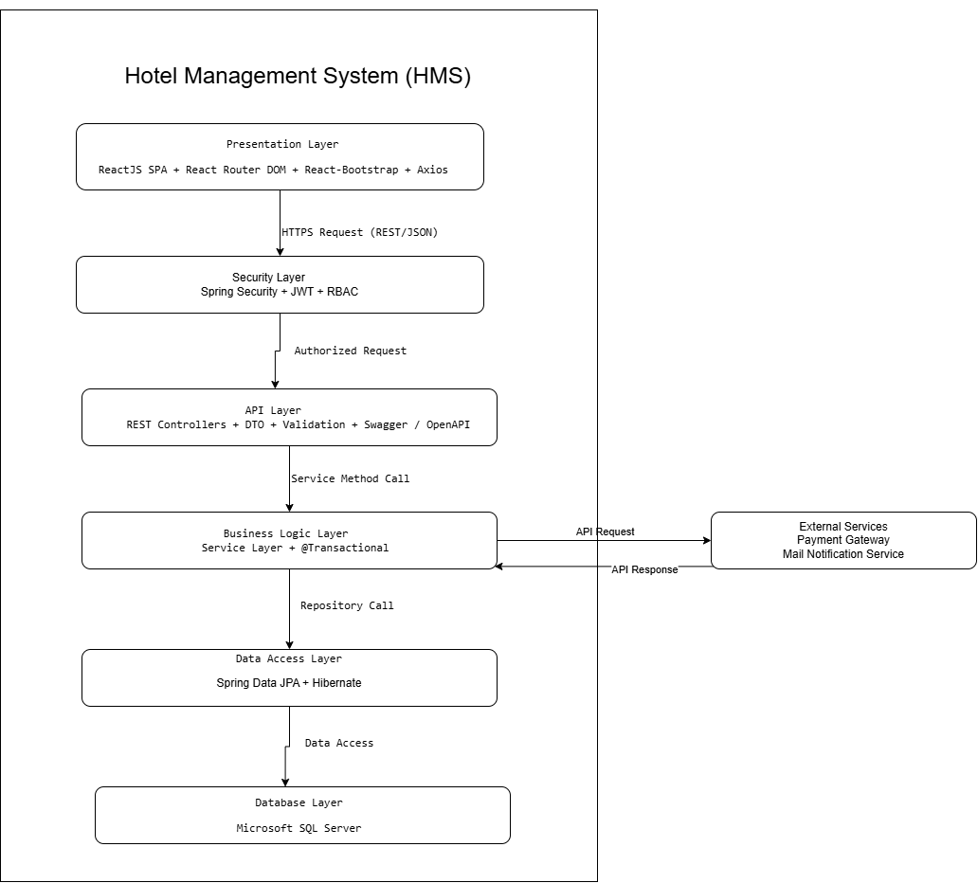
Figure 3-1: HMS Layered Architecture Pattern

Layer | Responsibility
Presentation | Renders the user interface, handles user interactions, manages client-side navigation, and sends HTTP/HTTPS requests via Axios.
Security | Intercepts protected requests, validates JWT tokens, verifies account status, and enforces role-based access control.
API | Receives REST requests, validates input data, delegates processing to the Business Logic Layer, and returns DTO responses.
Business Logic | Implements business rules, manages transactions, coordinates repositories, and integrates with external services.
Data Access | Abstracts persistence operations using Spring Data JPA, Hibernate ORM.
Database | Persists structured transactional data in Microsoft SQL Server and audit log documents in MongoDB.

3.2.1 Process View
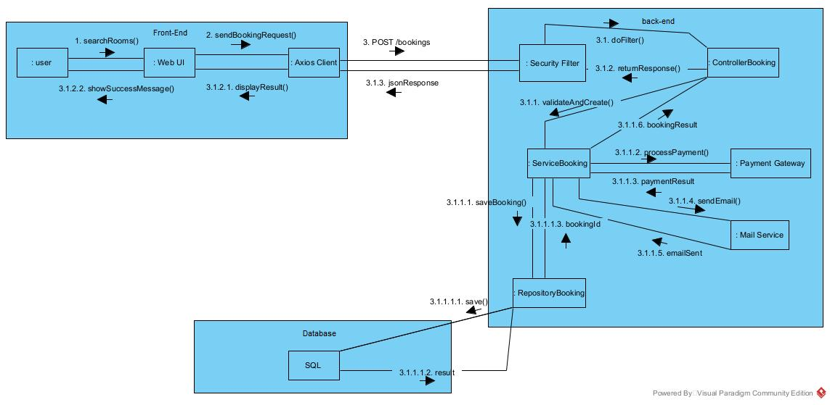
Figure 3-2: Booking Request Process Overview

3.2.2 Logical View
3.2.2.1 Frontend Logical View
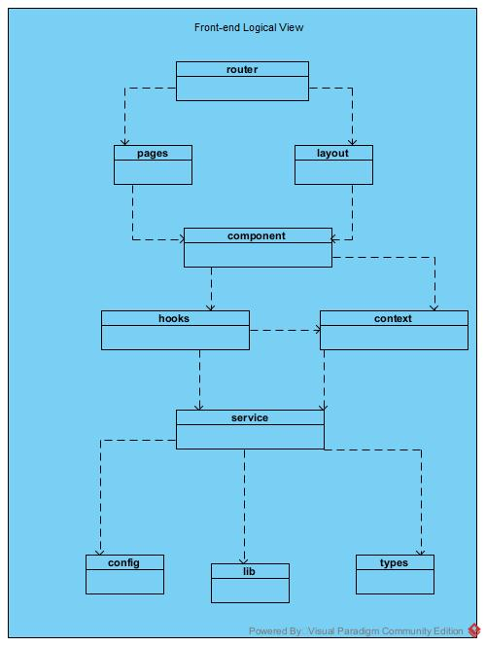

Figure 3-3: HMS FrontEnd Logical Overview

Package | Responsibility
contexts | Provides shared application state such as authentication status, current user information, and role data.
config | Stores application configuration such as API base URLs, constants, and environment settings.
router | Manages application routes, navigation, protected routes, and role-based access using React Router DOM.
layouts | Provides common page layouts such as headers, navigation bars, sidebars, and page containers.
pages | Contains page-level modules for major HMS functions such as booking, check-in, active stay, housekeeping, services, reviews, and administration.
components | Contains reusable UI components shared across multiple pages.
services | Handles communication with backend REST APIs using Axios and organizes API calls by functional module.
hooks | Contains reusable React Hooks for state handling, data loading, and shared frontend logic.
lib | Provides common utility functions and helper logic used by frontend modules.
types | Defines shared data structures and frontend data models used across components and services.

3.2.2.1 Backend Logical View
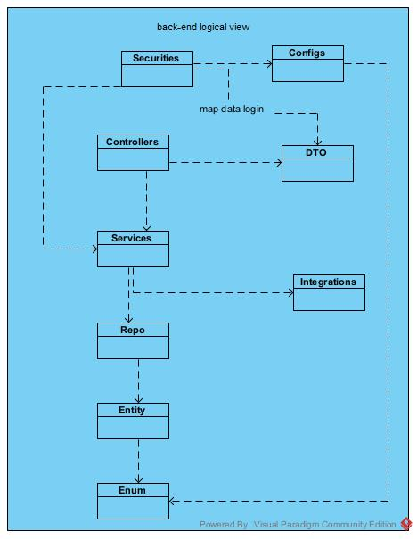
Figure 3-4: HMS Back-End Logical Overview

Package | Responsibility
config | Contains application-level configuration for CORS, Swagger/OpenAPI, database access, security, payment gateway, and mail integration.
security | Handles JWT authentication, password encoding, account validation, and role-based authorization.
controller | Receives REST API requests, validates request data, delegates processing to the Service layer, and returns response DTOs.
service | Implements business rules, manages transactions, coordinates repositories, and invokes external integrations when required.
repository | Provides data access operations for SQL Server using Spring Data repositories.
entity | Contains JPA entity models mapped to relational tables in Microsoft SQL Server through Hibernate ORM.
dto | Defines request and response data transfer objects used between API and service layers.
integration | Handles communication with external systems such as the Payment Gateway and Mail Notification Service.
enum | Defines shared constant value types such as user roles, reservation status, room status, payment status, and other domain states.

3.2.3 Development View

3.2.3.1 Package Diagram

3.2.3.1.1 Back end package diagram
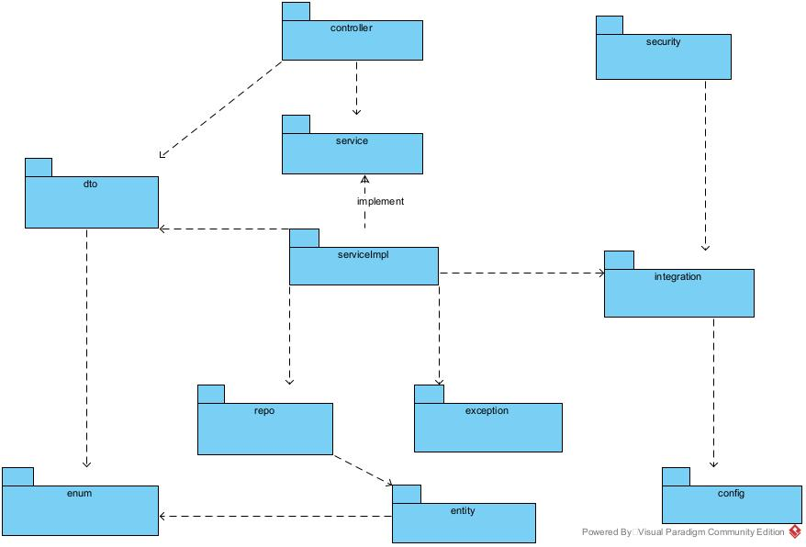
Figure 3-5: HMS Back-end Package Diagram

No | Package | Description
01 | Config | Contains application configuration for CORS, OpenAPI, security, database access, payment, and mail services.
02 | Security | Handles JWT authentication, password encoding, and role-based access control.
03 | Controller | Contains REST controllers that receive HTTP requests and delegate processing to services.
04 | DTO | Contains request and response objects used for data exchange between layers.
05 | Entity | Contains JPA entity classes mapped to relational tables in Microsoft SQL Server.
06 | Document | Contains MongoDB document models used for document-based data such as audit logs.
07 | Enums | Defines shared constant values such as user roles, reservation status, room status, and payment status.
08 | Exception | Contains custom exceptions and global exception handling components.
09 | Repository | Contains Spring Data repositories for accessing SQL Server and MongoDB data.
10 | Service | Defines service interfaces for business operations.
11 | ServiceImpl | Implements service interfaces, business rules, and transaction processing.
12 | Integration | Handles communication with external systems such as the Payment Gateway and Mail Notification Service.

3.2.3.1.2 Front-end package diagram
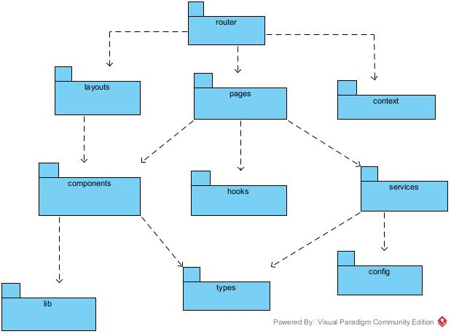
Figure 3-6: HMS Front-End Package Diagram

No | Package | Description
01 | router | Manages application routing, navigation, protected routes, and role-based route access.
02 | layouts | Defines shared page layouts such as headers, sidebars, navigation areas, and page containers.
03 | pages | Contains page-level components corresponding to major HMS screens and application routes.
04 | context | Manages shared application state such as authentication status, current user, and role information using React Context API.
05 | components | Contains reusable UI components shared across multiple pages.
06 | hooks | Contains reusable React Hooks for shared state handling, data loading, and frontend logic.
07 | services | Handles communication with backend REST APIs and organizes API calls by functional module.
08 | config | Contains frontend configuration such as API base URLs, environment settings, and shared constants.
09 | lib | Contains reusable utility functions and helper logic used across frontend modules.
10 | types | Defines shared data types and interfaces used by pages, components, and services.


3.2.4 Deployment View
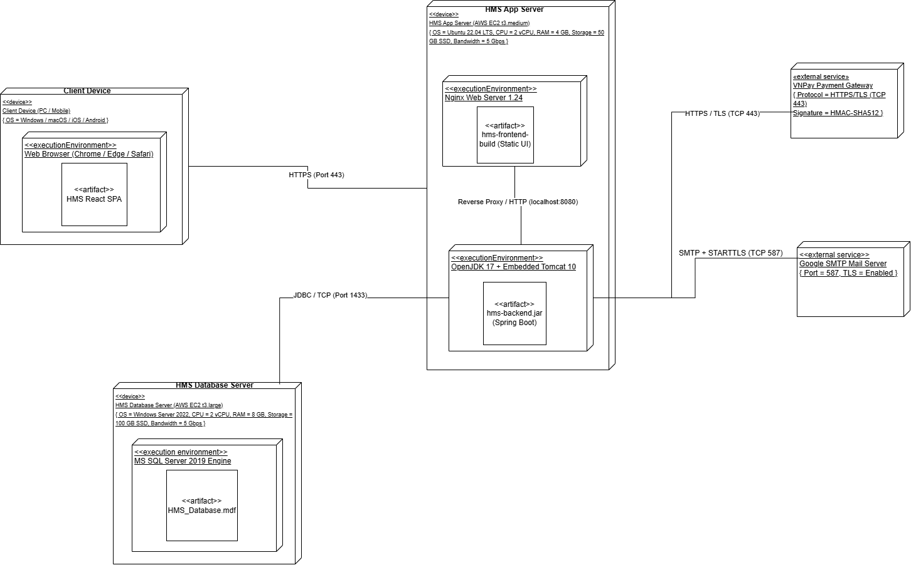
Figure 3-7: HMS Deployment Diagram

Configuration Description
No. | Component/Node | Description
01 | Client Device | A PC or mobile device running a supported web browser. Users access the Hotel Management System (HMS) through the browser.
02 | HMS App Server | An AWS EC2 instance running Ubuntu 22.04 LTS with 2 vCPUs, 4 GB RAM, and 50 GB SSD storage. It hosts the front-end and back-end applications.
03 | Nginx Web Server | Nginx 1.24 serves the React front-end build and forwards API requests to the Spring Boot application through HTTP on localhost:8080.
04 | Spring Boot Application | The hms-backend.jar application runs on OpenJDK 17 with Embedded Tomcat. It processes API requests, executes business logic, accesses the database, and integrates with external services.
05 | HMS Database Server | An AWS EC2 instance running Windows Server 2022 with 2 vCPUs, 8 GB RAM, and 100 GB SSD storage. It hosts the HMS database.
06 | Microsoft SQL Server | Microsoft SQL Server 2019 stores and manages HMS data. The Spring Boot application connects to the database using JDBC over TCP port 1433.
07 | VNPay Payment Gateway | An external payment service that processes online payment requests and returns payment results. Communication uses HTTPS/TLS over TCP port 443.
08 | Google SMTP Mail Server | An external email service used to send booking confirmations, password recovery messages, and other system notifications through SMTP with TLS over TCP port 587.

4.1 Common Design
This section defines the standardized architectural mechanisms, shared components, and cross-cutting conventions used by all HMS modules. To remove ambiguity, every mechanism is specified separately for the Backend (BE: Spring Boot) and the Frontend (FE: ReactJS), and the contract between them (API payloads, message codes, date formats, security tokens) is stated explicitly. The section covers general conventions (date/time, currency), exception handling, logging, message display, authentication and authorization, validation, security, UI structures, utility components, and transaction management.

4.1.1 General Conventions
All modules follow the same API, date/time, and currency conventions so that the Backend, the Frontend, and the database interpret data identically.

4.1.1.1 API Conventions
● Base path and format: all REST endpoints are served under /api/v1 and exchange JSON encoded as UTF-8.
● Pagination: list endpoints accept page (0-based), size (1-100, default 20) and sort (restricted to a whitelist of columns) and return Page<T> (content, page, size, totalElements, totalPages).
● Traceability: every response carries the header X-Trace-Id; the same value is written to the logs and returned in error payloads.
● Language: the Frontend sends Accept-Language (vi or en); the Backend localizes message text accordingly.

4.1.1.2 Date/Time and Currency Handling
Table 4.1-1 defines how each kind of temporal and monetary value is represented in every layer.
Table 4.1-1: Date/Time and Currency Representation
Data type | Backend (Java) | Database (SQL Server) | API (JSON) | UI display
Event instant (createdAt, paidAt, audit time) | Instant | DATETIME2(3), stored in UTC | ISO-8601 UTC, e.g. 2026-10-27T09:15:30.123Z | Converted to hotel timezone (Asia/Ho_Chi_Minh), e.g. 27/10/2026 16:15
Business date (check-in date, check-out date, report date) | LocalDate | DATE | yyyy-MM-dd, e.g. 2026-10-27 | dd/MM/yyyy (Vietnamese), dd MMM yyyy (English)
Standard time (check-in 14:00, check-out 12:00) | LocalTime (configurable) | Setting table | HH:mm | HH:mm
Money (price, deposit, payment, refund) | BigDecimal | DECIMAL(18,2) | String, e.g. "1500000.00" | Thousand separators with currency symbol, e.g. 1.500.000 VND (Intl.NumberFormat)

Rules:
● Single time source: the hotel timezone is configured once (app.hotel.timezone = Asia/Ho_Chi_Minh) and the JVM runs with -Duser.timezone=UTC. A java.time.Clock bean is injected wherever the current date or time is needed so that the logic is testable.
● Forbidden types: java.util.Date and LocalDateTime must not appear in DTOs or API contracts. Jackson is configured with JavaTimeModule and WRITE_DATES_AS_TIMESTAMPS = false.
● Nights and stay length: the number of nights is ChronoUnit.DAYS.between(checkInDate, checkOutDate) computed on LocalDate values, never from hours. The check-out date must be later than the check-in date (MSG04A), and the check-in date must not be earlier than today in the hotel timezone.
● Scheduled jobs: the 24-hour Pending reservation expiry job compares Instant values, so it is independent of the server timezone.
● Date ranges: filters use half-open intervals [from, to); the Frontend sends the day after the selected end date as the "to" value.
● Frontend formatting: all formatting goes through one module (lib/datetime.ts: formatDate, formatDateTime, toApiDate). Date pickers return only yyyy-MM-dd strings, and ad-hoc new Date(string) parsing is not allowed, which avoids one-day shifts caused by timezones.
● Money: amounts are non-negative, rounded HALF_UP to the configured scale, never handled as floating-point numbers, and always sent as strings to avoid precision loss in JavaScript.

4.1.2 Exception Handling

4.1.2.1 Backend
The HMS backend implements a centralized exception handling mechanism using Spring Boot @RestControllerAdvice (GlobalExceptionHandler). All runtime, validation, security, and business rule exceptions thrown from any Controller or Service are intercepted and transformed into a uniform JSON payload (ApiErrorResponse). Stack traces, SQL text, and internal class names are never returned to the client.
Response Payload Example:
{
"timestamp": "2026-10-27T09:15:30.123Z",
"status": 409,
"errorCode": "MSG08A",
"message": "The room is currently occupied.",
"path": "/api/v1/stays/12/check-in",
"traceId": "c0a8-4f2e-9b1a",
"validationErrors": [
{ "field": "checkOutDate", "code": "MSG04A", "message": "Check-out date must be after check-in date." }
]
}

Response Payload Attributes:
● timestamp (Instant): the exact UTC instant of the error, serialized as ISO-8601.
● status (int): HTTP status code (e.g., 400 Bad Request, 401 Unauthorized, 403 Forbidden, 404 Not Found, 409 Conflict, 422 Unprocessable Entity, 429 Too Many Requests, 500 Internal Server Error).
● errorCode (String): standardized code matching the SRS error catalogue (e.g., MSG01C - No Available Rooms, MSG04A - Invalid Dates, MSG08A - Room Occupied, MSG09 - Invalid Voucher, MSG10 - Balance Blocks Check-out) or a technical code (e.g., VALIDATION_ERROR, AUTH_FORBIDDEN, INTERNAL_ERROR).
● message (String): client-facing text localized from the message catalogue using Accept-Language.
● path (String): the request URI that caused the error.
● traceId (String): correlation identifier shared with the application log and the System_Error_Log table.
● validationErrors (List<FieldError>): list of {field, code, message}; a list is used (instead of a map) so that one field can report several violations. Empty for non-validation errors.
Table 4.1-2 maps each exception to its HTTP status, error code, log level, and persistence behavior.
Table 4.1-2: Exception Mapping
Exception | HTTP | errorCode | Log level | Persisted to System_Error_Log
MethodArgumentNotValidException, ConstraintViolationException, HttpMessageNotReadableException | 400 | VALIDATION_ERROR | WARN | No
AuthenticationException (bad credentials, invalid or expired token) | 401 | AUTH_INVALID_CREDENTIALS, AUTH_TOKEN_EXPIRED | WARN | Yes (security event)
AccountLockedException | 423 | AUTH_ACCOUNT_LOCKED | WARN | Yes (security event)
AccessDeniedException (RBAC violation) | 403 | AUTH_FORBIDDEN | WARN | Yes (security event)
ResourceNotFoundException (Room, Reservation, Stay, Invoice not found) | 404 | RESOURCE_NOT_FOUND | INFO | No
InvalidReservationStateException (illegal lifecycle transition) | 409 | MSGxx (state specific) | WARN | No
BusinessException (e.g., uninspected room assignment, non-zero balance check-out) | 422 | MSGxx (rule specific) | WARN | No
OptimisticLockingFailureException | 409 | CONCURRENT_UPDATE | WARN | No
PaymentGatewayException (VNPay/OnePay failure or timeout) | 502 / 504 | PAYMENT_GATEWAY_ERROR | ERROR | Yes
RateLimitExceededException | 429 | RATE_LIMITED | WARN | Yes (security event)
Any other Exception | 500 | INTERNAL_ERROR | ERROR (with stack trace) | Yes

The 500 response always uses a generic message: "The system encountered a problem. Please retry, or give the code {traceId} to the administrator." The former UnauthorizedOperationException is renamed AccessDeniedException so that 401 (not authenticated) and 403 (not authorized) are not confused.

4.1.2.2 Frontend
All HTTP calls go through one Axios instance (lib/http.ts) whose response interceptor applies the behavior in Table 4.1-3. Components never parse raw errors themselves.
Table 4.1-3: Frontend Error Handling Behavior
Condition | Frontend behavior
401 AUTH_TOKEN_EXPIRED | Call the refresh endpoint once and retry the original request. If refresh fails, clear the session, redirect to /login?reason=expired, and show the warning "Session expired, please sign in again".
401 other | Show the error message on the login form; no redirect loop.
403 | Navigate to the 403 Forbidden page; if the call was triggered by a button, show an error toast instead.
400 / 422 with validationErrors | Map each entry to its form field (React Hook Form setError), display the message under the field, and focus the first invalid field.
404 | Page route: show the 404 page. API call: show a warning toast.
409 / 422 business error | Show the localized message from the catalogue as an error toast or modal as defined in Table 4.1-5.
429 | Show a warning toast and disable the triggering action for the retry period.
5xx or network failure | Show a persistent error toast containing the traceId with "Copy code" and "Retry" buttons.
Unhandled React render error | Global and per-route ErrorBoundary renders a fallback screen ("Something went wrong") with a Reload button, and reports the error to the client-log endpoint.

4.1.3 Logging
Logging is divided into three independent streams: the application log (diagnostics), the system error log (persisted errors and security events for administrators), and the audit log (immutable business and administrative actions).

4.1.3.1 Application Log (Backend)
● Technology: SLF4J with Logback, JSON layout, written to logs/hms-app.log with daily and 100 MB rolling and 30 days of retention.
● Context (MDC): traceId (generated by TraceIdFilter and returned in X-Trace-Id), userId, role, clientIp, method, and uri are attached to every line.
● Levels: ERROR - unexpected failures and payment gateway errors; WARN - business rule, authentication, and authorization failures; INFO - request summary with duration and scheduled job runs; DEBUG - development only.
● Data protection: passwords, JWTs, card data, and full identity/passport numbers are never logged; identifiers are masked (e.g., ****1234).

4.1.3.2 System Error Log (Persisted Errors)
HTTP 500 errors, payment gateway failures, security events (401, 403, lockout, rate limit), and critical frontend errors are persisted to the System_Error_Log table so that administrators can review them without server access. Table 4.1-4 lists its structure.
Table 4.1-4: System_Error_Log Structure
Column | Type | Description
id | BIGINT, PK | Identity key.
trace_id | VARCHAR(36), indexed | Correlation id matching the application log and the API response.
occurred_at | DATETIME2(3), UTC | Time of the event.
level | VARCHAR(10) | ERROR or WARN.
source | VARCHAR(10) | BACKEND or FRONTEND.
error_code, http_status | VARCHAR(40), INT | Code and status returned to the client.
message, stack_trace | NVARCHAR(MAX) | Technical message and stack trace (visible to Administrator only).
user_id, client_ip, user_agent | BIGINT null, VARCHAR(45), VARCHAR(255) | Who and from where (null user for anonymous requests).
endpoint, http_method | VARCHAR(255), VARCHAR(10) | Failing request.
status | VARCHAR(15) | NEW, ACKNOWLEDGED, or RESOLVED (managed by Administrator).

4.1.3.3 Audit Log (Backend)
All monetary operations (deposit, payment, refund) and auditable administrative actions (user activation or deactivation, role change, price update, login failure) are written to the Audit_Log table in Microsoft SQL Server through AuditService (AOP annotation @Audited).
● Immutability: the application database account has only INSERT and SELECT permission on Audit_Log, and a database trigger rejects UPDATE and DELETE. Records cannot be edited or deleted by operational staff.
● Atomicity: audit records for monetary operations are written inside the same transaction as the business change (a rollback also rolls back the audit row); FAIL and security events are written with REQUIRES_NEW so they survive a rollback.
● Retention and access: records are retained for at least 12 months and are viewable only by the Administrator.
● Columns: id, occurred_at (UTC), actor_user_id, actor_role, actor_ip, action (e.g., PAYMENT_CREATE, REFUND, USER_DEACTIVATE, PRICE_UPDATE, ROLE_CHANGE, LOGIN_FAILED), entity_type, entity_id, old_value and new_value (masked JSON), result (SUCCESS or FAIL), and trace_id.

4.1.3.4 Frontend Logging
Only critical frontend errors (ErrorBoundary catches and 5xx responses) are sent to POST /api/v1/client-logs, which is rate-limited and size-limited, and stored in System_Error_Log with source FRONTEND. In development the browser console is used; production builds do not print sensitive data to the console.

4.1.3.5 Log Viewer (Administrator)
Stored errors are displayed in the screen Administration > System Logs, available only to the Administrator.
● Layout: two tabs - System Errors and Audit Trail - above a filter bar and a paginated table (server-side pagination).
● Columns: Time (hotel timezone), Level badge, Error code, Message (truncated to 80 characters), User, Endpoint, Trace ID, Status.
● Filters: date range, level, error code, user, status, and trace id search.
● Detail: clicking a row opens a modal with the full message, a scrollable stack trace (monospaced, with a Copy button), and a "Mark as resolved" action. There is no edit or delete action.
● Appearance: level badges follow Table 4.1-5: ERROR is red with a x-octagon icon, WARN is yellow with a triangle icon, INFO is blue with an info icon.

4.1.4 Messages Processing

4.1.4.1 Message Catalogue
● The system utilizes a standardized application message catalogue with predefined codes (MSG01A to MSG12B). Each entry defines: code, type (ERROR, WARNING, INFO, SUCCESS), display mode (INLINE, TOAST, MODAL, PAGE), and the Vietnamese and English texts with {0}-style placeholders.
● The catalogue is kept in one source file from which messages_vi.properties / messages_en.properties (Backend) and locales/vi.json / locales/en.json (Frontend) are generated, so both sides always show the same text.
● The user interface supports bilingual messaging: Vietnamese is the default for staff roles, and English is the default for guests/customers.
● Failed input validations keep the user on the same screen, preserve the entered data, and return standardized inline messages.

4.1.4.2 UI Display Specification
Table 4.1-5 fixes the color, icon, component, position, and dismissal behavior for each message type so that all screens look and behave consistently.
Table 4.1-5: Message Display Specification
Message type | Color (border / background) | Icon (Bootstrap Icons) | Component | Position | Auto-dismiss
Success | #198754 / #D1E7DD | bi-check-circle-fill | Toast | Top-right of viewport, 16 px from edges | 4 seconds
Information | #0DCAF0 / #CFF4FC | bi-info-circle-fill | Toast | Top-right | 5 seconds
Warning | #FFC107 / #FFF3CD | bi-exclamation-triangle-fill | Toast or Alert banner | Top-right (toast) or top of the form (banner) | 7 seconds
Business error | #DC3545 / #F8D7DA | bi-x-octagon-fill | Toast | Top-right | 8 seconds, can be closed manually
System error (5xx) | #DC3545 / #F8D7DA | bi-bug-fill | Toast with traceId and Copy button | Top-right | Never; closed manually
Field validation | #DC3545 red border and 12 px red text | bi-exclamation-circle | Form.Control.Feedback | Directly below the invalid field; a summary Alert at the top of the form when more than 3 errors | Until the field is corrected
Dangerous confirmation (cancel, refund, check-out with balance) | Red title bar | bi-question-octagon | Modal dialog | Center of the screen | Manual confirmation
Full-page 401 / 403 / 404 / 500 | Neutral gray with large icon | bi-lock, bi-shield-x, bi-search, bi-bug | Error page | Center of the page with a Back to home button | Not applicable

Display rules:
● At most three toasts are visible at once, and identical messages are not duplicated.
● Color is never the only indicator: every message includes an icon and text, and contrast is at least 4.5:1 (WCAG AA). Toasts use role="alert" or aria-live so that screen readers announce them.
● Error messages tell the user what happened and what to do next; technical details appear only in the traceId.

4.1.5 Authentication and Authorization

4.1.5.1 Backend
● Login: POST /api/v1/auth/login returns a JWT access token (15-minute lifetime) and a refresh token (7 days). The refresh token is sent as an HttpOnly, Secure, SameSite=Strict cookie, its hash is stored in the Refresh_Token table, and it is rotated on every use.
● Token content: claims sub (userId), role, tokenVersion, iat, exp, and jti, signed with a key of at least 256 bits supplied through environment configuration. Protected endpoints require the header Authorization: Bearer <token>.
● Immediate revocation: to satisfy the requirement that deactivating an account (UC-08) cuts access at once, JwtAuthFilter checks on each request that User.status is Active and that the token tokenVersion equals the stored value (cached for 30 seconds and evicted when an administrator changes status, role, or password). Logout adds the jti to a denylist until the token expires.
● Password policy: passwords are hashed with BCrypt (cost 12) and are never stored or transmitted in plaintext; minimum 8 characters with upper-case, lower-case, and digit. After 5 consecutive failures the account is locked for 15 minutes (HTTP 423). Login failures use one generic message so the existence of an account is not revealed.
● Authorization (RBAC): method security (@EnableMethodSecurity, @PreAuthorize) enforces the roles in Table 4.1-6 at the Controller layer. The Service layer additionally enforces data ownership (for example, a customer can read only their own reservations) to prevent insecure direct object references. Endpoints are deny-by-default: any endpoint without an explicit rule requires authentication.
Table 4.1-6 summarizes role permissions; the Screen Authorization Matrix in the SRS (Section 3.1.3, CR-06) remains the authoritative definition.
Table 4.1-6: Role Permission Summary
Function | Admin | Manager | Front-Desk | Housekeeping | Service | Customer
Manage users and roles | Yes | - | - | - | - | -
Configure room and service prices | Yes | Yes | - | - | - | -
Create / edit reservation | Yes | Yes | Yes | - | - | Own reservations
Check-in, check-out, room transfer, stay extension | Yes | Yes | Yes | - | - | -
Update room status | Yes | - | Yes | Yes | - | -
Create service orders | Yes | - | Yes | - | Yes | -
Payment and refund | Yes | Yes | Yes | - | - | Pay own booking
Reports | Yes | Yes | - | - | - | -
Audit trail and system logs | Yes | - | - | - | - | -

4.1.5.2 Frontend
● Token storage: the access token is kept in memory only (not in localStorage or sessionStorage) to limit exposure to XSS; renewal uses the refresh cookie.
● Route and component guards: AuthContext holds the user, role, and permissions; <ProtectedRoute roles={[...]}> blocks routes, the usePermission() hook and the <Can permission="..."> component hide or disable buttons and menu items.
● Principle: frontend guards only improve user experience; the Backend is the single source of enforcement and always re-checks every request.
● Session handling: after 30 minutes of inactivity a warning dialog appears one minute before automatic sign-out; sign-out is synchronized across browser tabs (BroadcastChannel).

4.1.6 Validation
Validation is performed on both sides, but the Backend is the only trusted source. Table 4.1-7 contrasts their responsibilities.
Table 4.1-7: Validation Responsibilities
Aspect | Backend | Frontend
Technology | Jakarta Bean Validation (@NotBlank, @Size, @Email, @Pattern, @Future) on DTOs with @Valid, custom validators (e.g., @ValidDateRange), and business rules in the Service layer. | React Hook Form with Zod schemas that mirror the Backend rules.
Role | Source of truth; mandatory for every request, including path and query parameters. | User experience only; never trusted.
When | Before the Controller method executes, and again in the Service for business rules. | On blur and on submit; the Submit button is disabled while a request is pending to prevent double submission.
Failure output | HTTP 400 or 422 with validationErrors (Section 4.1.2). | Inline message under the field (Section 4.1.4); mandatory fields are marked with *.

Table 4.1-8 lists the common validation rules reused by all modules.
Table 4.1-8: Common Validation Rules
Field | Rule
Email | Valid format, at most 254 characters, stored in lower case.
Phone number | Starts with 0 or +84 followed by 9 digits for Vietnamese numbers; E.164 format for international guests.
Full name | 1 to 100 characters, trimmed, no control characters.
ID / passport number | 9 to 12 alphanumeric characters; unique per document type.
Dates | Check-out later than check-in (MSG04A); check-in not before today in the hotel timezone; maximum stay of 30 nights (configurable).
Number of guests | At least 1 and not greater than the capacity of the selected room type.
Money | Greater than or equal to 0, at most 2 decimal places, and within a configured upper bound.
Voucher | Exists, not expired, and usage limit not exceeded (MSG09).
Paging and sorting | page >= 0; 1 <= size <= 100; sort column must be in the whitelist.

● Input hygiene: strings are trimmed; unknown JSON properties are rejected (FAIL_ON_UNKNOWN_PROPERTIES = true); file uploads are limited to whitelisted MIME types and extensions, 5 MB, and stored under random names.

4.1.7 Security
Table 4.1-9 lists the cross-cutting security controls. Authentication and authorization details are in Section 4.1.5, and validation in Section 4.1.6.
Table 4.1-9: Security Controls
Area | Layer | Control
Transport | BE / Infra | HTTPS with TLS 1.2 or higher; HTTP Strict Transport Security (HSTS).
CORS | BE | Only the configured Frontend origin is allowed; the wildcard * is not used together with credentials.
CSRF | BE / FE | API calls use the Bearer header, so CSRF protection is disabled for them; the refresh-cookie endpoint relies on SameSite=Strict and an Origin check.
Security headers | BE | Content-Security-Policy, X-Content-Type-Options: nosniff, X-Frame-Options: DENY, Referrer-Policy.
SQL injection | BE | Spring Data JPA and parameterized queries only; no SQL built by string concatenation; sort fields are whitelisted.
Cross-site scripting | FE | React output escaping; dangerouslySetInnerHTML is forbidden; any rich text is sanitized.
Brute force and abuse | BE | Rate limiting (e.g., Bucket4j): login 5 requests per minute per IP, other APIs 100 per minute per user; HTTP 429 when exceeded.
Sensitive data | BE / DB | Identity numbers encrypted at rest (AES-256 or Always Encrypted); masked in logs and UI; card data is never stored (handled by VNPay/OnePay).
Payments | BE | Idempotency-Key header on payment and refund APIs; gateway callbacks verified by HMAC signature and protected against replay.
Secrets | BE / Infra | Keys and passwords come from environment variables or a vault, never from source control; JWT signing key is rotated periodically.
Dependencies | DevOps | OWASP Dependency-Check or Dependabot in the CI pipeline.
Database access | DB | Application account with least privilege; encrypted backups.
API documentation | BE | Swagger UI (Springdoc-OpenAPI) disabled in production or restricted to the Administrator.
Reference standards | All | OWASP Top 10 and OWASP ASVS Level 2.

4.1.8 UI Structures (Frontend)
● The frontend is built as a Single Page Application (SPA) using ReactJS 18 with Functional Components, React Router DOM for client-side navigation, and React-Bootstrap for responsive UI layouts.
● The UI relies on common page layouts such as headers, navigation bars, sidebars, and page containers; menu items are rendered according to the user role (Section 4.1.5.2).
● To prevent memory bottlenecks, all list and search endpoints (e.g., room inventory, customer bookings, user accounts) implement server-side pagination and filtering using Spring Data Pageable and Page<T>; the shared DataTable component calls them with the parameters in Section 4.1.1.1.
● On forms, fields marked with * are mandatory and must be provided before actions like Confirm or Save can be executed.
● Loading, empty, and error states use shared components (skeleton loader, EmptyState, ErrorBoundary) so every screen behaves the same.

4.1.9 Utility Classes/Components

4.1.9.1 Backend
● GlobalExceptionHandler, ApiErrorResponse, and PageResponse<T> implement the error and paging contracts.
● Data Transfer Objects (DTO) with MapStruct mappers encapsulate data between the presentation layer and the service layer, so database Entity objects are never exposed through API payloads.
● TraceIdFilter, JwtAuthFilter, and RateLimitFilter form the security filter chain; AuditService and MessageResolver provide auditing and localized messages; DateTimeUtil wraps the injected Clock.

4.1.9.2 Frontend
● Reusable React Hooks provide shared state handling and data loading (useAuth, usePermission, usePagination, useApi); utility functions are organized in the hooks and lib packages (http.ts, datetime.ts, money.ts, i18n).
● Axios is used for asynchronous HTTP/HTTPS requests with JSON payloads through the single configured instance and interceptors described in Section 4.1.2.2.
● Shared components: DataTable, FormField, ConfirmModal, ToastHost, ErrorBoundary, DateRangePicker, and MoneyText.

4.1.10 Transaction Management (Backend)
The backend enforces strict ACID Transaction Management using Spring Boot @Transactional annotation at the Service layer; query-only methods use readOnly = true.
● Multi-step state changes - such as Guest Check-in (updating the Reservation status to Checked-In, creating a Guest Stay, initializing a Folio, and setting the Room status to Occupied), Room Transfers, Stay Extensions, and Check-outs - are executed within atomic database transactions. If any failure occurs, all partial changes are rolled back.
● Concurrency: optimistic locking (@Version) protects Room, Reservation, and Folio; room assignment uses a pessimistic lock to prevent double booking; the default isolation level is READ_COMMITTED.
● Idempotency: payment and refund operations accept an Idempotency-Key so a retried request is never applied twice.
● Configuration Isolation: the design enforces "Configuration Isolation" for historical records - updates to room category base tariffs or hotel service unit prices must not alter completed reservations, historical service orders, or finalized invoices, because the applicable unit price is snapshotted when the record is created.

4.2 Account & Authentication Management
The Account & Authentication subsystem coordinates identity access management, user registration, role governance, credential recovery, and secure JWT-based stateless session management across all user personas (Customer, Front-Desk Staff, Housekeeping Staff, Administrator). This section details the detailed component design covering UC-01 through UC-10.

4.2.1 Screen Design
Figure 4-1 illustrates the user authentication screen. Table 4-1 provides the control specifications for the login interface.
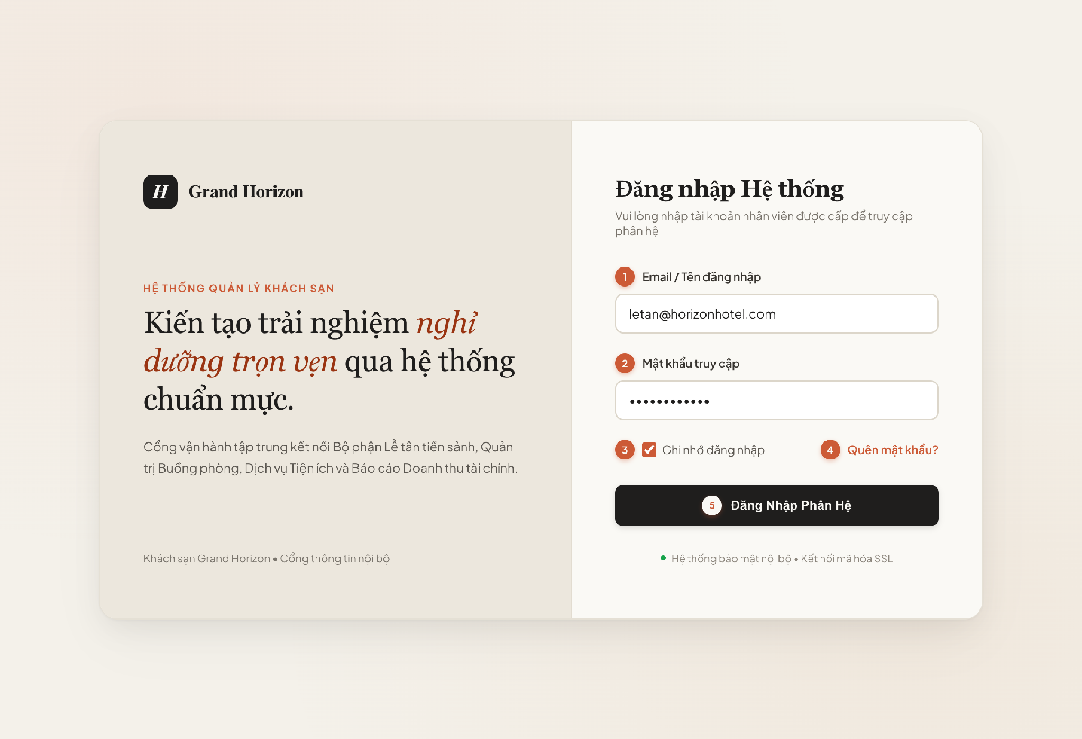
Figure 4-1: Screen Design of User Login (UC-02)

Table 4-1: Screen Definition for User Login (UC-02)
No | Object/Control Name | Type | Required | Length | Description
(1) | txtUsername | TextField | Yes | 4-100 chars | Input field for registered staff user email [DB Mapping: tbl_user.email]. Validates RFC 5322 syntax.
(2) | txtPassword | PasswordField | Yes | 6-50 chars | Secure masked password input. Compared against BCrypt hash [DB Mapping: tbl_user.password_hash].
(3) | chkRememberMe | Checkbox | No | Default: false | Controls refresh token cookie expiration (7 days persistent vs session-only).
(4) | lnkForgotPassword | Hyperlink | No | Redirect | Navigates to secure staff password recovery workflow (UC-10).
(5) | btnLogin | Button | Yes | Trigger API | Initiates Step 1 in Sequence Diagram UC-02; dispatches HTTP POST /api/v1/auth/login [Auth Filter Validation].

4.2 Account & Authentication Management
The Account & Authentication subsystem coordinates identity access management, user registration, role governance, credential recovery, and secure JWT-based stateless session management across all user personas (Customer, Front-Desk Staff, Housekeeping Staff, Administrator). This section details the detailed component design covering UC-01 through UC-10.

4.2.1 Screen Design
Figure 4-1 illustrates the user authentication screen. Table 4-1 provides the control specifications for the login interface.
Figure 4-1: Screen Design of User Login (UC-02)
Table 4-1: Screen Definition for User Login (UC-02)
No | Object/Control Name | Type | Required | Length | Description
(1) | txtUsername | TextField | Yes | 4-100 chars | Input field for registered staff user email [DB Mapping: tbl_user.email]. Validates RFC 5322 syntax.
(2) | txtPassword | PasswordField | Yes | 6-50 chars | Secure masked password input. Compared against BCrypt hash [DB Mapping: tbl_user.password_hash].
(3) | chkRememberMe | Checkbox | No | Default: false | Controls refresh token cookie expiration (7 days persistent vs session-only).
(4) | lnkForgotPassword | Hyperlink | No | Redirect | Navigates to secure staff password recovery workflow (UC-10).
(5) | btnLogin | Button | Yes | Trigger API | Initiates Step 1 in Sequence Diagram UC-02; dispatches HTTP POST /api/v1/auth/login [Auth Filter Validation].

4.2.2 Class/Component Design

4.2.2.1 Backend Class Diagram
The backend architecture strictly adheres to standard Java Spring Boot 3-Tier Enterprise patterns. The diagram uses flat layout and strictly applies standard UML relationship arrows: Realization (..|>) between ServiceImpl and Interface, Dependency (..>) from Controller to Service and Repository to Entity, and Association (-->) for Spring bean repository references and domain entity associations.
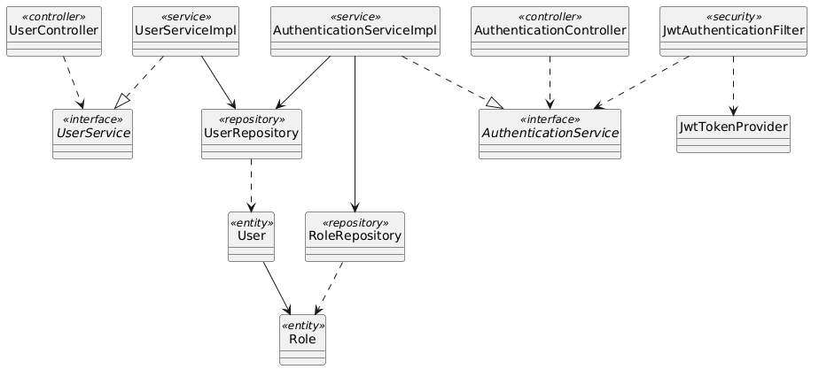
Figure 4-2: Backend Class/Component Structure Diagram for Account & Authentication

4.2.2.2 Classes/Component Description
4.2.2.2.1 AuthenticationController Class
Class | AuthenticationController
Description | Exposes REST endpoints for user authentication, token issuance, and password recovery.
Base Class | None
Constructor | + AuthenticationController(authService: AuthenticationService)
Prototype | @RestController @RequestMapping("/api/v1/auth") public class AuthenticationController
Source File | com/hotel/hms/controller/AuthenticationController.java
Namespace | com.hotel.hms.controller
Attributes | Name | Type | Description
 | authService | AuthenticationService | Business logic interface for credential authentication.
Methods | Name | Input | Output | Description
 | login | LoginRequestDTO request | ResponseEntity<AuthResponseDTO> | Authenticates credentials and returns JWT bearer token.
 | resetPassword | ResetPasswordDTO request | ResponseEntity<Void> | Validates token and commits updated credential.

4.2.2.2.2 AuthenticationServiceImpl Class
Class | AuthenticationServiceImpl
Description | Implements core authentication flows, BCrypt credential matching, and JWT token generation.
Base Class | AuthenticationService
Constructor | + AuthenticationServiceImpl(userRepo: UserRepository, roleRepo: RoleRepository, tokenProvider: JwtTokenProvider)
Prototype | @Service @Transactional public class AuthenticationServiceImpl implements AuthenticationService
Source File | com/hotel/hms/service/impl/AuthenticationServiceImpl.java
Namespace | com.hotel.hms.service.impl
Attributes | Name | Type | Description
 | userRepository | UserRepository | Data access for user identity retrieval.
 | roleRepository | RoleRepository | Data access for user authorization roles.
 | jwtTokenProvider | JwtTokenProvider | Component generating HMAC-SHA signed JWT tokens.
Methods | Name | Input | Output | Description
 | authenticate | LoginRequestDTO dto | AuthResponseDTO | Verifies password hash and produces JWT accessToken with role claims.
 | requestPasswordReset | String email | void | Generates reset token and invokes MailNotificationService.

4.2.2.2.3 UserRepository Class
Class | UserRepository
Description | Spring Data JPA repository providing database queries for User entity records.
Base Class | JpaRepository<User, Long>
Constructor | None (Spring Data JPA Interface)
Prototype | @Repository public interface UserRepository extends JpaRepository<User, Long>
Source File | com/hotel/hms/repository/UserRepository.java
Namespace | com.hotel.hms.repository
Attributes | Name | Type | Description
 | None | - | Inherits standard Spring Data JPA persistence context.
Methods | Name | Input | Output | Description
 | findByEmail | String email | Optional<User> | Retrieves active user account by unique email address.
 | existsByEmail | String email | boolean | Checks uniqueness of email during account registration.

4.2.2.2.4 User Class
Class | User
Description | JPA entity mapped to table 'User'. Represents staff and customer account credentials and operational status.
Base Class | None
Constructor | + User()
Prototype | @Entity @Table(name = "User") public class User
Source File | com/hotel/hms/entity/User.java
Namespace | com.hotel.hms.entity
Attributes | Name | Type | Description
 | userId | Long | Primary key identifier of user.
 | email | String | Unique email address used for system login.
 | passwordHash | String | BCrypt hashed secret key; never stored in plaintext.
 | fullName | String | Full legal name of the user.
 | role | Role | Many-to-One reference to Role entity.
 | phone | String | Contact telephone number (mapped to User.phone in Section 5).
 | status | String | Operational account status: ACTIVE, SUSPENDED, DELETED (mapped to User.status in Section 5).
Methods | Name | Input | Output | Description
 | getUserId | void | Long | Returns user primary key.
 | getPasswordHash | void | String | Returns hashed credential.

4.2.3 Object Interactions (Sequence Diagram)
Figure 4-3 illustrates the runtime sequence flow for UC-02 User Login. Table 4-2 details each interaction step.
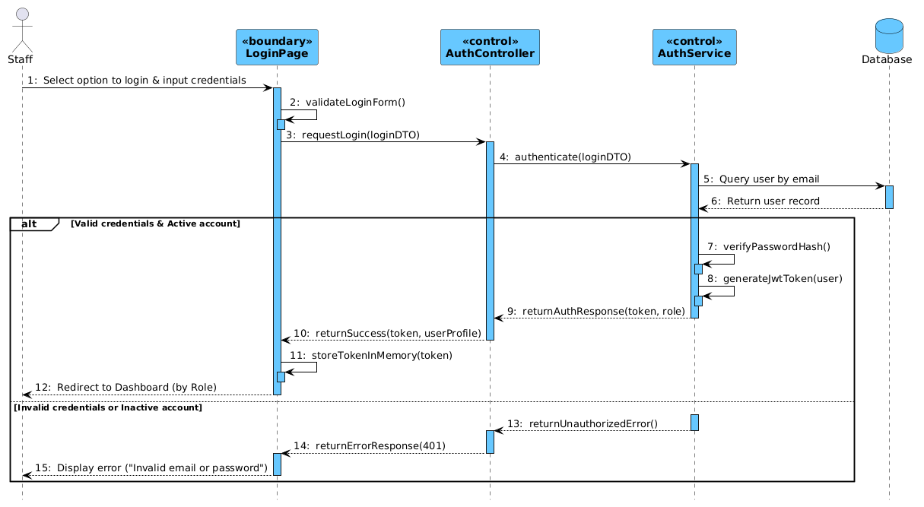
Figure 4-3: Sequence Diagram for UC-02 User Login Flow
Table 4-2: Interaction Steps for UC-02 User Login Flow
Step | Caller (From) | Callee (To) | Action / Method | Description
1 | Staff | LoginPage | Select option to login & input credentials | Staff accesses login screen and enters email and password.
2 | LoginPage | LoginPage | validateLoginForm() | Validates client-side input for non-empty fields and valid email format.
3 | LoginPage | AuthController | requestLogin(loginDTO) | Dispatches HTTP POST request with authentication credentials payload.
4 | AuthController | AuthService | authenticate(loginDTO) | Delegates credential authentication logic to security service layer.
5 | AuthService | Database | Query user by email | Retrieves active user account entity by unique email address.
6 | Database | AuthService | Return user record | Returns user record with encrypted password hash and assigned role.
7 [Success] | AuthService | AuthService | verifyPasswordHash() | Verifies submitted password against stored BCrypt hash.
8 [Success] | AuthService | AuthService | generateJwtToken(user) | Signs and generates JWT token containing user identity and role claims.
9 [Success] | AuthService | AuthController | returnAuthResponse(token, role) | Returns authentication response DTO with generated JWT token.
10 [Success] | AuthController | LoginPage | returnSuccess(token, userProfile) | Responds with HTTP 200 OK and authenticated user profile payload.
11 [Success] | LoginPage | LoginPage | storeTokenInMemory(token) | Saves JWT token in client state/memory for subsequent API calls.
12 [Success] | LoginPage | Staff | Redirect to Dashboard (by Role) | Redirects user to the designated portal based on their assigned role.
13 [Failure] | AuthService | AuthController | returnUnauthorizedError() | Throws BadCredentialsException when email/password is invalid or inactive.
14 [Failure] | AuthController | LoginPage | returnErrorResponse(401) | Responds with HTTP 401 Unauthorized status and error code.
15 [Failure] | LoginPage | Staff | Display error ("Invalid email or password") | Displays localized error toast notification on login form.

4.3 Room & Facility Management
The Room & Facility Management subsystem governs physical accommodation categories, room units, floor indexing, real-time cleanliness states, and maintenance lockouts (UC-11 through UC-20). This section details the complete technical design focusing on UC-19 (Update Housekeeping Status) and UC-20 (Set Room Maintenance).

4.3.1 Screen Design
Figures 4-4 and 4-5 show the screen designs for the Housekeeping Board and Set Room Maintenance Form. Tables 4-3 and 4-4 define their controls.
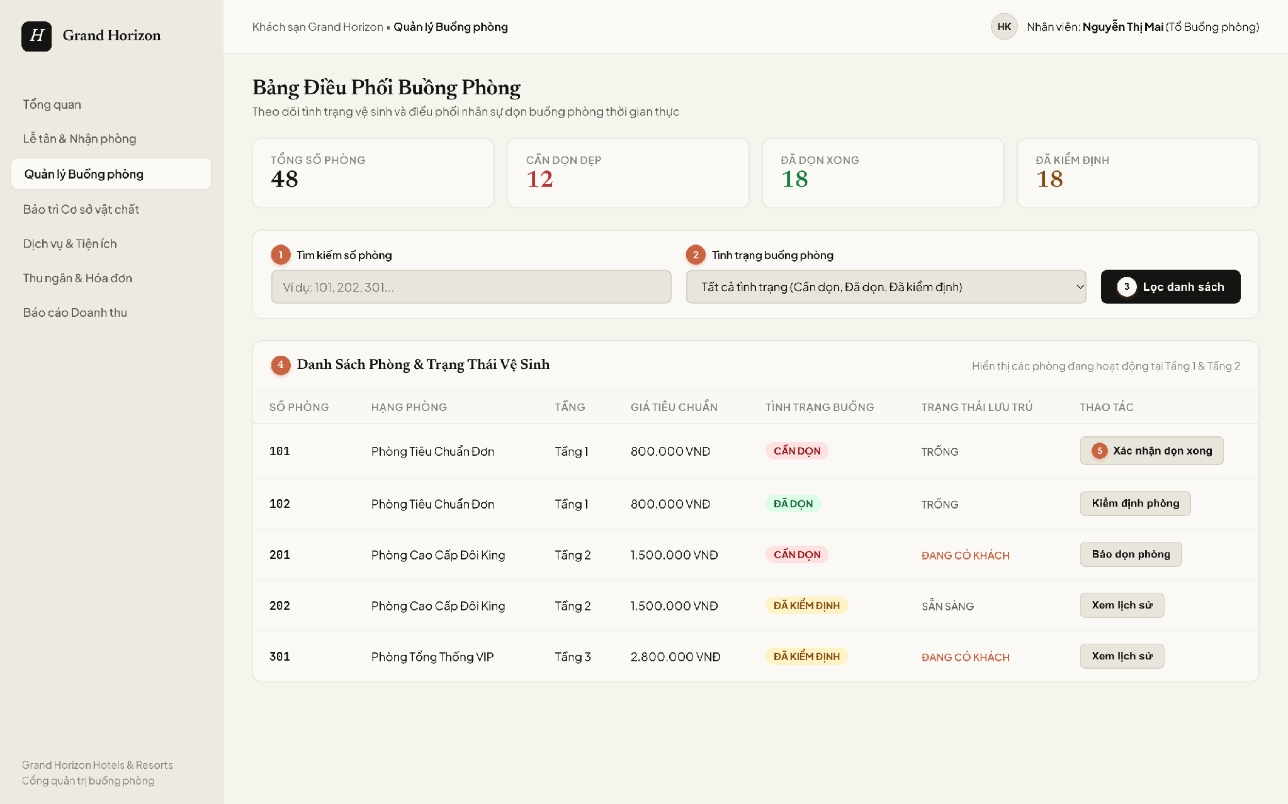
Figure 4-4: Screen Design of Housekeeping Board (UC-19)
Table 4-3: Screen Definition for Housekeeping Board (UC-19)
No | Object/Control Name | Type | Required | Length | Description
(1) | txtSearchRoomNo | TextBox | No | 50 chars | Keyword search filtering physical rooms by door number [DB Mapping: tbl_room.room_number].
(2) | cboHousekeepingStatus | Dropdown | No | N/A | Filter dropdown for sanitation criteria [DB Mapping: tbl_room.status in (DIRTY, CLEAN, INSPECTED)].
(3) | btnFilter | Button | Yes | Trigger API | Applies search criteria and executes GET /api/v1/housekeeping/rooms to re-render grid.
(4) | gridRoomList | Grid / Table | Yes | N/A | Dynamic room sanitation dataset [DB Mapping: tbl_room INNER JOIN tbl_room_type ON room_type_id].
(5) | btnConfirmClean | Button | Yes | Trigger API | Row action initiating Step 1 in Sequence Diagram UC-19; transitions room state [DB Action: UPDATE tbl_room.status = 'CLEAN'].

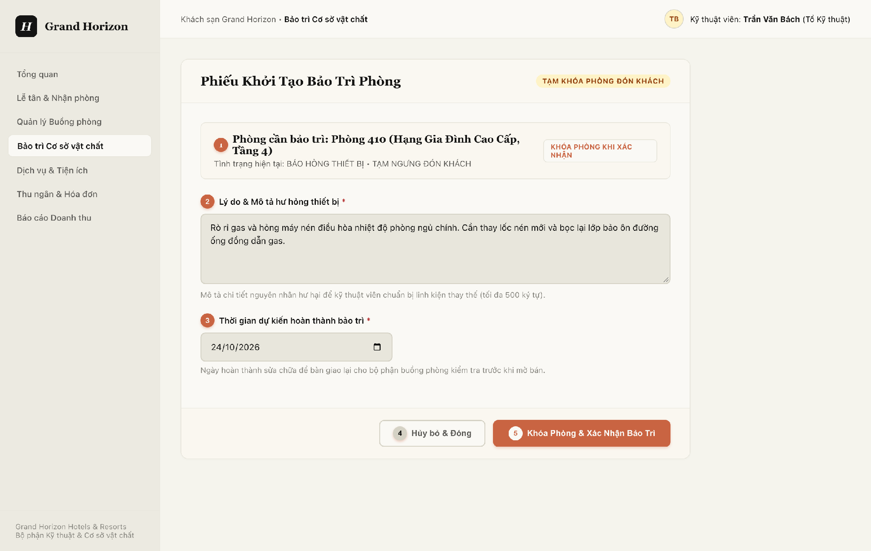
Figure 4-5: Screen Design of Set Room Maintenance Form (UC-20)
Table 4-4: Screen Definition for Set Room Maintenance Form (UC-20)
No | Object/Control Name | Type | Required | Length | Description
(1) | lblRoomSelected | Label / Display | Yes | N/A | Displays target physical room number and category [DB Mapping: tbl_room.room_number, tbl_room_type.type_name].
(2) | txtMaintenanceReason | TextArea | Yes | 500 chars | Mandatory technical explanation of defect [DB Mapping: tbl_room_maintenance.note] (*). Enforces Rule BR-16.
(3) | dtMaintainedAt | DatePicker | Yes | YYYY-MM-DD | Target completion date [DB Mapping: tbl_room_maintenance.maintained_at] (*).
(4) | btnCancel | Button | No | Redirect | Cancels maintenance order creation and returns to room overview.
(5) | btnConfirmMaintenance | Button | Yes | Trigger API | Dispatches POST /api/v1/rooms/maintenance [DB Action: INSERT tbl_room_maintenance, UPDATE tbl_room.status = 'UNDER_MAINTENANCE'].

4.3.2 Class/Component Design

4.3.2.1 Backend Class Diagram
Figure 4-6 presents the backend class diagram for Room & Facility Management using flat layout and rigorous UML relationships: Realization (..|>) for services, Dependency (..>) for controller and repository interactions, and Association (-->) for repository references and entity associations.
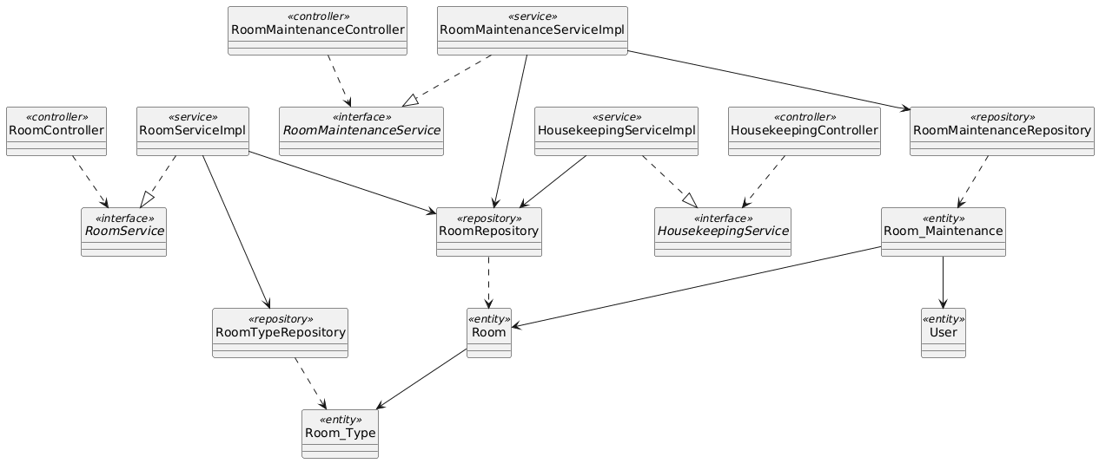
Figure 4-6: Backend Class/Component Structure Diagram for Room & Facility Management

4.3.2.2 Classes/Component Description
4.3.2.2.1 HousekeepingController Class
Class | HousekeepingController
Description | REST controller exposing endpoints for housekeeping board retrieval and room hygiene updates.
Base Class | None
Constructor | + HousekeepingController(housekeepingService: HousekeepingService)
Prototype | @RestController @RequestMapping("/api/v1/housekeeping") public class HousekeepingController
Source File | com/hotel/hms/controller/HousekeepingController.java
Namespace | com.hotel.hms.controller
Attributes | Name | Type | Description
 | housekeepingService | HousekeepingService | Service handling cleanliness transitions.
Methods | Name | Input | Output | Description
 | updateCleanliness | Long roomId, CleanlinessDTO dto | ResponseEntity<RoomDTO> | Updates room status to CLEAN.
 | getBoard | Integer floor, String status | ResponseEntity<List<RoomDTO>> | Retrieves rooms filtered by floor and status.

4.3.2.2.2 RoomMaintenanceServiceImpl Class
Class | RoomMaintenanceServiceImpl
Description | Service executing room maintenance scheduling, guest occupancy conflict verification, and inventory locking.
Base Class | RoomMaintenanceService
Constructor | + RoomMaintenanceServiceImpl(maintenanceRepo: RoomMaintenanceRepository, roomRepo: RoomRepository)
Prototype | @Service @Transactional public class RoomMaintenanceServiceImpl implements RoomMaintenanceService
Source File | com/hotel/hms/service/impl/RoomMaintenanceServiceImpl.java
Namespace | com.hotel.hms.service.impl
Attributes | Name | Type | Description
 | roomMaintenanceRepository | RoomMaintenanceRepository | Persistence repository for maintenance records.
 | roomRepository | RoomRepository | Persistence repository for room operational status.
Methods | Name | Input | Output | Description
 | scheduleMaintenance | Long roomId, MaintenanceDTO dto | MaintenanceResponseDTO | Checks occupancy, creates RoomMaintenance record, and sets room status to UNDER_MAINTENANCE.
 | checkOccupancyStatus | Room room | void | Throws RoomOccupiedException if room currently has active guest stay.

4.3.2.2.3 RoomRepository Class
Class | RoomRepository
Description | Spring Data JPA repository managing physical room records and operational states.
Base Class | JpaRepository<Room, Long>
Constructor | None (Spring Data JPA Interface)
Prototype | @Repository public interface RoomRepository extends JpaRepository<Room, Long>
Source File | com/hotel/hms/repository/RoomRepository.java
Namespace | com.hotel.hms.repository
Attributes | Name | Type | Description
 | None | - | Inherits Spring Data JPA persistence context.
Methods | Name | Input | Output | Description
 | findByRoomNumber | String roomNumber | Optional<Room> | Finds room record by unique door number.
 | updateRoomStatus | Long roomId, String status | int | Modifies room operational status in SQL Server.

4.3.2.2.4 Room Class
Class | Room
Description | JPA entity mapped to table 'Room'. Stores physical room number, room type reference, and status.
Base Class | None
Constructor | + Room()
Prototype | @Entity @Table(name = "Room") public class Room
Source File | com/hotel/hms/entity/Room.java
Namespace | com.hotel.hms.entity
Attributes | Name | Type | Description
 | roomId | Long | Primary key identifier of room.
 | roomNumber | String | Unique door number (e.g., '301').
 | status | String | Current state: VACANT, OCCUPIED, DIRTY, CLEAN, UNDER_MAINTENANCE.
 | roomType | Room_Type | Many-to-One reference to Room_Type entity.
Methods | Name | Input | Output | Description
 | isAvailable | void | boolean | Returns true if room is VACANT and CLEAN.
 | setStatus | String status | void | Sets new operational status.

4.3.3 Object Interactions (Sequence Diagram)
Figures 4-7 and 4-8 depict runtime sequence interactions for UC-19 and UC-20. Tables 4-5 and 4-6 list each interaction step.
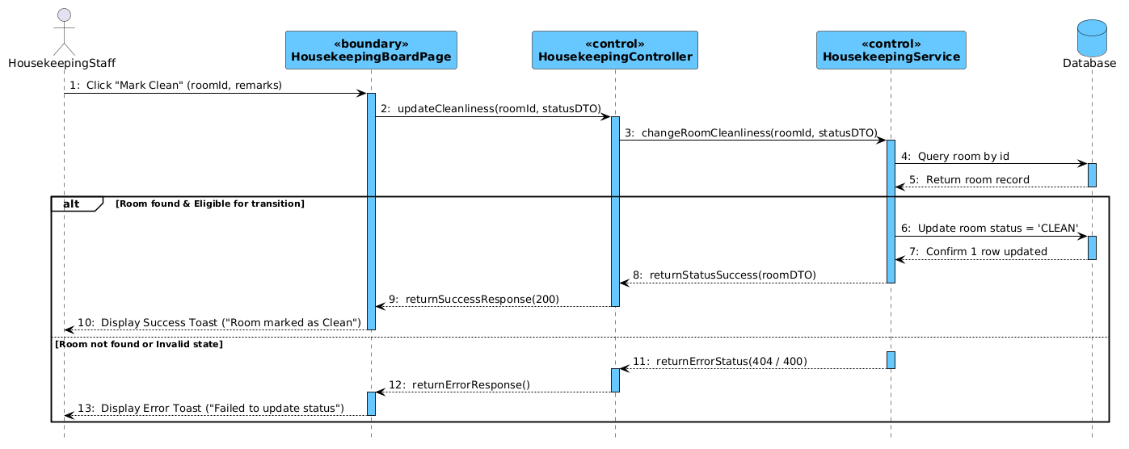
Figure 4-7: Sequence Diagram for UC-19 Update Housekeeping Status
Table 4-5: Interaction Steps for UC-19 Update Housekeeping Status
Step | Caller (From) | Callee (To) | Action / Method | Description
1 | HousekeepingStaff | HousekeepingBoardPage | Click "Mark Clean" (roomId, remarks) | Staff selects room on housekeeping board and submits cleanliness update.
2 | HousekeepingBoardPage | HousekeepingController | updateCleanliness(roomId, statusDTO) | Dispatches HTTP PUT request with target status and remarks.
3 | HousekeepingController | HousekeepingService | changeRoomCleanliness(roomId, statusDTO) | Delegates room cleanliness state transition to housekeeping service.
4 | HousekeepingService | Database | Query room by id | Retrieves physical room entity and validates current status.
5 | Database | HousekeepingService | Return room record | Returns room entity with current status and room category.
6 [Success] | HousekeepingService | Database | Update room status = 'CLEAN' | Updates room status to CLEAN and logs cleaning timestamp.
7 [Success] | Database | HousekeepingService | Confirm 1 row updated | Database confirms successful record update.
8 [Success] | HousekeepingService | HousekeepingController | returnStatusSuccess(roomDTO) | Returns updated room state DTO.
9 [Success] | HousekeepingController | HousekeepingBoardPage | returnSuccessResponse(200) | Responds with HTTP 200 OK status.
10 [Success] | HousekeepingBoardPage | HousekeepingStaff | Display Success Toast ("Room marked as Clean") | Displays success toast notification and updates room badge to Clean.
11 [Failure] | HousekeepingService | HousekeepingController | returnErrorStatus(404 / 400) | Returns error when room is not found or status transition is invalid.
12 [Failure] | HousekeepingController | HousekeepingBoardPage | returnErrorResponse() | Responds with HTTP 400/404 error response.
13 [Failure] | HousekeepingBoardPage | HousekeepingStaff | Display Error Toast ("Failed to update status") | Renders error toast notification on housekeeping board.

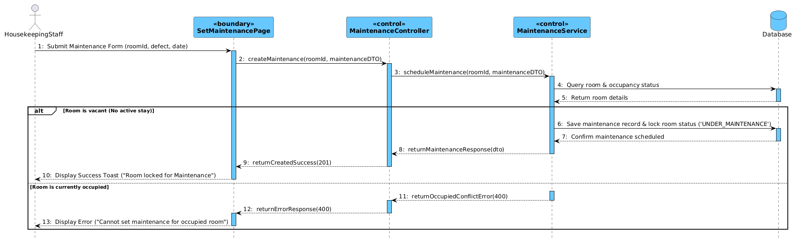
Figure 4-8: Sequence Diagram for UC-20 Set Room Maintenance
Table 4-6: Interaction Steps for UC-20 Set Room Maintenance
Step | Caller (From) | Callee (To) | Action / Method | Description
1 | HousekeepingStaff | SetMaintenancePage | Submit Maintenance Form (roomId, defect, date) | Staff submits maintenance form with defect reason and expected completion.
2 | SetMaintenancePage | MaintenanceController | createMaintenance(roomId, maintenanceDTO) | Dispatches HTTP POST request to schedule maintenance ticket.
3 | MaintenanceController | MaintenanceService | scheduleMaintenance(roomId, maintenanceDTO) | Delegates maintenance scheduling logic to maintenance service layer.
4 | MaintenanceService | Database | Query room & occupancy status | Checks room occupancy to ensure no active guest stay is present.
5 | Database | MaintenanceService | Return room details | Returns room record with current status and stay assignments.
6 [Success] | MaintenanceService | Database | Save maintenance record & lock room status ('UNDER_MAINTENANCE') | Atomically inserts maintenance order and updates room status to UNDER_MAINTENANCE.
7 [Success] | Database | MaintenanceService | Confirm maintenance scheduled | Database confirms maintenance transaction committed.
8 [Success] | MaintenanceService | MaintenanceController | returnMaintenanceResponse(dto) | Returns maintenance ticket response DTO.
9 [Success] | MaintenanceController | SetMaintenancePage | returnCreatedSuccess(201) | Responds with HTTP 201 Created status.
10 [Success] | SetMaintenancePage | HousekeepingStaff | Display Success Toast ("Room locked for Maintenance") | Closes modal and updates room card status to Under Maintenance.
11 [Failure] | MaintenanceService | MaintenanceController | returnOccupiedConflictError(400) | Returns conflict error when room is currently occupied by guests.
12 [Failure] | MaintenanceController | SetMaintenancePage | returnErrorResponse(400) | Responds with HTTP 400 Bad Request error.
13 [Failure] | SetMaintenancePage | HousekeepingStaff | Display Error ("Cannot set maintenance for occupied room") | Displays validation error prohibiting maintenance lock on occupied room.

4.4 Reservation & Front-Desk Operations
The Reservation & Front-Desk subsystem manages guest accommodation discovery, online reservation checkout, front-desk arrival check-in, physical room key allocation, and active guest stay tracking (UC-21 through UC-30). This section details UC-21/23 (Room Reservation) and UC-27 (Guest Check-in).

4.4.1 Screen Design
Figures 4-9 and 4-10 illustrate the user interfaces for Booking Checkout and Guest Check-in. Tables 4-7 and 4-8 define their controls.
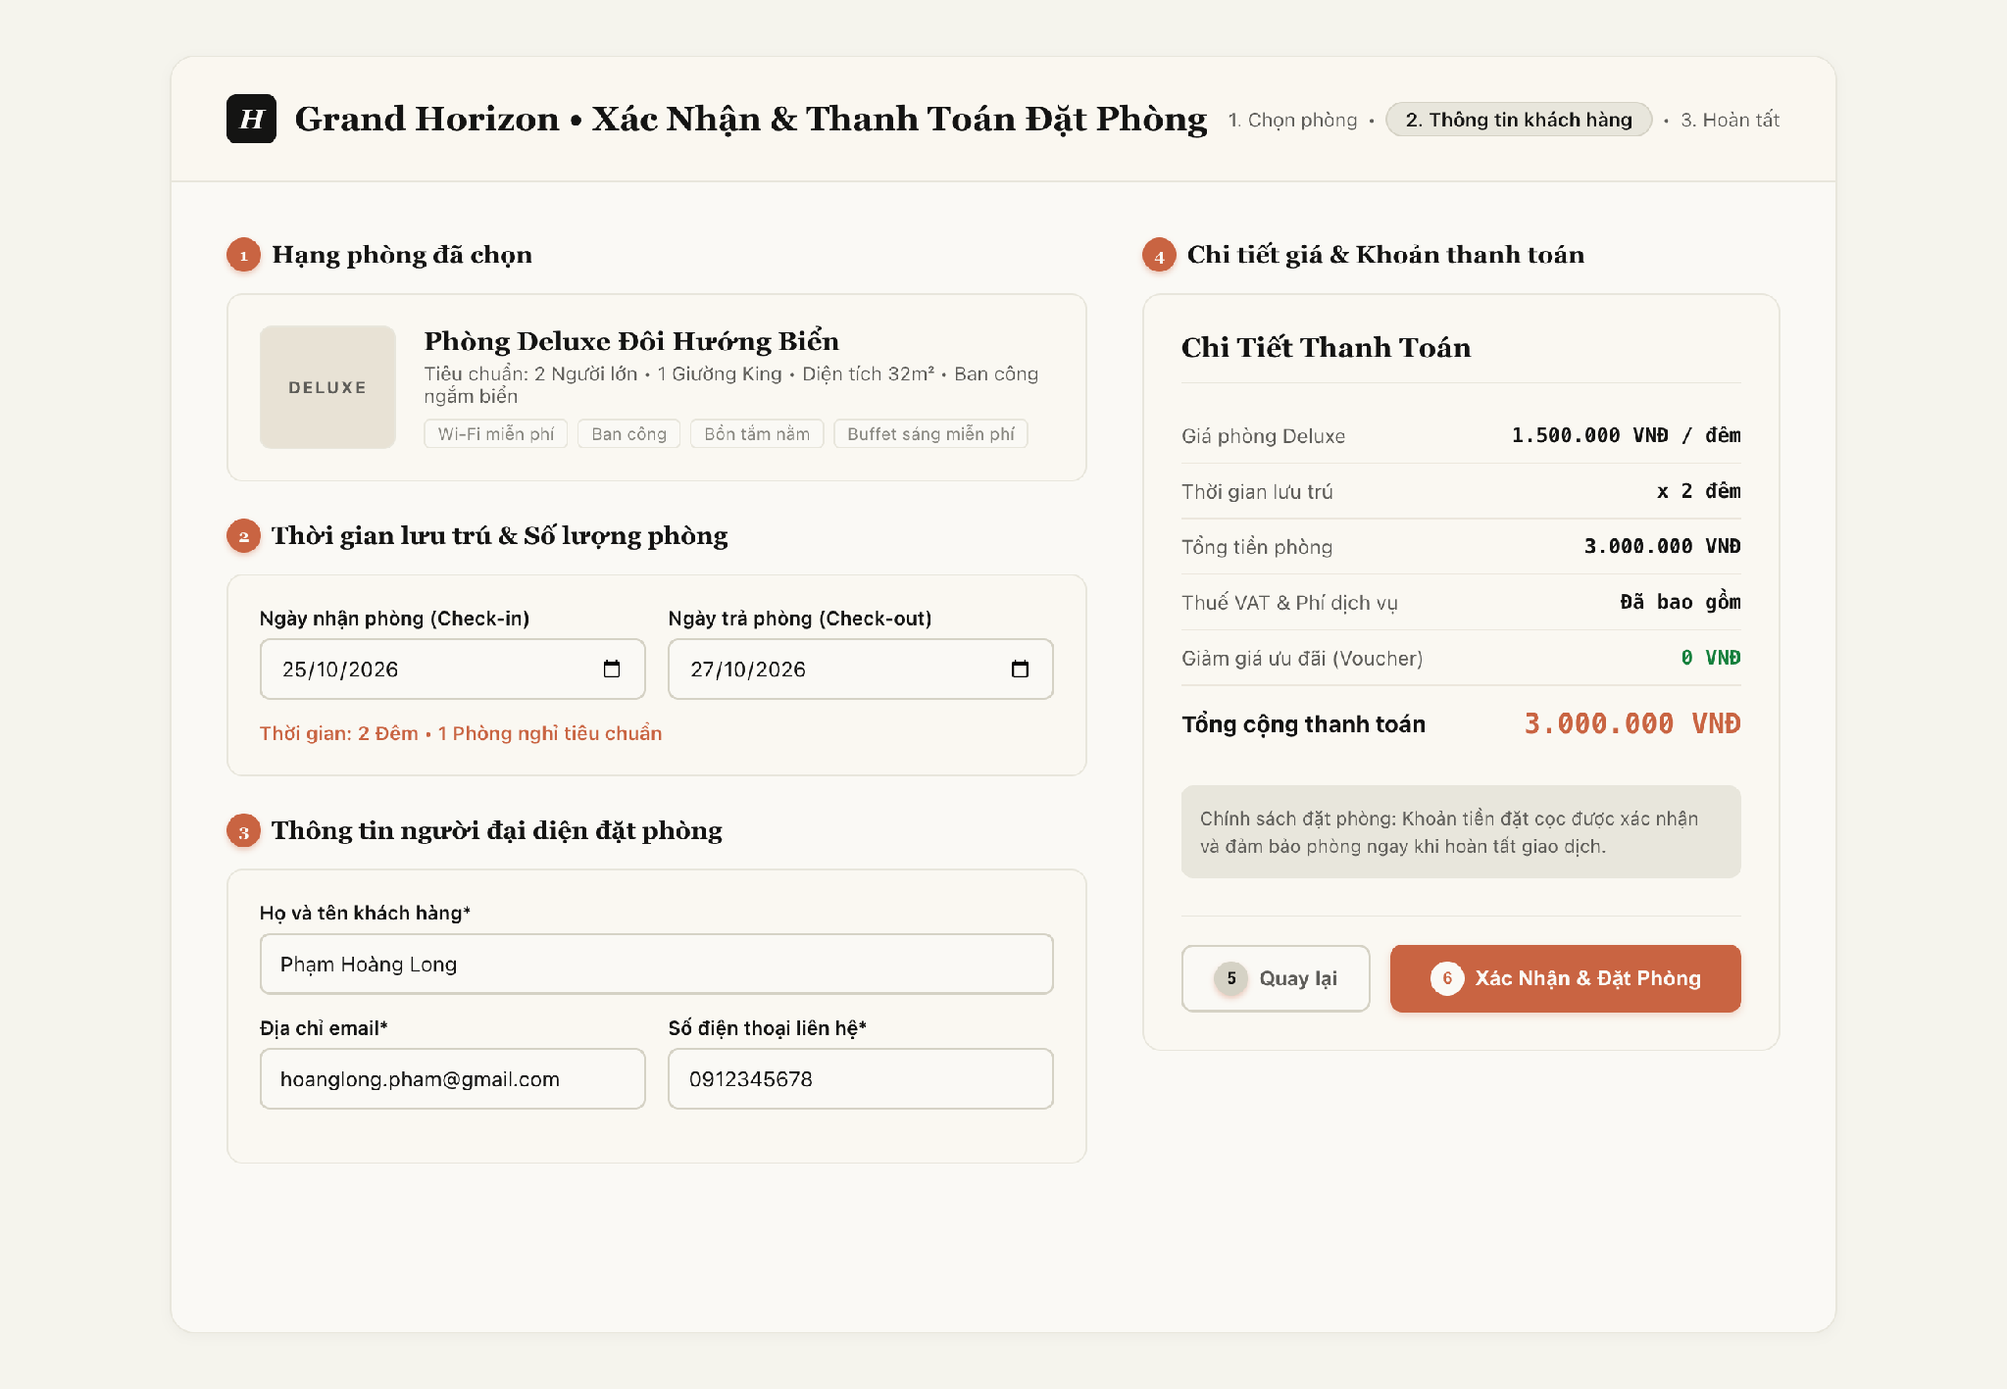
Figure 4-9: Screen Design of Booking Checkout (UC-23)
Table 4-7: Screen Definition for Booking Checkout (UC-23)
No | Object/Control Name | Type | Required | Length | Description
(1) | pnlRoomOverview | Display / Panel | Yes | N/A | Displays reserved room category, capacity, and base price [DB Mapping: tbl_room_type.type_name, capacity, base_price].
(2) | pnlBookingDates | Input / Panel | Yes | N/A | Selects scheduled stay interval and room count [DB Mapping: tbl_reservation.check_in_date, check_out_date, tbl_reservation_detail.quantity].
(3) | pnlGuestContact | Input / Panel | Yes | N/A | Primary guest contact information fields [DB Mapping: tbl_reservation.contact_name, contact_email, contact_phone].
(4) | tblPriceDetails | Display / Table | Yes | Currency | Itemized tariff calculation [DB Mapping: tbl_reservation_detail.agreed_rate * duration; tbl_payment.amount deposit].
(5) | btnBack | Button | No | Redirect | Navigates back to room search and category selection catalog.
(6) | btnConfirmBooking | Button | Yes | Trigger API | Initiates Step 1 in Sequence Diagram UC-23 [DB Action: INSERT tbl_reservation (status='CONFIRMED'), INSERT tbl_reservation_detail, INSERT tbl_payment].

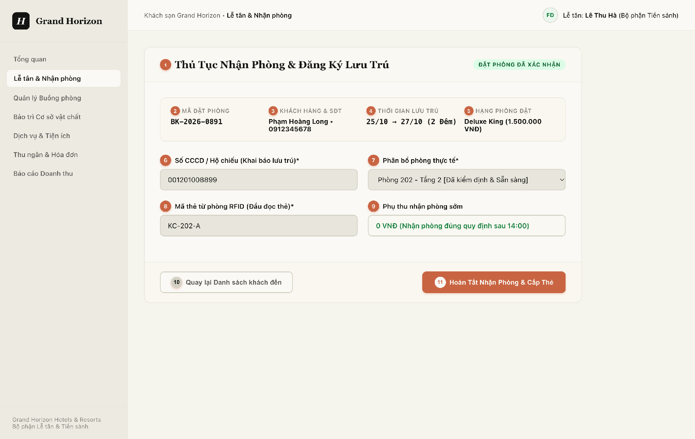
Figure 4-10: Screen Design of Guest Check-in Form (UC-27)
Table 4-8: Screen Definition for Guest Check-in Form (UC-27)
No | Object/Control Name | Type | Required | Length | Description
(1) | lblCheckinTitle | Label / Header | Yes | N/A | Header identifying the active check-in registration workflow.
(2) | txtBookingCode | Display / Text | Yes | 20 chars | Displays verified reservation code [DB Mapping: tbl_reservation.reservation_code].
(3) | txtGuestProfile | Display / Text | Yes | 100 chars | Displays registered guest full name and phone number [DB Mapping: tbl_customer.full_name, phone_number].
(4) | txtStayInterval | Display / Date | Yes | N/A | Displays check-in / check-out dates and night duration [DB Mapping: tbl_guest_stay.actual_check_in, expected_check_out].
(5) | txtRoomCategory | Display / Text | Yes | 50 chars | Displays reserved room category name and standard rate [DB Mapping: tbl_room_type.type_name].
(6) | txtIdentityCard | TextBox | Yes | 9-20 chars | Mandatory Citizen ID / Passport number for legal lodging registry [DB Mapping: tbl_customer.identity_card_number] (*).
(7) | cboAssignRoom | Dropdown | Yes | N/A | Selects clean, inspected room for assignment [DB Mapping: tbl_room.room_id; DB Action: INSERT tbl_stay_room_assignment] (*).
(8) | txtKeyCardNumber | TextBox | Yes | 20 chars | Physical RFID card number encoded for door access [DB Action: RFID Card Encoder Sync] (*).
(9) | txtEarlySurcharge | Display / Currency | No | N/A | Calculated early check-in surcharge if arriving before 14:00 [DB Mapping: tbl_additional_charge.amount].
(10) | btnBackToArrivals | Button | No | Redirect | Returns to front-desk pending arrivals queue without saving.
(11) | btnCompleteCheckin | Button | Yes | Trigger API | Initiates Step 1 in Sequence Diagram UC-27 [DB Action: INSERT tbl_guest_stay, INSERT tbl_stay_room_assignment, UPDATE tbl_room.status='OCCUPIED', INSERT tbl_folio].

4.4.2 Class/Component Design

4.4.2.1 Backend Class Diagram
Figure 4-11 illustrates the backend class structure for Reservation and Front-Desk operations. Crucially, it utilizes UML Composition (*--) for lifecycle-dependent parent-child entities: Reservation *-- Reservation_Detail and Guest_Stay *-- Stay_Room_Assignment, alongside Realization (..|>) for services and Association (-->) for repository references and domain entity associations.
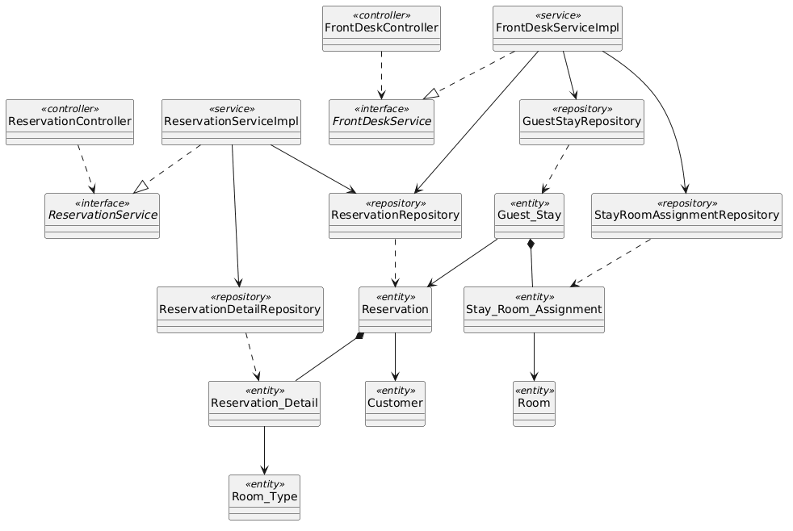
Figure 4-11: Backend Class/Component Structure Diagram for Reservation & Front-Desk

4.4.2.2 Classes/Component Description
4.4.2.2.1 ReservationController Class
Class | ReservationController
Description | REST controller exposing endpoints for booking creation, cancellation, and guest booking inquiries.
Base Class | None
Constructor | + ReservationController(reservationService: ReservationService)
Prototype | @RestController @RequestMapping("/api/v1/reservations") public class ReservationController
Source File | com/hotel/hms/controller/ReservationController.java
Namespace | com.hotel.hms.controller
Attributes | Name | Type | Description
 | reservationService | ReservationService | Business logic interface for room reservations.
Methods | Name | Input | Output | Description
 | createReservation | ReservationRequestDTO dto | ResponseEntity<ReservationResponseDTO> | Validates quota and creates room reservation.
 | getReservation | Long id | ResponseEntity<ReservationResponseDTO> | Retrieves reservation itinerary details.

4.4.2.2.2 FrontDeskServiceImpl Class
Class | FrontDeskServiceImpl
Description | Service executing front-desk arrival check-in, physical room assignment, and Guest_Stay creation.
Base Class | FrontDeskService
Constructor | + FrontDeskServiceImpl(resRepo: ReservationRepository, stayRepo: GuestStayRepository, roomRepo: RoomRepository, assignRepo: StayRoomAssignmentRepository)
Prototype | @Service @Transactional public class FrontDeskServiceImpl implements FrontDeskService
Source File | com/hotel/hms/service/impl/FrontDeskServiceImpl.java
Namespace | com.hotel.hms.service.impl
Attributes | Name | Type | Description
 | reservationRepository | ReservationRepository | Access to reservation records.
 | guestStayRepository | GuestStayRepository | Persistence for active guest stay records.
 | roomRepository | RoomRepository | Persistence for updating room operational status.
 | stayRoomAssignmentRepository | StayRoomAssignmentRepository | Persistence for room door allocations.
Methods | Name | Input | Output | Description
 | performCheckIn | CheckInRequestDTO dto | CheckInResponseDTO | Allocates room, creates GuestStay, updates room status to OCCUPIED, opens folio.
 | transferRoom | Long stayId, Long newRoomId | void | Transfers guest stay to new room and marks old room DIRTY.

4.4.2.2.3 ReservationRepository Class
Class | ReservationRepository
Description | Spring Data JPA repository managing Reservation entity records and booking status queries.
Base Class | JpaRepository<Reservation, Long>
Constructor | None (Spring Data JPA Interface)
Prototype | @Repository public interface ReservationRepository extends JpaRepository<Reservation, Long>
Source File | com/hotel/hms/repository/ReservationRepository.java
Namespace | com.hotel.hms.repository
Attributes | Name | Type | Description
 | None | - | Inherits Spring Data JPA persistence context.
Methods | Name | Input | Output | Description
 | findByReservationId | Long id | Optional<Reservation> | Queries reservation by ID.
 | findActiveBookingsByDate | LocalDate date | List<Reservation> | Queries active bookings for arrival dispatch.

4.4.2.2.4 Guest_Stay Class
Class | Guest_Stay
Description | JPA entity mapped to table 'Guest_Stay'. Records actual check-in and check-out timestamps of an active stay.
Base Class | None
Constructor | + Guest_Stay()
Prototype | @Entity @Table(name = "Guest_Stay") public class Guest_Stay
Source File | com/hotel/hms/entity/Guest_Stay.java
Namespace | com.hotel.hms.entity
Attributes | Name | Type | Description
 | stayId | Long | Primary key identifier of guest stay.
 | actualCheckIn | LocalDateTime | Recorded check-in arrival timestamp.
 | actualCheckOut | LocalDateTime | Recorded departure timestamp.
 | status | String | Stay status: CHECKED_IN, CHECKED_OUT.
 | reservation | Reservation | Many-to-One reference to Reservation entity.
Methods | Name | Input | Output | Description
 | getStayId | void | Long | Returns stay primary key.
 | setStatus | String status | void | Sets stay status.

4.4.3 Object Interactions (Sequence Diagram)
Figures 4-12 and 4-13 depict the runtime interactions for Room Reservation and Guest Check-in. Tables 4-9 and 4-10 list each step.
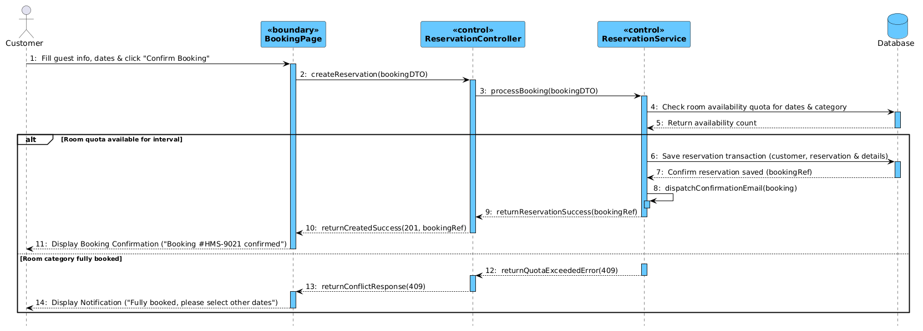
Figure 4-12: Sequence Diagram for UC-23 Room Reservation
Table 4-9: Interaction Steps for UC-23 Room Reservation
Step | Caller (From) | Callee (To) | Action / Method | Description
1 | Customer | BookingPage | Fill guest info, dates & click "Confirm Booking" | Guest fills contact details, check-in/out dates, and chooses room category.
2 | BookingPage | ReservationController | createReservation(bookingDTO) | Dispatches HTTP POST request with reservation payload.
3 | ReservationController | ReservationService | processBooking(bookingDTO) | Delegates booking business rules and allocation to reservation service.
4 | ReservationService | Database | Check room availability quota for dates & category | Queries inventory count to verify capacity for requested interval.
5 | Database | ReservationService | Return availability count | Returns remaining vacant room count for category.
6 [Success] | ReservationService | Database | Save reservation transaction (customer, reservation & details) | Atomically creates customer profile, reservation header, and room detail rows.
7 [Success] | Database | ReservationService | Confirm reservation saved (bookingRef) | Database confirms booking transaction and returns reference code.
8 [Success] | ReservationService | ReservationService | dispatchConfirmationEmail(booking) | Asynchronously triggers booking confirmation email to customer.
9 [Success] | ReservationService | ReservationController | returnReservationSuccess(bookingRef) | Returns reservation confirmation response DTO.
10 [Success] | ReservationController | BookingPage | returnCreatedSuccess(201, bookingRef) | Responds with HTTP 201 Created and booking reference.
11 [Success] | BookingPage | Customer | Display Booking Confirmation ("Booking #HMS-9021 confirmed") | Renders booking confirmation screen with code and instructions.
12 [Failure] | ReservationService | ReservationController | returnQuotaExceededError(409) | Returns inventory conflict error when requested room type is fully booked.
13 [Failure] | ReservationController | BookingPage | returnConflictResponse(409) | Responds with HTTP 409 Conflict status.
14 [Failure] | BookingPage | Customer | Display Notification ("Fully booked, please select other dates") | Displays alert requesting customer to choose alternative dates or categories.

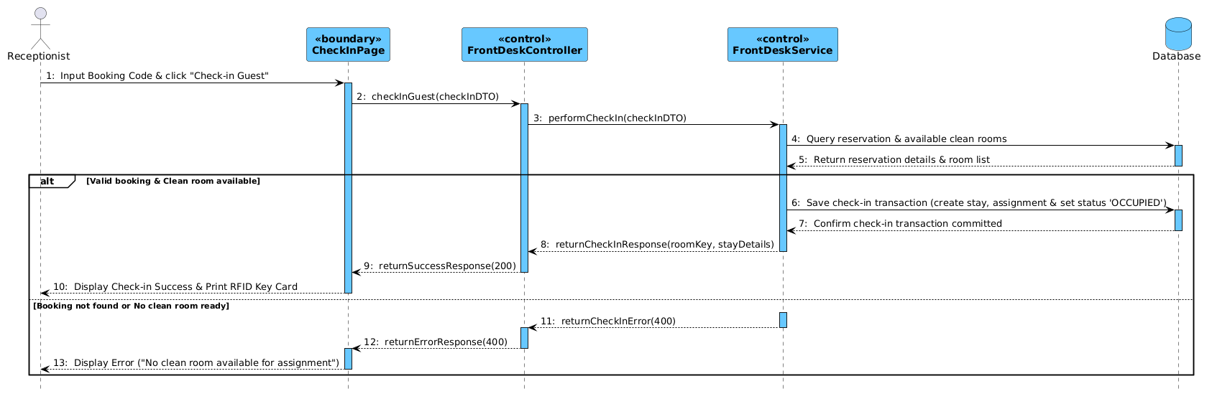
Figure 4-13: Sequence Diagram for UC-27 Guest Check-in
Table 4-10: Interaction Steps for UC-27 Guest Check-in
Step | Caller (From) | Callee (To) | Action / Method | Description
1 | Receptionist | CheckInPage | Input Booking Code & click "Check-in Guest" | Front-desk receptionist enters booking code and initiates check-in.
2 | CheckInPage | FrontDeskController | checkInGuest(checkInDTO) | Dispatches HTTP POST request with check-in payload.
3 | FrontDeskController | FrontDeskService | performCheckIn(checkInDTO) | Transfers check-in workflow to front-desk service layer.
4 | FrontDeskService | Database | Query reservation & available clean rooms | Verifies booking status and searches for available CLEAN rooms of category.
5 | Database | FrontDeskService | Return reservation details & room list | Returns verified reservation details and eligible room candidates.
6 [Success] | FrontDeskService | Database | Save check-in transaction (create stay, assignment & set status 'OCCUPIED') | Atomically creates guest stay, assigns physical room, and marks room OCCUPIED.
7 [Success] | Database | FrontDeskService | Confirm check-in transaction committed | Database confirms transaction committed successfully.
8 [Success] | FrontDeskService | FrontDeskController | returnCheckInResponse(roomKey, stayDetails) | Returns check-in summary DTO with RFID room key payload.
9 [Success] | FrontDeskController | CheckInPage | returnSuccessResponse(200) | Responds with HTTP 200 OK status.
10 [Success] | CheckInPage | Receptionist | Display Check-in Success & Print RFID Key Card | Renders check-in success badge and triggers RFID key encoder.
11 [Failure] | FrontDeskService | FrontDeskController | returnCheckInError(400) | Returns error if booking is not found or no clean room is available.
12 [Failure] | FrontDeskController | CheckInPage | returnErrorResponse(400) | Responds with HTTP 400 Bad Request error.
13 [Failure] | CheckInPage | Receptionist | Display Error ("No clean room available for assignment") | Displays descriptive error alert banner on check-in interface.

4.5 Ancillary Services & Billing Management
The Ancillary Services & Billing subsystem coordinates on-premise hotel service catalogs (dining, laundry, spa), room folio charge posting, voucher discount applications, multi-currency invoicing, and payment settlements (UC-31 through UC-40). This section details UC-35 (Order Hotel Service) and UC-37/39 (Folio Invoicing & Payment Settlement).

4.5.1 Screen Design
Figure 4-14 illustrates the hotel service catalog interface used for posting service orders to guest folios. Table 4-11 lists its controls.
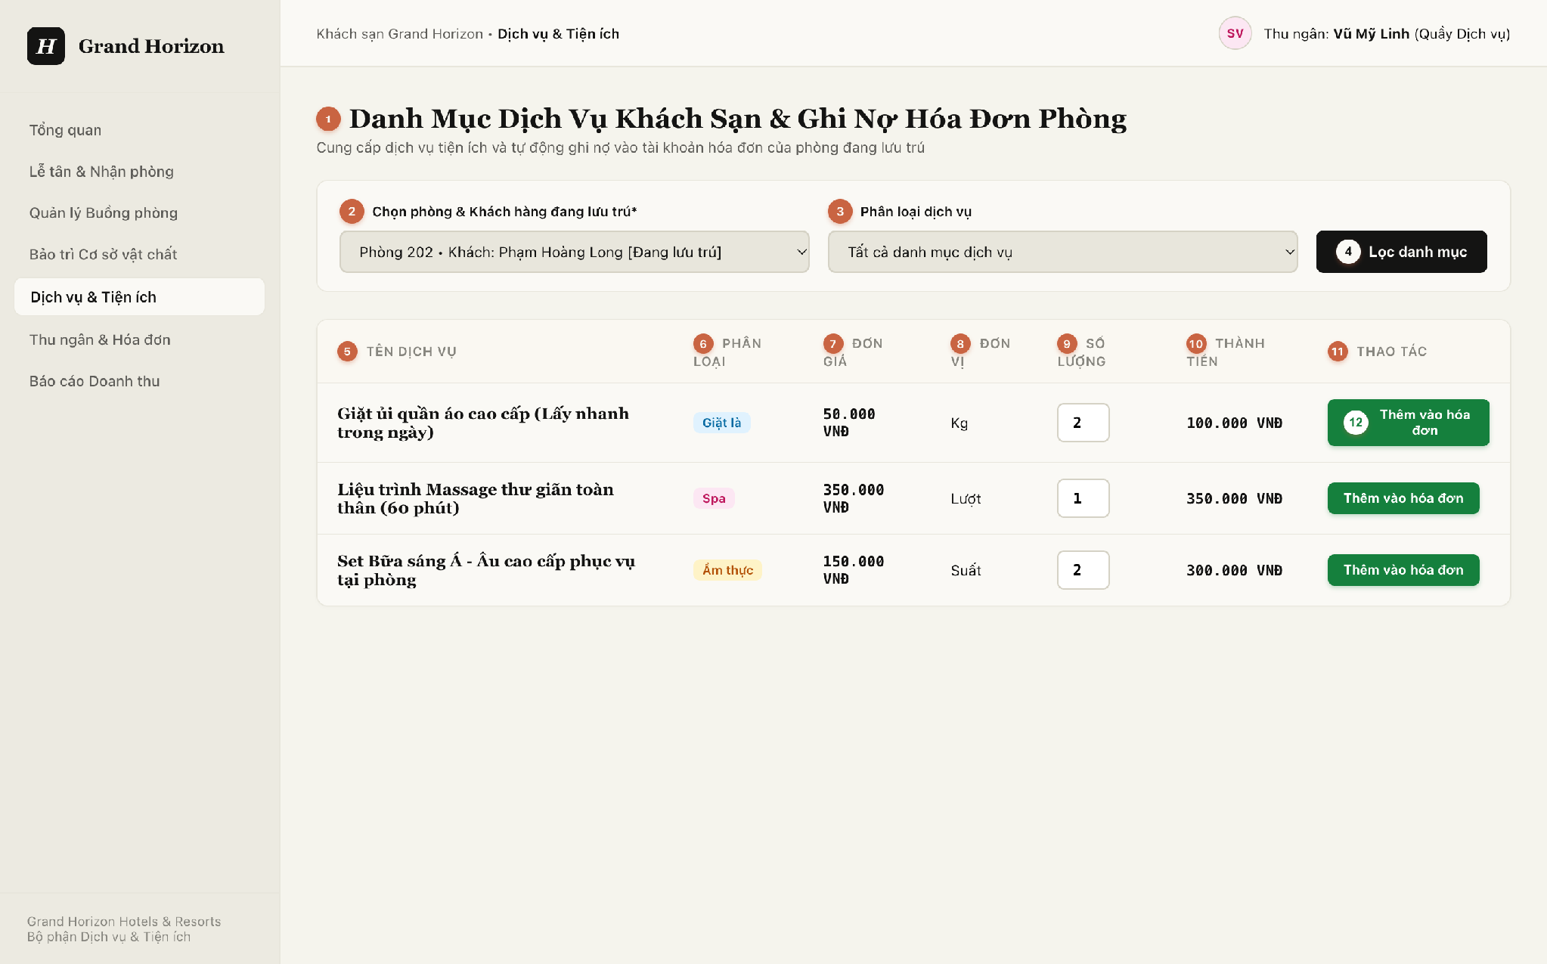
Figure 4-14: Screen Design of Available Hotel Services (UC-34 & UC-35)
Table 4-11: Screen Definition for Hotel Service Ordering (UC-35)
No | Object/Control Name | Type | Required | Length | Description
(1) | lblCatalogTitle | Label / Header | Yes | N/A | Header identifying the ancillary service catalog and folio debit workflow.
(2) | cboActiveGuestStay | Dropdown | Yes | N/A | Selects active occupied guest stay to receive service charges [DB Mapping: tbl_guest_stay.stay_id, tbl_room.room_number] (*).
(3) | cboCategoryFilter | Dropdown | No | N/A | Department categorization filter (All, Laundry, Spa & Wellness, Food & Beverage).
(4) | btnFilterCatalog | Button | No | Trigger API | Filters displayed service catalog list according to selected department.
(5) | colServiceName | Display / Text | Yes | 100 chars | Commercial name of service item [DB Mapping: tbl_service.service_name].
(6) | colCategory | Display / Badge | Yes | 50 chars | Department categorization badge (Laundry, Spa, Dining).
(7) | colUnitPrice | Display / Currency | Yes | N/A | Official standard unit price [DB Mapping: tbl_service.unit_price].
(8) | colUnit | Display / Text | Yes | 20 chars | Service measurement unit (Kg, Session, Set).
(9) | txtQuantity | NumberInput | Yes | Min: 1, Max: 99 | Order quantity selected by staff or guest [DB Mapping: tbl_service_order.quantity].
(10) | colTotalAmount | Display / Currency | Yes | N/A | Item charge subtotal dynamically computed as unit_price * quantity.
(11) | colActionHeader | Label / Header | Yes | N/A | Column header for row operational action buttons.
(12) | btnAddToFolio | Button | Yes | Trigger API | Direct order button [DB Action: INSERT into tbl_service_order (status='POSTED'); UPDATE tbl_folio.total_amount].

4.5.2 Class/Component Design

4.5.2.1 Backend Class Diagram
Figure 4-15 illustrates the backend class structure for Ancillary Services and Billing Management. It enforces Composition (*--) for Folio *-- Additional_Charge, Realization (..|>) for all billing and order services, Dependency (..>) for controller endpoints and JPA queries, and Association (-->) for repository references and billing entity associations.
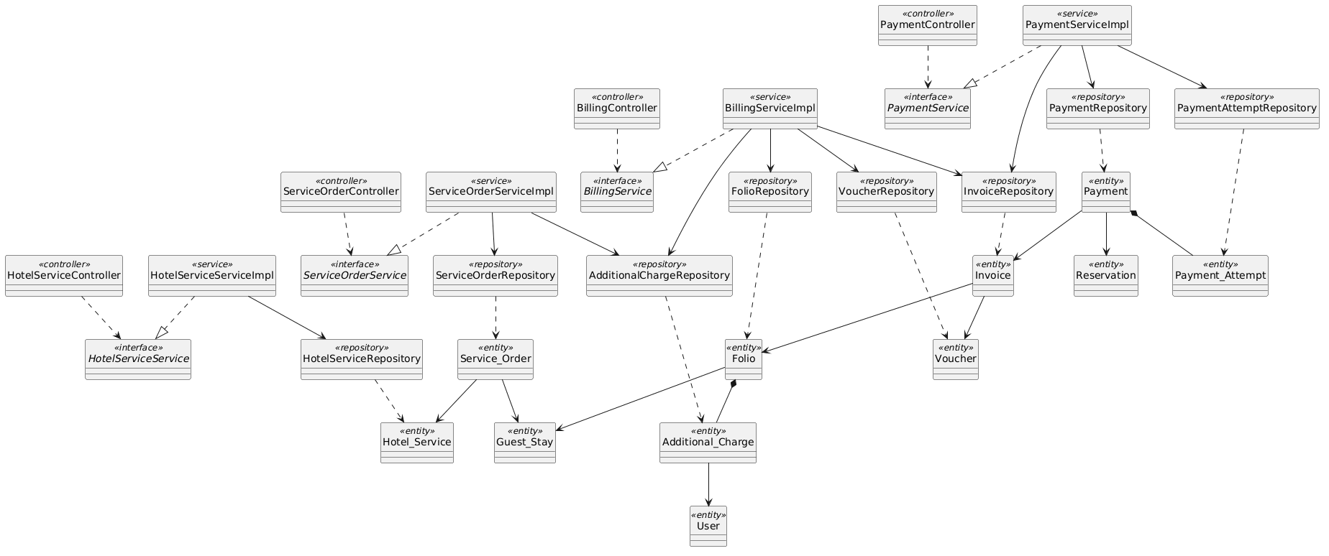
Figure 4-15: Backend Class/Component Structure Diagram for Ancillary Services & Billing

4.5.2.2 Classes/Component Description
4.5.2.2.1 BillingController Class
Class | BillingController
Description | REST controller exposing endpoints for folio compilation, voucher discounts, checkout invoicing, and payment processing.
Base Class | None
Constructor | + BillingController(billingService: BillingService)
Prototype | @RestController @RequestMapping("/api/v1/billing") public class BillingController
Source File | com/hotel/hms/controller/BillingController.java
Namespace | com.hotel.hms.controller
Attributes | Name | Type | Description
 | billingService | BillingService | Business logic interface for folio billing and payment settlements.
Methods | Name | Input | Output | Description
 | getFolioDetails | Long stayId | ResponseEntity<FolioDTO> | Retrieves itemized room and service charges for an active stay.
 | processCheckOutPayment | PaymentSettlementDTO dto | ResponseEntity<InvoiceReceiptDTO> | Finalizes folio, records payment, and creates fiscal Invoice.

4.5.2.2.2 BillingServiceImpl Class
Class | BillingServiceImpl
Description | Service executing folio item consolidation, tax/discount computations, payment gateway settlement, and invoice generation.
Base Class | BillingService
Constructor | + BillingServiceImpl(folioRepo: FolioRepository, invoiceRepo: InvoiceRepository, paymentRepo: PaymentRepository, gateway: PaymentGateway)
Prototype | @Service @Transactional public class BillingServiceImpl implements BillingService
Source File | com/hotel/hms/service/impl/BillingServiceImpl.java
Namespace | com.hotel.hms.service.impl
Attributes | Name | Type | Description
 | folioRepository | FolioRepository | Access to guest folio records and items.
 | invoiceRepository | InvoiceRepository | Persistence for generated Invoice entities.
 | paymentRepository | PaymentRepository | Persistence for completed transaction payments.
 | paymentGateway | PaymentGateway | Integration client for electronic payment transactions.
Methods | Name | Input | Output | Description
 | settleFolioAndCheckout | PaymentSettlementDTO dto | InvoiceReceiptDTO | Validates balance, executes transaction, issues Invoice, and closes Folio.
 | applyVoucher | Long folioId, String voucherCode | FolioDTO | Applies discount voucher to folio grand total.

4.5.2.2.3 Folio Class
Class | Folio
Description | JPA entity mapped to table 'Folio'. Tracks aggregate financial charges and balance incurred during a guest stay.
Base Class | None
Constructor | + Folio()
Prototype | @Entity @Table(name = "Folio") public class Folio
Source File | com/hotel/hms/entity/Folio.java
Namespace | com.hotel.hms.entity
Attributes | Name | Type | Description
 | folioId | Long | Primary key identifier of folio.
 | createdAt | LocalDateTime | Timestamp when folio account was created upon check-in (mapped to Folio.created_at in Section 5).
 | totalAmount | BigDecimal | Current cumulative financial balance.
 | status | String | Folio status: OPEN, SETTLED, CLOSED.
 | guestStay | Guest_Stay | One-to-One reference to Guest_Stay entity.
Methods | Name | Input | Output | Description
 | getFolioId | void | Long | Returns folio primary key.
 | getTotalAmount | void | BigDecimal | Returns current balance.

4.5.2.2.4 Invoice Class
Class | Invoice
Description | JPA entity mapped to table 'Invoice'. Represents legally binding fiscal receipt issued upon stay settlement.
Base Class | None
Constructor | + Invoice()
Prototype | @Entity @Table(name = "Invoice") public class Invoice
Source File | com/hotel/hms/entity/Invoice.java
Namespace | com.hotel.hms.entity
Attributes | Name | Type | Description
 | invoiceId | Long | Primary key identifier of invoice.
 | issueDate | LocalDateTime | Timestamp when invoice was generated upon checkout (mapped to Invoice.issue_date in Section 5).
 | totalAmount | BigDecimal | Final billed total including taxes and discounts.
 | finalAmount | BigDecimal | Payable total amount after voucher discount deduction (mapped to Invoice.final_amount in Section 5).
 | voucher | Voucher | Optional promotional discount voucher applied (Many-to-One, mapped to Invoice.voucher_id in Section 5).
 | status | String | Invoice settlement status: PAID, UNPAID, CANCELLED (mapped to Invoice.status in Section 5).
 | folio | Folio | Many-to-One reference to settled Folio.
Methods | Name | Input | Output | Description
 | getInvoiceId | void | Long | Returns invoice ID.
 | getTotalAmount | void | BigDecimal | Returns grand total.

4.5.3 Object Interactions (Sequence Diagram)
Figure 4-16 illustrates the runtime interaction flow for UC-37 & UC-39 Check-out & Payment Settlement. Table 4-12 details each step.
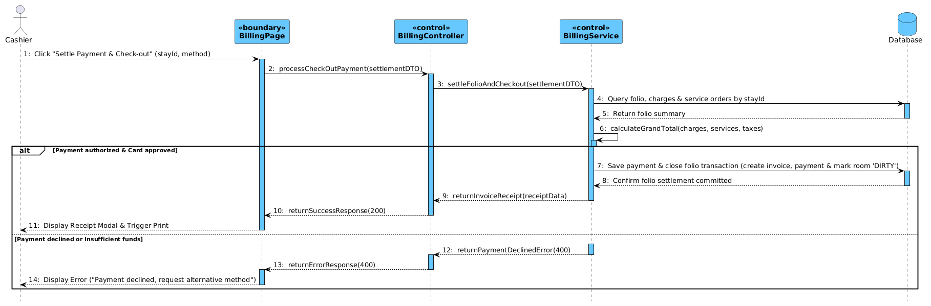
Figure 4-16: Sequence Diagram for UC-37 & UC-39 Check-out & Payment Settlement
Table 4-12: Interaction Steps for UC-37 & UC-39 Check-out & Payment Settlement
Step | Caller (From) | Callee (To) | Action / Method | Description
1 | Cashier | BillingPage | Click "Settle Payment & Check-out" (stayId, method) | Cashier verifies folio charges and initiates final payment settlement.
2 | BillingPage | BillingController | processCheckOutPayment(settlementDTO) | Dispatches HTTP POST request with settlement parameters.
3 | BillingController | BillingService | settleFolioAndCheckout(settlementDTO) | Delegates folio closing and payment settlement to billing service.
4 | BillingService | Database | Query folio, charges & service orders by stayId | Loads folio line items, room charges, and consumed service orders.
5 | Database | BillingService | Return folio summary | Returns itemized consumption records and preliminary balance.
6 | BillingService | BillingService | calculateGrandTotal(charges, services, taxes) | Calculates net subtotal, applicable taxes (VAT), discounts, and total due.
7 [Success] | BillingService | Database | Save payment & close folio transaction (create invoice, payment & mark room 'DIRTY') | Atomically creates fiscal invoice, records payment, closes folio, and sets room DIRTY.
8 [Success] | Database | BillingService | Confirm folio settlement committed | Database confirms payment and folio transaction committed.
9 [Success] | BillingService | BillingController | returnInvoiceReceipt(receiptData) | Returns itemized invoice receipt DTO.
10 [Success] | BillingController | BillingPage | returnSuccessResponse(200) | Responds with HTTP 200 OK status.
11 [Success] | BillingPage | Cashier | Display Receipt Modal & Trigger Print | Displays receipt modal with invoice breakdown and triggers print dialog.
12 [Failure] | BillingService | BillingController | returnPaymentDeclinedError(400) | Returns payment gateway rejection or insufficient funds error.
13 [Failure] | BillingController | BillingPage | returnErrorResponse(400) | Responds with HTTP 400 Bad Request error.
14 [Failure] | BillingPage | Cashier | Display Error ("Payment declined, request alternative method") | Displays payment failure notification requesting alternative payment.

4.6 Reviews, Audit & Reporting Management
The Reviews, Audit & Reporting subsystem oversees guest satisfaction feedback, automated audit logging of sensitive actions, and management operational intelligence reports covering room occupancy ratios, revenue per available room (RevPAR), and department revenue trends (UC-41 through UC-50). This section details UC-41 (Submit Room Review) and UC-46 (Revenue Analytics Report).

4.6.1 Screen Design
Figure 4-17 illustrates the executive revenue analytics dashboard (UC-46). Table 4-13 specifies the control definitions for the interface.
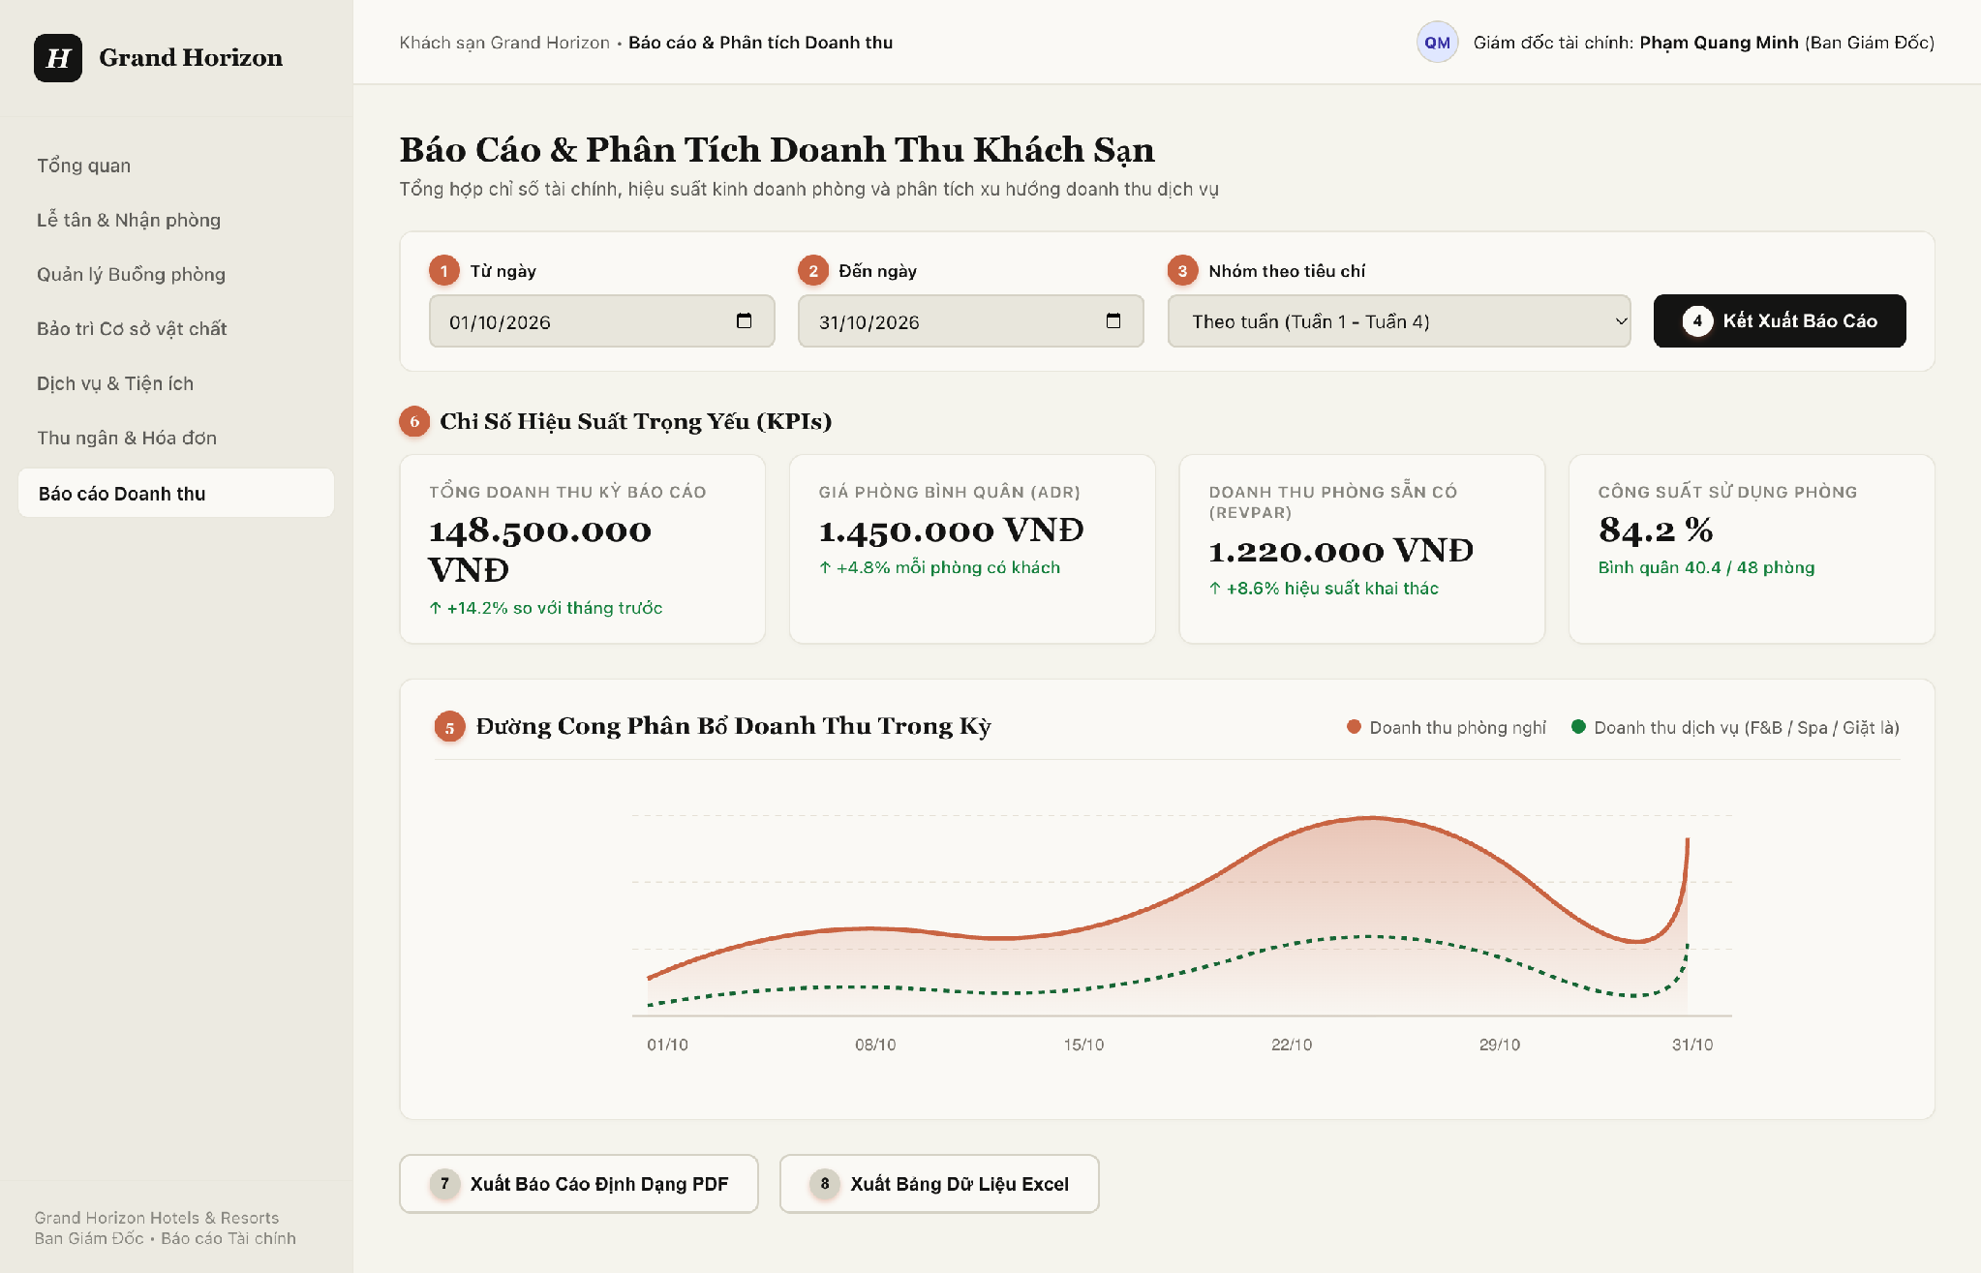
Figure 4-17: Screen Design of Management Revenue Analytics Dashboard (UC-46)
Table 4-13: Screen Definition for Management Revenue Analytics (UC-46)
No | Object/Control Name | Type | Required | Length | Description
(1) | dtFromDate | DatePicker | Yes | YYYY-MM-DD | Start date of analytics reporting period filter (*).
(2) | dtToDate | DatePicker | Yes | YYYY-MM-DD | End date of analytics reporting period filter (*).
(3) | cboReportGrouping | Dropdown | Yes | N/A | Temporal grouping criteria: Daily, Weekly, Monthly, or by Room Category.
(4) | btnGenerateReport | Button | Yes | Trigger API | Dispatches analytics query to backend; aggregates data from tbl_invoice, tbl_payment, and tbl_service_order.
(5) | chartRevenueTrend | Chart | Yes | Area / Line Chart | Renders graphical revenue curve comparing room tariff revenue vs ancillary service revenue.
(6) | kpiCards | KPICard / Display | Yes | Metrics | Executive summary metric cards: Gross Property Revenue, ADR, RevPAR, and Room Occupancy Rate.
(7) | btnExportPDF | Button | No | N/A | Exports current analytics view to structured executive PDF report.
(8) | btnExportExcel | Button | No | N/A | Exports raw transactional dataset to Microsoft Excel workbook.

4.6.2 Class/Component Design

4.6.2.1 Backend Class Diagram
Figure 4-18 illustrates the backend class structure for Reviews & Reporting. It uses flat layout with standard UML relationship arrows: Realization (..|>) for reporting services, Dependency (..>) for controller endpoints and query invocations, and Association (-->) for repository references and review entity associations.
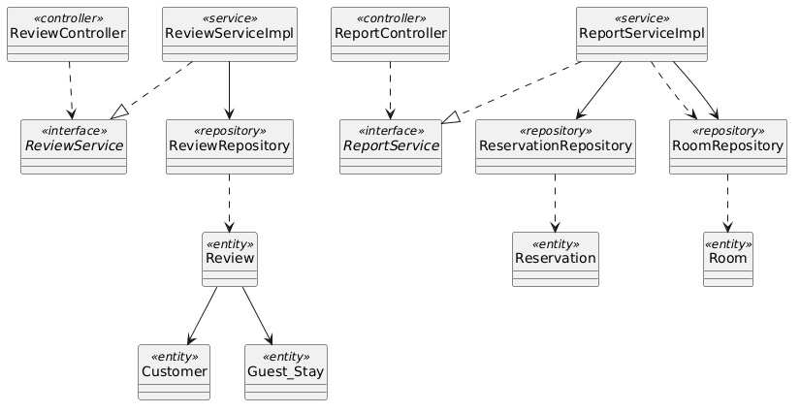
Figure 4-18: Backend Class/Component Structure Diagram for Reviews & Reporting

4.6.2.2 Classes/Component Description
4.6.2.2.1 ReportController Class
Class | ReportController
Description | REST controller exposing analytical endpoints for room occupancy and property revenue intelligence.
Base Class | None
Constructor | + ReportController(reportService: ReportService)
Prototype | @RestController @RequestMapping("/api/v1/reports") public class ReportController
Source File | com/hotel/hms/controller/ReportController.java
Namespace | com.hotel.hms.controller
Attributes | Name | Type | Description
 | reportService | ReportService | Service calculating analytical KPIs.
Methods | Name | Input | Output | Description
 | getRevenueReport | LocalDate from, LocalDate to | ResponseEntity<RevenueReportDTO> | Calculates total revenue, ADR, and RevPAR over time window.
 | getOccupancyReport | LocalDate from, LocalDate to | ResponseEntity<OccupancyReportDTO> | Calculates room occupancy percentages and turnover ratios.

4.6.2.2.2 ReportServiceImpl Class
Class | ReportServiceImpl
Description | Service aggregating multi-table relational data to produce executive business intelligence metrics.
Base Class | ReportService
Constructor | + ReportServiceImpl(resRepo: ReservationRepository, roomRepo: RoomRepository)
Prototype | @Service @Transactional(readOnly = true) public class ReportServiceImpl implements ReportService
Source File | com/hotel/hms/service/impl/ReportServiceImpl.java
Namespace | com.hotel.hms.service.impl
Attributes | Name | Type | Description
 | reservationRepository | ReservationRepository | Read-only access for booking revenue aggregation.
 | roomRepository | RoomRepository | Read-only access for total physical room capacity queries.
Methods | Name | Input | Output | Description
 | generateRevenueReport | LocalDate from, LocalDate to | RevenueReportDTO | Aggregates revenue, computes Average Daily Rate (ADR) and RevPAR.
 | compileSummaryKPIs | BigDecimal rev, Integer rooms | KPIOverviewDTO | Synthesizes high-level summary cards.

4.6.2.2.3 ReviewRepository Class
Class | ReviewRepository
Description | Spring Data JPA repository managing guest reviews and satisfaction ratings.
Base Class | JpaRepository<Review, Long>
Constructor | None (Spring Data JPA Interface)
Prototype | @Repository public interface ReviewRepository extends JpaRepository<Review, Long>
Source File | com/hotel/hms/repository/ReviewRepository.java
Namespace | com.hotel.hms.repository
Attributes | Name | Type | Description
 | None | - | Inherits Spring Data JPA persistence context.
Methods | Name | Input | Output | Description
 | findByCustomer_CustomerId | Long customerId | List<Review> | Queries reviews submitted by customer.
 | calculateAverageRating | void | Double | Calculates average property rating score across all reviews.

4.6.2.2.4 Review Class
Class | Review
Description | JPA entity mapped to table 'Review'. Stores star rating, feedback comment, and submission date.
Base Class | None
Constructor | + Review()
Prototype | @Entity @Table(name = "Review") public class Review
Source File | com/hotel/hms/entity/Review.java
Namespace | com.hotel.hms.entity
Attributes | Name | Type | Description
 | reviewId | Long | Primary key identifier of review.
 | rating | Integer | Rating score from 1 to 5 stars.
 | comment | String | Written feedback notes from guest.
 | reviewDate | LocalDateTime | Timestamp when review was submitted.
 | customer | Customer | Many-to-One reference to Customer entity.
 | guestStay | Guest_Stay | Many-to-One reference to completed hotel stay (mapped to Review.stay_id in Section 5).
Methods | Name | Input | Output | Description
 | getRating | void | Integer | Returns star rating.
 | getComment | void | String | Returns written feedback.

4.6.3 Object Interactions (Sequence Diagram)
Figure 4-19 depicts the runtime sequence flow for UC-46 Generate Revenue Analytics Report. Table 4-14 details each step.
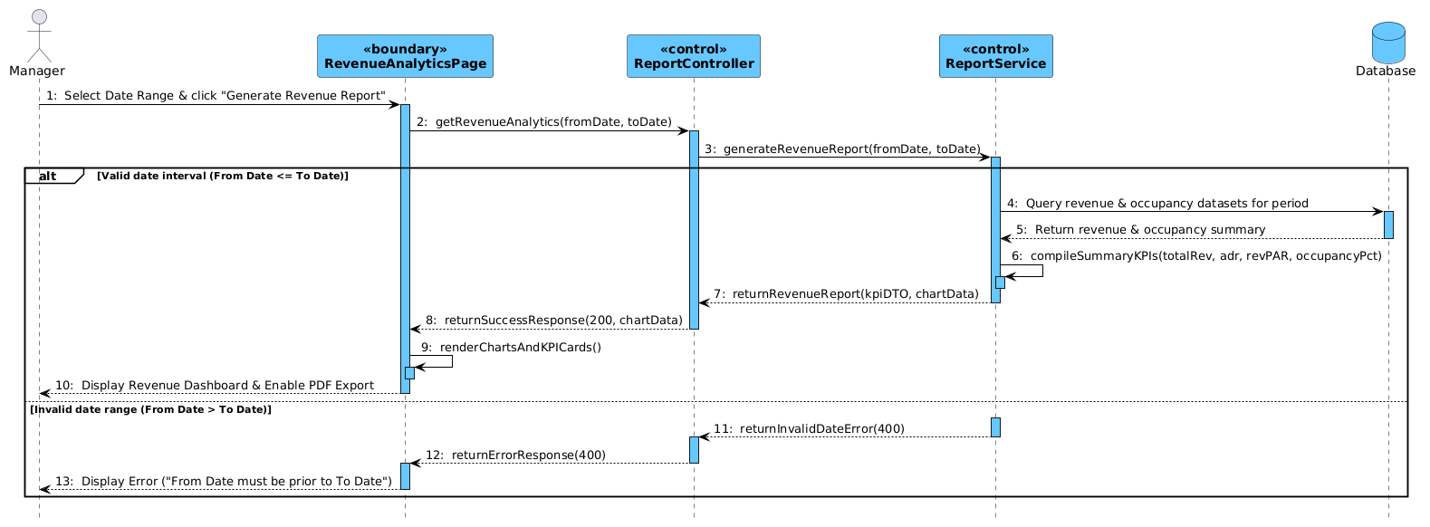
Figure 4-19: Sequence Diagram for UC-46 Generate Revenue Analytics Report
Table 4-14: Interaction Steps for UC-46 Generate Revenue Analytics Report
Step | Caller (From) | Callee (To) | Action / Method | Description
1 | Manager | RevenueAnalyticsPage | Select Date Range & click "Generate Revenue Report" | Hotel Manager selects date interval and requests revenue report.
2 | RevenueAnalyticsPage | ReportController | getRevenueAnalytics(fromDate, toDate) | Dispatches HTTP GET request with date filter query parameters.
3 | ReportController | ReportService | generateRevenueReport(fromDate, toDate) | Delegates analytical reporting calculations to reporting service.
4 [Success] | ReportService | Database | Query revenue & occupancy datasets for period | Queries invoices, room revenue, and daily occupied room inventory.
5 [Success] | Database | ReportService | Return revenue & occupancy summary | Returns aggregate metrics dataset for requested period.
6 [Success] | ReportService | ReportService | compileSummaryKPIs(totalRev, adr, revPAR, occupancyPct) | Calculates key KPIs: Total Revenue, ADR, RevPAR, and Occupancy Rate.
7 [Success] | ReportService | ReportController | returnRevenueReport(kpiDTO, chartData) | Returns compiled report DTO with time-series chart data.
8 [Success] | ReportController | RevenueAnalyticsPage | returnSuccessResponse(200, chartData) | Responds with HTTP 200 OK and chart dataset.
9 [Success] | RevenueAnalyticsPage | RevenueAnalyticsPage | renderChartsAndKPICards() | Renders revenue trend line charts and summary KPI cards.
10 [Success] | RevenueAnalyticsPage | Manager | Display Revenue Dashboard & Enable PDF Export | Displays analytics dashboard and activates PDF/Excel export buttons.
11 [Failure] | ReportService | ReportController | returnInvalidDateError(400) | Returns date validation error when From Date is after To Date.
12 [Failure] | ReportController | RevenueAnalyticsPage | returnErrorResponse(400) | Responds with HTTP 400 Bad Request error.
13 [Failure] | RevenueAnalyticsPage | Manager | Display Error ("From Date must be prior to To Date") | Displays date range error toast message to Manager.

5. Database Design

5.1 Database Design

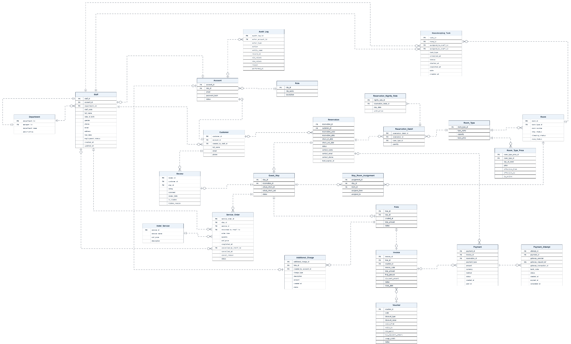

a. Role
# | Field name | Type | Size | Unique | Not Null | PK/FK | Notes
1 | role_id | INT | 4 | Yes | Yes | PK | Auto-increment primary key.
2 | role_name | NVARCHAR | 100 | Yes | Yes
3 | description | NVARCHAR | 500 | No | No

b. Account
# | Field name | Type | Size | Unique | Not Null | PK/FK | Notes
1 | account_id | INT | 4 | Yes | Yes | PK | Auto-increment primary key.
2 | role_id | INT | 4 | No | Yes | FK | References Role.role_id.
3 | email | NVARCHAR | 254 | Yes | Yes
4 | password_hash | VARCHAR | 255 | No | Yes
5 | status | NVARCHAR | 30 | No | Yes

c. Room_Type
# | Field name | Type | Size | Unique | Not Null | PK/FK | Notes
1 | room_type_id | INT | 4 | Yes | Yes | PK | Auto-increment primary key.
2 | type_name | NVARCHAR | 100 | No | Yes
3 | capacity | INT | 4 | No | Yes
4 | base_price | DECIMAL | 18,2 | No | Yes

d. Room
# | Field name | Type | Size | Unique | Not Null | PK/FK | Notes
1 | room_id | INT | 4 | Yes | Yes | PK | Auto-increment primary key.
2 | room_type_id | INT | 4 | No | Yes | FK | References Room_Type.room_type_id.
3 | room_number | NVARCHAR | 100 | Yes | Yes
4 | stay_status | NVARCHAR | 30 | No | Yes
5 | cleaning_status | NVARCHAR | 30 | No | Yes
6 | room_status | NVARCHAR | 30 | No | Yes

e. Reservation
# | Field name | Type | Size | Unique | Not Null | PK/FK | Notes
1 | reservation_id | INT | 4 | Yes | Yes | PK | Auto-increment primary key.
2 | customer_id | INT | 4 | No | Yes | FK | References Customer.customer_id.
3 | reservation_code | VARCHAR | 50 | Yes | Yes
4 | reservation_date | DATETIME2(0) | 6 | No | Yes
5 | check_in_date | DATE | 3 | No | Yes
6 | check_out_date | DATE | 3 | No | Yes
7 | status | NVARCHAR | 30 | No | Yes
8 | contact_name | NVARCHAR | 100 | No | Yes
9 | contact_email | NVARCHAR | 254 | No | Yes
10 | contact_phone | VARCHAR | 20 | No | Yes
11 | hold_expires_at | DATETIME2(0) | 6 | No | Yes

f. Reservation_Detail
# | Field name | Type | Size | Unique | Not Null | PK/FK | Notes
1 | reservation_detail_id | INT | 4 | Yes | Yes | PK | Auto-increment primary key.
2 | reservation_id | INT | 4 | No | Yes | FK | References Reservation.reservation_id.
3 | room_type_id | INT | 4 | No | Yes | FK | References Room_Type.room_type_id.
4 | quantity | INT | 4 | No | Yes

g. Guest_Stay
# | Field name | Type | Size | Unique | Not Null | PK/FK | Notes
1 | stay_id | INT | 4 | Yes | Yes | PK | Auto-increment primary key.
2 | reservation_id | INT | 4 | No | Yes | FK | References Reservation.reservation_id.
3 | actual_check_in | DATETIME2(0) | 6 | No | Yes
4 | actual_check_out | DATETIME2(0) | 6 | No | No
5 | status | NVARCHAR | 30 | No | Yes

h. Stay_Room_Assignment
# | Field name | Type | Size | Unique | Not Null | PK/FK | Notes
1 | assignment_id | INT | 4 | Yes | Yes | PK | Auto-increment primary key.
2 | stay_id | INT | 4 | No | Yes | FK | References Guest_Stay.stay_id.
3 | room_id | INT | 4 | No | Yes | FK | References Room.room_id.
4 | assigned_from | DATETIME2(0) | 6 | No | Yes
5 | assigned_to | DATETIME2(0) | 6 | No | No

i. Review
# | Field name | Type | Size | Unique | Not Null | PK/FK | Notes
1 | review_id | INT | 4 | Yes | Yes | PK | Auto-increment primary key.
2 | customer_id | INT | 4 | No | Yes | FK | References Customer.customer_id.
3 | stay_id | INT | 4 | No | Yes | FK | References Guest_Stay.stay_id.
4 | rating | INT | 4 | No | Yes |  | Allowed values: 1 to 5.
5 | comment | NVARCHAR | 2000 | No | No
6 | review_date | DATETIME2(0) | 6 | No | Yes
7 | is_hidden | BIT | 1 | No | Yes
8 | hidden_reason | NVARCHAR | 500 | No | No

j. Hotel_Service
# | Field name | Type | Size | Unique | Not Null | PK/FK | Notes
1 | service_id | INT | 4 | Yes | Yes | PK | Auto-increment primary key.
2 | service_name | NVARCHAR | 100 | No | Yes
3 | unit_price | DECIMAL | 18,2 | No | Yes
4 | description | NVARCHAR | 500 | No | No

k. Service_Order
# | Field name | Type | Size | Unique | Not Null | PK/FK | Notes
1 | service_order_id | INT | 4 | Yes | Yes | PK | Auto-increment primary key.
2 | stay_id | INT | 4 | No | Yes | FK | References Guest_Stay.stay_id.
3 | service_id | INT | 4 | No | Yes | FK | References Hotel_Service.service_id.
4 | recorded_by_staff_id | INT | 4 | No | Yes | FK | References Staff.staff_id.
5 | order_time | DATETIME2(0) | 6 | No | Yes
6 | quantity | INT | 4 | No | Yes
7 | unit_price | DECIMAL | 18,2 | No | Yes |  | Price snapshot at ordering time.
8 | completed_at | DATETIME2(0) | 6 | No | No
9 | cancelled_by_staff_id | INT | 4 | No | No | FK | References Staff.staff_id.
10 | cancelled_at | DATETIME2(0) | 6 | No | No
11 | cancel_reason | NVARCHAR | 500 | No | No
12 | status | NVARCHAR | 30 | No | Yes

l. Folio
# | Field name | Type | Size | Unique | Not Null | PK/FK | Notes
1 | folio_id | INT | 4 | Yes | Yes | PK | Auto-increment primary key.
2 | stay_id | INT | 4 | No | Yes | FK | References Guest_Stay.stay_id.
3 | created_at | DATETIME2(0) | 6 | No | Yes
4 | total_amount | DECIMAL | 18,2 | No | Yes
5 | status | NVARCHAR | 30 | No | Yes

m. Additional_Charge
# | Field name | Type | Size | Unique | Not Null | PK/FK | Notes
1 | additional_charge_id | INT | 4 | Yes | Yes | PK | Auto-increment primary key.
2 | folio_id | INT | 4 | No | Yes | FK | References Folio.folio_id.
3 | created_by_account_id | INT | 4 | No | Yes | FK | References Account.account_id.
4 | charge_type | NVARCHAR | 30 | No | Yes
5 | description | NVARCHAR | 500 | No | No
6 | amount | DECIMAL | 18,2 | No | Yes
7 | created_at | DATETIME2(0) | 6 | No | Yes
8 | status | NVARCHAR | 30 | No | Yes

n. Voucher
# | Field name | Type | Size | Unique | Not Null | PK/FK | Notes
1 | voucher_id | INT | 4 | Yes | Yes | PK | Auto-increment primary key.
2 | code | VARCHAR | 50 | Yes | Yes
3 | discount_type | NVARCHAR | 30 | No | Yes |  | Percentage or Fixed Amount.
4 | discount_value | DECIMAL | 18,2 | No | Yes |  | Percentage or monetary value, depending on discount_type.
5 | valid_from | DATETIME2(0) | 6 | No | Yes
6 | valid_to | DATETIME2(0) | 6 | No | Yes
7 | min_spend | DECIMAL | 18,2 | No | Yes
8 | max_discount_amount | DECIMAL | 18,2 | No | Yes
9 | usage_limit | INT | 4 | No | Yes
10 | status | NVARCHAR | 30 | No | Yes

o. Invoice
# | Field name | Type | Size | Unique | Not Null | PK/FK | Notes
1 | invoice_id | INT | 4 | Yes | Yes | PK | Auto-increment primary key.
2 | folio_id | INT | 4 | No | Yes | FK | References Folio.folio_id.
3 | voucher_id | INT | 4 | No | No | FK | References Voucher.voucher_id.
4 | invoice_code | VARCHAR | 30 | Yes | Yes |  | System-generated invoice reference.
5 | total_amount | DECIMAL | 18,2 | No | Yes
6 | final_amount | DECIMAL | 18,2 | No | Yes
7 | discount_amount | DECIMAL | 18,2 | No | Yes
8 | status | NVARCHAR | 30 | No | Yes
9 | issue_date | DATETIME2(0) | 6 | No | Yes

p. Payment
# | Field name | Type | Size | Unique | Not Null | PK/FK | Notes
1 | payment_id | INT | 4 | Yes | Yes | PK | Auto-increment primary key.
2 | invoice_id | INT | 4 | No | No | FK | References Invoice.invoice_id.; May be NULL for a reservation deposit.
3 | reservation_id | INT | 4 | No | No | FK | References Reservation.reservation_id.; Links a payment to its reservation when applicable.
4 | payment_type | NVARCHAR | 30 | No | Yes
5 | amount | DECIMAL | 18,2 | No | Yes
6 | currency | CHAR | 3 | No | Yes |  | ISO currency code, e.g. VND.
7 | method | NVARCHAR | 30 | No | Yes
8 | status | NVARCHAR | 30 | No | Yes
9 | created_at | DATETIME2(0) | 6 | No | Yes
10 | paid_at | DATETIME2(0) | 6 | No | No

q. Customer
# | Field name | Type | Size | Unique | Not Null | PK/FK | Notes
1 | customer_id | INT | 4 | Yes | Yes | PK | Auto-increment primary key.
2 | account_id | INT | 4 | Yes | No | FK | References Account.account_id.
3 | created_by_staff_id | INT | 4 | No | No | FK | References Staff.staff_id.
4 | full_name | NVARCHAR | 100 | No | Yes
5 | email | NVARCHAR | 254 | No | No
6 | phone | VARCHAR | 20 | No | No

r. Payment_Attempt
# | Field name | Type | Size | Unique | Not Null | PK/FK | Notes
1 | attempt_id | INT | 4 | Yes | Yes | PK | Auto-increment primary key.
2 | payment_id | INT | 4 | No | Yes | FK | References Payment.payment_id.
3 | gateway_provider | NVARCHAR | 100 | No | Yes
4 | gateway_request_ref | NVARCHAR | 100 | Yes | Yes
5 | gateway_transaction_id | VARCHAR | 100 | No | No
6 | bank_code | VARCHAR | 50 | No | No
7 | status | NVARCHAR | 30 | No | Yes |  | Pending, Success, Failed, Expired, or Uncertain.
8 | created_at | DATETIME2(0) | 6 | No | Yes
9 | expired_at | DATETIME2(0) | 6 | No | No
10 | completed_at | DATETIME2(0) | 6 | No | No

s. Staff
# | Field name | Type | Size | Unique | Not Null | PK/FK | Notes
1 | staff_id | INT | 4 | Yes | Yes | PK | Auto-increment primary key.
2 | account_id | INT | 4 | Yes | Yes | FK | References Account.account_id.
3 | department_id | INT | 4 | No | Yes | FK | References Department.department_id.
4 | staff_code | VARCHAR | 50 | Yes | Yes
5 | full_name | NVARCHAR | 100 | No | Yes
6 | date_of_birth | DATE | 3 | No | No
7 | gender | NVARCHAR | 100 | No | No
8 | phone | VARCHAR | 20 | No | No
9 | email | NVARCHAR | 254 | No | Yes
10 | address | NVARCHAR | 100 | No | No
11 | hire_date | DATE | 3 | No | Yes
12 | employment_status | NVARCHAR | 30 | No | Yes
13 | created_at | DATETIME2(0) | 6 | No | Yes
14 | updated_at | DATETIME2(0) | 6 | No | Yes

t. Department
# | Field name | Type | Size | Unique | Not Null | PK/FK | Notes
1 | department_id | INT | 4 | Yes | Yes | PK | Auto-increment primary key.
2 | manager_id | INT | 4 | No | Yes | FK | References Staff.staff_id.
3 | department_name | NVARCHAR | 100 | Yes | Yes
4 | description | NVARCHAR | 500 | No | No

u. Audit_Log
# | Field name | Type | Size | Unique | Not Null | PK/FK | Notes
1 | audit_log_id | INT | 4 | Yes | Yes | PK | Auto-increment primary key.
2 | actor_account_id | INT | 4 | No | No | FK | References Account.account_id.
3 | actor_type | NVARCHAR | 30 | No | Yes
4 | action | NVARCHAR | 30 | No | Yes |  | CREATE, UPDATE, or DELETE.
5 | entity_name | NVARCHAR | 100 | No | Yes
6 | record_id | INT | 4 | No | Yes |  | Identifier of the affected record; no fixed-table FK.
7 | old_values | NVARCHAR | MAX | No | No |  | JSON snapshot.
8 | new_values | NVARCHAR | MAX | No | No |  | JSON snapshot.
9 | reason | NVARCHAR | 500 | No | No
10 | performed_at | DATETIME2(0) | 6 | No | Yes

v. Room_Type_Price
# | Field name | Type | Size | Unique | Not Null | PK/FK | Notes
1 | room_type_price_id | INT | 4 | Yes | Yes | PK | Auto-increment primary key.
2 | room_type_id | INT | 4 | No | Yes | FK | References Room_Type.room_type_id.
3 | day_of_week | INT | 4 | No | Yes |  | 1 = Monday through 7 = Sunday.
4 | price | DECIMAL | 18,2 | No | Yes
5 | effective_from | DATE | 3 | No | Yes |  | Prevent overlapping active rules for the same room type and weekday.
6 | effective_to | DATE | 3 | No | No
7 | is_active | BIT | 1 | No | Yes

w. Reservation_Nightly_Rate
# | Field name | Type | Size | Unique | Not Null | PK/FK | Notes
1 | nightly_rate_id | INT | 4 | Yes | Yes | PK | Auto-increment primary key.
2 | reservation_detail_id | INT | 4 | No | Yes | FK | References Reservation_Detail.reservation_detail_id.
3 | stay_date | DATE | 3 | No | Yes |  | Unique together with reservation_detail_id.
4 | unit_price | DECIMAL | 18,2 | No | Yes |  | Price snapshot for this stay date.

x. Housekeeping_Task
# | Field name | Type | Size | Unique | Not Null | PK/FK | Notes
1 | task_id | INT | 4 | Yes | Yes | PK | Auto-increment primary key.
2 | room_id | INT | 4 | No | Yes | FK | References Room.room_id.
3 | assigned_to_staff_id | INT | 4 | No | Yes | FK | References Staff.staff_id.
4 | assigned_by_staff_id | INT | 4 | No | Yes | FK | References Staff.staff_id.
5 | task_type | NVARCHAR | 30 | No | Yes |  | Cleaning or Maintenance.
6 | scheduled_at | DATETIME2(0) | 6 | No | Yes
7 | status | NVARCHAR | 30 | No | Yes
8 | started_at | DATETIME2(0) | 6 | No | No
9 | completed_at | DATETIME2(0) | 6 | No | No
10 | note | NVARCHAR | 500 | No | No
11 | created_at | DATETIME2(0) | 6 | No | Yes

5.2 Data File Design
[File List, in the table format as below]
# | File Name | Type | Notes
1 | Class name1
2 | Class name2
3 | ..

