

Q1 (0.5 point):

Software Requirements Specification

For

Online Car Rental Management System
Version 1.0 approved
Prepared by
Nguyen Dinh Giap-He194321

FPT University Ha Noi Campus
Thursday , April 2, 2026

Q2 (2.5 points):
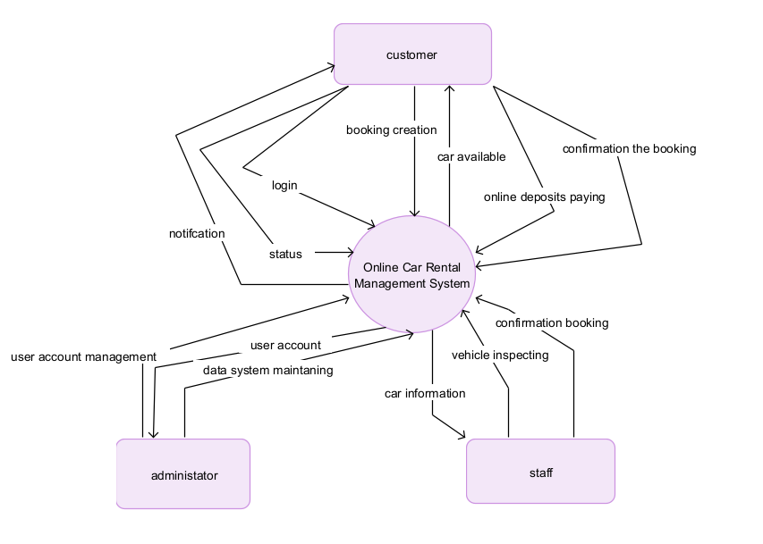

Q3 (4.0 point):
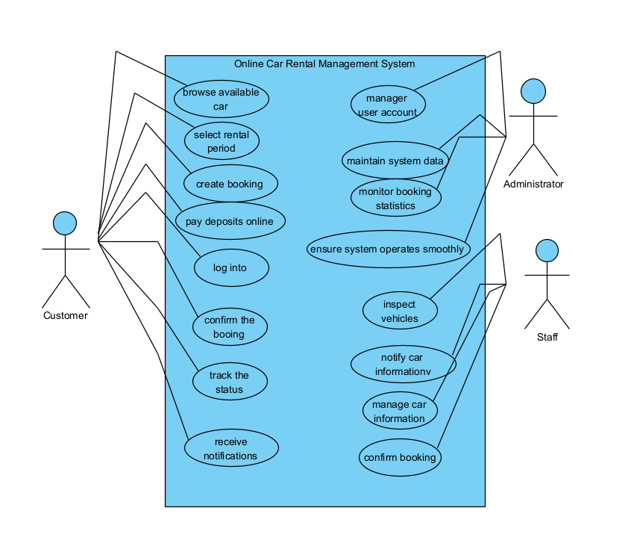
# | Actor | Description
01 | Customer | Customer who can log in system and submit a booking request by choosing a car and rental duration, confirm the booking and make a deposit payment
02 | Staff | Staff who can notify and can manage information car, confirm booking, and inspect vehicle when customer returned.
03 | Administrator | Administrators who can manage account users, maintain the system for ensuring system operates smoothly.

# | Use Case | Actors | Description
UC-01 | Browse available car | Customer | Customer can browse available car.
UC-02 | Monitor System Statistics | Administrator | Review system metrics such as number of cars browsing.
UC-03 | Create booking | Customer | Customers create booking the car when they check done the car which they want.
UC-04 | Receive notifications | Customer | Customers will receive notifications when customers book done.
UC-05 | Manage car information | Staff | Staff have responsibility mange car in the system and understand about car.
UC-06 | Confirm booking | Staff | After customer book the car which they want, so staff will check after
UC-07 | Maintain system data | Administrator | Admin will maintain the system usually to the system operate smoothly
UC-08 | Pay deposits online | Customer | Customers can pay online through mobile, so it is very convenient for user.

Q4 (3.0 points):
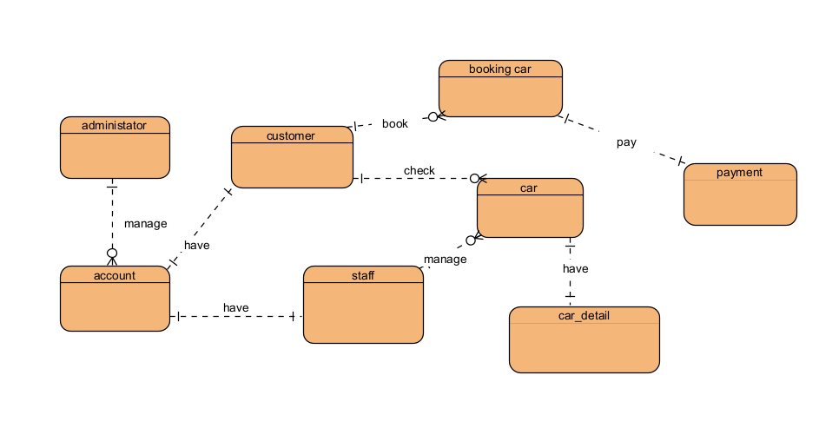
# | Entity | Description
01 | administrator | Represents people using the system. Stores user details, roles, and contact information and manage the data system
02 | account | Represents account login the system. Stores user details, roles, and contact information.
03 | customer | Represents people using the system. Stores user details, roles, and contact information, and using the system to book car.
04 | booking car | Represents notifications sent to users, including booking car, confirm booking.
05 | car | Represents information about cars , including model, modern, and color.
06 | staff | Represents people using the system. Stores user details, roles, and contact information, and manage information about car detail
07 | car_detail | Represent information about cars detail , including price and convenient
08 | payment | Represent information about payment for customer , it use pay online so it very convenient

