

Q1 (0.5 point):

Software Requirements Specification

for

Restaurant Management System at Vincom
Version 1.0 approved
Prepared by
Prepared by Nguyen Dinh Giap-He194321
FPT University Ha Noi Campus
Wednesday , April 8, 2026

Q2 (2.5 points):

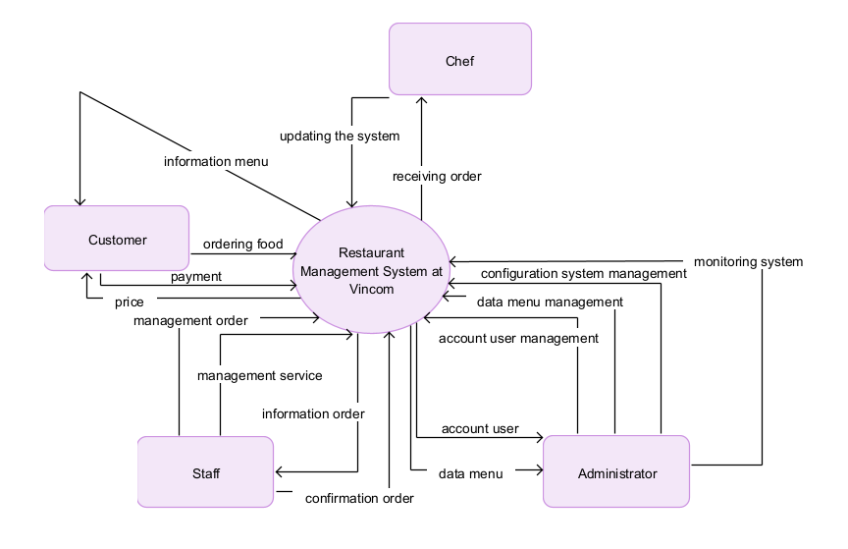

Q3 (4.0 point):
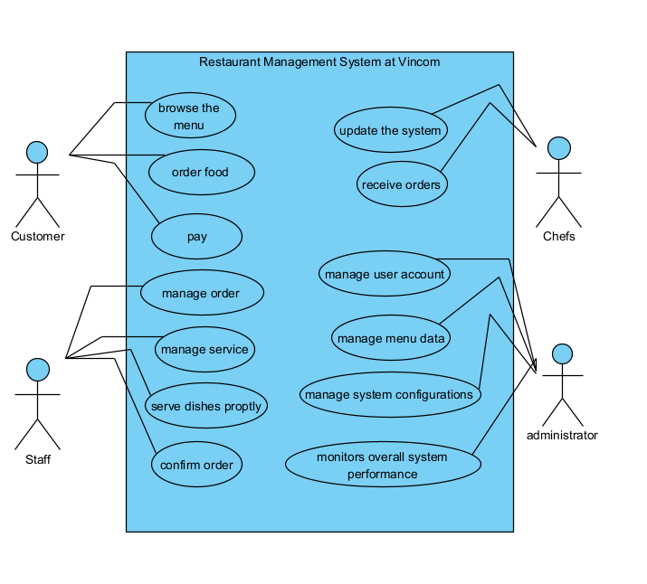

# | Actor | Description
01 | Customer | Customer who browses menu and place food order and pays the bill
02 | Staff | Staff who manage customer order, manage service, confirm order when customer order
03 | Chefs | Chef who cooks food for restaurants and receives orders from system and updates the system when food preparation starts and finishes.
04 | Administrators | Administrator who manages account user, menu data, system configurations, and monitors overall system performance

# | Use Case | Actors | Description
UC-01 | Browse menu | Customer | Customers can browse the menu to check favorite food and order
UC-02 | Order food | Customer | Customer order food after checking the menu
UC-03 | Monitor overall system performance | Administrator | Review system performance such as number of reports.
UC-04 | Update the system | Chefs | Chefs can update the system when food starts or finishes
UC-05 | Confirm order | Staff | Staff confirm order of customer when they order food from app
UC-06 | Manage menu data | Administrator | Update and maintain the menu data
UC-07 | Manage user account | Administrator | Administrators can manage account users and lock when they do not use the app, can maintain and update for user.
UC-08 | Pay | Customer | When ordering and receiving the food, customer must be pay for food ordering

Q4 (3.0 points):
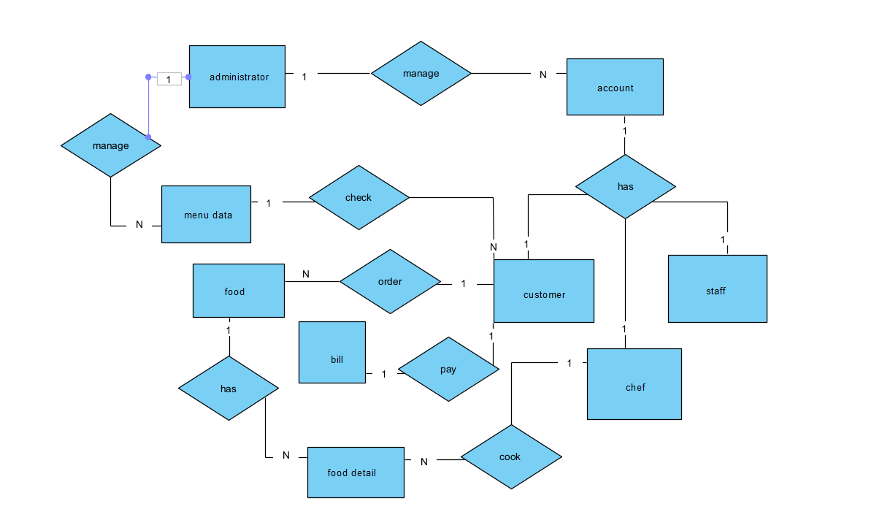
# | Entity | Description
01 | administrator | Represents people using the system. Stores user details, roles, and contact information and manage the data system
02 | account | Represents account login the system. Stores user details, roles, and contact information.
03 | customer | Represents people using the system. Stores user details, roles, contact information, and using the system to order food and pay the bill
04 | Food | Represents food for customer order
05 | Staff | Represents people using the system. Stores user details, roles, and contact information, and manage information about food detail
06 | Chef | Represents people using the system. Stores user details, roles, and contact information, and manage cooking food for restaurant.
07 | Menu data | Represents menu food for customer order and check
08 | Bill | Represents bill for food for customers when order and receive food.

