IC Design  Semester 4 - FAP201 | Lab02  Lighting an LED with Logic Gates
- Name:
- Code:

1. Requirement description:
Detailed reference: Page 69 - Getting Started with FPGAs Textbook.
You’re now ready to combine everything you’ve learned about Boolean logic and look-up tables in a real-world example on your FPGA development board. This project should illuminate an LED, but only when two switches are pushed at the same time. In other words, you’re using your first LUT by implementing an AND gate.

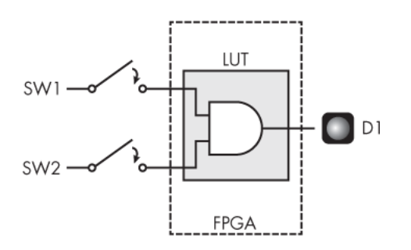
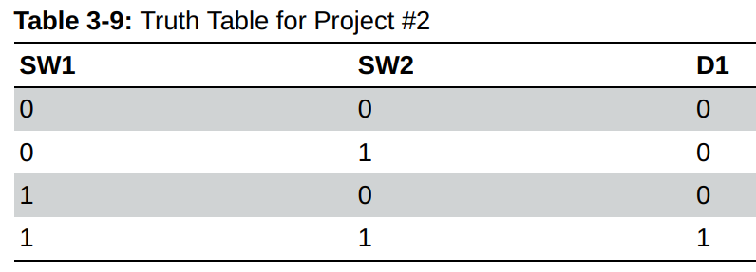
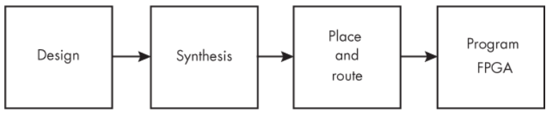
2. Hardware - Software requirements:
- Use Gowin design tools to write, synthesize, and simulate VHDL code.
- The kit must include basic components such as:
- LEDs: Display status or results.
- Switches/Buttons: Control inputs or signals.
- Clock: Clock signals for synchronizing operations.
- I/O Ports: Interface with external devices.
* Guidelines and tools: Download
3. Implementation process, results and evaluation:

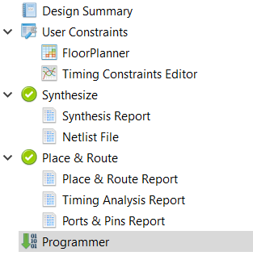

3.1. Design: (Can answer in text or attach a link to where the source code is stored)
* Note target device on software: GW5A-LV25UG324C2/I1
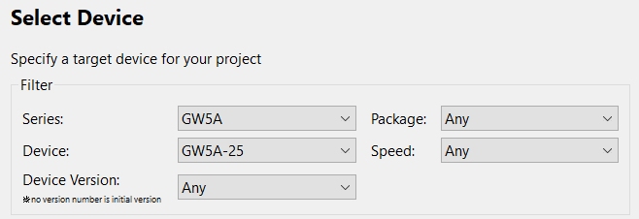
- Source code:
module Logic_gates_led(
input a,
input b,
output y );

assign y = a & b;
endmodule
- Testbench code:
`timescale 1ns/1ps

module Logic_gates_led_tb;
// Declare test inputs as reg and output as wire
reg a;
reg b;
wire y;

// Instantiate the Unit Under Test (UUT)
Logic_gates_led uut (
.a(a),
.b(b),
.y(y)
);

// Apply stimulus
initial begin
$monitor("Time=%0t | a=%b b=%b | y=%b", $time, a, b, y);

a = 0; b = 0;
#10;
a = 0; b = 1;
#10;
a = 1; b = 0;
#10;
a = 1; b = 1;
#10;

$finish;
end
endmodule
- User Constraints:
* List pin on FPGA Kit: Download

Function Signal | Pin on FPGA Kit
Led 1 | A9
Switch 2 | B16
Switch 1 | A15

3.2. Synthesis: (Can answer in text or provide evidence with images)
- Synthesis Details:
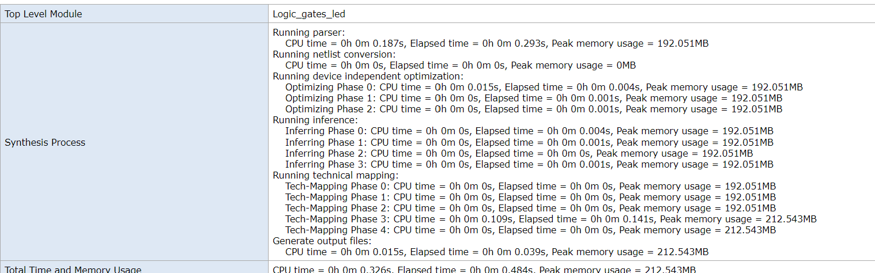
- Resource Usage Summary:
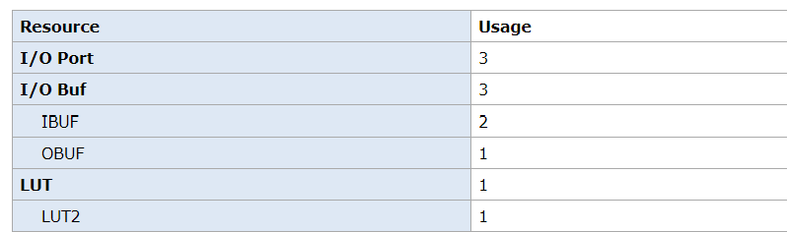
- Resource Utilization Summary:
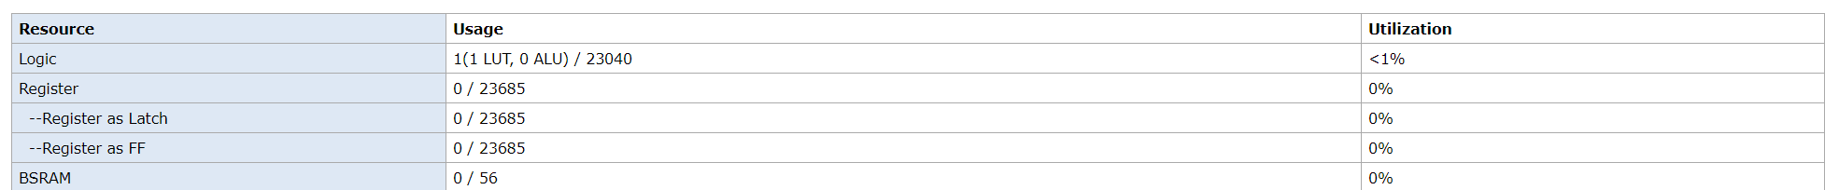

3.3. Place and route: (Can answer in text or provide evidence with images)
- PnR Details:
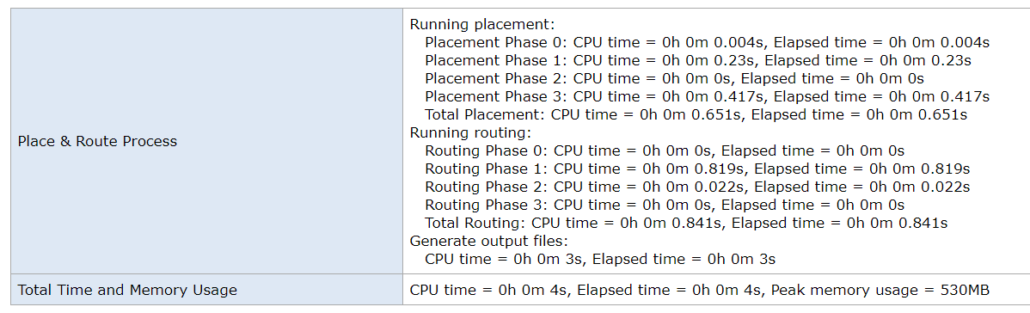
- Resource Usage Summary:
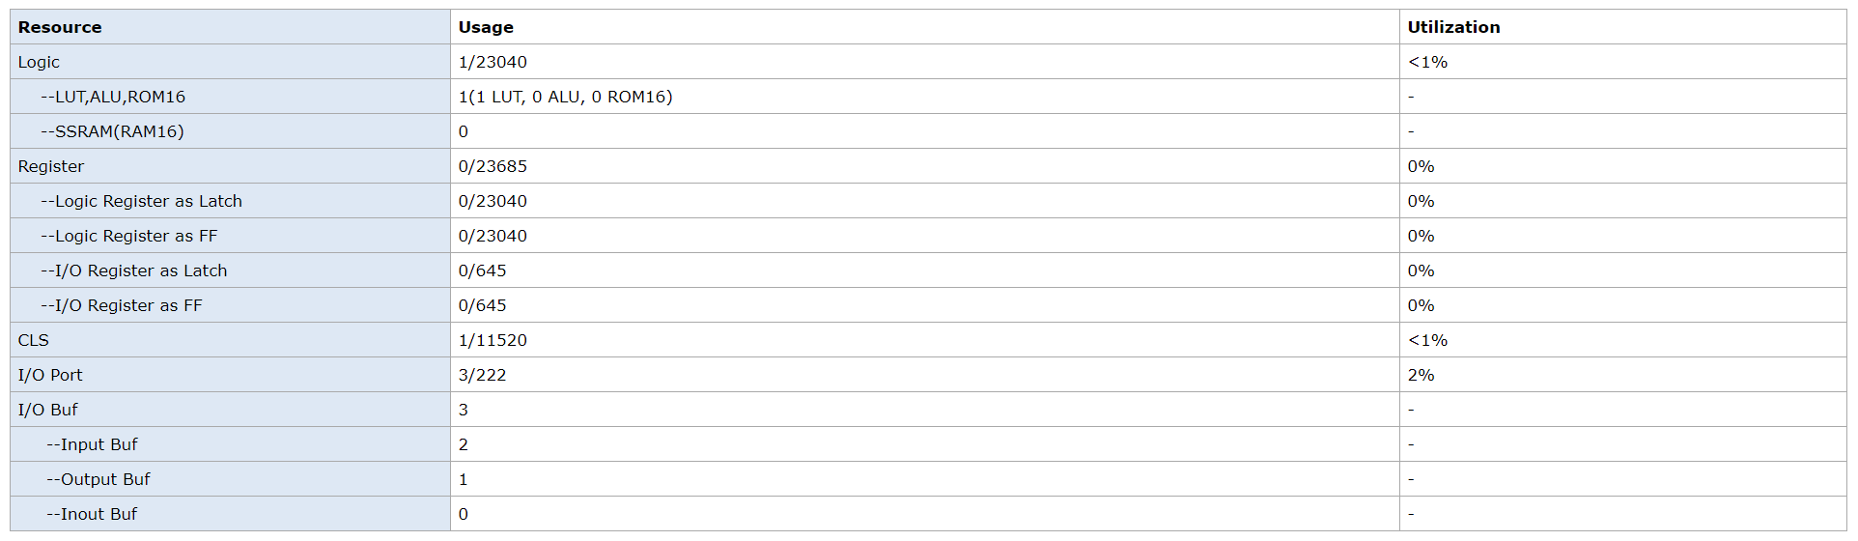
- I/O Bank Usage Summary:
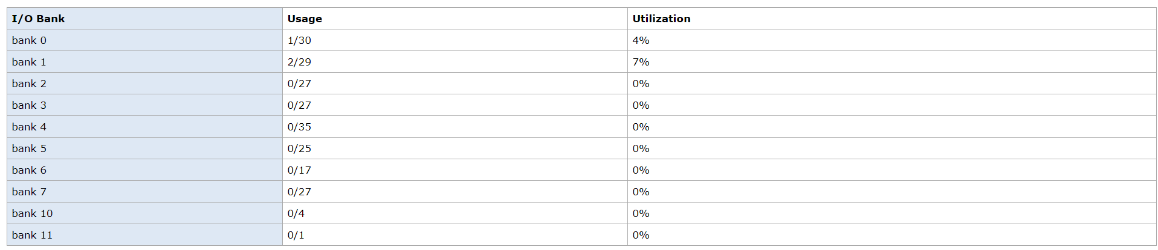
- Global Clock Usage Summary:
- Timing Summaries:
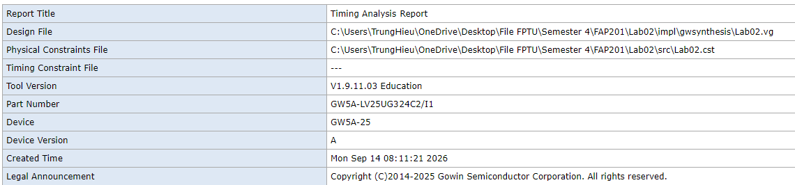

3.4. Program FPGA: (Can answer in text or provide evidence with images)
- Success or Failure ? If it is a failure, what are the causes and how can it be fixed ?
Success

*Options:
3.5. Simulation results: (Can answer in text or provide evidence with images)

