IC Design  Semester 4 - FAP201 | Lab06  Creating a Memory Game
- Name:
- Code:

1. Requirement description:
Detailed reference: Page 221 - Getting Started with FPGAs Textbook.
We’ll now put what you’ve learned about state machines into action by creating a memory game that runs on your development board. The player will have to remember and reproduce a pattern that grows longer as the game progresses, similar to a game like Simon. If the player can remember the entire pattern, they win.
The pattern is displayed using three LEDs. It starts simply, with just one LED lighting up. Then it’s the player’s turn to re-create the pattern by pressing the switch that matches the LED. If they push the wrong switch, the game is over. If they push the correct switch, the game continues, with the pattern expanding to a sequence of two LED blinks. The pattern keeps expanding until it’s seven blinks long (although you’ll be able to adjust the code to make it longer if you want). If the player re-creates the last pattern correctly, they may choose to play another round with a new pattern.
This project takes advantage of a peripheral that we haven’t used before: a seven-segment display. This device uses an arrangement of seven LEDs to display the digits 0 through 9 (and a selection of letters), like something you’d see on a digital clock. It will serve as a scoreboard, keeping track of the player’s progress through the pattern. We’ll also use it to display an F (for failure) if the player makes a mistake, or an A when the game is won.

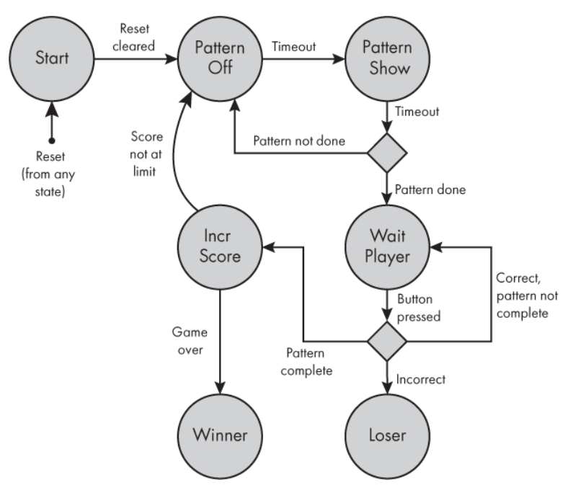
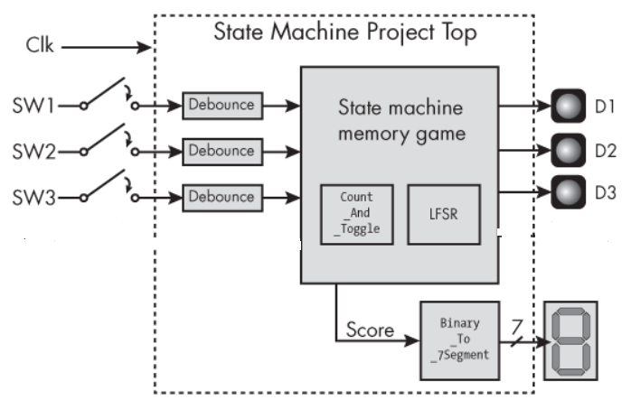
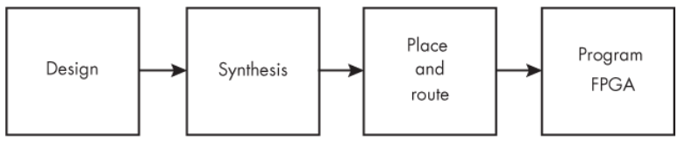
2. Hardware - Software requirements:
- Use Gowin design tools to write, synthesize, and simulate VHDL code.
- The kit must include basic components such as:
- LEDs: Display status or results.
- Switches/Buttons: Control inputs or signals.
- Clock: Clock signals for synchronizing operations.
- I/O Ports: Interface with external devices.
* Guidelines and tools: Download
3. Implementation process, results and evaluation:

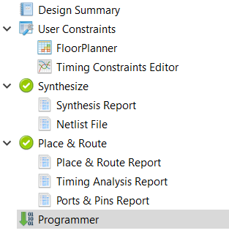

3.1. Design: (Can answer in text or attach a link to where the source code is stored)
* Note target device on software: GW5A-LV25UG324C2/I1
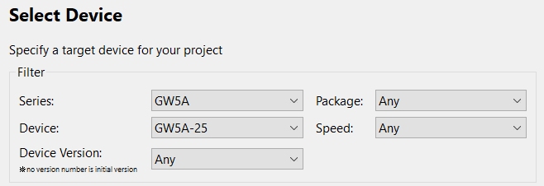
- Source code:
- Testbench code:
- User Constraints:
* List pin on FPGA Kit: Download

Function Signal | Pin on FPGA Kit

3.2. Synthesis: (Can answer in text or provide evidence with images)
- Synthesis Details:
- Resource Usage Summary:
- Resource Utilization Summary:

3.3. Place and route: (Can answer in text or provide evidence with images)
- PnR Details:
- Resource Usage Summary:
- I/O Bank Usage Summary:
- Global Clock Usage Summary:
- Timing Summaries:

3.4. Program FPGA: (Can answer in text or provide evidence with images)
- Success or Failure ? If it is a failure, what are the causes and how can it be fixed ?

*Options:
3.5. Simulation results: (Can answer in text or provide evidence with images)

