IC Design  Semester 4 - FAP201 | Lab01  Wiring Switches to LEDs
- Name:
- Code:

1. Requirement description:
Detailed reference: Page 43 - Getting Started with FPGAs Textbook.
Building process by creating a simple FPGA design: when you press one of the push-button switches on your FPGA development board, one of the LEDs should light up. The project assumes that you have three switches and three LEDs, so you’ll design and program your FPGA to wire up each switch to one of the LEDs.

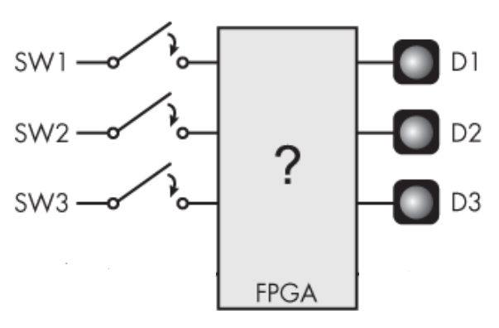
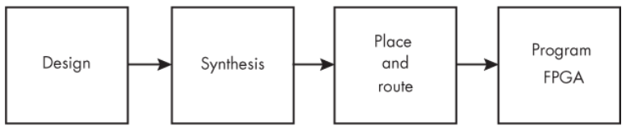
2. Hardware - Software requirements:
- Use Gowin design tools to write, synthesize, and simulate VHDL code.
- The kit must include basic components such as:
- LEDs: Display status or results.
- Switches/Buttons: Control inputs or signals.
- Clock: Clock signals for synchronizing operations.
- I/O Ports: Interface with external devices.
* Guidelines and tools: Download
3. Implementation process, results and evaluation:

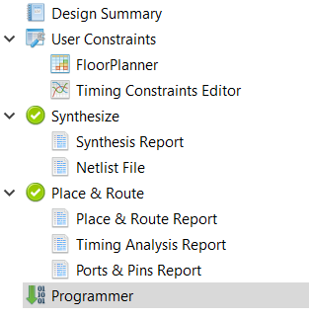

3.1. Design: (Can answer in text or attach a link to where the source code is stored)
* Note target device on software: GW5A-LV25UG324C2/I1
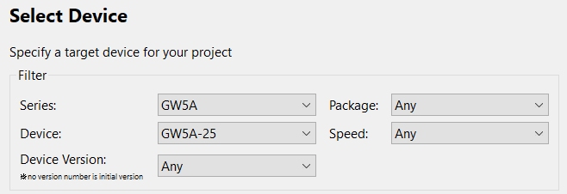
- Source code:
module Switches_To_LEDs
(input i_Switch_1,
input i_Switch_2,
input i_Switch_3,

output o_LED_1,
output o_LED_2,
output o_LED_3);

assign o_LED_1 = i_Switch_1;
assign o_LED_2 = i_Switch_2;
assign o_LED_3 = i_Switch_3;
endmodule
- Testbench code:
`timescale 1ns/1ps

module Switches_To_LEDs_tb;

// Các tín hiệu đầu vào của DUT
logic i_Switch_1;
logic i_Switch_2;
logic i_Switch_3;

// Các tín hiệu đầu ra của DUT
wire o_LED_1;
wire o_LED_2;
wire o_LED_3;

// Khởi tạo mạch cần kiểm tra
Switches_To_LEDs DUT (
.i_Switch_1(i_Switch_1),
.i_Switch_2(i_Switch_2),
.i_Switch_3(i_Switch_3),

.o_LED_1(o_LED_1),
.o_LED_2(o_LED_2),
.o_LED_3(o_LED_3)
);

// Tạo tín hiệu đầu vào cho mạch
initial begin

// Trường hợp 1: tất cả switch bằng 0
i_Switch_1 = 0;
i_Switch_2 = 0;
i_Switch_3 = 0;
#10;

// Trường hợp 2: bật switch 1
i_Switch_1 = 1;
i_Switch_2 = 0;
i_Switch_3 = 0;
#10;

// Trường hợp 3: bật switch 2
i_Switch_1 = 0;
i_Switch_2 = 1;
i_Switch_3 = 0;
#10;

// Trường hợp 4: bật switch 3
i_Switch_1 = 0;
i_Switch_2 = 0;
i_Switch_3 = 1;
#10;

// Trường hợp 5: bật switch 1 và switch 2
i_Switch_1 = 1;
i_Switch_2 = 1;
i_Switch_3 = 0;
#10;

// Trường hợp 6: bật switch 1 và switch 3
i_Switch_1 = 1;
i_Switch_2 = 0;
i_Switch_3 = 1;
#10;

// Trường hợp 7: bật switch 2 và switch 3
i_Switch_1 = 0;
i_Switch_2 = 1;
i_Switch_3 = 1;
#10;

// Trường hợp 8: bật cả ba switch
i_Switch_1 = 1;
i_Switch_2 = 1;
i_Switch_3 = 1;
#10;

// Dừng mô phỏng nhưng giữ Questa đang mở
$stop;
end

endmodule
- User Constraints:
* List pin on FPGA Kit: Download

Function Signal | Pin on FPGA Kit
LED1 | C14
LED2 | A9
LED3 | B9
KEY0 | C15
KEY1 | B16
KEY2 | A15

3.2. Synthesis: (Can answer in text or provide evidence with images)
- Synthesis Details:
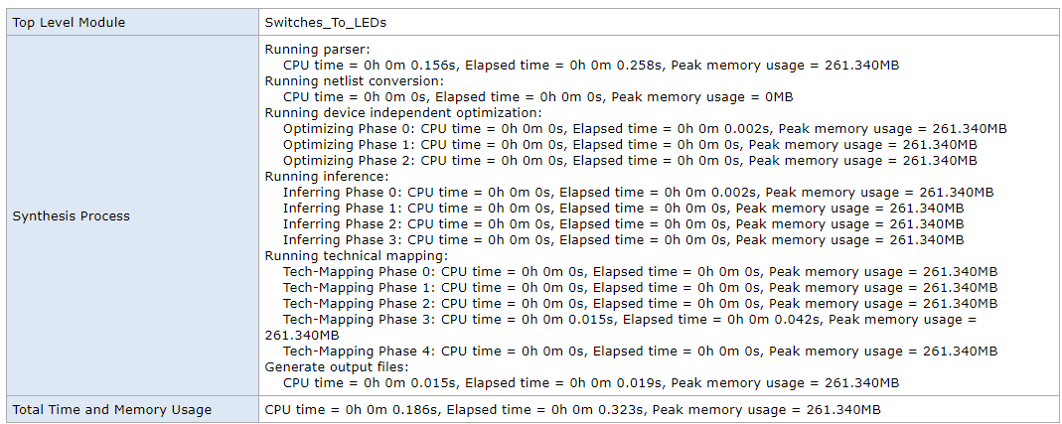
- Resource Usage Summary:
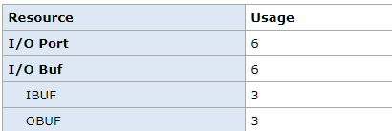
- Resource Utilization Summary:
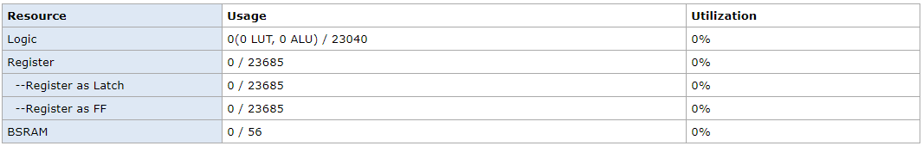

3.3. Place and route: (Can answer in text or provide evidence with images)
- PnR Details:
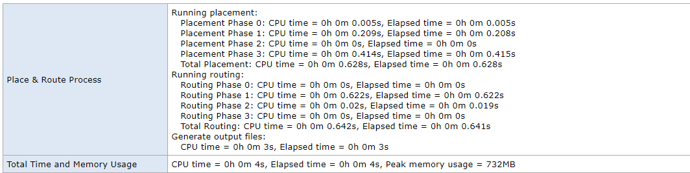
- Resource Usage Summary:
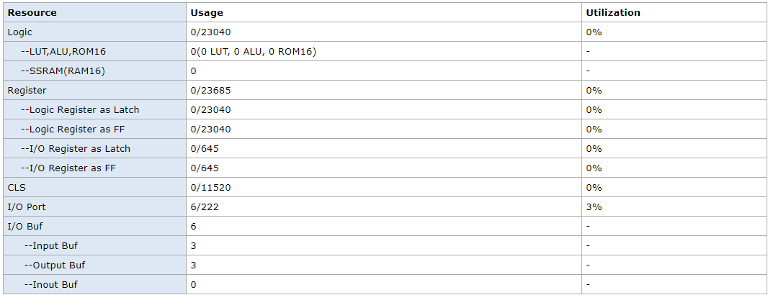
- I/O Bank Usage Summary:
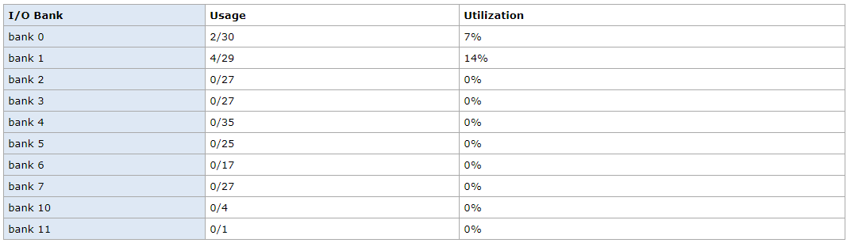
- Global Clock Usage Summary:
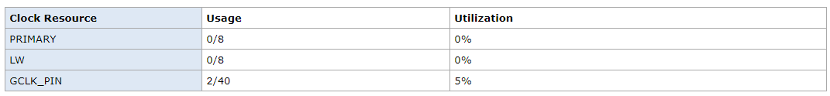
- Timing Summaries:
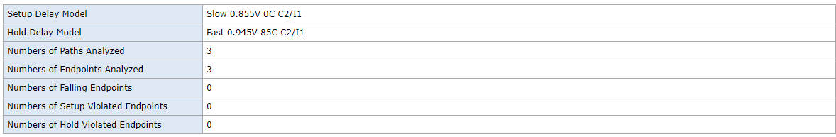

3.4. Program FPGA: (Can answer in text or provide evidence with images)
- Success or Failure ? If it is a failure, what are the causes and how can it be fixed ?
Success

*Options:
3.5. Simulation results: (Can answer in text or provide evidence with images)

