IC Design  Semester 4 - FAP201 | Lab03  Blinking an LED
- Name:
- Code:

1. Requirement description:
Detailed reference: Page 81 - Getting Started with FPGAs Textbook.
Now that you know how flip-flops work, we’ll make use of a couple of them in a project where the FPGA must remember information about its own state. Specifically, we’re going to toggle the state of an LED each time a switch is released. If the LED was off before the switch is released, it should turn on, and if the LED was on, it should turn off.

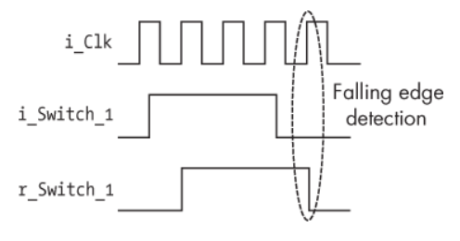 | 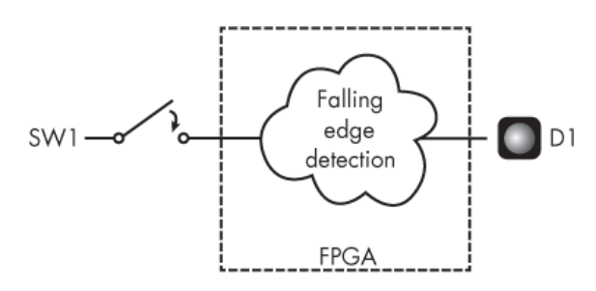

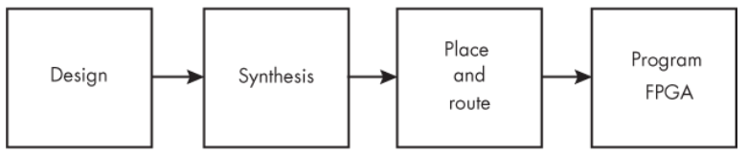
2. Hardware - Software requirements:
- Use Gowin design tools to write, synthesize, and simulate VHDL code.
- The kit must include basic components such as:
- LEDs: Display status or results.
- Switches/Buttons: Control inputs or signals.
- Clock: Clock signals for synchronizing operations.
- I/O Ports: Interface with external devices.
* Guidelines and tools: Download
3. Implementation process, results and evaluation:

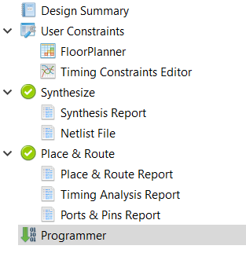

3.1. Design: (Can answer in text or attach a link to where the source code is stored)
* Note target device on software: GW5A-LV25UG324C2/I1
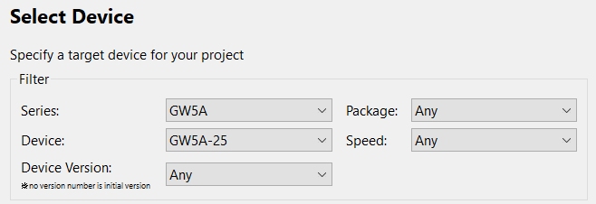
- Source code:
module LED_Toggle_Project(
input i_Clk,
input i_Switch_1,
output o_LED_1);

reg r_LED_1 = 1'b0;
reg r_Switch_1 = 1'b0;

always @(posedge i_Clk)
begin
r_Switch_1 <= i_Switch_1;
if (i_Switch_1 == 1'b0 && r_Switch_1 == 1'b1)
begin
r_LED_1 <= ~r_LED_1;
end
end

assign o_LED_1 = r_LED_1;
endmodule
- Testbench code:
`timescale 1ns / 1ps

module tb_LED_Toggle_Project;

reg r_Clk;
reg r_Switch_1;
wire w_LED_1;

LED_Toggle_Project uut (
.i_Clk(r_Clk),
.i_Switch_1(r_Switch_1),
.o_LED_1(w_LED_1)
);

always #10 r_Clk = ~r_Clk;

initial begin
$dumpfile("dump.vcd");
$dumpvars(0, tb_LED_Toggle_Project);

$monitor("Time = %0t ns | i_Switch_1 = %b | o_LED_1 = %b", $time, r_Switch_1, w_LED_1);

r_Clk = 1'b0;
r_Switch_1 = 1'b0;

#40;

r_Switch_1 = 1'b1;
#60;
r_Switch_1 = 1'b0;
#60;

r_Switch_1 = 1'b1;
#80;
r_Switch_1 = 1'b0;
#60;

r_Switch_1 = 1'b1;
#40;
r_Switch_1 = 1'b0;
#80;

$finish;
end

endmodule
- User Constraints:
* List pin on FPGA Kit: Download

Function Signal | Pin on FPGA Kit
o_LED_1 | D14
i_switch_1 | B16
i_Clk | T9

3.2. Synthesis: (Can answer in text or provide evidence with images)
- Synthesis Details:
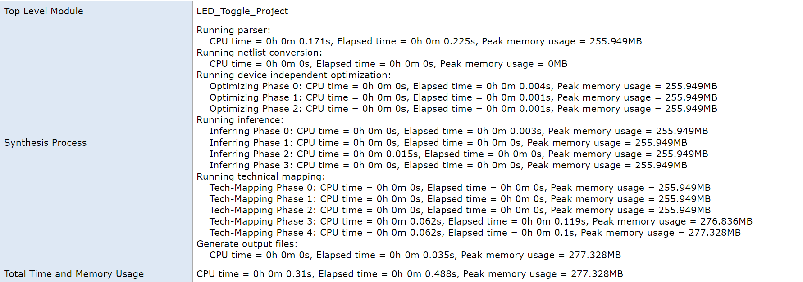
- Resource Usage Summary:
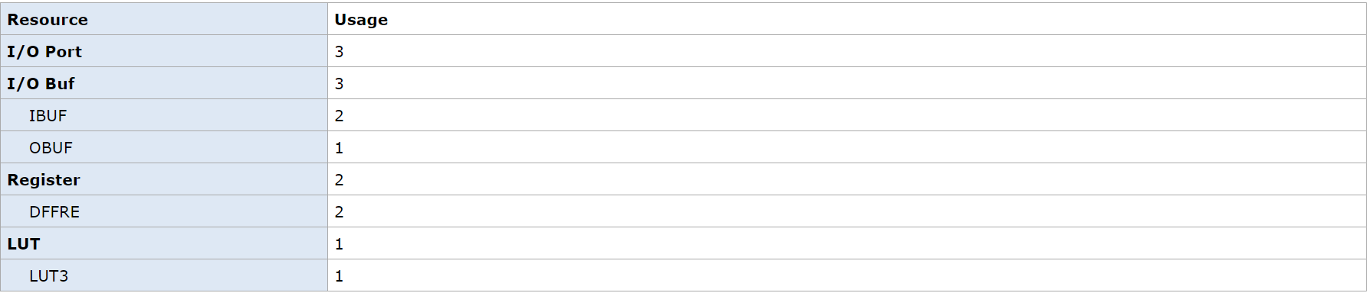
- Resource Utilization Summary:
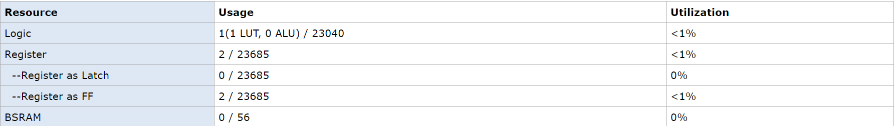

3.3. Place and route: (Can answer in text or provide evidence with images)
- PnR Details:
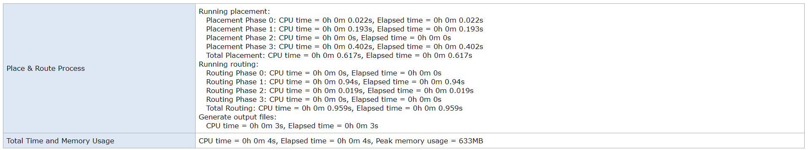
- Resource Usage Summary:
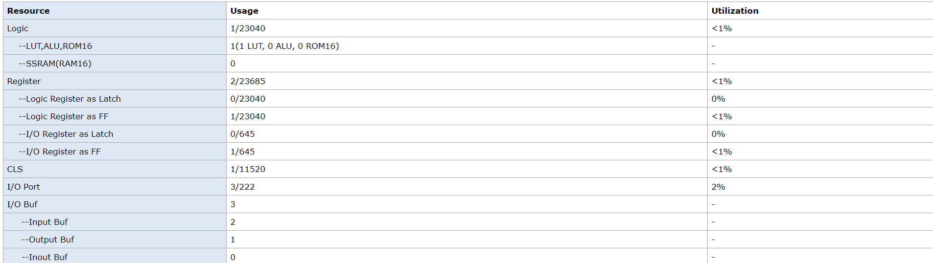
- I/O Bank Usage Summary:
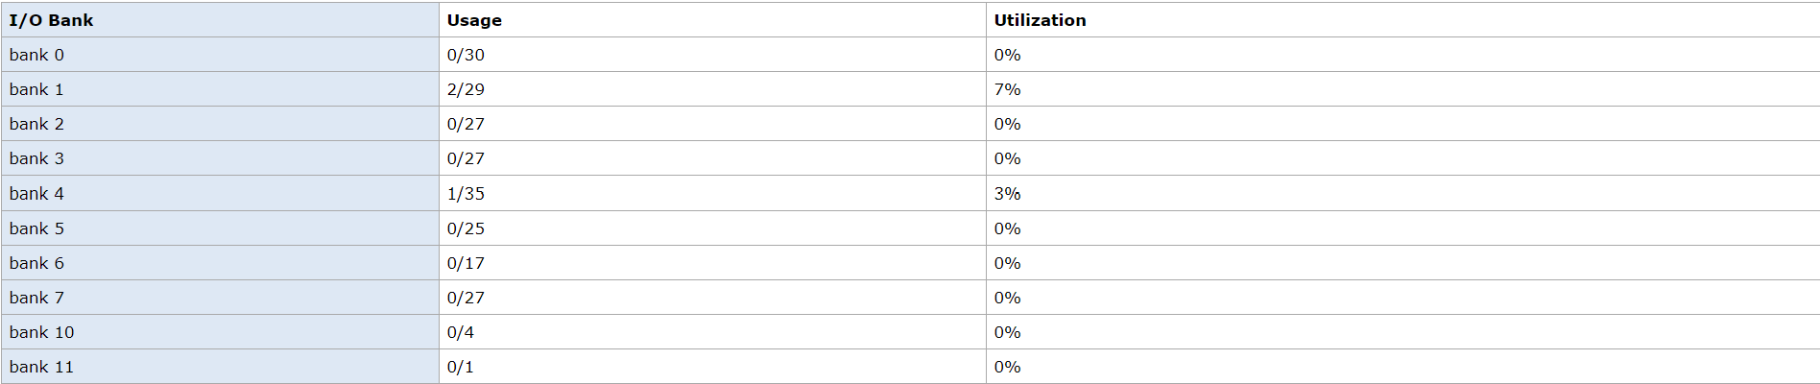
- Global Clock Usage Summary:
- Timing Summaries:
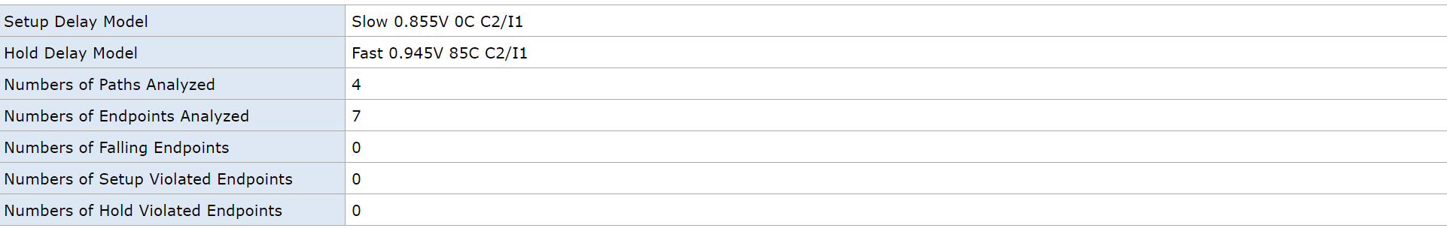

3.4. Program FPGA: (Can answer in text or provide evidence with images)
- Success or Failure ? If it is a failure, what are the causes and how can it be fixed ?
Success

*Options:
3.5. Simulation results: (Can answer in text or provide evidence with images)


