IC Design  Semester 4 - FAP201 | Lab04  Debouncing a Switch
- Name:
- Code:

1. Requirement description:
Detailed reference: Page 112 - Getting Started with FPGAs Textbook.
We programmed an FPGA to toggle an LED at the push of a button. However, there was a problem: pushing the button didn’t consistently toggle the state of the LED. This is because any physical switch, including a push-button or toggle switch, is subject to bouncing, or rapid signal fluctuations that occur when the switch is toggled or flipped. Still, it would be better if the LED toggled as expected each time the switch is pressed and released. To make this happen, we need to add a debounce filter to the switch. That is, we need to program the FPGA to ignore the bounces.
We create a debounce filter by making sure that the input from the switch is stable for some amount of time before allowing the output driving the LED to change.
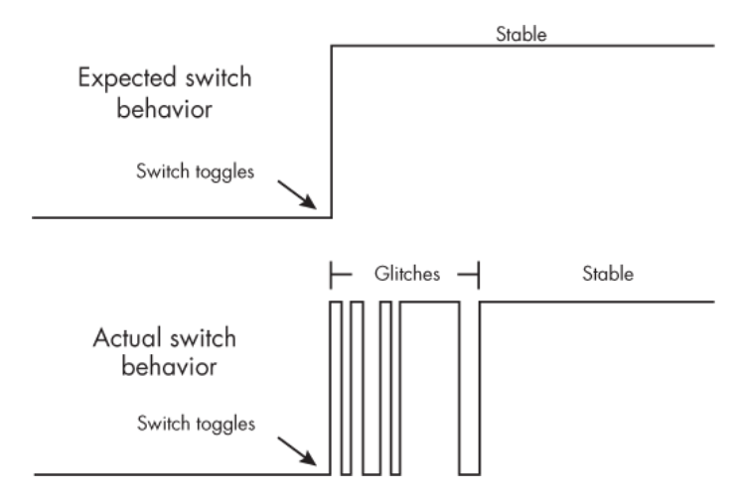
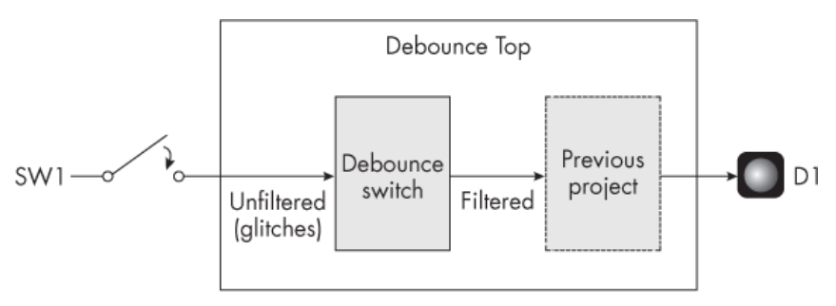
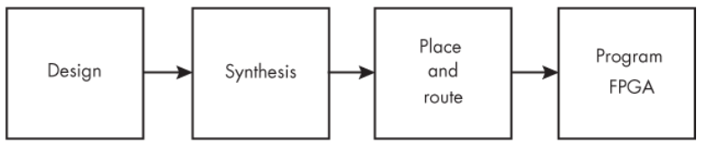
2. Hardware - Software requirements:
- Use Gowin design tools to write, synthesize, and simulate VHDL code.
- The kit must include basic components such as:
- LEDs: Display status or results.
- Switches/Buttons: Control inputs or signals.
- Clock: Clock signals for synchronizing operations.
- I/O Ports: Interface with external devices.
* Guidelines and tools: Download
3. Implementation process, results and evaluation:

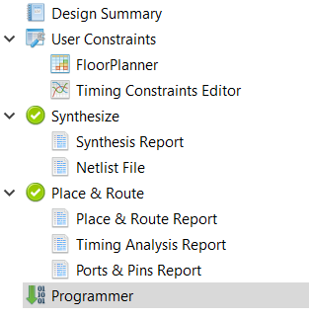

3.1. Design: (Can answer in text or attach a link to where the source code is stored)
* Note target device on software: GW5A-LV25UG324C2/I1
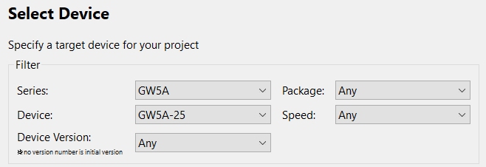
- Source code:
- Testbench code:
- User Constraints:
* List pin on FPGA Kit: Download

Function Signal | Pin on FPGA Kit

3.2. Synthesis: (Can answer in text or provide evidence with images)
- Synthesis Details:
- Resource Usage Summary:
- Resource Utilization Summary:

3.3. Place and route: (Can answer in text or provide evidence with images)
- PnR Details:
- Resource Usage Summary:
- I/O Bank Usage Summary:
- Global Clock Usage Summary:
- Timing Summaries:

3.4. Program FPGA: (Can answer in text or provide evidence with images)
- Success or Failure ? If it is a failure, what are the causes and how can it be fixed ?

*Options:
3.5. Simulation results: (Can answer in text or provide evidence with images)

