IC Design  Semester 4 - FAP201 | Lab05  Selectively Blinking an LED
- Name:
- Code:

1. Requirement description:
Detailed reference: Page 147 - Getting Started with FPGAs Textbook.
Now that we’ve introduced some building blocks, let’s start putting them together. The requirement for this project is to blink each of four LEDs on your development board on and off, but only one LED should be blinking at a time. You’ll select which LED to blink using two switches. Table 6-6 shows how the LED selection is performed.

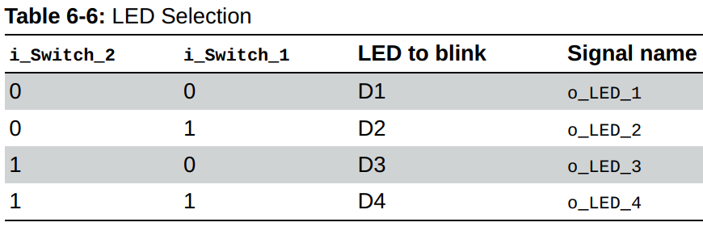
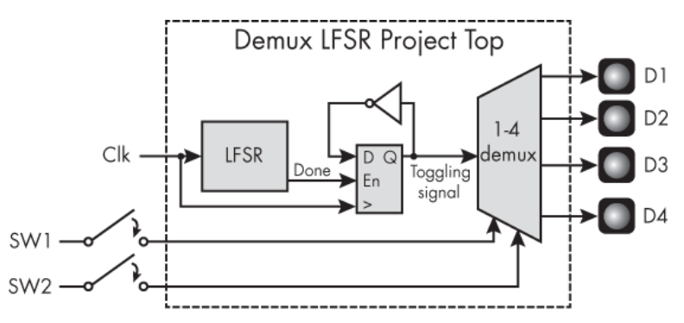
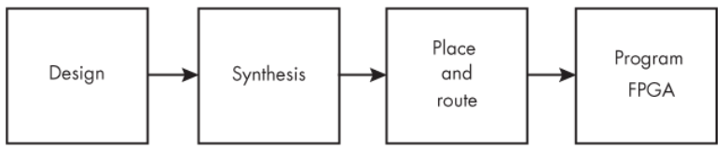
2. Hardware - Software requirements:
- Use Gowin design tools to write, synthesize, and simulate VHDL code.
- The kit must include basic components such as:
- LEDs: Display status or results.
- Switches/Buttons: Control inputs or signals.
- Clock: Clock signals for synchronizing operations.
- I/O Ports: Interface with external devices.
* Guidelines and tools: Download
3. Implementation process, results and evaluation:

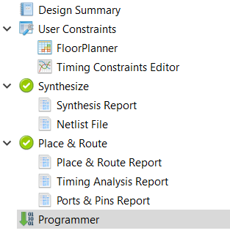

3.1. Design: (Can answer in text or attach a link to where the source code is stored)
* Note target device on software: GW5A-LV25UG324C2/I1
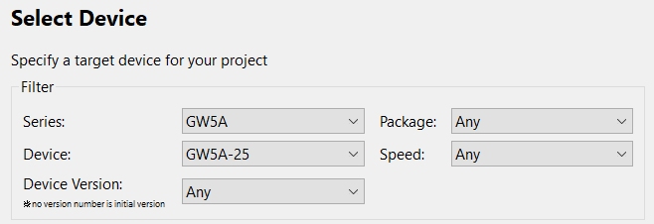
- Source code:
module Debounce_Filter #(parameter DEBOUNCE_LIMIT = 20) (
input i_Clk,
input i_Bouncy,
output o_Debounced);

reg [$clog2(DEBOUNCE_LIMIT)-1:0] r_Count = 0;
reg r_State = 1'b0;

always @(posedge i_Clk)
begin
if (i_Bouncy !== r_State && r_Count < DEBOUNCE_LIMIT-1)
begin
r_Count <= r_Count + 1;
end
else if (r_Count == DEBOUNCE_LIMIT-1)
begin
r_State <= i_Bouncy;
r_Count <= 0;
end
else
begin
r_Count <= 0;
end
end

assign o_Debounced = r_State;

endmodule

module Debounce_Project_Top
(input i_Clk,
input i_Switch_1,
output o_LED_1);

wire w_Debounced_Switch;

Debounce_Filter #(.DEBOUNCE_LIMIT(250000)) Debounce_Inst
(.i_Clk(i_Clk),
.i_Bouncy(i_Switch_1),
.o_Debounced(w_Debounced_Switch));

LED_Toggle_Project LED_Toggle_Inst
(.i_Clk(i_Clk),
.i_Switch_1(w_Debounced_Switch),
.o_LED_1(o_LED_1));

Endmodule

module LED_Toggle_Project(
input i_Clk,
input i_Switch_1,
output o_LED_1);

reg r_LED_1 = 1'b0;
reg r_Switch_1 = 1'b0;

always @(posedge i_Clk)
begin
r_Switch_1 <= i_Switch_1;
if (i_Switch_1 == 1'b0 && r_Switch_1 == 1'b1)
begin
r_LED_1 <= ~r_LED_1;
end
end

assign o_LED_1 = r_LED_1;
endmodule

- Testbench code:
module Debounce_Filter_TB ();

reg r_Clk = 1'b0, r_Bouncy = 1'b0;
wire w_Debounced;

always #2 r_Clk <= !r_Clk;

Debounce_Filter #(.DEBOUNCE_LIMIT(4)) UUT
(.i_Clk(r_Clk),
.i_Bouncy(r_Bouncy),
.o_Debounced(w_Debounced));

initial begin
$dumpfile("dump.vcd"); $dumpvars;
repeat(3) @(posedge r_Clk);
r_Bouncy <= 1'b1; // toggle state of input pin
@(posedge r_Clk);
r_Bouncy <= 1'b0; // simulate a glitch/bounce of switch
@(posedge r_Clk);
r_Bouncy <= 1'b1; // bounce goes away
repeat(6) @(posedge r_Clk);
$display("Test Complete");
$finish();
end

endmodule
- User Constraints:
* List pin on FPGA Kit: Download

Function Signal | Pin on FPGA Kit
Led1 | D14
Switch1 | B16
Clk1 | T9

3.2. Synthesis: (Can answer in text or provide evidence with images)
- Synthesis Details:
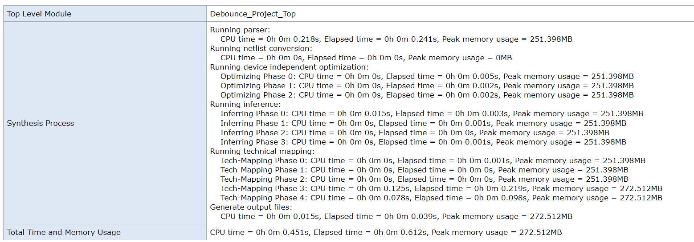
- Resource Usage Summary:
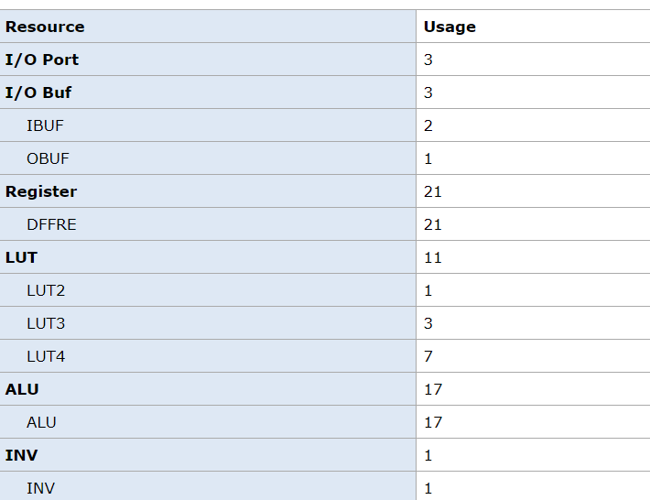
- Resource Utilization Summary:
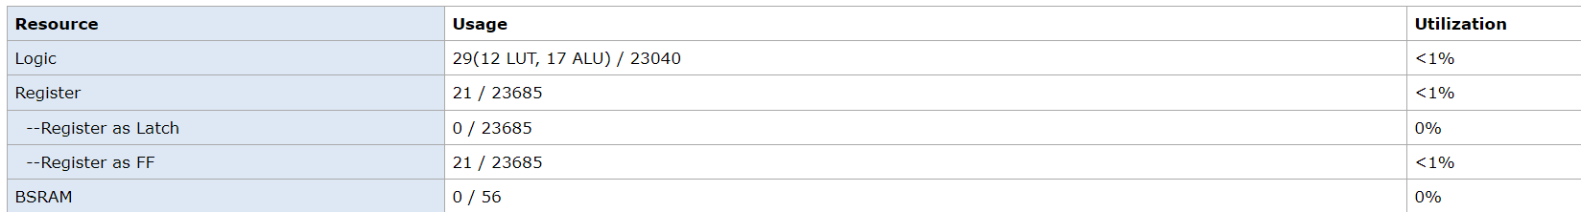

3.3. Place and route: (Can answer in text or provide evidence with images)
- PnR Details:
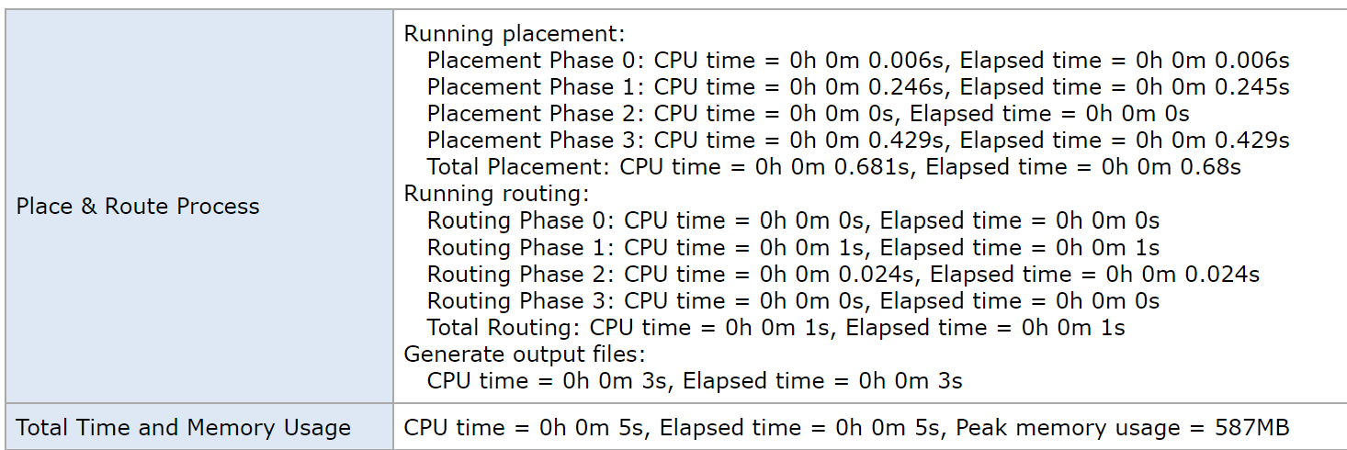
- Resource Usage Summary:
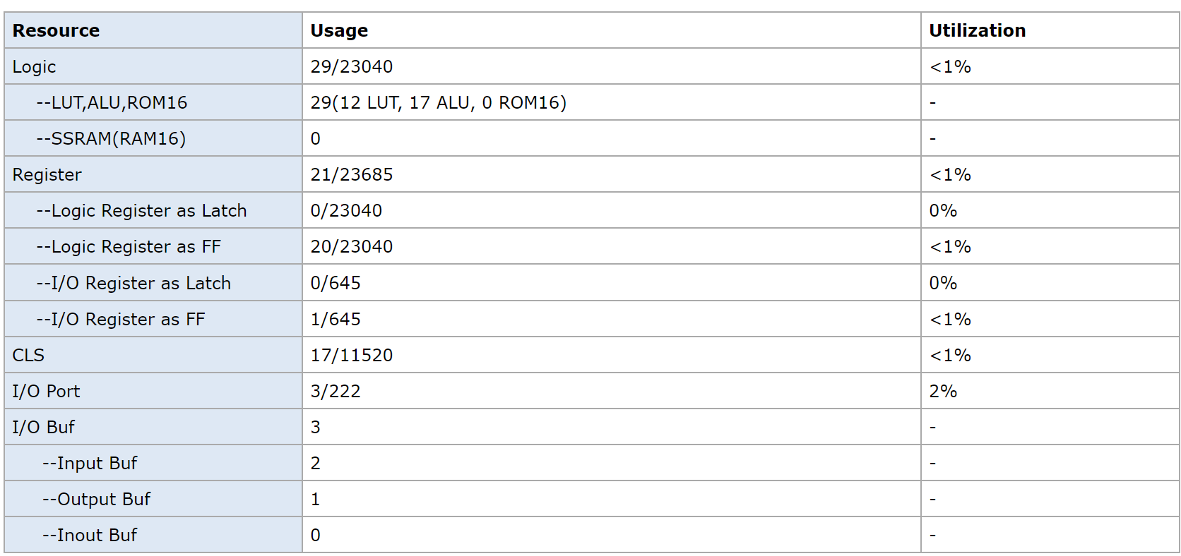
- I/O Bank Usage Summary:
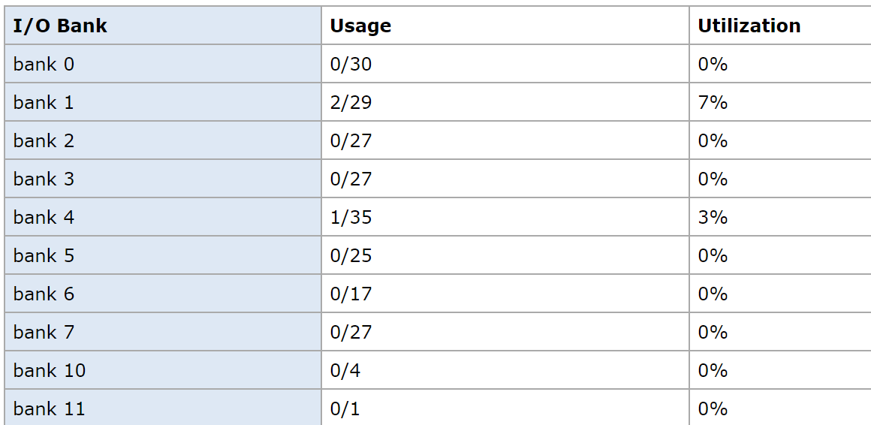
- Global Clock Usage Summary:
- Timing Summaries:
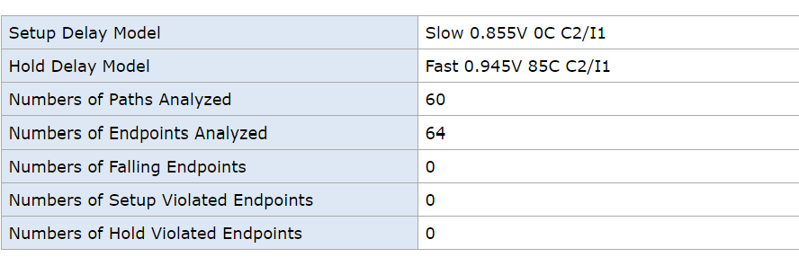

3.4. Program FPGA: (Can answer in text or provide evidence with images)
- Success or Failure ? If it is a failure, what are the causes and how can it be fixed ?
Success

*Options:
3.5. Simulation results: (Can answer in text or provide evidence with images)


