Abstract Factory

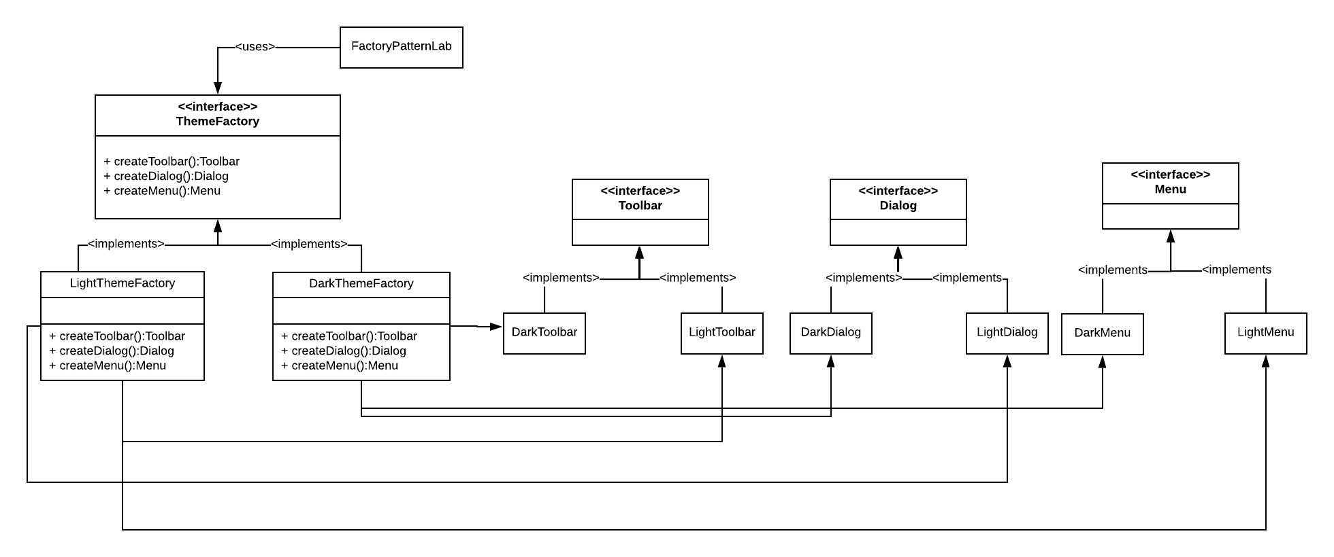

Three abstract products: Toolbar, Dialog, Menu

Two Factory methods: LightThemeFactory, DarkThemeFactory

**public** **class** FactoryPatternLab {

**public** **static** **void** main(String[] args) {

// **TODO** Auto-generated method stub

ThemeFactory lightFactory = **new** LightThemeFactory();

ThemeFactory darkFactory = **new** DarkThemeFactory();

System.***out***.println(lightFactory.createToolbar());

System.***out***.println(lightFactory.createDialog());

System.***out***.println(lightFactory.createMenu());

System.***out***.println(darkFactory.createToolbar());

System.***out***.println(darkFactory.createDialog());

System.***out***.println(darkFactory.createMenu());

}

}

P2I and polymorphism when we use the ThemeFactory to create products (Toolbar, Dialog and Menu)