**ASD – CS525**

Homework - UML Design, two applications

**Banking application:**

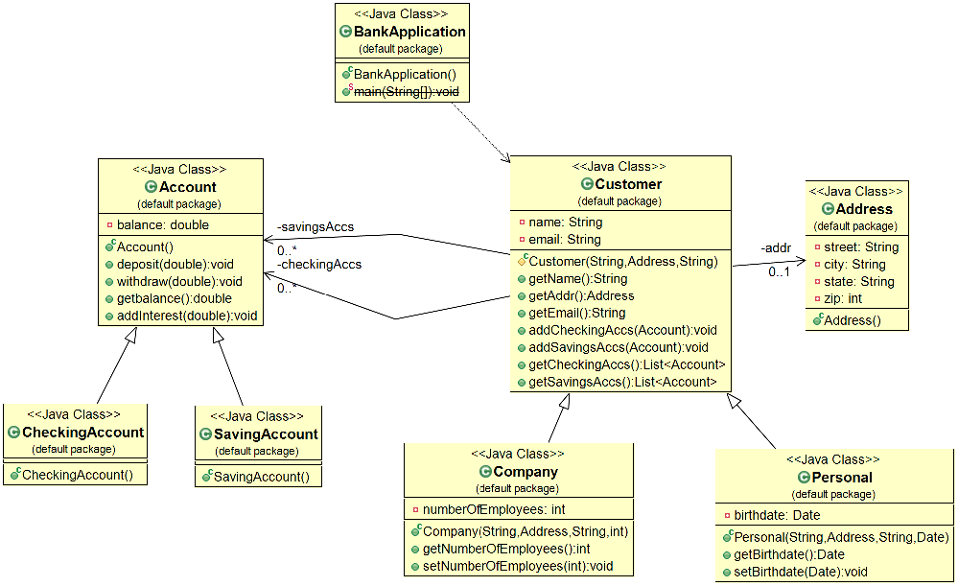

**Credit-card processing system:**

