**Framework Development**

**Patterns used**

|  |  |  |
| --- | --- | --- |
| **#** | **Pattern** | **Role** |
| **1** | Observer | Finco subject service is used to update the table view in GUI |
| **2** | Command | Sending email and notify to customer when user make deposit and withdraw money |
| **3** | Party | Use to store customer information |
| **4** | Account | use to store account information |
| **5** | Strategy | use to specify the action handler for each controller such as customer, debit, credit, and account list |
| **6** | Simple Factory | use to create customer, account and entry |
| **7** | Singleton | Use to get only one instance of Finco Database |
|  |  |  |

1. Observer pattern:

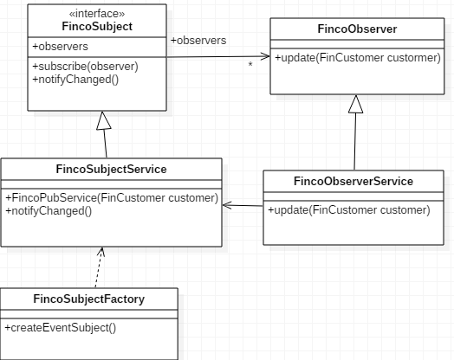

2. Command Pattern:

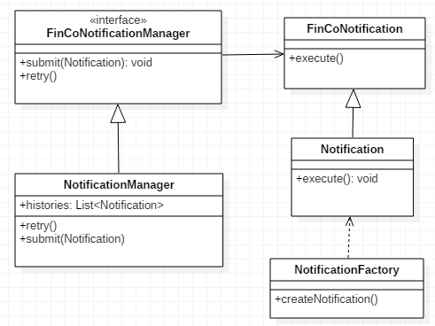

3. Party pattern:

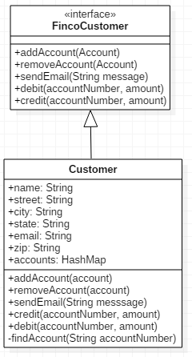

4. Account pattern:

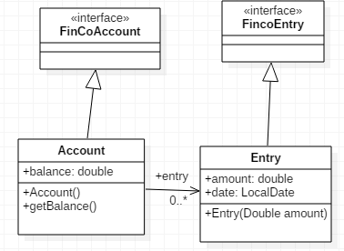

5. Strategy Pattern:

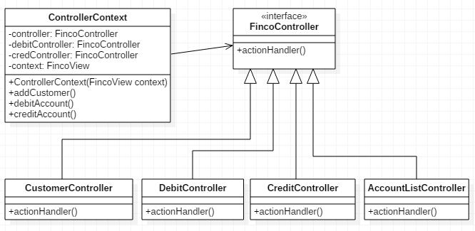

6. Simple Factory pattern: it can be use

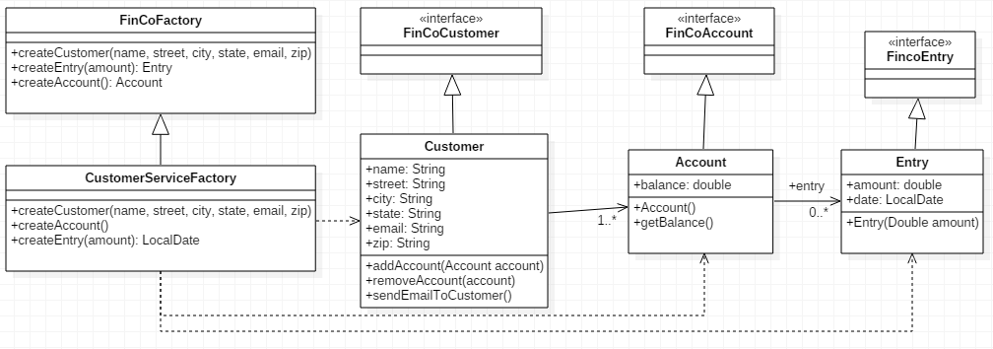

7. Singleton

