**A Profile Based Movie Recommendation System**

Đinh Xuân Hùng, Lâm Lê Đình Khang, Nguyễn Thị Khánh Hà

University of Information Technology (UIT) – VietNam National University HCM City

[18520791@gm.uit.edu.vn](mailto:18520791@gm.uit.edu.vn), [18520885@gm.uit.edu.vn](mailto:18520885@gm.uit.edu.vn), [18520692@gm.uit.edu.vn](mailto:18520692@gm.uit.edu.vn)

# **ABSTRACT**

In the context of the current covid 19 epidemic, the entertainment needs of each person increase sharply every day and watching movies is one of the top choices that people love.Through exploiting the thoughts and aspirations of customers will help businesses improve the quality of products and services. With the desire to contribute to helping entrepreneurs win the trust and interest of customers, we proceed to build a recommendation system in order to suggest movies to customers. Our project centers around building a movie recommendation system based on Collaborative filtering for handling Big Data. In particular we look at implementing four algorithms of item based collaborative filtering which are K-Nearest Neighbours(KNN), Alternating Least Squares(ALS) and Singular Value decomposition (SVD), Deep Neural Networks (DNN) and finally compare their performance in terms of standard measures.

**Key word:** Movies Recommendation System, Movies Recommendation System with Spark, Machine Learning, Big Data.

1. **INTRODUCTION**

Recommender systems are one of the most important applications of machine learning and are part of everyday life.. They are well-studied and proven to provide tremendous value to internet businesses and their consumers. Recommender systems can be loosely broken down into three categories: content-based systems, collaborative filtering systems, and hybrid systems, out of which we are going for item-based collaborative filtering systems. Item-based shared filtering recommends a product based on the browsing habits of other users who looked at the same item as me (users who looked at my item also looked at these other items). Further, Collaborative filtering systems can be further broken down into Memory-Based Collaborative Filtering and Model-based collaborative filtering. Model based algorithms uses the training data to create a model that can then be used to generate predictions while memory based collaborative filter just uses training data to generate a predictions.

We intend to implement one memory based algorithm and two model based algorithm. The algorithm implemented are K Nearest Neighbours (KNN), Alternating Least Square(ALS) and Singular Value decomposition (SVD), Deep Neural Networks (DNN) where KNN is memory based while ALS and Truncated Singular Value decomposition are model based.

Our report consists of 6 parts. Part 1 introduces the topic and motivation to study the above problem. Part 2 examines related works on the recommendation system problem. This is followed by Section 3 detailing the dataset used in movie recommendations. Section 4 presents the machine learning methods that we will apply on the above dataset. Section 5 presents our results when applying machine learning models on the above dataset. Finally, Section 6 will conclude the problem and suggest the next development direction.

1. **RELATED RESEARCH WORKS**

Many papers are available in literature on Big Data Analysis for Recommendation System using different platforms. Linyuan Lü,[1], reviewing recent developments in recommender systems and discuss the major issues. They have compared and evaluated available algorithms and examined their roles in the future development. In addition to algorithm, physical aspects are described to illustrate macroscopic behavior of recommender systems. Potential impacts and future directions are also discussed. They are emphasized that recommendation has great scientific depth and combines diverse research fields which makes it interesting for physicists as well as interdisciplinary researchers Sandra Garcia Esparza [2], proposed a collaborative filtering approach for producing recommendation for different products using reviews and opinions available on twitter or other social communication sites. Hongyan Liu[3], proposed recommendation method that analyzes the difference between the ratings and opinions of the user to identify the user’s preferences. This method considers explicit ratings and implicit opinions, an action that can address the problem of data sparseness. Based on these methods, they also conduct an empirical study of online restaurant customer reviews to create a restaurant recommendation system and demonstrate the effectiveness of the proposed methods. Li Chen [4], proposed a novel clustering method based on Latent Class Regression model (LCRM), which is essentially able to consider both the overall ratings and featurelevel opinion values (as extracted from textual reviews) to identify reviewers’ preference homogeneity. In the experiment, they tested the proposed recommender algorithm with two realworld datasets. More notably, they compared it with multiple related approaches, including the non-review based method and non-LCRM based variations Klavdiya [5], study the implementation of a predictive model on cloud using Hadoop and MapReduce programming concept.This paper represents a cloud recommendation system using mahout machine learning algorithm. Jai Prakash Verma [6], recommended summarization of reviews and feedback given by students or different stakeholders for an educational institution.

1. **DATASETS**

This dataset is taken from Kaggle [10].The datasets describe ratings and free-text tagging activities from MovieLens, a movie recommendation service. GroupLens Research has collected and made available rating data sets from the MovieLens web site (https://movielens.org). The data sets were collected over various periods of time, depending on the size of the set.[11]

It contains 20000263 ratings and 465564 tag applications across 27278 movies. These data were created by 138493 users between January 09, 1995 and March 31, 2015. This dataset was generated on October 17, 2016.

Users were selected at random for inclusion. All selected users had rated at least 20 movies.

(Hình minh họa dataset – 2 hình).

1. **METHODS OF IMPLEMENTATION**

Collaborative filtering approaches build a model from a user's past behavior (items previously purchased or selected and/or numerical ratings given to those items) as well as similar decisions made by other users; then use that model to predict items (or ratings for items) that the user may be interested in. Content-based filtering approaches utilize a series of discrete characteristics of an item in order to recommend additional items with similar properties. These approaches are often combined in Hybrid Recommender Systems. In this report, our team takes a collaborative filtering approach to a movie recommendation system.

1. KNN Algorithm

When it comes to recommending items/movies, we are interested in recommending only top K items/movies to user [7]. KNN relies on labeled input data to learn a function that generates appropriate output for unlabelled data. Our first step is to clean the given dataset and reduce the number of user and movies while keeping dimension of rating constant and reshape the dataset into a format which can be given as parameters. Reducing the number of users and movie is necessary as it reduces sparsity and more importantly, KNN doesn’t work properly in case of a large number of dimension. When a movie name is given as input, the KNN model selects movies from a dataset which have a fuzz ratio of more than 50 for the given input. It then calculates Euclidean distance for each selected movie for the input movie and selects K nearest movies with the smallest Euclidean distance as per calculation. Here, a simpler approach to select k is to set K = √ n where n is the number of data points in the training dataset(unique movies). From above K-nearest movies, we select top N movies which can be recommended to user.

1. ALS Algorithm

In collaborative filtering, matrix factorization is one of the solutions for sparse data problems. Alternating Least Square (ALS) [8] is also a matrix factorization algorithm that minimizes two loss functions alternatively obtained from matrix factorization.

In matrix factorization, the main goal is to divide the Rating Matrix into two lower dimension matrix which are the User matrix and Item Matrix. This algorithm assumes that there are k attributes or features which define each user and similarly there are k attributes or features that define each movie. Multiplying each feature of the user by the corresponding feature of the movie and adding it together gives a reasonable estimate of the user’s rating

1. SVD Algorithm

SVD is one of the matrix factorization algorithm which generates the matrices with the specified number of columns. Hence, SVD decreases the number of output and better works on the sparse matrices for features output. [9]

1. DNN Algorithm

Deep neural network (DNN) models can address these limitations of matrix factorization. DNNs can easily incorporate query features and item features (due to the flexibility of the input layer of the network), which can help capture the specific interests of a user and improve the relevance of recommendations.

1. **RESULT**
2. KNN Algorithm

Given below is the output of recommended movies to the user when a movie is given as an input string. The recommended movies seem similar to the given input movie.

(HÌNH 1)

Here, movie, item-user-matrix-sparse, model, movie-ToIndex and N is passed as arguments to the recommendation function where movie is input movie string, item-user-matrixsparse is list which consists non-zeros values of movie-id and user-id, model is K-NearestNeighbors, movie-To-index is mapper that maps movie index and its title as we have two different files for movie title and movie index and finally N here is 7 which is top N movies recommended for user.

1. ALS Algorithm

In the ALS algorithm, the recommended movies are generated based on the previous preferences and ratings given by the user. The given figure depicts the list of the movie which are preferred by user-id 7

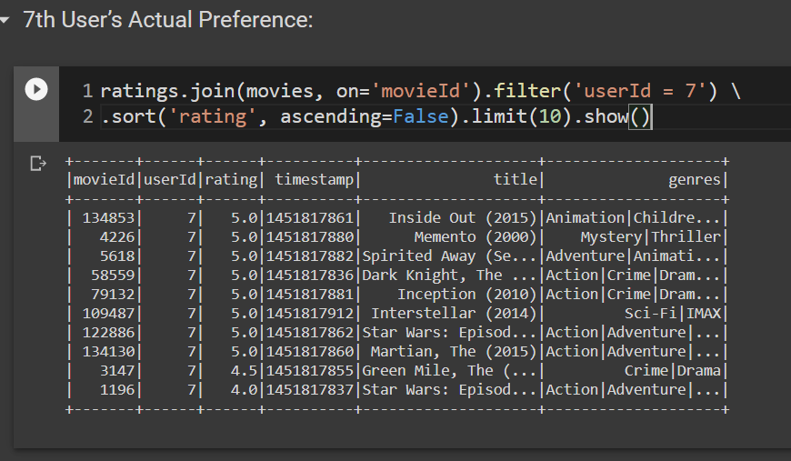

The below figure depicts the list of movie which are recommended to user-id 11 based on their preference and rating.

(Hình 3)

1. SVD Algorithm

In the SVD algorithm, the recommended movies are generated based on the previous preferences and ratings given by the user. The given figure depicts the list of the movie, which are preferred by user-id 11.

(Hình 4)

The below figure depicts the list of movie, which are recommended for user-id 11 based on their preference and rating.

(Hình 5)

1. DNN Algorithm
2. Performance Comparison

(Hình 6 )

(Hình 7 )

As you can see in above figure, performance of ALS is 77% while performance od SVD is 87% Hence, SVD works better than ALS.

1. **CONCLUSIONS AND DEVELOPMENT TRENDS**

In this report, we have introduced the movie recommendation system solution by applying machine learning algorithms such as KNN(k-nearest neighbors), ALS (Alternating Least Squares), SVD (Singular Value Decomposition), DNN (Deep Neural Network).The most important problem that we aim to is to build an optimal movie recommendation system, as a result, we experiment the movie recommendation system with the data set obtained only at a good level on the entire datasets.

From the results in this model, in the future we want to perform the problem with a larger dataset and apply methods and techniques to increase system quality to bring the best results.

# **REFERENCES**

[1] Linyuan Lü, Matúš Medo, Chi Ho Yeung, Yi-Cheng Zhang, Zi-Ke Zhang,Tao Zhoua, Recommender systems, Elsevier Journal – Physics Reports 519 (2012) 1–49

[2] Sandra Garcia Esparza, Michael P. O’Mahony, Barry Smyth, Mining the real-time web: A novel approach to product recommendation, Elsevier Journal - Knowledge-Based Systems 29 (2012) 3–11.

[3] Hongyan Liu, Jun He, Tingting Wang, Wenting Song, Xiaoyang Du, “Combining user preferences and user opinions for accurate recommendation”, Elsevier Journal- Electronic Commerce Research and Applications 12 (2013) 14–23.

[4] Li Chen, Feng Wang, “Preference-based clustering reviews for augmenting e-commerce recommendation”, Elsevier Journal - Knowledge-Based Systems 50 (2013) 44–59.

[5] Klavdiya Hammond, Aparna S. Varde, “Cloud Based Predictive Analytics”, 2013, IEEE 13’th International Conference on Data Mining Workshops.

[6] Jai Prakash, Bankim Patel, Atul Patel,”Web Mining: Opinion and Feedback Analysis for Educational Institutions”, 2013, IJCA, Volume 84 – No 6, December 2013.

[7] Gupta, Meenu, et al. ”Movie Recommender System Using Collaborative Filtering.” 2020 International Conference on Electronics and Sustainable Communication Systems (ICESC). IEEE, 2020.

[8] Li, Jung-Bin, et al. ”Implementation of an Alternating Least Square Model Based Collaborative Filtering Movie Recommendation System on Hadoop and Spark Platforms.” International Conference on Broadband and Wireless Computing, Communication and Applications. Springer, Cham, 2018.

[9] Kumar, D. (2021, January 12). Singular value DECOMPOSITION (SVD) in recommender system. Retrieved April 11, 2021, from <https://analyticsindiamag.com/singular-value-decomposition-svdapplication-recommender-system/>

[10] <https://www.kaggle.com/grouplens/movielens-20m-dataset>

[11] <https://grouplens.org/datasets/movielens/>