# ALS Algorithm

## Import Lib and init spark

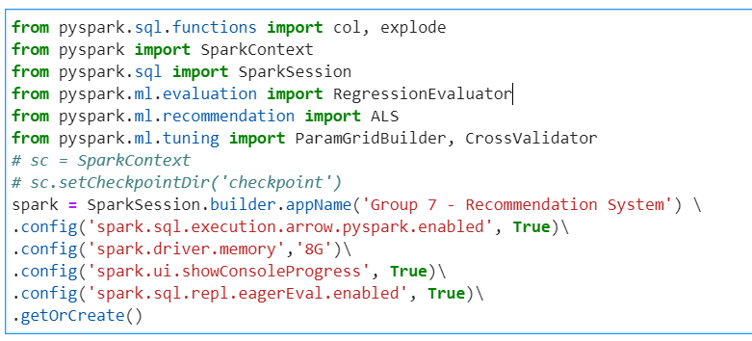

## Read data:

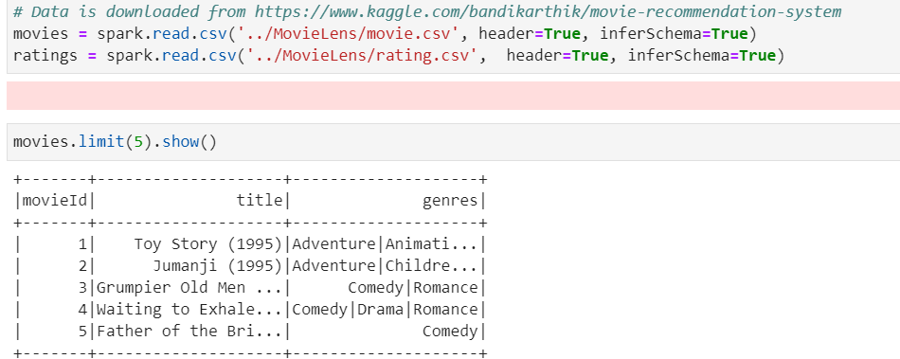

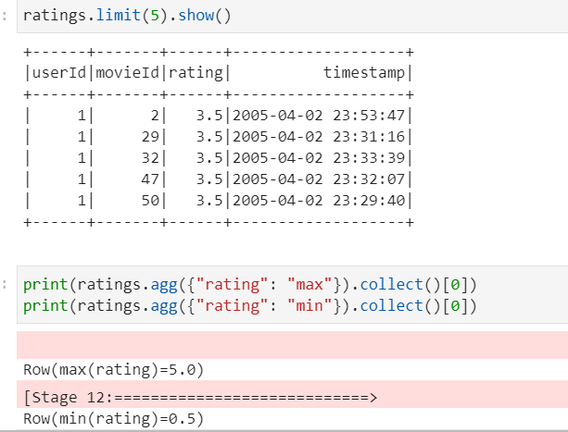

## Create test, train set and als model

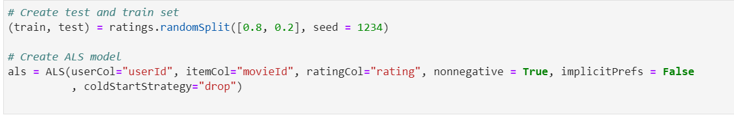

## Add hyperparameters and build cross validation

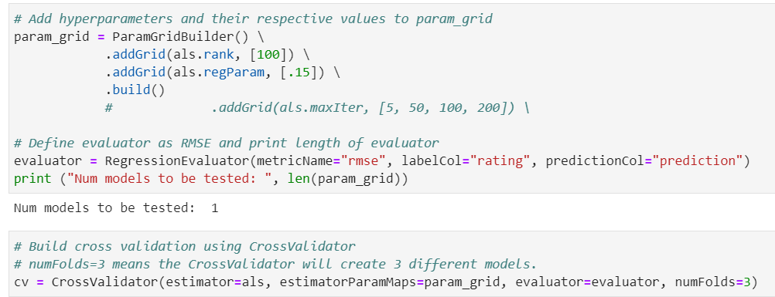

## Fit Model and get best model

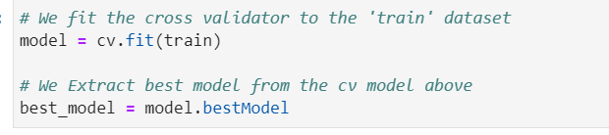

## Calculate RMSE

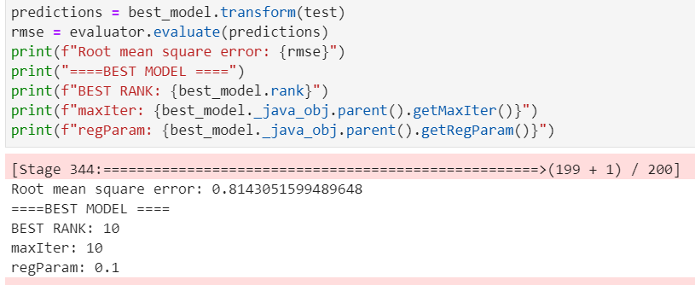

## Recommend movies for all users

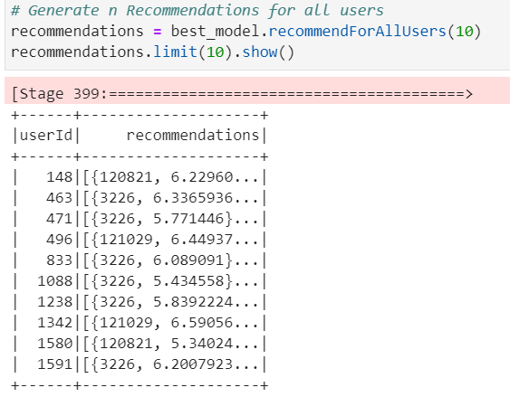

## Find 7th User’s Actual Preference:

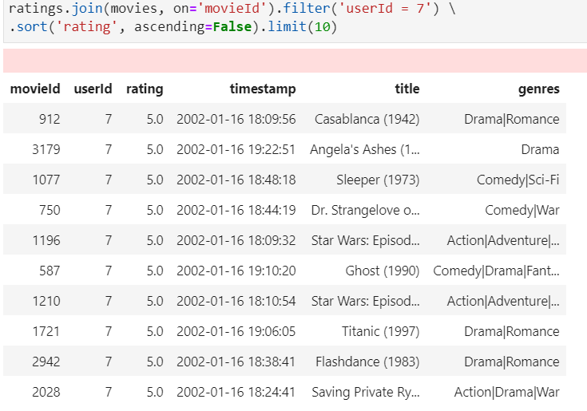

## Recommend film for 7th user

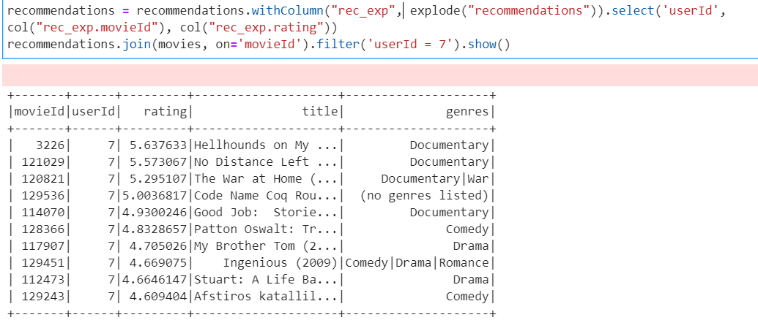

# SVD Algorithm

## Import Lib and init spark, dask

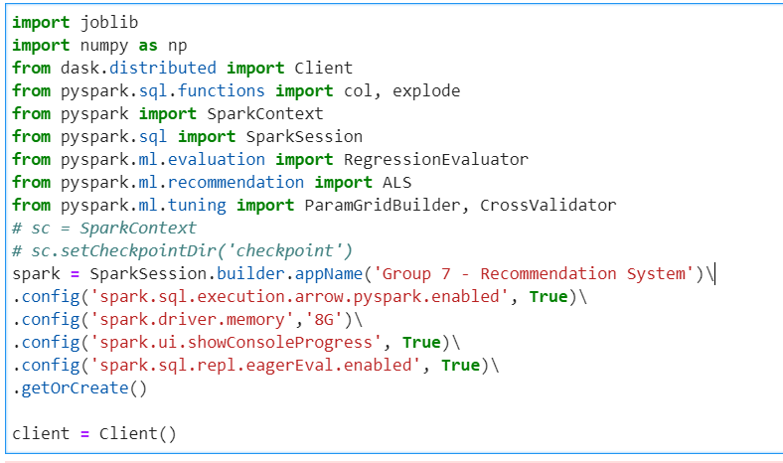

## Read data and install funk-svd lib

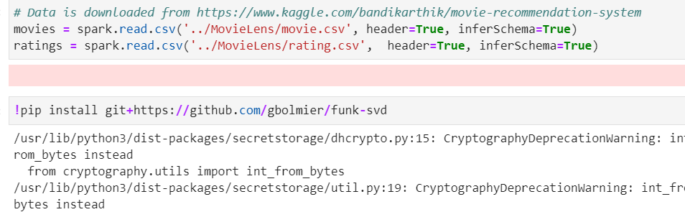

## Convert pyspark dataframe to pandas dataframe

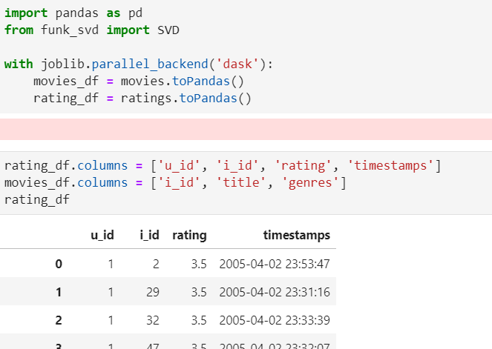

## Split data to train, test, validate set

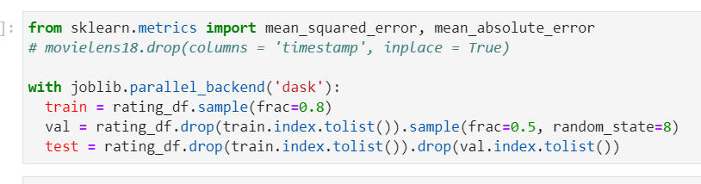

## Fit Model

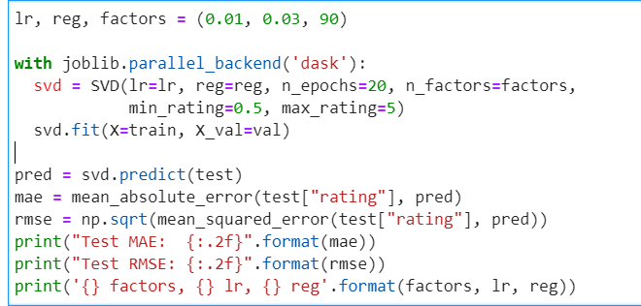

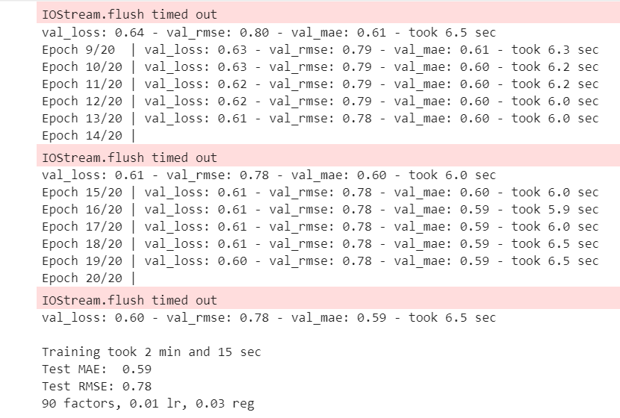

## Function to recommend movies:

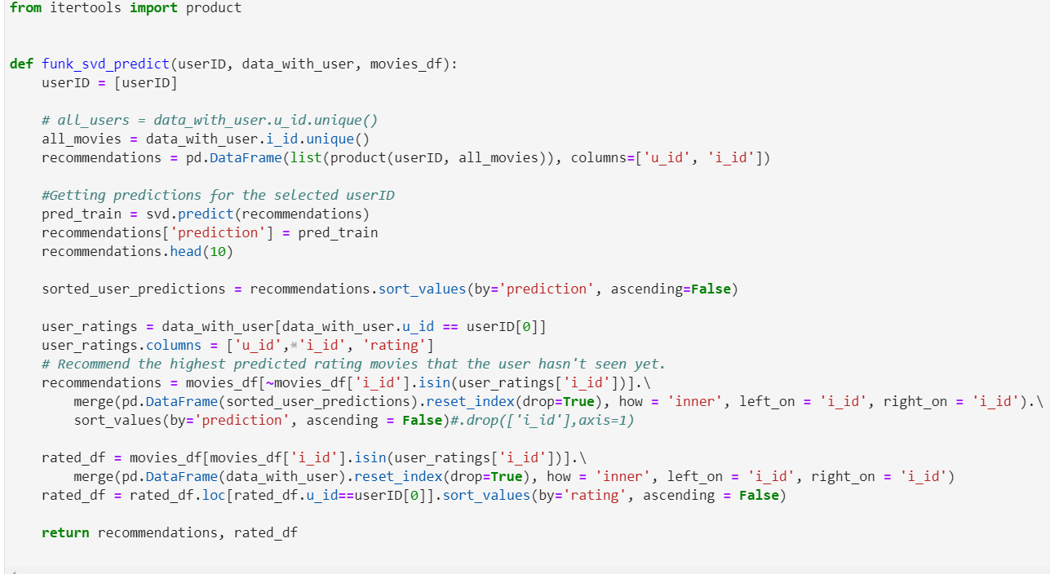

## Find 100th User’s Actual Preference:

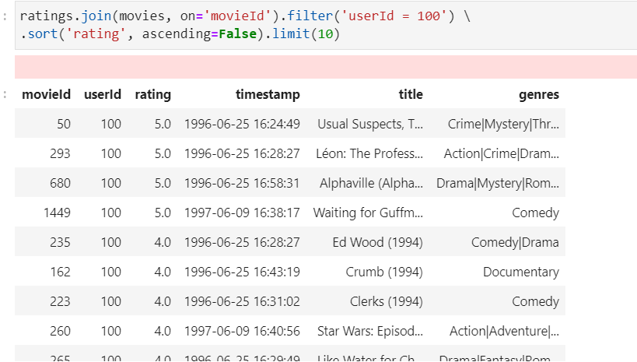

## Recommend film for 100th user

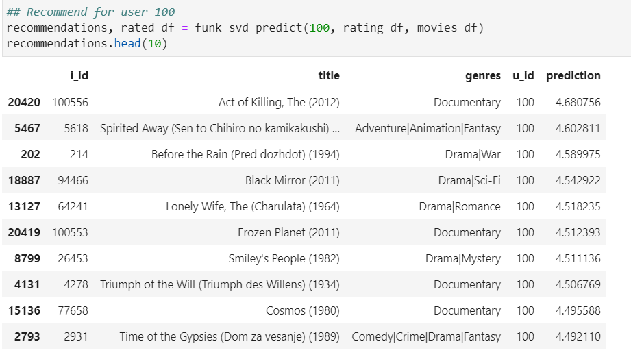

# KNN Algorithm

## Import Lib and init spark, dask

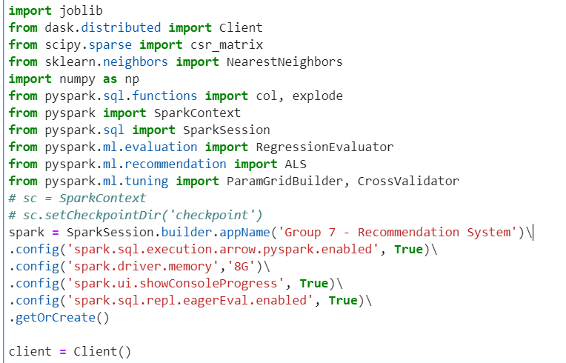

## Read data and convert pyspark dataframe to pandas dataframe:

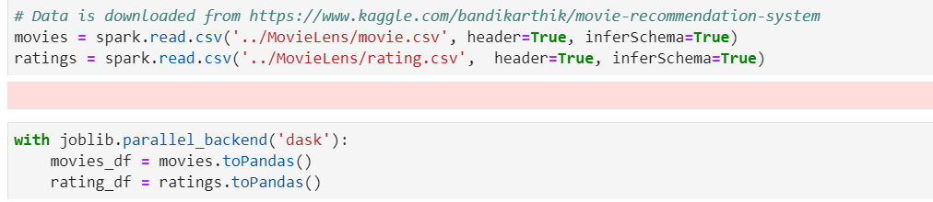

## Build And Fit Model

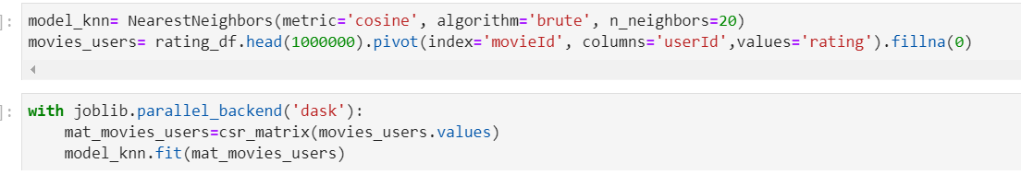

## Recommend Movies

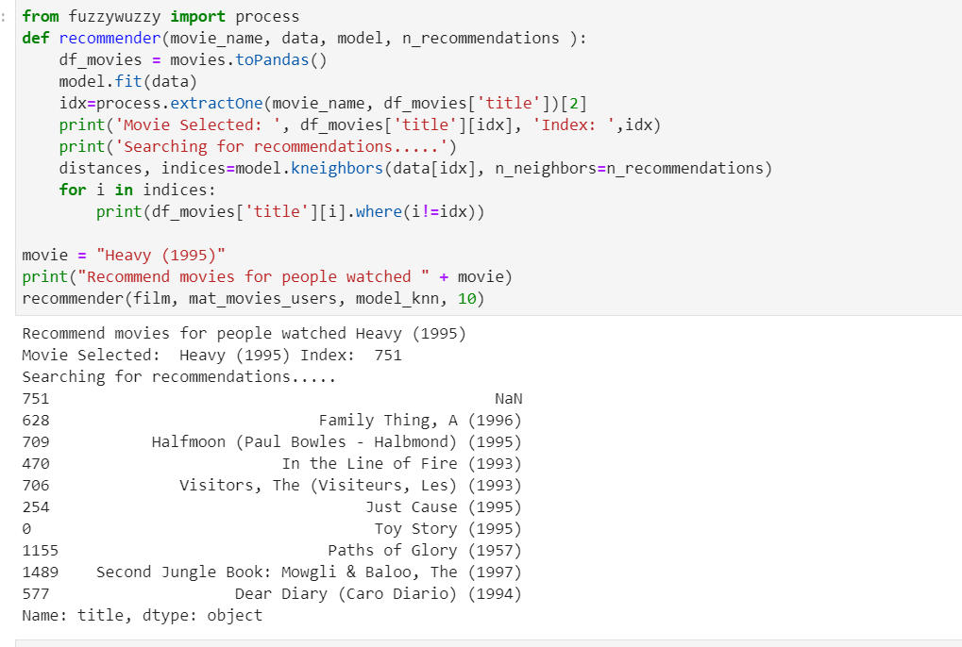

# Cosine similarity and Jaccard similarity

## Import Lib and init spark

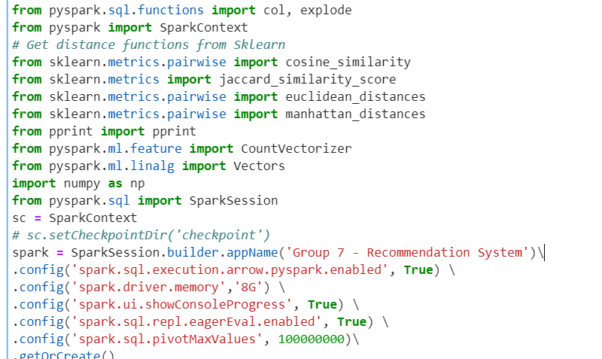

## Read data:



## Create new movies dataframe and change split genre to list from genres

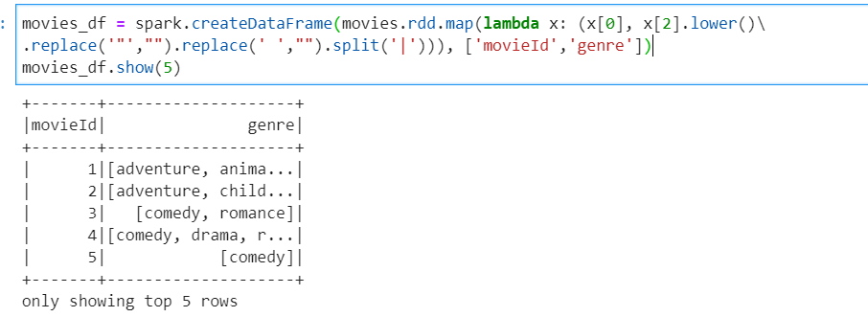  
Find Count of unique genre

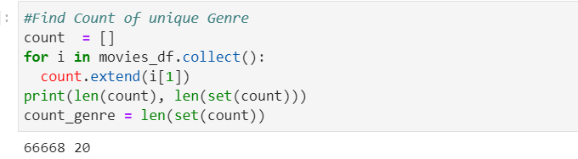

## Vectorize the data and fit model

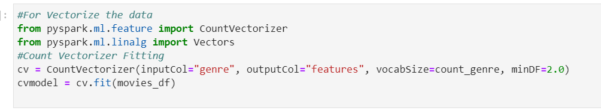

## Transform Data using Count Vectorizer

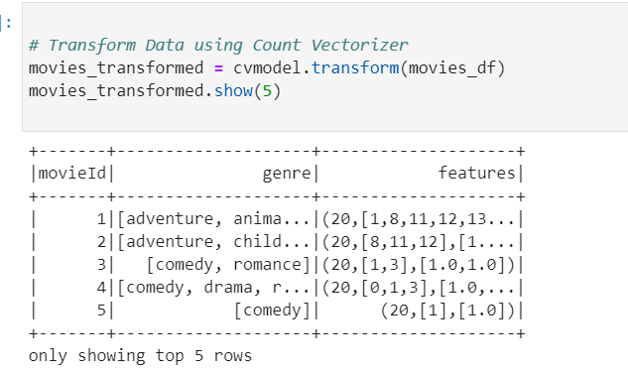

## Convert Sparse Vector to Dense

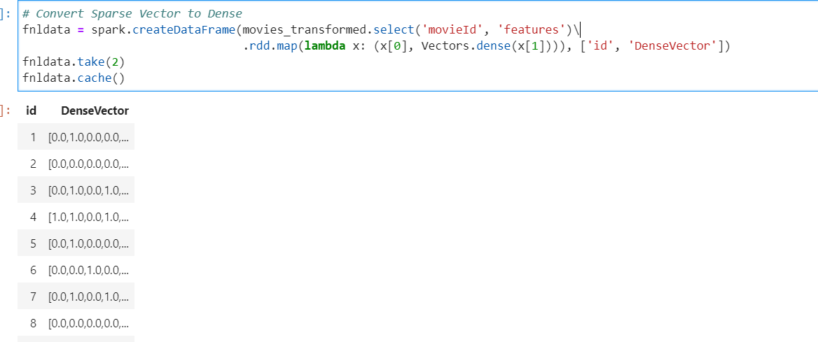

## Calculate Cosine similarity:

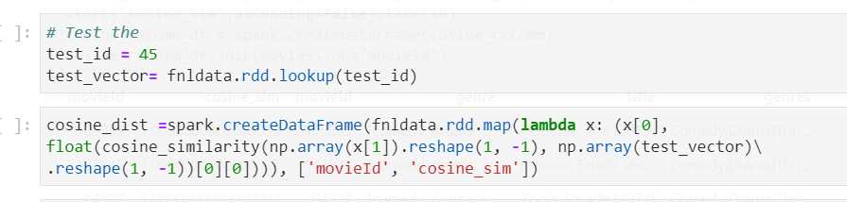

## Calculate Jaccard similarity:

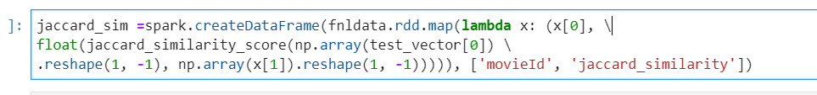

## Recommend movies for viewer who watched movie with movieId = 45

### Cosine recommend:

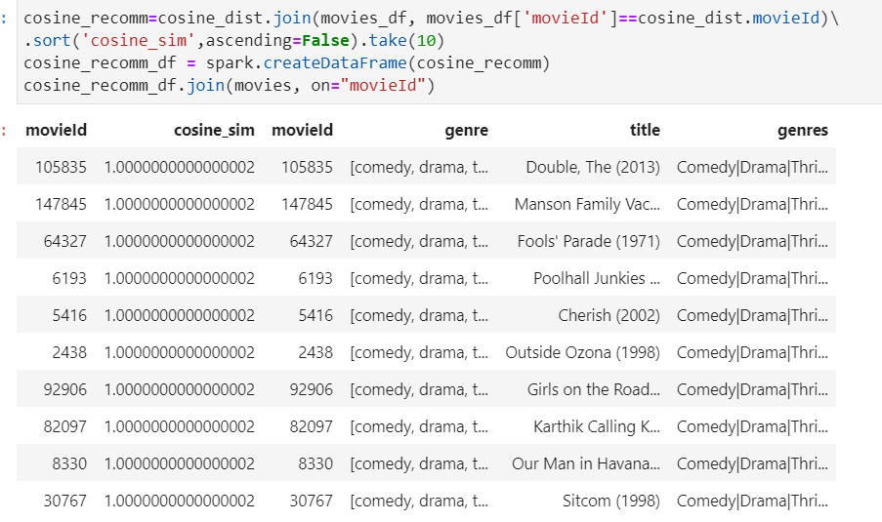

### Jaccard recommend

