**Màn hình đăng nhập**

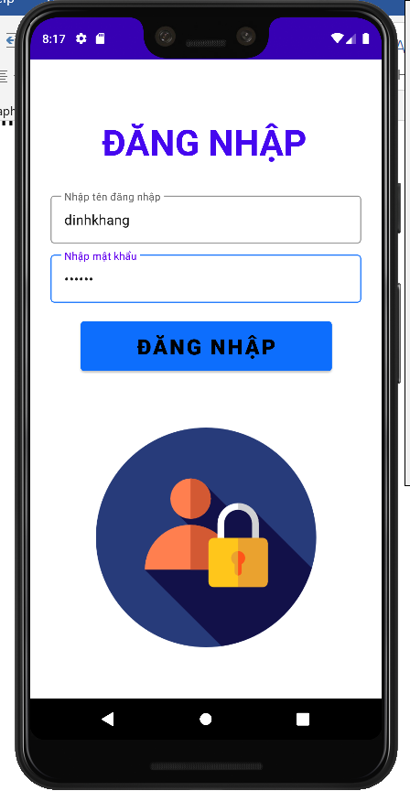

**Màn hình chính**

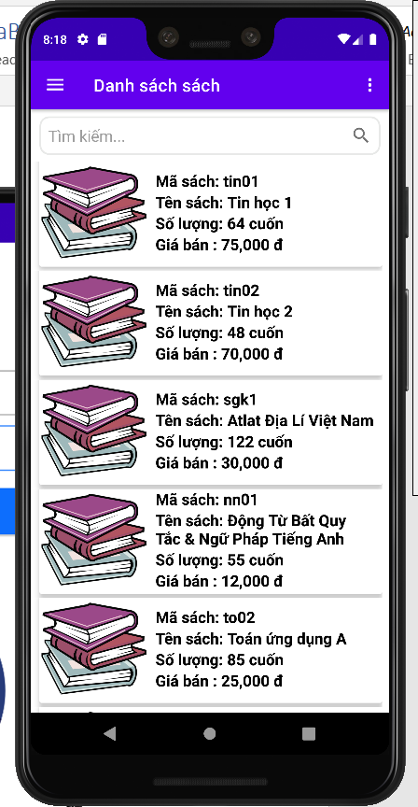

**Màn hình thêm sách**

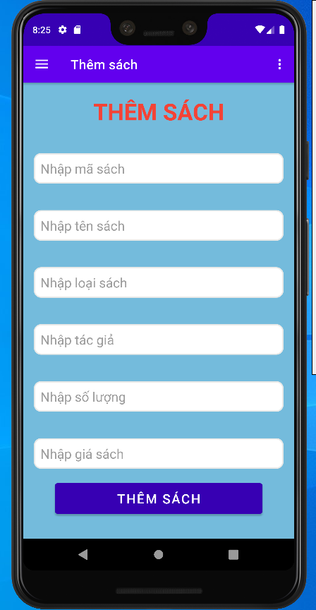

**Màn hình chi tiết sách**

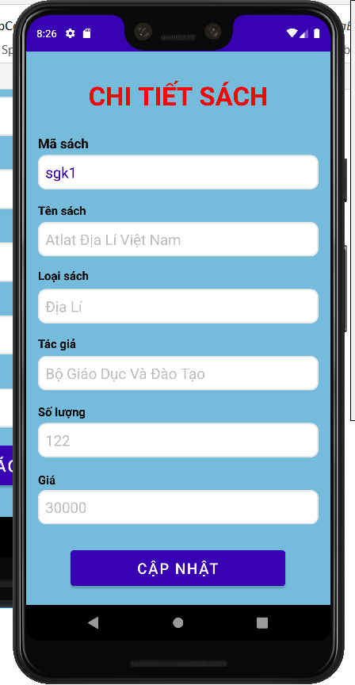

**Màn hình cập nhật**

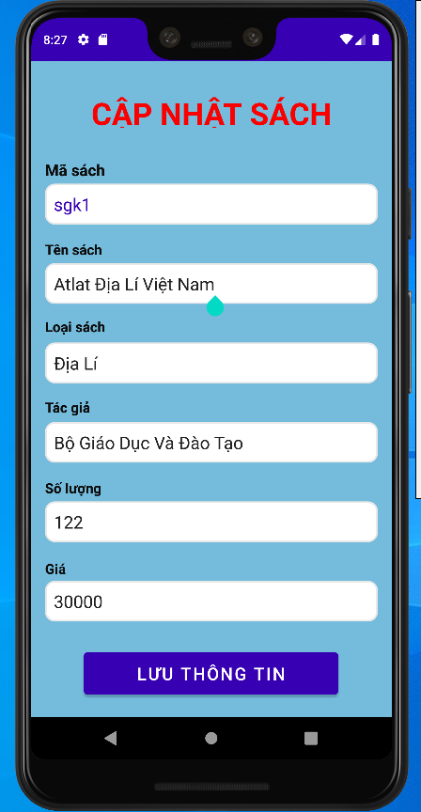

**Xóa sách**

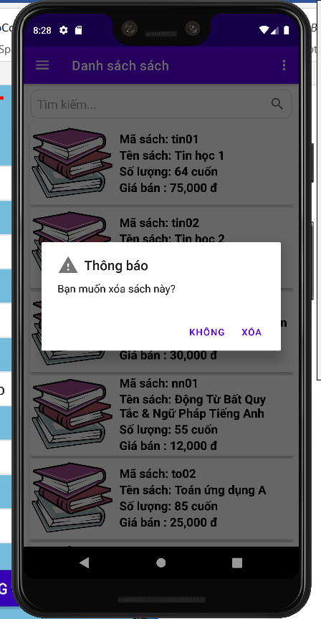

**Tìm kiếm**

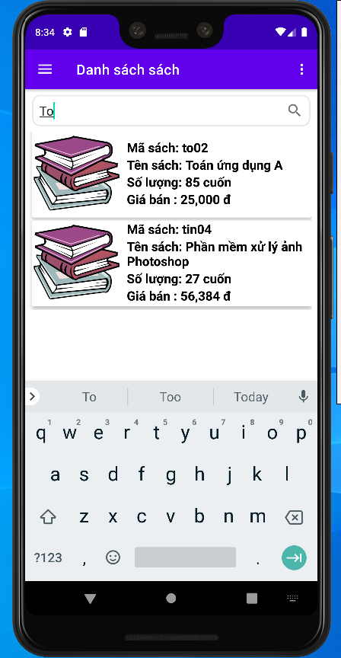

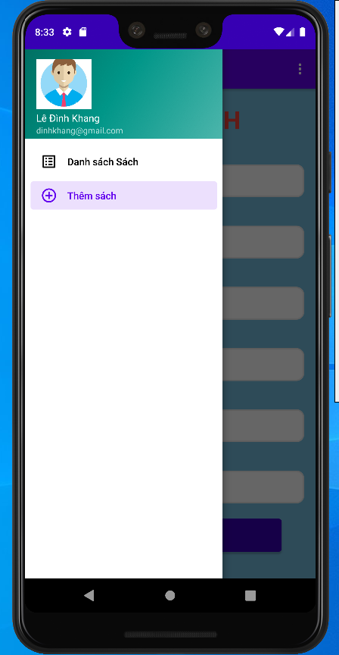

**Đăng xuất**

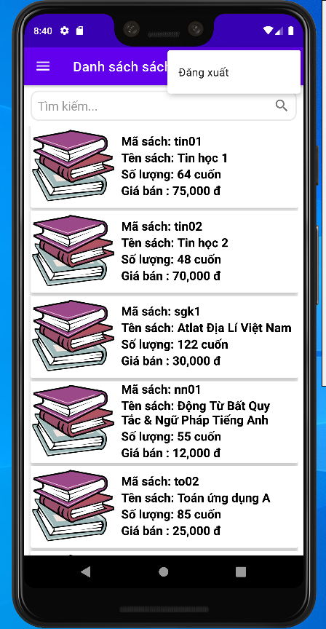

**ledinhkhang_activityLogin.java**

package com.ledinhkhang.qltv;  
  
import androidx.appcompat.app.AppCompatActivity;  
  
import android.content.Intent;  
import android.os.Bundle;  
import android.view.View;  
import android.widget.Button;  
import android.widget.EditText;  
import android.widget.Toast;  
  
public class ledinhkhang_activityLogin extends AppCompatActivity {  
 Button btn;  
 EditText email;  
 EditText password;  
 @Override  
 protected void onCreate(Bundle savedInstanceState) {  
 super.onCreate(savedInstanceState);  
 setContentView(R.layout.*activity_ledinhkhang_login*);  
  
 btn = findViewById(R.id.*btDangNhap*);  
 email = findViewById(R.id.*etSoLuong*);  
 password = findViewById(R.id.*etPassword*);  
 btn.setOnClickListener(new View.OnClickListener() {  
 @Override  
 public void onClick(View view) {  
 String mail = email.getText().toString();  
 String mk = password.getText().toString();  
 if(mail.equals("dinhkhang") && mk.equals("123456") )  
 {  
 Intent intent = new Intent(ledinhkhang_activityLogin.this, ledinhkhang_activitymain.class);  
 startActivity(intent);  
 finish();   
 Toast.*makeText*(getApplicationContext(),"Xin chào, Lê Đình Khang",Toast.*LENGTH_SHORT*).show();  
  
 }  
 else  
 {  
 Toast.*makeText*(ledinhkhang_activityLogin.this, "Tài khoản hoặc mật khẩu không đúng!", Toast.*LENGTH_SHORT*).show();  
 }  
 }  
 });  
 }  
}

**ledinhkhang_activitymain.java**

package com.ledinhkhang.qltv;  
  
import android.content.Intent;  
import android.os.Bundle;  
import android.view.MenuItem;  
import android.view.View;  
import android.view.Menu;  
  
import com.google.android.material.floatingactionbutton.FloatingActionButton;  
import com.google.android.material.snackbar.Snackbar;  
import com.google.android.material.navigation.NavigationView;  
  
import androidx.navigation.NavController;  
import androidx.navigation.Navigation;  
import androidx.navigation.ui.AppBarConfiguration;  
import androidx.navigation.ui.NavigationUI;  
import androidx.drawerlayout.widget.DrawerLayout;  
import androidx.appcompat.app.AppCompatActivity;  
import androidx.appcompat.widget.Toolbar;  
  
public class ledinhkhang_activitymain extends AppCompatActivity implements ledinhkhang_fragmentlistSach.IClickSendDataSach {  
  
 private AppBarConfiguration mAppBarConfiguration;  
  
 @Override  
 protected void onCreate(Bundle savedInstanceState) {  
 super.onCreate(savedInstanceState);  
 setContentView(R.layout.*activity_main*);  
 Toolbar toolbar = findViewById(R.id.*toolbar*);  
 setSupportActionBar(toolbar);  
  
 DrawerLayout drawer = findViewById(R.id.*drawer_layout*);  
 NavigationView navigationView = findViewById(R.id.*nav_view*);  
 // Passing each menu ID as a set of Ids because each  
 // menu should be considered as top level destinations.  
 mAppBarConfiguration = new AppBarConfiguration.Builder(  
 R.id.*nav_home*, R.id.*nav_gallery*)  
 .setDrawerLayout(drawer)  
 .build();  
 NavController navController = Navigation.*findNavController*(this, R.id.*nav_host_fragment*);  
 NavigationUI.*setupActionBarWithNavController*(this, navController, mAppBarConfiguration);  
 NavigationUI.*setupWithNavController*(navigationView, navController);  
 }  
  
 @Override  
 public boolean onCreateOptionsMenu(Menu menu) {  
 // Inflate the menu; this adds items to the action bar if it is present.  
 getMenuInflater().inflate(R.menu.*main*, menu);  
 return true;  
 }  
  
 @Override  
 public boolean onOptionsItemSelected(MenuItem item) {  
 // Handle item selection  
 switch (item.getItemId()) {  
 case R.id.*action_logout*:  
 Intent intent = new Intent(ledinhkhang_activitymain.this,ledinhkhang_activityLogin.class);  
 startActivity(intent);  
 finish();  
 return true;  
  
 default:  
 return super.onOptionsItemSelected(item);  
 }  
 }  
 @Override  
 public boolean onSupportNavigateUp() {  
 NavController navController = Navigation.*findNavController*(this, R.id.*nav_host_fragment*);  
 return NavigationUI.*navigateUp*(navController, mAppBarConfiguration)  
 || super.onSupportNavigateUp();  
 }  
  
 @Override  
 public void onItemClickSach(ledinhkhang_Sach sach) {  
 Intent intent = new Intent(ledinhkhang_activitymain.this,ledinhkhang_activityUpdate.class);  
 Bundle bundle = new Bundle();  
 bundle.putSerializable("SACH",sach);  
 intent.putExtras(bundle);  
 startActivity(intent);  
 }  
}

**ledinhkhang_activityUpdate.java**

package com.ledinhkhang.qltv;  
  
import androidx.appcompat.app.AppCompatActivity;  
  
import android.content.Intent;  
import android.os.Bundle;  
import android.widget.Button;  
import android.widget.EditText;  
import android.widget.TextView;  
import android.widget.Toast;  
  
public class ledinhkhang_activityUpdate extends AppCompatActivity {  
 private EditText etMa,etTen,etLoai,etTacGia,etSoLuong,etGia;  
 private Button btnUpdate;  
 private TextView textView;  
 @Override  
 protected void onCreate(Bundle savedInstanceState) {  
 super.onCreate(savedInstanceState);  
 setContentView(R.layout.*activity_ledinhkhang_update*);  
 anhXa();  
 btnUpdate.setOnClickListener(view -> {  
 if(btnUpdate.getText().toString().equals("CẬP NHẬT")) {  
 textView.setText("CẬP NHẬT SÁCH");  
 etTen.setEnabled(true);  
 etLoai.setEnabled(true);  
 etTacGia.setEnabled(true);  
 etSoLuong.setEnabled(true);  
 etGia.setEnabled(true);  
 btnUpdate.setText("LƯU THÔNG TIN");  
 }else if(btnUpdate.getText().toString().equals("LƯU THÔNG TIN")){  
 String ten = etTen.getText().toString();  
 String ma = etMa.getText().toString();  
 String loai = etLoai.getText().toString();  
 String tacgia = etTacGia.getText().toString();  
 String soluong = etSoLuong.getText().toString();  
 String gia = etGia.getText().toString();  
 if(ten.isEmpty() || ma.isEmpty() || loai.isEmpty() ||tacgia.isEmpty() ||  
 soluong.isEmpty() ||gia.isEmpty() ) {  
 Toast.*makeText*(getApplicationContext(),"Chưa điền đầy đủ thông tin",Toast.*LENGTH_SHORT*).show();  
 }else{  
 ledinhkhang_Sach khachHANG = new ledinhkhang_Sach(ma,ten,loai,tacgia  
 ,Long.*valueOf*(soluong),Long.*valueOf*(gia));  
 ledinhkhang_DatabaseApp.*getInstance*(getApplicationContext()).getSachDao()  
 .updateSach(khachHANG);  
 Toast.*makeText*(getApplicationContext(),"Cập nhật thành công",Toast.*LENGTH_SHORT*).show();  
 textView.setText("CHI TIẾT SÁCH");  
 btnUpdate.setText("CẬP NHẬT");  
 etTen.setEnabled(false);  
 etLoai.setEnabled(false);  
 etTacGia.setEnabled(false);  
 etSoLuong.setEnabled(false);  
 etGia.setEnabled(false);  
 //cap nhat thanh cong, chuyen ve man hinh chinh  
 Intent intent = new Intent(ledinhkhang_activityUpdate.this,ledinhkhang_activitymain.class);  
 startActivity(intent);  
  
  
  
 }  
 }  
  
 });  
  
 }  
  
 private void anhXa() {  
 Intent intent = getIntent();  
 Bundle bundle = intent.getExtras();  
 ledinhkhang_Sach sach = (ledinhkhang_Sach) bundle.getSerializable("SACH");  
 etTen = findViewById(R.id.*etTenSU*);  
 etTen.setText(sach.getTenSach());  
  
 etMa = findViewById(R.id.*etmaSU*);  
 etMa.setText(sach.getMaSach());  
  
 etLoai = findViewById(R.id.*etLoaiU*);  
 etLoai.setText(sach.getLoaiSach());  
  
 etTacGia = findViewById(R.id.*etTacU*);  
 etTacGia.setText(sach.getTacGia());  
  
 etSoLuong = findViewById(R.id.*etSoU*);  
 etSoLuong.setText(sach.getSoLuong()+"");  
  
 etGia = findViewById(R.id.*etGiaU*);  
 etGia.setText(sach.getGiaban()+"");  
  
 btnUpdate = findViewById(R.id.*btnUpdate*);  
 textView = findViewById(R.id.*textView*);  
 }  
}

**ledinhkhang_AdapterSach.java**

package com.ledinhkhang.qltv;  
  
import android.content.Context;  
import android.view.LayoutInflater;  
import android.view.View;  
import android.view.ViewGroup;  
import android.widget.TextView;  
  
import androidx.annotation.NonNull;  
import androidx.recyclerview.widget.RecyclerView;  
  
import java.text.DecimalFormat;  
import java.util.List;  
  
public class ledinhkhang_AdapterSach extends RecyclerView.Adapter<ledinhkhang_AdapterSach.ViewHolder> {  
 private List<ledinhkhang_Sach> listsachs;  
 private final ledinhkhang_IClickListener clickListener;  
 private final Context mContext;  
  
 public ledinhkhang_AdapterSach( Context mContext,ledinhkhang_IClickListener clickListener) {  
 this.mContext = mContext;  
 this.clickListener = clickListener;  
 }  
 public void setDta(List<ledinhkhang_Sach> listsachs){  
 this.listsachs = listsachs;  
 notifyDataSetChanged();  
 }  
  
 @NonNull  
 @Override  
 public ViewHolder onCreateViewHolder(@NonNull ViewGroup parent, int viewType) {  
 LayoutInflater inflater = LayoutInflater.*from*(mContext);  
 View studentView =  
 inflater.inflate(R.layout.*item_sach*, parent, false);  
 return new ViewHolder(studentView);  
 }  
  
 @Override  
 public void onBindViewHolder(@NonNull ViewHolder holder, int position) {  
 ledinhkhang_Sach sach = listsachs.get(position);  
 holder.txt_maSP.setText("Mã sách: " + sach.getMaSach());  
 holder.txt_tenSP.setText("Tên sách: " + sach.getTenSach());  
 holder.txt_soLuong.setText("Số lượng: " + sach.getSoLuong() +(" cuốn"));  
 DecimalFormat formatter = new DecimalFormat("###,###,###");  
 holder.txt_Giaca.setText("Giá bán : "+formatter.format(sach.getGiaban())+" đ");  
 holder.setClick(sach);  
 }  
  
 @Override  
 public int getItemCount() {  
 return listsachs.size();  
 }  
  
  
 public class ViewHolder extends RecyclerView.ViewHolder {  
 TextView txt_maSP;  
 TextView txt_tenSP,txt_Giaca;  
 TextView txt_soLuong;  
 public ViewHolder(@NonNull View itemView) {  
 super(itemView);  
 txt_maSP = itemView.findViewById(R.id.*tvMaSP*);  
 txt_tenSP = itemView.findViewById(R.id.*tvtenSp*);  
 txt_soLuong = itemView.findViewById(R.id.*tvSoLuong*);  
 txt_Giaca = itemView.findViewById(R.id.*tvGiaBan*);  
  
 }  
 public void setClick(ledinhkhang_Sach sach) {  
 itemView.setOnLongClickListener(view -> {  
 clickListener.OnLongClickListenerKhachHang(sach);  
 return true;  
 });  
  
 itemView.setOnClickListener(view ->{  
 clickListener.OnClickListenerKhachHang(sach);  
 });  
 }  
 }  
}

**ledinhkhang_DatabaseApp.java**

package com.ledinhkhang.qltv;  
  
import android.content.Context;  
  
import androidx.room.Database;  
import androidx.room.Room;  
import androidx.room.RoomDatabase;  
  
@Database(entities = {ledinhkhang_Sach.class}, version = 1)  
public abstract class ledinhkhang_DatabaseApp extends RoomDatabase {  
 public abstract ledinhkhang_ISachDao getSachDao();  
 private static ledinhkhang_DatabaseApp *instance*;  
 public static synchronized ledinhkhang_DatabaseApp getInstance(Context context) {  
 if (*instance* == null) {  
 *instance* = Room.*databaseBuilder*(context.getApplicationContext(), ledinhkhang_DatabaseApp.class,"quanlithuvien")  
 .allowMainThreadQueries()  
 .build();  
 }  
 return *instance*;  
 }  
 public static void destroyInstance() {  
 *instance* = null;  
 }  
}

**ledinhkhang_fragmentaddSach.java**

package com.ledinhkhang.qltv;  
  
  
import android.content.Intent;  
import android.os.Bundle;  
import android.view.LayoutInflater;  
import android.view.View;  
import android.view.ViewGroup;  
import android.widget.Button;  
import android.widget.EditText;  
import android.widget.Toast;  
  
import androidx.annotation.NonNull;  
import androidx.annotation.Nullable;  
import androidx.fragment.app.Fragment;  
  
public class ledinhkhang_fragmentaddSach extends Fragment {  
 private EditText etMa,etTen,etLoai,etTacGia,etSoLuong,etGia;  
 private Button btnThem;  
   
 public View onCreateView(@NonNull LayoutInflater inflater,  
 ViewGroup container, Bundle savedInstanceState) {  
 return inflater.inflate(R.layout.*fragment_addsach*, container, false);  
 }  
  
 @Override  
 public void onViewCreated(@NonNull View view, @Nullable Bundle savedInstanceState) {  
 super.onViewCreated(view, savedInstanceState);  
 AnhXa(view);  
 btnThem.setOnClickListener(view1 -> {  
 String ma = etMa.getText().toString();  
 String ten = etTen.getText().toString();  
 String loai = etLoai.getText().toString();  
 String tacgia = etTacGia.getText().toString();  
 String soluong = etSoLuong.getText().toString();  
 String gia = etGia.getText().toString();  
  
 if(ma.isEmpty() || ten.isEmpty() || loai.isEmpty() ||tacgia.isEmpty() ||  
 soluong.isEmpty() ||gia.isEmpty() ) {  
 Toast.*makeText*(getContext(),"Chưa điền đầy đủ thông tin",Toast.*LENGTH_SHORT*).show();  
 }else{  
 if(ledinhkhang_DatabaseApp.*getInstance*(getContext()).getSachDao().check(ma).size() == 0){  
  
 ledinhkhang_Sach khachHANG = new ledinhkhang_Sach(ma,ten,loai,tacgia  
 ,Long.*valueOf*(soluong),Long.*valueOf*(gia));  
 ledinhkhang_DatabaseApp.*getInstance*(getContext()).getSachDao()  
 .insertSach(khachHANG);  
 Toast.*makeText*(getContext(),"Thêm thành công",Toast.*LENGTH_SHORT*).show();  
 setEdittex();  
 //them sach thanh cong, chuyen ve man hinh chinh  
 Intent intent = new Intent(getActivity(), ledinhkhang_activitymain.class);  
 startActivity(intent);  
 }else{  
 Toast.*makeText*(getContext(),"Mã sách đã tồn tại",Toast.*LENGTH_SHORT*).show();  
  
 }  
 }  
 });  
 }  
  
 private void setEdittext() {  
 etMa.setText("");  
 etTen.setText("");  
 etLoai.setText("");  
 etTacGia.setText("");  
 etSoLuong.setText("");  
 etGia.setText("");  
 }  
 private void AnhXa(View view) {  
 etMa = view.findViewById(R.id.*etMaSach*);  
 etTen = view.findViewById(R.id.*etTenSach*);  
 etLoai = view.findViewById(R.id.*etLoaiSach*);  
 etTacGia = view.findViewById(R.id.*etTacGia*);  
 etSoLuong = view.findViewById(R.id.*etSoLuong*);  
 etGia = view.findViewById(R.id.*etGia*);  
 btnThem = view.findViewById(R.id.*btnThem*);  
 }  
}

**ledinhkhang_fragmentlistSach.java**

package com.ledinhkhang.qltv;  
  
import android.app.AlertDialog;  
import android.content.Context;  
import android.os.Bundle;  
import android.text.Editable;  
import android.text.TextWatcher;  
import android.view.LayoutInflater;  
import android.view.View;  
import android.view.ViewGroup;  
import android.widget.EditText;  
  
import androidx.annotation.NonNull;  
import androidx.annotation.Nullable;  
import androidx.fragment.app.Fragment;  
import androidx.recyclerview.widget.LinearLayoutManager;  
import androidx.recyclerview.widget.RecyclerView;  
  
import java.util.ArrayList;  
  
  
  
public class ledinhkhang_fragmentlistSach extends Fragment implements ledinhkhang_IClickListener{  
 private ledinhkhang_AdapterSach adapterSach;  
 private IClickSendDataSach iClickSendDataSach;  
 public interface IClickSendDataSach {  
 public void onItemClickSach(ledinhkhang_Sach sach);  
 }  
  
 @Override  
 public void onAttach(@NonNull Context context) {  
 super.onAttach(context);  
 if (context instanceof IClickSendDataSach ){  
 iClickSendDataSach= (IClickSendDataSach ) context;  
 } else {  
 throw new RuntimeException(context.toString() + " must implement onViewSelected");  
 }  
 }  
  
 public View onCreateView(@NonNull LayoutInflater inflater,  
 ViewGroup container, Bundle savedInstanceState) {  
 return inflater.inflate(R.layout.*fragment_listsach*, container, false);  
 }  
  
 @Override  
 public void onViewCreated(@NonNull View view, @Nullable Bundle savedInstanceState) {  
 super.onViewCreated(view, savedInstanceState);  
 EditText etTimkiemDH = view.findViewById(R.id.*etTimkiemSanPham*);  
 RecyclerView rvSach = view.findViewById(R.id.*rvSanPham*);  
 adapterSach = new ledinhkhang_AdapterSach(getContext(),this);  
 adapterSach.setDta(getListSachs());  
 rvSach.setHasFixedSize(true);  
 rvSach.setLayoutManager(new LinearLayoutManager(getContext(),LinearLayoutManager.*VERTICAL*,false));  
 rvSach.setAdapter(adapterSach);  
  
  
 etTimkiemDH.addTextChangedListener(new TextWatcher() {  
 @Override  
 public void beforeTextChanged(CharSequence s, int start, int count, int after) {  
  
 }  
  
 @Override  
 public void onTextChanged(CharSequence s, int start, int before, int count) {  
  
 }  
  
 @Override  
 public void afterTextChanged(Editable s) {  
 adapterSach.setDta(timkiemSach(getListSachs(),s.toString()));  
 }  
 });  
 }  
  
 private ArrayList<ledinhkhang_Sach> getListSachs() {  
 return (ArrayList<ledinhkhang_Sach>) ledinhkhang_DatabaseApp.*getInstance*(getContext()).getSachDao().getListSach();  
 }  
  
 @Override  
 public void OnClickListenerKhachHang(ledinhkhang_Sach sach) {  
 iClickSendDataSach.onItemClickSach(sach);  
 }  
  
 @Override  
 public void OnLongClickListenerKhachHang(ledinhkhang_Sach sach) {  
 AlertDialog.Builder builder = new AlertDialog.Builder(getContext());  
 builder.setTitle("Thông báo")  
 .setMessage("Bạn muốn xóa sách này?")  
 .setPositiveButton("XÓA", (dialogInterface, i) -> {  
 ledinhkhang_DatabaseApp.*getInstance*(getContext()).getSachDao().deleteSach(sach);  
 adapterSach.setDta(ledinhkhang_DatabaseApp.*getInstance*(getContext()).getSachDao().getListSach());  
 })  
 .setNegativeButton("KHÔNG", (dialogInterface, i) -> dialogInterface.dismiss()).setIcon(R.drawable.*ic_baseline_warning_24*)  
 .show();  
 }  
 private ArrayList<ledinhkhang_Sach> timkiemSach(ArrayList<ledinhkhang_Sach> list, String s){  
 ArrayList<ledinhkhang_Sach> list1 = new ArrayList<>();  
 for( ledinhkhang_Sach item : list){  
 if(item.getTenSach().trim().toLowerCase().contains(s.trim().toLowerCase())){  
 list1.add(item);  
 }  
 }  
 return list1;  
 }  
  
 @Override  
 public void onResume() {  
 super.onResume();  
 adapterSach.setDta(getListSachs());  
 }  
}

**ledinhkhang_Sach.java**

package com.ledinhkhang.qltv;  
  
import androidx.annotation.NonNull;  
import androidx.room.Entity;  
import androidx.room.PrimaryKey;  
  
import java.io.Serializable;  
  
@Entity(tableName = "Sach")  
public class ledinhkhang_Sach implements Serializable {  
 @PrimaryKey  
 @NonNull  
 private String maSach;  
 private String tenSach;  
 private String loaiSach;  
 private String tacGia;  
 private Long soLuong;  
 private Long giaban;  
  
 public ledinhkhang_Sach(@NonNull String maSach, String tenSach, String loaiSach,  
 String tacGia, Long soLuong, Long giaban) {  
 this.maSach = maSach;  
 this.tenSach = tenSach;  
 this.loaiSach = loaiSach;  
 this.tacGia = tacGia;  
 this.soLuong = soLuong;  
 this.giaban = giaban;  
 }  
  
 @NonNull  
 public String getMaSach() {  
 return maSach;  
 }  
  
 public void setMaSach(@NonNull String maSach) {  
 this.maSach = maSach;  
 }  
  
 public String getTenSach() {  
 return tenSach;  
 }  
  
 public void setTenSach(String tenSach) {  
 this.tenSach = tenSach;  
 }  
  
 public String getLoaiSach() {  
 return loaiSach;  
 }  
  
 public void setLoaiSach(String loaiSach) {  
 this.loaiSach = loaiSach;  
 }  
  
 public String getTacGia() {  
 return tacGia;  
 }  
  
 public void setTacGia(String tacGia) {  
 this.tacGia = tacGia;  
 }  
  
 public Long getSoLuong() {  
 return soLuong;  
 }  
  
 public void setSoLuong(Long soLuong) {  
 this.soLuong = soLuong;  
 }  
  
 public Long getGiaban() {  
 return giaban;  
 }  
  
 public void setGiaban(Long giaban) {  
 this.giaban = giaban;  
 }  
}

**ledinhkhang_SachDao.java**

package com.ledinhkhang.qltv;  
  
import androidx.room.Dao;  
import androidx.room.Delete;  
import androidx.room.Insert;  
import androidx.room.Query;  
import androidx.room.Update;  
  
import java.util.List;  
  
@Dao  
public interface ledinhkhang_ISachDao {  
  
 @Insert  
 public void insertSach(ledinhkhang_Sach sach);  
  
 @Update  
 public void updateSach(ledinhkhang_Sach sach);  
  
 @Delete  
 public void deleteSach(ledinhkhang_Sach sach);  
  
 @Query("SELECT * FROM Sach")  
 public List<ledinhkhang_Sach> getListSach();  
  
 @Query("SELECT * FROM sach WHERE maSach = :masach")  
 public List<ledinhkhang_Sach> check(String masach);  
}