Simple Healthy Lifestyles Can Fight Acne

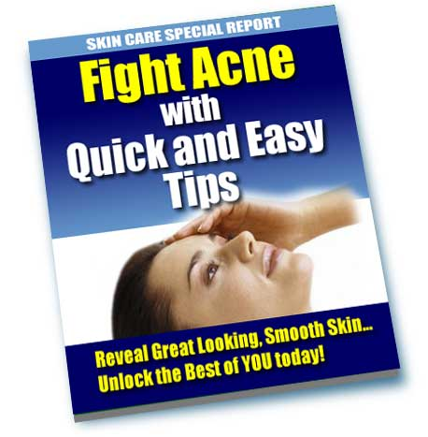

I am sure that every one of you is familiar with acne. Almost all of us got this skin disorder, right? Well, technically known as acne vulgaris, this skin disorder affects millions of people from different walks of life, annually. Studies have found out that most of the adolescents are the usual target of this disease, although infants and adults are also affected. It is even found out that about 80 percent of the teenagers develop acne, particularly for women.

What is acne?

According to certain studies, acne varies from quite mild to tremendously severe. It typically forms when the lining of the skin duct as well as the sebaceous glands start to work overtime. With the onset of acne, the lining of the duct actually shed cells which are then transported away to the shell of the skin by the sebum. Once the duct is blocked, it is when the sebum and cells start to amass, forming a plug known as comedo.

Once the plug stays below the plane of the skin, whiteheads or “closed comedo” occurs. If the plug boosts and pops out of the skin duct, it is called “open comedo” or blackhead since the top is dark. As you may know, this is not absolutely dirt, thus it will not wash away.

There are a lot of factors that contribute to the formation of acne, but in terms of its real cause, no one is actually certain as to what exactly causes acne to develop or why it starts in adolescence. However, factor like hereditary top the list. It has long been deemed as the most important factor that plays a large role in the acne’s development. As what most people believe, if a member of your family had acne, there is a great possibility that you will have acne too.

Although acne is very prevalent among teenagers, acne should not control your life. There are a lot of ways to fight acne, and one of those is maintaining a healthy lifestyle.

Healthy Lifestyle Changes

Experts have said that when treating a person for acne, the only way to obtain results from effective treatments is through various healthy lifestyle changes. When I say “healthy lifestyle changes”, it includes the way you eat, sleep, work, play, etc. As much as possible, you should try to focus on all areas that need changing. This is very important in order for a sustained effort to be completed. If your goal is to treat your bothering acne, then try to treat your whole self as many ways as possible.

Overcoming Stress

One of the most common dilemmas that face people is stress. Stress that is not normal. So what happens when the body gets too stressed out? Experts have found out that in this case, the adrenal cortex converts adrenal androgens to the hormone testosterone in both men and women, which in turn results in overactive sebaceous glands. As found out, the ovaries of women are capable of producing 25 percent of the testosterone, while 75 percent of the hormone comes from the adrenal androgens.

When the body of both male and female is stressed, more adrenal androgen is released, causing a double amount of testosterone. It is this doubling effect that causes the T zone of the face to be oily, while other areas are still dry from dehydration. Also note that adult acne is sometimes the by-product of stress and dehydration. And, water and estrogen are the factors that calm the body’s stress alarm system.

Some Other Tips for Controlling Acne

Here are some other tips that have helped hundreds of people suffering from acne. Hopefully, these will help you too:

Water is Best

Water is by far the most effective treatment for acne. The main support for this claim is the fact that water is alkaline (pH 7.3) and can be considered as a natural treatment or an almost free acne treatment. Thus, it is best that you drink at least eight glasses of water per day (10 to 12 is better). This will help your body in getting rid of oil, waste and toxins, and water even helps to moisten your skin as it keeps your pores from clogging. Perhaps what is most important is that, water helps to relieve stress and relax your body in the end, so you can have a better sleep. Note that water and sleep are factors that help reduce stress. Along with this, try to lessen your coffees, sodas, teas and alcohols intake as much as possible. The reason behind this is that they are partial diuretics that they drive more water out of the cells of the body than they put in.

Avoid Astringents

If your goal is to have a beautiful skin, then you should try to avoid astringent natural soaps and any astringent agents that shrink your skin’s pores, such as oatmeal, witch hazel, very cold water and rubbing alcohol. It was found out actually that when your skin pores shrink, more oils are clogged in the pores of the skin, causing the onset of acne.

Avoid Stimulants

Coffee, tea, cigarettes, as well as excessive sugar from sweets and soda should be avoided. It is often said that anything potential for affecting the entire body, brain and nervous system can easily stimulate the sebaceous glands to release more oil. This oil has to leave the body through the pores, worsening your acne in the end. Stimulants even trigger stress.

Watch Your Diet

Note that diet affects acne. So be careful with what you eat. As much as possible, try to eat foods that are low in fat, as fats produce more oils in the body that are capable of producing acne.

Avoid Alcohol

A number of people think that alcohol is one of the best ways to relax and relieve stress. Well, alcohol may do this, but studies have found out that alcohol causes the formation of acne. It is considered capable for producing acne knowing that it is an astringent, thus it shrinks the skin pores, making them more prone to clogging. Aside from that, alcohol inhibits sleep, therefore causing more fatigue and stress, leading to worse acne.

Hot and Very Cold Count

When considering baths, you should avoid hot and very cold water on areas of the skin affected by acne. Use warm water instead; perhaps well below 98.5 degrees on your skin.

Avoid Scrubbing and Abrasives

Scrubbing and abrasives should be avoided. Experts have said that they irritate the skin, which should be left intact as a natural barrier against the acne-causing bacteria.

Sun for Beautiful Skin

As you may know, sun does kill bacteria, but it doesn’t mean that it won’t harm the skin. Note that the sun also acts as an astringent that dries, tightens and clogs the skin pores. Thus, you should just spend limited time under the sun. At least 15 minutes to the face and arms daily is enough.

Avoid Extremely Cold Weather

If extreme heat causes clogging of the pores, extremely cold weather causes it as well. So, avoid extremely cold weather so you don’t freeze and clog pores. It is ideal that you moisturize your face and body, and stay in temperatures ranging from 70 to 80 degrees Fahrenheit.

Swimming Does Help

Exercise for stress reduction by swimming in a properly treated indoor swimming pool. But, use the Ozone purified pool if possible. It is interesting to know that the swimming pool water is typically 75 to 85 degrees Fahrenheit, which is well below the normal temperature of 98.6 degrees of your body. Therefore, the swimming water cools your whole body, including the acne affected areas, while providing excellent exercise to the rest of you. This even reduces stress as well as physical attention.

Think Clean

It is also necessary that you change linens, wash cloths and body towels after each use. It is for the fact that they are great places for acne-causing bacteria to grow and be reapplied to the skin later. Also, wash white facial cloths, pillow covers, as well as personal undergarments daily with Vinegar, tea tree oil or essential oils of Lime, lemon or orange so to lessen the acne-related bacterial development. It is also often suggested that you apply a natural detergent for washing.

Indeed, there are a lot of ways to control and fight acne, but maintaining a healthy lifestyle is so far the best one to consider. It is important to note that healthy lifestyles will lead you to attaining a healthier skin and a healthier body. Changing your unfavorable habits will reward you with better general health, more energy, and clearer skin to show the world. If you were once afraid to make changes, please don’t be. Of course, the initial affects may be hard to grasp at first, but as you go on, you will find out that you can quickly learn to adapt with them.

Get a Free 30-Day Supply of a Leading Acne Cleanser
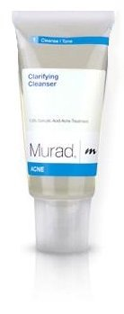
I've arranged an exclusive offer for readers of this eBook to get a free 30-day supply of Clarifying Cleanser.

Clarifying Cleanser is the first step toward eliminating acne permanently. Not only does this deep cleansing gel work to eliminate the acne you have, it's designed to keep your skin clear from future breakouts!

To take advantage of this special offer visit:
http://www.linkbrander.com/go/40049

