Think Clean and Green to Flawless Skin

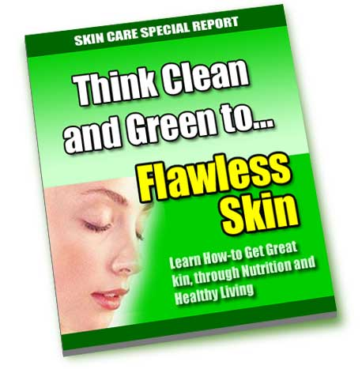

Introduction

Let’s accept the fact: many of us are skin conscious. As much as possible, we wanted to have a fresh, good looking skin. However, many of us failed to recognize that simple steps are the best ways to attain it. We just tend to ignore what is actually right or wrong for our skin. We tend to buy some beauty products that just worsen whatever skin imperfections we have as it turns out in the end. So, now is the time for change. We must do something to beat up all those bothering skin conditions we have.

Think and Act CLEAN

One thing that is true in our society since the early days is, some companies, if not all, that produce skin care products would like you to believe that a perfect, beautiful complexion can be purchased in a jar. But the truth is, a truly radiant, blemish free and moist skin is a result of being clean. If I say “clean”, it means clean from deep within and not just skin deep.

Most of the medical professionals commonly suggest that people with skin problems must practice certain skin care methods that will help improve the condition of the skin. One of the most recommended ways is to clean the skin gently by washing it with a mild cleanser, at least once in the morning and once in the evening, as well as after a heavy work out. But behind that way, there is one thing that’s very crucial for maintaining a beautiful skin, and that is: to create clean blood that continuously supplies wonderful nutrients right to the doorway of each and every cell in your body. If you will start practicing this, there’s no doubt that you’re well on your way to having beautiful skin.

But, how can you make it possible?

Well, these days keeping toxins out of your blood and organs in the body seems difficult. The primary reason is that, most of us dwell in a “sea” of chemicals and drugs. We even eat mostly refined foods. Now, if your main “goal” is a healthy and beautiful skin, then it’s now time for you to have a somewhat conscious effort to cleanse these dangerous substances out of your system while placing in the finest nutrients. There is a particular good news that you must know about your own system, that is, your body is constantly in a cleansing mode. It was created with the ability to drive out toxins as long as the energy necessary for it to function is supplied.

The bottom line is: cleansing energy is more abundant when you supply your body with the nutritious foods. Note the word “nutritious”.

Main Organs That Keep Your Skin Beautiful

Our body is made up of different organs that are responsible for providing us with beautiful and healthy skin. These specifically include:

- Liver
- Kidneys
- Adrenals
- Thyroid
- Large Intestines
- Small Intestines

Note that with these organs mentioned, you are accountable to them as well. It is now your role to keep them clean at all times. You will just find out in the end that beautiful skin will result from your daily efforts.

Liver and Kidneys

It is interesting to know that our liver and kidneys are the two filtering organs that provide ongoing “housecleaning services”, as I prefer to call it, constantly. You must be aware that these days, these organs are seriously well-worn and even underpaid. So, why overload them with outside challenges? Is it hard for you to just protect them from outside harm? It’s not that hard though. Simply feed them well and they will keep you, including your skin healthy in the end.
Adrenals

Also, lying on top of your kidneys are your walnut-sized adrenals. These organs are often called the “workhorses” of the human body perhaps for the reason that they are responsible for making a number of essential hormones like the DHEA, estrogen, progesterone, testosterone, and pregnenolone. Speaking of hormones, it is necessary to note that healthy hormones are the essential ingredient when seeking energy, as well as healthy skin.

Thyroid

It is often said that if your thyroid is well nourished and energetic, it is capable of providing hormones and works closely with your adrenals to form essential energy. Note that a dry, sluggish and flaky skin is actually the evidence of a weak thyroid. So, strengthen it.

Large and Small Intestines

Studies have revealed that the general well being of one’s liver, kidneys, adrenals and thyroid is dependent on the general condition of the small and large intestines. Aside from providing nutrients to these organs, the small and large intestines hold the responsibility of removing whatever waste product is accumulated in the body. If the small and large intestines failed to perform this role, the waste that was meant for elimination will remain in your intestines and this will result to thickening of the skin, which will eventually produce oils and blemishes. Clean intestines actually mirror a pure and flawless skin.

Several reports have noted that drugs, alcohol, chemicals and heavy metals like mercury and lead do daily damage to millions of people in the world. The liver is primarily damaged by the refined oils containing trans-fatty acids, while the kidneys are damaged by the common table salt that is devoid of natural minerals. Perhaps the main reason for this is the fact that thousands of processed foods that people usually consume everyday have trans-fats and refined salt. In addition, it was found out that those pasteurized as well as homogenized dairy products tend to clog the kidneys, thus they must be avoided. But, to attain a healthy and beautiful skin, you definitely need to add foods into your diet that nourish those mentioned six organs of the beauty.

Think GREEN

Today, there is what many dermatologists call as “Spring”. In Chinese medicine, spring is the season when the liver cleanses and heals naturally by way of driving out the dangerous toxins that were accumulated in the body through the refined foods that we eat. Many experts suggest green foods, including chlorella, as they are said to be excellent for the liver. Note that green foods refer to those green leafy veggies such as spinach, kale, dandelion greens and broccoli. These foods are what many people consider as the “especially wonderful foods”. Now, for a healthy and beautiful skin, have them cooked, raw, juiced and even cultured.

More Foods Necessary for Nourishing Your Body and Skin

Generally, super food formulas provide a mix of nutrients necessary for the body and skin. These include the cereal grasses, algae and green veggies. So, it is best for you to look for one that contains organic ingredients, but also note that the food was designed to heal and nourish the small and large intestines. It is often said that such foods are ideal in the morning for the reason that they assist your blood to alkalize. Also, they are pleasant to take than a handful of supplements. They even provide minerals, fatty acids and protein to the body.

Other foods known to contribute to healthy skin include the raw and virgin fats and oils. One particular perfect source is the coconut oil, which is especially good for the thyroid. Also, mineral-rich food such as dark green leafy vegetables, ocean vegetables and seafood are important. And, the antioxidant-rich foods like black currant and blueberry juice and green tea are a daily must as well.

Furthermore, there is one more group foods that is worth mentioning – the fermented or cultured foods. These foods are actually found in every traditional culture around the world and many have considered these as the news stars of a wholesome diet. Just like some of the above mentioned foods, they are necessary for maintaining a healthy and wonderful skin.

Conclusion

As presented, there are a lot of ways to attain and maintain a beautiful skin. All you need to consider is to exert some efforts on changing your habits. Eating nutritious foods such as those mentioned above are perhaps one of the most necessary moves to consider if you want a good looking skin. Simply think clean and green and have a beautiful skin.

Get a Free 30-Day Supply of a Leading Acne Cleanser
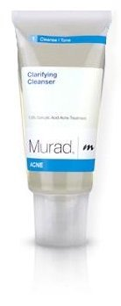
I've arranged an exclusive offer for readers of this eBook to get a free 30-day supply of Clarifying Cleanser.

Clarifying Cleanser is the first step toward eliminating acne permanently. Not only does this deep cleansing gel work to eliminate the acne you have, it's designed to keep your skin clear from future breakouts!

To take advantage of this special offer visit:
http://www.linkbrander.com/go/40049

