Part 1
I am using Ubuntu 24.04 LTS but the official code of HiWonder use ROS 2 Humble which is officially supported on Ubuntu 22. So I use docker to containerize the environment.

There are many difficulties and errors along the way:

1. Redundant Package (holonomic_sim)
- Launching worlds.launch.py halted with package 'holonomic_sim' not found.
- The line pkg_share_dir = get_package_share_directory('holonomic_sim') remained in worlds.launch.py. The variable was never passed to downstream execution nodes.
- Fix: Removed from worlds.launch.py.

2.ros2_control Elimination
- ros2_control_node aborted during boot: what(): no ros2_control tag.
- ROSOrin Pro robots feature Mecanum base + multi-DOF robotic arm. For SLAM and 2D navigation, the manipulator arm are disabled to conserve physics compute. Because the resulting URDF defines only mobile base links (base_footprint, base_link, 4 wheel assemblies), no <ros2_control> XML block is generated.
- Fix: Commented out IgnitionROS2ControlPlugin inside robot.gazebo.xacro. Stripped controller_manager and joint_state_broadcaster spawners from spwan_model.launch.py.

3. Resolving TF Frame Collisions
- SLAM mapping suffered from rotational drift and ghost walls, accompanied by persistent TF_OLD_DATA warnings.
- Both ros_ign_bridge.launch.py and spwan_model.launch.py instantiated a static_transform_publisher. Concurrently, slam_toolbox (and AMCL) published dynamic estimates of map → odom. The dual publishers produced timestamp jitter and buffer discards in tf2.
- Disabled all instances of static_transform_publisher between map and odom, granting exclusive authority to SLAM Toolbox and AMCL.
4. Slippage: Mecanum wheels in Gazebo exhibit high slip during aggressive velocity transitions.
  - Linear velocity v_x from 1 to 0.5 m/s
  - Lateral velocity v_y from 1 to 0.5 m/s
  - Yaw velocity Omega from 0.5 to 0.2 rad/s

Part 2
1. NaVILA: Legged Robot Vision-Language-Action Model for Navigation
Focus: Enabling legged robots (humanoids,...) to navigate complex, continuous environments by translating natural language instructions into low-level motor control
- Research Problem: Traditional Vision-and-Language Navigation (VLN) either predict high-level waypoints or rely on discrete graphs. Direct motor command generation from VLMs struggles with generalization and temporal reasoning. Legged robots require continuous real-time joint control, obstacle avoidance.
- Key Ideas & Framework:
  - Architecture: High-level language reasoning is decoupled from real-time low-level control.
  - Mid-Level Language Actions: The high-level VLM (built on VILA) ingests visual observation frames and natural language instructions to predict mid-level directional commands in natural language ("moving forward 75cm", "turn right 30 degrees").
  - RL Policy: An end-to-end policy (trained via PPO in Isaac Lab) ingests these mid-level text commands along with a 2.5D height map generated from raw LiDAR point clouds to output precise joint motor positions while avoiding obstacles.
  - Data Pipeline: Uses YouTube video walkthroughs with 3D pose estimation and LLM rephrasing to pre-train VLM navigation capabilities on real-world.
- Main Contributions:
  - Proposes NaVILA, a 2-level VLA framework unifying spatial-language understanding with real-time legged motion
  - Introduces a vision-based RL policy using LiDAR height maps for travel.
  - Establishes the VLN-CE-Isaac benchmark for evaluating joint dynamics and continuous low-level control.
  - Demonstrates real-world deployment on Unitree Go2 and humanoid (Unitree H1, Booster T1) robots across indoor and outdoor environments.
2. Mobility VLA: Multimodal Instruction Navigation with Long-Context VLMs and Topological Graphs
Focus: Solving Multimodal Instruction Navigation with demonstration Tours (MINT), allowing robots to process text and- mage queries across large environments using pre-recorded video tours
- Research Problem: Standard VLNs focus on text-only instructions without prior environment knowledge, requiring active exploration. In contrast, real-world user interactions are often multimodal (holding an item and asking "Where should I return this?") or require context across large spaces. Existing VLMs suffer from context-length limitations.
- Key Ideas & Framework:
  - Demonstration Tour Prior: Leverages a pre-recorded video tour (recorded via teleoperation or smartphone) from which an offline topological graph is built using Structure-from-Motion (COLMAP).
  - Long-Context VLM Goal Finding: A high-level long-context VLM (Gemini 1.5 Pro) ingests the entire video, along with the user prompt (text + image) to output a single target goal frame index
  - Topological Graph Path Planning: A classical low-level policy localizes the robot’s current view in the graph using visual feature matching (PnP), computes the shortest path via Dijkstra's algorithm, and generates 2D relative waypoint actions executed by a MPC controller.
- Main Contributions:
  - Formulates the MIN / MINT navigation task incorporating multimodal prompts and video demonstration tours.
  - Proposes Mobility VLA, combining long-context VLM reasoning with topological graph navigation.
  - Demonstrates real-world navigation across an office environment and home settings with high success rates.

Key Differences Comparison
Feature | NaVILA | Mobility VLA
Target | Legged Robots (Quadrupeds, Humanoids) | Wheeled / Mobile robot
Motion Control | Low-level joint motor commands via RL policy + LiDAR height map | 2D relative waypoint actions via MPC / topological graph
Environment Prior | Immediate navigation (no pre-recorded tour needed) | Pre-recorded demonstration video tour + offline topological graph
VLM Output Format | natural language actions ("moving forward 75cm") | Target goal frame index within the video tour
Instruction | Natural Language navigation instructions | Multimodal Instructions (language + image prompts)
VLM Model Architecture | VILA-based multimodal video model | Gemini 1.5 Pro long-context VLM
Core Innovation | Unifying VLM spatial reasoning with legged joint control | Combining long-context VLM reasoning with topological graph planning

Reproduce Mobility VLA

1. Reproduction Pipeline & Representative Outputs
My reproduction connects the high-level perception model from the paper's code (Appendix 7.8) with a topological graph (networkx).

Execution Trace & Output Visualizations

Representative Case: Multimodal Instruction (MM)
[INPUT QUERY]:
Text (d): "Where should I return this?"
Image (I): <PIL.JpegImage image mode=RGB size=320x240>

[VLM STAGE 1: CHAIN-OF-THOUGHT REASONING]:
"The user query asks 'Where should I return this?' while presenting an image of
an empty blue plastic storage container.
Scanning tour frames for inventory and tool return locations:
- Frames 040-110: General office cubicles and conference rooms (no bins).
- Frames 210-235: Storage depot and hardware assembly shelving.
- Frame 222: Shows the exact multi-tier shelving unit where matching blue
and gray plastic bins are stored and labeled for return.
Conclusion: The most appropriate destination is Frame 222."

[VLM STAGE 2: ISOLATED GOAL INDEX]:
Target Node: Frame 222

[CONTROLLER OUTPUT (Graph G)]:
Current Localized Node (v_s): Frame 15 (Distance to target: 28.5 m)
Planned Dijkstra Path (S):
v_15 ──► v_42 ──► v_89 ──► v_145 ──► v_190 ──► v_222
Step 0 Waypoint Action (a_0):
Δx = +1.45 m (Surge forward)
Δy = -0.12 m (Lateral correction)
Δθ = +0.08 rad (Heading alignment)

2. Quantitative Evaluation & Metrics

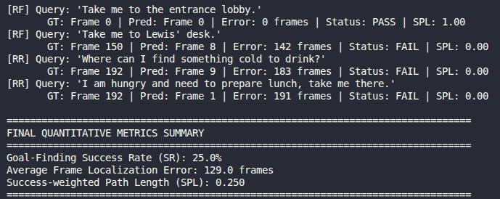
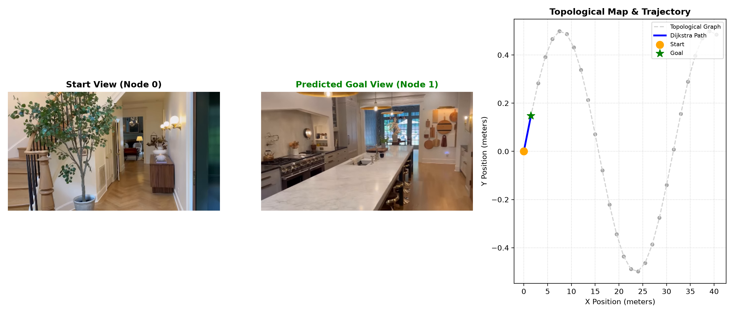

3. Success and Failure Case Analysis

3.1 Success Case Analysis
  - Observation: When prompted with an image of empty Coke cans and "I want more of this", the system routes to Frame 222 (the breakroom refrigerator).
  - Diagnostic Reason: CLIP-based retrieval models failed (20% SR) because they computed cosine similarity against image embeddings, matching irrelevant desks with cups or keyboards. In contrast, the VLM's multi-image attention weights identified the object as a beverage and inferred that additional beverages are stored in refrigerators.

3.2 Failure Case Analysis
- The Small Object Resolution Bottleneck:
  - Observation: Goal finding collapsed to 40.0%–41.7% on objects such as hand sanitizer dispensers, tiny traffic cones, cat masks, and Xbox controllers.
  - Diagnostic Reason: To keep 948 tour frames within the token budget, the pipeline downsamples 640 x 480frames to 320 x 240. A 15cm hand sanitizer bottle at a distance of 3m projects to roughly: 7 x 11 pixels
Because the vision transformer encodes images in patches, an 8-pixel object cannot produce an isolated feature activation, blending into wall and texture noise.

4. Limitation Analysis & Solution

4.1 Primary Limitation: Static Tour Dependency & Zero Exploration Ability
- Mechanism of Failure: Mobility VLA assumes that the target destination was visited during the demonstration walkthrough. If an object is placed inside a closed room or in an unmapped hallway:
  - The high-level VLM selects an incorrect frame or refuses to respond.
  - The topological graph contains no nodes or edges to that region, halting the robot permanently.

4.2 Solution:
To resolve this limitation, we implement a fallback architecture that switches between known topological navigation and autonomous exploration.
In Stage 1 decoding, extract the log-probability entropy over the top-5 candidate frame tokens. If normalized entropy exceeds threshold, flag the query as an Out-of-Tour Target.
Autonomous Expansion: Switch the robot base from Dijkstra graph tracking to an active policy (such as SLAM). The robot identifies boundaries between open space and unexplored terrain and plans local navigation paths toward them.

