Use Case diagram ATM:

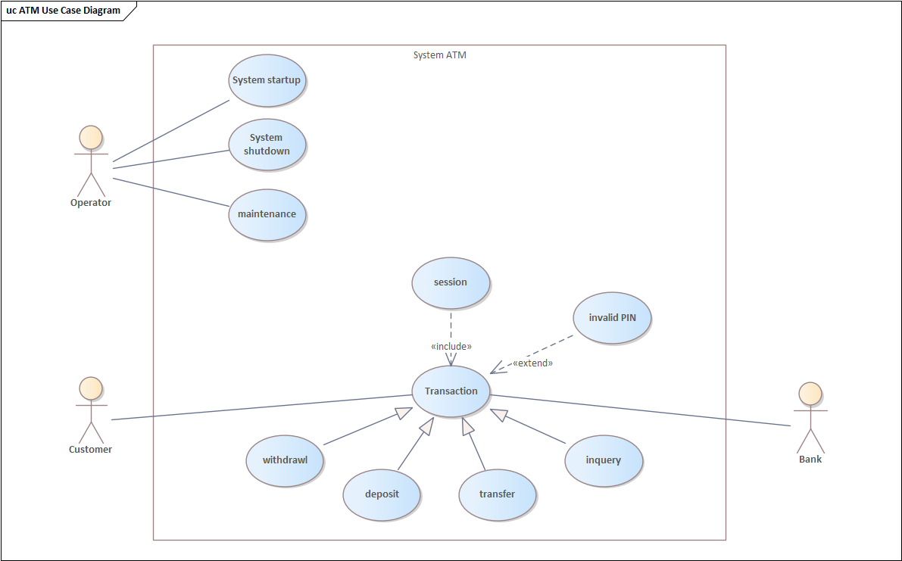

Class diagram ATM:

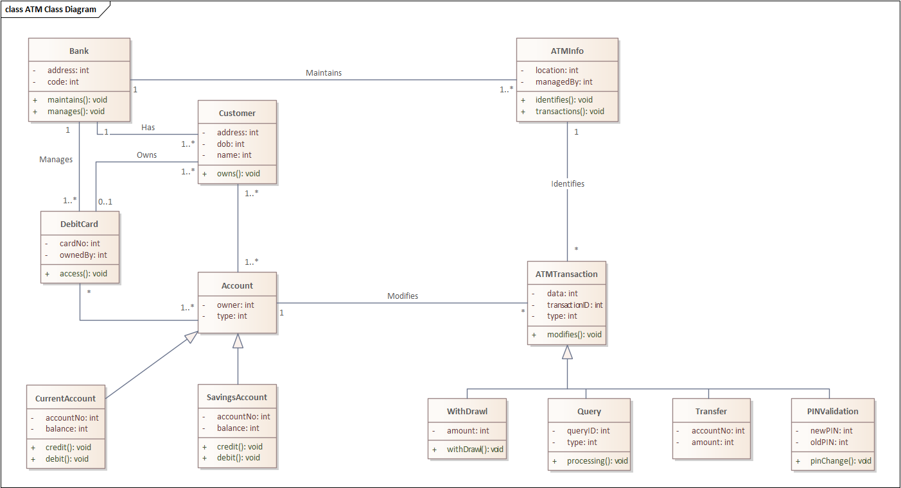

Drawl Sequence Diagram:

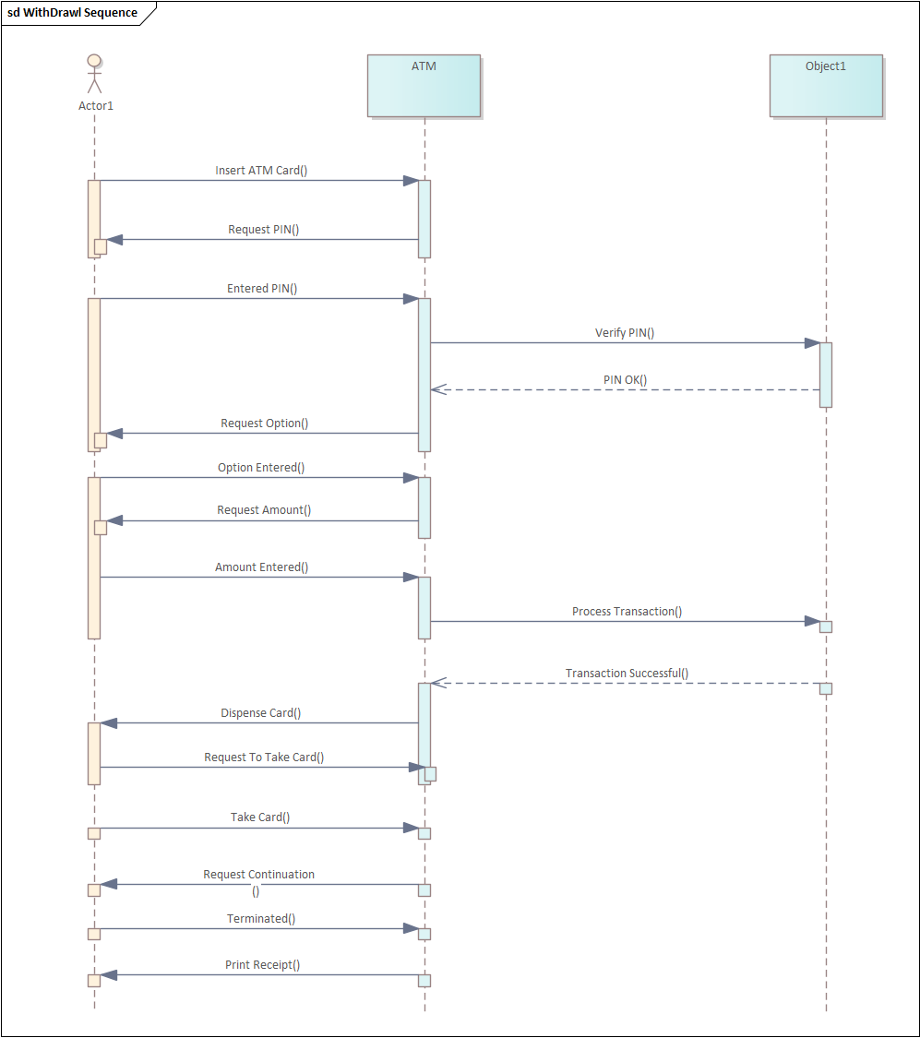

Statechart Diagram Drawl:

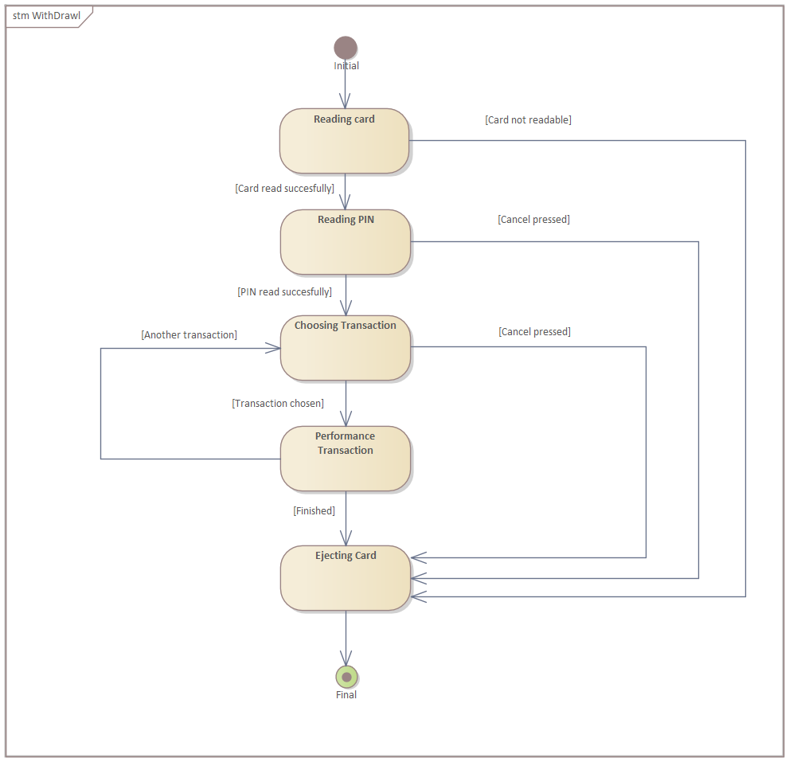

Component Diagram:

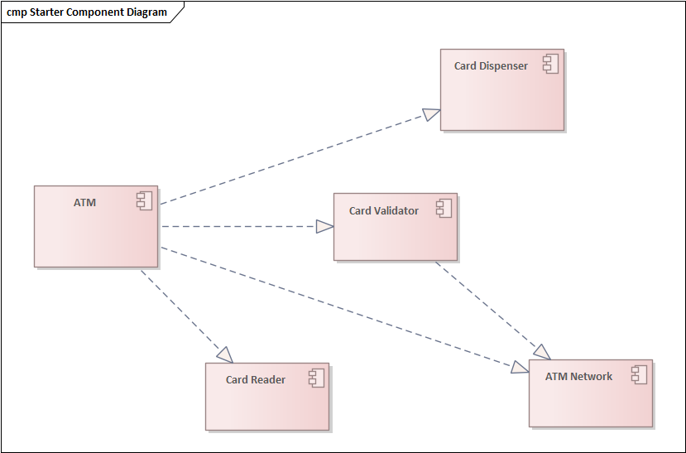

Deployment Diagram:

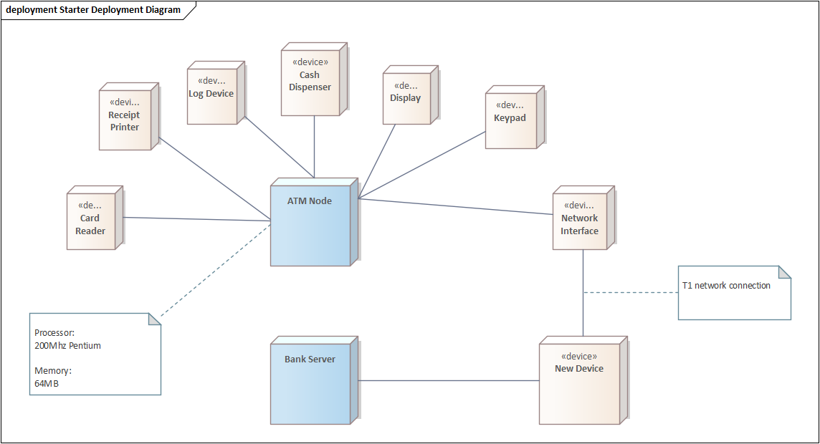

Activity Diagram:

