Description of the multi-target pest data set Pest24

The data set is mainly organized in the following three folders:
- JPEGimages: contains 25,378 high-quality multi-pest images photographed properly; all the images are in 'jpg' format, with a reduced resolution of 800*600 pixels for easy deep learning.
- Annotations: contains the annotation files in .xml and .csv formats, each for an image;
- ImageSets: We partitioned the whole data into a training set (12701), a validation set (5077) and a test set (7600) for pest detection evaluation. This fold contains three text files, train.txt, val.txt and test.txt, which record the file names of images in the training, validation and test data sets, respectively. Using the three files, users can easily collect the images in each of the three sets and their annotations from the first two folders for the training, validation and test data sets we used in our paper.

For the convenience of further investigation by other researchers, we also plan to publish the raw 28,958 high-quality images with a resolution of 2095*1944 pixels a raw data.

Structure of the annotation files
The annotation files are submitted in XML formats, each for an image with the same name. 'xml' is a commonly used descriptive markup language. Below is an example of a 'xml' file:

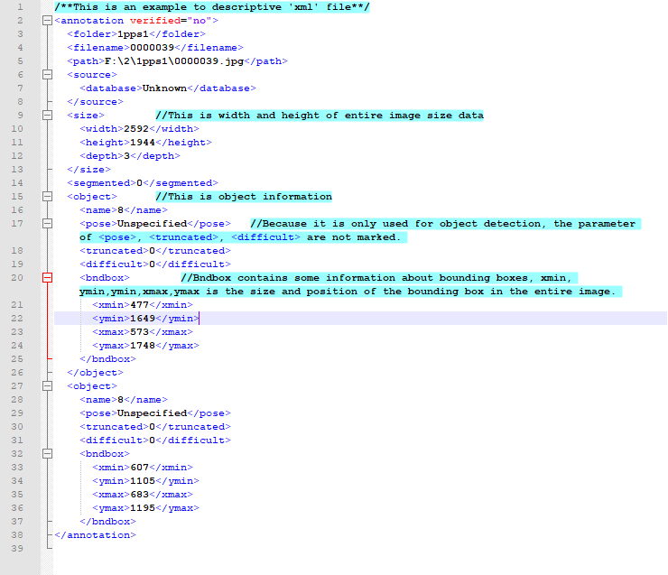
Fig. An example of ‘xml‘ files

About the pest images requirement

About All images of Pest24 were taken by a specialized automatic pest image acquisition device made by Institute of Intelligent Machine, Chinese Academy of Sciences, as shown in Fig. 1. The device can be setup in field and automatically traps and takes photos of field crop pests. In this work, we collected 28,958 raw images taken from 2017 to 2018, which involve 38 categories of crop pests required to be monitored by the Ministry of Agriculture of China. Pest24 only consider the rest 24 categories, which have more than 11 instances in all the images, as targets to be detected in the present work.
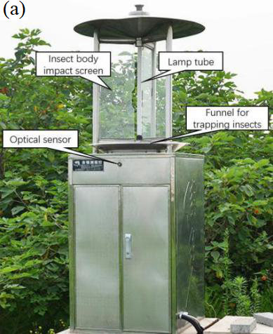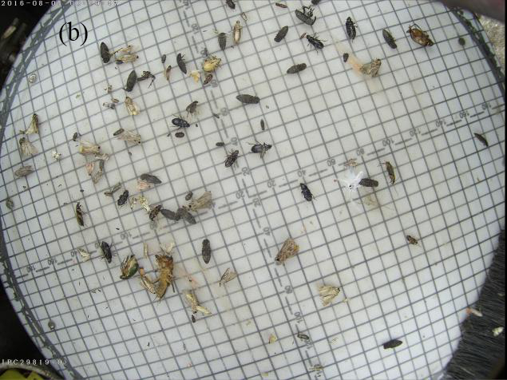
Fig. 1. Pest image acquisition. (a) The automatic mechatronic device used for collecting pest images and (b) an example of pest images acquired

About the 24 categories of pests
The 24 categories of pests belong to the 38 agricultural pests required to monitor by the Ministry of Agriculture of China. The taxonomy is shown in Fig.2. Table 1 lists the properties of the 24 classes of pests in Pest24, and Table 2 reports the numbers of images and instances of each pest category in Pest24.
Fig. 2 Taxonomy of the 38 agricultural pests required to monitor by the Ministry of Agriculture of China. The 24 pest categories present in Pest24 are in bold

Table 1 Description of the 24 classes of pests in Pest24
Index | Pest name | Portrait | Relative scale (%) | Color discrepancy | Index | Pest name | Portrait | Relative scale (%) | Color discrepancy
1 | Rice planthopper | 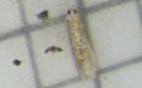 | 0.034 | 57.78 | 15 | Spodoptera cabbage | 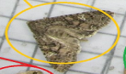 | 0.42 | 106.05
2 | Rice Leaf Roller | 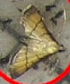 | 0.123 | 79.55 | 16 | Scotogramma trifolii Rottemberg | 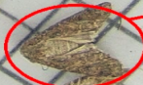 | 0.28 | 91.63
3 | Striped rice borer | 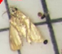 | 0.186 | 74.48 | 24 | Yellow tiger | 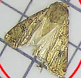 | 0.398 | 90.48
5 | Armyworm | 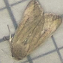 | 0.394 | 91.97 | 25 | Land tiger | 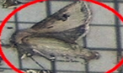 | 0.639 | 98.3
6 | Bollworm | 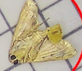 | 0.281 | 87.84 | 28 | eight-character tiger | 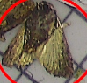 | 0.441 | 119.98
7 | Meadow borer | 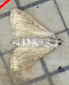 | 0.226 | 73.08 | 29 | holotrichia oblita | 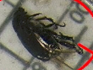 | 0.334 | 221.38
8 | Athetis lepigone | 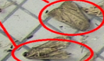 | 0.13 | 89.65 | 31 | holotrichia parallela | 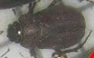 | 0.255 | 189.16
10 | Spodoptera litura | 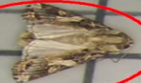 | 0.458 | 89.16 | 32 | Anomala corpulenta | 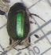 | 0.249 | 164.35
11 | Spodoptera exigua | 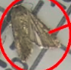 | 0.138 | 83.44 | 34 | Gryllotalpa orientalis | 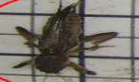 | 0.95 | 139.06
12 | Stem borer | 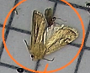 | 0.277 | 78.69 | 35 | Nematode trench | 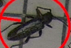 | 0.32 | 143.15
13 | Little Gecko | 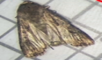 | 0.57 | 110.52 | 36 | Agriotes fuscicollis Miwa | 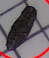 | 0.114 | 173.86
14 | Plutella xylostella | 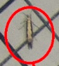 | 0.043 | 83.03 | 37 | Melahotus | 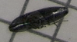 | 0.158 | 188.86
Note: "Index" denotes the index of each pest category in our data document. "Relative scale" denotes the proportion of each object in an image. "Color discrepancy" denotes the difference between the object color and the surrounding background color.

Table 2 Numbers of images and instances of each pest category in Pest24
Index | Pest name | images | instances |  | Index | Pest name | images | instances
1 | Rice planthopper | 316 |  | 1511 | 15 | Spodoptera cabbage | 1707 | 2302
2 | Rice Leaf Roller | 944 |  | 1240 | 16 | Scotogramma trifolii Rottemberg | 3223 | 4679
3 | Chilo suppressalis | 454 |  | 1285 | 24 | Yellow tiger | 1388 | 1686
5 | Armyworm | 3828 |  | 8880 | 25 | Land tiger | 369 | 475
6 | Bollworm | 9049 |  | 28014 | 28 | Eight-character tiger | 154 | 168
7 | Meadow borer | 5526 |  | 16516 | 29 | Holotrichia oblita | 90 | 108
8 | Athetis lepigone | 7520 |  | 30339 | 31 | Holotrichia parallela | 3111 | 11675
10 | Spodoptera litura | 1588 |  | 1951 | 32 | Anomala corpulenta | 5228 | 53347
11 | Spodoptera exigua | 3614 |  | 7263 | 34 | Gryllotalpa orientalis | 3629 | 6528
12 | Stem borer | 1357 |  | 1804 | 35 | Nematode trench | 118 | 167
13 | Little Gecko | 2503 |  | 4279 | 36 | Agriotes fuscicollis Miwa | 1814 | 6484
14 | Plutella xylostella | 531 |  | 953 | 37 | Melahotus | 239 | 768

