Hochschule Rhein-Waal

Rhine-Waal University of Applied Sciences

Faculty of Communication and Environment

**SPRINT 2 REPORT**

CI_4.03 Software Engineering

**Group 2:**

**Developer: Nguyen Dang Tien Loi (Scrum Master)**

**Developer: Dinh Quang Minh (Product Owner)**

**Developer: Edwin Changiyoga (Tester)**

**Reporter: Geeth (Reporter)**

Instructed by:

Pedro Ribeiro

Submission Date:

15 July 2020

Contents

Summary 3

1. Introduction 4

a. Sprint 2 Review: 4

b. Test Result: 7

2. Sprint 2 Retrospective: 9

a. Result of team’s inspection among themselves: 9

3. Conclusions 12

References: 13

Table of Figure

Figure 1: Sprint 2 Backlog 4

Figure 2: Picture Function 5

Figure 3: Register Function 6

Figure 4: Login Function 7

Figure 5: UML Class Diagram 9

Figure 6: Sprint Retrospective 11

# Summary

**Introduction:**

This Sprint 2 Report is aimed to provide an overview on the second phase of Development of the BioApp. As can be seen from the Sprint 2 Backlog, target of Sprint 2 is to complete the Login & Image Display Function, amend the App UI as instructor’s suggestions and Implement initial Test.

**Sprint 2 Review:**

Login & Register Function have been developed via insert user SQLite User table. User might insert Username & Password as wish and login after registration.

Image Display: Image of several Trees have been displayed on the List View. However it is hardcoded rather than assigned as User’s requirement and further development is needed.

App UI have been modified via User Testing by rearranging Button and List View to support User’s experience.

**Sprint 2 Retrospective:**

What was good ? Despite limited time due to Exam period, group still manage to finish Sprint 2 as scheduled.

What was bad ? Image Display is more complicated that expectation, we haven’t figure out how to save data in the virtual machine.

Further detail shall be discussed in the following pages.

# Introduction

In this course of Software Engineering, a group requires to create an application to show plant symbiosis with other plants. This application is created through a scrum agile system, which divides the period of working in the project as a sprint. At the end of each sprint, the sprint needs to be reviewed. The team also takes this time to inspect their working performance during the previous sprint. Not only that, the team also needs to discuss the next steps which are what-to-do for the next sprint. To archive the result of the last sprint review, the teams introspective, and the discussion about the future sprint; it’s necessary to create a report about it.

The sprint 2 report is the second report created during the project. As the name implied, the sprint 2 report contains the documentation regarding the 2nd sprint during 26 June until 15 July. The report shows the activity and the result of the project. The report also shows the result of the teams introspective on the team’s performance during the sprint. The report also should show the result of discussion for the third sprint. However, because of a lack of time, the third sprint became impossible. Thus, there is no discussion for the future sprint which left that specific part of the report empty.

# **Sprint 2 Review:**

The activities and results of the 2nd sprint:

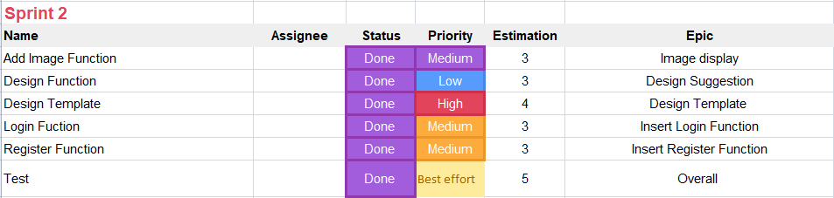

Figure 1: Sprint 2 Backlog

Component of application which have been finished:

* **Picture Function**

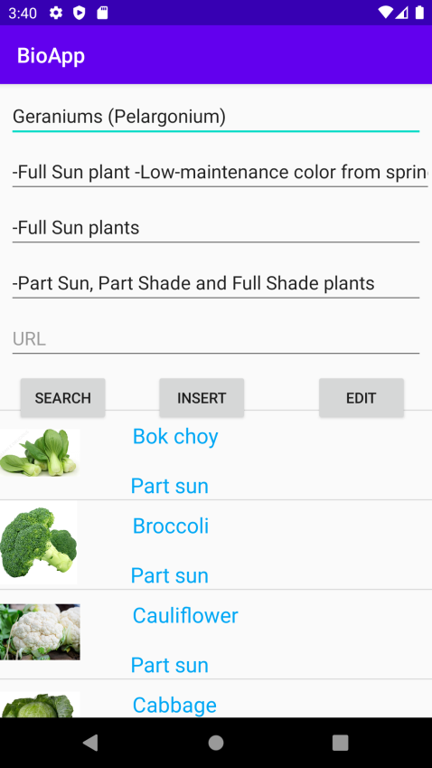

Figure 2: Picture Function

Now, the app can show pictures.

Log of activity:

* Provide a specialized space which will be used to show the picture.
* New codes which allow the program to show the hard-coded pictures.
* Add the pictures of plants into the database.
* Pictures cannot be freely selected by customers.
* ***Registration function***

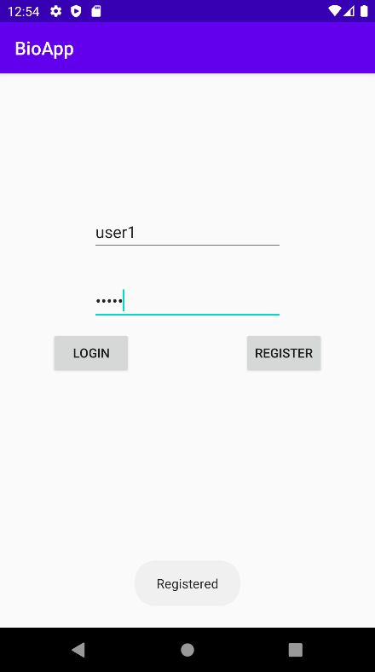

Figure 3: Register Function

The user can register into the app for more personalized use.

Log of activity:

* Add new button to register.
* Add a registration UI to put the information for registration.
* Fill the registration UI with form for new users to write in.
* Write the code to connect the main UI and the registration UI through the buttons.
* Create a new entry on database which will be used for saving user personal information.
* Write new codes for sending the info from the app into the database.
* Write the code to affirm that the user has successfully registered and returned to the main UI.
* ***Login function***

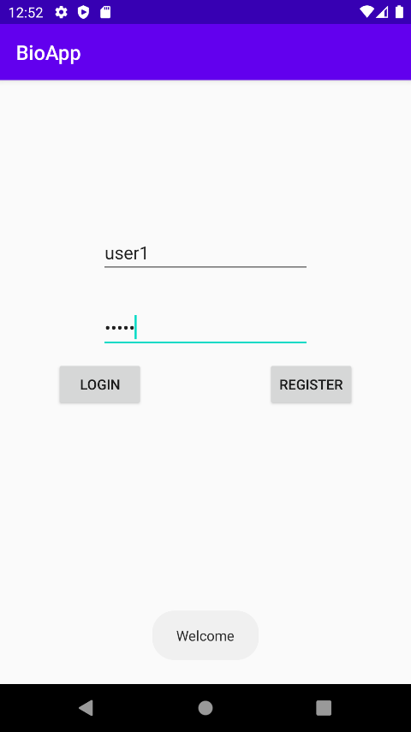

Figure 4: Login Function

When the user has registered to the app, they can log in to access their personal use.

Log of activity:

* Add new button to login.
* Add a Login UI to put credential such as username and password.
* Write the code that connects Main UI and Login UI through the button.
* Write the code to authorize the credentials that are written in the Login UI with credentials in the database.

# Test Result:

The test was conducted under 5 criteria, and the results are:

* ***UI Testing***

The app shows a clear interface without any visible bugs. Each textbox and button doesn’t block one another. The text is visible and doesn’t break the textbox.

* ***Rule based Testing***

The app has been imposed to do as it is told. Thus the app have been giving correct answer which corresponding with the question given.

* ***Regression Testing***

The app has received additional code in the system. The new code doesn’t seem to affect other code as the code is implemented independently.

* ***Functional Testing***

The app has been created with a lot of tools that help the user to use the app. Each role of widget in the app is working as intended.

* ***Security Testing***

The app security is good because the SQLite is local database.

**Review Check**

* ***Verifiability:***

The app can be realistically tested by the developers.

* ***Comprehensibility:***

The app is constructed logically. This allows developers to understand the application.

* ***Traceability:***

The origins of the requirements are clearly stated.

* ***Adaptability:***

Almost all of functions are implemented separately to reduce the influences to other functions.

**Detailed UML Class diagram** 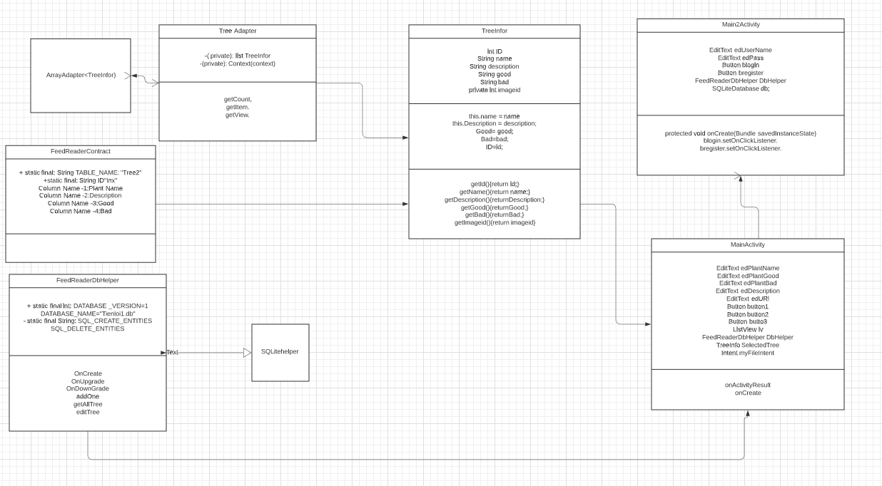

Figure 5: UML Class Diagram

# **Sprint 2 Retrospective:**

# **Result of team’s inspection among themselves:**

After some discussion, the result of the introspection is divided into 4 categories: what have gone well, what haven’t gone well, what have been learned, and what should be improved later:

***What have gone well?***

* In this busy time, the team still spends some time working on the project each day.
* The communication between team to prevent misunderstanding is satisfactory.
* The result of discussion is satisfying the purpose of discussion.
* All tasks have been managed and distributed efficiently.
* Problem can be finished with team efforts.

***What haven’t gone well?***

* A lack of time to actually finish the app.
* Discussion face to face is impossible to do.

***What have been learned?***

* How to effectively work as a scrum team.
* It’s better to do some research first before trying some technique.
* The correct picture of the plants.
* Understand the relations between the software and the client versus the software and the developers.
* Understand the boundary of the system which allows structured app development.
* Whatapps is one of the simple yet efficient group communication tools

***What should be improved later?***

* Preparation of the topic for the discussion to increase efficiency.
* Further understanding of agile development tool such as source tree.

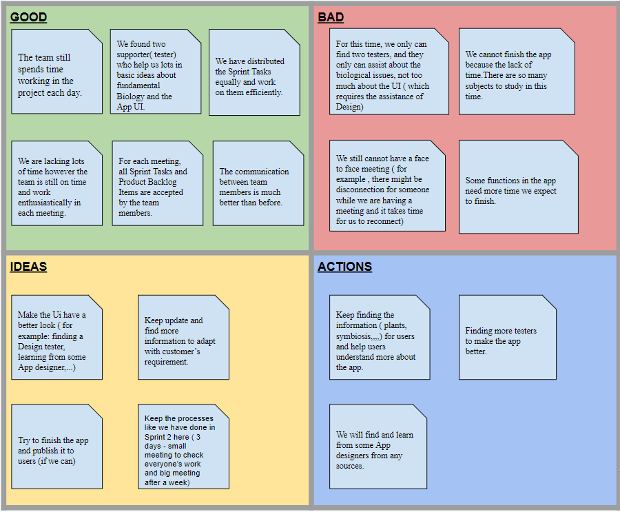

Figure 6: Sprint Retrospective

# Conclusions

The sprint 2 report shows the progress of the project. The project has received additional progress which can be categorized into three functions; picture function, registration function, and login function.

The tests result also satisfactory from 5 different kinds of tests which are UI test, rule based test, regression test, functional test, and security test. This review has complied with 4 standards which are verifiability, comprehensibility, traceability, and adaptability.

The retrospective of the team has been done. There are things that have gone well and have gone worse. However, it’s agreeable that there is a lot to learn from this experience.

# References:

CI_4.03 Software Engineering, SS2020: Pedro Ribeiro (M. Sc.).

<https://en.wikipedia.org/wiki/List_of_companion_plants>

<https://en.wikipedia.org/wiki/Symbiosis>

<https://www.youtube.com/watch?v=5d0bULrnCb8>

<https://www.youtube.com/watch?v=OkC7HKtiZC0&list=PLGLfVvz_LVvQ5G-LdJ8RLqe-ndo7QITYc> (All UML course).