OurBook+

Software Development Plan

Version <1.0>

Revision History

|  |  |  |  |
| --- | --- | --- | --- |
| **Date** | **Version** | **Description** | **Author** |
| 09/Nov/22 | 1.0 | First version of Software development plan document prepared for PA1.  Tasks:  Kỳ: write section 2, 3, 4.1, 4.2.3, 4.3, edit document  Uyên: write section 4.2.1, 4.3.1  Hoàng: write section 2.1, 4.2.2  Minh: write section 1, 4.3.2 | Đinh Mỹ Kỳ  Nguyễn Minh Uyên  Phạm Việt Hoàng  Trương Nhật Minh |
|  |  |  |  |
|  |  |  |  |
|  |  |  |  |

Table of Contents

**1.** **Introduction 4**

**2.** **Project Overview 4**

*2.1* *Project Purpose, Scope, and Objectives 4*

*2.2* *Assumptions and Constraints 4*

*2.3* *Project Deliverables 4*

**3.** **Project Organization 4**

*3.1* *Organizational Structure 4*

*3.2* *Roles and Responsibilities 4*

**4.** **Management Process 4**

*4.1* *Project Estimates 4*

*4.2* *Project Plan 4*

4.2.1 Phase and Iteration Plan 5

4.2.2 Releases 5

4.2.3 Project Schedule 5

4.2.4 Project Resourcing 5

*4.3* *Project Monitoring and Control 5*

4.3.1 Reporting 5

4.3.2 Risk Management 5

4.3.3 Configuration Management 6

Software Development Plan

# 

# Introduction

## 1.1 Purpose

- The Software Development Plan's goal is to collect all the information required for managing the project. It is the plan created and used by managers to guide the development effort, and it describes the methodology to develop the software.

- Users of the software development plan include the following:

+ Project manager: uses it to schedule the project, determine the resources needed, and monitor the progress.

+ Project team members: use it to comprehend what they need to do, when they need to do it, and which other activities they must rely on.

## 1.2 Scope

The OurBook+ project's overall plan is described in this software development plan.

## 1.3 Overview

This Software Development Plan contains the following information:

- Project Overview: gives an explanation of the goals, scope, and purpose of the project. Additionally, it outlines the products that the project is supposed to produce.

- Project Organization: describes the project team's organizational structure.

- Management Process: defines the the project’s estimated cost, key phases, project milestones, schedules, and specifies how the project will be monitored.

*Reference:* <https://sceweb.uhcl.edu/helm/rationalunifiedprocess/webtmpl/templates/mgmnt/rup_sdpln_sp.htm>

# Project Overview

## Project Purpose, Scope, and Objectives

Reading books is essential to broaden one’s knowledge. However, as far as we know, there is not any software for book readers to read 100% free books in both electronic and traditional printed formats. Thus, OurBook+ is a non-profit “bookshelf” for bidirectional interaction to share, read, borrow books. This makes reading books easier than ever: download pdf e-books or read e-books directly on our website, book appointments to borrow printed books. Also, anyone can be a contributor to build up the free bookshelf, even the readers can share their books to other users. Besides that, OurBook+ provides many interactive features such as Q&A, chat, etc. to enhance the community of book readers.

## Assumptions and Constraints

- There will be no more people added during the project

- The project has a fixed schedule of 11 weeks, so the time and schedule to complete each task must follow the plan for the project to be finished on time.

- Zero-budget project

## Project Deliverables

- Vision document

- Software Development Plan

- User Interface Design

- Database Design

- Use case

- Sprint reports

- Source codes

- Test plan

# Project Organization

## Organizational Structure

## Roles and Responsibilities

|  |  |  |
| --- | --- | --- |
| **Role** | **Person** | **Responsibilities** |
| Team Lead & Project Manager | Đinh Mỹ Kỳ | - Plan the project  - Assign tasks for members  - Keep track of each member’s work to ensure that tasks are completed on time  - Ensure the development is professional and ethical.  - Ensure software requirements (System and User requirements)  - Monitor the meetings  - Write weekly reports  - Edit documents and submit the group’s work |
| Implementer (Front end) | Đinh Mỹ Kỳ  Nguyễn Minh Uyên | - Write source code for web front end  - Review source code  - Collaborate with backend developers |
| Implementer (Backend) | Phạm Việt Hoàng  Trương Nhật Minh | - Write source code for web back end  - Review source code  - Collaborate with front end developers |
| Business Analyst | Nguyễn Minh Uyên  Đinh Mỹ Kỳ | - Clarify the purpose of the product  - Document requirements  - Communicate with team members about the requirement |
| UI/UX Designer | Đinh Mỹ Kỳ | - Design the user interface for the product based on product’s features and requirements  - Create UI prototype  - Communicate with team members about how user interface corresponds with product’s features |
| Database Designer | Phạm Việt Hoàng  Trương Nhật Minh | - Design the database schema for the product based on product’s feature  - Communicate with team members about how database corresponds with product’s features |
| Tester | Đinh Mỹ Kỳ  Nguyễn Minh Uyên  Phạm Việt Hoàng  Trương Nhật Minh | - Write test plan and test cases  - Perform test on different devices: computer, mobile phone, tablet |

# Management Process

## Project Estimates

- Project’s schedule:

The project is fixed in 11 weeks.

- Project’s cost:

We estimate the cost per hour for each member to do the project is $20. Each member needs to spend approximately 5 hours per week on average to complete his or her tasks of that week. The project spans for 11 weeks. Our team consists of 4 members.

Therefore, the estimated cost for our project is 20 x 5 x 11 x 4 = $4400

## Project Plan

### Phase and Iteration Plan

Section 4.2.1 provides overall plan according to each phase and iteration. Each phase includes starting date, ending date and overall objectives. The milestones are Start, M1, M2, M3, M4, and Finish along with some criterion.

|  |  |  |  |  |  |  |
| --- | --- | --- | --- | --- | --- | --- |
| **Disciplines** | **Inception** | **Elaboration** | |  | **Construction** |  |
|  | Sprint 1  (29/10-12/11) | Sprint 2  (12/11-26/11) | | Sprint 3  (26/11-10/12) | Sprint 4  (10/12-24/12) | Sprint 5  (24/12-7/01) |
| Business Modeling | 💎 Start |  | |  |  |  |
| Requirements |  | 💎 M1 | |  |  |  |
| Analysis & Design |  |  | | 💎 M2 |  |  |
| Implementation |  |  |  |  | 💎 M3 |  |
| Test |  |  | |  |  | 💎 M4 |
| Deployment |  |  | |  |  |  |
| Configuration and Change Management |  |  | |  |  |  |
| Project Management |  |  | |  |  |  |
| Environment |  |  | |  |  |  |

Finish 💎

|  |  |
| --- | --- |
| **Milestones** | **Criteria** |
| M1: Finish business modeling and requirements and environment (there is an additional week for editing) | + Business modeling and requirements should be clearly specified.  + The environment is determined based on group’s dicussion. |
| M2: Finish analysis and design, complete nearly half of the implementation, start Configuration & Change Management and half way through Project Management | + Analysis and design must fit the product’s features.  + Implementation must be done cooperatively between Front End and Back End, which means each task must be completed in both Front End and Back End before the team move to a new task.  + Implementation starts later than analysis and design (after the sketch UI design is completed).  + Project management: continue assigning tasks and keep track of tasks done by each member. |
| M3: In the 3rd phase of implementation, start testing and recheck the environment. | Keep implementing (writing source codes), fix identified bugs and start to perform unit test. |
| M4: In the last sprint of all disciplines, basically nearly finish, conduct tests again, prepare for deployment | + Fix all the bugs identified  + Complete the remaing feature (if there is any)  + Conduct tests again |
| Finish: Release | Expect to have 2 releases corresponds with deadline of PA5 and PA6 |

### Releases

There are 2 builds we will produce for testing. The schedule is as follows:

|  |  |  |
| --- | --- | --- |
| **Activity** | **Start date** | **End date** |
| Test case 1 + Report + Release 1 | 29/11/2022 | 12/12/2022 |
| Test case 2 + Report + Release 2 | 13/12/2022 | 7/01/2022 |

* + 1. *Project Schedule*

This section contains the detailed schedule of each tasks in each phase.







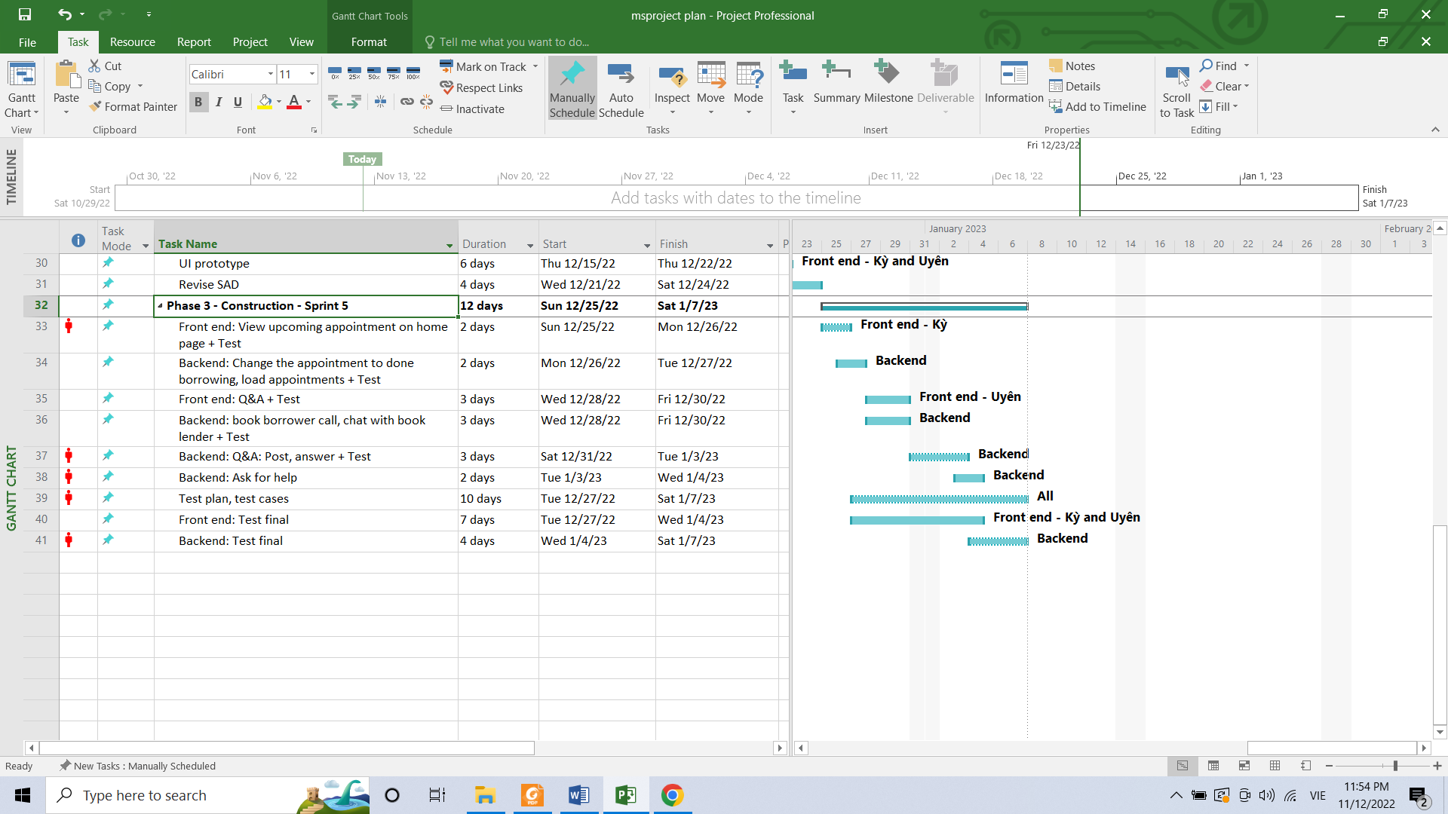

## Project Monitoring and Control

### Reporting

=========== 2/11, Sprint 1 ===============

Team members present:

Đinh Mỹ Kỳ

Nguyễn Minh Uyên

Trương Nhật Minh

Phạm Việt Hoàng

Team members absent:

None

Status reports:

* Đinh Mỹ Kỳ
  + Completed tasks
    - Present the UI design of the product to the team
    - Divide tasks for front end developers (Đinh Mỹ Kỳ and Nguyễn Minh Uyên)
    - Study web’s front end development
  + To-do Tasks
    - Front end: home screen, search book, view book details, borrow book
* Nguyễn Minh Uyên
  + Completed task
    - Study web’s front end development
  + To-do Tasks
    - Front end: share book, view cart, Q&A, Log in/ Sign up
* Trương Nhật Minh
  + Completed task
    - Study web’s back end development
  + To-do Tasks
    - Divide tasks between back end developers (Trương Nhật Minh and Phạm Việt Hoàng)
    - Back end development for project
    - Find dataset of books for the project
* Phạm Việt Hoàng
  + Completed task
    - Study web’s back end development
  + To-do Tasks
    - Divide tasks between back end developers (Trương Nhật Minh and Phạm Việt Hoàng)
    - Back end Development for project
    - Find dataset of books for the project

Actions (if any)

Summary of the meeting

Divide tasks between members and project manager (Đinh Mỹ Kỳ) presents her UI design.

=========== 9/11, Sprint 1 ===============

Team members present:

Đinh Mỹ Kỳ

Nguyễn Minh Uyên

Trương Nhật Minh

Team members absent:

Phạm Việt Hoàng (got sick, but already communicate with team on the meeting’s topic)

Status reports:

* Đinh Mỹ Kỳ
  + Completed tasks
    - Prepare for section 2 (Positioning) of vision document, 4.3.2 (Risk Management) of software plan document.
    - Study web’s front end development
    - Assign tasks of front end and backend for the next week
  + To-do Tasks
    - Divide tasks for members to complete vision and software plan document
    - Write vision and software plan document
    - Do Front end of home screen first
* Nguyễn Minh Uyên
  + Completed task
    - Study web’s front end development
  + To-do Tasks
    - Write vision and software plan document
    - Do Front end of Log in/Sign up first
* Trương Nhật Minh
  + Completed task
    - Study web’s back end development
    - Define the first 2 important backend tasks: Minh will do Login/Signup, Hoàng will find data of books
  + To-do Tasks
    - Identify all the remaining tasks for backend
    - Write vision and software plan document
    - Do Backend Login/Signup first
    - Design database together with Hoàng

Actions (if any)

Summary of the meeting

Discuss on section 2.1, 2.2, 3.1, 3.2 of vision document. Assign tasks for front end, backend to complete first. Need to complete vision and software plan document together before deadline

### Risk Management

|  |  |  |  |  |  |
| --- | --- | --- | --- | --- | --- |
| *Risk ID* | *Risk Description* | *Probability* | *Impact* | *Priority* | *Mitigation Strategy or Contingency Plan* |
| 1 | Estimation: Time estimated for each task (the initial plan) is not enough for implementation | Seldom  (7%) | Serious  3 | 21 | If there’s still time left, we can reschedule the whole plan to prioritize more important features. |
| 2 | People: Members may have some sudden works or get sick so they cannot attend the meeting for discussion on project | Seldom  (7%) | Serious  3 | 21 | Either reschedule the meeting or record the meeting if the absent member’s role is not necessary in that meeting. |
| 3 | Technology: The new technology is used in the project when most members are not familiar, so the team members may have some difficulties implementing during the process | Ocassional  (10%) | Moderate  2 | 20 | Members who already know how to use it will train those who don't know how to use. |
| 4 | Requirements: Users may not be familiar with how to use the software | Seldom  (7%) | Moderate  2 | 14 | A thorough guide on how to use the software is provided with the finished product. |
| 5 | Technology: Some sudden changes in code cause misunderstanding | Unlikely  (3%) | Serious  3 | 9 | Discuss about each member’s code |

### 

### Configuration Management

*-* Github: collaborate coding, upload submitted docs and project assignments.

- Google drive: store and share documents, files to write together for each sprint.

- Trello: manage, assign tasks and keep track of tasks for each sprint.

- Slack, Messenger: discuss on the project