Lò Ấp Trứng

IOT Project Report



Student: Do Dinh Nam

ID: HE150684

Class: SE1604

TAble of  
Contents

**"Lo Ap Trung" ..………………………………………………………..……. 3**

**Hardware required ……………………………………………………..…. 3**

**Circuit …………………………………………………………………..……… 4**

**Code …………………………………………………………………………….. 5**

“Lò Ấp Trứng”

In this project, I design a system to check the temperature of “Lo Ap Trung”. I use a temperature sensor to measures ambient temperatures of the room and display on LCD. When the temperature is lower 35*C or higher than 39*C, the red LED will blink and piezo ring like an alarm to notice user that the temperature is out of safe range. When temperature is from 35*C to 39*C the green LED will lighting and the piezo is off to show that the temperature is safe for the eggs.

Hardware required

* Arduino Uno R3
* LCD 16x2
* Temperature Sensor [TMP35]
* (4x)331 Ohm Resistor
* 20k Ohm Potentiometer
* Green LED
* Red LED
* Piezo

Circuit

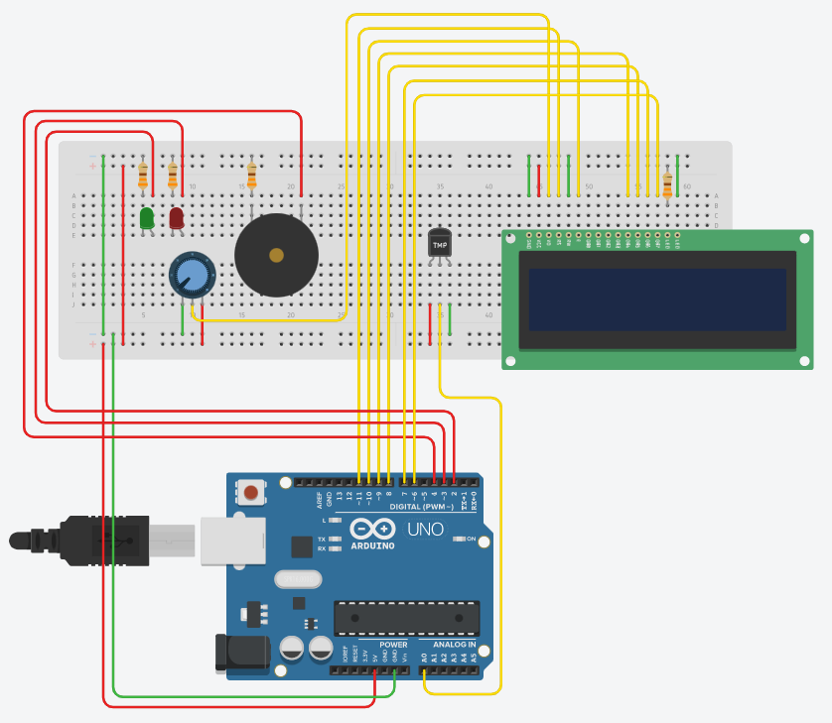

Code

// C++ code

//

#include <LiquidCrystal.h>

const int rs = 11, en = 10, d4 = 9, d5 = 8, d6 = 7, d7 = 6;

LiquidCrystal lcd(rs, en, d4, d5, d6, d7);

int val;

int tempPin = 0;

int greenPin = 2;

int redPin = 3;

void setup() {

pinMode(greenPin, OUTPUT);

pinMode(redPin, OUTPUT);

pinMode(10, OUTPUT);

lcd.begin(16, 2);

Serial.begin(9600);

}

void loop() {

val = analogRead(tempPin);

float mv = ( val/1023.0)*5000;

float cel = mv/10;

lcd.setCursor(0, 0);

lcd.print("Temprature:");

lcd.setCursor(0,1);

lcd.print(cel);

lcd.print(" Celcious");

delay(500);

if(cel >= 35 && cel <= 39) {

digitalWrite(redPin, LOW);

digitalWrite(greenPin, HIGH);

} else {

digitalWrite(greenPin, LOW);

digitalWrite(redPin, HIGH);

delay(300);

digitalWrite(redPin, LOW);

delay(300);

tone(4, 523, 100);

}

}