# 4 tiêu chí:

+ task achievement: khả năng trả lời vấn đề bài thi đưa ra

+ coherence and cohesion: tính gắn kết và liền mạch của các câu và đoạn văn

+ lexical resource: vốn từ vựng được sử dụng trong bài

+ grammatical range and accuracy: biết và sử dụng chính xác các cấu trúc ngữ pháp

# Cách phát triển idea, công thức PEERI:

+ point luận điểm chính rõ ràng (what).

+ explain giải thích cho luận điểm (how/ why).

+ example ví dụ cụ thể, khách quan (không lấy ví dụ quá personal/ ví dụ phải khách quan: thương hiệu nổi tiếng trên thế giới,).

+ result việc đó ảnh hưởng tới cá nhân, gia đình, xã hội, môi trường như thế nào?

+if câu lật lại vấn đề (nếu không… thì …- điều kiện loại 1) khẳng định chắc chắn hơn idea mình đã nói.

* **VD: Young people leave rural areas to study or work in cities. What r the advantages and disadvantages?**

AD:

*+ id1: better job opportunities (point)*

Explain: most large companies and organizations ather in the urban areas

Example: FPT or Samsung

Result: Increase the chance of having a well-paid job

If: live in the countryside => difficult to find jobs

*+ id2: better education systems*

Explain: most good schools and famous universities and center education more than in the countryside

Major cities have more prestigious university

Example: qualified expert, modern facilities (chuyên gia chuyên môn cao, cơ sở vật chất hiện đại)

Result: better studying experience and higher quality qualification => contribute to their career success

If: study in rural areas => difficult to compete in the job market

DISA:

*+ Id1: high living cost*

Explain: In cities, the fee for everything always gets at a high level

Example: About fee moving, daily fee. Cant make, plant by ourself, must buy everything from outside.

We need to buy everything at supermarket or market with higher fees instead of planting vegetable at garden or buy everything with lower fees at rural place

Result: Increase daily fees, saving money is very important

If: live in the countryside => it is easier to control fee than life city.

*+ Id2: higher unemployment rates*

Explain:

Example:

Result:

If:

# Các dạng đề essay writing

------------------------------------------------------------------------------------------------------------

## Discussion: thảo luận về 2 mặt của vấn đề

Ex: discuss both views and give ur opinion/ is this a positive or negative development/ do the advantages outweigh the disadvantages?

1. Intro: câu 1 nêu ngữ cảnh (paraphase đề bài). câu 2 trả lời đề bài. mẫu câu trả lời đề bài: while there are several N(s/es) (view 1), I argue that (view 2)
2. Body1: bàn về view 1- quan điểm mình không đồng ý

On the one hand, …

Furthermore, …

1. Body2: bàn về view 2- quan điểm mình đồng ý

However, …

On the other hand, I content that…

*(Nếu viết cả hai idea 1 phía => dễ bị bí idea)*

*(Nếu viết hai idea trái nhau => luận điểm mạnh mẽ hơn)*

1. Conclusion: 1 câu paraphase intro

In conclusion, although (view1), I believe that (view2)

1. **Ví dụ:**

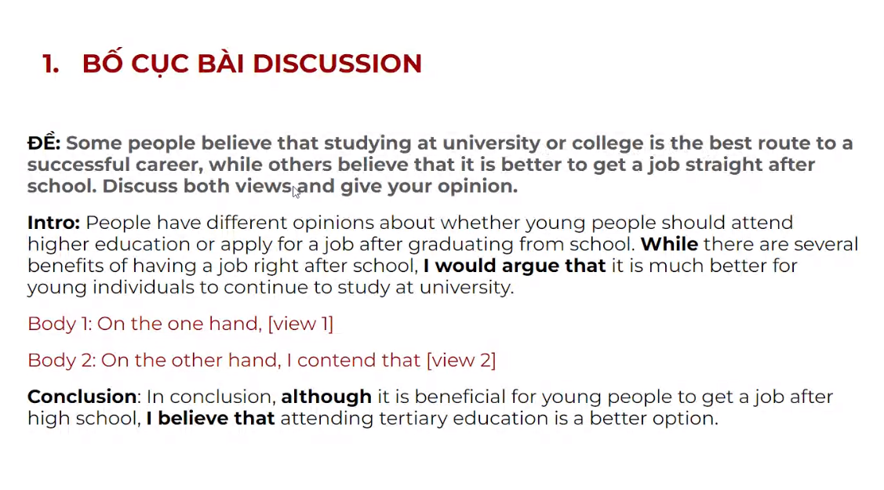

*Đồng ý: lên đại học đi học*

*Không đồng ý: sau tốt nghiệp đi làm luôn*

**Body1**: On the one hand, (view1)

**Body2**: On the other hand, I content that (view2)

------------------------------------------------------------------------------------------------------------

## Opinion: Nêu ý kiện và bảo vệ quan điểm

### 2 view

Ex: Do u agree or disagree

***(Captured)***

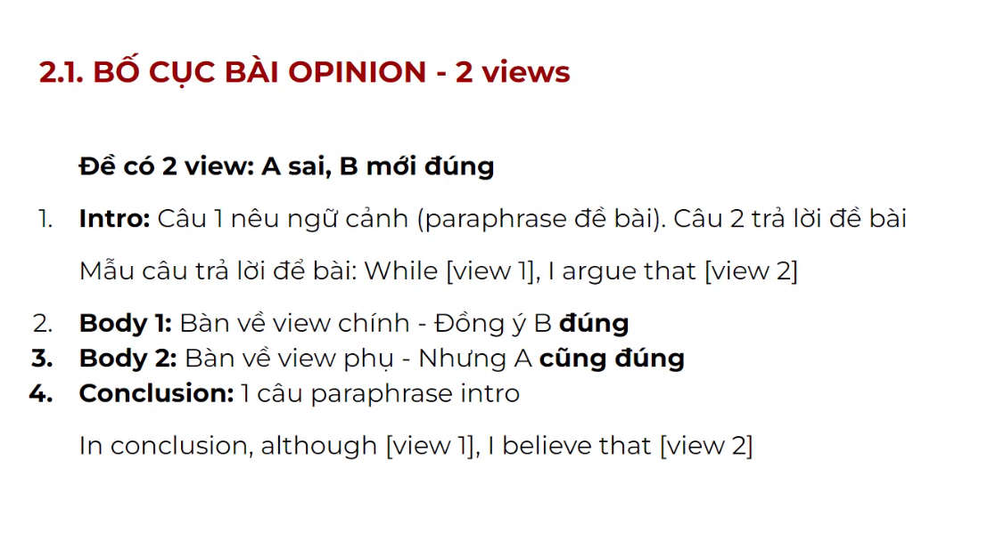

**VÍ DỤ**

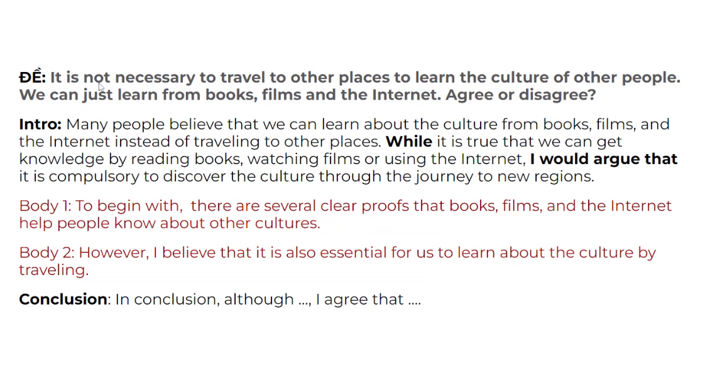

**Body1**: *To begin with, there are several* clear proofs that books, films, and the Internet help people know about other cultures.

Furthermore, …

**Body2**: *However, I believe that* it is also essential for us to learn about the culture by travelling.

Conclusion: In conclusion, although …, I agree that …

**Ví dụ 2:** Some people say that the government should not invest in space exploration. They should spend more money on peoples live. Do you agree or disagree?

**Intro1**: At nearly time, we have paid billions of dollars to invest in space exploration. But many people think that the government should spend money on human life instead of investing in planetary science. While it is true that the life of citizens can be better if citizens have money support from the government, I argue that it is also important to invest in space exploration.

*Intro2*: Many people believe that government should spend more money on their citizen live instead of space exploration. While it is true that people's lives could be improved if the government spent more money on them, I would argue that it is also important to invest in space exploration.

*Sample1:* Many people believe the government should pay attention to their people's lives instead of allocating funds to explore the space.

*Sample2:* Human life and space exploration are essential. While it is true that we should spend more money on people's lives, I would argue that we need to invest in exploring the universe.

*Sample3:* Many people believe the government should spend more money on people's lives than investing in space exploration. While investing in space exploration helps the government discover new information, I would argue that they should spend more money on people’s live.

*Sample4:* Many people believe that government should pay more attention to taking care of people's lives instead of investing in space exploration. While it has several benefits for broadening our knowledge and horizons, I would argue that government should pay more fund on people's lives.

***TEACHER’S SAMPLE:***

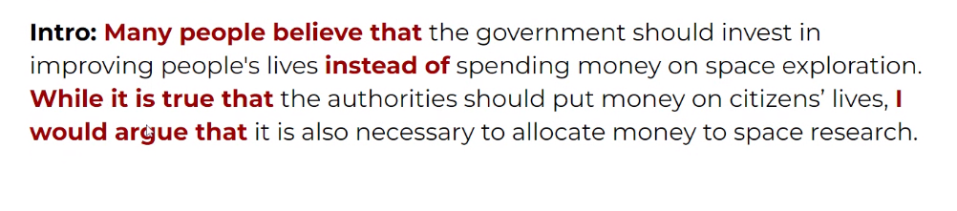

***Example:***

Some people think that all teenagers should be required to do unpaid work in their free time to help the local community. They believe this would be benefit both the individual teenager and society as a whole  
Do you agree or disagree?

**In recent times, many people think that the young generation should take part in charity activities to improve human life and help poor people pass difficult times instead of spending time on useless joy in their spare time. While it is true because it has useful for society and other humans, I would argue that it is also essential for teenagers to have many experiences in growing times.**

Recently, many people think that the young generation should participate in charity work to help people with disadvantages and strengthen the community in their spare time instead of doing non-beneficial activities. I strongly agree with this opinion because it brings many benefits to society, I also believe that it is essential for the young generation.

------------------------------------------------------------------------------------------------------------

### 1 view

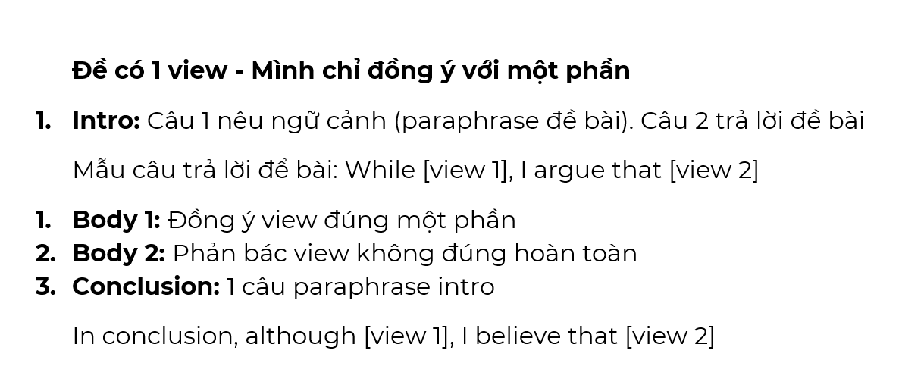

ĐỀ: Whether or not someone achieve their aims mostly by luck. Agree or disagree?

**Intro**: Opinions differ as to whether or not luck contributes to someone’s success. While luck is an important role to support people to accomplish their goals, I would argue that hard work and determination are much more vital factors contributing to the achievements of an individual.

=>

**Introduction:**

There are several opinions content that luck can decide to success of each people. while it is true that luck is a key point to decide the successful career of one person, I would argue that with other luck, we need to do hard work, have a passion, and attempt to archive our goal.

***Body 1:*** *On the one hand, I believe that*

*Furthermore, …*

***Body 2:*** *On the other hand, I would argue that*

***Conclusion:*** *In conclusion, although …, I believe that ….*

* aim = success = achievement = goal
* important = essential = vital
* A play an important role in B
* crucial = vital = essential
* Point: Hard work plays an important role in someone's success

+ explain: when we hard work in studying at school, we can get higher-score in a test, an exam because we spend many times on learning new knowledges and new skills. therefore, we can focus on doing homework, and should be able to get many experiences at all.

+ example:

+ result:

+ if:

------------------------------------------------------------------------------------------------------------

## Cause- Effect- Solution

Ex:

**Intro**: Trong thời buổi công nghệ thông tin phát triển, chúng ta có nhiều cách để tiếp cận các tài nguyên thông qua máy tính, nhưng dường như càng ngày càng có nhiều trẻ em sử dụng chúng để chơi game dẫn đến nhiều hậu quả xấu. Chính vì thế, chúng ta cần phải có những giải pháp để giảm thiểu vấn đề xấu này đang xảy ra. Bài tiểu luận này sẽ nêu ra từng vấn đề và giải pháp cho từng vấn đề đó.

**Conclusion**: Mặc dù khó có thể đạt hiệu quả một cách nhanh chóng, nhưng tôi tin những giải pháp của mình sẽ giúp hạn chế một cách hiệu quả và thay đổi thói quen sử dụng cho trẻ em.

**Đề bài nêu một vấn đề, hỏi về 2 trong 3 yếu tố**

1. **Intro:** Câu 1 nêu ngữ cảnh (paraphrase đề bài). Câu 2 nêu [mệnh đề 1], and [mệnh đề 2]

Mẫu câu trả lời để bài:

There are several causes of this phenomenon, and a number of feasible solutions should be adopted to tackle this problem. This essay will outline each of these problems and the solutions to each of them.

1. **Body 1:** Nêu 2 causes/effects
2. **Body 2:** Nêu 2 effects/solutions
3. **Conclusion:** 1 câu paraphrase intro

**MẪU CÂU TRONG BÀI CAUSE - EFFECT – SOLUTION**

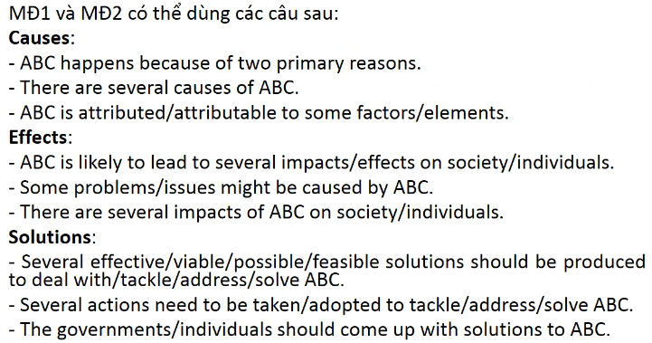

**ĐỀ: People today do not feel safe either at home or when they are out. What are the causes & solutions?**

**Intro:** Nowadays, people are increasingly insecure not only when they are at home but also when they go out. There are several causes of this phenomenon, and a number of feasible solutions should be adopted to tackle this problem.

Body 1: There are two reasons why people are afraid of going out or staying at their houses.

Body 2: In order to reduce the fears of citizens, governments should come up with several solutions.

**Conclusion**: In conclusion, although many issues make people feel unsafe in their own houses or in public, there are several effective ways to address these problems.

* Today = Nowadays = These days = In this day and age
* not only… but also…
* set a severe regulation/law, severely fine, ...

1. Intro:
2. Cause:
3. Effect:
4. Solution:

------------------------------------------------------------------------------------------------------------

* Thematic essay:

1. Intro (thesis statement)
2. Body (3 paragraphs) Relevant arguments and examples
3. Conclusion Wrap everything up

* For-then-against essay:

1. Body 1: Advantage
2. Body 2: Disadvantage

* A summary: Single piece of text

A synthesis: Several text into a single one

<http://explainwell.org/index.php/table-of-contents-synthesize-text/summary-and-synthesis-what-is-the-difference/>

Summary là quá trình tóm tắt thông tin một cách ngắn gọn, trung thực và đầy đủ về một văn bản, một bài báo hoặc một đoạn văn. Mục đích của Summary là cung cấp cho người đọc một cái nhìn tổng quan về nội dung của bài viết trong thời gian ngắn nhất. Một summary tốt phải truyền tải được những ý chính của bài viết mà không bỏ lỡ những thông tin quan trọng và phải sử dụng ngôn từ và cấu trúc câu súc tích, dễ hiểu.

Synthesis là quá trình kết hợp hoặc tổng hợp các thông tin từ nhiều nguồn khác nhau để tạo ra một cái nhìn mới hoặc đưa ra một quan điểm mới. Mục đích của Synthesis là tạo ra một sản phẩm mới từ các thông tin và ý kiến đã có sẵn. Trong quá trình Synthesis, người viết phải phân tích, so sánh và kết hợp các thông tin từ các nguồn khác nhau để tạo ra một ý tưởng mới hoặc giải quyết một vấn đề.

* Tóm lại, Summary là quá trình tóm tắt thông tin một cách ngắn gọn và đầy đủ, trong khi Synthesis là quá trình tổng hợp và kết hợp các thông tin từ nhiều nguồn khác nhau để tạo ra một quan điểm mới hoặc sản phẩm mới.

------------------------------------------------------------------------------------------------------------

* **💡** Nếu từ chỉ có 1 âm tiết: **ADJ/ADV + đuôi -er + than**

VD: Nam is **taller than** me.  
Nam **cao hơn** tôi.  
→ **tall**là tính từ ngắn nên dạng so sánh hơn là **taller**.

**💡** Nếu từ có 2 âm tiết trở lên:**more + ADJ/ADV + than**

**VD:** This problem is **more difficult** **than** that one.  
Vấn đề này **khó hơn** vấn đề kia.  
→ **difficult** là tính từ dài nên dạng so sánh hơn là **more difficult**.

* **💡** Nếu từ chỉ có 1 âm tiết: **the + ADJ/ADV + -est**

VD: Nam is **the tallest** student in his class.  
Nam là học sinh **cao nhất** trong lớp.  
→ **tall**là tính từ ngắn nên dạng so sánh nhất là **the** **tallest**.

**💡** Nếu từ có 2 âm tiết trở lên:**the + most + ADJ/ADV**  
VD: This is **the most difficult** problem in the book.  
Đây là vấn đề **khó nhất** trong sách.  
→ **difficult**là tính từ dài nên dạng so sánh nhất là **the most difficult**.

* **short adj/adv- er and short adj/adv- er**

**The living standard is getting better and better.**

Chất lượng cuộc sống càng ngày càng trở nên tốt hơn.

**more and more + long adj/ adv**

**Your clothes are more and more fashionable!**

Quần áo bạn càng ngày càng thời trang đấy!

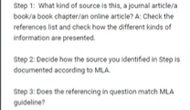

* Compare and Contrast
* Thesis:

While S1 and S2 means of communication are similar in N1, they differ in regard to their N2

**…. However**, instead …. This essay will compare the two opinions and =>

+ choose the most preferred one.

**+ discuss about the similarities and differences between 2 arguments.**

* Body1_Similarity:

One similarity between S1 and S2 about N relate to N.

**First**, …. **One of the most important reasons is …. For example**, …. **In addition**, ….

* Body2_Differently:

However, there are clearly many differences in the way V, the most notable of which is N1.

Another significant difference is N2.

**On the other hand**, … **One reason is that …** **For instance**, … **Also**,

* **Summary:**

**To sum up**, … is better than … While …

VD: **Question:**

Some people want to live in a house while others prefer living in an apartment. Does living in a house bring more advantages than living in an apartment?

**Sample answer:**

Many people argue that living in a house is the greatest choice. **However**, others**instead**want to live in a flat. This essay will compare the two opinions and choose the most preferred one.

**First**, there are definitely some advantages to living in an apartment. **One of the most important reasons** is that it provides great comfort. The apartment is part of a larger building, giving the feeling of living in a small social association that is responsible for any necessary repairs, or maintenance. **For example**, if the roof needs to be fixed, the landlord pays for the repairs. **In addition**, there are various amenities and facilities nearby, including shopping centers, education centers, medical stores, bus stops, and more.

**On the other hand**, living in your own house does not provide the facilities you can enjoy when living in a flat. **One reason is that** living in a house with a large area is quite lonely. It also brings boredom and takes away the joy of living with so many people around. **For instance**, sitting alone in a garden with no one around to share life experiences would be a boring experience. **Also**, the maintenance and cleaning of the house is the responsibility of the owner, so living in the house is expensive.

**To sum up**, living in an apartment is better than living alone in a house. While a home provides a large and spacious moving area, living in an apartment enhances social interaction and adds fun to life.