

**CAR RENTAL MANAGEMENT SYSTEM**

**Software Design Document**

– Hanoi, August 2019 –

**Table of Contents**

**I. Overview** **8**

1. Code Packages/Namespaces 8

2. Database Design 8

**II. Code Designs** **13**

1. Manage order car/ View order list 13

a. Class Diagram 13

c. Class Specifications 13

c. Sequence Diagram(s) 14

d. Database queries 14

2. Manage order car/ View order details 14

a. Class Diagram 14

b. Class Specifications 14

c. Sequence Diagram(s) 15

d. Database queries 15

3. Manage order car/ Extra surcharge 16

a. Class Diagram 16

b. Class Specifications 16

c. Sequence Diagram(s) 17

d. Database queries 17

4. Manage order car/ Accept order, Cancel order, History/Cancel booking 17

a. Class Diagram 17

b. Class Specifications 17

c. Sequence Diagram(s) 18

d. Database queries 18

5. History/ View list booked car 18

a. Class Diagram 18

b. Class Specifications 19

c. Sequence Diagram(s) 19

d. Database queries 19

6. History/ View booking details 20

a. Class Diagram 20

b. Class Specifications 20

c. Sequence Diagram(s) 21

d. Database queries 21

7. History/ Edit booking 21

a. Class Diagram 21

b. Class Specifications 21

c. Sequence Diagram(s) 22

d. Database queries 22

8. History/ Feedback 23

a. Class Diagram 23

b. Class Specifications 23

c. Sequence Diagram(s) 24

d. Database queries 24

9. Car rental/ Find car 24

a. Class Diagram 24

b. Class Specifications 24

c. Sequence Diagram(s) 25

d. Database queries 25

10. Car rental/View list car 25

a. Class Diagram 25

b. Class Specifications 25

c. Sequence Diagram(s) 26

d. Database queries 26

11. Car rental/ View detail car 26

a. Class Diagram 26

b. Class Specifications 26

c. Sequence Diagram(s) 27

d. Database queries 27

12. Car rental/ Car rental 27

a. Class Diagram 27

b. Class Specifications 27

c. Sequence Diagram(s) 28

d. Database queries 28

13. Car rental/ View feedback 28

a. Class Diagram 28

b. Class Specifications 28

c. Sequence Diagram(s) 29

d. Database queries 29

14. Car rental/ Add driving license 29

a. Class Diagram 29

b. Class Specifications 29

c. Sequence Diagram(s) 30

d. Database queries 31

15. Individual 31

a. Class Diagram 31

b. Class Specifications 31

c. Sequence Diagram(s) 32

d. Database queries 32

16. View address 32

a. Class Diagram 32

b. Class Specification 32

c. Sequence Diagram(s) 33

d. Database queries 33

17. Add address 33

a. Class Diagram 33

b. Class Specification 34

c. Sequence Diagram(s) 34

d. Database queries 35

18. Account information 35

a. Class Diagram 35

b. Class Specification 35

c. Sequence Diagram(s) 36

d. Database queries 36

19. Verification driver’s license 36

a. Class Diagram 36

b. Class Specification 37

c. Sequence Diagram(s) 38

d. Database queries 38

20. Verification email 38

a. Class Diagram 38

b. Class Specification 39

c. Sequence Diagram(s) 39

d. Database queries 39

21. Edit information 39

a. Class Diagram 39

b. Class Specification 40

c. Sequence Diagram(s) 41

d. Database queries 41

22. Change password 41

a. Class Diagram 41

b. Class Specification 42

c. Sequence Diagram(s) 42

d. Database queries 42

23. My Car 42

a. Screen Design 42

b. Class Diagram 43

c. Class Specifications 43

d. Sequence Diagram(s) 44

e. Database queries 44

24. Car Information 45

a. Screen Design 45

b. Class Diagram 45

c. Class Specifications 46

d. Sequence Diagram(s) 47

e. Database queries 48

25. Add New Car 48

a. Class Diagram 48

b. Class Specifications 49

c. Sequence Diagram(s) 51

d. Database queries 52

26. Login 52

a. Class Diagram 52

b. Class Specifications 52

c. Sequence Diagram(s) 53

d. Database queries 53

27. Register 54

a. Class Diagram 54

b. Class Specifications 54

c. Sequence Diagram(s) 54

d. Database queries 55

28. Forget Password 56

a. Class Diagram 56

b. Class Specifications 56

c. Sequence Diagram(s) 56

d. Database queries 57

29. Support 57

a. Class Diagram 57

b. Class Specifications 58

c. Sequence Diagram(s) 58

d. Database queries 59

30. Home 59

a. Class Diagram 60

b. Class Specifications 60

c. Sequence Diagram(s) 61

d. Database queries 61

31. Notification 62

a. Class Diagram 62

b. Class Specifications 62

c. Sequence Diagram(s) 63

d. Database queries 63

32. Notification Detail 63

a. Class Diagram 63

b. Class Specifications 64

c. Sequence Diagram(s) 65

d. Database queries 65

# I. Overview

## 1. Code Packages/Namespaces

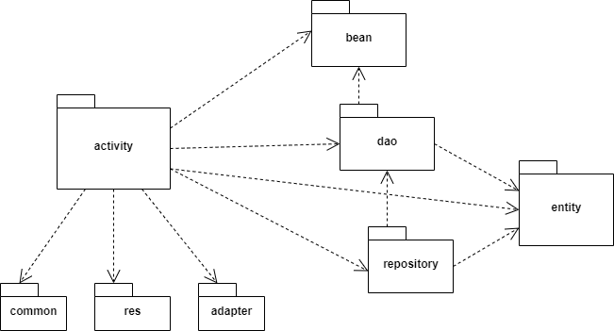

***Package descriptions & package class naming conventions***

| **No** | **Package** | **Description** |
| --- | --- | --- |
| *01* | *activity* | *Contain Activity files* |
| *02* | *common* | *Contain common files* |
| *03* | *res* | *Contain application resources* |
| *04* | *adapter* | *Contain adapter files* |
| *05* | *bean* | *Contain objects* |
| *06* | *dao* | *Contain DAO files* |
| *07* | *repository* | *Contain repository files* |
| *08* | *entity* | *Contain entities* |

## 2. Database Design

**2.1 Database Schema**

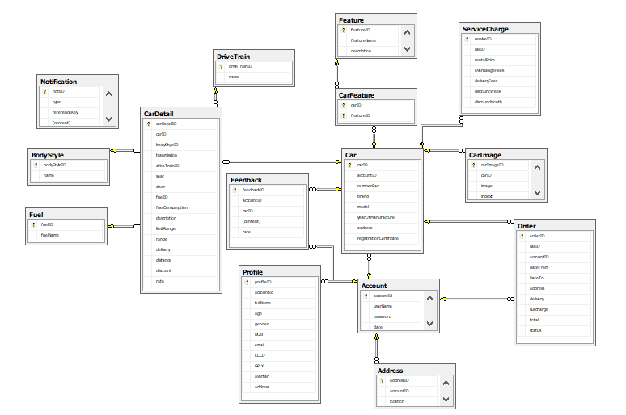

**2.2 Database table**

***Account***

| **#** | **Field name** | **Type** | **Size** | **Unique** | **Not Null** | **PK/FK** | **Notes** |
| --- | --- | --- | --- | --- | --- | --- | --- |
| 1 | accountD | int |  |  |  | PK |  |
| 2 | userName | nvarchar | 200 |  |  |  |  |
| 3 | password | varchar | 10 |  |  |  |  |
| 4 | date | datetime |  |  |  |  |  |

***Profile***

| **#** | **Field name** | **Type** | **Size** | **Unique** | **Not Null** | **PK/FK** | **Notes** |
| --- | --- | --- | --- | --- | --- | --- | --- |
| 1 | profileID | int |  |  |  | PK |  |
| 2 | accountID | int |  |  |  | FK |  |
| 3 | fullName | nvarchar | 200 |  |  |  |  |
| 4 | age | int |  |  |  |  |  |
| 5 | gende | bit |  |  |  |  |  |
| 6 | DOB | date |  |  |  |  |  |
| 7 | email | varchar | 50 |  |  |  |  |
| 8 | CCCD | text |  |  |  |  |  |
| 9 | GPLX | text |  |  |  |  |  |
| 10 | avartar | text |  |  |  |  |  |
| 11 | addressID | int |  |  |  |  |  |

***Address***

| **#** | **Field name** | **Type** | **Size** | **Unique** | **Not Null** | **PK/FK** | **Notes** |
| --- | --- | --- | --- | --- | --- | --- | --- |
| 1 | addressID | int |  |  |  | PK |  |
| 2 | accountID | int |  |  |  |  |  |
| 3 | location | nvarchar | 200 |  |  | FK |  |

***Notification***

| **#** | **Field name** | **Type** | **Size** | **Unique** | **Not Null** | **PK/FK** | **Notes** |
| --- | --- | --- | --- | --- | --- | --- | --- |
| 1 | notiID | int |  |  |  | PK |  |
| 2 | type | varchar | 50 |  |  |  |  |
| 3 | referenceKey | int |  |  |  |  |  |
| 4 | content | text |  |  |  |  |  |

***Car***

| **#** | **Field name** | **Type** | **Size** | **Unique** | **Not Null** | **PK/FK** | **Notes** |
| --- | --- | --- | --- | --- | --- | --- | --- |
| 1 | carID | int |  |  |  | PK |  |
| 2 | accountID | int |  |  |  | FK |  |
| 3 | numberPad | varchar | 50 |  |  |  |  |
| 4 | brand | varchar | 50 |  |  |  |  |
| 5 | model | varchar | 50 |  |  |  |  |
| 6 | yearOfManufacture | date |  |  |  |  |  |
| 7 | address | nvarchar | 200 |  |  |  |  |
| 8 | registrationCertificate | text |  |  |  |  |  |

***CarImage***

| **#** | **Field name** | **Type** | **Size** | **Unique** | **Not Null** | **PK/FK** | **Notes** |
| --- | --- | --- | --- | --- | --- | --- | --- |
| 1 | carImageID | int |  |  |  | PK |  |
| 2 | image | text |  |  |  |  |  |
| 3 | indext | int |  |  |  |  |  |
| 4 | carID | int |  |  |  | FK |  |

***Feature***

| **#** | **Field name** | **Type** | **Size** | **Unique** | **Not Null** | **PK/FK** | **Notes** |
| --- | --- | --- | --- | --- | --- | --- | --- |
| 1 | featureID | int |  |  |  | PK |  |
| 2 | deatureName | varchar | 200 |  |  |  |  |
| 3 | description | text |  |  |  |  |  |

***CarFeature***

| **#** | **Field name** | **Type** | **Size** | **Unique** | **Not Null** | **PK/FK** | **Notes** |
| --- | --- | --- | --- | --- | --- | --- | --- |
| 1 | carID | int |  |  |  | PK,FK |  |
| 2 | featureID | int |  |  |  | PK,FK |  |

***DriverTrain***

| **#** | **Field name** | **Type** | **Size** | **Unique** | **Not Null** | **PK/FK** | **Notes** |
| --- | --- | --- | --- | --- | --- | --- | --- |
| 1 | driveTrainID | int |  |  |  | PK |  |
| 2 | name | int |  |  |  |  |  |

***Fuel***

| **#** | **Field name** | **Type** | **Size** | **Unique** | **Not Null** | **PK/FK** | **Notes** |
| --- | --- | --- | --- | --- | --- | --- | --- |
| 1 | fuelID | int |  |  |  | PK |  |
| 2 | fuelName | varchar | 100 |  |  |  |  |

***ServiceCharge***

| **#** | **Field name** | **Type** | **Size** | **Unique** | **Not Null** | **PK/FK** | **Notes** |
| --- | --- | --- | --- | --- | --- | --- | --- |
| 1 | serviceID | int |  |  |  | PK |  |
| 2 | carID | int |  |  |  | FK |  |
| 3 | rentalPrice | float |  |  |  |  |  |
| 4 | overRangeFees | float |  |  |  |  |  |
| 5 | deliveryFees | float |  |  |  |  |  |
| 6 | discountWeek | float |  |  |  |  |  |
| 7 | discountMonth | float |  |  |  |  |  |

***BodyStyle***

| **#** | **Field name** | **Type** | **Size** | **Unique** | **Not Null** | **PK/FK** | **Notes** |
| --- | --- | --- | --- | --- | --- | --- | --- |
| 1 | bodyStyleID | int |  |  |  | PK |  |
| 2 | name | varchar | 200 |  |  |  |  |

***CarDetail***

| **#** | **Field name** | **Type** | **Size** | **Unique** | **Not Null** | **PK/FK** | **Notes** |
| --- | --- | --- | --- | --- | --- | --- | --- |
| 1 | carDetailID | int |  |  |  | PK |  |
| 2 | carID | int |  |  |  | FK |  |
| 3 | bodyStyleID | int |  |  |  | FK |  |
| 4 | transmission | bit |  |  |  |  |  |
| 5 | driveTrainID | int |  |  |  | FK |  |
| 6 | seat | int |  |  |  |  |  |
| 7 | door | int |  |  |  |  |  |
| 8 | fuelID | int |  |  |  | FK |  |
| 9 | fuelConsumption | float |  |  |  |  |  |
| 10 | description | text |  |  |  |  |  |
| 11 | limitRange | bit |  |  |  |  |  |
| 12 | range | int |  |  |  |  |  |
| 13 | delivery | bit |  |  |  |  |  |
| 14 | distance | int |  |  |  |  |  |
| 15 | discount | bit |  |  |  |  |  |
| 16 | rate | float |  |  |  |  |  |

***Order***

| **#** | **Field name** | **Type** | **Size** | **Unique** | **Not Null** | **PK/FK** | **Notes** |
| --- | --- | --- | --- | --- | --- | --- | --- |
| 1 | orderID | int |  |  |  | PK |  |
| 2 | carID | int |  |  |  | FK |  |
| 3 | accountID | int |  |  |  | FK |  |
| 4 | dateFrom | datetime |  |  |  |  |  |
| 5 | dateTo | datetime |  |  |  |  |  |
| 6 | address | nvarchar | 200 |  |  |  |  |
| 7 | delivery | bit |  |  |  |  |  |
| 8 | surcharge | float |  |  |  |  |  |
| 9 | total | float |  |  |  |  |  |
| 10 | status | varchar | 50 |  |  |  |  |

***Feedback***

| **#** | **Field name** | **Type** | **Size** | **Unique** | **Not Null** | **PK/FK** | **Notes** |
| --- | --- | --- | --- | --- | --- | --- | --- |
| 1 | feedbackID | int |  |  |  | PK |  |
| 2 | accountID | int |  |  |  | FK |  |
| 3 | carID | int |  |  |  | FK |  |
| 4 | content | text |  |  |  |  |  |
| 5 | rate | int |  |  |  |  |  |

# II. Code Designs

## 1. Manage order car/ View order list

### a. Class Diagram

### c. Class Specifications

***IndividualActivity Class***

| **No** | **Method** | **Description** |
| --- | --- | --- |
| 1 | onClick(View) | Method that is called when the view(component) is clicked |
| 2 | onCreate(Bundle) | Method is used to start an activity |

***ViewOrderListActivity Class***

| **No** | **Method** | **Description** |
| --- | --- | --- |
| 1 | onCreate(Bundle) | Method is used to start an activity |

***OrderDAO Class***

| **No** | **Method** | **Description** |
| --- | --- | --- |
| 1 | getAllOrder(int) | Method is used to get all order of car by accountId |

### c. Sequence Diagram(s)

### d. Database queries

- SELECT * FROM Order o JOIN Car c ON o.IdC = c.IdC WHERE c.IdA = ?

- SELECT * FROM Car WHERE IdA = ?

## 2. Manage order car/ View order details

### a. Class Diagram

### b. Class Specifications

***ViewOrderListActivity Class***

| **No** | **Method** | **Description** |
| --- | --- | --- |
| 1 | onClick(View) | Method that is called when the view(component) is clicked |
| 2 | onCreate(Bundle) | Method is used to start an activity |

***ViewOrderDetailActivity Class***

| **No** | **Method** | **Description** |
| --- | --- | --- |
| 1 | onCreate(Bundle) | Method is used to start an activity |

***OrderDAO Class***

| **No** | **Method** | **Description** |
| --- | --- | --- |
| 1 | getOrderById(int) | Method is used to get order of car by orderID |

### c. Sequence Diagram(s)

### d. Database queries

- SELECT * FROM Order WHERE IdO = ?

- SELECT * FROM Car WHERE IdC = ?

## 3. Manage order car/ Extra surcharge

### a. Class Diagram

### b. Class Specifications

***ViewOrderDetailActivity Class***

| **No** | **Method** | **Description** |
| --- | --- | --- |
| 1 | onClick(View) | Method that is called when the view(component) is clicked |
| 2 | onCreate(Bundle) | Method is used to start an activity |

***ExtraSurchargeActivity Class***

| **No** | **Method** | **Description** |
| --- | --- | --- |
| 1 | onCreate(Bundle) | Method is used to start an activity |

***OrderDAO Class***

| **No** | **Method** | **Description** |
| --- | --- | --- |
| 1 | setSurcharge(int, double) | Method is used to set surcharge for order and set status of order is finish |

***ChargesDAO Class***

| **No** | **Method** | **Description** |
| --- | --- | --- |
| 1 | getAllCharges(int) | Method is used to get all charges of car |

### c. Sequence Diagram(s)

### d. Database queries

- SELECT * FROM Charges WHERE IdC = ?

- UPDATE Order SET surcharge = ? WHERE IdO = ?

## 4. Manage order car/ Accept order, Cancel order, History/Cancel booking

### a. Class Diagram

### b. Class Specifications

***ViewOrderDetailActivity Class***

| **No** | **Method** | **Description** |
| --- | --- | --- |
| 1 | onClick(View) | Method that is called when the view(component) is clicked |
| 2 | onCreate(Bundle) | Method is used to start an activity |

***SetStatusOrderActivity Class***

| **No** | **Method** | **Description** |
| --- | --- | --- |
| 1 | onCreate(Bundle) | Method is used to start an activity |

***OrderDAO Class***

| **No** | **Method** | **Description** |
| --- | --- | --- |
| 1 | setStatusOrder(int) | Method is used to set status for Order |

### c. Sequence Diagram(s)

### d. Database queries

- UPDATE Order SET status = ‘…’ WHERE IdO = ?

## 5. History/ View list booked car

### a. Class Diagram

### b. Class Specifications

***HomeActivity Class***

| **No** | **Method** | **Description** |
| --- | --- | --- |
| 1 | onClick(View) | Method that is called when the view(component) is clicked |
| 2 | onCreate(Bundle) | Method is used to start an activity |

***ViewListBookedActivity Class***

| **No** | **Method** | **Description** |
| --- | --- | --- |
| 1 | onCreate(Bundle) | Method is used to start an activity |

***OrderDAO Class***

| **No** | **Method** | **Description** |
| --- | --- | --- |
| 1 | getListBooked(int) | Method is used to get order of car by accountID |

### c. Sequence Diagram(s)

### d. Database queries

- SELECT * FROM Order WHERE IdA = ?

- SELECT * FROM Car WHERE IdC = ?

## 6. History/ View booking details

### a. Class Diagram

### b. Class Specifications

***ViewOrderListActivity Class***

| **No** | **Method** | **Description** |
| --- | --- | --- |
| 1 | onClick(View) | Method that is called when the view(component) is clicked |
| 2 | onCreate(Bundle) | Method is used to start an activity |

***ViewOrderDetailActivity Class***

| **No** | **Method** | **Description** |
| --- | --- | --- |
| 1 | onCreate(Bundle) | Method is used to start an activity |

***OrderDAO Class***

| **No** | **Method** | **Description** |
| --- | --- | --- |
| 1 | getOrderById(int) | Method is used to get order of car by orderID |

### c. Sequence Diagram(s)

### d. Database queries

- SELECT * FROM Order WHERE IdO = ?

- SELECT * FROM Car WHERE IdC = ?

## 7. History/ Edit booking

### a. Class Diagram

### b. Class Specifications

***ViewBookingDetailActivity Class***

| **No** | **Method** | **Description** |
| --- | --- | --- |
| 1 | onClick(View) | Method that is called when the view(component) is clicked |
| 2 | onCreate(Bundle) | Method is used to start an activity |

***EditBookingActivity Class***

| **No** | **Method** | **Description** |
| --- | --- | --- |
| 1 | onCreate(Bundle) | Method is used to start an activity |

***OrderDAO Class***

| **No** | **Method** | **Description** |
| --- | --- | --- |
| 1 | getOrderById(int) | Method is used to get order of car by orderID |
| 2 | updateOrder(Order) | Method is used to update order by orderID |

### c. Sequence Diagram(s)

### d. Database queries

- UPDATE Order SET …… WHERE IdO = ?

## 8. History/ Feedback

### a. Class Diagram

### b. Class Specifications

***ViewBookingDetailActivity Class***

| **No** | **Method** | **Description** |
| --- | --- | --- |
| 1 | onClick(View) | Method that is called when the view(component) is clicked |
| 2 | onCreate(Bundle) | Method is used to start an activity |

***FeedbackActivity Class***

| **No** | **Method** | **Description** |
| --- | --- | --- |
| 1 | onCreate(Bundle) | Method is used to start an activity |

***FeedbackDAO Class***

| **No** | **Method** | **Description** |
| --- | --- | --- |
| 1 | createFeedback(int) | Method is used to create feedback for car |

### c. Sequence Diagram(s)

### d. Database queries

- INSERT INTO Feedback (IdA, IdC, content, rate) VALUES(?,?,?,?)

## 9. Car rental/ Find car

### a. Class Diagram

### b. Class Specifications

***FindCarActivity Class***

| **No** | **Method** | **Description** |
| --- | --- | --- |
| 1 | onClick(View) | Method that is called when the view(component) is clicked |
| 2 | onCreate(Bundle) | Method is used to start an activity |

### c. Sequence Diagram(s)

### d. Database queries

## 10. Car rental/View list car

### a. Class Diagram

### b. Class Specifications

***ViewListCarActivity Class***

| **No** | **Method** | **Description** |
| --- | --- | --- |
| 1 | onClick(View) | Method that is called when the view(component) is clicked |
| 2 | onCreate(Bundle) | Method is used to start an activity |

### c. Sequence Diagram(s)

### d. Database queries

## 11. Car rental/ View detail car

### a. Class Diagram

### b. Class Specifications

***ViewCarDetailActivity Class***

| **No** | **Method** | **Description** |
| --- | --- | --- |
| 1 | onClick(View) | Method that is called when the view(component) is clicked |
| 2 | onCreate(Bundle) | Method is used to start an activity |

### c. Sequence Diagram(s)

### d. Database queries

## 12. Car rental/ Car rental

### a. Class Diagram

### b. Class Specifications

***RentalCarActivity Class***

| **No** | **Method** | **Description** |
| --- | --- | --- |
| 1 | onClick(View) | Method that is called when the view(component) is clicked |
| 2 | onCreate(Bundle) | Method is used to start an activity |

### c. Sequence Diagram(s)

### d. Database queries

## 13. Car rental/ View feedback

### a. Class Diagram

### b. Class Specifications

***ViewFeedbackActivity Class***

| **No** | **Method** | **Description** |
| --- | --- | --- |
| 1 | onClick(View) | Method that is called when the view(component) is clicked |
| 2 | onCreate(Bundle) | Method is used to start an activity |

### c. Sequence Diagram(s)

### d. Database queries

## 14. Car rental/ Add driving license

### a. Class Diagram

### b. Class Specifications

***CarRentalDocumentActivity Class***

| **No** | **Method** | **Description** |
| --- | --- | --- |
| 1 | onClick(View) | Method that is called when the view(component) is clicked |
| 2 | onCreate(Bundle) | Method is used to start an activity |

### c. Sequence Diagram(s)

### d. Database queries

## 15. Individual

### a. Class Diagram

### b. Class Specifications

***IndividualActivity Class***

| **No** | **Method** | **Description** |
| --- | --- | --- |
| 1 | onClick(View) | Method that is called when the view(component) is clicked |
| 2 | onCreate(Bundle) | Method is used to start an activity |

### c. Sequence Diagram(s)

### d. Database queries

## 16. View address

### a. Class Diagram

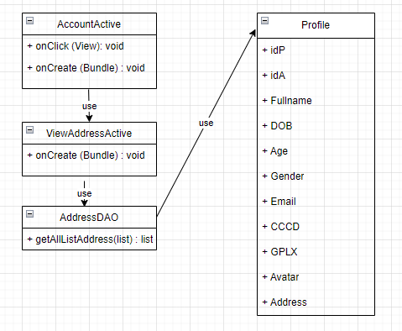

### b. Class Specification

**AccountActive**

| **No** | **Method** | **Description** |
| --- | --- | --- |
| 01 | onClick(View) | Method that is called when the view is clicked |
| 02 | onCreate(Bundle) | Method is used to start activity |

**ViewAddressActive**

| **No** | **Method** | **Description** |
| --- | --- | --- |
| 01 | onCreate(Bundle) | Method is used to start an activity |

**AddressDAO**

| **No** | **Method** | **Description** |
| --- | --- | --- |
| 01 | getAllListAddress(list) | Get all list address of account |

### c. Sequence Diagram(s)

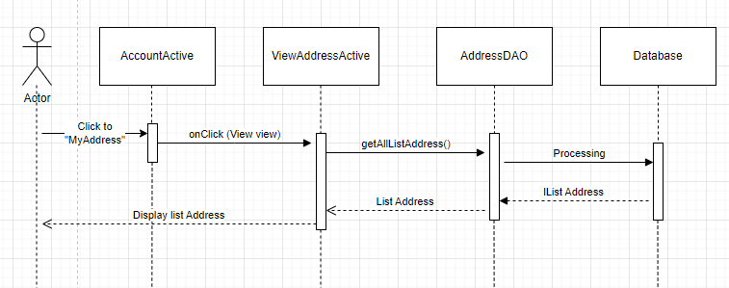

### d. Database queries

* Select * from Profile where idA = ?

## 17. Add address

### a. Class Diagram

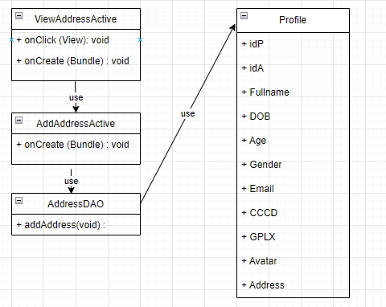

### b. Class Specification

**ViewAddressActive**

| **No** | **Method** | **Description** |
| --- | --- | --- |
| 01 | onClick(View) | Method that is called when the view is clicked |
| 02 | onCreate(Bundle) | Method is used to start activity |

**AddAddressActive**

| **No** | **Method** | **Description** |
| --- | --- | --- |
| 01 | onCreate(Bundle) | Method is used to start an activity |

**AddressDAO**

| **No** | **Method** | **Description** |
| --- | --- | --- |
| 01 | addAddress(String):list | Add a new address into the table information . |

### c. Sequence Diagram(s)

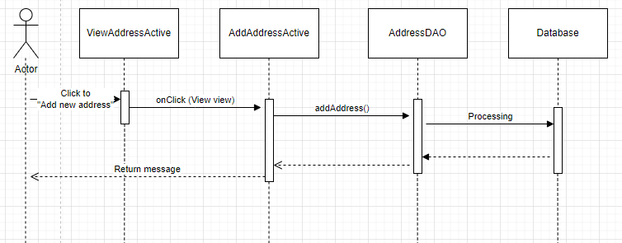

### d. Database queries

* Insert into Information Address = ? where idA = ?

## 18. Account information

### a. Class Diagram

### 

### b. Class Specification

**AccountActive**

| **No** | **Method** | **Description** |
| --- | --- | --- |
| 01 | onClick(View) | Method that is called when the view is clicked |
| 02 | onCreate(Bundle) | Method is used to start activity |

**ViewAccountActive**

| **No** | **Method** | **Description** |
| --- | --- | --- |
| 01 | onCreate(Bundle) | Method is used to start an activity |

**AddressDAO**

| **No** | **Method** | **Description** |
| --- | --- | --- |
| 01 | getAccount(int):Account | Get an Account object . |

### c. Sequence Diagram(s)

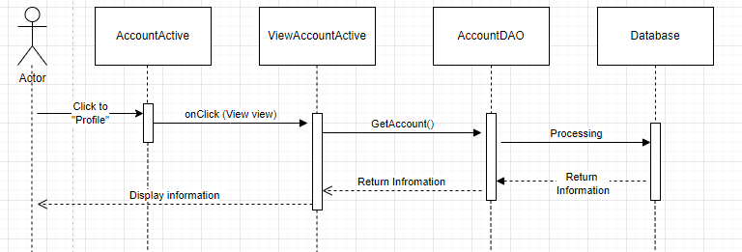

### d. Database queries

* Select * from Account a

inner join Profile p

On a.idA = p.idA = ?

## 19. Verification driver’s license

### a. Class Diagram

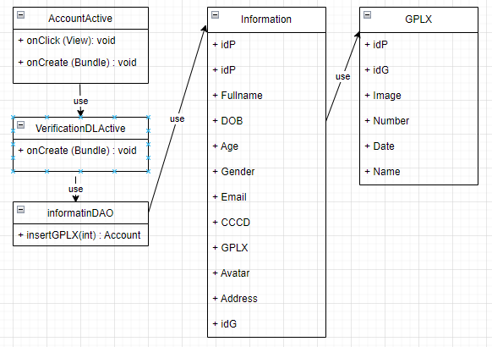

### b. Class Specification

**AccountActive**

| **No** | **Method** | **Description** |
| --- | --- | --- |
| 01 | onClick(View) | Method that is called when the view is clicked |
| 02 | onCreate(Bundle) | Method is used to start activity |

**VerificationDLActive**

| **No** | **Method** | **Description** |
| --- | --- | --- |
| 01 | onCreate(Bundle) | Method is used to start an activity |

**informationDAO**

| **No** | **Method** | **Description** |
| --- | --- | --- |
| 01 | insertGPLXt(int): void | insert driver’s license . |

### 

### c. Sequence Diagram(s)

### 

### d. Database queries

* Insert into GPLX g

inner join Information i

on i.idp = g.idP = ?

## 20. Verification email

### a. Class Diagram

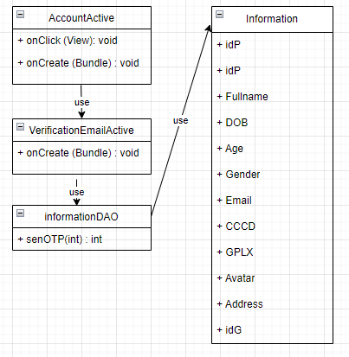

### b. Class Specification

**AccountActive**

| **No** | **Method** | **Description** |
| --- | --- | --- |
| 01 | onClick(View) | Method that is called when the view is clicked |
| 02 | onCreate(Bundle) | Method is used to start activity |

**VerificationEmailtActive**

| **No** | **Method** | **Description** |
| --- | --- | --- |
| 01 | onCreate(Bundle) | Method is used to start an activity |

**InformationDAO**

| **No** | **Method** | **Description** |
| --- | --- | --- |
| 01 | sendOTPt(int):int | Send code OTP to email . |

### 

### c. Sequence Diagram(s)

### d. Database queries

## 21. Edit information

### a. Class Diagram

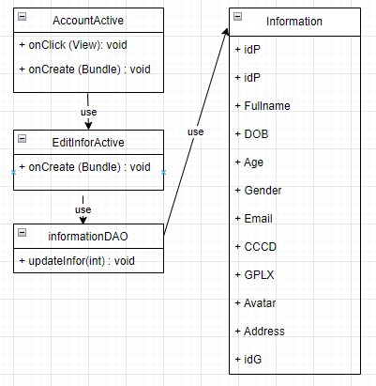

### b. Class Specification

**AccountActive**

| **No** | **Method** | **Description** |
| --- | --- | --- |
| 01 | onClick(View) | Method that is called when the view is clicked |
| 02 | onCreate(Bundle) | Method is used to start activity |

**EditInforActive**

| **No** | **Method** | **Description** |
| --- | --- | --- |
| 01 | onCreate(Bundle) | Method is used to start an activity |

**InformationDAO**

| **No** | **Method** | **Description** |
| --- | --- | --- |
| 01 | updateInfor(int): void | Update information of account . |

### 

### c. Sequence Diagram(s)

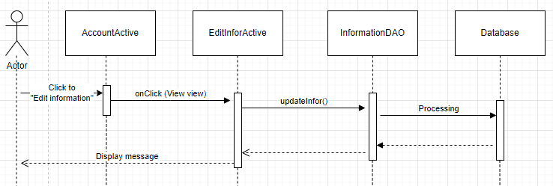

### d. Database queries

* Update Information

set Full name = ?, Age =?,

Gender = ?, Avarta = ?

where idP = ?

## 22. Change password

### a. Class Diagram

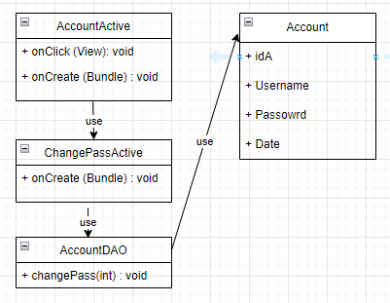

### b. Class Specification

**AccountActive**

| **No** | **Method** | **Description** |
| --- | --- | --- |
| 01 | onClick(View) | Method that is called when the view is clicked |
| 02 | onCreate(Bundle) | Method is used to start activity |

**ChangePassActive**

| **No** | **Method** | **Description** |
| --- | --- | --- |
| 01 | onCreate(Bundle) | Method is used to start an activity |

**AccountDAO**

| **No** | **Method** | **Description** |
| --- | --- | --- |
| 01 | changePass(int): void | Change password. |

### c. Sequence Diagram(s)

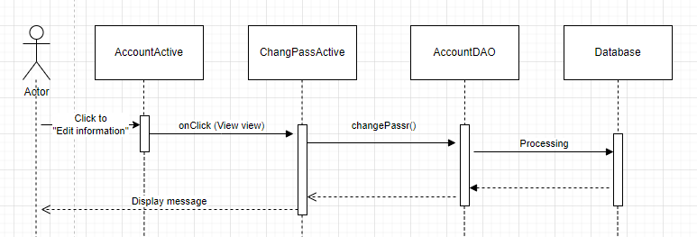

### d. Database queries

* update Account set password = ? where username = ?

## 23. My Car

### a. Screen Design

**Table 1:** **My Car Definition**

| **No** | **Object/Control Name** | **Type** | **Required** | **Length** | **Description** |
| --- | --- | --- | --- | --- | --- |
| 1 | Back | Button | Yes |  | Display by icon left arrow |
| 2 | Screen name | Text | Yes | 20 |  |
| 3 | Add new car | Button | Yes |  | Display by icon plus |
| 4 | Car item | Button |  |  | Display car’s basic information |

### b. Class Diagram

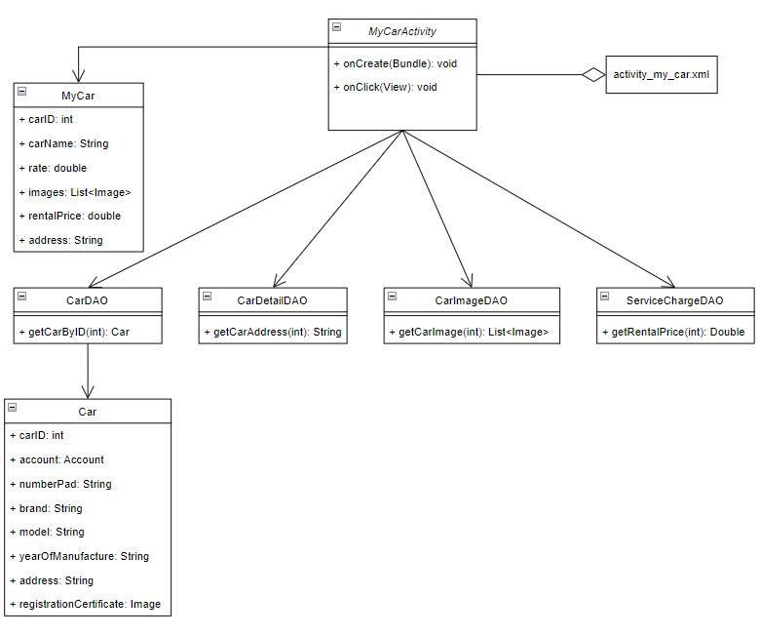

### c. Class Specifications

***MyCarActivity***

| **No** | **Method** | **Description** |
| --- | --- | --- |
| *01* | *onCreate()* |  |
| *02* | *onClick()* |  |

***CarDAO***

| **No** | **Method** | **Description** |
| --- | --- | --- |
| *01* | *getCarByID()* | *Get the car from database by its id* |

***CarDetailDAO***

| **No** | **Method** | **Description** |
| --- | --- | --- |
| *01* | *getCarAddress()* | *Get address information of the car by car’s id* |

***CarImageDAO***

| **No** | **Method** | **Description** |
| --- | --- | --- |
| *01* | *getCarImage()* | *Get all images of the car from database by car’s id* |

***ServiceChargeDAO***

| **No** | **Method** | **Description** |
| --- | --- | --- |
| *01* | *getRentalPrice()* | *Get rental price of the car by car’s id* |

### d. Sequence Diagram(s)

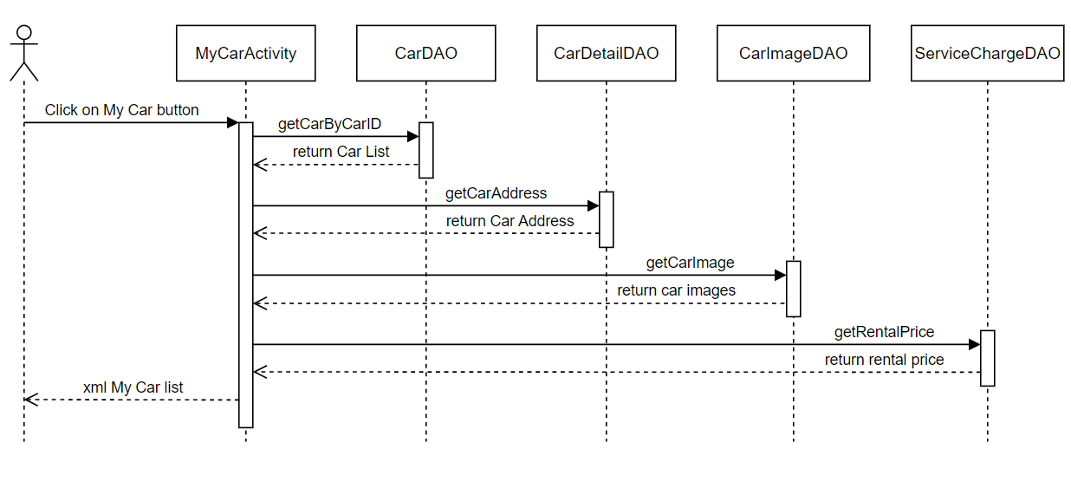

### e. Database queries

*- select * from Car where carID = ?*

*- select address from CarDetail where carID = ?*

*- select * from CarImage where carID = ?*

*- select retal_price from ServiceCharge where carID = ?*

## 24. Car Information

### a. Screen Design

**Table 2:** **Car Information Definition**

| **No** | **Object/Control Name** | **Type** | **Required** | **Length** | **Description** |
| --- | --- | --- | --- | --- | --- |
| 1 | Back | Button | Yes |  | Display by icon left arrow |
| 2 | Screen name | Text | Yes | 20 |  |
| 3 | Image | Button | Yes |  |  |
| 4 | Previous | Button |  |  |  |
| 5 | Next | Button |  |  |  |
| 6 | Name | Button |  |  |  |
| 7 | Rental price | Text |  | 10 |  |
| 8 | Address | Text |  | 50 |  |
| 9 | Seat | Text |  | 2 |  |
| 10 | Door | Text |  | 2 |  |
| 11 | Fuel | Text |  | 20 |  |
| 12 | Transmission | Text |  | 20 |  |
| 13 | Body style | Text |  | 20 |  |
| 14 | Drivetrain | Text |  | 20 |  |
| 15 | Description | Text |  | 200 |  |
| 16 | Feature | Icon |  |  |  |

### b. Class Diagram

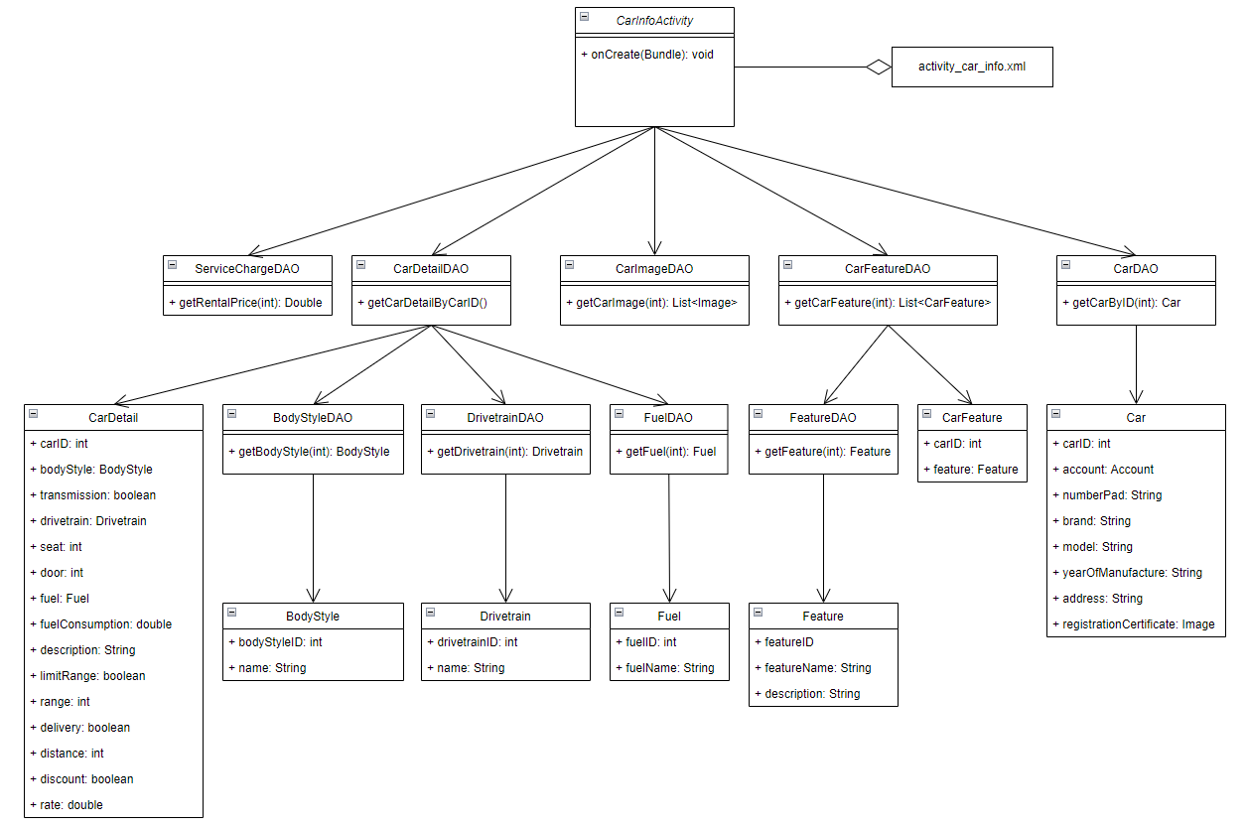

### c. Class Specifications

***CarInformationActivity***

| **No** | **Method** | **Description** |
| --- | --- | --- |
| *01* | *onCreate()* |  |
|  |  |  |

***CarDetailDAO***

| **No** | **Method** | **Description** |
| --- | --- | --- |
| *01* | *getCarDetailByCarID()* | *Get all details information of the car by its id* |
|  |  |  |

***CarImageDAO***

| **No** | **Method** | **Description** |
| --- | --- | --- |
| *01* | *getCarImage()* | *Get all images of the car from database* |
|  |  |  |

***CarDAO***

| **No** | **Method** | **Description** |
| --- | --- | --- |
| *01* | *getCarByCarID()* | *Get the car from database by its id* |
|  |  |  |

***CarFeatureDAO***

| **No** | **Method** | **Description** |
| --- | --- | --- |
| *01* | *getCarFeature()* | *Get the list of features of the car* |
|  |  |  |

***ServiceChargeDAO***

| **No** | **Method** | **Description** |
| --- | --- | --- |
| *01* | *getRentalPrice()* | *Get rental price of the car* |
|  |  |  |

***BodyStyleDAO***

| **No** | **Method** | **Description** |
| --- | --- | --- |
| *01* | *getBodyStyle()* | *Get body style of the car* |
|  |  |  |

***DrivetrainDAO***

| **No** | **Method** | **Description** |
| --- | --- | --- |
| *01* | *getDrivetrain()* | *Get drivetrain of the car* |
|  |  |  |

***FuelDAO***

| **No** | **Method** | **Description** |
| --- | --- | --- |
| *01* | *getFuel()* | *Get fuel type of the car* |
|  |  |  |

***FeatureDAO***

| **No** | **Method** | **Description** |
| --- | --- | --- |
| *01* | *getFeature()* | *Get the feature’s information* |
|  |  |  |

### d. Sequence Diagram(s)

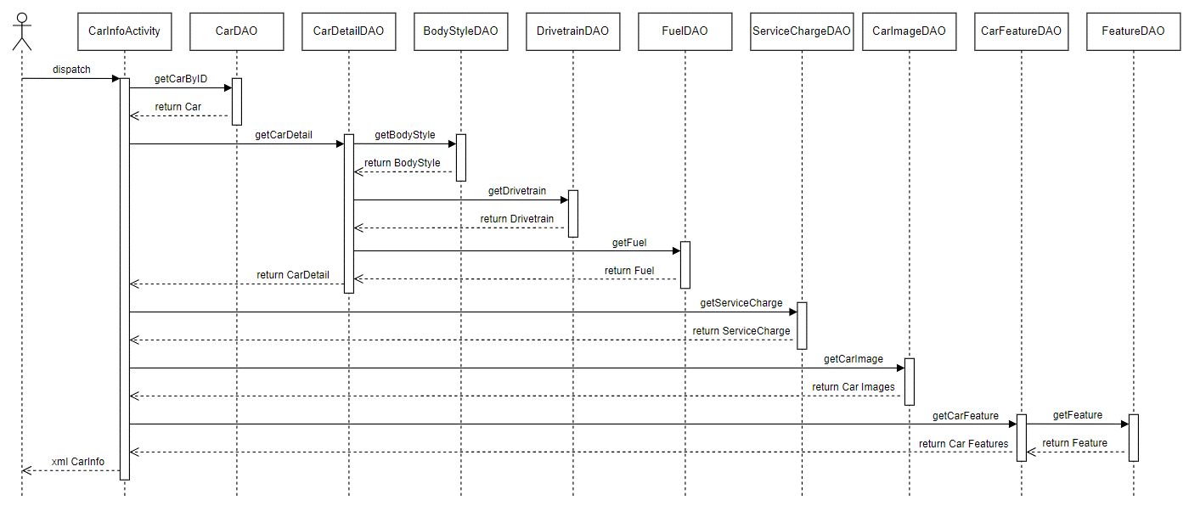

### e. Database queries

*- select * from Car where carID = ?*

*- select * from CarDetail where carID = ?*

*- select * from BodyStyle where bodystyleID = ?*

*- select * from Drivetrain where drivetrainID = ?*

*- select * form Fuel where fuelID = ?*

*- select * from ServiceCharge where carID = ?*

*- select * from CarImage where carID = ?*

*- select * from CarFeature where carID = ?*

*- select * from Feature where featured = ?*

## 25. Add New Car

### a. Class Diagram

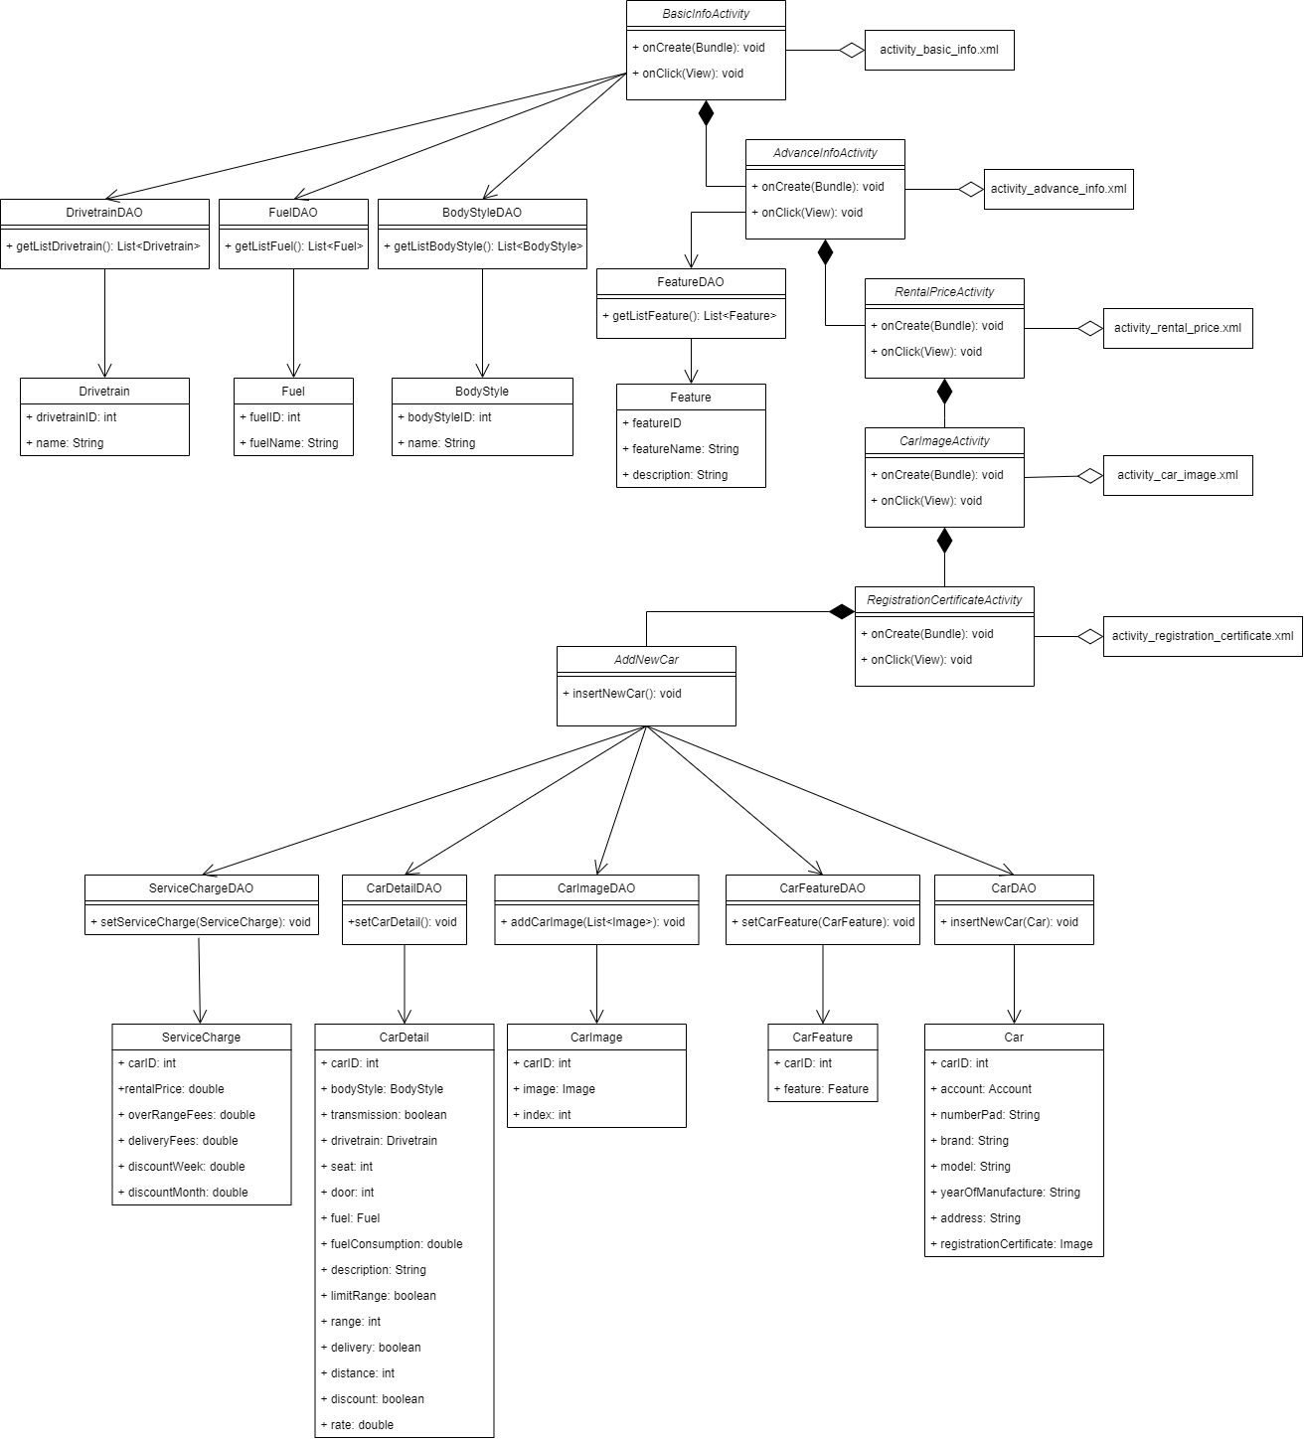

### b. Class Specifications

***AddNewCar***

| **No** | **Method** | **Description** |
| --- | --- | --- |
| *01* | *insertNewCar()* | *Insert new car’s information into the database* |
|  |  |  |

***BasicInfoActivity***

| **No** | **Method** | **Description** |
| --- | --- | --- |
| *01* | *onCreate()* | *Create graphic user interface* |
| *02* | *onClick()* | *Direct user to next screen* |

***AdvanceInfoActivity***

| **No** | **Method** | **Description** |
| --- | --- | --- |
| *01* | *onCreate()* | *Create graphic user interface* |
| *02* | *onClick()* | *Direct user to next screen* |

***RentalPriceActivity***

| **No** | **Method** | **Description** |
| --- | --- | --- |
| *01* | *onCreate()* | *Create graphic user interface* |
| *02* | *onClick()* | *Direct user to next screen* |

***CarImageActivity***

| **No** | **Method** | **Description** |
| --- | --- | --- |
| *01* | *onCreate()* | *Create graphic user interface* |
| *02* | *onClick()* | *Direct user to next screen* |

***RegistrationCertifiateActivity***

| **No** | **Method** | **Description** |
| --- | --- | --- |
| *01* | *onCreate()* | *Create graphic user interface* |
| *02* | *onClick()* | *Direct user to next screen* |

***DrivetrainDAO***

| **No** | **Method** | **Description** |
| --- | --- | --- |
| *01* | *getListDrivetrain()* | *Get list of all drivetrains* |
|  |  |  |

***FuelDAO***

| **No** | **Method** | **Description** |
| --- | --- | --- |
| *01* | *getListFuel()* | *Get list of all fuel type* |
|  |  |  |

***BodyStyleDAO***

| **No** | **Method** | **Description** |
| --- | --- | --- |
| *01* | *getListBodyStyle()* | *Get list of all bodystyle* |
|  |  |  |

***FeatureDAO***

| **No** | **Method** | **Description** |
| --- | --- | --- |
| *01* | *getListFeature()* | *Get list of all feature* |
|  |  |  |

***CarDAO***

| **No** | **Method** | **Description** |
| --- | --- | --- |
| *01* | *insertNewCar()* | *Insert new car in to the database* |
|  |  |  |

***ServiceChargeDAO***

| **No** | **Method** | **Description** |
| --- | --- | --- |
| *01* | *setServiceCharge()* | *Set service charge of the new car in database* |
|  |  |  |

***CarDetailDAO***

| **No** | **Method** | **Description** |
| --- | --- | --- |
| *01* | *setCarDetail()* | *Set details information of the new car in database* |
|  |  |  |

***CarImageDAO***

| **No** | **Method** | **Description** |
| --- | --- | --- |
| *01* | *addCarImage()* | *Add new car’s images into the database* |
|  |  |  |

### c. Sequence Diagram(s)

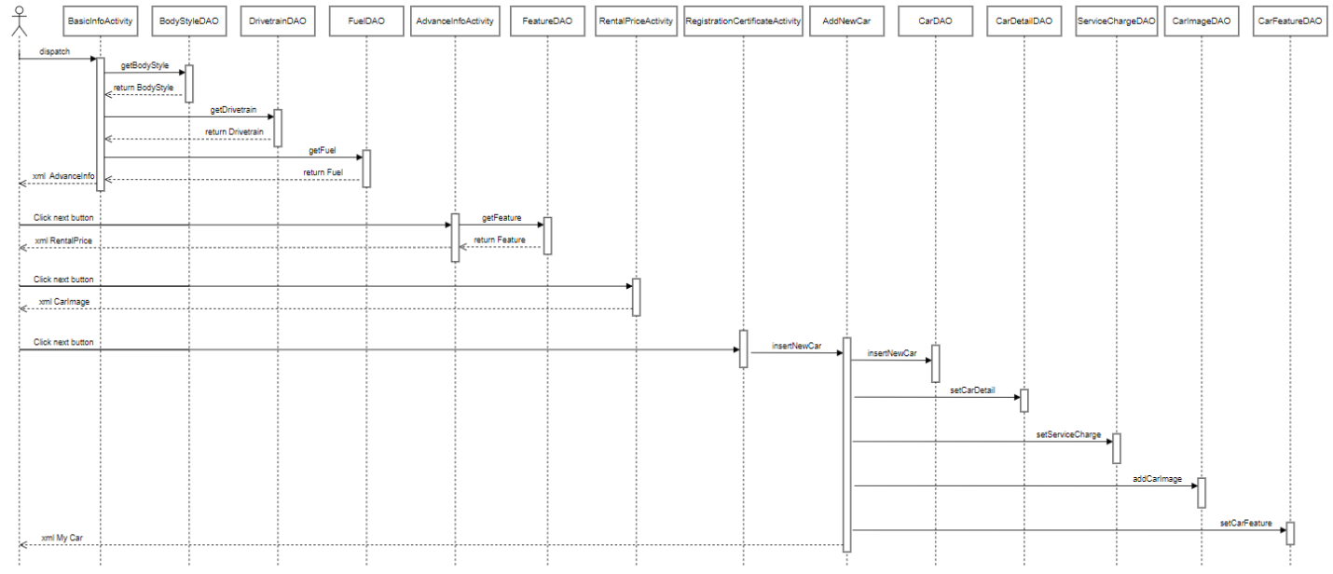

### d. Database queries

*- insert into Car[accountID, number_pad, brand, model, year_of_manufacture, address, registration_certificate] values (?,?,?,?,?,?,?)*

*- insert into CarDetail[carID, body_style, transmission, drivetrain, seat, door, fuel, fuel_consumption, description, limit_range, range, delivery, distance, discount, rate] values (?,?,?,?,?,?,?,?,?,?,?,?,?,?,?)*

*- insert into ServiceCharge[carID, rental_price, over_range_fees, delivery_fees, discount_week, discount_month] values (?,?,?,?,?,?)*

*- insert into CarImage[carID, image, index] values (?,?,?)*

*- insert into CarFeature[carID, featured] values (?,?)*

## 26. Login

### a. Class Diagram

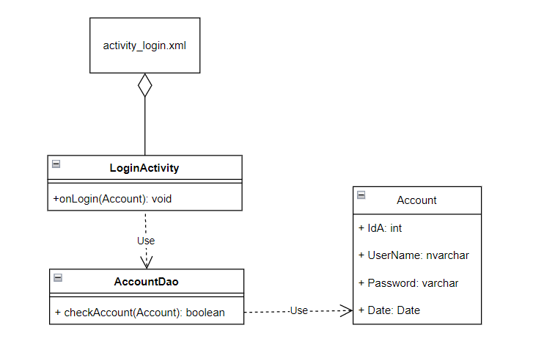

### b. Class Specifications

***LoginActivity class***

| **No** | **Method** | **Description** |
| --- | --- | --- |
| 01 | onLogin(View view) | Method for users to login to the app |

***AccountDAO Class***

| **No** | **Method** | **Description** |
| --- | --- | --- |
| 01 | checkAccount(Account) | get username and password data |

### c. Sequence Diagram(s)

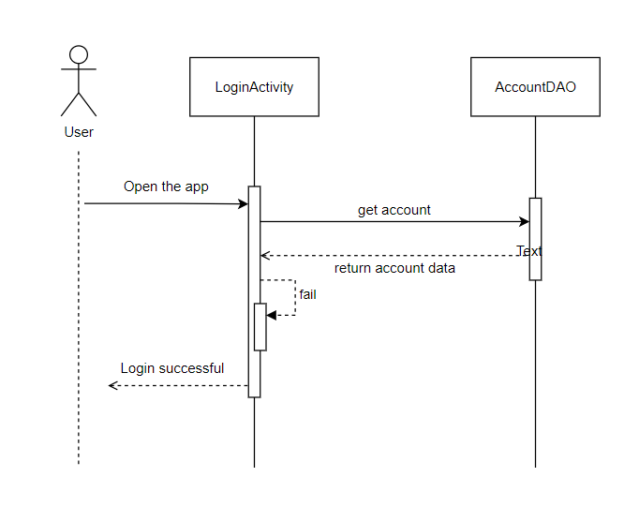

### d. Database queries

* select * from Account where username = ?

## 27. Register

### a. Class Diagram

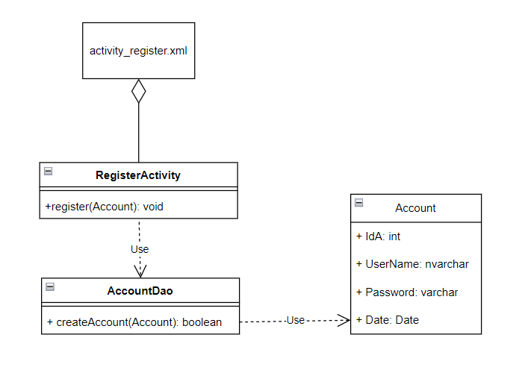

### b. Class Specifications

***RegisterActivity class***

| **No** | **Method** | **Description** |
| --- | --- | --- |
| 01 | onRegister(View view) | Method for users to register account |

***AccountDAO Class***

| **No** | **Method** | **Description** |
| --- | --- | --- |
| 01 | createAccount(Account) | Create a new data for the account table |

### c. Sequence Diagram(s)

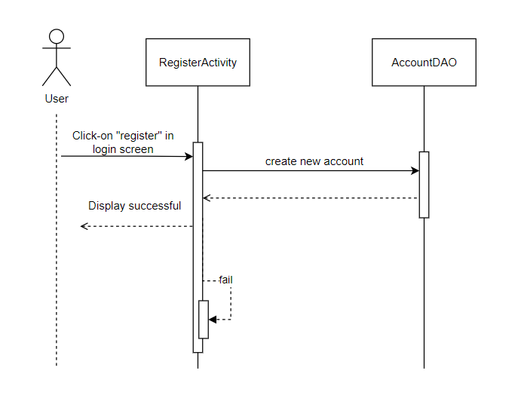

### d. Database queries

* INSERT INTO [dbo].[Account] username, password Values(?,?)

## 28. Forget Password

### a. Class Diagram

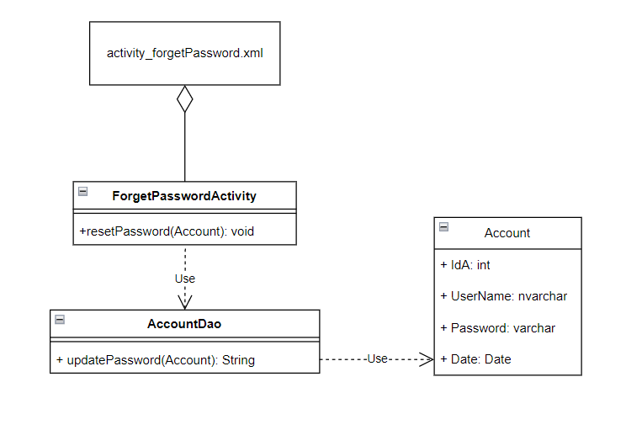

### b. Class Specifications

***ForgetPasswordActivity Class***

| **No** | **Method** | **Description** |
| --- | --- | --- |
| *01* | *resetPassword(Account)* | *Reset password* |

***AccountDAO***

| **No** | **Method** | **Description** |
| --- | --- | --- |
| *01* | *updatePassword* | *Allow user to change new password* |

### c. Sequence Diagram(s)

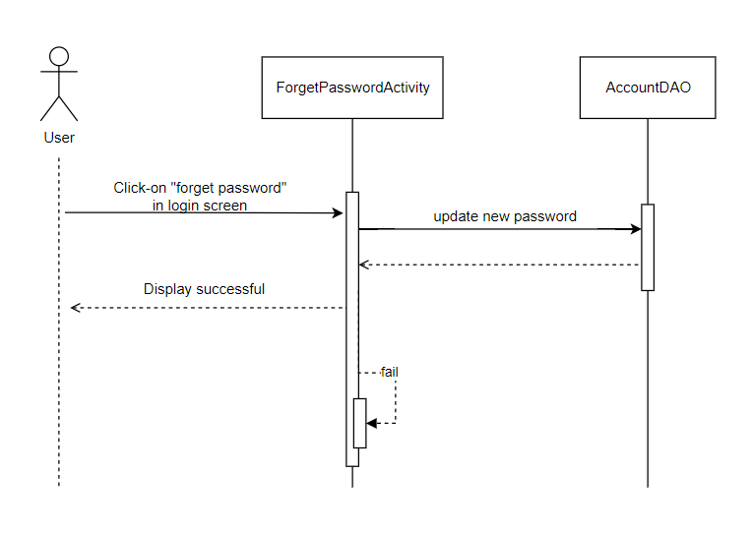

### d. Database queries

*UPDATE* [dbo].[Account]

*SET password = ?*

*WHERE username = ?;*

## 29. Support

### a. Class Diagram

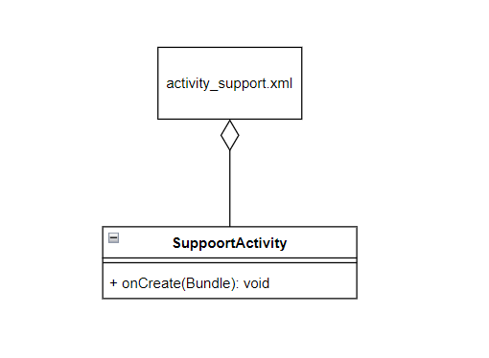

### b. Class Specifications

***SupportActivity class***

| **No** | **Method** | **Description** |
| --- | --- | --- |
| *01* | *onCreate* | *Display some information related to the app to the user, for example phone number, email, ....* |

### c. Sequence Diagram(s)

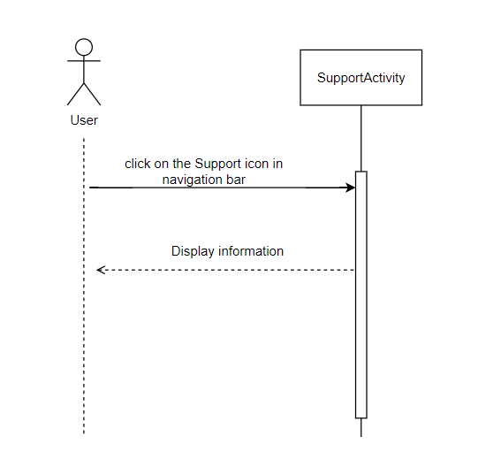

### d. Database queries

## 30. Home

### a. Class Diagram

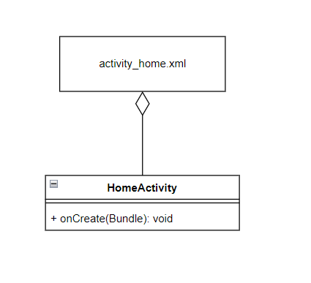

### b. Class Specifications

***HomeActivity Class***

| **No** | **Method** | **Description** |
| --- | --- | --- |
| *01* | *onCreate* | *Show outstanding features* |

#### 

### c. Sequence Diagram(s)

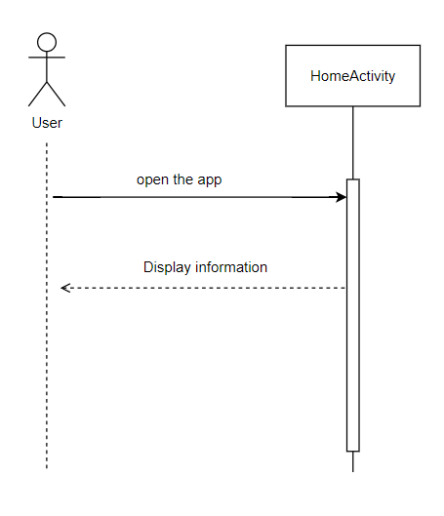

### d. Database queries

## 31. Notification

### a. Class Diagram

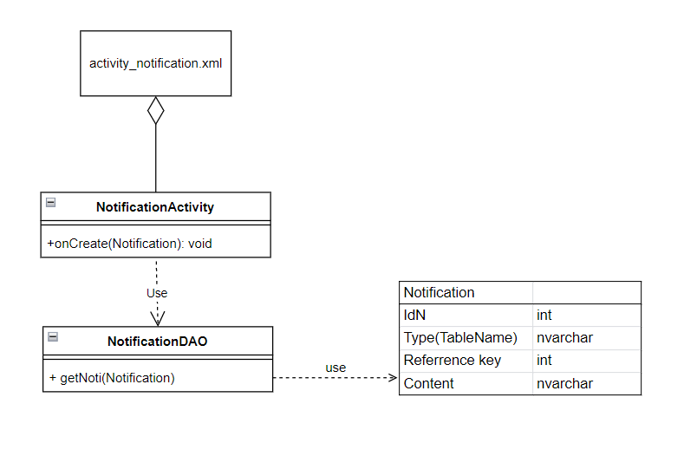

### b. Class Specifications

***NotificationActivity Class***

| **No** | **Method** | **Description** |
| --- | --- | --- |
| *01* | *onCreate(Notification)* | *display the notification title and a small part of the content* |

***NotificationDAO***

| **No** | **Method** | **Description** |
| --- | --- | --- |
| *01* | *getNoti(Notification)* | *get data of notification* |

### c. Sequence Diagram(s)

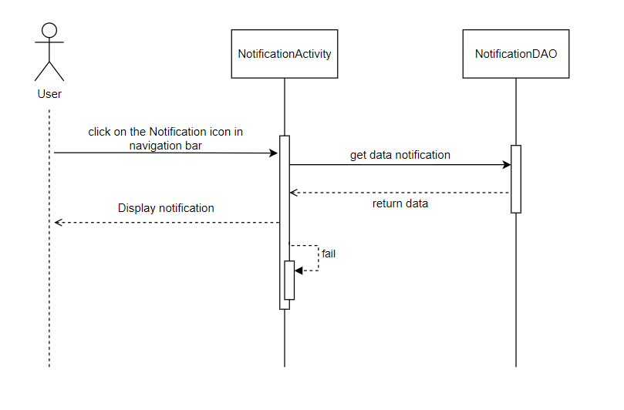

### d. Database queries

select * from Notification

## 32. Notification Detail

### a. Class Diagram

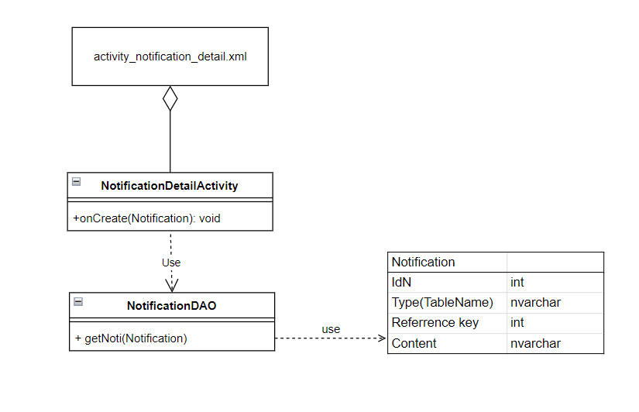

### b. Class Specifications

***NotificationDetailActivity Class***

| **No** | **Method** | **Description** |
| --- | --- | --- |
| *01* | *onCreate(Notification)* | *display the notification title and all of the content* |

***NotificationDAO***

| **No** | **Method** | **Description** |
| --- | --- | --- |
| *01* | *getNoti(Notification)* | *get data of notification* |

### c. Sequence Diagram(s)

### d. Database queries

select * from Notification