

**CAR RENTAL MANAGEMENT SYSTEM**

**Software Requirement Specification**

– Hanoi, February 2023 –

**Table of Contents**

1 Overall Description **7**

1.1 Introduction 7

1.2 Feature Descriptions 8

1.2.1 Screen Functions 8

1.2.2 Non-Screen Functions 9

1.2.3 Common Requirements 9

1.3 Screen Description 10

1.3.1 Screen Flow 10

1.3.2 Screen Details 10

1.3.3 User Authorization 12

2 System Features **13**

2.1 Car rental 13

2.1.1 Find car 13

2.1.1.1 Screen Design 13

2.1.1.2 Use case Specification 14

2.1.2 View list car 16

2.1.2.1 Screen Design 16

2.1.2.2 Use case Specification 17

2.1.3 View car detail 19

2.1.3.1 Screen Design 19

2.1.3.2 Use case Specification 20

2.1.4 Car rental 22

2.1.4.1 Screen Design 22

2.1.4.2 Use case Specification 23

2.1.5 Car rental documents 25

2.1.5.1 Screen Design 25

2.1.5.2 Use case Specification 26

2.1.6 View feedback 28

2.1.6.1 Screen Design 28

2.1.6.2 Use case Specification 29

2.2 Individual 31

2.2.1 View list 31

2.2.1.1 Screen Design 31

2.2.1.2 Use case Specification 31

2.3 Manage order car 33

2.3.1 Use case diagram 33

2.3.2 View order list 34

2.3.2.1 Screen Design 34

2.3.2.2 Use case Specification 35

2.3.3 View order details 36

2.3.3.1 Screen Design 36

2.3.3.2 Use case Specification 37

2.3.4 Accept order 38

2.3.4.1 Screen Design 38

2.3.4.2 Use case Specification 39

2.3.5 Cancel order 40

2.3.5.1 Screen Design 40

2.3.5.2 Use case Specification 42

2.3.6 Extra surcharge 44

2.3.6.1 Screen Design 44

2.3.6.2 Use case Specification 44

2.4 History 46

2.4.1 Use case diagram 46

2.4.2 View list booked car 47

2.4.2.1 Screen Design 47

2.4.2.2 Use case Specification 47

2.4.3 View booking details 49

2.4.3.1 Screen Design 49

2.4.3.2 Use case Specification 50

2.4.4 Edit booking 51

2.4.4.1 Screen Design 51

2.4.4.2 Use case Specification 52

2.4.5 Cancel booking 53

2.4.5.1 Screen Design 53

2.4.5.2 Use case Specification 55

2.4.6 Feedback 57

2.4.6.1 Screen Design 57

2.4.6.2 Use case Specification 57

2.5 Manage Rental Car 59

2.5.1 My Car 59

2.5.1.1 Screen Design 59

2.5.1.2 Use case Specification 60

2.5.2 Car Information 62

2.5.2.1 Screen Design 62

2.5.2.2 Use case Specification 63

2.5.3 Add New Car 64

2.5.3.1 Use Case diagram 64

2.5.3.2 UC0301 – Add Basic Information 66

2.5.3.2.1 Screen Design 66

2.5.3.2.2 Use case Specification 67

2.5.3.3 UC0302 - Add Advance Information 68

2.5.3.3.1 Screen Design 68

2.5.3.3.2 Use case Specification 69

2.5.3.4 UC0303 - Set Rental Price 71

2.5.3.4.1 Screen Design 71

2.5.3.4.2 Use case Specification 72

2.5.3.5 UC0304 - Upload Car Image 73

2.5.3.5.1 Screen Design 73

2.5.3.5.2 Use case Specification 74

2.5.3.6 UC0305 - Upload Registration Certificate 75

2.5.3.6.1 Screen Design 75

2.5.3.6.2 Use case Specification 76

2.6 Manage Account 77

6.1 View address 77

1.1.1 Screen Design 77

1.2.2 Use case Specification 78

6.2 Add address 79

1.2.1 Screen Design 79

1.2.2 Use case Specification 80

6.3 Account 82

1.3.1 Screen Design 82

1.3.2 Use case Specification 83

6.4 Verification driver licence 84

1.4.1 Screen Design 84

1.4.2 Use case Specification 85

6.5 Verification email 86

1.5.1 Screen Design 86

1.5.2 Use case Specification 87

6.6 Edit information 88

1.6.1 Screen Design 88

1.6.2 Use case Specification 89

6.7 Change password 90

1.7.1 Screen Design 90

1.7.2 Use case Specification 91

2.7. Common 92

2.7.1 Login 92

2.7.1.1 Screen Design 92

2.7.1.2 Use case Specification 94

2.7.2 Register 95

2.7.2.1 Screen Design 95

2.7.2.2 Use case Specification 96

2.7.3 Forgot password 97

2.7.3.1 Screen Design 97

2.7.3.2 Use case Specification 98

2.7.4 Support 99

2.7.4.1 Screen Design 99

2.7.4.2 Use case Specification 101

2.7.5 Home 102

2.7.5.1 Screen Design 102

2.7.5.2 Use case Specification 104

2.7.6 Notification 105

2.7.6.1 Screen Design 105

2.7.6.2 Use case Specification 107

2.7.7 Notification detail 108

2.7.7.1 Screen Design 108

2.7.7.2 Use case Specification 109

# 1 Overall Description

## 1.1 Introduction

The Car Rental Management System is a software that allows people to rent a car with a molden solution instead of the current manual process. The system is expected to evolve over sea several releases, connecting to the internet ordering service from anywhere and anytime, to help the movement become more convenient.

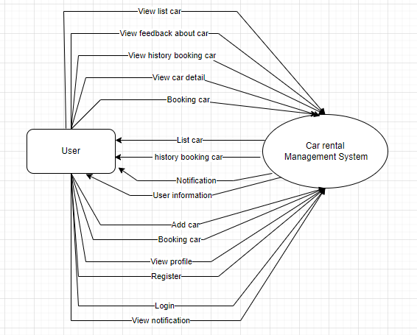

Figure 1-1: Cafeteria System overview

As described in Figure 1-1, the system will have the following component:

* User
* Car Rental Management System

## 1.2 Feature Descriptions

### 1.2.1 Screen Functions

| **#** | **Feature** | **System Function** | **Description** |
| --- | --- | --- | --- |
| 1 | Manage order car | View order list | View list order cars |
| 2 | Manage order car | View order details | View details of each order car |
| 3 | Manage order | Extra surcharge | Add surcharge for order before finish order |
| 4 | History | View list booked car | View the list of booked cars |
| 5 | History | View booking details | View details of each booking car |
| 6 | History | Edit booking | Edit the booking that has not been accepted by the car owner |
| 7 | History | Feedback | Feedback on the use of the booked car |
| 8 | Car rental | Find car | Find car that matches with user’s address |
| 9 | Car rental | View list car | View list car to rent |
| 10 | Car rental | View car detail | View detail of each car |
| 11 | Car rental | Car rental | Rental car |
| 12 | Car rental | Car rental document | Add document to rental car |
| 13 | Car rental | View Feedback | View feedback of each car |
| 14 | Individual | View list | View list menu |
| 15 | Manage rental car | View my car | View list of registered car for rental |
| 16 | Manage rental car | View car information | View information of registered car |
| 17 | Manage rental car | Add new car | Register new car for rental |
| 18 | Manage Account | View address | View list address entered |
| 19 | Manage Account | Add address | Add new address |
| 20 | Manage Account | Edit information | Edit information of account |
| 21 | Manage Account | Verify email | Email verification |
| 22 | Manage Account | Verify driver’s licence | Driver’s licence verification |
| 23 | Manage Account | Change password | Change old password |
| 24 | Manage Account | Account | View information of account |
| 25 | Login | Login | Log in to the app |
| 26 | Register | Register | Register a new account to login to the app |
| 27 | Forget password | Forget password | Recover password when forgot password |
| 28 | Support | Support | Support and guide users to use the app |
| 29 | Home | Home | Booking display and some other functions |
| 30 | Notification | Notification | Notify the app's information to the user and confirm the booking. |
| 31 | Notification detail | Notification detail | Show details of a notification |

### 1.2.2 Non-Screen Functions

| **#** | **Feature** | **System Function** | **Description** |
| --- | --- | --- | --- |
| 1 | Manage order car | Accept order | Accept order car |
| 2 | Manage order car | Cancel order | Cancel order car |
| 3 | History | Cancel booking | Cancel of booking that not accepted by car owner or finish |

### 1.2.3 Common Requirements

* Vehicle Management: ability to add, edit, and manage vehicles, including make, model, year, and rental price.
* Reservation Management: ability to make, edit, and manage reservations, including pickup and return dates and locations.
* Billing and Invoicing: ability to generate invoices and receipts, including rental fees and any additional charges.
* Customer Support: ability to provide customer support
* Customer Management: The system should allow for the creation, storage, and retrieval of customer information, such as name, contact information, and rental history.
* Reservation and Booking Management: The system should allow customers to reserve and book vehicles, and allow staff to manage the availability of vehicles.
* Rental Agreement Generation: The system should generate rental agreements that include the terms and conditions of the rental, as well as any fees or penalties associated with late returns or damage to the vehicle.
* User-friendly Interface: The system should have a user-friendly interface that is easy to navigate, making it simple for customers and staff to interact with the system.

## 1.3 Screen Description

### 1.3.1 Screen Flow

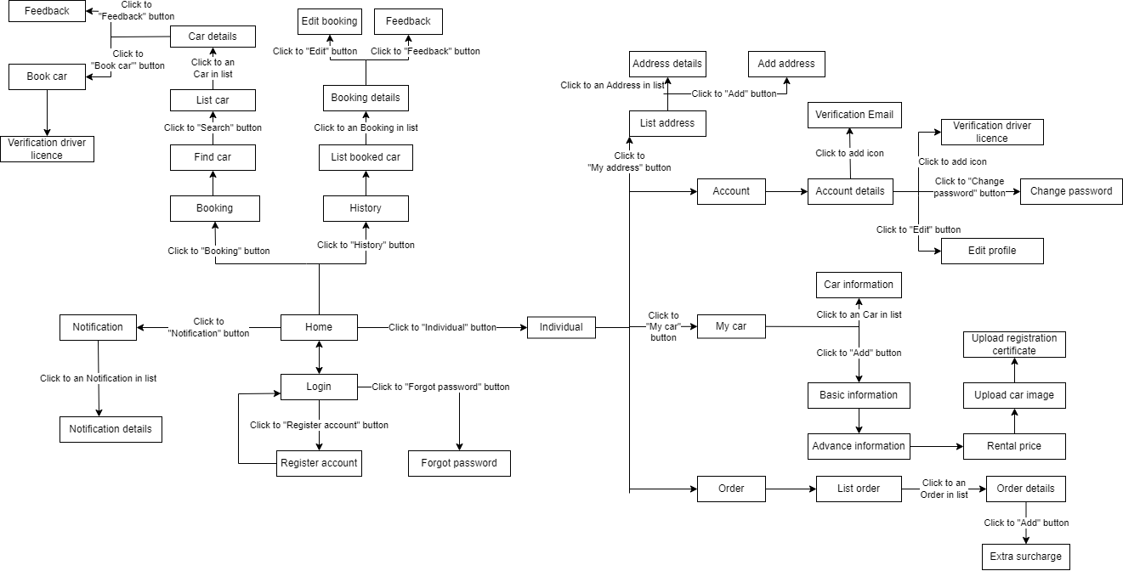

### 1.3.2 Screen Details

| **#** | **Feature** | **Screen** | **Description** |
| --- | --- | --- | --- |
| 1 | Manage order | Order list | View list order cars |
| 2 | Manage order | Order details | View details of each order car |
| 3 | Manage order | Extra surcharge | Add surcharge for order before finish order |
| 4 | History | List booked car | View the list of booked cars |
| 5 | History | Booking details | View details of each booking car |
| 6 | History | Edit booking | Edit the booking that has not been accepted by the car owner |
| 7 | History | Feedback | Feedback on the use of the booked car |
| 8 | Car rental | Find car | Find car that matches with user’s address |
| 9 | Car rental | List car | View list car to rent |
| 10 | Car rental | Car detail | View detail of each car |
| 11 | Car rental | Car rental | Rental car |
| 12 | Car rental | Car rental document | Add document to rental car |
| 13 | Car rental | View feedback | View feedback of each car |
| 14 | Car rental | View list | View list menu |
| 15 | Manage rental car | My Car | View list of registered car for rental |
| 16 | Manage rental car | Car Information | View information of registered car |
| 17 | Manage rental car | Add Basic Information | Enter basic information of the car that is being registered for rental |
| 18 | Manage rental car | Add Advance Information | Enter advance information of the car that is being registered for rental |
| 19 | Manage rental car | Set Rental Price | Set rental price for the car that is being registered for rental |
| 20 | Manage rental car | Upload Car Image | Upload images of the car that is being registered for rental |
| 21 | Manage rental car | Upload Registration Certificate | Upload registration certificate image of the car that is being registered for rental |
| 22 | Common | Login | Log in to the app |
| 23 | Common | Register | Register a new account to login to the app |
| 24 | Common | Forget password | Recover password when forgot password |
| 25 | Common | Support | Support and guide users to use the app |
| 26 | Common | Home | Booking display and some other functions |
| 27 | Common | Notification | Notify the app's information to the user and confirm the booking. |
| 28 | Common | Notification detail | Show details of a notification |
| 29 | Account | Add address | Add new address |
| 30 | Account | View address | View address entered |
| 31 | Account | Account | View information account |
| 32 | Account | Verify email | Email verification |
| 33 | Account | Verify driver's licence | Driver’s licence verification |
| 34 | Account | Change password | Change old password to new password |
| 35 | Account | Edit information | Edit information of account |

### 1.3.3 User Authorization

| **Screen** | **Role1** |
| --- | --- |
| View order list | X |
| View order details | X |
| Extra surcharge | X |
| View list booked car | X |
| View booking details | X |
| Edit booking | X |
| Feedback | X |
| Find car | X |
| List car | X |
| Car detail | X |
| Car rental | X |
| Car rental document | X |
| View feedback | X |
| View list | X |
| My Car | X |
| Car Information | X |
| Add Basic Information | X |
| Add Advance Information | X |
| Set Rental Price | X |
| Upload Car Image | X |
| Upload Registration Certificate | X |
| Add address | X |
| View address | X |
| Account | X |
| Edit information | X |
| Verify driver’s licence | X |
| Verify email | X |
| Change password | X |
| Login | X |
| Register | X |
| Forget password | X |
| Support | X |
| Home | X |
| Notification | X |
| Notification detail | X |

In which:

* Role1: User

# 2 System Features

## 2.1 Car rental

### 2.1.1 Find car

#### 2.1.1.1 Screen Design

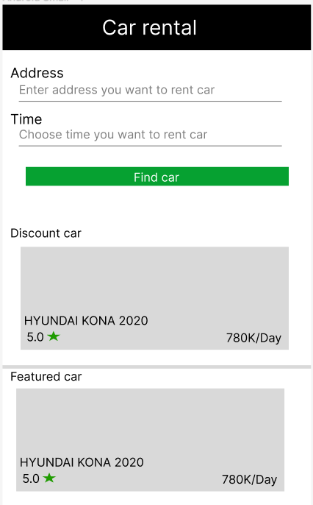

**Figure 3-1**: Screen Design of Find car

**Table 1-1: Screen Definition**

| **#** | **Field Name** | **Type** | **Mandatory** | **Max Length** | **Description** |
| --- | --- | --- | --- | --- | --- |
| 1 | Address | Text | Yes | 1000 | Address that you want to rent a car |
| 2 | Time | DateTime | Yes | 100 | Date and time you want to rent car |
| 3 | Find car | Button |  |  | Find car base on address and time |
| 4 | Discount car | List image |  |  | List of cars that are discounted |
| 5 | Featured car | List image |  |  | List of cars that are rented a lot |

#### 2.1.1.2 Use case Specification

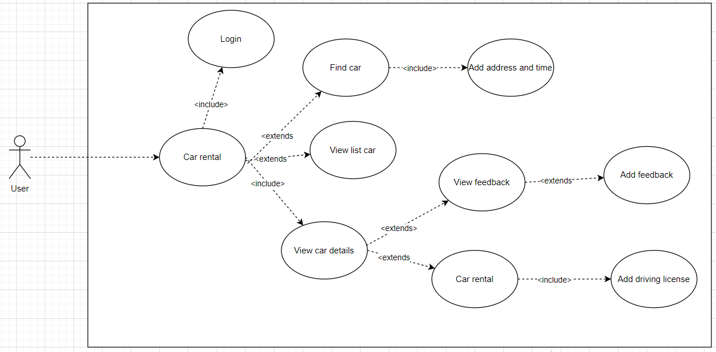

**Figure 3-2:** Login Use-Case Diagram

| **Use Case ID** | | **UC01** | **Use Case Name** | | **Find car** | |
| --- | --- | --- | --- | --- | --- | --- |
| **Author** | | **TuanVQ** | **Version** | **1.0** | **Date** | **06/02/2013** |
| **Actor** | | CRS User | | | | |
| **Description** | | The function allows a user to be able find a car to rent | | | | |
| **Precondition** | | PRE-01: User must have an active account in the system  PRE-02: User must login into system | | | | |
| **Trigger** | | TRG-01: | | | | |
| **Post-Condition** | | POS-01: The system displays a screen find car to rent | | | | |
| **Main flows** | | | | | | |
| ***Step*** | ***Actor*** | ***Action*** | | | | |
| *1* | User | Click to Icon app | | | | |
| *2* | CRS | Display Login screen | | | | |
| *3* | User | Enter user name & password into User Name & Password fields on the Login screen, then click on Login button. | | | | |
| *4* | CRS | Validate the entered user name & password and then display Home screen | | | | |
| *5* | User | Click to Booking car button | | | | |
| *6* | CRS | System display booking screen with following filed:   * Address * Time * Find car button * List discount count * List car rent a lot | | | | |
| *7* | User | User enter address and time want to rent car then click to button find car | | | | |

**Alternative flows**

| **AT1** | At step 2,4,6 in the main flows**,** if there is an internal error in the system, | |
| --- | --- | --- |
| **Sub step** | **Actor** | **Action** |
| 2.1  4.1  6.1 | CRS | Display "Error" page with message "Internal System Error, please contact with administrator" |

| **AT2** | At step 4 in the main flows**,** if CRS failed to validate user name & password | |
| --- | --- | --- |
| **Sub step** | **Actor** | **Action** |
| 4.1 | LMS | Display "Login" page with message "Your user name or password is not correct." |
|  |  |  |

***Business Rules***

| ***#*** | ***Rule Description*** |
| --- | --- |
| *BR01* |  |
| *BR02* |  |

### 2.1.2 View list car

#### 2.1.2.1 Screen Design

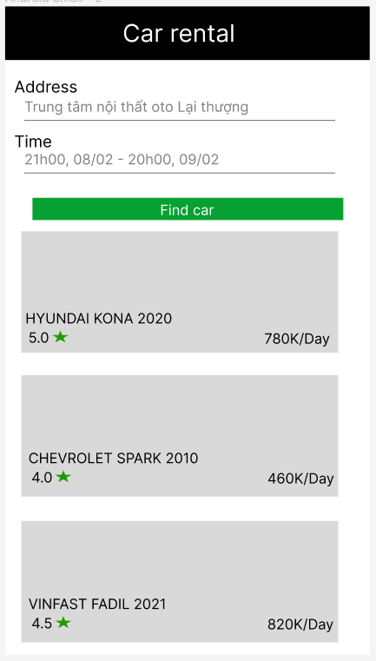

**Figure 3-1**: Screen Design of List car

**Table 1-1: Screen Definition**

| **#** | **Field Name** | **Type** | **Mandatory** | **Max Length** | **Description** |
| --- | --- | --- | --- | --- | --- |
| 1 | Address | Text | Yes | 1000 | Address that you want to rent a car |
| 2 | Time | DateTime | Yes | 100 | Date and time you want to rent car |
| 3 | Find car | Button |  |  | Find car base on address and time |
| 4 | List car | List image |  |  | List car that match information |

#### 2.1.2.2 Use case Specification



| **Use Case ID** | | **UC01** | **Use Case Name** | | **View list car** | |
| --- | --- | --- | --- | --- | --- | --- |
| **Author** | | **TuanVQ** | **Version** | **1.0** | **Date** | **06/02/2013** |
| **Actor** | | CRM User | | | | |
| **Description** | | The function allows a user to be able view list car | | | | |
| **Precondition** | | PRE-01: User must have an active account in the system  PRE-02: User must login into system | | | | |
| **Trigger** | | TRG-01: | | | | |
| **Post-Condition** | | POS-01: The system displays a list of cars that match the criteria entered by the user | | | | |
| **Main flows** | | | | | | |
| ***Step*** | ***Actor*** | ***Action*** | | | | |
| *1* | User | Click to Icon app | | | | |
| *2* | CRS | Display Login screen | | | | |
| *3* | User | Enter user name & password into User Name & Password fields on the Login screen, then click on Login button. | | | | |
| *4* | CRS | Validate the entered user name & password and then display Home screen | | | | |
| *5* | User | Click to Booking car button | | | | |
| *6* | CRS | System display booking screen with following filed:   * Address * Time * Find car button * List discount count * List car rent a lot | | | | |
| 7 | User | User enter address and time want to book car then press button Find car | | | | |
| 8 | CRS | System display list cars that match information user entered | | | | |

**Alternative flows**

| **AT1** | At step 2,4,6,8 in the main flows**,** if there is an internal error in the system, | |
| --- | --- | --- |
| **Sub step** | **Actor** | **Action** |
| 2.1  4.1  6.1  8.1 | CRS | Display "Error" page with message "Internal System Error, please contact with administrator" |

| **AT2** | At step 4 in the main flows**,** if CRS failed to validate user name & password | |
| --- | --- | --- |
| **Sub step** | **Actor** | **Action** |
| 4.1 | LMS | Display "Login" page with message "Your user name or password is not correct." |
|  |  |  |

| **AT3** | At step 8 in the main flows**,** if CRS doesn’t find information that match | |
| --- | --- | --- |
| **Sub step** | **Actor** | **Action** |
| 8.1 | LMS | Display messenger" No car match " |

***Business Rules***

| ***#*** | ***Rule Description*** |
| --- | --- |
| *BR01* |  |
| *BR02* |  |

### 2.1.3 View car detail

#### 2.1.3.1 Screen Design

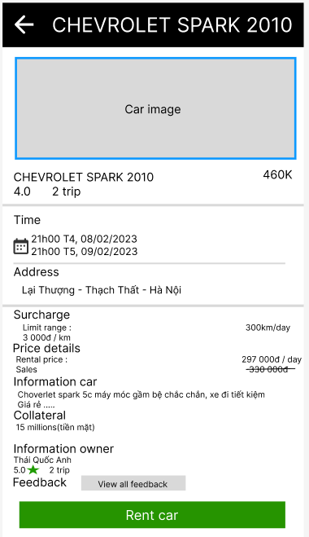

**Figure 3-1**: Screen Design of Car details

**Table 1-1: Screen Definition**

| **#** | **Field Name** | **Type** | **Mandatory** | **Max Length** | **Description** |
| --- | --- | --- | --- | --- | --- |
| 1 | Car name | Text |  |  | Name of car |
| 2 | Trip number | Number |  |  | Number of people who rented a car |
| 3 | Price | Money |  |  | Total car rental price |
| 4 | Time | DateTime |  |  | Car rental time |
| 5 | Address | Text |  |  | Address car delivery place |
| 6 | Surcharge | Money |  |  | Fees incurred during car rental |
| 7 | Price details | Money |  |  | Price details |
| 8 | Information car | Text |  |  | All information of car |
| 9 | Collateral | Text |  |  | Collateral when renting a car |
| 10 | Information owner | Text |  |  | Car rental information |
| 11 | Feedback | Text |  |  | Car rental reviews |

#### 2.1.3.2 Use case Specification



| **Use Case ID** | | **UC01** | **Use Case Name** | | **View car detail** | |
| --- | --- | --- | --- | --- | --- | --- |
| **Author** | | **TuanVQ** | **Version** | **1.0** | **Date** | **06/02/2013** |
| **Actor** | | CRM User | | | | |
| **Description** | | The function allows a user to be able view car details | | | | |
| **Precondition** | | PRE-01: User must have an active account in the system  PRE-02: User must login into system | | | | |
| **Trigger** | | TRG-01: | | | | |
| **Post-Condition** | | POS-01: The system displays a list of cars that match the criteria entered by the user | | | | |
| **Main flows** | | | | | | |
| ***Step*** | ***Actor*** | ***Action*** | | | | |
| *1* | User | Click to Icon app | | | | |
| *2* | CRS | Display Login screen | | | | |
| *3* | User | Enter user name & password into User Name & Password fields on the Login screen, then click on Login button. | | | | |
| *4* | CRS | Validate the entered user name & password and then display Home screen | | | | |
| *5* | User | Click to Booking car button | | | | |
| *6* | CRS | System display booking screen with following filed:   * Address * Time * Find car button * List discount count * List car rent a lot | | | | |
| 7 | User | User enter address and time want to book car then press button Find car | | | | |
| 8 | CRS | System display list cars that match information user entered | | | | |
| 9 | User | Click a car to see more information | | | | |
| 10 | CRS | Display all information about the car(name, owner, price….) | | | | |

**Alternative flows**

| **AT1** | At step 2,4,6,8,10 in the main flows**,** if there is an internal error in the system, | |
| --- | --- | --- |
| **Sub step** | **Actor** | **Action** |
| 2.1  4.1  6.1  8.1  10.1 | CRS | Display "Error" page with message "Internal System Error, please contact with administrator" |

| **AT2** | At step 4 in the main flows**,** if CRS failed to validate user name & password | |
| --- | --- | --- |
| **Sub step** | **Actor** | **Action** |
| 4.1 | LMS | Display "Login" page with message "Your user name or password is not correct." |
|  |  |  |

| **AT3** | At step 8 in the main flows**,** if CRS doesn’t find information that match | |
| --- | --- | --- |
| **Sub step** | **Actor** | **Action** |
| 8.1 | LMS | Display messenger" No car match " |

***Business Rules***

| ***#*** | ***Rule Description*** |
| --- | --- |
| *BR01* |  |
| *BR02* |  |

### 2.1.4 Car rental

#### 2.1.4.1 Screen Design

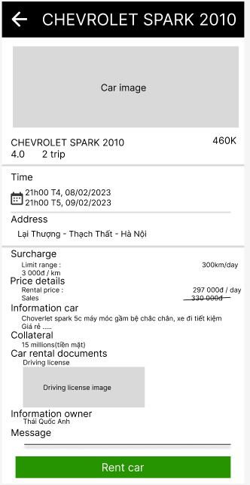

**Figure 3-1**: Screen Design of car rental

**Table 1-1: Screen Definition**

| **#** | **Field Name** | **Type** | **Mandatory** | **Max Length** | **Description** |
| --- | --- | --- | --- | --- | --- |
| 1 | Car name | Text |  |  | Name of car |
| 2 | Trip number | Number |  |  | Number of people who rented a car |
| 3 | Price | Money |  |  | Total car rental price |
| 4 | Time | DateTime |  |  | Car rental time |
| 5 | Address | Text |  |  | Address car delivery place |
| 6 | Surcharge | Money |  |  | Fees incurred during car rental |
| 7 | Price details | Money |  |  | Price details |
| 8 | Information car | Text |  |  | All information of car |
| 9 | Collateral | Text |  |  | Collateral when renting a car |
| 10 | Information owner | Text |  |  | Car rental information |
| 11 | Car rental documents | Image |  |  | Car rental documents |

#### 2.1.4.2 Use case Specification



| **Use Case ID** | | **UC01** | **Use Case Name** | | **Car rental** | |
| --- | --- | --- | --- | --- | --- | --- |
| **Author** | | **TuanVQ** | **Version** | **1.0** | **Date** | **06/02/2013** |
| **Actor** | | CRM User | | | | |
| **Description** | | The function allows a user to be able rental car | | | | |
| **Precondition** | | PRE-01: User must have an active account in the system  PRE-02: User must login into system | | | | |
| **Trigger** | | TRG-01: | | | | |
| **Post-Condition** | | POS-01: The system displays a list of cars that match the criteria entered by the user | | | | |
| **Main flows** | | | | | | |
| ***Step*** | ***Actor*** | ***Action*** | | | | |
| *1* | User | Click to Icon app | | | | |
| *2* | CRS | Display Login screen | | | | |
| *3* | User | Enter user name & password into User Name & Password fields on the Login screen, then click on Login button. | | | | |
| *4* | CRS | Validate the entered user name & password and then display Home screen | | | | |
| *5* | User | Click to Booking car button | | | | |
| *6* | CRS | System display booking screen with following filed:   * Address * Time * Find car button * List discount count * List car rent a lot | | | | |
| 7 | User | User enter address and time want to book car then press button Find car | | | | |
| 8 | CRS | System display list cars that match information user entered | | | | |
| 9 | User | Click a car to see more information | | | | |
| 10 | CRS | Display all information of car(name, owner, price….) | | | | |
| 11 | User | Click to button booking car | | | | |
| 12 | CRS | System will display message “Rental successful” | | | | |

**Alternative flows**

| **AT1** | At step 2,4,6,8,10,12 in the main flows**,** if there is an internal error in the system, | |
| --- | --- | --- |
| **Sub step** | **Actor** | **Action** |
| 2.1  4.1  6.1  8.1  10.1  12.1 | CRS | Display "Error" page with message "Internal System Error, please contact with administrator" |

| **AT2** | At step 4 in the main flows**,** if CRS failed to validate user name & password | |
| --- | --- | --- |
| **Sub step** | **Actor** | **Action** |
| 4.1 | CRS | Display "Login" page with message "Your user name or password is not correct." |

| **AT3** | At step 8 in the main flows**,** if CRS doesn’t find information that match | |
| --- | --- | --- |
| **Sub step** | **Actor** | **Action** |
| 4.1 | CRS | Display messenger" No car match " |

| **AT4** | At step 12 in the main flows**,** if user doesn’t have Car driving licence | |
| --- | --- | --- |
| **Sub step** | **Actor** | **Action** |
| 12 | CRS | Display messenger" Please update your driving licence" |

***Business Rules***

| ***#*** | ***Rule Description*** |
| --- | --- |
| *BR01* |  |
| *BR02* |  |

### 2.1.5 Car rental documents

#### 2.1.5.1 Screen Design

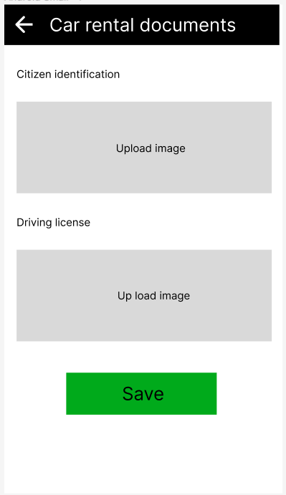

**Figure 3-1**: Screen Design of car rental document

**Table 1-1: Screen Definition**

| **#** | **Field Name** | **Type** | **Mandatory** | **Max Length** | **Description** |
| --- | --- | --- | --- | --- | --- |
| 1 | Citizen identification | Text |  |  | Citizen's documents |
| 2 | Driving licence | Text |  |  | Citizen's documents |
| 3 | Price | Button |  |  |  |
| 4 | Back | Button |  |  |  |
| 5 | Save | Button |  |  |  |

#### 2.1.5.2 Use case Specification



| **Use Case ID** | | **UC01** | **Use Case Name** | | **Car rental document** | |
| --- | --- | --- | --- | --- | --- | --- |
| **Author** | | **TuanVQ** | **Version** | **1.0** | **Date** | **06/02/2013** |
| **Actor** | | CRM User | | | | |
| **Description** | | The function allows a user to be able add document to rental car | | | | |
| **Precondition** | | PRE-01: User must have an active account in the system  PRE-02: User must login into system | | | | |
| **Trigger** | | TRG-01: | | | | |
| **Post-Condition** | | POS-01: The system displays a list of cars that match the criteria entered by the user | | | | |
| **Main flows** | | | | | | |
| ***Step*** | ***Actor*** | ***Action*** | | | | |
| *1* | User | Click to Icon app | | | | |
| *2* | CRS | Display Login screen | | | | |
| *3* | User | Enter user name & password into User Name & Password fields on the Login screen, then click on Login button. | | | | |
| *4* | CRS | Validate the entered user name & password and then display Home screen | | | | |
| *5* | User | Click to Booking car button | | | | |
| *6* | CRS | System display booking screen with following filed:   * Address * Time * Find car button * List discount count * List car rent a lot | | | | |
| 7 | User | User enter address and time want to book car then press button Find car | | | | |
| 8 | CRS | System display list cars that match information user entered | | | | |
| 9 | User | Click a car to see more information | | | | |
| 10 | CRS | Display all information about the car(name, owner, price….) | | | | |
| 11 | User | Add car rental documents and click to button booking car | | | | |
| 12 | CRS | System will display message “Rental successful” | | | | |

**Alternative flows**

| **AT1** | At step 2,4,6,8,10,12 in the main flows**,** if there is an internal error in the system, | |
| --- | --- | --- |
| **Sub step** | **Actor** | **Action** |
| 2.1  4.1  6.1  8.1  10.1  12.1 | CRS | Display "Error" page with message "Internal System Error, please contact with administrator" |

| **AT2** | At step 4 in the main flows**,** if CRS failed to validate user name & password | |
| --- | --- | --- |
| **Sub step** | **Actor** | **Action** |
| 4.1 | CRS | Display "Login" page with message "Your user name or password is not correct." |

| **AT3** | At step 8 in the main flows**,** if CRS doesn’t find information that match | |
| --- | --- | --- |
| **Sub step** | **Actor** | **Action** |
| 4.1 | CRS | Display messenger" No car match " |

| **AT4** | At step 12 in the main flows**,** if user doesn’t have Car driving licence | |
| --- | --- | --- |
| **Sub step** | **Actor** | **Action** |
| 12 | CRS | Display messenger" Please update your driving licence" |

***Business Rules***

| ***#*** | ***Rule Description*** |
| --- | --- |
| *BR01* |  |
| *BR02* |  |

### 2.1.6 View feedback

#### 2.1.6.1 Screen Design

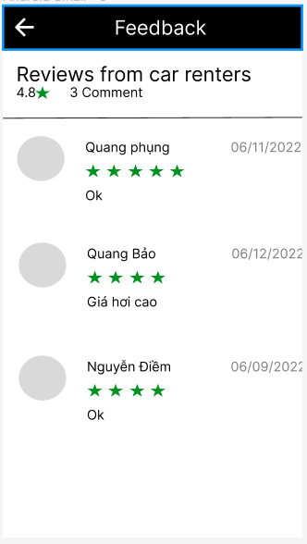

**Figure 3-1**: Screen Design of Feedback

**Table 1-1: Screen Definition**

| **#** | **Field Name** | **Type** | **Mandatory** | **Max Length** | **Description** |
| --- | --- | --- | --- | --- | --- |
| 1 | Rate |  |  |  | Number of stars received out of 5 |
| 2 | Renter's name | Text |  |  | Renter's name |
| 3 | Date | Date |  |  | Comment time |

#### 2.1.6.2 Use case Specification



| **Use Case ID** | | **UC01** | **Use Case Name** | | **View list car** | |
| --- | --- | --- | --- | --- | --- | --- |
| **Author** | | **TuanVQ** | **Version** | **1.0** | **Date** | **06/02/2013** |
| **Actor** | | CRM User | | | | |
| **Description** | | The function allows a user to be able view feedback about car | | | | |
| **Precondition** | | PRE-01: User must have an active account in the system  PRE-02: User must login into system | | | | |
| **Trigger** | | TRG-01: | | | | |
| **Post-Condition** | | POS-01: The system displays a list of cars that match the criteria entered by the user | | | | |
| **Main flows** | | | | | | |
| ***Step*** | ***Actor*** | ***Action*** | | | | |
| *1* | User | Click to Icon app | | | | |
| *2* | CRS | Display Login screen | | | | |
| *3* | User | Enter user name & password into User Name & Password fields on the Login screen, then click on Login button. | | | | |
| *4* | CRS | Validate the entered user name & password and then display Home screen | | | | |
| *5* | User | Click to History | | | | |
| *6* | CRS | Display View list booked car screen with the following fields:  - Range of car  - Address  - Time  - Cancel button | | | | |
| 7 | User | Choose a rented car | | | | |
| 8 | CRS | Display all information about the car(name, owner, price….) | | | | |
| 9 | User | Click a button view all feedback | | | | |
| 10 | CRS | Display all feedback about this car | | | | |

**Alternative flows**

| **AT1** | At step 2,4,6,8,10 in the main flows**,** if there is an internal error in the system, | |
| --- | --- | --- |
| **Sub step** | **Actor** | **Action** |
| 2.1  4.1  6.1  8.1  10.1 | CRS | Display "Error" page with message "Internal System Error, please contact with administrator" |

| **AT2** | At step 4 in the main flows**,** if CRS failed to validate user name & password | |
| --- | --- | --- |
| **Sub step** | **Actor** | **Action** |
| 4.1 | CRS | Display "Login" page with message "Your user name or password is not correct." |

***Business Rules***

| ***#*** | ***Rule Description*** |
| --- | --- |
| *BR01* |  |
| *BR02* |  |

## 2.2 Individual

### 2.2.1 View list

#### 2.2.1.1 Screen Design

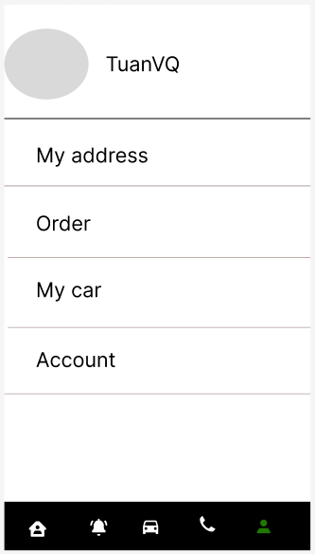

**Figure 3-1**: Screen Design of list item

**Table 1-1: Screen Definition**

| **#** | **Field Name** | **Type** | **Mandatory** | **Max Length** | **Description** |
| --- | --- | --- | --- | --- | --- |
| 1 | My address | Button |  |  | Your address |
| 2 | Account | Button |  |  | Your account information |
| 3 | My car | Button |  |  | Car information |
| 4 | Order | Button |  |  | Order information |
| 5 | Logout | Button |  |  |  |

#### 2.2.1.2 Use case Specification

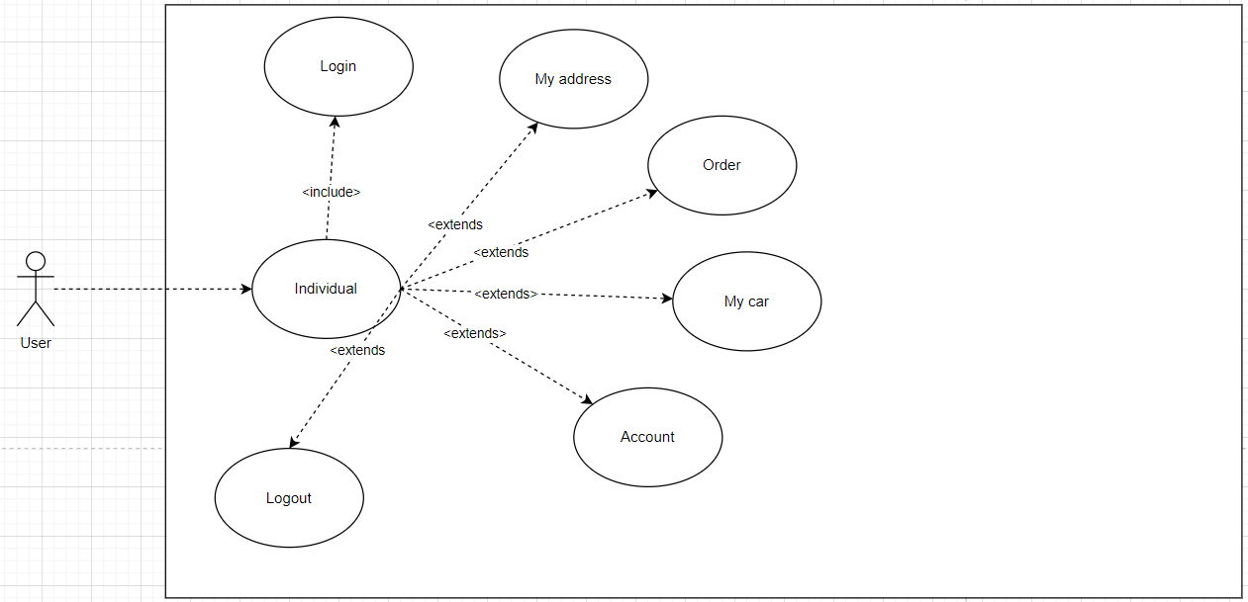

**Figure 3-2:** Individuals Use-Case Diagram

| **Use Case ID** | | **UC01** | **Use Case Name** | | **View List** | |
| --- | --- | --- | --- | --- | --- | --- |
| **Author** | | **TuanVQ** | **Version** | **1.0** | **Date** | **06/02/2013** |
| **Actor** | | CRS User | | | | |
| **Description** | | The function allows a user to be able see information of account, car, contract…. | | | | |
| **Precondition** | | PRE-01: User must have an active account in the system  PRE-02: User must login into system | | | | |
| **Trigger** | | TRG-01: | | | | |
| **Post-Condition** | | POS-01: The system displays a screen of account, car, contract …. | | | | |
| **Main flows** | | | | | | |
| ***Step*** | ***Actor*** | ***Action*** | | | | |
| *1* | User | Click to Icon app | | | | |
| *2* | CRS | Display Login screen | | | | |
| *3* | User | Enter user name & password into User Name & Password fields on the Login screen, then click on Login button. | | | | |
| *4* | CRS | Validate the entered user name & password and then display Home screen | | | | |
| *5* | User | Click to “Individual” in nav-bar | | | | |
| *6* | CRS | System display screen with following filed:   * My address * Account * My car * Contract * Logout | | | | |

**Alternative flows**

| **AT1** | At step 2,4,6 in the main flows**,** if there is an internal error in the system, | |
| --- | --- | --- |
| **Sub step** | **Actor** | **Action** |
| 2.1  4.1  6.1 | CRS | Display "Error" page with message "Internal System Error, please contact with administrator" |

| **AT2** | At step 4 in the main flows**,** if LMS failed to validate user name & password | |
| --- | --- | --- |
| **Sub step** | **Actor** | **Action** |
| 4.1 | LMS | Display "Login" page with message "Your user name or password is not correct." |

***Business Rules***

| ***#*** | ***Rule Description*** |
| --- | --- |
| *BR01* |  |
| *BR02* |  |

## 2.3 Manage order car

### 2.3.1 Use case diagram

| **Use Case ID** | **User case Name** | **Description** |
| --- | --- | --- |
| UC-0402 | View order list | Allow the user to view list order car |
| UC-0403 | View order details | Allow the user to view details of each order car |
| UC-0404 | Accept order | Allow the car owner to accept order car |
| UC-0405 | Cancel order | Allow the car owner to cancel order car |
| UC-0406 | Extra surcharge | Allow the car owner to add surcharge into order before finish |

3

### 2.3.2 View order list

#### 2.3.2.1 Screen Design

**Figure 4.2.1**: Screen Design of View order list

**Table 4.2.1: Screen Definition**

| **#** | **Field Name** | **Type** | **Mandatory** | **Max Length** | **Description** |
| --- | --- | --- | --- | --- | --- |
| 1 | Account name | Text |  |  |  |
| 2 | Range of car |  |  |  |  |
| 2 | Address | Text |  |  |  |
| 3 | Time | Number |  |  |  |
| 4 | Cancel | Button |  |  | Cancel order |

#### 2.3.2.2 Use case Specification

| **Use Case ID** | | **UC0402** | **Use Case Name** | | **View order list** | |
| --- | --- | --- | --- | --- | --- | --- |
| **Author** | | **LuongTTH** | **Version** | **1.0** | **Date** | **05/02/2023** |
| **Actor** | | CRS User | | | | |
| **Description** | | The function allows a car owner to be able to view list order cars. | | | | |
| **Precondition** | | PRE-01: CRS user must register a car in the app | | | | |
| **Trigger** | | TRG-01: | | | | |
| **Post-Condition** | | POS-01: | | | | |
| **Main flows** | | | | | | |
| ***Step*** | ***Actor*** | ***Action*** | | | | |
| *1* | User | Type URL into location field of internet browser and then press enter | | | | |
| *2* | CRS | Display View order list screen with the following fields:  - Account name  - Range of car  - Address  - Time  - Cancel button | | | | |

**Alternative flows**

| **AT1** | At step 2 in the main flows**,** if there is an internal error in the system, | |
| --- | --- | --- |
| **Sub step** | **Actor** | **Action** |
| 2.1 | CRS | Display "Error" page with message "System error, please reload the page" |

***Business Rules***

| ***#*** | ***Rule Description*** |
| --- | --- |
| *BR01* | *Must show the account name of the car hirer and the address and time of the rental* |

### 2.3.3 View order details

#### 2.3.3.1 Screen Design

**Figure 4.3.1**: Screen Design of View order details

**Table 4.3.1: Screen Definition**

| **#** | **Field Name** | **Type** | **Mandatory** | **Max Length** | **Description** |
| --- | --- | --- | --- | --- | --- |
| 1 | Car Name | Text |  |  |  |
| 2 | Account name | Text |  |  | Car rental account name |
| 3 | Price | Money |  |  |  |
| 4 | Time | DateTime |  |  |  |
| 5 | Address | Text |  |  | Car delivery location |
| 6 | Mortgage type | Text |  |  |  |
| 7 | Accept | Button |  |  | Accept order |
| 8 | Cancel | Button |  |  | Cancel order |
| 9 | Extra surcharge | Button |  |  | Add extra surcharge |

#### 2.3.3.2 Use case Specification

| **Use Case ID** | | **UC0403** | **Use Case Name** | | **View order details** | |
| --- | --- | --- | --- | --- | --- | --- |
| **Author** | | **LuongTTH** | **Version** | **1.0** | **Date** | **05/02/2023** |
| **Actor** | | CRS User | | | | |
| **Description** | | The function allows a car owner to be able to view list order cars. | | | | |
| **Precondition** | | PRE-01: CRS user must register a car in the app | | | | |
| **Trigger** | | TRG-01: | | | | |
| **Post-Condition** | | POS-01: | | | | |
| **Main flows** | | | | | | |
| ***Step*** | ***Actor*** | ***Action*** | | | | |
| *1* | User | Go to View order list and click to an order | | | | |
| *2* | CRS | Display View order details screen with the following fields:  - Car name  - Account name  - Price  - Time  - Address  - Mortgage type  - Accept, Cancel, Extra surcharge button | | | | |

**Alternative flows**

| **AT1** | At step 2 in the main flows**,** if there is an internal error in the system, | |
| --- | --- | --- |
| **Sub step** | **Actor** | **Action** |
| 2.1 | CRS | Display "Error" page with message "System error, please reload the page" |

***Business Rules***

| ***#*** | ***Rule Description*** |
| --- | --- |
| *BR01* | *Must show the account name of the car hirer and the address and time of the rental* |

### 2.3.4 Accept order

#### 2.3.4.1 Screen Design

**Figure 4.4.1**: Screen Design of Accept order

**Table 4.4.1: Screen Definition**

| **#** | **Field Name** | **Type** | **Mandatory** | **Max Length** | **Description** |
| --- | --- | --- | --- | --- | --- |
| 1 | Car Name | Text |  |  |  |
| 2 | Account name | Text |  |  | Car rental account name |
| 3 | Price | Money |  |  |  |
| 4 | Time | DateTime |  |  |  |
| 5 | Address | Text |  |  | Car delivery location |
| 6 | Mortgage type | Text |  |  |  |
| 7 | Accept | Button |  |  | Accept order |
| 8 | Cancel | Button |  |  | Cancel order |
| 9 | Extra surcharge | Button |  |  | Add extra surcharge |

#### 2.3.4.2 Use case Specification

| **Use Case ID** | | **UC0404** | **Use Case Name** | | **Accept order** | |
| --- | --- | --- | --- | --- | --- | --- |
| **Author** | | **LuongTTH** | **Version** | **1.0** | **Date** | **05/02/2023** |
| **Actor** | | CRS User | | | | |
| **Description** | | The function allows a car owner to be able to accept order. | | | | |
| **Precondition** | | PRE-01: CRS user must register a car in the app  PRE-02: CRS user must have order car by another user | | | | |
| **Trigger** | | TRG-01: | | | | |
| **Post-Condition** | | POS-01: | | | | |
| **Main flows** | | | | | | |
| ***Step*** | ***Actor*** | ***Action*** | | | | |
| *1* | User | Go to View order list and click to an order | | | | |
| *2* | CRS | Display View order details screen with the following fields:  - Car name  - Account name  - Price  - Time  - Address  - Mortgage type  - Accept, Cancel, Extra surcharge button | | | | |
| *3* | User | Click to Accept button | | | | |
| *4* | CRS | Change status of this order to accepted and display “Successful” screen | | | | |

**Alternative flows**

| **AT1** | At step 2 in the main flows**,** if there is an internal error in the system, | |
| --- | --- | --- |
| **Sub step** | **Actor** | **Action** |
| 2.1 | CRS | Display "Error" page with message "System error, please reload the page" |

| **AT2** | At step 4 in the main flows**,** if system can’t save change | |
| --- | --- | --- |
| **Sub step** | **Actor** | **Action** |
| 2.1 | CRS | Display "Error" page with message "Accept order fail." |

***Business Rules***

| ***#*** | ***Rule Description*** |
| --- | --- |
| *BR01* | *The car owner must read all information of order then accept order* |

### 2.3.5 Cancel order

#### 2.3.5.1 Screen Design

**Figure 4.5.1**: Screen Design of Cancel order

**Table 4.5.1: Screen Definition**

| **#** | **Field Name** | **Type** | **Mandatory** | **Max Length** | **Description** |
| --- | --- | --- | --- | --- | --- |
| 1 | Car Name | Text |  |  |  |
| 2 | Account name | Text |  |  | Car rental account name |
| 3 | Price | Money |  |  |  |
| 4 | Time | DateTime |  |  |  |
| 5 | Address | Text |  |  | Car delivery location |
| 6 | Mortgage type | Text |  |  |  |
| 7 | Accept | Button |  |  | Accept order |
| 8 | Cancel | Button |  |  | Cancel order |
| 9 | Extra surcharge | Button |  |  | Add extra surcharge |

| **#** | **Field Name** | **Type** | **Mandatory** | **Max Length** | **Description** |
| --- | --- | --- | --- | --- | --- |
| 1 | Account name | Text |  |  |  |
| 2 | Address | Text |  |  |  |
| 3 | Time | Number |  |  |  |
| 4 | Cancel | Button |  |  | Cancel order |

#### 2.3.5.2 Use case Specification

| **Use Case ID** | | **UC0405** | **Use Case Name** | | **Cancel order** | |
| --- | --- | --- | --- | --- | --- | --- |
| **Author** | | **LuongTTH** | **Version** | **1.0** | **Date** | **05/02/2023** |
| **Actor** | | CRS User | | | | |
| **Description** | | The function allows a car owner to be able to accept order. | | | | |
| **Precondition** | | PRE-01: CRS user must register a car in the app  PRE-02: CRS user must have order car by another user | | | | |
| **Trigger** | | TRG-01: | | | | |
| **Post-Condition** | | POS-01: | | | | |
| **Main flows** | | | | | | |
| ***Step*** | ***Actor*** | ***Action*** | | | | |
| *1* | User | Go to the View list order Screen or View order detail screen | | | | |
| *2* | CRS | Display View order list screen with the following fields:  - Account name  - Address  - Time  OR display View order details screen with the following fields:  - Car name  - Account name  - Price  - Time  - Address  - Mortgage type  - Accept, Cancel, Extra surcharge button | | | | |
| *3* | User | Click to Cancel button | | | | |
| *4* | CRS | Display “Confirm” screen | | | | |
| *5* | User | If click to Ok button | | | | |
| *6* | CRS | Change status of order to cancel and display “Successful” screen | | | | |
| *7* | User | If click to Cancel button | | | | |
| *8* | CRS | Return View list order or View order details screen | | | | |

**Alternative flows**

| **AT1** | At step 2 in the main flows**,** if there is an internal error in the system, | |
| --- | --- | --- |
| **Sub step** | **Actor** | **Action** |
| 2.1 | CRS | Display "Error" page with message "System error, please reload the page" |

| **AT2** | At step 5 in the main flows**,** if system can’t save change | |
| --- | --- | --- |
| **Sub step** | **Actor** | **Action** |
| 2.1 | CRS | Display "Error" page with message "Cancel order fail." |

***Business Rules***

| ***#*** | ***Rule Description*** |
| --- | --- |
| *BR01* | *Before cancel the order, there must be a confirmation with the user* |

### 2.3.6 Extra surcharge

#### 2.3.6.1 Screen Design

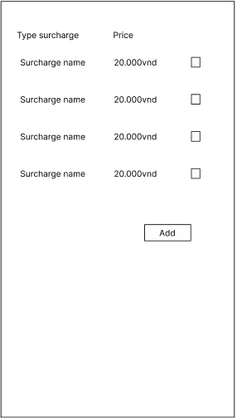

**Figure 4.6.1**: Screen Design of Extra surcharge

**Table 4.6.1: Screen Definition**

| **#** | **Field Name** | **Type** | **Mandatory** | **Max Length** | **Description** |
| --- | --- | --- | --- | --- | --- |
| 1 | Surcharge name | Text |  |  |  |
| 2 | Price | Money |  |  |  |
| 3 | Select | Select |  |  |  |
| 4 | Add | Button |  |  | Add surcharges into order |

#### 2.3.6.2 Use case Specification

| **Use Case ID** | | **UC0406** | **Use Case Name** | | **Extra surcharge** | |
| --- | --- | --- | --- | --- | --- | --- |
| **Author** | | **LuongTTH** | **Version** | **1.0** | **Date** | **05/02/2023** |
| **Actor** | | CRS User | | | | |
| **Description** | | The function allows a car owner to be able to add surcharges into order before finish. | | | | |
| **Precondition** | | PRE-01: CRS user must register a car in the app  PRE-02: CRS user must have order car by another user | | | | |
| **Trigger** | | TRG-01: | | | | |
| **Post-Condition** | | POS-01: | | | | |
| **Main flows** | | | | | | |
| ***Step*** | ***Actor*** | ***Action*** | | | | |
| *1* | User | Go to the View order detail screen and click to Extra surcharge | | | | |
| *2* | CRS | Display View order details screen with the following fields:  - Surcharge name  - Price  - Select  - Add button | | | | |
| *3* | User | Click to surcharge name that user want and click to Add button | | | | |
| *4* | CRS | Display “Confirm” screen | | | | |
| *5* | User | If click to Ok button | | | | |
| *6* | CRS | Change status of order to cancel and display “Successful” screen | | | | |
| *7* | User | If click to Cancel button | | | | |
| *8* | CRS | Return View order details screen | | | | |

**Alternative flows**

| **AT1** | At step 2 in the main flows**,** if there is an internal error in the system, | |
| --- | --- | --- |
| **Sub step** | **Actor** | **Action** |
| 2.1 | CRS | Display "Error" page with message "System error, please reload the page" |

| **AT2** | At step 5 in the main flows**,** if system can’t save change | |
| --- | --- | --- |
| **Sub step** | **Actor** | **Action** |
| 2.1 | CRS | Display "Error" page with message "Add surcharge fail." |

***Business Rules***

| ***#*** | ***Rule Description*** |
| --- | --- |
| *BR01* | *Before add surcharge into the order, there must be a confirmation with the user* |

## 2.4 History

### 2.4.1 Use case diagram

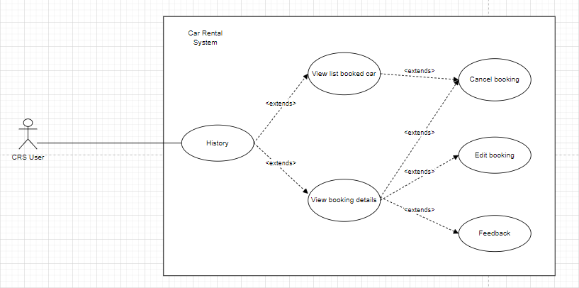

| **Use Case ID** | **User case Name** | **Description** |
| --- | --- | --- |
| UC-0502 | View list booked car | Allow the user to view list booked car |
| UC-0503 | View booking details | Allow the user to view details of each booking car |
| UC-0504 | Edit booking | Allow the user to edit booking that not accepted by car owner |
| UC-0505 | Cancel booking | Allow the user to cancel booking that pending or not finish |
| UC-0506 | Feedback | Allow the user to feedback about the car |

### 2.4.2 View list booked car

#### 2.4.2.1 Screen Design

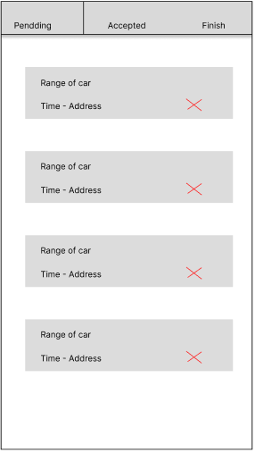

**Figure 5.2.1**: Screen Design of View list booked car

**Table 5.2.1: Screen Definition**

| **#** | **Field Name** | **Type** | **Mandatory** | **Max Length** | **Description** |
| --- | --- | --- | --- | --- | --- |
| 1 | Range of car | Text |  |  |  |
| 2 | Address | Text |  |  |  |
| 3 | Time | Number |  |  |  |
| 4 | Cancel | Button |  |  | Cancel booking |

#### 2.4.2.2 Use case Specification

| **Use Case ID** | | **UC0502** | **Use Case Name** | | **View list booked car** | |
| --- | --- | --- | --- | --- | --- | --- |
| **Author** | | **LuongTTH** | **Version** | **1.0** | **Date** | **05/02/2023** |
| **Actor** | | CRS User | | | | |
| **Description** | | The function allows a user to be able to view list booked car. | | | | |
| **Precondition** | | PRE-01: | | | | |
| **Trigger** | | TRG-01: | | | | |
| **Post-Condition** | | POS-01: | | | | |
| **Main flows** | | | | | | |
| ***Step*** | ***Actor*** | ***Action*** | | | | |
| *1* | User | Go to History screen | | | | |
| *2* | CRS | Display View list booked car screen with the following fields:  - Range of car  - Address  - Time  - Cancel button | | | | |

**Alternative flows**

| **AT1** | At step 2 in the main flows**,** if there is an internal error in the system, | |
| --- | --- | --- |
| **Sub step** | **Actor** | **Action** |
| 2.1 | CRS | Display "Error" page with message "System error, please reload the page" |

***Business Rules***

| ***#*** | ***Rule Description*** |
| --- | --- |
| *BR01* | *Must show the range of car and the address and time of the rental* |

### 2.4.3 View booking details

#### 2.4.3.1 Screen Design

**Figure 5.3.1**: Screen Design of View booking details

**Table 5.3.1: Screen Definition**

| **#** | **Field Name** | **Type** | **Mandatory** | **Max Length** | **Description** |
| --- | --- | --- | --- | --- | --- |
| 1 | Car Name | Text |  |  |  |
| 2 | Account name | Text |  |  | Car owner account name |
| 3 | Price | Money |  |  |  |
| 4 | Time | DateTime |  |  |  |
| 5 | Address | Text |  |  | Car delivery location |
| 6 | Mortgage type | Text |  |  |  |
| 7 | Status | Text |  |  | Status of booking |
| 8 | Cancel | Button |  |  | Cancel booking |
| 9 | Edit | Button |  |  | Go to Edit booking screen |
| 10 | Feedback | Button |  |  | Go to Feedback screen |

#### 2.4.3.2 Use case Specification

| **Use Case ID** | | **UC0503** | **Use Case Name** | | **View booking details** | |
| --- | --- | --- | --- | --- | --- | --- |
| **Author** | | **LuongTTH** | **Version** | **1.0** | **Date** | **05/02/2023** |
| **Actor** | | CRS User | | | | |
| **Description** | | The function allows a user to be able to view booking details. | | | | |
| **Precondition** | | PRE-01: | | | | |
| **Trigger** | | TRG-01: | | | | |
| **Post-Condition** | | POS-01: | | | | |
| **Main flows** | | | | | | |
| ***Step*** | ***Actor*** | ***Action*** | | | | |
| *1* | User | Go to View booking details screen | | | | |
| *2* | CRS | Display View booking details screen with the following fields:  - Car name  - Account name  - Price  - Time  - Address  - Mortgage type  - Status  - Cancel, Edit, Feedback button | | | | |

**Alternative flows**

| **AT1** | At step 2 in the main flows**,** if there is an internal error in the system, | |
| --- | --- | --- |
| **Sub step** | **Actor** | **Action** |
| 2.1 | CRS | Display "Error" page with message "System error, please reload the page" |

***Business Rules***

| ***#*** | ***Rule Description*** |
| --- | --- |
| *BR01* | *Allow user view status of booking and can edit booking that not accept by car owner* |

### 2.4.4 Edit booking

#### 2.4.4.1 Screen Design

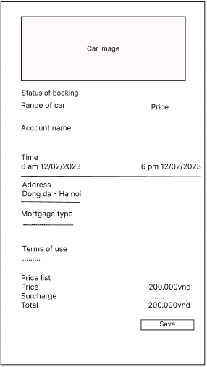

**Figure 5.4.1**: Screen Design of Edit booking

**Table 5.4.1: Screen Definition**

| **#** | **Field Name** | **Type** | **Mandatory** | **Max Length** | **Description** |
| --- | --- | --- | --- | --- | --- |
| 1 | Car Name | Text |  |  |  |
| 2 | Account name | Text |  |  | Car owner account name |
| 3 | Price | Money |  |  |  |
| 4 | Time | DateTime |  |  |  |
| 5 | Address | Text |  |  | Car delivery location |
| 6 | Mortgage type | Text |  |  |  |
| 7 | Status | Text |  |  | Status of booking |
| 8 | Back | Button |  |  | Go to View booking details screen |
| 9 | Save | Button |  |  | Save change |

#### 2.4.4.2 Use case Specification

| **Use Case ID** | | **UC0504** | **Use Case Name** | | **Edit booking** | |
| --- | --- | --- | --- | --- | --- | --- |
| **Author** | | **LuongTTH** | **Version** | **1.0** | **Date** | **05/02/2023** |
| **Actor** | | CRS User | | | | |
| **Description** | | The function allows a user to be able to edit booking that has not been accepted by the car owner. | | | | |
| **Precondition** | | PRE-01: Create new booking | | | | |
| **Trigger** | | TRG-01: | | | | |
| **Post-Condition** | | POS-01: | | | | |
| **Main flows** | | | | | | |
| ***Step*** | ***Actor*** | ***Action*** | | | | |
| *1* | User | Go to View booking details and click to Edit button | | | | |
| *2* | CRS | Display Edit booking screen with the following fields:  - Car name  - Account name  - Price  - Time  - Address  - Mortgage type  - Status  - Back, Save button | | | | |
| *3* | User | Fill into the fields that need to edit and click to Save button | | | | |
| *4* | CRS | Verify information and save change | | | | |
| *5* | CRS | Display “Successful” screen and return View booking details screen | | | | |

**Alternative flows**

| **AT1** | At step 2 in the main flows**,** if there is an internal error in the system, | |
| --- | --- | --- |
| **Sub step** | **Actor** | **Action** |
| 2.1 | CRS | Display "Error" page with message "System error, please reload the page" |

| **AT2** | At step 4 in the main flows**,** if fields is invalid | |
| --- | --- | --- |
| **Sub step** | **Actor** | **Action** |
| 2.1 | CRS | Display "Error" page with message "Information is invalid" |

***Business Rules***

| ***#*** | ***Rule Description*** |
| --- | --- |
| *BR01* | *Verify information before save change* |

### 2.4.5 Cancel booking

#### 2.4.5.1 Screen Design

**Figure 5.5.1**: Screen Design of Cancel booking

**Table 5.5.1: Screen Definition**

| **#** | **Field Name** | **Type** | **Mandatory** | **Max Length** | **Description** |
| --- | --- | --- | --- | --- | --- |
| 1 | Range of car | Text |  |  |  |
| 2 | Address | Text |  |  |  |
| 3 | Time | Number |  |  |  |
| 4 | Cancel | Button |  |  | Cancel booking |

| **#** | **Field Name** | **Type** | **Mandatory** | **Max Length** | **Description** |
| --- | --- | --- | --- | --- | --- |
| 1 | Car Name | Text |  |  |  |
| 2 | Account name | Text |  |  | Car owner account name |
| 3 | Price | Money |  |  |  |
| 4 | Time | DateTime |  |  |  |
| 5 | Address | Text |  |  | Car delivery location |
| 6 | Mortgage type | Text |  |  |  |
| 7 | Status | Text |  |  | Status of booking |
| 8 | Cancel | Button |  |  | Cancel booking |
| 9 | Edit | Button |  |  | Go to Edit booking screen |
| 10 | Feedback | Button |  |  | Go to Feedback screen |

#### 2.4.5.2 Use case Specification

| **Use Case ID** | | **UC0505** | **Use Case Name** | | **Cancel booking** | |
| --- | --- | --- | --- | --- | --- | --- |
| **Author** | | **LuongTTH** | **Version** | **1.0** | **Date** | **05/02/2023** |
| **Actor** | | CRS User | | | | |
| **Description** | | The function allows a user to be able to cancel a booking that is pending or accepted by the car owner but not finish. | | | | |
| **Precondition** | | PRE-01: Create new booking | | | | |
| **Trigger** | | TRG-01: | | | | |
| **Post-Condition** | | POS-01: | | | | |
| **Main flows** | | | | | | |
| ***Step*** | ***Actor*** | ***Action*** | | | | |
| *1* | User | Go to View list booked car screen or View booking details screen | | | | |
| *2* | CRS | Display View list booked car screen with the following fields:  - Range of car  - Address  - Time  - Cancel button  Display View booking details screen with the following fields:  - Car name  - Account name  - Price  - Time  - Address  - Mortgage type  - Status  - Cancel, Edit, Feedback button | | | | |
| *3* | User | Click to Cancel button | | | | |
| *4* | CRS | Display “Confirm” screen | | | | |
| *5* | User | If click to Ok button | | | | |
| *6* | CRS | Cancel booking and display “Successful” screen | | | | |
| *7* | User | If click to Cancel button | | | | |
| *8* | CRS | Return View list booked car or View booking details screen | | | | |

**Alternative flows**

| **AT1** | At step 2 in the main flows**,** if there is an internal error in the system, | |
| --- | --- | --- |
| **Sub step** | **Actor** | **Action** |
| 2.1 | CRS | Display "Error" page with message "System error, please reload the page" |

| **AT2** | At step 4 in the main flows**,** if can’t cancel booking | |
| --- | --- | --- |
| **Sub step** | **Actor** | **Action** |
| 2.1 | CRS | Display "Error" page with message "Can’t cancel booking" |

***Business Rules***

| ***#*** | ***Rule Description*** |
| --- | --- |
| *BR01* | *Before cancel booking in the app must be confirm with user* |

### 2.4.6 Feedback

#### 2.4.6.1 Screen Design

**Figure 5.6.1**: Screen Design of Feedback

**Table 5.6.1: Screen Definition**

| **#** | **Field Name** | **Type** | **Mandatory** | **Max Length** | **Description** |
| --- | --- | --- | --- | --- | --- |
| 1 | Rate |  |  |  |  |
| 2 | Comment | Text |  | 200 |  |
| 3 | Send | Button |  |  | Send feedback |

#### 2.4.6.2 Use case Specification

| **Use Case ID** | | **UC0506** | **Use Case Name** | | **Feedback** | |
| --- | --- | --- | --- | --- | --- | --- |
| **Author** | | **LuongTTH** | **Version** | **1.0** | **Date** | **05/02/2023** |
| **Actor** | | CRS User | | | | |
| **Description** | | The function allows a user to be able to give feedback about the car and user experience. | | | | |
| **Precondition** | | PRE-01: Must have booking that finished | | | | |
| **Trigger** | | TRG-01: | | | | |
| **Post-Condition** | | POS-01: | | | | |
| **Main flows** | | | | | | |
| ***Step*** | ***Actor*** | ***Action*** | | | | |
| *1* | User | Go to View booking details screen and click to Feedback button | | | | |
| *2* | CRS | Display Feedback screen with the following fields:  - Rate  - Comment  - Send button | | | | |
| *3* | User | Fill information into fields and click to send | | | | |
| *4* | CRS | Save information about user’s feedback for this car | | | | |

**Alternative flows**

| **AT1** | At step 2 in the main flows**,** if there is an internal error in the system, | |
| --- | --- | --- |
| **Sub step** | **Actor** | **Action** |
| 2.1 | CRS | Display "Error" page with message "System error, please reload the page" |

| **AT2** | At step 4 in the main flows**,** if can’t save information | |
| --- | --- | --- |
| **Sub step** | **Actor** | **Action** |
| 2.1 | CRS | Display "Error" page with message "Can’t send feedback" |

***Business Rules***

| ***#*** | ***Rule Description*** |
| --- | --- |
| *BR01* |  |

## 2.5 Manage Rental Car

### 2.5.1 My Car

#### 2.5.1.1 Screen Design

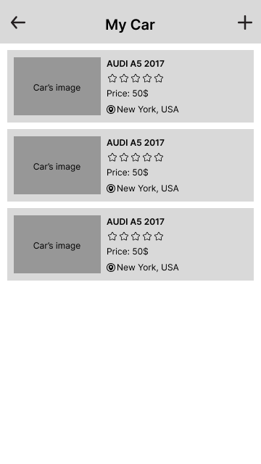

**Figure 3-1**: Screen Design of My Car

**Table 1-1: Screen Definition**

| **#** | **Field Name** | **Type** | **Mandatory** | **Max Length** | **Description** |
| --- | --- | --- | --- | --- | --- |
| 1 | Back | Button | Yes |  | Display by icon left arrow |
| 2 | Screen name | Text | Yes | 20 |  |
| 3 | Add new car | Button | Yes |  | Display by icon plus |
| 4 | Car item | Button |  |  | Display car’s basic information |

#### 2.5.1.2 Use case Specification

**Figure 3-2:** View My Car Use-Case Diagram

| **Use Case ID** | | **UC01** | **Use Case Name** | | **View My Car** | |
| --- | --- | --- | --- | --- | --- | --- |
| **Author** | | **NamDD** | **Version** | **1.0** | **Date** | **07/02/2023** |
| **Actor** | | CRMS user | | | | |
| **Description** | | The function allows a user to be able to view a list of their rental cars. | | | | |
| **Precondition** | | PRE-01: The user is logged in to the system | | | | |
| **Trigger** | | TRG-01: The user wants to view a list of rental cars. | | | | |
| **Post-Condition** | | POS-01: | | | | |
| **Main flows** | | | | | | |
| ***Step*** | ***Actor*** | ***Action*** | | | | |
| *1* | User | Click on the My Car button in Account screen. | | | | |
| *2* | CRMS | Display My Car screen with the following fields:  - Back button  - Screen name  - Add new car button  - Car item button includes car’s image, name, rating, rental price, address. | | | | |
| *3* | User | Clicks on a Car item button. | | | | |
| *4* | CRMS | Displays Car Information screen. | | | | |
|  |  |  | | | | |

**Alternative flows**

| **AT1** | At step 2 in the main flows**,** if there is an internal error in the system, | |
| --- | --- | --- |
| **Sub step** | **Actor** | **Action** |
| 2.1 | CRMS | Display "Error" page with message "Internal System Error, please contact with administrator" |
|  |  |  |
|  |  |  |

| **AT2** | At step 3 in the main flows**,** if the user clicks on Add new car button. | |
| --- | --- | --- |
| **Sub step** | **Actor** | **Action** |
| 3.1 | CRMS | Displays Add Basic Information screen. |
|  |  |  |

***Business Rules***

| ***#*** | ***Rule Description*** |
| --- | --- |
| *BR01* |  |
| *BR02* |  |

### 2.5.2 Car Information

#### 2.5.2.1 Screen Design

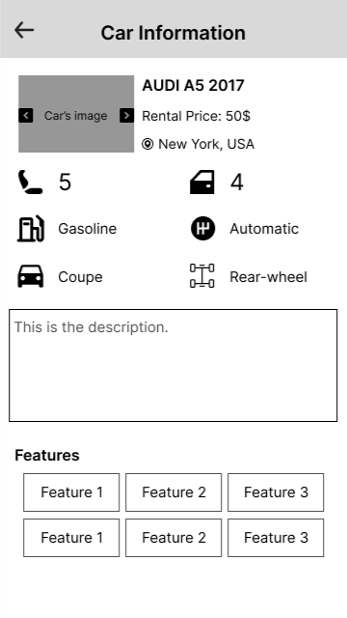

**Figure 3-1**: Screen Design of View Car Information

**Table 1-1: Screen Definition**

| **#** | **Field Name** | **Type** | **Mandatory** | **Max Length** | **Description** |
| --- | --- | --- | --- | --- | --- |
| 1 | Back | Button | Yes |  | Display by icon left arrow |
| 2 | Screen name | Text | Yes | 20 |  |
| 3 | Image | Button | Yes |  |  |
| 4 | Previous | Button |  |  |  |
| 5 | Next | Button |  |  |  |
| 6 | Name | Button |  |  |  |
| 7 | Rental price | Text |  | 10 |  |
| 8 | Address | Text |  | 50 |  |
| 9 | Seat | Text |  | 2 |  |
| 10 | Door | Text |  | 2 |  |
| 11 | Fuel | Text |  | 20 |  |
| 12 | Transmission | Text |  | 20 |  |
| 13 | Body style | Text |  | 20 |  |
| 14 | Drivetrain | Text |  | 20 |  |
| 15 | Description | Text |  | 200 |  |
| 16 | Feature | Icon |  |  |  |

#### 2.5.2.2 Use case Specification

**Figure 3-2:** View Car Information Use-Case Diagram

| **Use Case ID** | | **UC01** | **Use Case Name** | | **View Car Information** | |
| --- | --- | --- | --- | --- | --- | --- |
| **Author** | | **NamDD** | **Version** | **1.0** | **Date** | **07/02/2023** |
| **Actor** | | CRMS user | | | | |
| **Description** | | The function allows a user to be able to view detailed information of a car. | | | | |
| **Precondition** | | PRE-01: The user is logged in to the system | | | | |
| **Trigger** | | TRG-01: The user wants to view a car’s information. | | | | |
| **Post-Condition** | | POS-01: | | | | |
| **Main flows** | | | | | | |
| ***Step*** | ***Actor*** | ***Action*** | | | | |
| *1* | User | Clicks on the Car item button in My Car screen. | | | | |
| *2* | CRMS | Display Car Information screen with the following fields:  - Back button  - Screen name  - Image  - Previous and Next button  - Name, Rental price, Address, Seat, Door, Gasoline, Transmission, Body style, Drivetrain, and Description.  - Feature icons. | | | | |
| *3* | User | Clicks on a Previous or Next button. | | | | |
| *4* | CRMS | Slides the car’s image to the previous image or next image. | | | | |
|  |  |  | | | | |

**Alternative flows**

| **AT1** | At step 2 in the main flows**,** if there is an internal error in the system, | |
| --- | --- | --- |
| **Sub step** | **Actor** | **Action** |
| 2.1 | CRMS | Display "Error" page with message "Internal System Error, please contact with administrator" |
|  |  |  |
|  |  |  |

| **AT2** |  | |
| --- | --- | --- |
| **Sub step** | **Actor** | **Action** |
|  |  |  |
|  |  |  |

***Business Rules***

| ***#*** | ***Rule Description*** |
| --- | --- |
| *BR01* |  |
| *BR02* |  |

### 2.5.3 Add New Car

#### 2.5.3.1 Use Case diagram

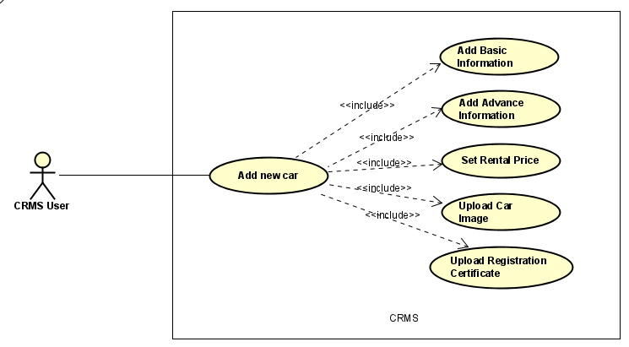

| **Use Case ID** | **User case Name** | **Description** |
| --- | --- | --- |
| UC0301 | Add Basic Information | Allow a user to add the basic information of a car |
| UC0302 | Add Advance Information | Allow a user to add the advance information of a car |
| UC0303 | Set Rental Price | Allow a user to set rental price of a car |
| UC0304 | Upload Car Image | Allow a user to upload car’s images |
| UC0305 | Upload Registration Certificate | Allow user to upload car’s registration certification image |

#### 2.5.3.2 UC0301 – Add Basic Information

##### 2.5.3.2.1 Screen Design

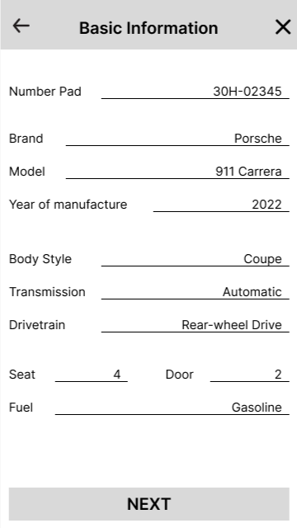

**Figure 3-1**: Screen Design of Add Basic Information

**Table 1-1: Screen Definition**

| **#** | **Field Name** | **Type** | **Mandatory** | **Max Length** | **Description** |
| --- | --- | --- | --- | --- | --- |
| 1 | Back | Button | Yes |  | Display by icon left arrow |
| 2 | Screen name | Text | Yes | 20 |  |
| 3 | Cancel | Button | Yes |  | Display by icon x |
| 4 | Number Pad | Text |  |  |  |
|  | Brand | Text |  |  |  |
|  | Model | Text |  |  |  |
|  | Year of manufacture | Year |  |  |  |
|  | Body style | Text |  |  |  |
|  | Transmission | Text |  |  |  |
|  | Drivetrain | Text |  |  |  |
|  | Seat | Number |  |  |  |
|  | Door | Number |  |  |  |
|  | Fuel | Text |  |  |  |
|  | Next | Button |  |  |  |

##### 2.5.3.2.2 Use case Specification

| **Use Case ID** | | **UC0301** | **Use Case Name** | | **Add Basic Information** | |
| --- | --- | --- | --- | --- | --- | --- |
| **Author** | | **NamDD** | **Version** | **1.0** | **Date** | **07/02/2023** |
| **Actor** | | CRMS user | | | | |
| **Description** | | The function allows a user to be able to fill in the basic information of a car. | | | | |
| **Precondition** | | PRE-01: The user is logged in to the system | | | | |
| **Trigger** | | TRG-01: The user wants to add basic information about the car. | | | | |
| **Post-Condition** | | POS-01: | | | | |
| **Main flows** | | | | | | |
| ***Step*** | ***Actor*** | ***Action*** | | | | |
| *1* | User | Click on Add new car in My Car screen. | | | | |
| *2* | CRMS | Display Basic Information screen with the following fields:  - Back button  - Screen name  - Cancel button  - Number pad, Brand, Model, Year of manufacture, Body style, Transmission, Drivetrain, Seat, Door, Fuel. | | | | |
| *3* | User | Enter number pad, brand, model, year of manufacture, body style, transmission, drivetrain, seat, door, fuel into Number pad, Brand, Model, Year of manufacture, Body style, Transmission, Drivetrain, Seat, Door, and Fuel fields and then click on Next button in Basic Information screen. | | | | |
| *4* | CRMS | Display Add Advance Information screen | | | | |
|  |  |  | | | | |

**Alternative flows**

| **AT1** | At step 2 in the main flows**,** if there is an internal error in the system, | |
| --- | --- | --- |
| **Sub step** | **Actor** | **Action** |
| 2.1 | CRMS | Display "Error" page with message "Internal System Error, please contact with administrator" |
|  |  |  |
|  |  |  |

| **AT2** | At step 3 in the main flows**,** if the user clicks on the Cancel button. | |
| --- | --- | --- |
| **Sub step** | **Actor** | **Action** |
| 3.1 | CRMS | Displays My Car screen. |
|  |  |  |

#### 2.5.3.3 UC0302 - Add Advance Information

##### 2.5.3.3.1 Screen Design

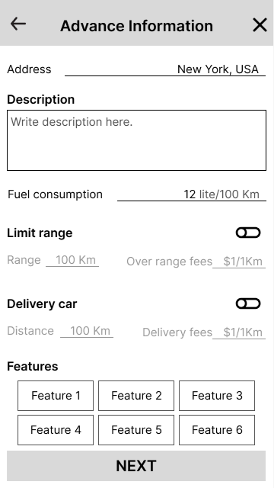

**Figure 3-1**: Screen Design of Add Advance Information

**Table 1-1: Screen Definition**

| **#** | **Field Name** | **Type** | **Mandatory** | **Max Length** | **Description** |
| --- | --- | --- | --- | --- | --- |
| 1 | Back | Button | Yes |  | Display by icon left arrow |
| 2 | Screen name | Text | Yes | 20 |  |
| 3 | Cancel | Button | Yes |  | Display by icon x |
| 4 | Address | Text |  | 50 |  |
| 5 | Description | Text |  | 200 |  |
| 6 | Fuel consumption | Number |  |  |  |
| 7 | Limit range | Button |  |  |  |
| 8 | Range | Number |  |  | Disable if Limit range button is off |
| 9 | Over range fees | Number |  |  | Disable if Limit range button is off |
| 10 | Delivery car | Button |  |  |  |
| 11 | Distance | Number |  |  | Disable if Delivery car button is off |
| 12 | Delivery fees | Number |  |  | Disable if Delivery car button is off |
| 13 | Feature | Button |  |  |  |
| 14 | Next | Button |  |  |  |

##### 2.5.3.3.2 Use case Specification

| **Use Case ID** | | **UC0302** | **Use Case Name** | | **Add Advance Information** | |
| --- | --- | --- | --- | --- | --- | --- |
| **Author** | | **NamDD** | **Version** | **1.0** | **Date** | **07/02/2023** |
| **Actor** | | CRMS user | | | | |
| **Description** | | The function allows a user to be able to fill advance information of a car. | | | | |
| **Precondition** | | PRE-01: The user is logged in to the system  PRE-02: The user have to completed adding basic information of the car at Add Basic Information screen | | | | |
| **Trigger** | | TRG-01: The user wants to add advanced information about the car. | | | | |
| **Post-Condition** | | POS-01: | | | | |
| **Main flows** | | | | | | |
| ***Step*** | ***Actor*** | ***Action*** | | | | |
| *1* | User | Click on Next button in Add Basic Information screen. | | | | |
| *2* | CRMS | Display Add Advance Information screen with the following fields:  - Back button  - Screen name  - Cancel button  - Address, Description, Fuel consumption  - Limit range button  - Range and Over range fees  - Delivery car button  - Distance and Delivery fees  - Features  - Next button | | | | |
| *3* | User | Enter address, description, fuel consumption into Address, Description, Fuel consumption fields; then clicks on Limit range button and then enter range, over range fees into Range, Over range fees fields; then clicks on Delivery car button and then enter distance, delivery fees in to Distance, Delivery fees fields; then clicks on Feature buttons and then clicks on Next button in Add Advance Information screen. | | | | |
| *4* | CRMS | Display Set Rental Price screen. | | | | |
|  |  |  | | | | |

**Alternative flows**

| **AT1** | At step 2 in the main flows**,** if there is an internal error in the system, | |
| --- | --- | --- |
| **Sub step** | **Actor** | **Action** |
| 2.1 | CRMS | Display "Error" page with message "Internal System Error, please contact with administrator" |
|  |  |  |
|  |  |  |

| **AT2** | At step 3 in the main flows**,** if the user clicks on the Cancel button. | |
| --- | --- | --- |
| **Sub step** | **Actor** | **Action** |
| 3.1 | CRMS | Displays My Car screen. |
|  |  |  |

#### 2.5.3.4 UC0303 - Set Rental Price

##### 2.5.3.4.1 Screen Design

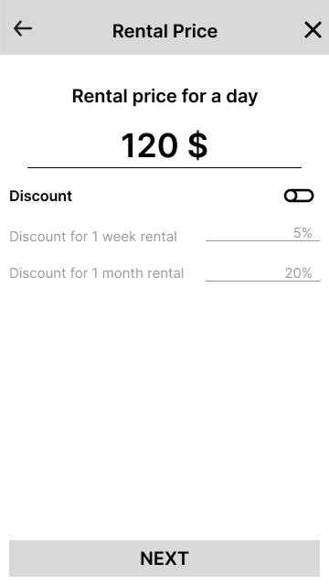

**Figure 3-1**: Screen Design of Set Rental Price

**Table 1-1: Screen Definition**

| **#** | **Field Name** | **Type** | **Mandatory** | **Max Length** | **Description** |
| --- | --- | --- | --- | --- | --- |
| 1 | Back | Button | Yes |  | Display by icon left arrow |
| 2 | Screen name | Text | Yes | 20 |  |
| 3 | Cancel | Button | Yes |  | Display by icon x |
| 4 | Rental price | Number |  |  |  |
| 5 | Discount | Button |  |  |  |
| 6 | Week discount | Number |  |  | Disable if Discount button is off |
| 7 | Month discount | Number |  |  | Disable if Discount button is off |

##### 2.5.3.4.2 Use case Specification

| **Use Case ID** | | **UC0303** | **Use Case Name** | | **Set Rental Price** | |
| --- | --- | --- | --- | --- | --- | --- |
| **Author** | | **NamDD** | **Version** | **1.0** | **Date** | **07/02/2023** |
| **Actor** | | CRMS user | | | | |
| **Description** | | The function allows a user to be able to set the rental price for a car. | | | | |
| **Precondition** | | PRE-01: The user is logged in to the system  PRE-02: The user have to completed adding advance information of the car at Add Advance Information screen | | | | |
| **Trigger** | | TRG-01: The user wants to set the rental price of the car. | | | | |
| **Post-Condition** | | POS-01: | | | | |
| **Main flows** | | | | | | |
| ***Step*** | ***Actor*** | ***Action*** | | | | |
| *1* | User | Click on Next button in Add Advance Information screen. | | | | |
| *2* | CRMS | Display Set Rental Price screen with the following fields:  - Back button  - Screen name  - Cancel button  - Discount button  - Week discount and Month discount | | | | |
| *3* | User | Enter rental price into Rental price field and then click on Discount button then enter week discount and month discount into Week discount and Month discount fields and then click on Next button in Set Rental Price screen. | | | | |
| *4* | CRMS | Display Upload Car Image screen. | | | | |
|  |  |  | | | | |

**Alternative flows**

| **AT1** | At step 2 in the main flows**,** if there is an internal error in the system, | |
| --- | --- | --- |
| **Sub step** | **Actor** | **Action** |
| 2.1 | CRMS | Display "Error" page with message "Internal System Error, please contact with administrator" |
|  |  |  |
|  |  |  |

| **AT2** | At step 3 in the main flows**,** if the user clicks on the Cancel button. | |
| --- | --- | --- |
| **Sub step** | **Actor** | **Action** |
| 3.1 | CRMS | Displays My Car screen. |
|  |  |  |

#### 2.5.3.5 UC0304 - Upload Car Image

##### 2.5.3.5.1 Screen Design

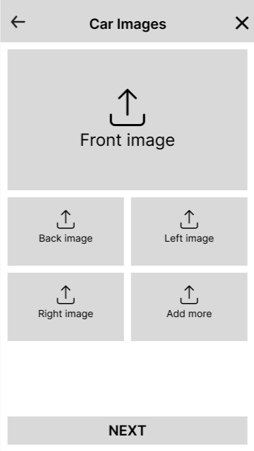

**Figure 3-1**: Screen Design of My Car

**Table 1-1: Screen Definition**

| **#** | **Field Name** | **Type** | **Mandatory** | **Max Length** | **Description** |
| --- | --- | --- | --- | --- | --- |
| 1 | Back | Button | Yes |  | Display by icon left arrow |
| 2 | Screen name | Text | Yes | 20 |  |
| 3 | Cancel | Button | Yes |  | Display by icon x |
| 4 | Front image | Button |  |  |  |
|  | Back image | Button |  |  |  |
|  | Left image | Button |  |  |  |
|  | Right image | Button |  |  |  |
|  | Add more | Button |  |  |  |
|  | Next | Button |  |  |  |

##### 2.5.3.5.2 Use case Specification

| **Use Case ID** | | **UC0304** | **Use Case Name** | | **Upload Car Image** | |
| --- | --- | --- | --- | --- | --- | --- |
| **Author** | | **NamDD** | **Version** | **1.0** | **Date** | **07/02/2023** |
| **Actor** | | CRMS user | | | | |
| **Description** | | The function allows a user to be able to upload car’s images. | | | | |
| **Precondition** | | PRE-01: The user is logged in to the system  PRE-02: The user have to completed set rental price of the car at Set Rental Price screen | | | | |
| **Trigger** | | TRG-01: The user wants to upload car’s images. | | | | |
| **Post-Condition** | | POS-01: | | | | |
| **Main flows** | | | | | | |
| ***Step*** | ***Actor*** | ***Action*** | | | | |
| *1* | User | Click on Next button in Set Rental Price screen. | | | | |
| *2* | CRMS | Display Car Image screen with the following fields:  - Back button  - Screen name  - Cancel button  - Front image, Back image, Left image, Right image, Add more button  - Next button | | | | |
| *3* | User | Upload front image, back image, left image, right image to Front image, Back image, Left image, Right image fields and then click on Next button in Upload Car Image screen. | | | | |
| *4* | CRMS | Display Upload Registration Certificate screen. | | | | |
|  |  |  | | | | |

**Alternative flows**

| **AT1** | At step 2 in the main flows**,** if there is an internal error in the system, | |
| --- | --- | --- |
| **Sub step** | **Actor** | **Action** |
| 2.1 | CRMS | Display "Error" page with message "Internal System Error, please contact with administrator" |
|  |  |  |
|  |  |  |

| **AT2** | At step 3 in the main flows**,** if the user clicks on the Cancel button. | |
| --- | --- | --- |
| **Sub step** | **Actor** | **Action** |
| 3.1 | CRMS | Displays Car List screen. |
|  |  |  |

#### 2.5.3.6 UC0305 - Upload Registration Certificate

##### 2.5.3.6.1 Screen Design

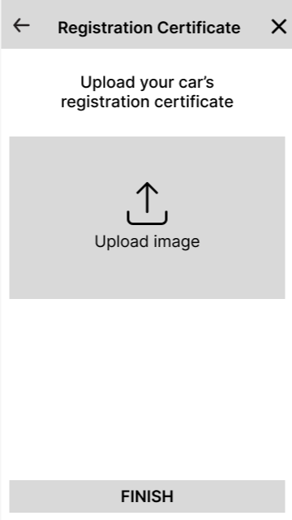

**Figure 3-1**: Screen Design of My Car

**Table 1-1: Screen Definition**

| **#** | **Field Name** | **Type** | **Mandatory** | **Max Length** | **Description** |
| --- | --- | --- | --- | --- | --- |
| 1 | Back | Button | Yes |  | Display by icon left arrow |
| 2 | Screen name | Text | Yes | 20 |  |
| 3 | Cancel | Button | Yes |  | Display by icon x |
| 4 | Upload | Button |  |  |  |
| 5 | Finish | Button | Yes |  |  |

##### 2.5.3.6.2 Use case Specification

| **Use Case ID** | | **UC0305** | **Use Case Name** | | **Upload Registration Certification** | |
| --- | --- | --- | --- | --- | --- | --- |
| **Author** | | **NamDD** | **Version** | **1.0** | **Date** | **07/02/2023** |
| **Actor** | | CRMS user | | | | |
| **Description** | | The function allows a user to be able to upload the registration certificate’s image. | | | | |
| **Precondition** | | PRE-01: The user is logged in to the system  PRE-02: The user have to completed uploading car’s images at Upload Car Image screen | | | | |
| **Trigger** | | TRG-01: The user wants to upload images of the car's registration certificate. | | | | |
| **Post-Condition** | | POS-01: New car information is saved to the data system of CRMS | | | | |
| **Main flows** | | | | | | |
| ***Step*** | ***Actor*** | ***Action*** | | | | |
| *1* | User | Click on the My Car button in the Account screen. | | | | |
| *2* | CRMS | Display My Car screen with the following fields:  - Back button  - Screen name  - Cancel button  - Upload button  - Finish button | | | | |
| *3* | User | Upload image to Upload field and then clicks on Finish button in Upload Registration Certificate screen | | | | |
| *4* | CRMS | Save new car information into the database and then display a popup with the message “Add new car successful” and then display My Car screen. | | | | |
|  |  |  | | | | |

**Alternative flows**

| **AT1** | At step 2 in the main flows**,** if there is an internal error in the system, | |
| --- | --- | --- |
| **Sub step** | **Actor** | **Action** |
| 2.1 | CRMS | Display "Error" page with message "Internal System Error, please contact with administrator" |
|  |  |  |
|  |  |  |

| **AT2** | At step 3 in the main flows**,** if the user clicks on the Cancel button. | |
| --- | --- | --- |
| **Sub step** | **Actor** | **Action** |
| 3.1 | CRMS | Displays Car List screen. |
|  |  |  |

| **AT3** | At step 4 in the main flows**,** if the system cannot save the new car’s information. | |
| --- | --- | --- |
| **Sub step** | **Actor** | **Action** |
| 3.1 | CRMS | Display popup with message “Add new car failed!”. |
|  |  |  |

## 2.6 Manage Account

### 6.1 View address

#### 1.1.1 Screen Design

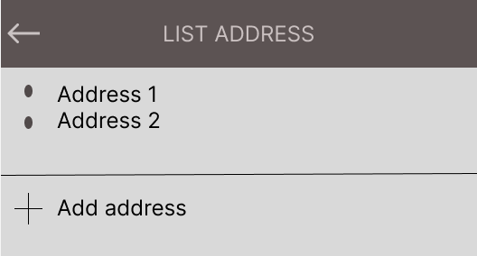

**Table 1-1: Screen Definition**

| **#** | **Field Name** | **Type** | **Mandatory** | **Max Length** | **Description** |
| --- | --- | --- | --- | --- | --- |
| 1 | Back | button |  | 20 | Back to page “Account” |
| 2 | List address | Text |  | 100 |  |
| 3 | Address 1 | Text |  | 50 |  |
| 4 | Add address | Button |  | 50 |  |

#### 1.2.2 Use case Specification

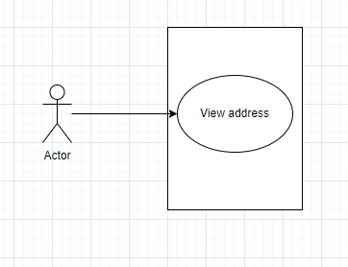

**Figure 3-2:** Login Use-Case Diagram

| **Use Case ID** | | **UC01** | **Use Case Name** | | **View address** | |
| --- | --- | --- | --- | --- | --- | --- |
| **Author** | | **BaoNN** | **Version** | **1.0** | **Date** | **11/05/2013** |
| **Actor** | | User | | | | |
| **Description** | | View which addresses user has added | | | | |
| **Precondition** | | PRE-01: Login in to the app | | | | |
| **Trigger** | | TRG-01:User want to choose address | | | | |
| **Post-Condition** | | POS-01: | | | | |
| **Main flows** | | | | | | |
| ***Step*** | ***Actor*** | ***Action*** | | | | |
| *1* | User | User click in the button “List address” | | | | |
| *2* | System | Display Login screen with the following fields:  - List address  - Address 1  - Add address | | | | |
| *3* | User | User click button “Add address” | | | | |
| *4* | System | Redirect to the Add address screen | | | | |

**Alternative flows**

| **AT1** | At step 2 in the main flows**,** if there is an internal error in the system, | |
| --- | --- | --- |
| **Sub step** | **Actor** | **Action** |
| 2.1 | System | Display "Error" page with message "Error message" |

| **AT2** | At step 3 in the main flows**,** if user click button “Add address” | |
| --- | --- | --- |
| **Sub step** | **Actor** | **Action** |
| 3.1 | System | Redirect to the Add address screen |

### 6.2 Add address

#### 1.2.1 Screen Design

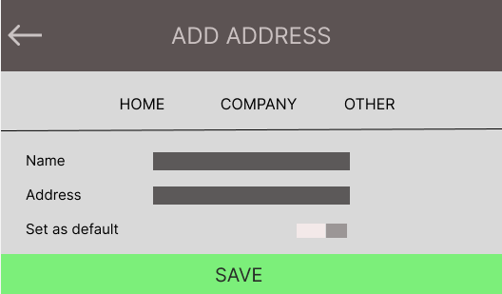

**Table 1-1: Screen Definition**

| **#** | **Field Name** | **Type** | **Mandatory** | **Max Length** | **Description** |
| --- | --- | --- | --- | --- | --- |
| 1 | Back | button | Yes | 20 | Back to page “List address” |
| 2 | Add address | Text | Yes | 100 |  |
| 3 | Home | Button |  | 50 | Address type |
| 4 | Company | Button |  | 50 | Address type |
| 5 | Other | Button |  | 50 | Address type |
| 6 | Name | Text | Yes | 200 | Name of Address |
| 7 | Address | Text | Yes | 200 | Address |
| 8 | Set as default | Button |  | 50 | Choose this address as default |
| 9 | Save | Button |  |  | Save address |

#### 1.2.2 Use case Specification

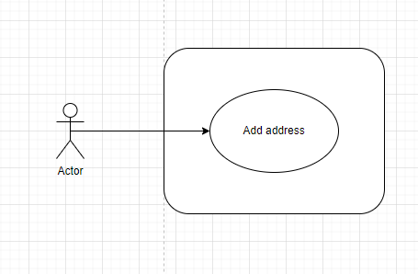

### 

**Figure 3-2:** Add address Use-Case Diagram

| **Use Case ID** | | **UC01** | **Use Case Name** | | **Add address** | |
| --- | --- | --- | --- | --- | --- | --- |
| **Author** | | **BaoNN** | **Version** | **1.0** | **Date** | **11/05/2013** |
| **Actor** | | User | | | | |
| **Description** | | Add new address | | | | |
| **Precondition** | | PRE-01: Login in to the app | | | | |
| **Trigger** | | TRG-01: User want to add address | | | | |
| **Post-Condition** | | POS-01: | | | | |
| **Main flows** | | | | | | |
| ***Step*** | ***Actor*** | ***Action*** | | | | |
| *1* | User | User click in the button “Add address” | | | | |
| *2* | System | Display Login screen with the following fields:  - Add address  - Home  - Company  - Other  - Name  - Address  - Set as default  - Save | | | | |
| *3* | User | User click button “Save” | | | | |
| *4* | System | Add the address in the database | | | | |

**Alternative flows**

| **AT1** | At step 3 in the main flows**,** if there is an internal error in the system, | |
| --- | --- | --- |
| **Sub step** | **Actor** | **Action** |
| 2.1 | System | Display "Error" page with message "Error message" |

### 6.3 Account

#### 1.3.1 Screen Design

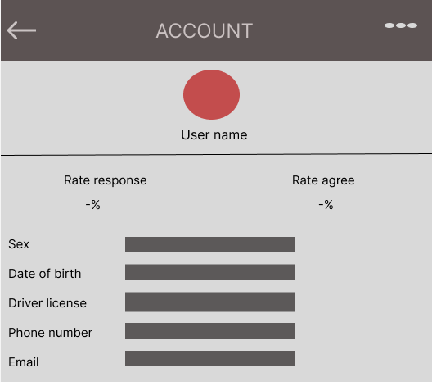

**Figure 3-1**: Screen Design of Tools

**Table 1-1: Screen Definition**

| **#** | **Field Name** | **Type** | **Mandatory** | **Max Length** | **Description** |
| --- | --- | --- | --- | --- | --- |
| 1 | Back | Button | No | 50 | Back to “Account” screen |
| 2 | Account | Image | No | 100 | Image of user |
| 3 | Rate response | Text | No | 100 | Response rate |
| 4 | Rate agree | Text | No | 100 | Agree rate |
| 5 | Date of birth | Text | Yes | 200 | Date of birth |
| 6 | Sex | Text | Yes | 50 | Sex |
| 7 | Driver licence | Text | Yes | 200 | Driving licence |
| 8 | Phone number | Text | Yes | 200 | Phone number |
| 9 | Email | Text | Yes | 200 | Email of user |
| 10 | Name user | Text | Yes | 100 | Name of user |

#### 1.3.2 Use case Specification

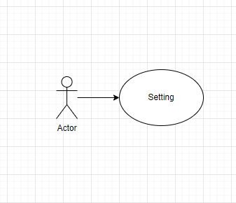

**Figure 3-2:** Account Use-Case Diagram

| **Use Case ID** | | **UC1515** | **Use Case Name** | | **Tools** | |
| --- | --- | --- | --- | --- | --- | --- |
| **Author** | | **BaoNN** | **Version** | **1.0** | **Date** | **29/01/2023** |
| **Actor** | | FinPlan user | | | | |
| **Description** | | View detail account | | | | |
| **Precondition** | | PRE-01: Sign in to the app | | | | |
| **Trigger** | | TRG-01: The user wants to view details of the account. | | | | |
| **Post-Condition** | | POS-01: | | | | |
| **Main flows** | | | | | | |
| ***Step*** | ***Actor*** | ***Action*** | | | | |
| *1* | User | Click on the “Account” button . | | | | |
| *2* | System | Display Tools screen with the following fields:  - Back button  - Image user  - Name user  - Button setting  - Sex  - Driver’s licence  - Phone number  - Email  - Rate response  - Rate agree | | | | |
| *3* | User | Click the settings button. | | | | |
| *4* | System | Redirect to edit information screen | | | | |

**Alternative flows**

| **AT1** | At step 2 in the main flows**,** if there is an internal error in the system, | |
| --- | --- | --- |
| **Sub step** | **Actor** | **Action** |
| 2.1 | System | Display "Error" page with message "Internal System Error, please contact with administrator" |

### 6.4 Verification driver licence

#### 1.4.1 Screen Design

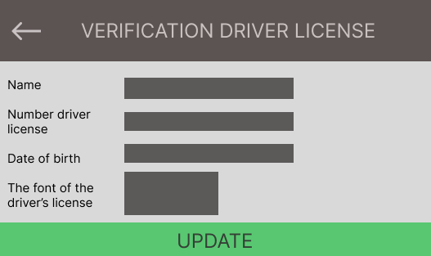

**Figure 3-1**: Screen Design of Exchanger

**Table 1-1: Screen Definition**

| **#** | **Field Name** | **Type** | **Mandatory** | **Max Length** | **Description** |
| --- | --- | --- | --- | --- | --- |
| 1 | Back | Button |  | 20 | Back to “Account”screen |
| 2 | Name | Text | Yes | 50 |  |
| 3 | Number driver’s licence | Text | Yes | 20 |  |
| 4 | Date of birth | Text | Yes | 100 |  |
| 5 | Font of the driver's licence | Image | Yes | 200 |  |
| 6 | Update | Button |  | 300 | Update driver licence |

#### 1.4.2 Use case Specification

**Figure 3-2:** Verification driver’s licence Use-Case Diagram

| **Use Case ID** | | **UC16** | **Use Case Name** | | **Exchanger** | |
| --- | --- | --- | --- | --- | --- | --- |
| **Author** | | **BaoNN** | **Version** | **1.0** | **Date** | **29/01/2023** |
| **Actor** | | User | | | | |
| **Description** | | Update driver's licence | | | | |
| **Precondition** | | PRE-01: Sign in to the app | | | | |
| **Trigger** | | TRG-01: The user wants to update driver’s licence. | | | | |
| **Post-Condition** | | POS-01: | | | | |
| **Main flows** | | | | | | |
| ***Step*** | ***Actor*** | ***Action*** | | | | |
| *1* | User | Click on the “verify” button at the “Account” screen. | | | | |
| *2* | System | Display Exchanger screen with the following fields:  - Back button  - Name  - Number driver licence  - Date of birth  - Font of the driver's licence  - Update | | | | |
| *3* | User | Enter each field and click “Update” | | | | |
| *4* | System | Validate each field and update driver licence in the database | | | | |

**Alternative flows**

| **AT1** | At step 4 in the main flows**,** if the system validates input wrong. | |
| --- | --- | --- |
| **Sub step** | **Actor** | **Action** |
| 4.1 | System | Display page with message "Enter again!" |

### 6.5 Verification email

#### 1.5.1 Screen Design

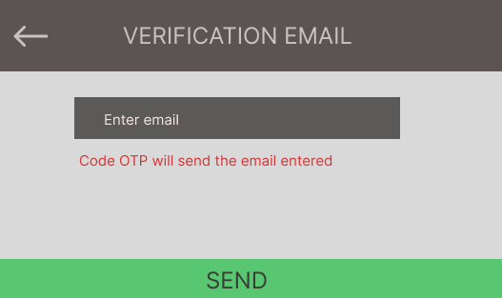

**Figure 3-1**: Screen Design of Interest Rate

**Table 1-1: Screen Definition**

| **#** | **Field Name** | **Type** | **Mandatory** | **Max Length** | **Description** |
| --- | --- | --- | --- | --- | --- |
| 1 | Back | Button |  |  | Back to “Account” screen |
| 2 | Verification email | Text | Yes | 100 |  |
| 3 | Enter email | Text | Yes | 200 |  |
| 4 | Send | Button |  | 200 |  |

#### 1.5.2 Use case Specification

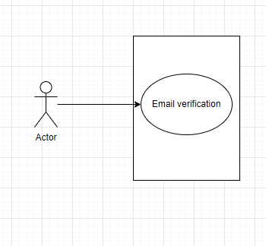

**Figure 3-2:** Verification email Use-Case Diagram

| **Use Case ID** | | **UC17** | **Use Case Name** | | **Interest Rate** | |
| --- | --- | --- | --- | --- | --- | --- |
| **Author** | | **BaoNN** | **Version** | **1.0** | **Date** | **29/01/2023** |
| **Actor** | | User | | | | |
| **Description** | | Users want to verify email. | | | | |
| **Precondition** | | PRE-01: Sign in to the app | | | | |
| **Trigger** | | TRG-01: The user wants to verify the email. | | | | |
| **Post-Condition** | | POS-01: | | | | |
| **Main flows** | | | | | | |
| ***Step*** | ***Actor*** | ***Action*** | | | | |
| *1* | User | Click on the icon button at the “Account”screen. | | | | |
| *2* | System | Display Interest Rate screen with the following fields:  - Back button  - Enter email  - Code OTP will send the email entered  - Send | | | | |
| *3* | User | Enter email want to verification | | | | |
| *4* | System | Send OTP code to email entered | | | | |

**Alternative flows**

| **AT1** | At step 3 in the main flows**,** if there is an internal error in the system. | |
| --- | --- | --- |
| **Sub step** | **Actor** | **Action** |
| 3.1   |  | | --- | | System | Display "Error" page with message "Internal System Error, please contact with administrator" |

***Business Rules***

| ***#*** | ***Rule Description*** |
| --- | --- |
| *BR01* | *Enter an already existing email* |
| *BR02* |  |

### 6.6 Edit information

#### 1.6.1 Screen Design

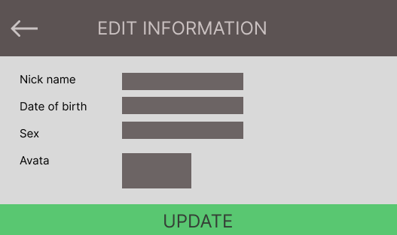

**Figure 3-1**: Screen Design of Export File

**Table 1-1: Screen Definition**

| **#** | **Field Name** | **Type** | **Mandatory** | **Max Length** | **Description** |
| --- | --- | --- | --- | --- | --- |
| 1 | Back | Button |  | 50 | Back to “Account” screen |
| 2 | Edit information | Text |  | 100 |  |
| 3 | Nick name | Text |  | 100 |  |
| 4 | Date of birth | Date |  | 100 |  |
| 5 | Sex | Choose |  | 50 |  |
| 6 | Avata | Button |  | 200 |  |
| 7 | Update | Button |  | 200 |  |

#### 1.6.2 Use case Specification

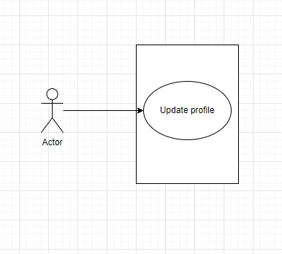

**Figure 3-2:** Update profile Use-Case Diagram

| **Use Case ID** | | **UC18** | **Use Case Name** | | **Export File** | |
| --- | --- | --- | --- | --- | --- | --- |
| **Author** | | **BaoNN** | **Version** | **1.0** | **Date** | **29/01/2023** |
| **Actor** | | User | | | | |
| **Description** | | Users want to change their profile. | | | | |
| **Precondition** | | PRE-01: Sign in to the app | | | | |
| **Trigger** | | TRG-01: Users want to change their profile. | | | | |
| **Post-Condition** | | POS-01: | | | | |
| **Main flows** | | | | | | |
| ***Step*** | ***Actor*** | ***Action*** | | | | |
| *1* | User | Click on the “Thay đổi hồ sơ” button at the “Account” screen. | | | | |
| *2* | System | Display Login screen with the following fields:  - Back button  - Nick name  - Date of birth  - Sex  - Avata  - Update | | | | |
| *3* | User | Enter each field and click “Update”button | | | | |
| *4* | System | Verification each filed.. | | | | |

**Alternative flows**

| **AT1** | At step 3 in the main flows**,** if the system verification wrong, | |
| --- | --- | --- |
| **Sub step** | **Actor** | **Action** |
| 3.1 | System | Display page with message "Enter again" |

### 6.7 Change password

#### 1.7.1 Screen Design

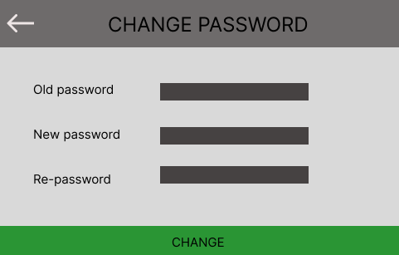

**Figure 3-1**: Screen Design of change password

**Table 1-1: Screen Definition**

| **#** | **Field Name** | **Type** | **Mandatory** | **Max Length** | **Description** |
| --- | --- | --- | --- | --- | --- |
| 1 | Back | Button |  |  | Back to “Account” screen |
| 2 | Change password | Text | Yes | 100 |  |
| 3 | Old password | Text | Yes | 50 |  |
| 4 | New password | Text | Yes | 50 |  |
| 5 | Re-password | Text |  | 50 |  |

#### 1.7.2 Use case Specification

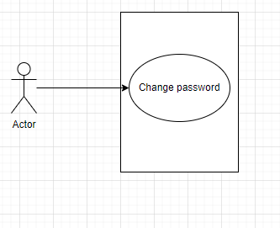

**Figure 3-2:** Change password Use-Case Diagram

| **Use Case ID** | | **UC19** | **Use Case Name** | | **Tax Calculator** | |
| --- | --- | --- | --- | --- | --- | --- |
| **Author** | | **BaoNN** | **Version** | **1.0** | **Date** | **29/01/2023** |
| **Actor** | | User | | | | |
| **Description** | | The user wants to change the password. | | | | |
| **Precondition** | | PRE-01: Sign in to the app | | | | |
| **Trigger** | | TRG-01: The user wants to change the password. | | | | |
| **Post-Condition** | | POS-01: | | | | |
| **Main flows** | | | | | | |
| ***Step*** | ***Actor*** | ***Action*** | | | | |
| *1* | User | Click on the “Thay đổi mật khẩu” button at the “Account”screen. | | | | |
| *2* | System | Display “Change password” screen with the following fields:  - Back button  - Screen name  - Old password  - New password  - Re-password  - Change | | | | |
| *3* | User | Enter each field. | | | | |
| *4* | System | Validate the entered to these each field | | | | |

**Alternative flows**

| **AT1** | At step 3 in the main flows**,** if the system verification wrong | |
| --- | --- | --- |
| **Sub step** | **Actor** | **Action** |
| 2.1 | System | Display page with message "Wrong old password", “New password need to be in correct format ” or ”Re-password doesn't match” |

***Business Rules***

| ***#*** | ***Rule Description*** |
| --- | --- |
| *BR01* | *New password need to be correct format* |
| *BR02* | *Re-password need the same new password* |

## 2.7. Common

### 2.7.1 Login

#### 2.7.1.1 Screen Design

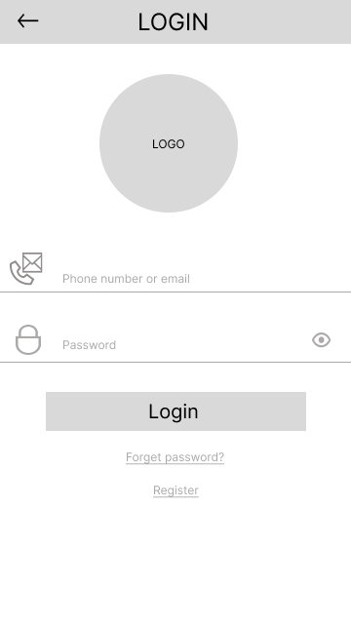

**Table 1-1: Screen Definition**

| **#** | **Field Name** | **Type** | **Mandatory** | **Max Length** | **Description** |
| --- | --- | --- | --- | --- | --- |
| 1 | Back | Button |  |  | Back to “Home” screen |
| 2 | Phone number or email | Text | Yes | 50 |  |
| 3 | Password | Text | Yes | 20 |  |
| 4 | Login | Button |  |  | Link to “Home” screen |
| 5 | Forget password | Link | Yes | 200 | Link to “Forgot password” screen |
| 6 | Register | Link | Yes | 200 | Link to “Register” screen |

#### 2.7.1.2 Use case Specification

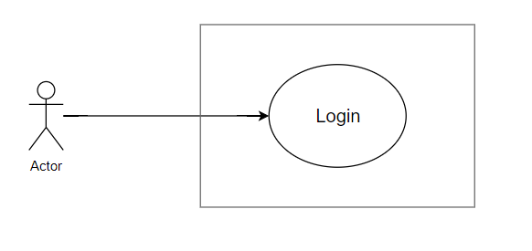

**Figure 1-2:** Login Use-Case Diagram

| **Use Case ID** | | **UC20** | **Use Case Name** | | **Login** | |
| --- | --- | --- | --- | --- | --- | --- |
| **Author** | | **HuyCQ** | **Version** | **1.0** | **Date** | **29/01/2023** |
| **Actor** | | User, CRMS | | | | |
| **Description** | | User want to login | | | | |
| **Precondition** | | PRE-01: Sign in to the app | | | | |
| **Trigger** | | TRG-01: User want to login | | | | |
| **Post-Condition** | | POS-01: | | | | |
| **Main flows** | | | | | | |
| ***Step*** | ***Actor*** | ***Action*** | | | | |
| *1* | User | Click on the “Account” when open app to login | | | | |
| *2* | CRMS | Display Login screen with the following fields:  - Back button  - Log  - Phone number or email  - Password  - Login button  - Forget password | | | | |
| *3* | User | Enter each field and click “Login” button | | | | |
| *4* | CRMS | Verification each field -> Go to “Home” screen | | | | |
| *5* | User | Click on “Forget password” | | | | |
| *6* | CRMS | Display “Forget password” screen. | | | | |
| *7* | User | Click on “Register” | | | | |
| *8* | CRMS | Display “Register” screen. | | | | |

**Alternative flows**

| **AT1** | At step 3 in the main flows**,** if the system verification wrong, | |
| --- | --- | --- |
| **Sub step** | **Actor** | **Action** |
| 3.1 | System | Display page with message "Enter again" |

### 2.7.2 Register

#### 2.7.2.1 Screen Design

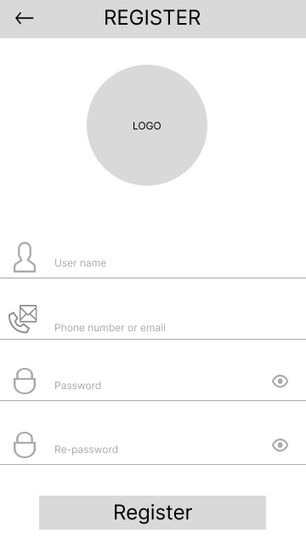

**Table 2-1: Screen Definition**

| **#** | **Field Name** | **Type** | **Mandatory** | **Max Length** | **Description** |
| --- | --- | --- | --- | --- | --- |
| 1 | Back | Button |  |  | Back to “Login” screen |
| 2 | User name | Text | Yes | 50 |  |
| 3 | Phone number or email | Text | Yes | 50 |  |
| 4 | Password | Text | Yes | 20 |  |
| 5 | Re-password | Text | Yes | 20 |  |
| 6 | Register | Button |  |  | Link to “Login” screen to login with new account |

#### 2.7.2.2 Use case Specification

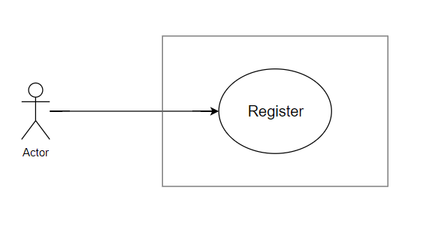

**Figure 2-2:** Register Use-Case Diagram

| **Use Case ID** | | **UC21** | **Use Case Name** | | **Register** | |
| --- | --- | --- | --- | --- | --- | --- |
| **Author** | | **HuyCQ** | **Version** | **1.0** | **Date** | **29/01/2023** |
| **Actor** | | User, CRMS | | | | |
| **Description** | | User want to Register | | | | |
| **Precondition** | | PRE-01: Sign in to the app | | | | |
| **Trigger** | | TRG-01: User want to Register | | | | |
| **Post-Condition** | | POS-01: | | | | |
| **Main flows** | | | | | | |
| ***Step*** | ***Actor*** | ***Action*** | | | | |
| *1* | User | Enter each field and click “Register” button | | | | |
| *2* | CRMS | Verification each field -> Go to “Login” screen | | | | |

**Alternative flows**

| **AT1** | At step 3 in the main flows**,** if the system verification wrong, | |
| --- | --- | --- |
| **Sub step** | **Actor** | **Action** |
| 3.1 | CRMS | Display pop-up with message "Register failed" |

### 2.7.3 Forgot password

#### 2.7.3.1 Screen Design

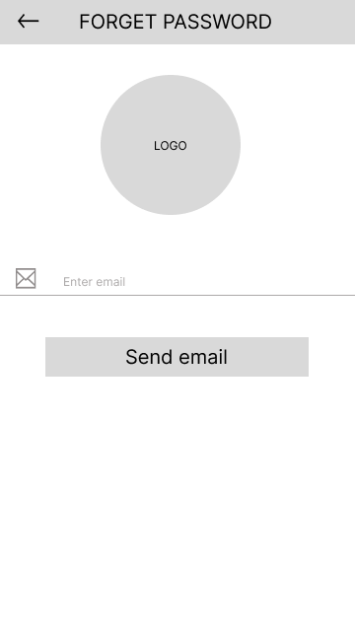

**Table 3-1: Screen Definition**

| **#** | **Field Name** | **Type** | **Mandatory** | **Max Length** | **Description** |
| --- | --- | --- | --- | --- | --- |
| 1 | Back | Button |  |  | Back to “Login” screen |
| 2 | Logo | Image | Yes |  | Logo app |
| 3 | Enter email | Text | Yes | 50 |  |
| 4 | Send email | Button | Yes |  |  |

#### 

#### 2.7.3.2 Use case Specification

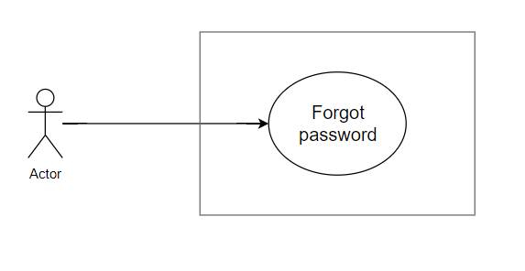

**Figure 2-2:** Register Use-Case Diagram

| **Use Case ID** | | **UC22** | **Use Case Name** | | **Forget password** | |
| --- | --- | --- | --- | --- | --- | --- |
| **Author** | | **HuyCQ** | **Version** | **1.0** | **Date** | **29/01/2023** |
| **Actor** | | User, CRMS | | | | |
| **Description** | | User want to password retrieval | | | | |
| **Precondition** | | PRE-01: Sign in to the app | | | | |
| **Trigger** | | TRG-01: User want to password retrieval | | | | |
| **Post-Condition** | | POS-01: | | | | |
| **Main flows** | | | | | | |
| ***Step*** | ***Actor*** | ***Action*** | | | | |
| *1* | User | Enter each field and click “Send email” button | | | | |
| *2* | CRMS | Verification each field -> Send new password to email of user. | | | | |
| *3* | User | Click “Back” button | | | | |
| *4* | CRMS | Return “Login” screen | | | | |

**Alternative flows**

| **AT1** | At step 3 in the main flows**,** if the system verification wrong, | |
| --- | --- | --- |
| **Sub step** | **Actor** | **Action** |
| 3.1 | CRMS | Display pop-up with message "Wrong email" |

### 2.7.4 Support

#### 2.7.4.1 Screen Design

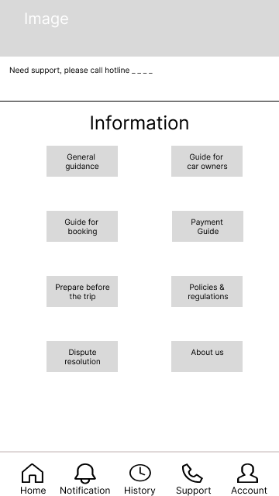

**Table 4-1: Screen Definition**

| **#** | **Field Name** | **Type** | **Mandatory** | **Max Length** | **Description** |
| --- | --- | --- | --- | --- | --- |
| 1 | Image | Image |  |  | Image app |
| 2 | Text | Text |  | max |  |
| 3 | General guidance | Button |  |  | Display pop-up show general guidance |
| 4 | Guide for car owners | Button |  |  | Display pop-up show guide for car owners |
| 5 | Guide for booking | Button |  |  | Display pop-up show guide for booking |
| 6 | Payment Guide | Button |  |  | Display pop-up show guide for car owners |
| 7 | Prepare before the trip | Button |  |  | Display pop-up show payment guide |
| 8 | Policies & regulations | Button |  |  | Display pop-up show guide policies & regulations |
| 9 | Dispute resolution | Button |  |  | Display pop-up show guide dispute resolution |
| 10 | About us | Button |  |  | Display pop-up show about us |
| 11 | Home | Button |  |  | Link to “Home” screen |
| 12 | Notification | Button |  |  | Link to “Notification” screen |
| 13 | History | Button |  |  | Link to “History” screen |
| 14 | Support | Button |  |  | Link to “Support” screen |
| 15 | Account | Button |  |  | Link to “Account” screen |

#### 

#### 2.7.4.2 Use case Specification

#### 

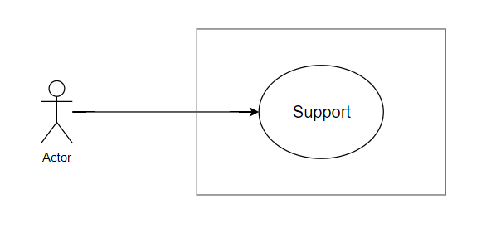

**Figure 2-2:** Register Use-Case Diagram

| **Use Case ID** | | **UC23** | **Use Case Name** | | **Support** | |
| --- | --- | --- | --- | --- | --- | --- |
| **Author** | | **HuyCQ** | **Version** | **1.0** | **Date** | **29/01/2023** |
| **Actor** | | User, CRMS | | | | |
| **Description** | | User want to support | | | | |
| **Precondition** | | PRE-01: Sign in to the app | | | | |
| **Trigger** | | TRG-01: User want to support | | | | |
| **Post-Condition** | | POS-01: | | | | |
| **Main flows** | | | | | | |
| ***Step*** | ***Actor*** | ***Action*** | | | | |
| *1* | User | Click “General guidance” button | | | | |
| *2* | CRMS | Display pop-up show general guidance | | | | |
| *3* | User | Click “Guide for car owners” button | | | | |
| *4* | CRMS | Display pop-up show guide for car owners | | | | |
| *5* | User | Click “Guide for booking” button | | | | |
| *6* | CRMS | Display pop-up show guide for booking | | | | |
| *7* | User | Click “Payment Guide” button | | | | |
| *8* | CRMS | Display pop-up show payment Guide | | | | |
| *9* | User | Click “Prepare before the trip” button | | | | |
| *10* | CRMS | Display pop-up show prepare before the trip | | | | |
| *11* | User | Click “Policies & regulations” button | | | | |
| *12* | CRMS | Display pop-up show policies & regulations | | | | |
| *13* | User | Click “Dispute resolution” button | | | | |
| *14* | CRMS | Display pop-up show dispute resolution | | | | |
| *15* | User | Click “About us” button | | | | |
| *16* | CRMS | Display pop-up show about us | | | | |
| *17* | User | Click “Home” button | | | | |
| *18* | CRMS | Link to “Home” screen | | | | |
| *19* | User | Click “Notification” button | | | | |
| *20* | CRMS | Link to “Notification” screen | | | | |
| *21* | User | Click “History” button | | | | |
| *22* | CRMS | Link to “History” screen | | | | |
| *23* | User | Click “Account” button | | | | |
| *24* | CRMS | Link to “Account” screen | | | | |

**Alternative flows**

| **AT1** | At step 3 in the main flows**,** if the system verification wrong, | |
| --- | --- | --- |
| **Sub step** | **Actor** | **Action** |
| 3.1 | CRMS |  |

### 2.7.5 Home

#### 2.7.5.1 Screen Design

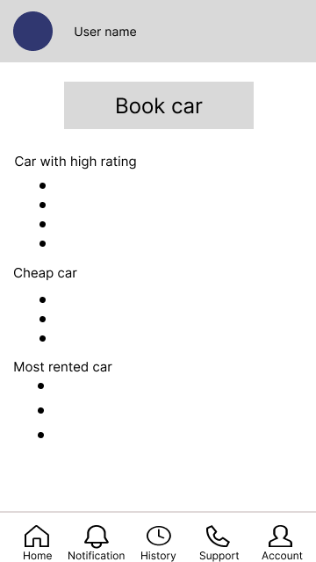

**Table 5-1: Screen Definition**

| **#** | **Field Name** | **Type** | **Mandatory** | **Max Length** | **Description** |
| --- | --- | --- | --- | --- | --- |
| 1 | Image | Image | yes |  | Image user |
| 2 | User name | Text | yes | 50 |  |
| 3 | Book car | Button |  |  | Go to “Book car” screen |
| 4 | Home | Button |  |  | Link to “Home” screen |
| 5 | Notification | Button |  |  | Link to “Notification” screen |
| 6 | History | Button |  |  | Link to “History” screen |
| 7 | Support | Button |  |  | Link to “Support” screen |
| 8 | Account | Button |  |  | Link to “Account” screen |

#### 

#### 2.7.5.2 Use case Specification

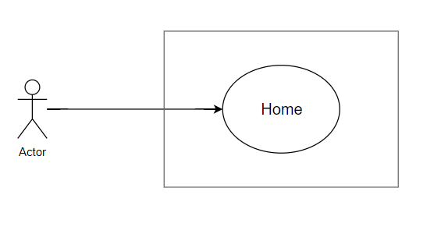

**Figure 2-2:** Register Use-Case Diagram

| **Use Case ID** | | **UC24** | **Use Case Name** | | **Home** | |
| --- | --- | --- | --- | --- | --- | --- |
| **Author** | | **HuyCQ** | **Version** | **1.0** | **Date** | **29/01/2023** |
| **Actor** | | User, CRMS | | | | |
| **Description** | | User want to book car and discovery | | | | |
| **Precondition** | | PRE-01: Sign in to the app | | | | |
| **Trigger** | | TRG-01: User want to book car and discovery | | | | |
| **Post-Condition** | | POS-01: | | | | |
| **Main flows** | | | | | | |
| ***Step*** | ***Actor*** | ***Action*** | | | | |
| *1* | User | Click “Book car” button | | | | |
| *2* | CRMS | Go to “Book car” screen | | | | |
| *3* | User | Click “Support” button | | | | |
| *4* | CRMS | Link to “Support” screen | | | | |
| *5* | User | Click “Notification” button | | | | |
| *6* | CRMS | Link to “Notification” screen | | | | |
| *7* | User | Click “History” button | | | | |
| *8* | CRMS | Link to “History” screen | | | | |
| *9* | User | Click “Account” button | | | | |
| *10* | CRMS | Link to “Account” screen | | | | |

**Alternative flows**

| **AT1** | At step 3 in the main flows**,** if the system verification wrong, | |
| --- | --- | --- |
| **Sub step** | **Actor** | **Action** |
| 3.1 | CRMS | Display pop-up with message "Driver's licence not yet verified" |

### 2.7.6 Notification

#### 2.7.6.1 Screen Design

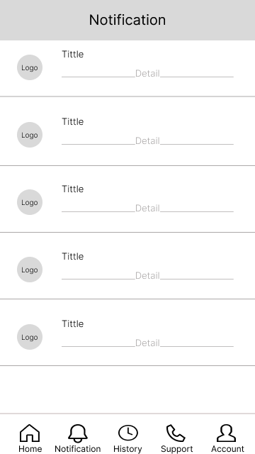

**Table 6-1: Screen Definition**

| **#** | **Field Name** | **Type** | **Mandatory** | **Max Length** | **Description** |
| --- | --- | --- | --- | --- | --- |
| 1 | Logo | Image | yes |  | Logo app |
| 2 | Tittle | Text | yes | max |  |
| 3 | Detail | Text | yes | max |  |
| 4 | Home | Button |  |  | Link to “Home” screen |
| 5 | Notification | Button |  |  | Link to “Notification” screen |
| 6 | History | Button |  |  | Link to “History” screen |
| 7 | Support | Button |  |  | Link to “Support” screen |
| 8 | Account | Button |  |  | Link to “Account” screen |

#### 

#### 2.7.6.2 Use case Specification

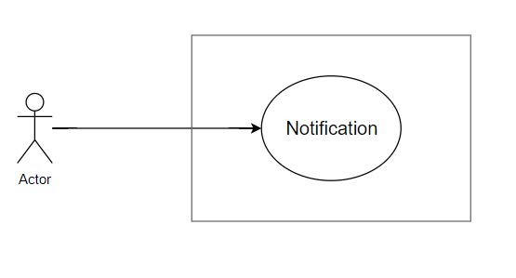

**Figure 2-2:** Register Use-Case Diagram

| **Use Case ID** | | **UC25** | **Use Case Name** | | **Notification** | |
| --- | --- | --- | --- | --- | --- | --- |
| **Author** | | **HuyCQ** | **Version** | **1.0** | **Date** | **29/01/2023** |
| **Actor** | | User, CRMS | | | | |
| **Description** | | User want to view notification | | | | |
| **Precondition** | | PRE-01: Sign in to the app | | | | |
| **Trigger** | | TRG-01: User want to view notification | | | | |
| **Post-Condition** | | POS-01: | | | | |
| **Main flows** | | | | | | |
| ***Step*** | ***Actor*** | ***Action*** | | | | |
| *1* | User | Click “Title” | | | | |
| *2* | CRMS | Go to “Notification detail” screen | | | | |
| *3* | User | Click “Support” button | | | | |
| *4* | CRMS | Link to “Support” screen | | | | |
| *5* | User | Click “Home” button | | | | |
| *6* | CRMS | Link to “Home” screen | | | | |
| *7* | User | Click “History” button | | | | |
| *8* | CRMS | Link to “History” screen | | | | |
| *9* | User | Click “Account” button | | | | |
| *10* | CRMS | Link to “Account” screen | | | | |

**Alternative flows**

| **AT1** | At step 3 in the main flows**,** if the system verification wrong, | |
| --- | --- | --- |
| **Sub step** | **Actor** | **Action** |
| 3.1 | CRMS | Error |

### 2.7.7 Notification detail

#### 2.7.7.1 Screen Design

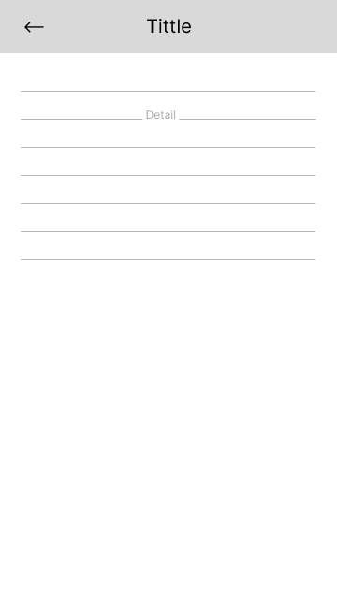

**Table 7-1: Screen Definition**

| **#** | **Field Name** | **Type** | **Mandatory** | **Max Length** | **Description** |
| --- | --- | --- | --- | --- | --- |
| 1 | Back | Button | yes |  | Go back to “Notification” screen |
| 2 | Tittle | Text | yes | max |  |
| 3 | Detail | Text | yes | max |  |

#### 

#### 2.7.7.2 Use case Specification

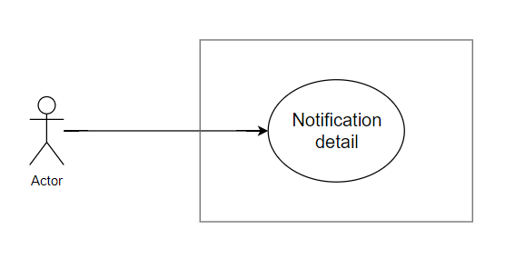

**Figure 2-2:** Register Use-Case Diagram

| **Use Case ID** | | **UC26** | **Use Case Name** | | **Notification detail** | |
| --- | --- | --- | --- | --- | --- | --- |
| **Author** | | **HuyCQ** | **Version** | **1.0** | **Date** | **29/01/2023** |
| **Actor** | | User, CRMS | | | | |
| **Description** | | User want to view notification detail | | | | |
| **Precondition** | | PRE-01: Sign in to the app | | | | |
| **Trigger** | | TRG-01: User want to view notification detail | | | | |
| **Post-Condition** | | POS-01: | | | | |
| **Main flows** | | | | | | |
| ***Step*** | ***Actor*** | ***Action*** | | | | |
| *1* | User | Click “Back” button | | | | |
| *2* | CRMS | Go to “Notification” screen | | | | |

**Alternative flows**

| **AT1** | At step 3 in the main flows**,** if the system verification wrong, | |
| --- | --- | --- |
| **Sub step** | **Actor** | **Action** |
| 3.1 | CRMS | Error |